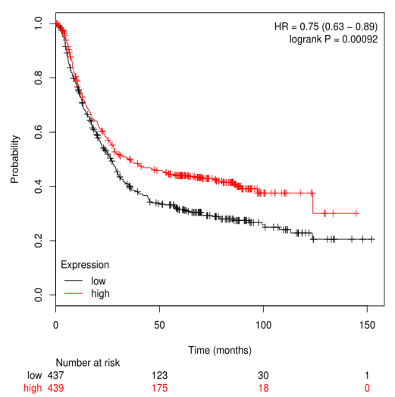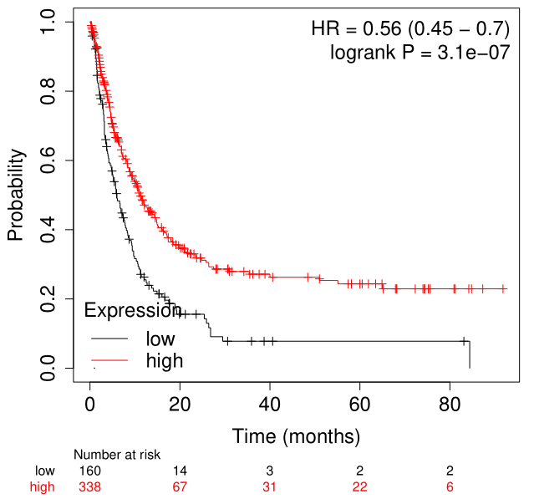
Supplementary Figure S1

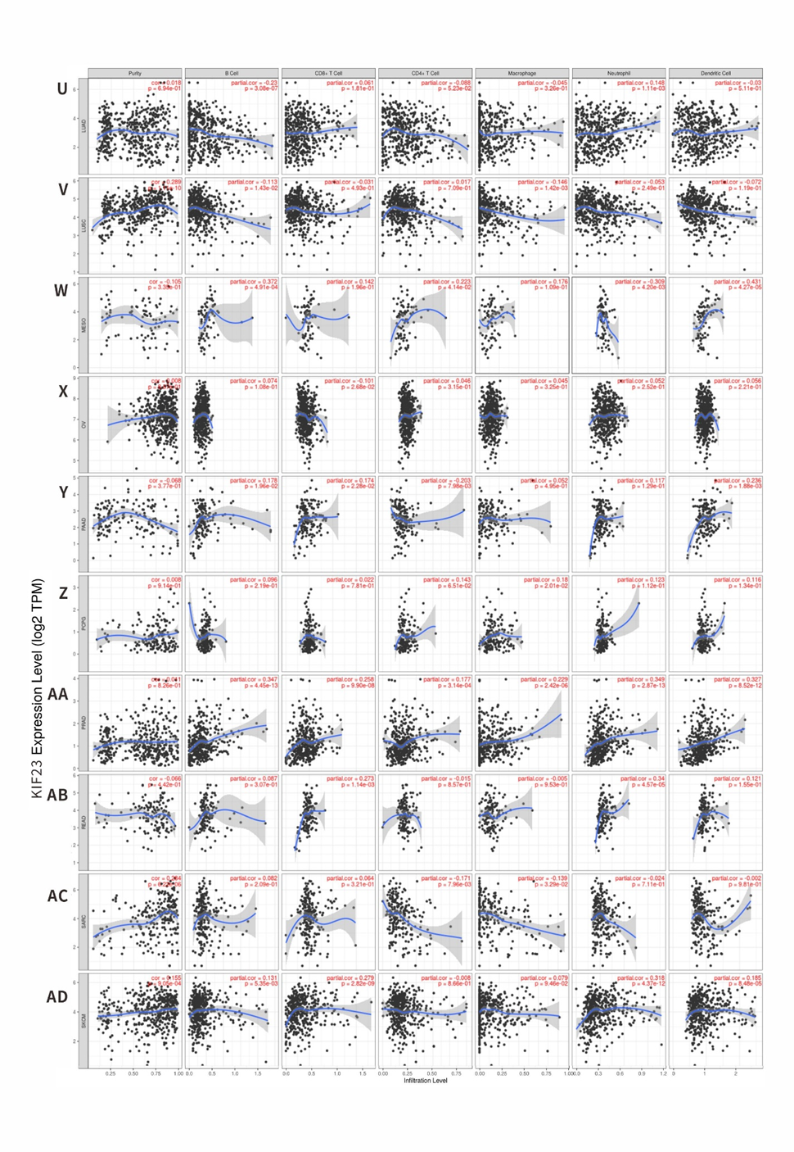
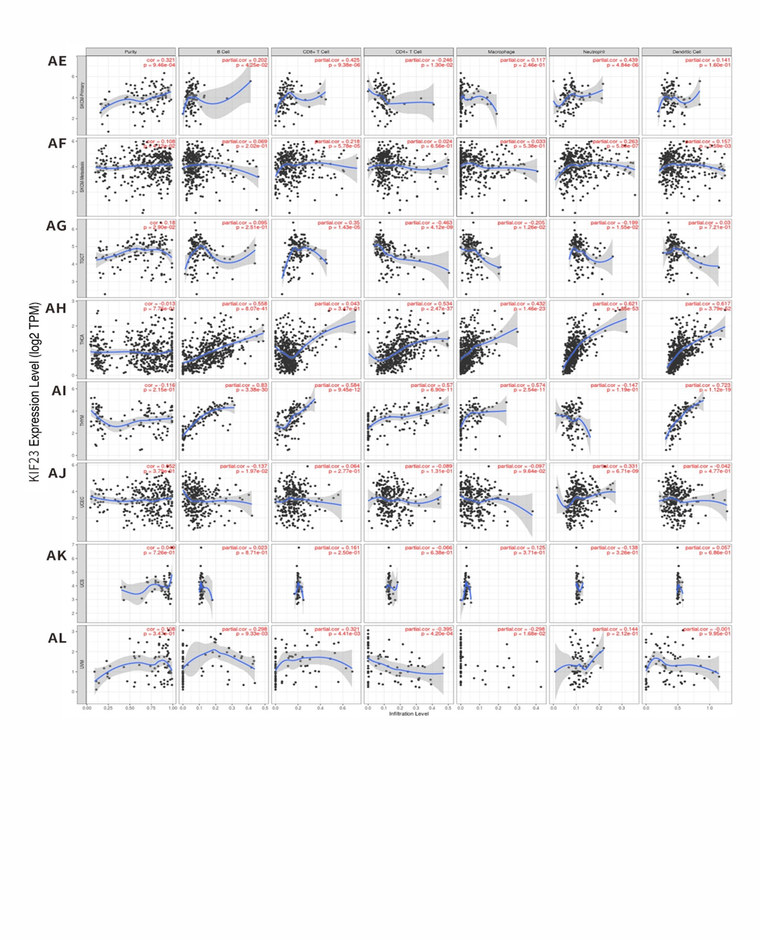
Supplementary Figure S2. Correlation of KIF23 expression with immune infiltration levels in diverse types of cancer in the TIMER database.

