Antibacterial and anti-virulence effects of furazolidone on Trueperella pyogenes and Pseudomonas aeruginosa
Qin Chenª, Kelei Zhao^{b,}*, Heyue Liª, Kanghua Liuª, Jing Li^{b}, Yiwen Chu^{b}, Balakrishnan Prithiviraj^{c}, Bisong Yueª, Xiuyue Zhang^{a,}*
ª Key Laboratory of Bio-resources and Eco-environment, Ministry of Education, College of Life Sciences, Sichuan University, Chengdu, 610064, China.
^{b} Antibiotics Research and Re-evaluation Key Laboratory of Sichuan Province, College of Pharmacy, Sichuan Industrial Institute of Antibiotics, Chengdu University, Chengdu 610052, China.
^{c} Marine Bio-products Research Laboratory, Department of Plant, Food and Environmental Sciences, Dalhousie University, Truro, NS, Canada.
* Corresponding author at: Antibiotics Research and Re-evaluation Key Laboratory of Sichuan Province, College of Pharmacy, Sichuan Industrial Institute of Antibiotics, Chengdu University, No. 168 Huaguan Road, 610052, Chengdu, Sichuan, PR China; Key Laboratory of Bio-resources and Eco-environment, Ministry of Education, College of Life Sciences, Sichuan University, No. 24, South Section 1, Yihuan Road, 610064, Chengdu, Sichuan, PR China.
E-mail addresses: zhaokelei@cdu.edu.cn (K. Zhao), zhangxiuyue@scu.edu.cn (X. Zhang).

Supplementary Figures
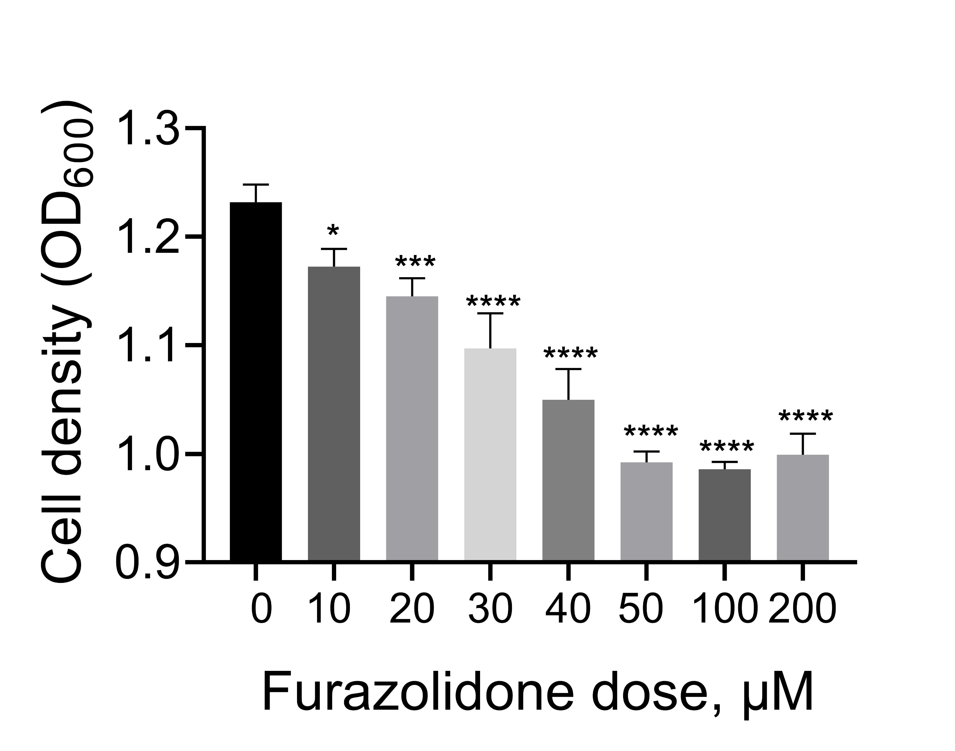
Supplementary Fig. S1. Effect of furazolidone on the growth of Pseudomonas aeruginosa PAO1 cultured in lysogeny broth (LB) broth. Date shown the mean ± standard deviation (SD) of three independent experiments. One-way ANOVA, * p < 0.05, *** p < 0.001, **** p < 0.0001.

Supplementary Fig. S2. Effect of furazolidone on the expression of virulence-related genes of Trueperella pyogenes TP13 as determined by qPCR. Date shown the mean ± standard deviation (SD) of three independent experiments. Unpaired t-test: ** p < 0.01, **** p < 0.0001.

Supplementary Tables
Supplementary Table S1. Effect of 55 compounds on the growth of T. pyogenes TP13.
Compounds | Effect of growthª
2,5-Dihydroxyphenylacetic acid lactone | No change
2,5-Furandicarboxylic acid | No change
5-Hydroxymethylfurfural | No change
Sesamol | No change
2-Benzoxazolinone | No change
3-Indoleacetic acid | No change
Carbendazim | No change
L-5-Hydroxytryptophan | No change
Fenbendazole | No change
5-Hydroxymethyl-2-furancarboxylic acid | No change
L-Pyroglutamic acid | No change
Sulfathiazole sodium | Decrease
Succinylsulfathiazole | No change
Tazobactam | Decrease
5-Methyluridine | No change
Acadesine phosphate | No change
2'-Deoxyguanosine | No change
Uracil 1-β-D-arabinofuranoside | No change
Kinetin (6-Furfuryladenine) | No change
Cotinine | No change
Creatinine | No change
Arctigenin | No change
Methoxsalen (8-Methoxypsoralen) | No change
Harmine | Decrease
Nifuratel (Methylmercadone) | Decrease
Oxaceprol (N-Acetyl-L-hydroxyproline) | No change
Pilocarpine Hydrochloride | No change
Metronidazole | No change
Nifursol | Increase
Nithiamide | No change
Furazolidone | Decrease
Nitrofurantoin | Decrease
Nitrofurazone | Decrease
Ribavirin | No change
Dimetridazole | No change
Dinotefuran | Increase
Ronidazole | Decrease
Tizoxanide | No change
Bisantrene | Increase
Andrographolide | No change
Ursodiol | No change
Bilobalide | Increase
5-Amino-3H-imidazole-4-Carboxamide | Increase
Allantoin | No change
Methyl 2-furoate | No change
5-Methylfurfural | Increase
Aminothiazole | Increase
Chloramphenicol | Decrease
11β-Hydroxyandrosterone | Increase
Urocanic acid | No change
3-Formyl-2-phenylindole | No change
DL-3-Phenyllactic acid | No change
D-Cycloserine | No change
Timepidium bromide | No change
14-Deoxy-11,12-didehydroandrographolide | No change
All of T. pyogenes were cultured in BHI+5% FBS broth and independently repeated for three times.
ª Compared with T. pyogenes treated by DMSO or water, un-paired t test, p < 0.05. Bold color indicates p < 0.01.

Supplementary Table S2. Primers used in this study
Gene | Sequence (5’-3’)
lasRrtF | CTTCATCGTCGGCAACTAC
lasRrtR | GTCTGGTAGATGGACGGTTC
lasBrtF | ATCGGCTACGACATCAAGAAGG
lasBrtR | CCGCTGTTGTAGTTGCTGGTG
rhlRrtF | GCTCCTCGGAAATGGTGGT
rhlRrtR | GGAAAGCACGCTGAGCAAAT
rhlArtF | ACTGAACCAGGCGATGCTC
rhlArtR | GCTCCAGGCAAGCCAAGTA
pqsRrtF | CACTGGTTGAAGCGGGAGA
pqsRrtR | TCGTTCTGCGATACGGTGAG
pqsArtF | GCTGAGCGGTCCTTTGGC
pqsArtR | TGGAACCCGAGGTGTATTGC
pqsDrtF | GCTGTACGGCTTGCAGATGG
pqsDrtR | CAGGTCCAGCAGTCCGTCTT
pqsErtF | ATGTTGAGGCTTTCGGCT
pqsErtR | GCAGTGGTCGTAGTGCTTGTG
hcnArtF | GCAGACATGACCATCCACCTC
hcnArtR | CGGTTGCTTTCGGTTTCCA
phzA1rtF | GCAACTGGACCACGGAAAG
phzA1rtR | GCACGCAGTTTCTGTATCGG
16SrtF | TCGCATCCTGTTGTCCTCCA
16SrtR | TTAGCCAGGGTCAGCGTCA

