Supplemental Figures
Supplemental Figure 1
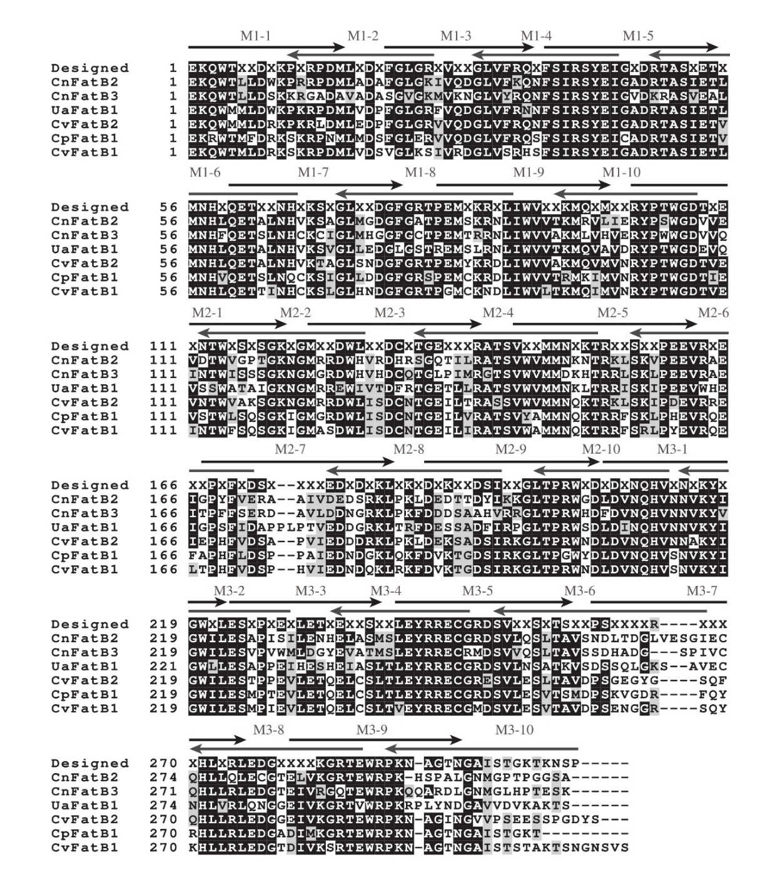
Supplemental Figure 1. Sequence alignment of the six parental acyl-ACP TEs and the Designed acyl-ACP TE protein. The multiple sequence alignment was constructed by using ClustalW2 (http://www.ebi.ac.uk/Tools/msa/clustalw2/). The “X” residues in the Designed sequence identify the amino acids that were potentially varied in the reassembled acyl-ACP TE variants. Arrows (labeled as M1-1 to M1-10, M2-1 to M2-10, and M3-1 to M3-10) indicate the location of the primers that were used to reassemble the Designed acyl-ACP TE sequences. Conserved residues are shown with white font on a black background, and white font residues on a grey background identify residues that are functionally similar.

Supplemental Figure 2
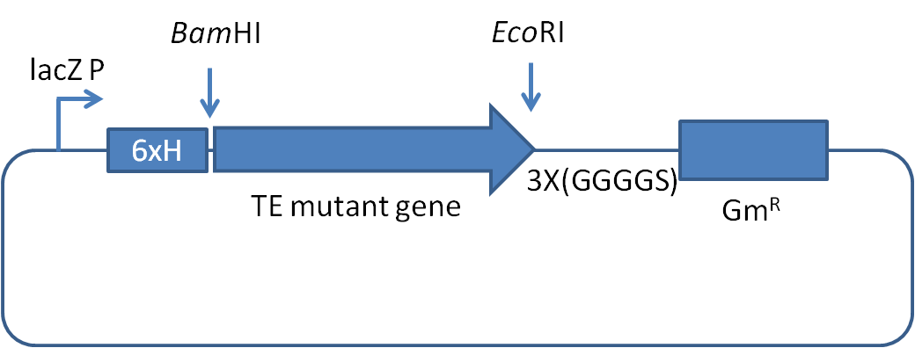

Supplemental Figure 2. Schematic map of the pUCHisGm expression vector used to construct the acyl-ACP TE variant library. 6xH, hexa-histidine sequence tag; lacZ P, promoter of lacZ gene; 3x(GGGGS), [Gly-Gly-Gly-Gly-Ser]₃ linker sequence; Gm^{R}, gentamicin-resistance gene, fused in-frame with the acyl-ACP TE sequence.

Supplemental Figure 3. Multisequence alignment of acyl-ACP TE variants characterized in this study.
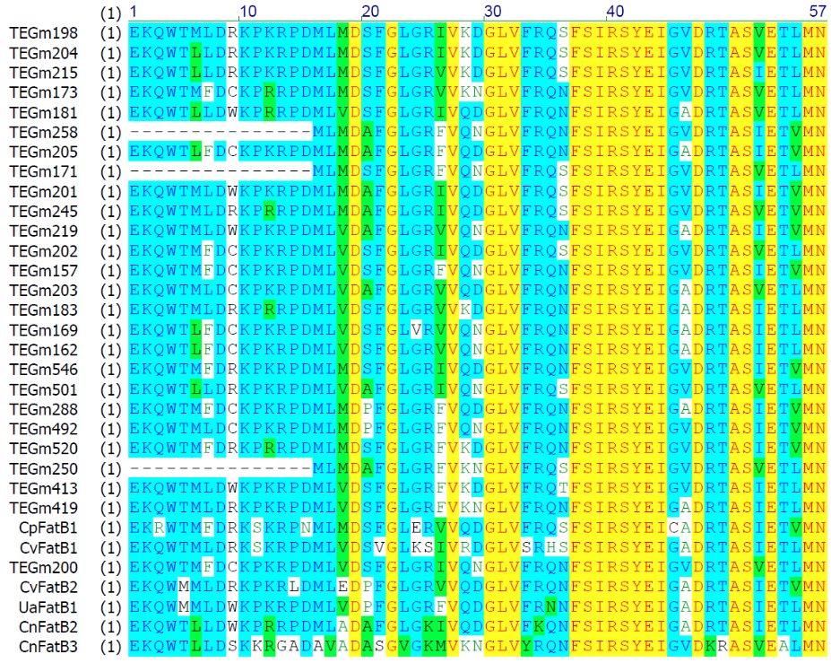
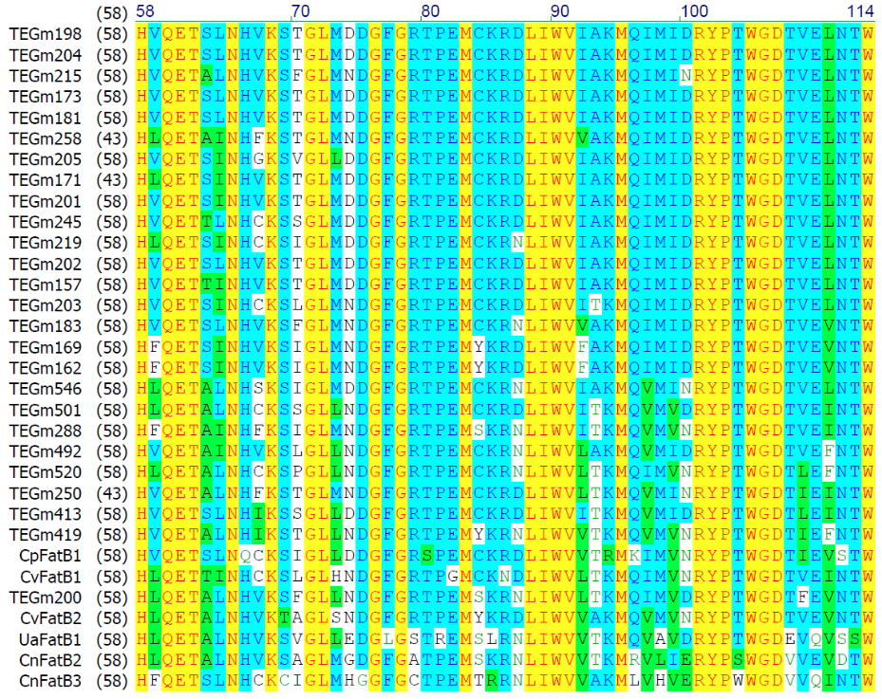

Supplemental Figure 3 (continued)
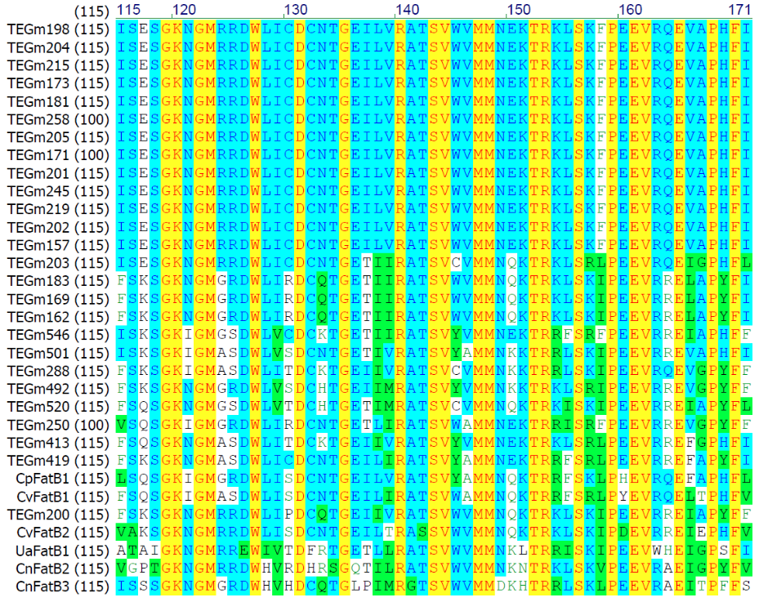
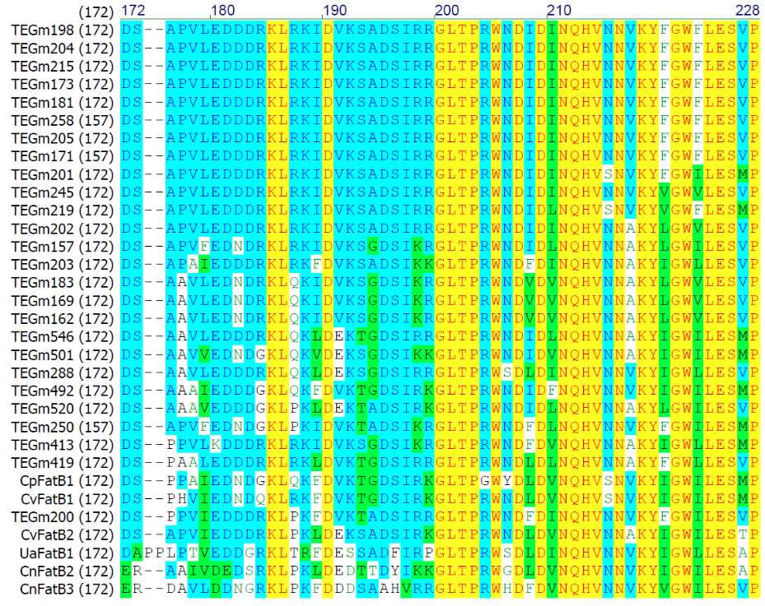

Supplemental Figure 3 (continued)
