Supporting Information

V-SYNTHES2 - THE NEXT GENERATION TOOL FOR STRUCTURE-BASED VIRTUAL SCREENING OF GIGA-SCALE CHEMICAL SPACES
Antonina L. Nazarova^{1,2§}, Anastasiia V. Sadybekov^{1,2§}, Arman A. Sadybekov^{1§}, Yurii S. Moroz^{3,4}, Dmytro S. Radchenko⁴, Olga O. Tarkhanova⁵, Vsevolod Katritch^{1,2,6,7*}
¹Department of Quantitative & Computational Biology, University of Southern California, Los Angeles, CA 90089, USA
²Center for New Technologies in Drug Discovery and Development, University of Southern California, Los Angeles, CA 90089, USA
³Taras Shevchenko National University of Kyiv, Kyiv, Ukraine
⁴Enamine Ltd., Kyiv, Ukraine
⁵Chemspace LLC, Kyiv, Ukraine
⁶Department of Chemistry, Bridge Institute, USC Michelson Center for Convergent Biosciences, University of Southern California, Los Angeles, CA 90089, USA
⁷Department of Pharmacology and Pharmaceutical Sciences, University of Southern California, Los Angeles, CA 90089, USA
§These authors contributed to the study equally
*Corresponding authors: Vsevolod Katritch (katritch@usc.edu)

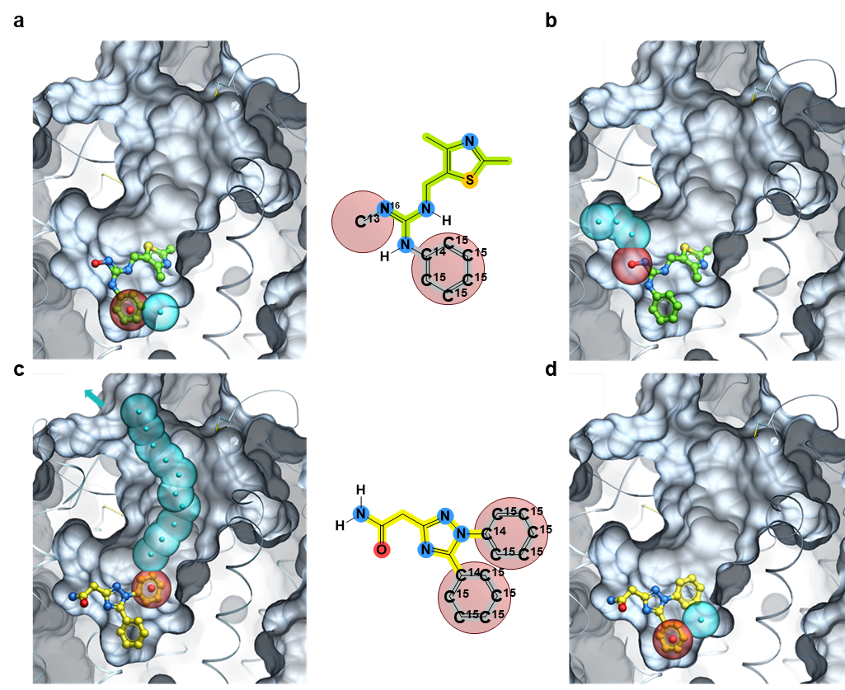
Figure SI 1. CapSelect's Automated Selection of MEL fragments in V-SYNTHES2 pipeline. Selection of optimal scaffold-MEL fragment combinations for extended molecule growth for 3-component and bridge-component reactions REAl Space subset. (a)-(b) 'Unproductive Outcome' where both aromatic and methyl-based capped R-group (red) are near a pocket's dead-end, showing a limited growth pathway and minimal space for a second synthon. The phenyl capped R-group allows only one non-capped sphere, while the methyl capped R-group permits three spheres, indicating space for a maximum of two methyl groups during enumeration; (c)-(d) 'Productive Outcome' where one capped R-group accommodates >10 spheres in the pocket, indicating sufficient space for an enumerated ligand's docking, even though another phenyl-based capped R-group faces an immediate sub-pocket crash. MEL fragment having two phenyl-capped R-groups, the potential to allocate several spheres on one group increases its likelihood of selection for enumeration, despite a clash in the other phenyl-based R route. The capped R-groups are depicted as red sticks at the 2D molecule representation and are encased in red transparent spheres in the docked 3D structures.

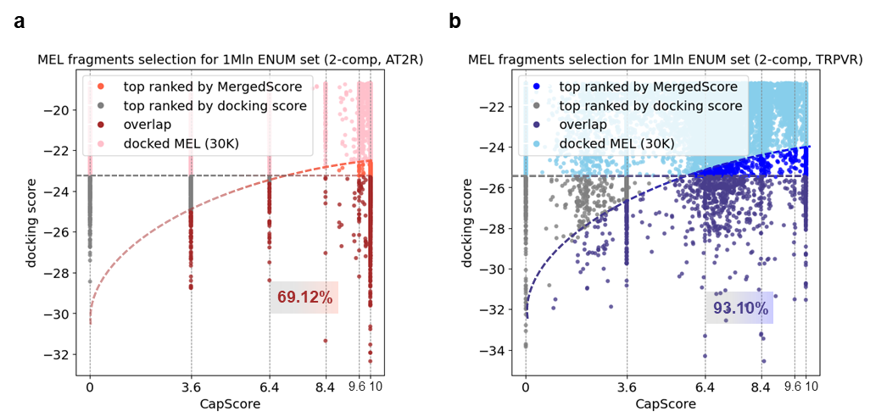
Figure SI 2. 2D diagram of docking score vs. CapScore for MEL docking results. 2D diagram showing the docking score vs. CapScore for MEL docking results, highlighting the selection of promising MEL fragments for the enumeration stage in the 2-component reaction set of V-SYNTHES2 screening for various receptor targets: (a) AT2 receptor – deep and narrow pocket receptor; (b) TRPV - shallow receptor pocket at the intersection of two receptor domains. The colored selection of the best-ranked fragments by the MergedScore corresponds to the number required to generate 1 million fully enumerated fragments. The number inside the intersection of MergedScore-based selected MEL with docking score-only selected MEL indicates the percentage of overlap between these two sets.

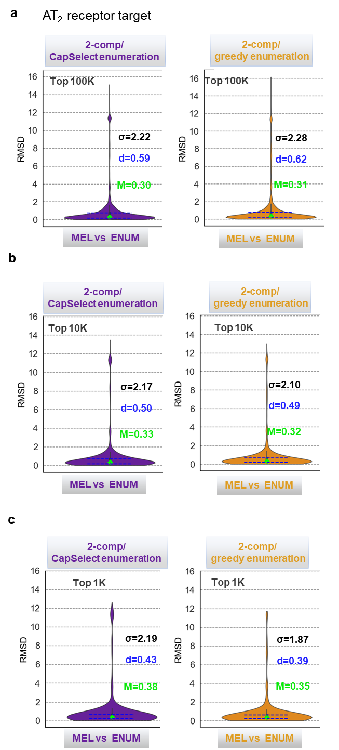
Figure SI 3. Violin plot visualization of RMSD values comparing the binding pose of the MEL fragment with the corresponding synthons of the fully enumerated molecules in 2-component reaction sets of V-SYNTHES2 for AT2 receptor screening. Promising MEL fragments were selected for the generation of the enumerated subset using docking score-only (greedy enumeration) or CapSelect-based strategies. Statistics are presented (a) for the first 100K compounds; (b) for the first 10K compounds and (c) the top 1K compounds with the highest docking scores. The lime dot in each plot indicates the median (M), while the blue dashed lines represent the quartiles, with the interquartile distance denoted as d and the statistical variance as σ.
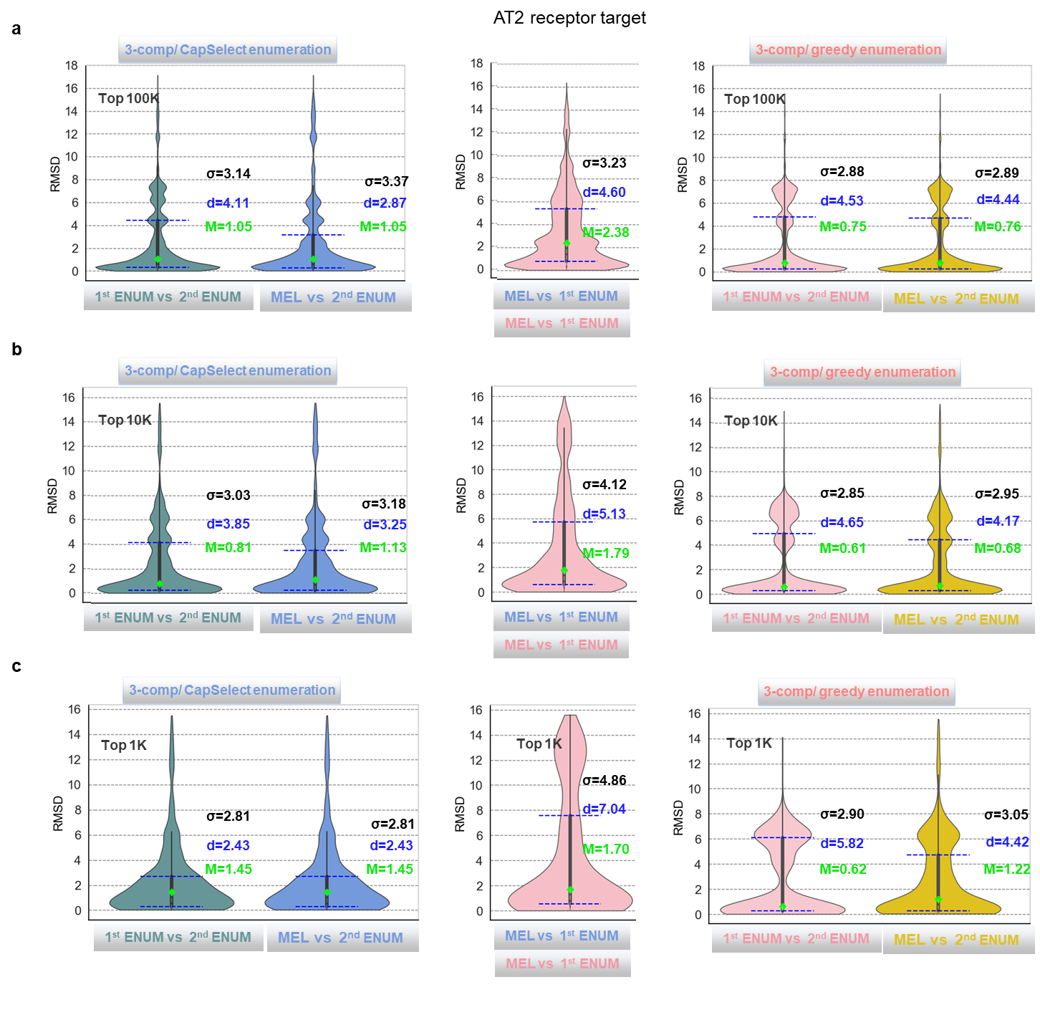
Figure SI 4. Violin plot visualization of RMSD values comparing the binding poses of the MEL fragment with the corresponding synthons of the fully enumerated molecules in the 3-component reaction set of V-SYNTHES2, which includes two stages of subsequent enumeration for AT2 receptor screening. For the initial stage, productive MEL fragments were selected based solely on docking scores after MEL docking. For the subsequent stages, promising MEL fragments were chosen using either docking score-only (greedy enumeration) or CapSelect-based strategies. Statistics are presented (a) for the first 100K compounds; (b) for the first 10K compounds and (c) the top 1K compounds with the highest docking scores. The lime dot in each plot indicates the median (M), while the blue dashed lines represent the quartiles, with the interquartile distance denoted as d and the statistical variance as σ.
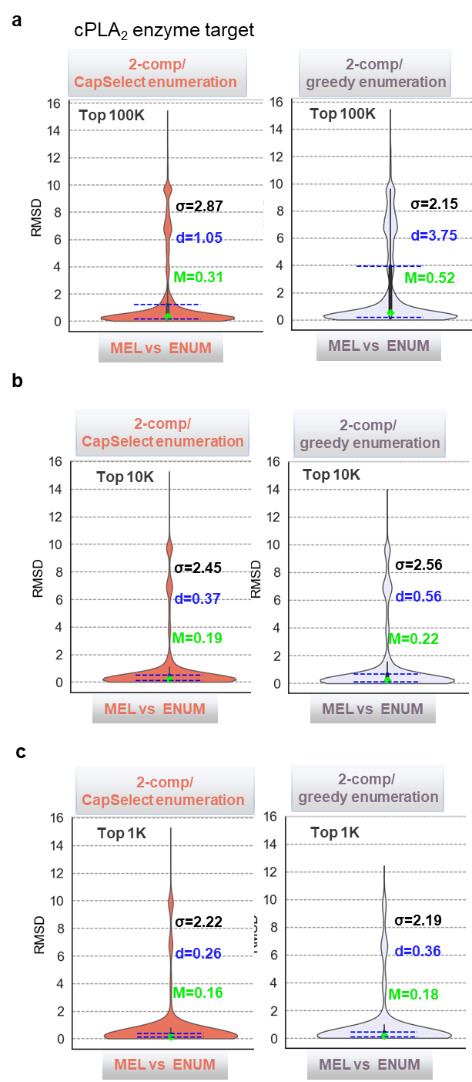
Figure SI 5. Violin plot visualization of RMSD values comparing the binding pose of the MEL fragment with the corresponding synthons of the fully enumerated molecules in 2-component reaction sets of V-SYNTHES2 for cPLA2 screening. Promising MEL fragments were selected for the generation of the enumerated subset using docking score-only (greedy enumeration) or CapSelect-based strategies. Statistics are presented (a) for the first 100K compounds; (b) for the first 10K compounds and (c) the top 1K compounds with the highest docking scores. The lime dot in each plot indicates the median (M), while the blue dashed lines represent the quartiles, with the interquartile distance denoted as d and the statistical variance as σ.
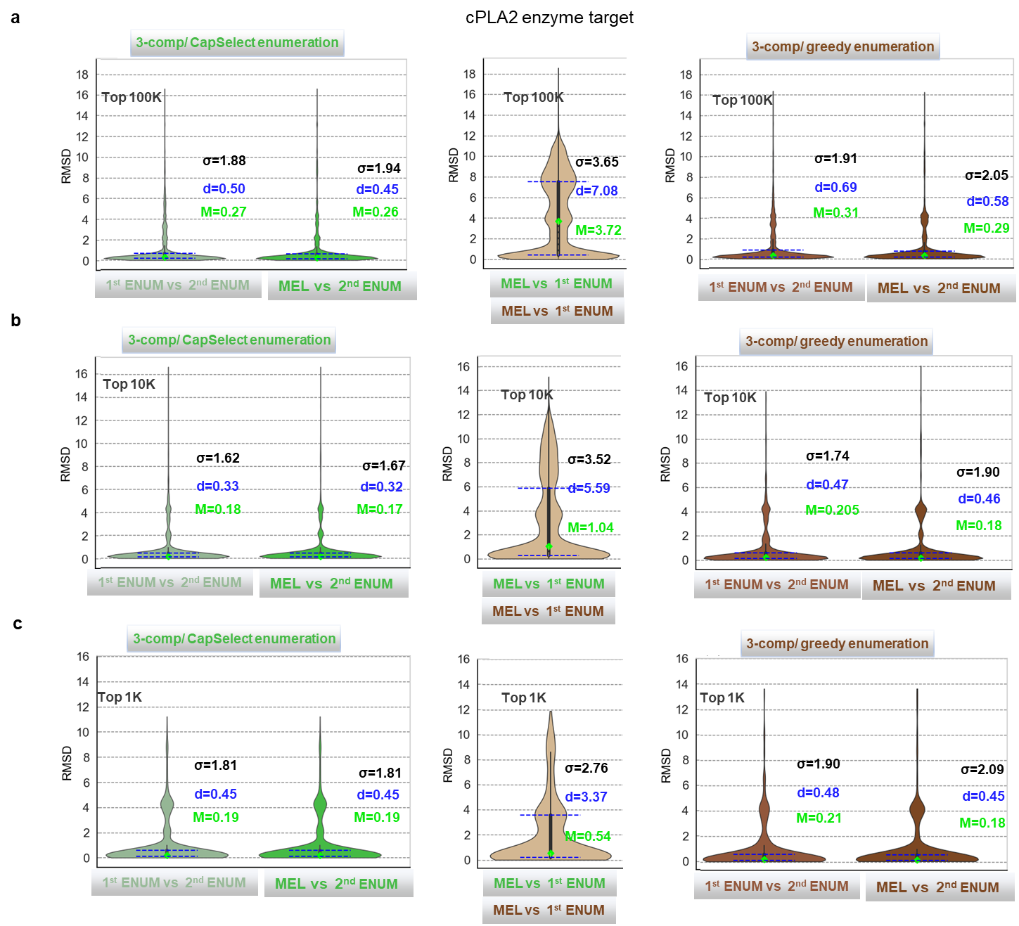
Figure SI 6. Violin plot visualization of RMSD values comparing the binding poses of the MEL fragment with the corresponding synthons of the fully enumerated molecules in the 3-component reaction set of V-SYNTHES2, which includes two stages of subsequent enumeration for cPLA2 screening. For the initial stage, productive MEL fragments were selected based solely on docking scores after MEL docking. For the subsequent stages, promising MEL fragments were chosen using either docking score-only (greedy enumeration) or CapSelect-based strategies. Statistics are presented (a) for the first 100K compounds; (b) for the first 10K compounds and (c) the top 1K compounds with the highest docking scores. The lime dot in each plot indicates the median (M), while the blue dashed lines represent the quartiles, with the interquartile distance denoted as d and the statistical variance as σ.

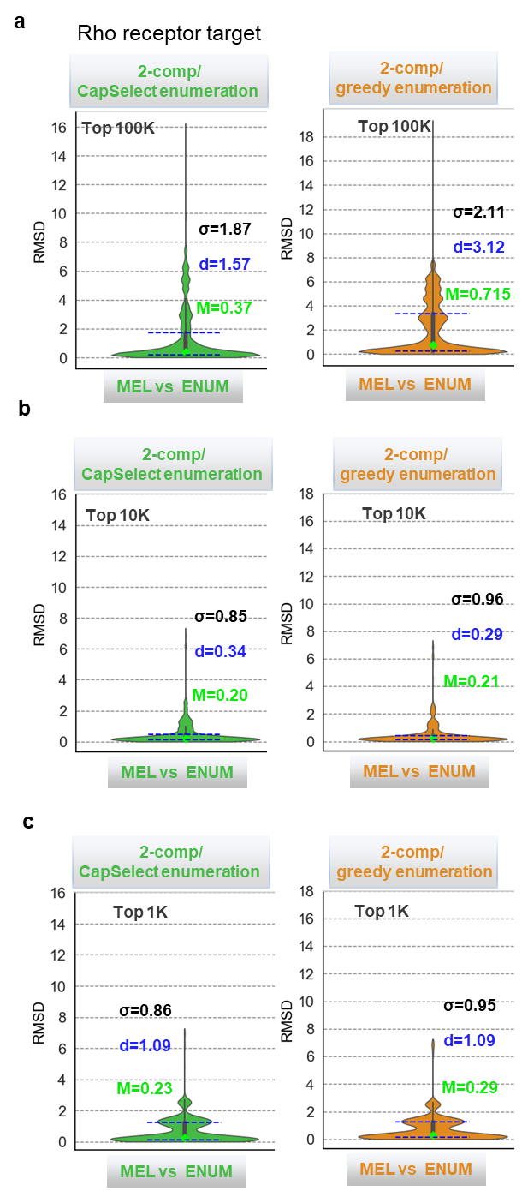
Figure SI 7. Violin plot visualization of RMSD values comparing the binding pose of the MEL fragment with the corresponding synthons of the fully enumerated molecules in 2-component reaction sets of V-SYNTHES2 for CB2 receptor screening. Promising MEL fragments were selected for the generation of the enumerated subset using docking score-only (greedy enumeration) or CapSelect-based strategies. Statistics are presented (a) for the first 100K compounds; (b) for the first 10K compounds and (c) the top 1K compounds with the highest docking scores. The lime dot in each plot indicates the median (M), while the blue dashed lines represent the quartiles, with the interquartile distance denoted as d and the statistical variance as σ.

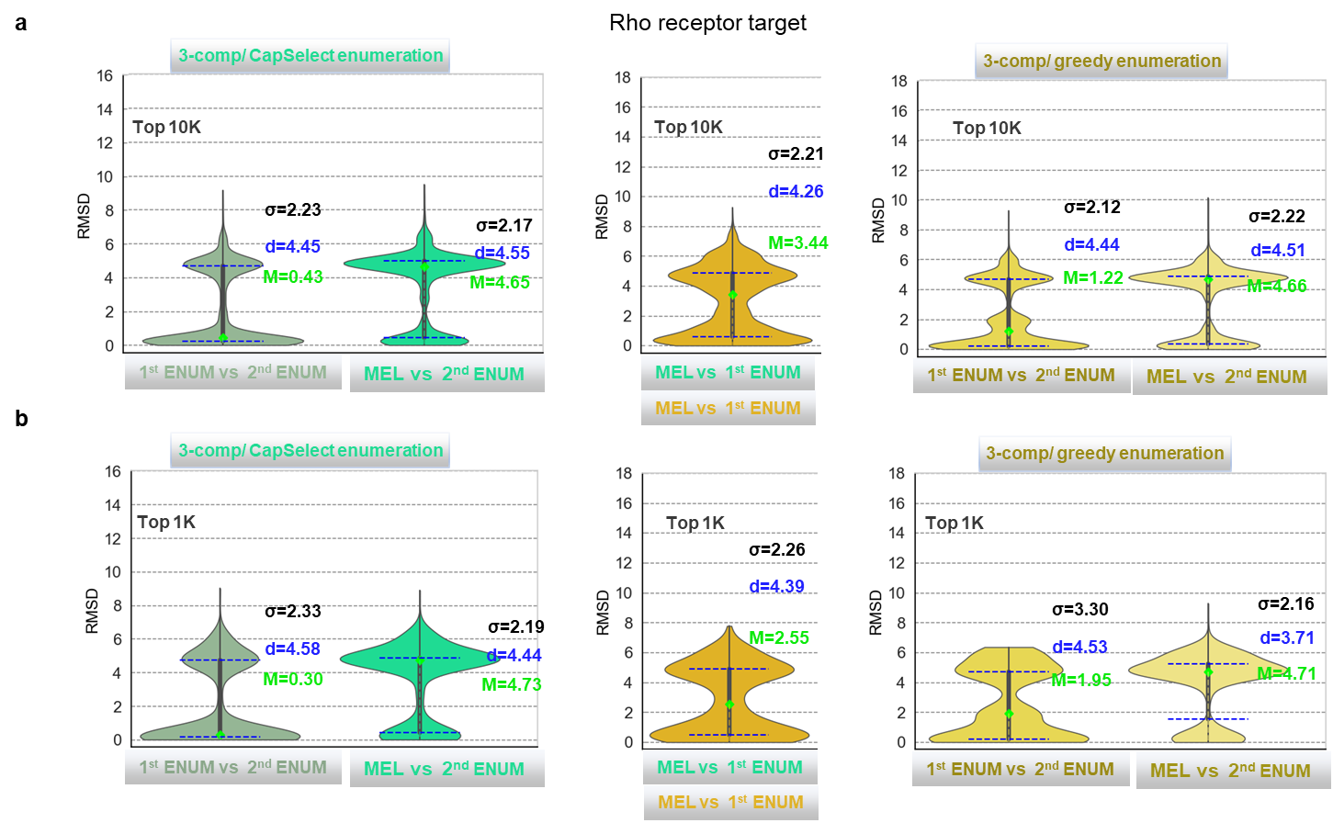
Figure SI 8. Violin plot visualization of RMSD values comparing the binding poses of the MEL fragment with the corresponding synthons of the fully enumerated molecules in the 3-component reaction set of V-SYNTHES2, which includes two stages of subsequent enumeration for CB2 receptor screening. For the initial stage, productive MEL fragments were selected based solely on docking scores after MEL docking. For the subsequent stages, promising MEL fragments were chosen using either docking score-only (greedy enumeration) or CapSelect-based strategies. Statistics are presented (a) for the first 10K compounds and (b) the top 1K compounds with the highest docking scores. The lime dot in each plot indicates the median (M), while the blue dashed lines represent the quartiles, with the interquartile distance denoted as d and the statistical variance as σ.

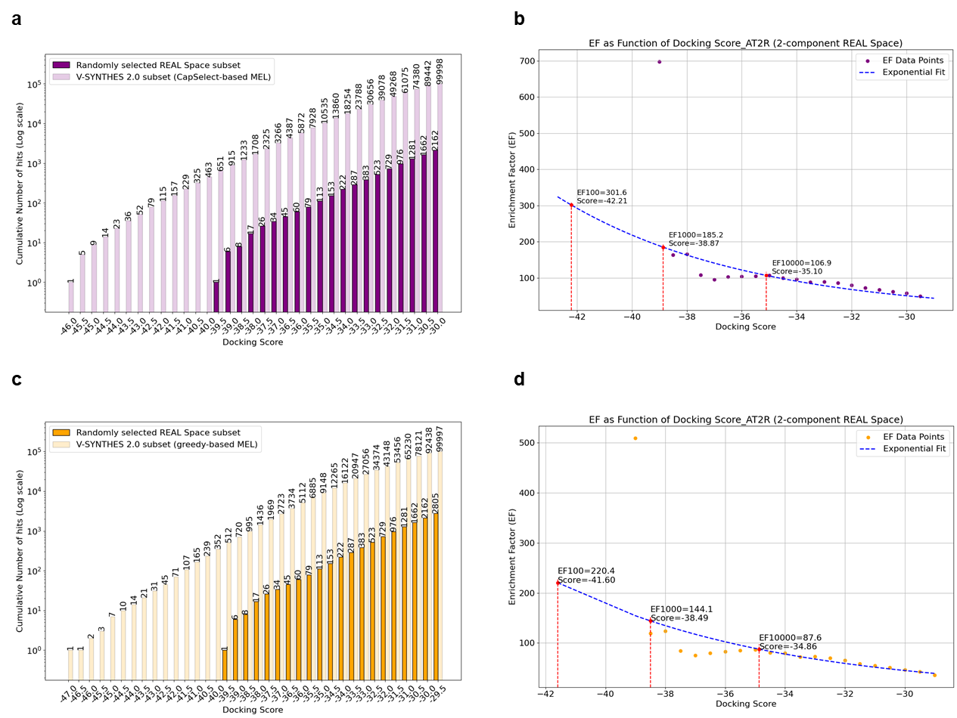
Figure SI 9. V-SYNTHES 2.0 versus conventional VLS performance for the 2-component REAL Space in the AT2 receptor screening campaign. The V-SYNTHES2 enumerated subset was derived from MEL fragments selected by (a)-(b) the CapSelect approach or (c)-(d) greedy approaches. The cumulative histogram presents the number of hits (on a logarithmic scale) against the docking score threshold in the V-SYNTHES 2.0 obtained subset and the REAL diversity (random) subset. Additionally, the scatter plot displays the enrichment factors, highlighting the superior performance of V-SYNTHES 2.0 compared to conventional VLS, with the enrichment factor for 10,000, 1000 and 100 virtual hits indicated by a star (statistically reliable enrichment factor (EF) values were identified at the 10,000 hits threshold and used for statistical comparisons. The exclusion of the leftmost points from the exponential trend line ensured reliability at this threshold, despite the less precise 1,000 and 100 hits thresholds, which were accessed only for consistency with the V-SYNTHES 1.0¹ methodology purposes).

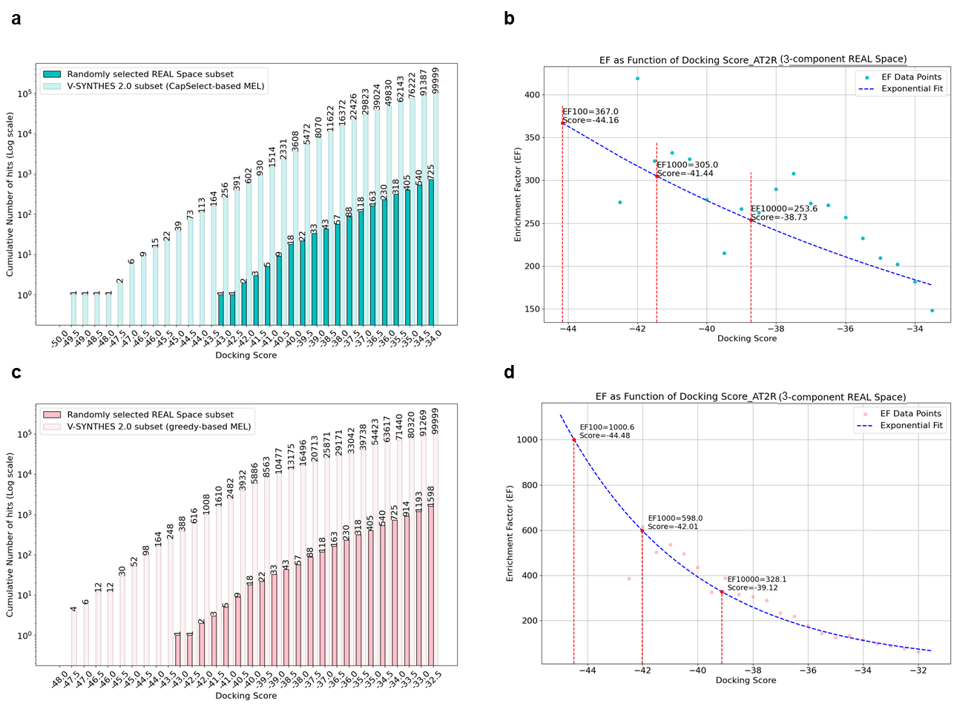
Figure SI 10. V-SYNTHES 2.0 versus conventional VLS performance for the 3-component REAL Space in the AT2 receptor screening campaign. The V-SYNTHES2 enumerated subset was derived from MEL fragments selected by (a)-(b) the CapSelect approach or (c)-(d) greedy approaches. The cumulative histogram presents the number of hits (on a logarithmic scale) against the docking score threshold in the V-SYNTHES 2.0 obtained subset and the REAL diversity (random) subset. Additionally, the scatter plot displays the enrichment factors, highlighting the superior performance of V-SYNTHES 2.0 compared to conventional VLS, with the enrichment factor for 10,000, 1000 and 100 virtual hits indicated by a star (statistically reliable enrichment factor (EF) values were identified at the 10,000 hits threshold and used for statistical comparisons. The exclusion of the leftmost points from the exponential trend line ensured reliability at this threshold, despite the less precise 1,000 and 100 hits thresholds, which were accessed only for consistency with the V-SYNTHES 1.0¹ methodology purposes).
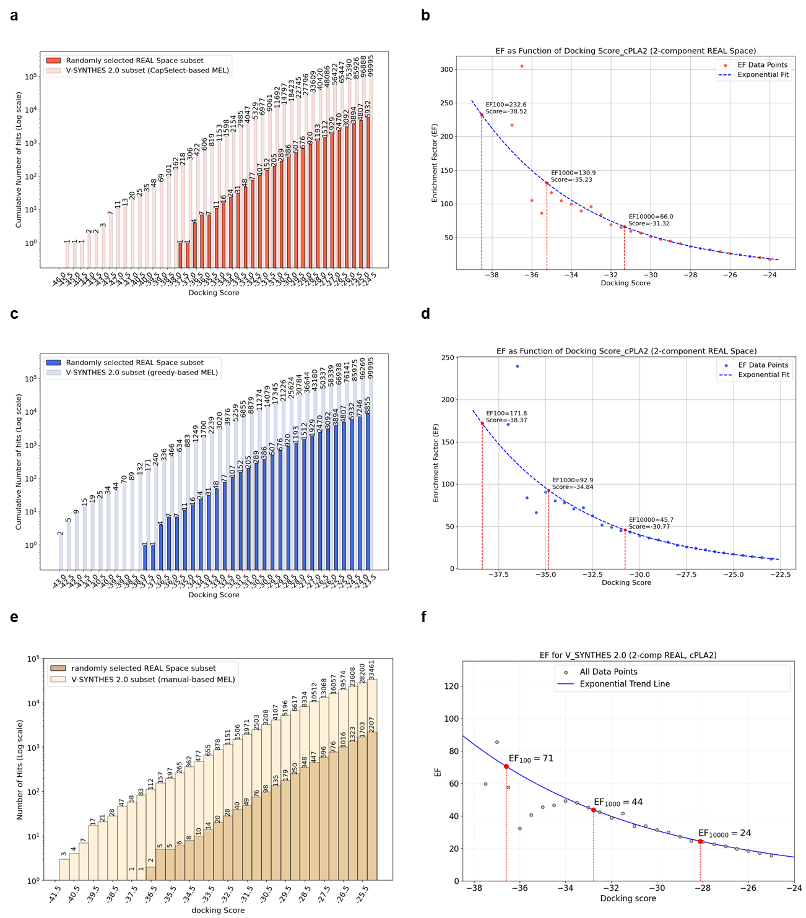
Figure SI 11. V-SYNTHES 2.0 versus conventional VLS performance for the 2-component REAL Space in the cPLA2 enzyme screening campaign. The V-SYNTHES2 enumerated subset was derived from MEL fragments selected by (a)-(b) the CapSelect approach or (c)-(d) greedy approaches. The cumulative histogram presents the number of hits (on a logarithmic scale) against the docking score threshold in the V-SYNTHES 2.0 obtained subset and the REAL diversity (random) subset. Additionally, the scatter plot displays the enrichment factors, highlighting the superior performance of V-SYNTHES 2.0 compared to conventional VLS, with the enrichment factor for 10,000, 1000 and 100 virtual hits indicated by a star (statistically reliable enrichment factor (EF) values were identified at the 10,000 hits threshold and used for statistical comparisons. The exclusion of the leftmost points from the exponential trend line ensured reliability at this threshold, despite the less precise 1,000 and 100 hits thresholds, which were accessed only for consistency with the V-SYNTHES 1.0¹ methodology purposes).
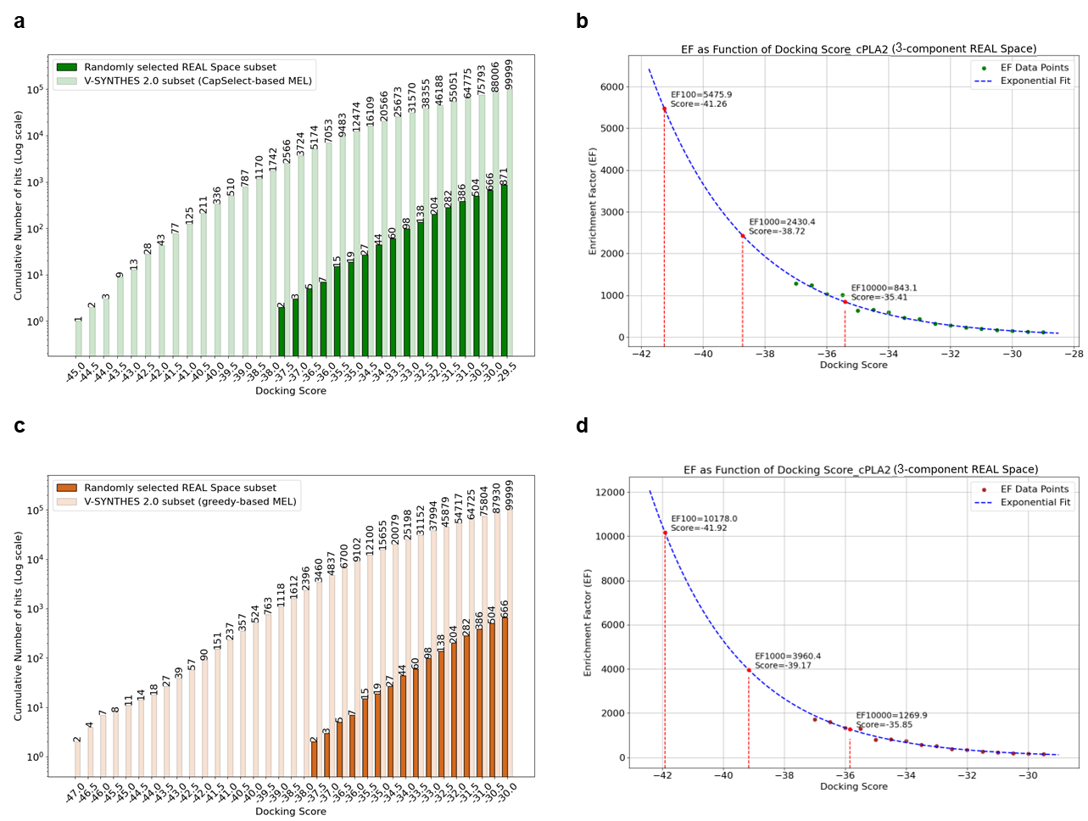
Figure SI 12. V-SYNTHES 2.0 versus conventional VLS performance for the 3-component REAL Space in the cPLA2 enzyme screening campaign. The V-SYNTHES2 enumerated subset was derived from MEL fragments selected by (a)-(b) the CapSelect approach or (c)-(d) greedy approaches. The cumulative histogram presents the number of hits (on a logarithmic scale) against the docking score threshold in the V-SYNTHES 2.0 obtained subset and the REAL diversity (random) subset. Additionally, the scatter plot displays the enrichment factors, highlighting the superior performance of V-SYNTHES 2.0 compared to conventional VLS, with the enrichment factor for 10,000, 1000 and 100 virtual hits indicated by a star (statistically reliable enrichment factor (EF) values were identified at the 10,000 hits threshold and used for statistical comparisons. The exclusion of the leftmost points from the exponential trend line ensured reliability at this threshold, despite the less precise 1,000 and 100 hits thresholds, which were accessed only for consistency with the V-SYNTHES 1.0¹ methodology purposes).
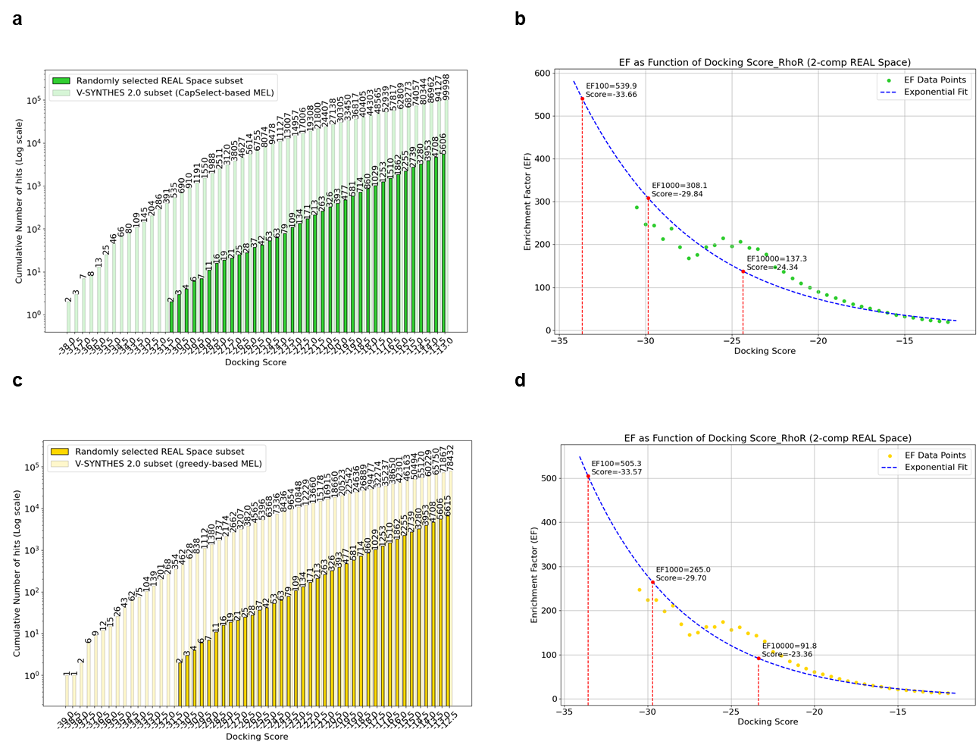
Figure SI 13. V-SYNTHES 2.0 versus conventional VLS performance for the 2-component REAL Space in the Rho receptor screening campaign. The V-SYNTHES2 enumerated subset was derived from MEL fragments selected by (a)-(b) the CapSelect approach or (c)-(d) greedy approaches. The cumulative histogram presents the number of hits (on a logarithmic scale) against the docking score threshold in the V-SYNTHES 2.0 obtained subset and the REAL diversity (random) subset. Additionally, the scatter plot displays the enrichment factors, highlighting the superior performance of V-SYNTHES 2.0 compared to conventional VLS, with the enrichment factor for 10,000, 1000 and 100 virtual hits indicated by a star (statistically reliable enrichment factor (EF) values were identified at the 10,000 hits threshold and used for statistical comparisons. The exclusion of the leftmost points from the exponential trend line ensured reliability at this threshold, despite the less precise 1,000 and 100 hits thresholds, which were accessed only for consistency with the V-SYNTHES 1.0¹ methodology purposes).

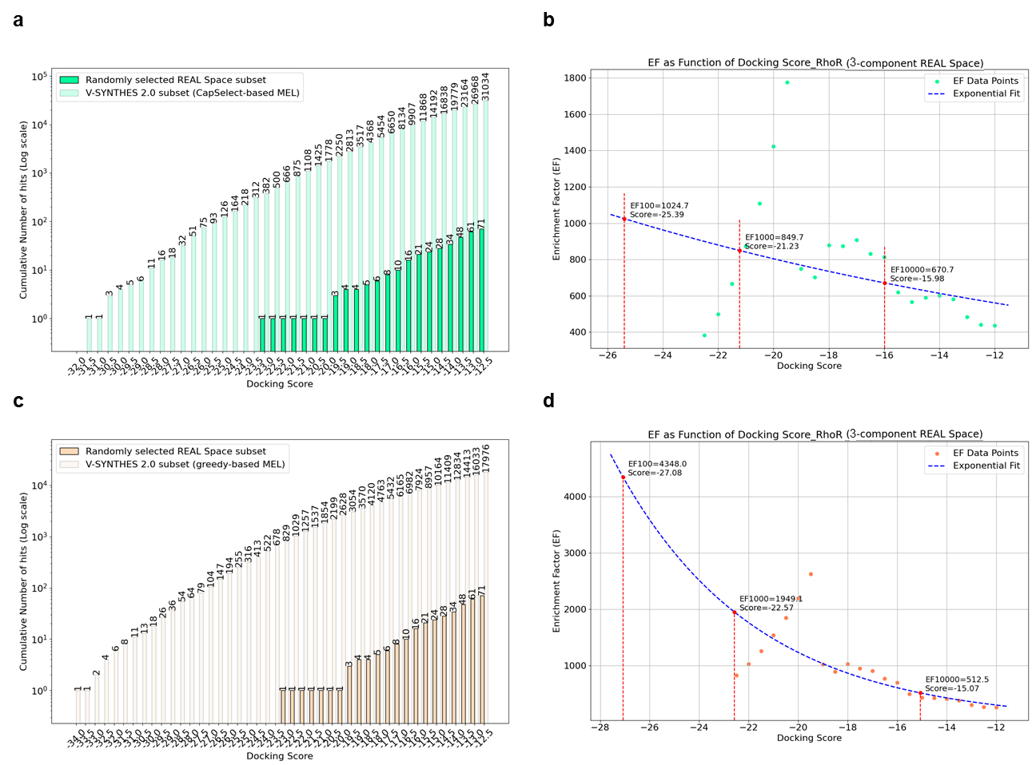
Figure SI 14. V-SYNTHES 2.0 versus conventional VLS performance for the 3-component REAL Space in the Rho receptor screening campaign. The V-SYNTHES2 enumerated subset was derived from MEL fragments selected by (a)-(b) the CapSelect approach or (c)-(d) greedy approaches. The cumulative histogram presents the number of hits (on a logarithmic scale) against the docking score threshold in the V-SYNTHES 2.0 obtained subset and the REAL diversity (random) subset. Additionally, the scatter plot displays the enrichment factors, highlighting the superior performance of V-SYNTHES 2.0 compared to conventional VLS, with the enrichment factor for 10,000, 1000 and 100 virtual hits indicated by a star (statistically reliable enrichment factor (EF) values were identified at the 10,000 hits threshold and used for statistical comparisons. The exclusion of the leftmost points from the exponential trend line ensured reliability at this threshold, despite the less precise 1,000 and 100 hits thresholds, which were accessed only for consistency with the V-SYNTHES 1.0¹ methodology purposes).

Table SI 1. RMSD statistics comparing the binding poses of the MEL fragment with the corresponding synthons of the fully enumerated molecules in the 2-component, and 3-component reaction sets of V-SYNTHES2 for AT2, cPLA2 and Rho screening pipelines. Statistics are presented for the first 100K, 10K and 1K compounds with the highest docking scores. Promising MEL fragments were chosen using either docking score-only (greedy enumeration) or CapSelect-based strategies.
Target | AT2 |  | cPLA2 |  | Rho
REAL Space reaction set | 2-comp | 3-comp | 2-comp | 3-comp | 2-comp | 3-comp
first 100K best scored fully enumerated molecules
median RMSD (M), CapSelect-based subset | 0.30 | 1.05 | 0.31 | 0.26 | 0.37 | NA
median RMSD (M), greedy-based subset | 0.59 | 0.76 | 1.05 | 0.29 | 1.57 | NA
interquartile distance (d), CapSelect-based subset | 0.31 | 2.87 | 0.52 | 0.45 | 0.715 | NA
interquartile distance (d), greedy-based subset | 0.62 | 4.44 | 3.75 | 0.58 | 3.12 | NA
first 10K best scored fully enumerated molecules
median RMSD (M), CapSelect-based subset | 0.33 | 1.13 | 0.19 | 0.17 | 0.20 | 4.65
median RMSD (M), greedy-based subset | 0.50 | 0.68 | 0.37 | 0.18 | 0.34 | 4.66
interquartile distance (d), CapSelect-based subset | 0.32 | 3.25 | 0.22 | 0.32 | 0.21 | 4.55
interquartile distance (d), greedy-based subset | 0.49 | 4.17 | 0.56 | 0.46 | 0.29 | 4.51
first 1K best scored fully enumerated molecules
median RMSD (M), CapSelect-based subset | 0.38 | 1.45 | 0.16 | 0.19 | 0.23 | 4.73
median RMSD (M), greedy-based subset | 0.43 | 1.22 | 0.26 | 0.18 | 1.09 | 4.71
interquartile distance (d), CapSelect-based subset | 0.35 | 2.43 | 0.18 | 0.45 | 0.29 | 4.44
interquartile distance (d), greedy-based subset | 0.39 | 4.42 | 0.36 | 0.45 | 1.09 | 3.71
NA* indicates insufficient data for meaningful statistical analysis.

Table SI 2. Enrichment factor for 10,000 (EF_{10,000}) virtual hits from the performance comparison of V-SYNTHES 2.0 versus conventional VLS for 2- and 3- component reaction REAL Space targeting the AT2, cPLA2 and Rho. The V-SYNTHES2 subset was generated from promising MEL fragments chosen using either docking score-only (greedy enumeration) or CapSelect-based strategies.
Target | EF_{10,000}
Target | CapSelect vs. REAL diversity set | greedy vs. REAL diversity set | CapSelect vs. greedy set
2-component reaction REAL Space
AT2 | 106.9 | 87.6 | 1.2
cPLA2 | 66.0 | 45.7 | 1.4 (3.0*)
Rho | 137.3 | 91.8 | 1.5
3-component reaction REAL Space
AT2 | 253.6 | 328.1 | 0.77
cPLA2 | 843.1 | 1270.0 | 0.66
Rho | 670.7 | 512.5 | 1.3
*:Obtained with 20 billion REAL Space (2021 release). A manual strategy for selecting promising MEL fragments was employed by visually assessing the binding pose and manageable growth space within the pocket.

Table SI 3. V-SYNTHES2 benchmarking statistics for 2-component, 3-component reaction sets for AT2, Rho and cPLA2 targets.
Target | AT2 |  | Rho |  | cPLA2
REAL Space reaction set | 2-comp | bridge-like | 2-comp | bridge-like | 2-comp | bridge-like
MEL Space, frags | 1710727 | 140000 | 1710727 | 140000 | 1710727 | 140000
MEL DOCKING_SCORE_THRESHOLD, kcal/mol | -12.0
MEL docked&filtered, frags | 969359 | 76066 | 75500 | 9476 | 257155 | 16766
MEL required for 1st ENUM set (CapSelect-based selection), frags | 1986 | NA | 485 | NA | 1190 | NA
MEL required for 1st ENUM set (greedy-based selection), frags | 2256 | 13683 | 527 | 9476 | 1359 | 12335
1st ENUM set (CapSelect-based MEL enumeration), cmpds | 981010 | NA | 986891 | NA | 980381 | NA
1st ENUM set (greedy-based MELenumeration), cmpds | 984716 | 980117 | 986071 | 756380 | 981886 | 980015
1st ENUM set DOCKING_SCORE_THRESHOLD, kcal/mol | -12.0
1st ENUM (CapSelect-based set) docked&filtered, cmpds | 871834 | NA | 109957 | NA | 563298 | NA
1st ENUM (greedy-based set) docked&filtered, cmpds | 863807 | 763930 | 78432 | 9565 | 510891 | 364344
MEL required for 2nd ENUM set (CapSelect-based selection), frags |  | 847 |  | 531 |  | 679
MEL required for 2nd ENUM set (greedy-based selection), frags |  | 831 |  | 508 |  | 742
2nd ENUM set (CapSelect-based MEL enumeration), cmpds |  | 980495 |  | 980106 |  | 982368
2nd ENUM set (greedy-based MEL enumeration), cmpds |  | 981456 |  | 981192 |  | 980024
2nd ENUM (CapSelect-based set) docked&filtered, cmpds |  | 593822* |  | 31034 |  | 731626
2nd ENUM (greedy-based set) docked&filtered, cmpds |  | 504747* |  | 17976 |  | 710081
NA: Initial productive MEL fragments for 3-component sets were selected based on docking scores (greedy-based approach); subsequent stages used either docking score-only (greedy enumeration) or CapSelect-based strategies. The reported compound counts reflect those that passed the specified docking score threshold. For productive MEL selection using the CapSelect algorithm, we selected the top 30,000 fragments based on docking scores. For the final hit selection following full enumeration, we retained the top 10,000 docked compounds with the highest scores.
*: Docking score threshold was set at -22.

Table SI 4. Structural redundancy within MEL of REAL Space.
 | 2-component MEL | 3-component MEL
N of frags | 1710727 | 140000
N of redundant frags | 593268 | 0
% of redundant frags | 34.67% | 0%

Table SI 5. Screening statistics confirming the successful completion of all docking jobs executed during V-SYNTHES2 benchmarking, including 2-component, 3-component reaction sets screened against AT2, CB2, and cPLA2 targets.
2-component REAL
Docking Job | AT2_MEL | AT2_CapSelect | AT2_greedy | RHO_MEL | RHO_CapSelect | RHO_greedy | cPLA2_MEL | cPLA2_CapSelect | cPLA2_greedy
1 | 49888 | 39963 | 39968 | 49986 | 39989 | 39992 | 49988 | 39995 | 39995
2 | 49930 | 39959 | 39966 | 49997 | 39996 | 39993 | 49992 | 39991 | 39994
3 | 49939 | 39956 | 39966 | 49995 | 39992 | 39993 | 49989 | 39995 | 39993
4 | 49943 | 39967 | 39964 | 49994 | 39995 | 39994 | 49988 | 39992 | 39989
5 | 49920 | 39972 | 39960 | 49994 | 39995 | 39991 | 49993 | 39992 | 39994
6 | 49903 | 39958 | 39949 | 49991 | 39994 | 39992 | 49990 | 39991 | 39991
7 | 49915 | 39961 | 39968 | 49993 | 39996 | 39994 | 49987 | 39986 | 39990
8 | 49933 | 39958 | 39956 | 49986 | 39993 | 39994 | 49987 | 39993 | 39994
9 | 49935 | 39970 | 39970 | 49989 | 39989 | 39994 | 49990 | 39994 | 39993
10 | 49939 | 39971 | 39970 | 49987 | 39993 | 39992 | 49987 | 39995 | 39994
11 | 49946 | 39967 | 39983 | 49988 | 39998 | 39991 | 49982 | 39990 | 39991
12 | 49947 | 39961 | 39969 | 49984 | 39986 | 39992 | 49991 | 39987 | 39984
13 | 49914 | 39945 | 39975 | 49995 | 39996 | 39992 | 49982 | 39991 | 39994
14 | 49919 | 39963 | 39964 | 49994 | 39992 | 39992 | 49989 | 39992 | 39992
15 | 49917 | 39955 | 39965 | 49991 | 39993 | 39995 | 49991 | 39995 | 39991
16 | 49921 | 39963 | 39955 | 49992 | 39986 | 39990 | 49993 | 39991 | 39994
17 | 49948 | 39972 | 39952 | 49991 | 39993 | 39990 | 49993 | 39991 | 39991
18 | 49955 | 39952 | 39967 | 10724 | 39993 | 39994 | 10725 | 39993 | 39996
19 | 49948 | 39952 | 39937 | 49978 | 39989 | 39993 | 49989 | 39994 | 39997
20 | 49894 | 39973 | 39953 | 49994 | 39992 | 39993 | 49994 | 39994 | 39992
21 | 49945 | 39964 | 39966 | 49981 | 39991 | 39990 | 49989 | 39995 | 39993
22 | 49930 | 39972 | 39973 | 49987 | 39992 | 39990 | 49987 | 39995 | 39994
23 | 49938 | 39959 | 39979 | 49985 | 39992 | 39994 | 49988 | 39992 | 39991
24 | 49943 | 39965 | 39965 | 49995 | 39992 | 39988 | 49990 | 39989 | 39987
25 | 49933 | 20996 | 24687 | 49990 | 26887 | 26067 | 49990 | 20377 | 21882
26 | 49921 |  |  | 49992 |  |  | 49995
27 | 49939 |  |  | 49989 |  |  | 49990
28 | 49932 |  |  | 49986 |  |  | 49982
29 | 49936 |  |  | 49992 |  |  | 49990
30 | 49940 |  |  | 49993 |  |  | 49995
31 | 49931 |  |  | 49994 |  |  | 49996
32 | 49945 |  |  | 49991 |  |  | 49989
33 | 49947 |  |  | 49992 |  |  | 49991
34 | 49942 |  |  | 49982 |  |  | 49987
35 | 10716 |  |  | 49987 |  |  | 49987
SUM | 1708392 | 980094 | 983827 | 1710379 | 986704 | 985880 | 1710366 | 980190 | 981696
3-component REAL
Docking Job | AT2_MEL | AT2_greedy_1st ENUM | AT2_CapSelect_2nd ENUM | AT2_greedy_2nd ENUM | RHO_MEL | RHO_greedy_1st ENUM | RHO_CapSelect_2nd ENUM | RHO_greedy_2nd ENUM | cPLA2_MEL | cPLA2_greedy_1st ENUM | cPLA2_CapSelect_2nd ENUM | cPLA2_greedy_2nd ENUM
1 | 1000 | 39929 | 39980 | 39970 | 1000 | 39992 | 39997 | 39995 | 1000 | 39996 | 39999 | 39998
2 | 1000 | 39937 | 39963 | 39952 | 1000 | 39994 | 39999 | 39998 | 1000 | 39995 | 39999 | 39997
3 | 1000 | 39941 | 39974 | 39970 | 1000 | 39993 | 39997 | 39997 | 1000 | 39992 | 40000 | 39999
4 | 998 | 39922 | 39973 | 39966 |  | 39992 | 39992 | 39994 | 998 | 39995 | 39998 | 39999
5 | 999 | 39932 | 39970 | 39974 |  | 39996 | 39999 | 39996 | 1000 | 39988 | 39997 | 39997
6 | 1000 | 39928 | 39973 | 39951 |  | 39997 | 39998 | 39995 | 1000 | 39998 | 40000 | 40000
7 | 999 | 39916 | 39970 | 39970 |  | 39989 | 39998 | 39997 | 999 | 39995 | 39997 | 39998
8 | 1000 | 1147 | 1000 | 39973 | 39978 | 39993 | 39999 | 39997 | 1000 | 39974 | 39998 | 39998
9 | 999 | 39944 | 1000 | 39977 | 39980 | 39993 | 39999 | 39995 | 1000 | 39990 | 39998 | 39996
10 | 305 | 39925 | 304 | 39962 | 39967 | 39993 | 39995 | 39992 | 305 | 39998 | 39996 | 39997
11 | 1000 |  | 1000 | 39967 | 39967 | 39996 | 39998 | 39996 | 1000 | 39995 | 39994 | 39998
12 | 1000 |  | 1000 | 39983 | 39960 | 39987 | 39999 | 39997 | 1000 | 39995 | 39997 | 39998
13 | 999 |  | 1000 | 39962 | 39971 | 39991 | 39997 | 39992 | 1000 | 39995 | 39997 | 39999
14 | 998 |  | 1000 | 39974 | 39964 | 39994 | 39997 | 39997 | 1000 | 39995 | 39996 | 39998
15 | 997 |  | 1000 | 39973 | 39970 | 39996 | 39995 | 39999 | 999 | 39992 | 39997 | 39999
16 | 998 |  | 999 | 39964 | 39974 | 39994 | 39999 | 39997 | 999 | 39992 | 39996 | 39998
17 | 999 |  | 1000 | 39973 | 39969 | 36376 | 39998 | 39996 | 1000 | 39993 | 39999 | 39996
18 | 996 |  | 1000 | 39976 | 39967 | 39992 | 39997 | 39995 | 1000 | 39992 | 39994 | 39999
19 |  |  |  | 39976 | 39980 |  | 39997 | 40000 |  | 39997 | 39998 | 39999
20 |  |  |  | 39963 | 39962 |  | 39998 | 39996 |  | 39997 | 39999 | 39998
21 |  |  |  | 39968 | 39965 |  | 40000 | 39995 |  | 39995 | 39997 | 39999
22 |  |  |  | 39962 | 39961 |  | 39999 | 39998 |  | 39997 | 39998 | 39999
23 |  |  |  | 39975 | 39974 |  | 39996 | 39999 |  | 39995 | 39995 | 39997
24 |  |  |  | 39960 | 39973 |  | 39997 | 39997 |  | 39994 | 39997 | 39998
25 |  |  |  | 20471 | 21434 |  | 20105 | 21191 |  | 20012 | 22367 | 20024
SUM | 17287 | 360521 | 290106 | 979712 | 703916 | 716258 | 980045 | 981101 | 17300 | 979857 | 982303 | 979978

Table SI 6. Postprocessing results for 10,000 compounds received from V-SYNHTES2 screenings for AT2 and cPLA2 proteins.

Target | AT2 |  | cPLA2
 | 2-comp | 3-comp | 2-comp |  | 3-comp
PAINS* > 0.5 | 0.16% | 0% | 0.3% |  | 0%
Tox class** > 0.5 | 1.2% | 3.1% | 2.3% |  | 12%
Tox score** > 1 | 11% | 19.7% | 12% |  | 17%
Bad groups | 13% | 31% | 12% |  | 34%
Predicted logS < -5 | 15% | 11% | 5% |  | 1.3%
Predicted logS < -6 | 0.6% | 0.27% | 0.16% |  | 0%
Duplicates | 11% | 0.16% | 3.8% |  | 0.3%
Diversity
N of clusters at Tanimoto = 0.3  (N of singletons)  (Molsoft fingerprints) | 1315  (513) | 1271  (351) | 1517  (688) | 640  (218)
N of clusters at Tanimoto = 0.3  (N of singletons)  (ECFP) | 4531  (2536) | 3957  (2019) | 5480  (3379) | 3330  (1434)

* Predict Pan Assay Interference Compound (PAINS) as predicted by ICM-Pro, a value >0.5 indicates high probability of being a PAINS Compound
** The Tox Score by ICM-Pro gives a prediction for how reactive or toxic a chemical is. Tox Score >1. indicates substructure/substituent that is flagged as unfavorable, Tox Class > 0.5 indicates toxic compound

LITERATURE
(1) Sadybekov, A. A.; Sadybekov, A. V.; Liu, Y.; Iliopoulos-Tsoutsouvas, C.; Huang, X.-P.; Pickett, J.; Houser, B.; Patel, N.; Tran, N. K.; Tong, F.; et al. Synthon-based ligand discovery in virtual libraries of over 11 billion compounds. Nature 2021, 601 (7893), 452-459. DOI: 10.1038/s41586-021-04220-9.

