Supplementary information for Ionic Driven Waveguide Integrated Memristor
Kunhao Lei^{1,†}, Zijia Wang^{1,†}, Kai Xu¹, Shuo Lin¹, Kangjian Bao^{3,4}, Boshu Sun^{3,4}, Ruizhe Liu¹, Hui Ma¹, Jiawei Weng¹, Jialing Jian^{3,4}, Qingyan Deng^{3,4}, Wei Zhang⁵, Changgui Lin⁵, Shixun Dai⁵, Lan Li^{3,4} and Hongtao Lin^{1,2*}

¹ The State Key Lab of Brain-Machine Intelligence, Key Laboratory of Micro-Nano Electronics and Smart System of Zhejiang Province, College of Information Science and Electronic Engineering, Zhejiang University, Hangzhou, Zhejiang 310027, China
² College of Integrated Circuits, Zhejiang University, Hangzhou, Zhenjiang 311200, China
3 Key Laboratory of 3D Micro/Nano Fabrication and Characterization of Zhejiang Province, School of Engineering, Westlake University, Hangzhou, Zhejiang 310030, China
4 Institute of Advanced Technology, Westlake Institute for Advanced Study, Hangzhou, Zhejiang 310024, China
5 Laboratory of Infrared Materials and Devices, The Research Institute of Advanced Technologies, Ningbo University, Ningbo, Zhejiang 315211, China
† These authors contributed equally to this work.
* Corresponding author: hometown@zju.edu.cn

SI.1: Ellipsometry characterization of the doped GSSe films.
For novel tunable photonic devices, the variation in the optical constants of materials plays a critical role. In this study, we employed ellipsometry to characterize the variations in the refractive index and extinction coefficient of GSSe films. Given that in metal-doped ChGs, the change in the effective refractive index is dependent on the non-uniform spatial distribution of metal ions within the film, we present here a qualitative analysis for reference purposes. Among them, at a wavelength of 1550 nm, the photo-induced dissolution of Ag exhibits a higher contrast in refractive index, as compared to the GSSe film doped with an Ag⁺ solution. This finding aligns with the Raman spectroscopy characterization, which shows a more pronounced contrast in the peaks of GSSe films at 84 cm⁻¹ and 170 cm⁻¹ before and after photodoped. The observed increase in the refractive index of the GSSe films suggests a redshift in the absorption edge and a decrease in the bandgap.
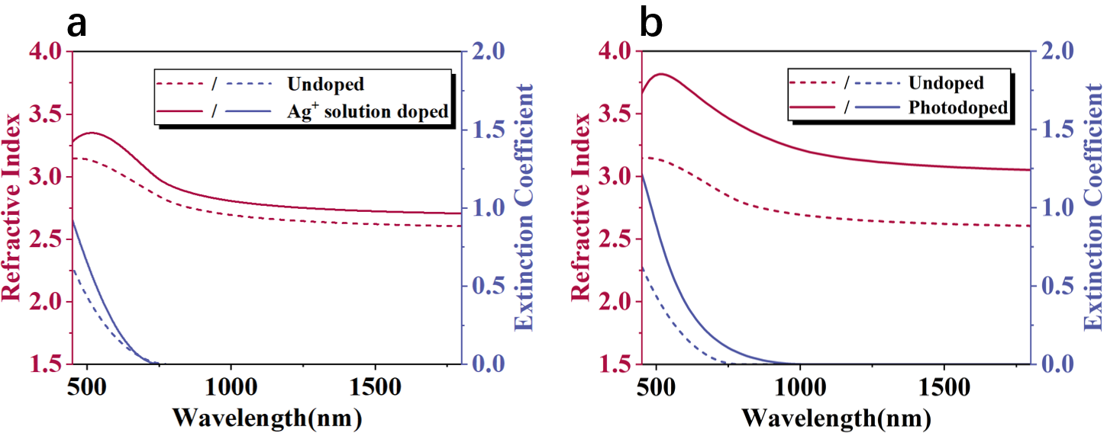
Fig. S1 Ellipsometry characterization of the Ag⁺ solution doped and photodoped GSSe films.

SI.2: FIB-TEM and EDS characterization of the dynamic memristor
Figure S2 presents the focused ion beam transmission electron microscope (FIB-TEM) image of the doping region of the dynamic memristor (as indicated by the red box in Figure S2a, together with the energy dispersive spectrometer (EDS) elemental mapping that illustrates the distribution of germanium (Ge), antimony (Sb), selenium (Se), and metallic silver (Ag). Additionally, the energy dispersive spectrometer (EDS) elemental mapping is provided, revealing the distribution of germanium (Ge), antimony (Sb), selenium (Se), and metallic silver (Ag). As illustrated in Figure S2, following Ag+ solution doping, metallic Ag exhibits a relatively uniform distribution within the GSSe waveguide, with an atomic ratio reaching up to 35.3%.
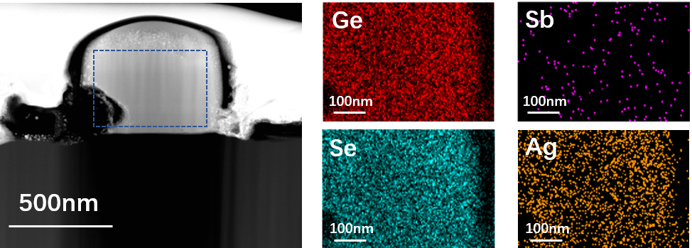
Fig. S2 TEM images and EDS characterization of the dynamic memristor.

SI.3: Dark current and capacitance characterization of the dynamic memristor
Figure S3a presents the dark current characterization results of the dynamic memristor. A semiconductor analyzer was employed to scan the device across a voltage range of 0 to 150 volts. Owing to the superior insulation properties of the substrate silicon oxide, the device consistently exhibited a low dark current throughout the measurement process, with the maximum current at 150 volts being approximately 296.7 pA. Meanwhile, we also conducted a capacitance measurement of the dynamic memristor, as shown in Figure S3b. Owing to the limited output voltage range of the test module, the capacitance was evaluated within a voltage span of −25 V to +25 V. The results indicate that the device exhibits a relatively stable capacitance of approximately 0.45 pF across this range, with no significant variation observed.
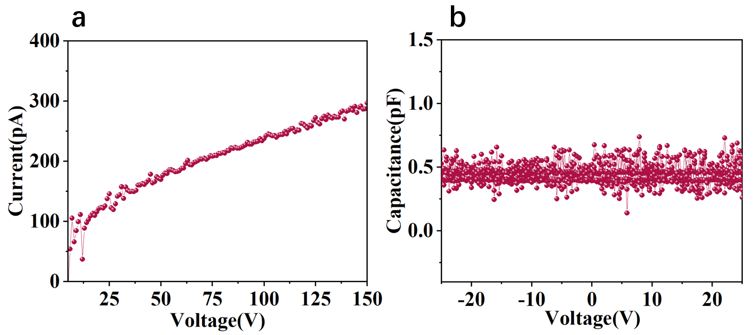
Fig. S3 Dark current and capacitance of the dynamic memristor.

SI.4: The impact of various external conditions on the relaxation time of dynamic memristors
First, we characterized the relaxation response of the micro-ring dynamic memristor under different temperature conditions. A voltage was initially applied to the micro-ring to transition it into the high-loss set state, after which the transmission spectrum was measured and recorded, and the quality factor was subsequently analyzed. Due to prior switching cycles, the device was in a fatigued state, resulting in a relatively slow relaxation recovery process. As shown in Figures S4a and b, the quality factor remained unchanged during the initial phase but gradually increased over time before reaching a steady state, indicating progressive reduction in optical loss and eventual completion of the reset process. The early-stage recovery dynamics were fitted with an exponential growth model. The fitting results reveal that the time constant for quality factor relaxation is 8.4 minutes at 50°C, significantly shorter than the 28.4 minutes observed at 30°C, demonstrating that elevated temperatures facilitate the redistribution of Ag nanoclusters within the device.
Furthermore, we characterized the relaxation response of the waveguide attenuator under varying illumination conditions. Specifically, the device was driven into the high absorption state by applying a voltage signal. The transmission of the waveguide was monitored at a fixed wavelength using a data acquisition system, under two distinct lighting conditions: with the measurement platform illumination turned off and with the illumination intensity set to its maximum level. The corresponding results are presented in Figures S4c and d. The results indicate that the relaxation recovery speed of the device was enhanced to a certain extent under illumination. It is speculated that a photodoping-like process described in the main text may have occurred, in which light exposure facilitated the re-dissolution and redistribution of Ag nanoclusters.
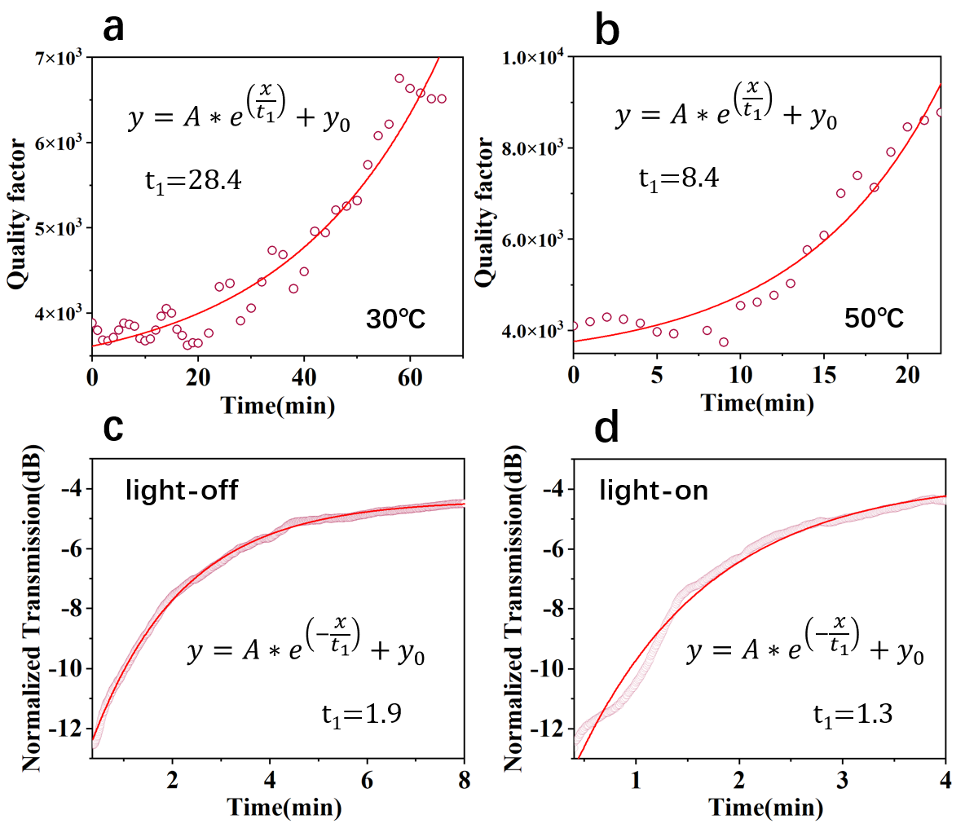
Fig. S4 a,b) Relaxation behavior of the Q factor in the micro-ring dynamic memristor at 30 °C and 50 °C. c,d) Relaxation behavior of the transmission in waveguide attenuators under different illumination conditions.

SI.5: Paired-pulse depression (PPD) characteristics of the dynamic memristor
The PPD index of the waveguide attenuation dynamic memristor was quantified by using the following equation:
$PPD=\frac{T_{2}-T_{1}}{T_{1}}×100\%$ (1)
Where T₁ and T₂ represent the inhibitory postsynaptic transmission peaks of the waveguide attenuator elicited by the first and second presynaptic pulses, respectively. The shorter pulse interval causes a deeper attenuation in the transmission peak value of the second pulse for the waveguide attenuator, leading to a higher absolute value of the PPD index. It can be observed from Figure S5 that the PPD index curve exhibits an exponential decay trend as a function of the pulse interval Δt, and can be effectively fitted using a double exponential equation:
$PPD index=C_{1}\exp\left(-\frac{∆t}{τ_{1}}\right)+C_{2}exp\left(-\frac{∆t}{τ_{2}}\right) ($2)
Where the fitted values of 𝜏₁ and 𝜏₂ were 1.12 and 20.04 seconds, respectively. With the increasing interval time, the PPD index progressively decreases, consistent with established neurobiological principles. Additionally, the response times of 𝜏₁ and 𝜏₂ on the order of seconds can effectively simulate the augmentation and post-tetanic potentiation mechanisms observed in biological neurology.
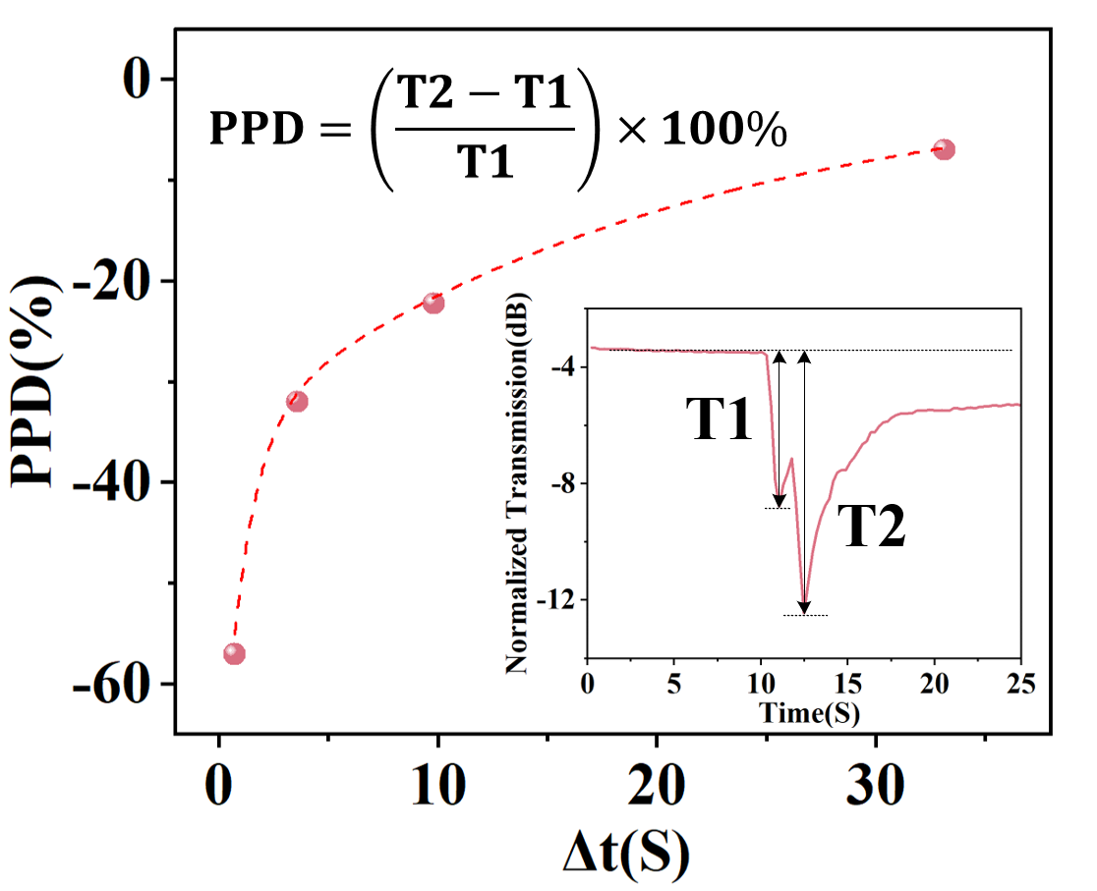
Fig. S5 PPD index as a function of pulse interval (Δt)

SI.6: Characterization of the photorefractive effects of the GSSe MRR
In thermally evaporated chalcogenide compound films, a significant number of chemically bonded species exhibit the same polarity. Upon exposure to light, these homopolar bonds may undergo break and reconstruction, which in turn influences the variation in the refractive index of the film. Therefore, throughout the entire experiment conducted on the photo-induced metal-doped GSSe waveguide, an MRR reference group was established without depositing metal Ag above the waveguide. This reference group underwent the same UV light illumination conditions in parallel with the MRR experimental group, in which Ag was deposited above the waveguide by sputtering.
Figure S3 illustrates the wavelength shift of the resonance peak within the reference MRR communication band over the entire 0–150 minute illumination period. It can be observed from the results that with increasing UV exposure time, the resonant peak experiences a redshift. This phenomenon corresponds to the photorefractive effect of the chalcogenide film, characterized by an increase in refractive index, which progressively drives the structural properties of the film toward those of bulk glass materials. Meanwhile, when the exposure time reaches 75 minutes, the photorefractive effect has nearly reached saturation. The wavelength shifts presented in Figures 4d and 4f of the origin text have been adjusted to account for photorefractive effects, thereby reflecting the refractive index changes induced by the metal-doped chalcogenide waveguide.
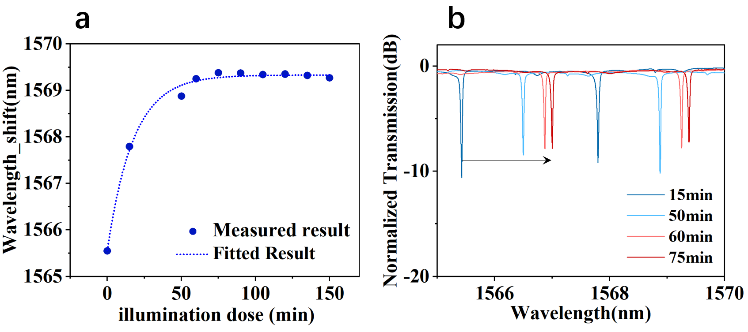
Fig. S6 The wavelength shift of the MRR resonance peak in the reference group exhibits variation in response to UV light illumination.

SI.7: Processing and preprocessing of the DeepShip dataset
Firstly, we apply a 3-second slicing procedure to the DeepShip dataset for two primary reasons. First, since the original audio recordings vary in length, slicing them into fixed durations is necessary to facilitate batch processing. Second, segmenting the audio files increases the dataset size, expanding the original few hundred recordings into tens of thousands of training samples. The processed dataset comprises a total of 50,434 samples, which are divided into training, validation, and test sets at a ratio of 6:2:2 for this study.
Subsequently, the Constant-Q Transform (CQT) is applied to the samples. As an advanced time-frequency analysis technique, CQT provides superior frequency resolution compared to the conventional Short-Time Fourier Transform (STFT). Notably, CQT's frequency resolution is proportional to frequency, making it especially effective for analyzing acoustic signals with wide frequency ranges. In the context of ship acoustic signals, CQT achieves high frequency resolution at low frequencies and high temporal resolution at high frequencies, thereby more accurately capturing the spectral structural characteristics. Guided by the specific properties of the DeepShip dataset, the CQT parameters were meticulously selected, as detailed in Table 1.
Parameters | Value | Reason
fmin | 20Hz | The low-frequency engine noise emitted by ships constitutes a significant acoustic characteristic.
n_bins | 96 | Using a greater number of frequency bins than the standard setting can enhance the ability to distinguish the acoustic characteristics of ships.
hop_length | 512 | Moderate temporal resolution, which effectively balances the trade-off between time and frequency resolution.
bins_per_octave | 12 | These standard settings are appropriate for conducting acoustic analysis.
sr | 32Hz | The DeepShip dataset retains its original sampling rate of 32 kHz to preserve a greater amount of acoustic information.
Table 1 Selection of CQT Parameters
Finally, we conducted a comparative analysis of the average CQT features across each category. Following the processing of the samples using the CQT, a time-frequency feature matrix of dimensions 96×188 was obtained. In this matrix, the 96-dimensions corresponds to the frequency axis discretization, while the 188-dimensional component represents the temporal sampling points. This time-frequency representation effectively preserves both the spectral characteristics of the signal and the temporal dynamics, thereby offering a comprehensive feature set for subsequent machine learning models. As illustrated in the Figure S7, the visualization of the original CQT features highlights the characteristic acoustic patterns of four distinct ship types. The spectrogram demonstrates that the CQT features for all ship categories are expressed in dB units, with values ranging from -75 dB to 0 dB and an average energy level of approximately -27 dB, reflecting the typical dynamic range of underwater acoustic signals. Regarding frequency distribution, the low-frequency band (0–20 bins, corresponding to the lower frequency range) exhibits a higher concentration of energy, indicated by the yellow-green regions. This observation aligns with the low-frequency noise typically radiated by a ship’s propeller and main engine. In contrast, the energy levels in the medium- and high-frequency bands (20–96 bins) are relatively weaker, primarily attributed to vibrations and mechanical noise from the ship’s structure. Distinct acoustic differences among the ship types are also evident: cargo ships display a relatively uniform energy distribution in the low-frequency range; tankers exhibit prominent harmonic structures in the medium- and low-frequency regions; passenger ships present more complex spectral patterns, indicative of their diverse onboard mechanical systems; and tugs demonstrate concentrated energy distribution in specific frequency bands. These distinguishing acoustic characteristics serve as the basis for subsequent feature extraction and classification tasks, demonstrating that the CQT feature extraction method effectively captures the essential acoustic features across different ship types. Furthermore, the Min-Max normalization method was employed to standardize the feature value ranges of each sample by mapping them to the interval [0, 1]. The corresponding results are presented in Figure 5b of the main text.
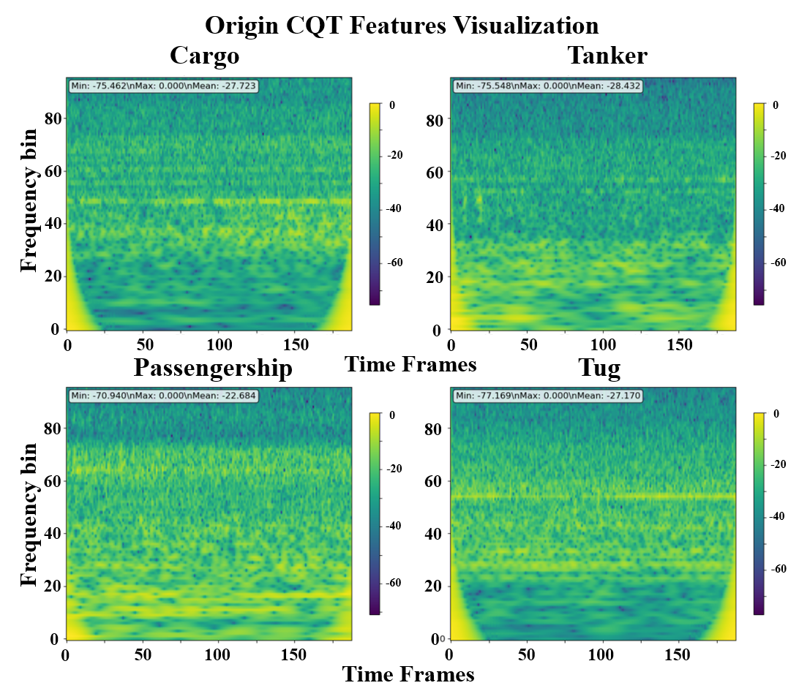
Fig. S7 CQT Feature Visualization

SI.8: Reservoir dynamics and information processing mechanism
The nonlinear characteristics of the reservoir constitute the foundation of its information processing capability. In our implementation, the nonlinear response is realized through a binary threshold function followed by dynamic processing. The input signal is initially transformed into a binary pulse sequence using this threshold function (binary_output = threshold_function(input_signal, θ)). Here, θ denotes the threshold parameter, which has been experimentally determined as 0.5. This binarization process not only simplifies the subsequent computational procedures but also improves the system's robustness to noise. The binarized signal subsequently proceeds to the dynamic processing stage, which simulates memristor state evolution. At each time point t, the system evaluates the contribution of all previous activations to the current state (state(t) = Σ contribution(t - τ) for all τ where activation occurred). Substituting the GSSe memristor dynamic response curve indicates that the contribution of each historical activation is determined through an exponential decay function (the fitting equation was presented in Figure 5c of the main text):
$$y=\sum_{t}^{t-τ}{（\frac{a}{1+e^{-b(τ-c)}}+d）}$$
This design emulates the complex dynamic behavior of memristors, wherein recent activations exert a stronger influence on the current state, whereas the impact of earlier activations diminishes progressively over time. The decay function, following a power-law form, enables the system to retain memory across various time scales, making it essential for effectively capturing both long-term and short-term dependencies in the input signals.

SI.9: Hybrid RC-CNN architecture design
Traditional reservoir computing (RC) systems typically utilize a simple linear output layer for final decision-making. Although this design is computationally efficient and easy to train, it may constrain system performance in complex classification tasks. To fully integrate the strengths of both reservoir computing and deep learning, we propose an innovative hybrid architecture that combines RC with a convolutional neural network (CNN). This architecture employs RC as the feature extraction front-end and a CNN as the classification decision back-end. The reservoir is responsible for capturing temporal features and dynamic patterns from raw time-series signals, while the CNN leverages its strong spatial feature learning capability to perform final classification. The entire network is trained in an end-to-end fashion, with the reservoir parameters held constant, while only the parameters of the CNN component are updated during training.
In the specific implementation, the features extracted by the reservoir are reshaped into a format compatible with CNN input. The original 96×188 feature matrix (representing 96 frequency channels and 188 time sampling points) is expanded into a 96×188×1 three-dimensional tensor, where the third dimension serves as the channel dimension. The overall CNN architecture comprises four convolutional modules, a dual-branch feature extraction mechanism, and a three-layer fully connected classifier. A progressive channel expansion strategy is implemented across the convolutional modules to gradually extract hierarchical feature representations. The first convolutional module utilizes a 5×5 convolutional kernel with a larger receptive field for initial feature extraction, transforming the single-channel input into a 32-dimensional feature space. Subsequent modules employ 3×3 convolutional kernels to capture local features. The number of channels increases in a power-of-two sequence, starting from 1 and progressing to 32, 64, 128, and 256, thereby achieving an effective balance between feature representation capability and computational efficiency. Each convolutional module follows a standard Conv-BN-ReLU-Dropout2d sequence. The batch normalization layer enhances training stability, the ReLU activation function introduces non-linear transformations, and the Dropout2d layer applies spatial regularization to mitigate overfitting. The dropout probability increases progressively from 0.1 to 0.25, reflecting the increasing need for regularization in deeper layers. Additionally, a 2×2 max pooling layer is incorporated at the end of each module for spatial downsampling, while the fourth module employs adaptive average pooling to unify the feature map size to 2×2.
Furthermore, the model innovatively employs a dual-branch feature fusion strategy to enhance the richness of feature representation. The global branch captures global semantic features through 1×1 adaptive average pooling, generating a 256-dimensional global feature vector. In contrast, the local branch directly flattens the output of the fourth convolutional module, preserving 1024-dimensional spatial local features. This design enables the model to capture both the overall semantic characteristics of the image and retain detailed spatial information. The two feature sets are concatenated to construct a 1280-dimensional comprehensive feature representation. The final classifier is structured as a three-layer fully connected network, with dimensions progressively decreasing from 1280 to 512 to 256 and finally to 4. Each hidden layer is followed by batch normalization, ReLU activation, and dropout regularization, with dropout probabilities of 0.6 and 0.4, respectively, to enhance the model's generalization capability. The output layer directly maps to the logits of the four categories, effectively addressing the requirements of multi-class classification tasks.
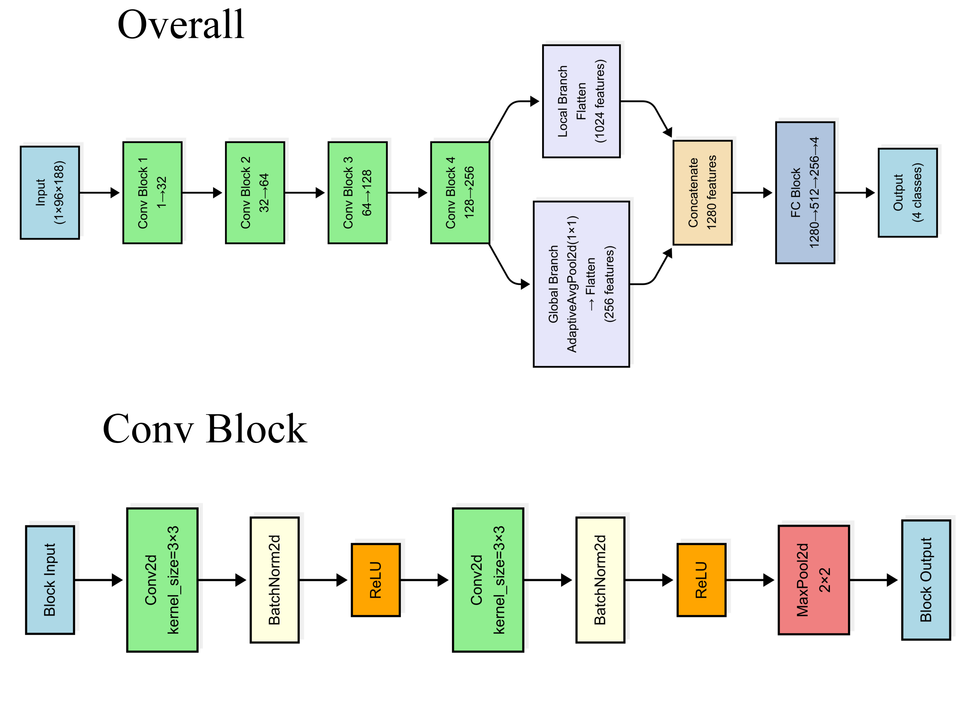
Fig. S9 Architecture of the CNN model

SI.10: Evaluation and comparison of model performance
To comprehensively evaluate the performance of the hybrid RC-CNN model in classifying ship acoustic signals, we designed a systematic comparative experiment. This experiment encompasses three distinct processing strategies: the original data was directly processed by CNN, the binary data was processed by CNN, and our fully hybrid RC-CNN model. The three processing strategies differ solely in the data processing phase, while the subsequent CNN framework remains identical across all approaches, ensuring that any performance discrepancies are not attributable to variations in the CNN architecture.
The deep learning training configuration employs the AdamW optimizer with a learning rate of 0.00005 and a weight decay of 1e-5, in conjunction with a learning rate scheduler that includes 10 warm-up steps and a cross-entropy loss function incorporating 0.2 label smoothing. The model is trained for a total of 50 epochs, with a gradient clipping threshold of 0.5 applied to prevent gradient explosion. Additionally, the training process implements a progressive unfreezing strategy, whereby network layers are unfrozen incrementally at the 10th, 15th, and 25th epochs. The model with the highest validation accuracy is automatically saved during training. As shown in the training results (Figures 6e and f in the original text), this configuration demonstrates strong performance, with the validation loss steadily decreasing and converging, while the validation accuracy continuously improves, reaching over 55%. Finally, through the use of a voting mechanism, the overall test accuracy reaches 77.7% for the CNN model, 73.0% for the optimized RC model, and 57.4% for the Binary model. The proposed approach integrates multiple established best practices in modern deep learning to ensure both training stability and optimal model performance.
The performance evaluation of the ship acoustic signals classification task should consider multiple evaluation indicators to comprehensively reflect the model's practical application value. In this study, we employed widely recognized classification metrics, including accuracy, precision, recall, and the F1 score, while also addressing the challenges posed by class imbalance and real-world application requirements. Accuracy, as one of the most intuitive performance measures, reflects the overall correctness of the model's classification. Specifically, for multi-class classification tasks, accuracy is defined as the ratio of correctly classified samples to the total number of samples: Accuracy = (TP + TN) / (TP + TN + FP + FN). Here, TP, TN, FP, and FN denote true positives, true negatives, false positives, and false negatives, respectively. Precision is a metric that evaluates the reliability of a model in predicting a specific category and is particularly important for minimizing false positives: Precision = TP / (TP + FP). In acoustic signals monitoring applications, high precision translates to fewer false alarms, which is essential for ensuring the system's operational efficiency. Recall, on the other hand, measures the completeness of a model in identifying instances of a specific category and is vital for ensuring that no critical targets are missed: Recall = TP / (TP + FN). In maritime safety contexts, a high recall ensures that important vessel types are not overlooked. The F1 score, defined as the harmonic mean of precision and recall, offers a balanced assessment of a model's performance by taking both metrics into account: F1 = 2 × (Precision × Recall) / (Precision + Recall).
Meanwhile, there are notable discrepancies in the distribution of samples across different ship types in the dataset, and this class imbalance significantly affects the evaluation of model performance. Specifically, the tanker category contains 82 samples, the passenger ship category includes 71 samples, whereas the cargo ship category has only 31 samples, and the tugboat category comprises 27 samples. Although this distribution reflects real-world maritime traffic characteristics, it introduces challenges in both model training and performance evaluation. The impact of class imbalance is primarily observed in two areas: First, categories with fewer instances receive relatively less attention during training, which may hinder the model's ability to fully capture the distinguishing features of these categories. Second, during performance evaluation, categories with more samples disproportionately influence overall performance metrics, potentially concealing performance deficiencies in minority categories. To address these issues and obtain a more accurate assessment of model performance, we implemented multiple strategies to mitigate the effects of class imbalance. During training, we applied class weight balancing techniques, assigning higher weights to underrepresented categories. In the evaluation phase, we reported both macro-average and weighted-average performance metrics to provide a comprehensive view of the model's effectiveness across all categories. As shown in Table 2, the performance metrics demonstrate substantial improvement when weight balancing techniques are employed, particularly in terms of macro-average measures, thereby validating the efficacy of our approach in addressing the class imbalance problem.
 |  | precision | recall | f1-score
Origin | Macro-average | 0.76 | 0.74 | 0.75
Origin | Weighted-average | 0.78 | 0.78 | 0.77
Binary | Macro-average | 0.66 | 0.49 | 0.45
Binary | Weighted-average | 0.63 | 0.57 | 0.53
RC | Macro-average | 0.73 | 0.69 | 0.70
RC | Weighted-average | 0.73 | 0.73 | 0.73
Table 2 The performance metrics include the macro average and weighted average across the three processing strategies.
In addition, by examining the classification performance of each vessel using the confusion matrix diagram (as shown in Figure S10), it can be observed that the data processed with the RC method results in a more balanced classification across categories compared to both the unprocessed data and the binary data processing approach. This provides experimental evidence for the effectiveness of the RC data processing method in addressing the issue of class imbalance.
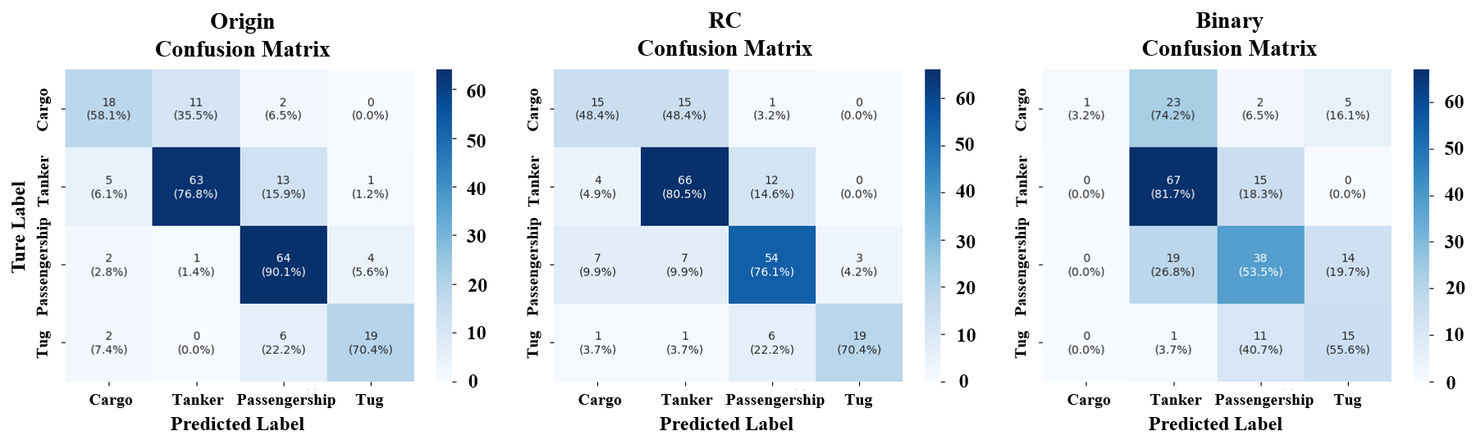
Fig. S10 Confusion matrix diagrams of three data processing methods
The hybrid RC model has demonstrated commendable performance in the classification of ship acoustic signals. Experimental results indicate an overall classification accuracy of 73.0%, which is notable given the complexity and class imbalance inherent in the dataset. Importantly, this level of performance significantly surpasses that of the simplified binary variant of the model. A detailed analysis of performance across individual ship categories (see Table 3) reveals that the reservoir computing model exhibits consistently strong and well-balanced classification accuracy across all categories.
Model | Class | Precision | Recall | F1-Score | Support
Ordinary | Cargo | 0.67 | 0.58 | 0.62 | 31
Ordinary | Tanker | 0.84 | 0.77 | 0.80 | 82
Ordinary | Passengership | 0.75 | 0.90 | 0.82 | 71
Ordinary | Tug | 0.79 | 0.70 | 0.75 | 27
Binary | Cargo | 1.00 | 0.03 | 0.06 | 31
Binary | Tanker | 0.61 | 0.82 | 0.70 | 82
Binary | Passengership | 0.58 | 0.54 | 0.55 | 71
Binary | Tug | 0.44 | 0.56 | 0.49 | 27
RC | Cargo | 0.56 | 0.48 | 0.52 | 31
RC | Tanker | 0.74 | 0.80 | 0.77 | 82
RC | Passengership | 0.74 | 0.76 | 0.75 | 71
RC | Tug | 0.86 | 0.70 | 0.78 | 27
Table 3 Detailed performance analysis of ship categories under three processing strategies.
The Tug category demonstrated the highest overall performance, with an precision of 0.86, a recall of 0.70, and an F1 score of 0.78. This superior performance suggests that the RC model exhibits strong adaptability to the complex operational characteristics of functional vessels. Tugs display considerable variability in acoustic features under different working conditions, and the RC model successfully identified the key distinguishing features within these dynamic patterns through its optimized feature extraction and processing mechanisms. The Tanker category also showed strong performance, achieving an accuracy of 0.74, a recall of 0.80, and an F1 score of 0.77. As large vessels, tankers typically exhibit stable low-frequency periodic vibration signals, which serve as ideal input for the RC model. The model effectively recognized these periodic patterns, resulting in a high recall, which holds considerable practical significance for maritime monitoring. The Passengership category exhibited balanced performance, with an accuracy of 0.74, a recall of 0.76, and an F1 score of 0.75. The complex mechanical systems of passenger ships generate diverse spectral structures, and the RC model's data processing strategy effectively extracted critical information from these multidimensional features, leading to consistent classification performance. Although the Cargo category presented greater challenges, the RC model still achieved acceptable results, with an accuracy of 0.56, a recall of 0.48, and an F1 score of 0.52. Given the diversity of cargo ship types and the limited sample size (31 samples), this outcome demonstrates the model's capability to manage complex intra-class variations.
Compared with the Binary model, the RC model demonstrates significantly superior performance across all ship categories. The most pronounced improvement is observed in the cargo ship category: although the Binary model achieves a precision of 1.00, its recall is merely 0.03, resulting in an F1 score of only 0.06—indicating minimal practical applicability. In contrast, the RC model attains a precision of 0.56 and a recall of 0.48, with the F1 score increasing to 0.52, representing an improvement of up to 8.67 times. The RC model also exhibits strong performance across other ship categories, further highlighting the effectiveness and advancement of its data processing strategy. When compared with the Ordinary model, the performance difference is relatively modest; however, the RC model offers a substantial advantage in terms of transmission efficiency. Specifically, the RC model can compress 32-bit raw data into a 1-bit representation with the binary process, achieving a compression ratio of 32:1. As a result, the data transmission volume is reduced to just 3.1% of that required by the Ordinary model (1.5625M/50M vs. 50M/50M). This significant enhancement in transmission efficiency can greatly reduce data transmission costs and network load in real-world maritime monitoring applications. Consequently, it enables faster data transmission, supports more timely decision-making, and facilitates the deployment of a larger number of monitoring nodes.

