Gel 1. Agarose gel showing PCR products obtained using the Miniexon protocol (Fernandes et al., 2001) for the detection of Trypanosoma cruzi in mammal samples. The expected band (~100 bp) is visible in positive samples. The table indicates the sample code and the corresponding mammal species.
Sample code | Species
KK100 | Pteronotus parnelli
KK302 | Artibeus jamaicensis
KK331 | Heteromys gaumeri
KK339 | Heteromys gaumeri
KK032 | Artibeus jamaicensis
KK038 | Artibeus jamaicensis
KK042 | Desmosus rotundus
KK118 | Glossophaga mutica
KK188 | Heteromys gaumeri
KK189 | Heteromys gaumeri
KK191 | Heteromys gaumeri
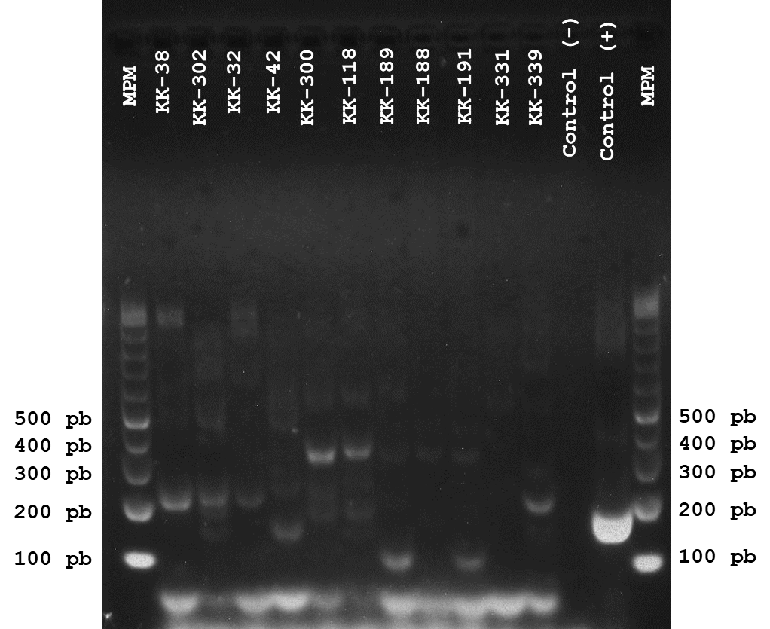

Gel 2. Agarose gel showing PCR products obtained using the Miniexon protocol (Fernandes et al., 2001) for the detection of Trypanosoma cruzi in mammal samples. The expected band (~100 bp) is visible in positive samples. The table indicates the sample code and the corresponding mammal species.
KK333 | Ototylomys phyllotis
KK340 | Heteromys gaumeri
KK022 | Heteromys gaumeri
KK043 | Heteromys gaumeri
KK052 | Ototylomys phyllotis
KK063 | Heteromys gaumeri
KK064 | Heteromys gaumeri
KK165 | Heteromys gaumeri
KK185 | Heteromys gaumeri
KK186 | Heteromys gaumeri
KK187 | Heteromys gaumeri
KK276 | Pteronotus parnelli
KK224 | Desmosus rotundus

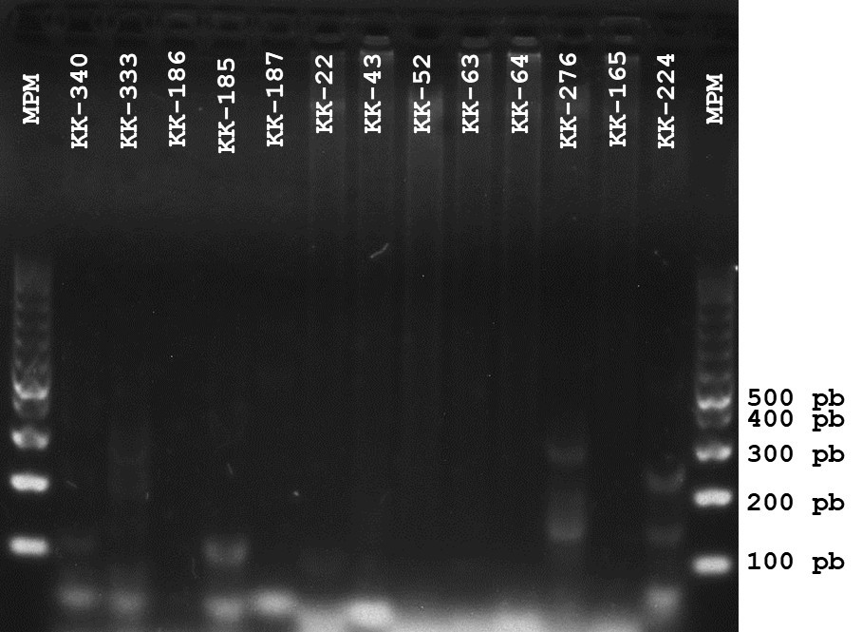

Gel 3. Agarose gel showing PCR products obtained using the Miniexon protocol (Fernandes et al., 2001) for the detection of Trypanosoma cruzi in mammal samples. The expected band (~100 bp) is visible in positive samples. The table indicates the sample code and the corresponding mammal species.
KK159 | Heteromys gaumeri
KK160 | Heteromys gaumeri
KK162 | Heteromys gaumeri
KK205 | Artibeus jamaicensis
KK214 | Molossus rufus
KK216 | Desmosus rotundus
KK222 | Artibeus jamaicensis
KK228 | Desmosus rotundus
KK252 | Heteromys gaumeri
KK253 | Heteromys gaumeri
KK275 | Mormoops megalophylla
KK282 | Heteromys gaumeri
KK283 | Ototylomys phyllotis

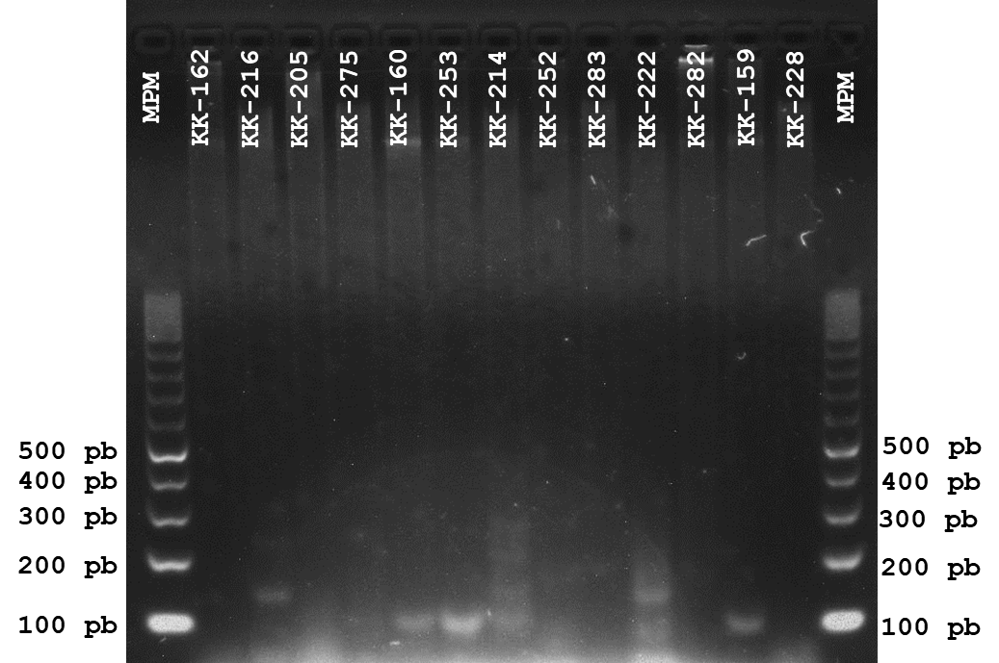

Gel 4. Agarose gel showing PCR products obtained using the Miniexon protocol (Fernandes et al., 2001) for the detection of Trypanosoma cruzi in mammal samples. The expected band (~100 bp) is visible in positive samples. The table indicates the sample code and the corresponding mammal species.
KK348 | Artibeus jamaicensis
KK350 | Artibeus jamaicensis
KK363 | Artibeus jamaicensis
KK380 | Heteromys gaumeri
KK410 | Pteronotus davyi
KK195 | Desmosus rotundus
KK223 | Desmosus rotundus
KK235 | Artibeus jamaicensis
KK245 | Heteromys gaumeri
KK247 | Heteromys gaumeri
KK264 | Heteromys gaumeri
KK277 | Mormoops megalophylla
KK284 | Heteromys gaumeri

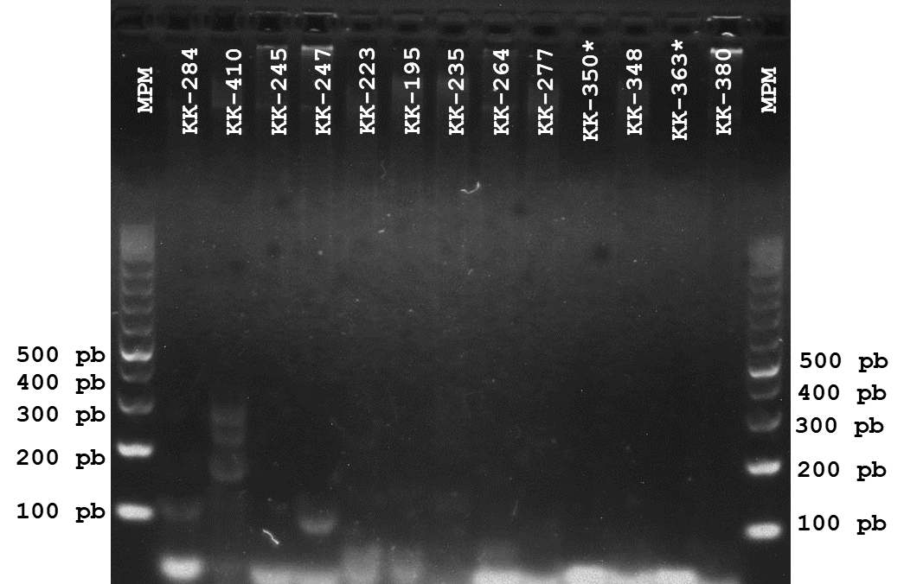

Gel 5. Agarose gel showing PCR products obtained using the Miniexon protocol (Fernandes et al., 2001) for the detection of Trypanosoma cruzi in mammal samples. The expected band (~100 bp) is visible in positive samples. The table indicates the sample code and the corresponding mammal species.
KK365 | Artibeus jamaicensis
KK366 | Pteronotus parnelli
KK367 | Artibeus jamaicensis
KK368 | Artibeus jamaicensis
KK371 | Dermanura phaeotis
KK377 | Heteromys gaumeri
KK379 | Heteromys gaumeri
KK391 | Oryzomys couesi
KK396 | Pteronotus parnelli
KK400 | Pteronotus davyi
KK405 | Pteronotus davyi

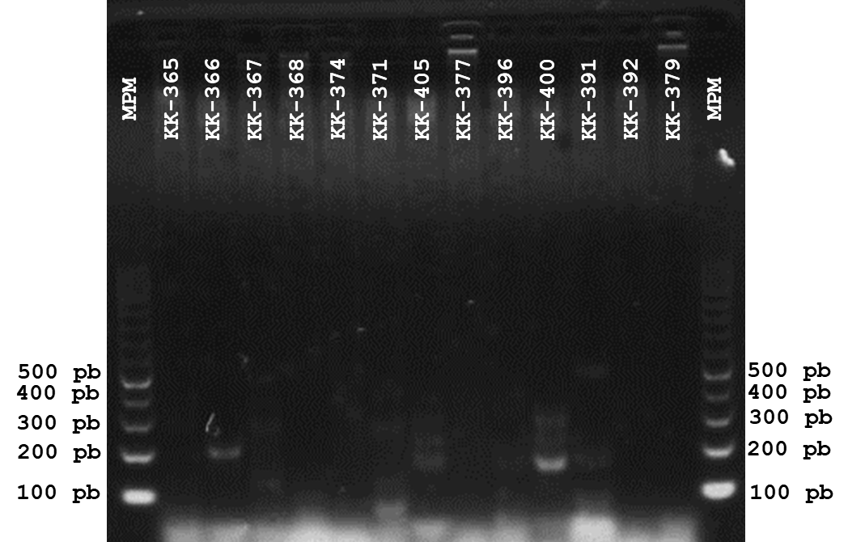

Gel 6. Agarose gel showing PCR products obtained using the Miniexon protocol (Fernandes et al., 2001) for the detection of Trypanosoma cruzi in mammal samples. The expected band (~100 bp) is visible in positive samples. The table indicates the sample code and the corresponding mammal species.
KK320 | Pteronotus parnelli
KK337 | Pteronotus parnelli
KK360 | Artibeus jamaicensis
KK369 | Artibeus jamaicensis
KK383 | Heteromys gaumeri
KK384 | Heteromys gaumeri
KK399 | Pteronotus davyi
KK412 | Pteronotus parnelli
KK414 | Pteronotus davyi
KK417 | Pteronotus parnelli
KK425 | Pteronotus parnelli
KK029 | Artibeus jamaicensis
KK048 | Artibeus jamaicensis

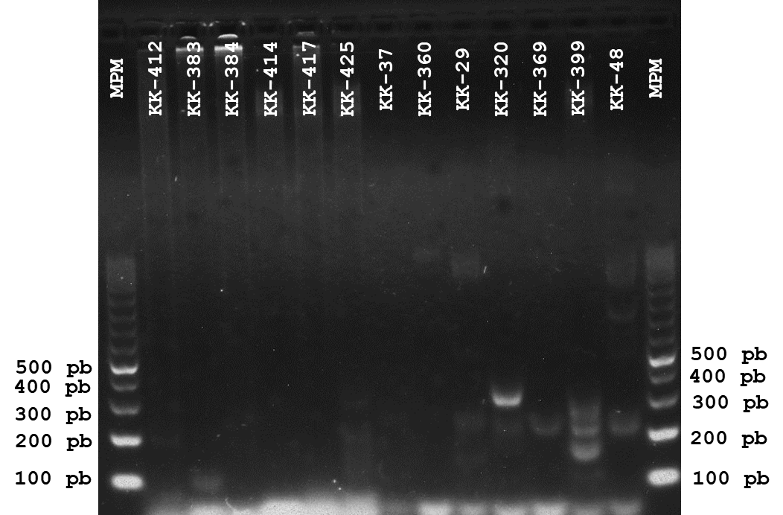
Gel 7. Agarose gel showing PCR products obtained using the Miniexon protocol (Fernandes et al., 2001) for the detection of Trypanosoma cruzi in mammal samples. The expected band (~100 bp) is visible in positive samples. The table indicates the sample code and the corresponding mammal species.
KK301 | Pteronotus parnelli
KK306 | Pteronotus parnelli
KK028 | Artibeus jamaicensis
KK055 | Dermanura tolteca

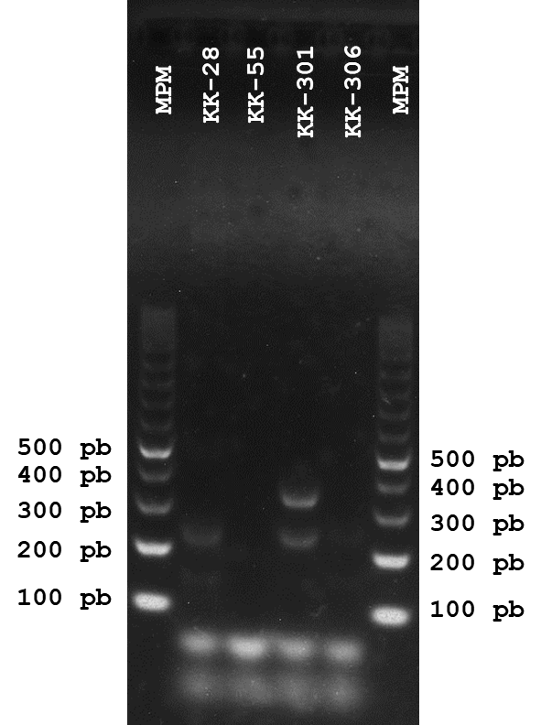

Gel 8. Agarose gel showing PCR products obtained using the Miniexon protocol (Fernandes et al., 2001) for the detection of Trypanosoma cruzi in mammal samples. The expected band (~100 bp) is visible in positive samples. The table indicates the sample code and the corresponding mammal species.
KK335 | Heteromys gaumeri
KK108 | Mormoops megalophylla
KK122 | Pteronotus parnelli
KK148 | Heteromys gaumeri
KK154 | Heteromys gaumeri
KK197 | Pteronotus davyi
KK204 | Artibeus jamaicensis
KK227 | Artibeus jamaicensis
KK239 | Desmosus rotundus
KK267 | Ototylomys phyllotis

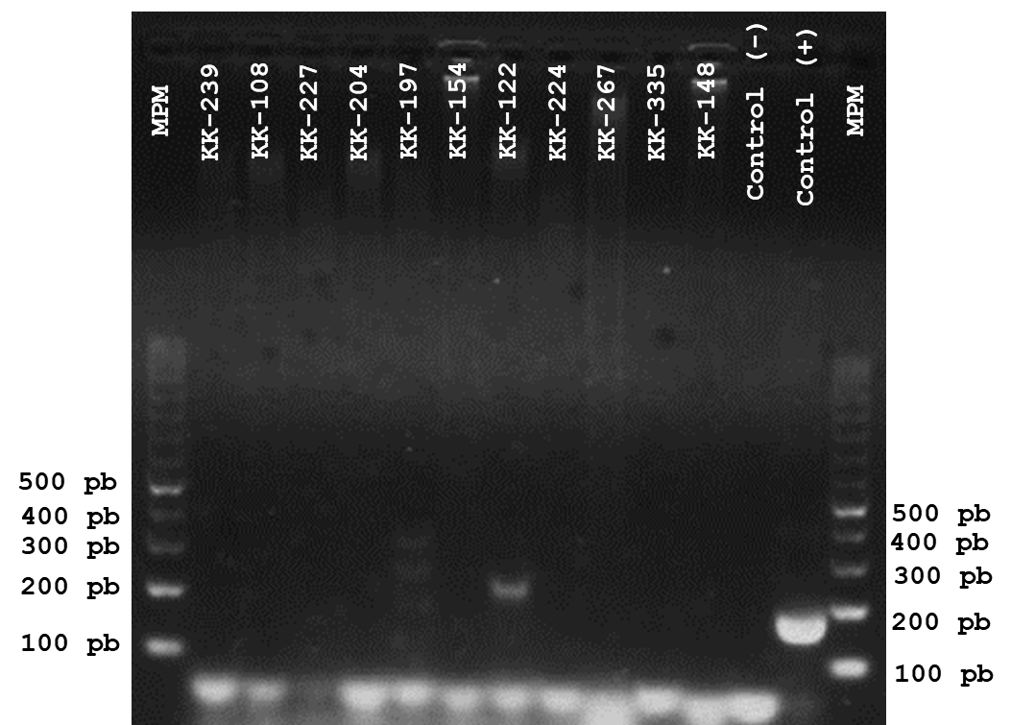

Gel 9. Agarose gel showing PCR products obtained using the Miniexon protocol (Fernandes et al., 2001) for the detection of Trypanosoma cruzi in mammal samples. The expected band (~100 bp) is visible in positive samples. The table indicates the sample code and the corresponding mammal species.
KK304 | Artibeus jamaicensis
KK316 | Pteronotus parnelli
KK324 | Artibeus jamaicensis
KK330 | Heteromys gaumeri
KK019 | Dermanura phaeotis
KK020 | Dermanura phaeotis
KK112 | Pteronotus parnelli
KK120 | Artibeus lituratus
KK125 | Artibeus jamaicensis
KK137 | Sturnira parvidens
KK143 | Pteronotus parnelli
KK144 | Pteronotus parnelli
KK150 | Heteromys gaumeri

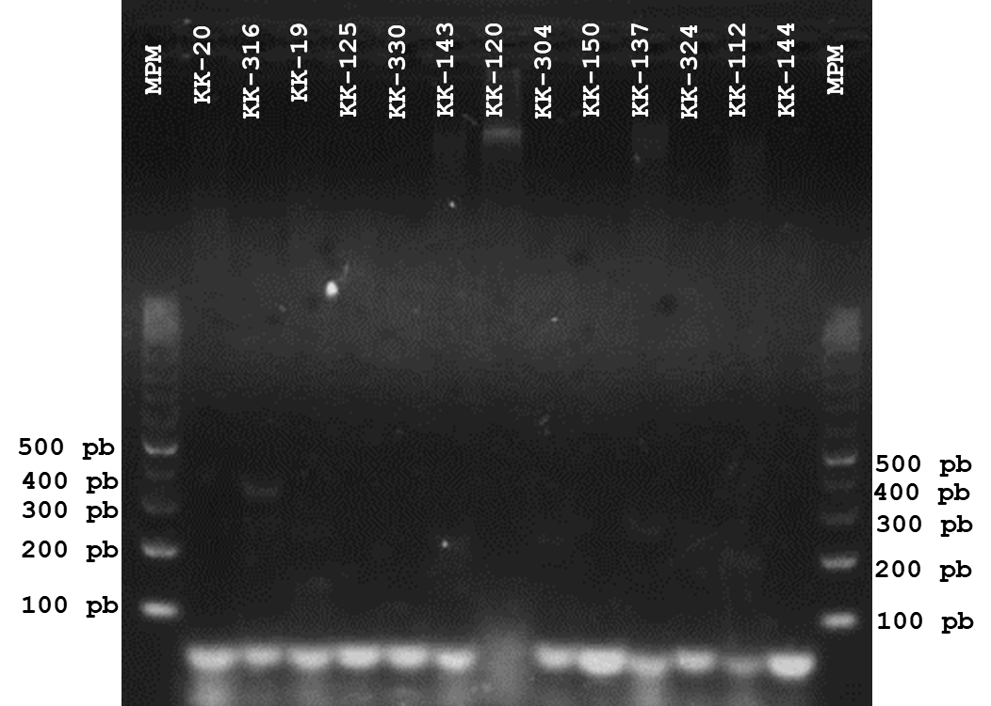

Gel 10. Agarose gel showing PCR products obtained using the Miniexon protocol (Fernandes et al., 2001) for the detection of Trypanosoma cruzi in mammal samples. The expected band (~100 bp) is visible in positive samples. The table indicates the sample code and the corresponding mammal species.
KK307 | Artibeus jamaicensis
KK317 | Artibeus jamaicensis
KK336 | Pteronotus parnelli
KK111 | Pteronotus parnelli
KK113 | Pteronotus parnelli
KK141 | Artibeus jamaicensis
KK157 | Heteromys gaumeri
KK161 | Heteromys gaumeri
KK163 | Heteromys gaumeri
KK164 | Heteromys gaumeri

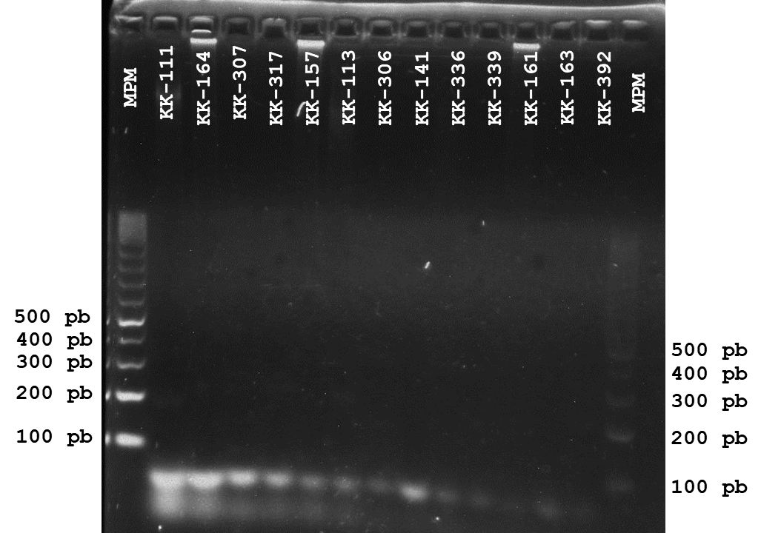

Gel 11. Agarose gel showing PCR products obtained using the Miniexon protocol (Fernandes et al., 2001) for the detection of Trypanosoma cruzi in mammal samples. The expected band (~100 bp) is visible in positive samples. The table indicates the sample code and the corresponding mammal species.
KK310 | Pteronotus parnelli
KK311 | Artibeus jamaicensis
KK313 | Artibeus jamaicensis
KK318 | Pteronotus parnelli
KK323 | Pteronotus parnelli
KK338 | Heteromys gaumeri
KK117 | Pteronotus parnelli
KK233 | Artibeus jamaicensis

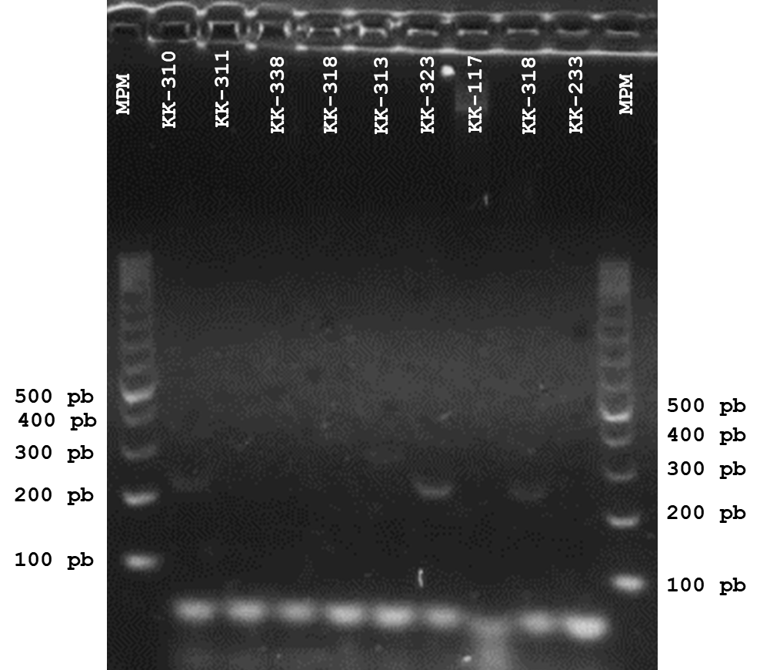
Gel 12. Agarose gel showing PCR products obtained using the Miniexon protocol (Fernandes et al., 2001) for the detection of Trypanosoma cruzi in Triatoma dimidiata. The expected band (~100 bp) is visible in positive samples. The first sample corresponds to a mammal. The remaining samples correspond to intestinal content or feces from the vector Triatoma dimidiata.
KK319 | Pteronotus parnelli

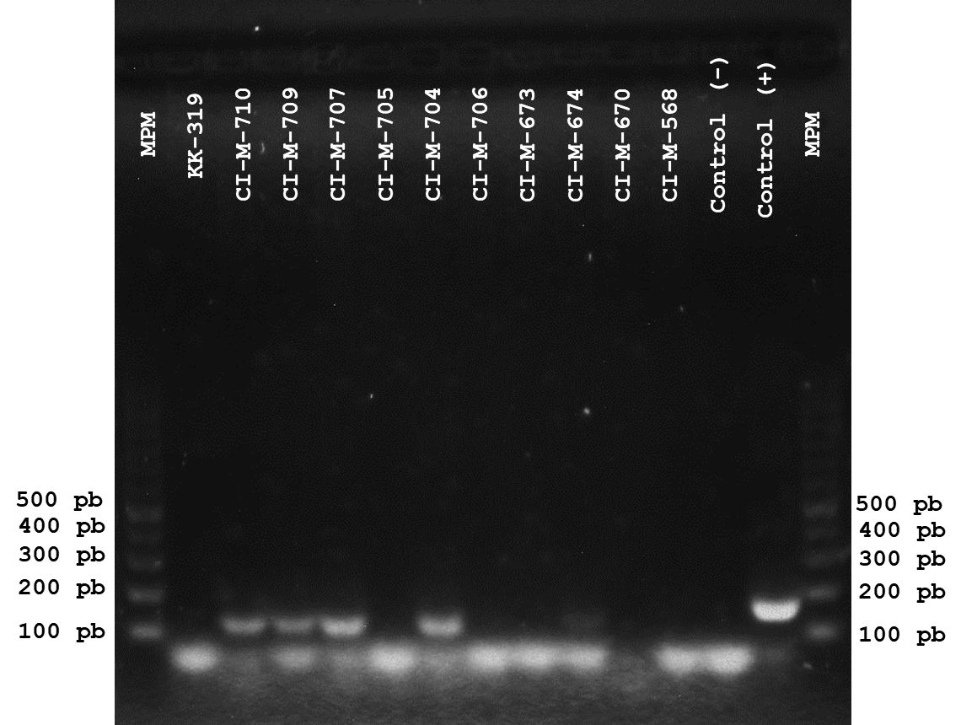

Gel 13. Agarose gel showing PCR products obtained using the Miniexon protocol (Fernandes et al., 2001) for the detection of Trypanosoma cruzi in Triatoma dimidiata. The expected band (~100 bp) is visible in positive samples. The samples correspond to intestinal content or feces
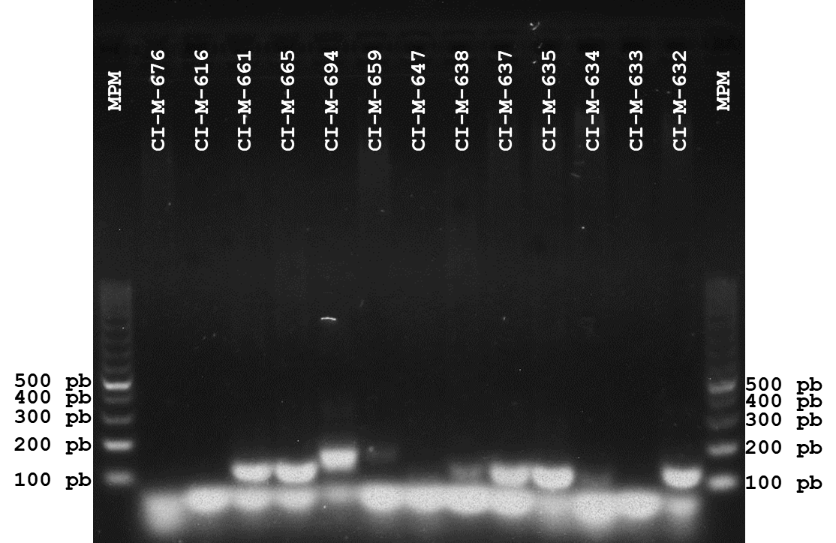

Gel 14. Agarose gel showing PCR products obtained using the Miniexon protocol (Fernandes et al., 2001) for the detection of Trypanosoma cruzi in Triatoma dimidiata. The expected band (~100 bp) is visible in positive samples. The samples correspond to intestinal content or feces.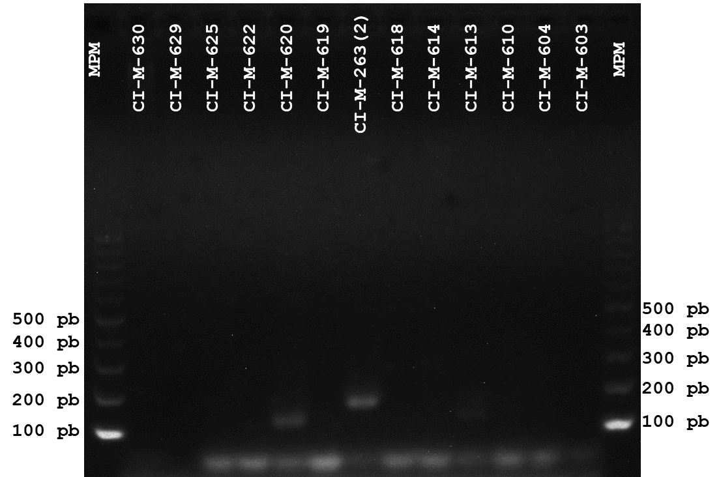

Gel 15. Agarose gel showing PCR products obtained using the Miniexon protocol (Fernandes et al., 2001) for the detection of Trypanosoma cruzi in Triatoma dimidiata. The expected band (~100 bp) is visible in positive samples. The samples correspond to intestinal content or feces.
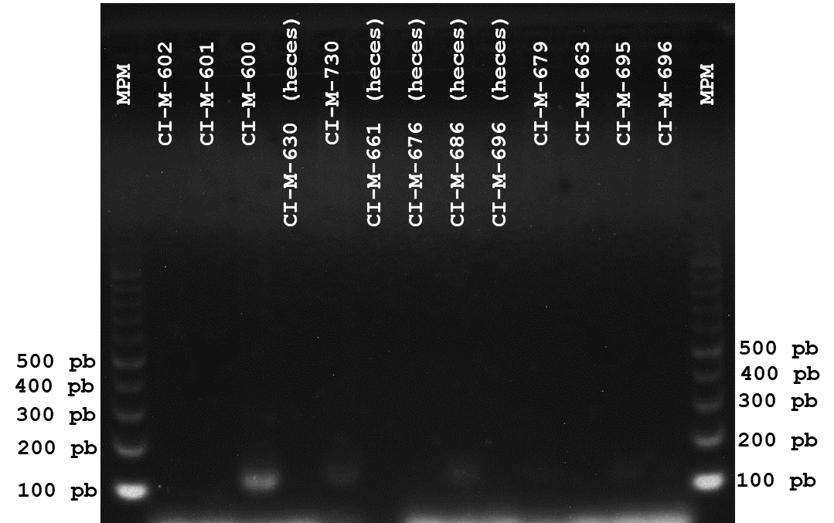

Gel 16. Agarose gel showing PCR products obtained using the Miniexon protocol (Fernandes et al., 2001) for the detection of Trypanosoma cruzi in Triatoma dimidiata. The expected band (~100 bp) is visible in positive samples. The samples correspond to intestinal content or feces.
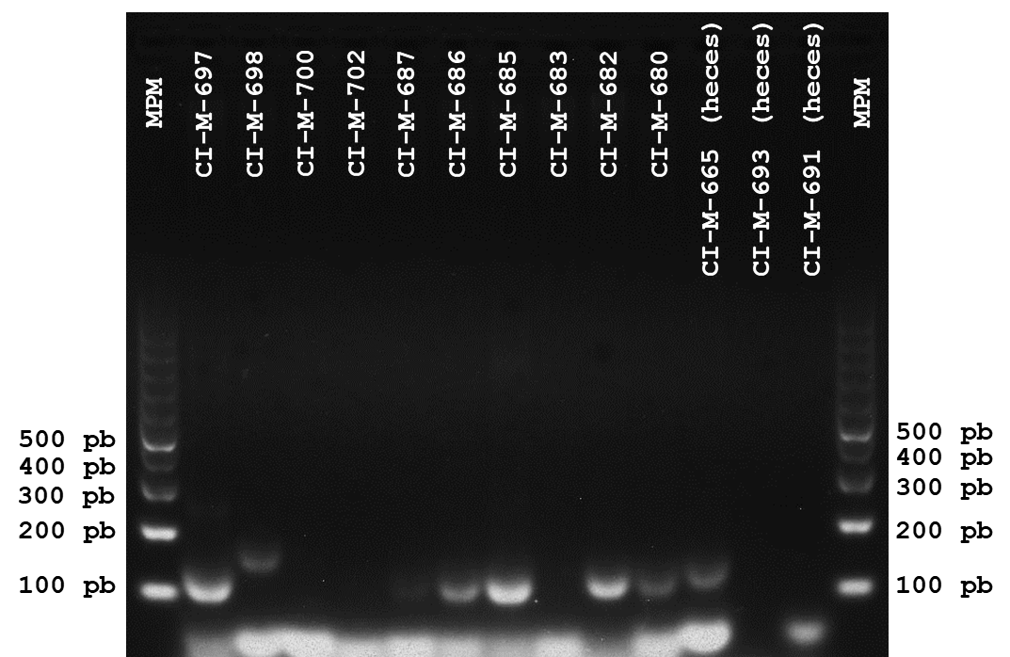

Gel 17. Agarose gel showing PCR products obtained using the Miniexon protocol (Fernandes et al., 2001) for the detection of Trypanosoma cruzi in Triatoma dimidiata. The expected band (~100 bp) is visible in positive samples. The samples correspond to intestinal content or feces.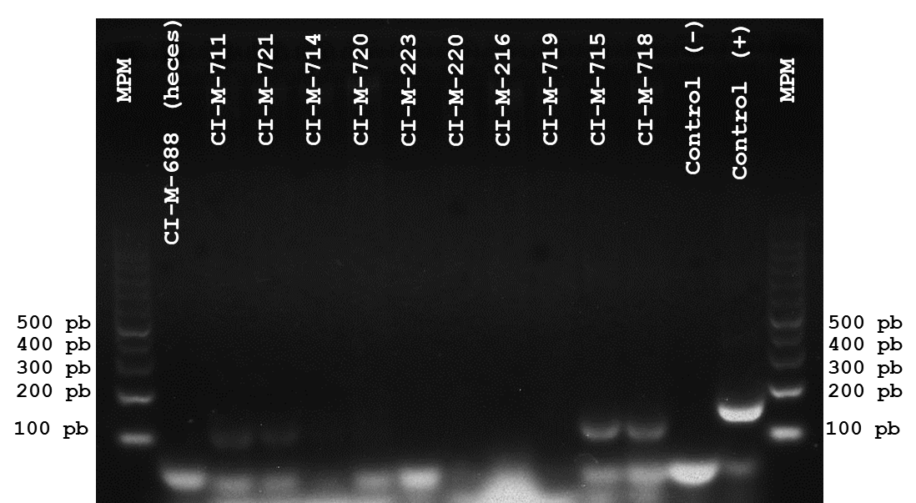

Gel 18. Agarose gel showing PCR products obtained using the Miniexon protocol (Fernandes et al., 2001) for the detection of Trypanosoma cruzi in Triatoma dimidiata. The expected band (~100 bp) is visible in positive samples. The samples correspond to intestinal content or feces.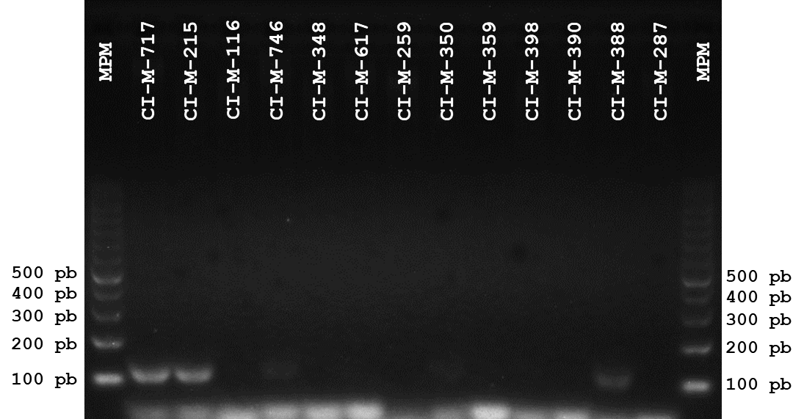
Gel 19. Agarose gel showing PCR products obtained using the Miniexon protocol (Fernandes et al., 2001) for the detection of Trypanosoma cruzi in Triatoma dimidiata. The expected band (~100 bp) is visible in positive samples. The samples correspond to intestinal content or feces.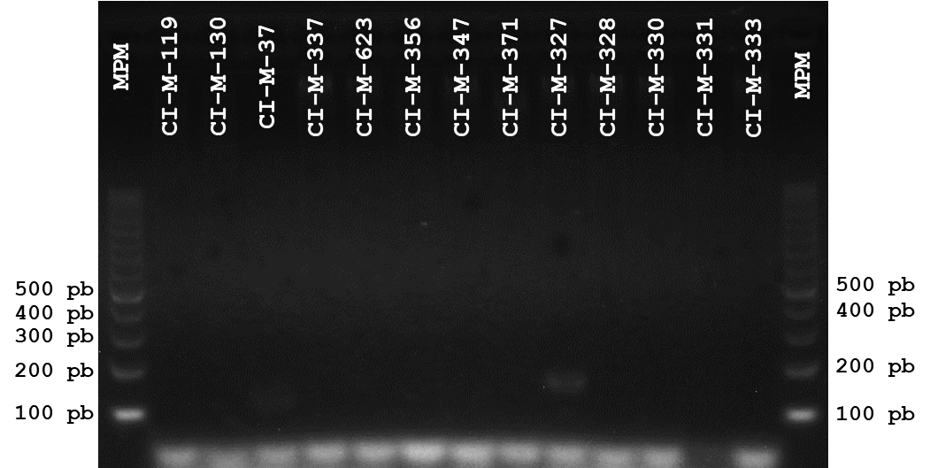

Gel 20. Agarose gel showing PCR products obtained using the Miniexon protocol (Fernandes et al., 2001) for the detection of Trypanosoma cruzi in Triatoma dimidiata. The expected band (~100 bp) is visible in positive samples. The samples correspond to intestinal content or feces.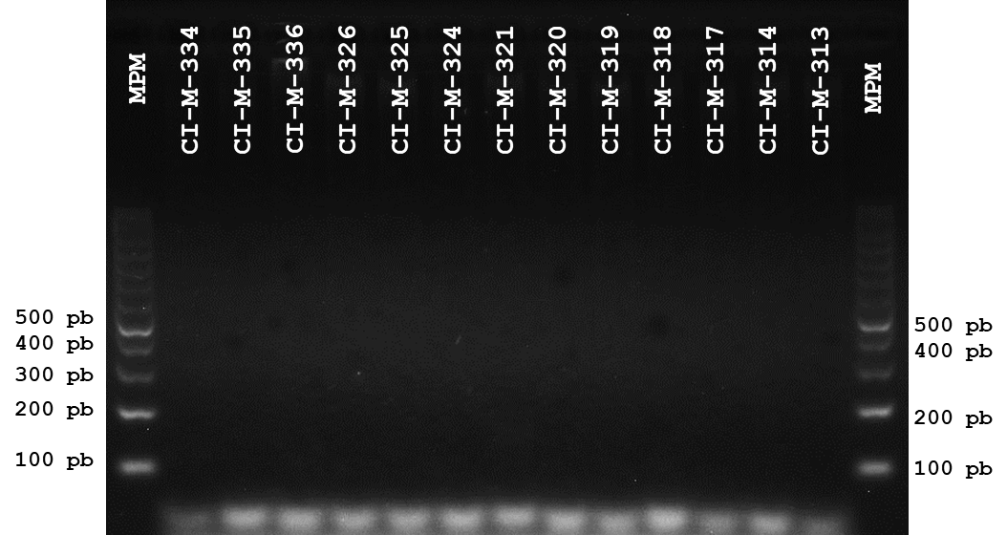

Gel 21. Agarose gel showing PCR products obtained using the Miniexon protocol (Fernandes et al., 2001) for the detection of Trypanosoma cruzi in Triatoma dimidiata. The expected band (~100 bp) is visible in positive samples. The samples correspond to intestinal content or feces.
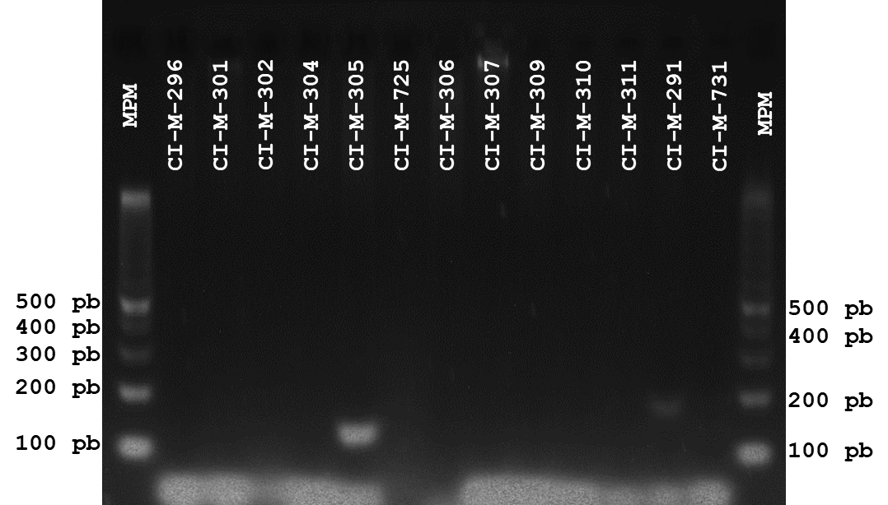

Gel 22. Agarose gel with PCR products obtained using the Miniexon protocol (Fernandes et al., 2001) for the detection of Trypanosoma cruzi in Triatoma dimidiata samples. The expected band (~100 bp) is visible in positive samples. The samples correspond to intestinal contents or feces.
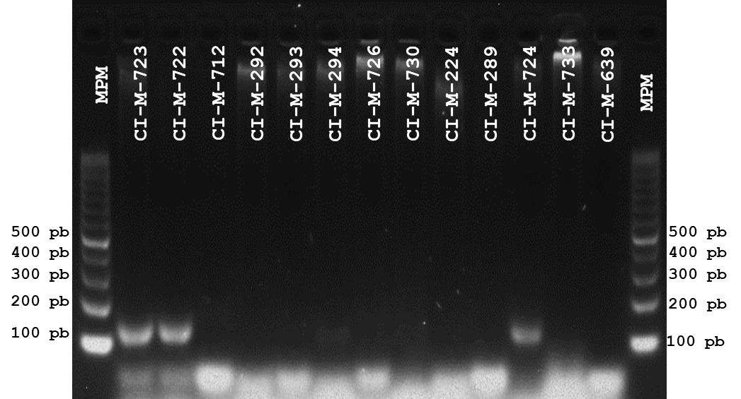

Gel 23. Agarose gel with PCR products obtained using the Miniexon protocol (Fernandes et al., 2001) for the detection of Trypanosoma cruzi in Triatoma dimidiata. The expected band (~100 bp) is visible in positive samples. The samples correspond to intestinal contents or feces.
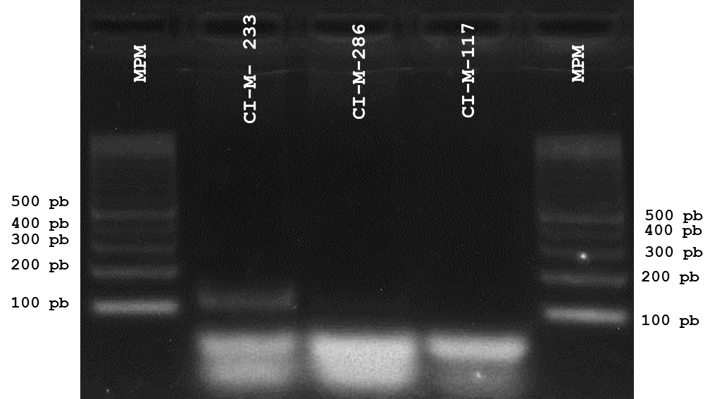

Gel 24. Gel de agarosa con productos de PCR obtenidos de la secuenciación mediante el protocolo de 18S (XXXX., XXXX) para la detección de Trypanosoma cruzi en muestras de mamíferos. En el gel de agarosa se observa la banda esperada (~100 bp) en muestras positivas.
Clave | Especie
KK019 | Dermanura phaeotis
KK032 | Artibeus jamaicensis
KK038 | Artibeus jamaicensis
KK048 | Artibeus jamaicensis
KK055 | Dermanura tolteca
KK108 | Mormoops megalophylla
KK112 | Pteronotus parnelli
KK113 | Pteronotus parnelli
KK137 | Sturnira parvidens
KK143 | Pteronotus parnelli
KK197 | Pteronotus davyi
KK205 | Artibeus jamaicensis
KK216 | Desmosus rotundus
KK222 | Artibeus jamaicensis
KK224 | Desmosus rotundus
KK228 | Desmosus rotundus
KK302 | Artibeus jamaicensis
KK317 | Artibeus jamaicensis
KK321 | Pteronotus parnelli
KK323 | Pteronotus parnelli
KK328 | Ototylomys phyllotis
KK336 | Pteronotus parnelli
KK363 | Artibeus jamaicensis
KK368 | Artibeus jamaicensis
KK374 | Artibeus jamaicensis
KK399 | Pteronotus davyi
KK405 | Pteronotus davyi
KK412 | Pteronotus parnelli
KK425 | Pteronotus parnelli

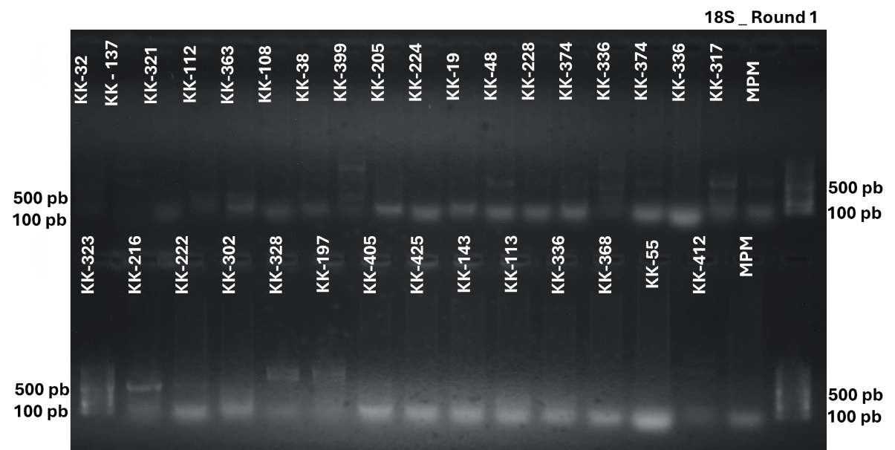

Gel 25. Agarose gel showing PCR products of the small subunit ribosomal RNA gene for the detection of Trypanosoma spp. in bat samples. The expected band (~600 bp) is visible in positive samples.
Clave | Especie
KK029 | Artibeus jamaicensis
KK034 | Artibeus jamaicensis
KK111 | Pteronotus parnelli
KK117 | Pteronotus parnelli
KK195 | Desmosus rotundus
KK277 | Mormoops megalophylla
KK310 | Pteronotus parnelli
KK311 | Artibeus jamaicensis
KK318 | Pteronotus parnelli
KK348 | Artibeus jamaicensis
KK350 | Artibeus jamaicensis
KK365 | Artibeus jamaicensis
KK367 | Artibeus jamaicensis
KK369 | Artibeus jamaicensis
KK396 | Pteronotus parnelli
KK400 | Pteronotus davyi
KK417 | Pteronotus parnelli

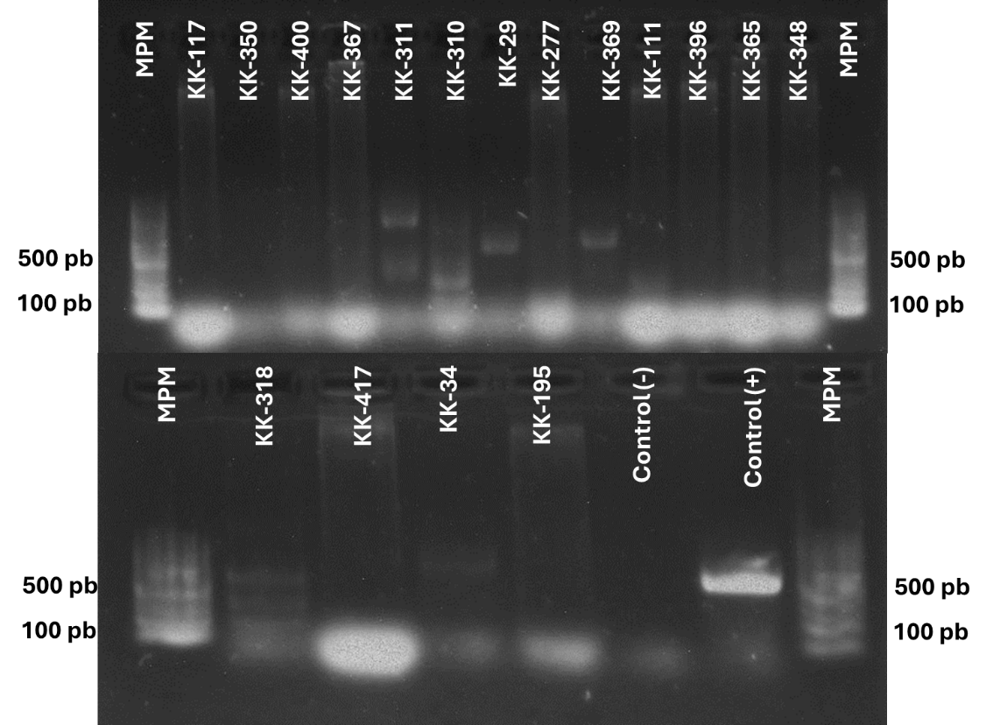
Gel 26. Agarose gel showing PCR products amplified from the small subunit ribosomal RNA gene for the detection of Trypanosoma spp. in mammal and bug samples. The expected band (~600 bp) is visible in positive samples. The first five samples correspond to mammals. The remaining samples correspond to intestinal contents or feces of Triatoma dimidiata.
Clave | Especie
KK214 | Molossus rufus
KK223 | Desmosus rotundus
KK316 | Pteronotus parnelli
KK414 | Pteronotus davyi
KK416 | Pteronotus parnelli

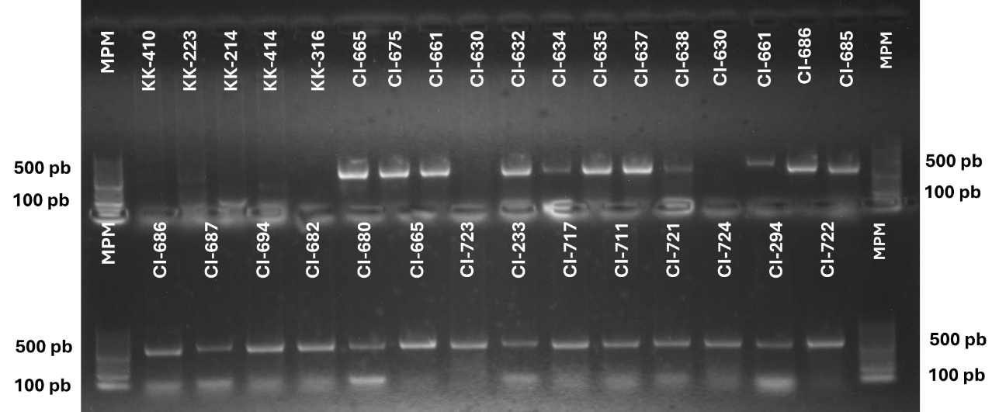

Gel 27. Agarose gel showing PCR products amplified from the small subunit ribosomal RNA gene for the detection of Trypanosoma spp. in mammal and bug samples. The expected band (~600 bp) is visible in positive samples. Samples labeled with “KK” correspond to mammals. The remaining samples correspond to intestinal contents of Triatoma dimidiata, except for those indicated, which were obtained from feces.
Clave | Especie
KK159 | Heteromys gaumeri
KK160 | Heteromys gaumeri
KK185 | Heteromys gaumeri
KK189 | Heteromys gaumeri
KK191 | Heteromys gaumeri
KK247 | Heteromys gaumeri
KK284 | Heteromys gaumeri

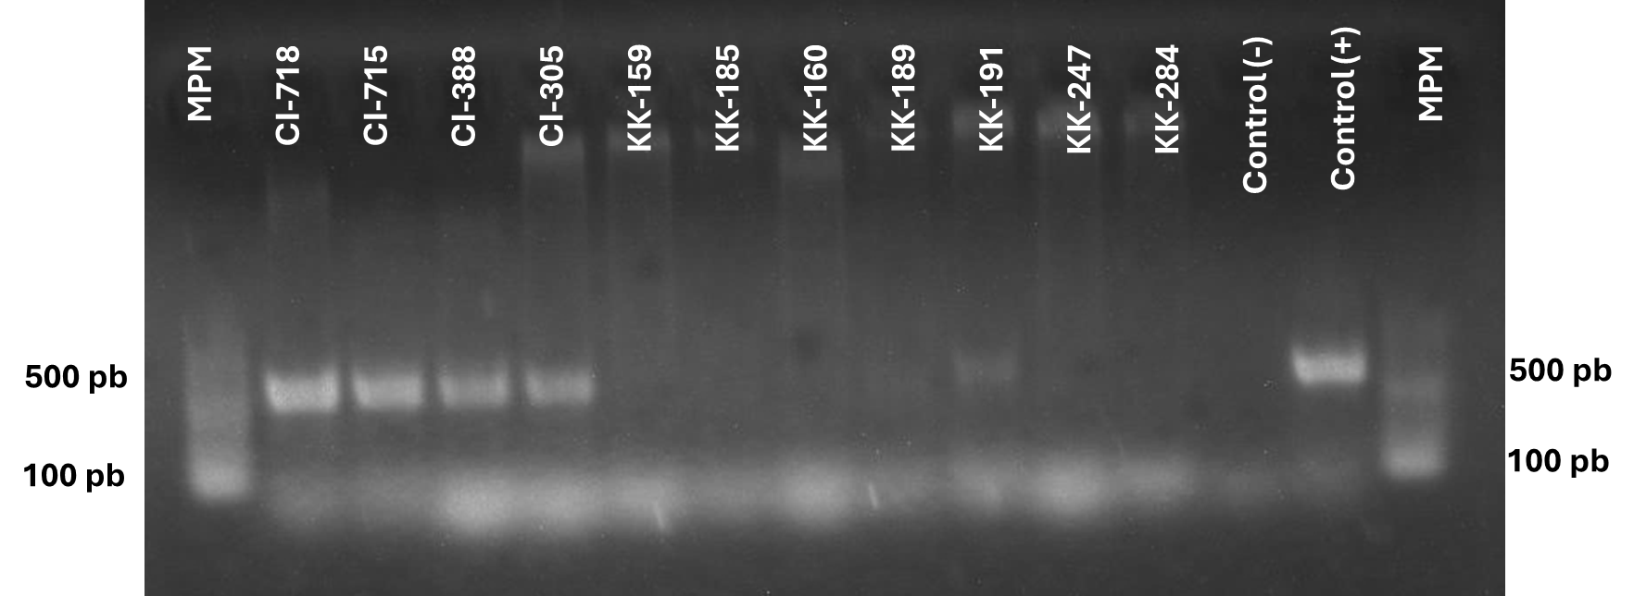

Gel 28. Agarose gel showing PCR products amplified from the small subunit ribosomal RNA gene for the detection of Trypanosoma spp. in bat samples. The expected band (~600 bp) is visible in positive samples.
Clave | Especie
KK019 | Dermanura phaeotis
KK032 | Artibeus jamaicensis
KK038 | Artibeus jamaicensis
KK048 | Artibeus jamaicensis
KK137 | Sturnira parvidens
KK204 | Artibeus jamaicensis
KK205 | Artibeus jamaicensis
KK228 | Desmosus rotundus
KK317 | Artibeus jamaicensis
KK323 | Pteronotus parnelli
KK336 | Pteronotus parnelli

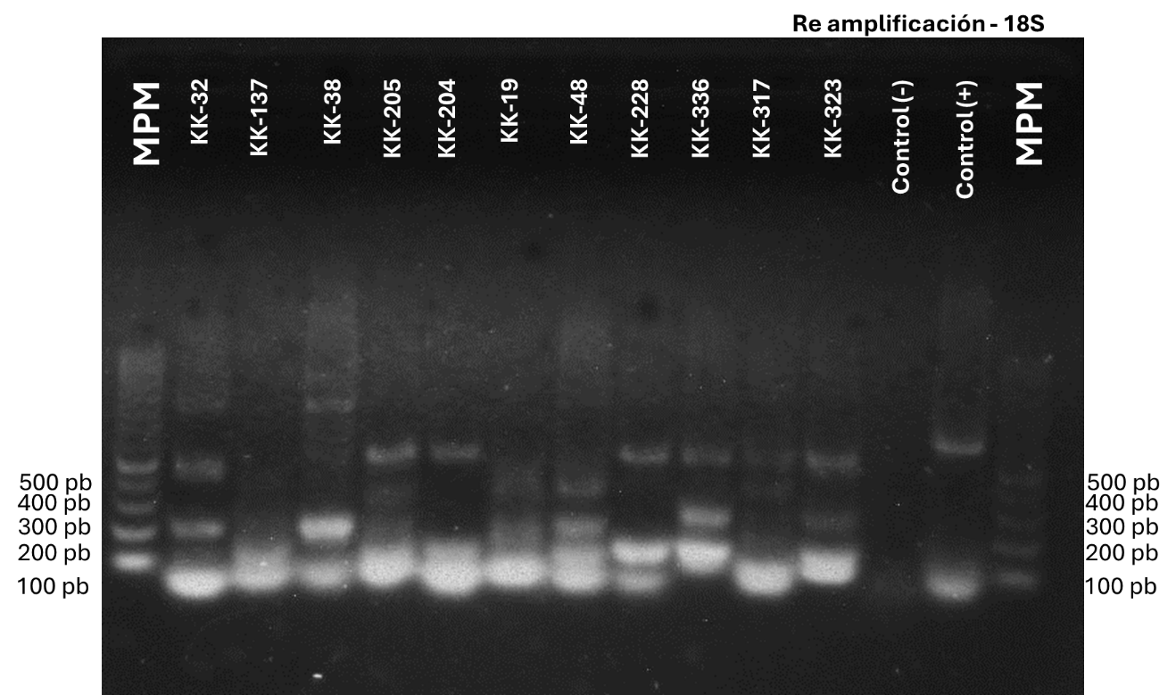

Gel 29. Agarose gel showing PCR products amplified from the small subunit ribosomal RNA gene for the detection of Trypanosoma spp. in mammal and bug samples. The expected band (~600 bp) is visible in positive samples. Samples labeled with "KK" correspond to mammals. The remaining samples correspond to intestinal contents or feces from Triatoma dimidiata.
Clave | Especie
KK029 | Artibeus jamaicensis
KK034 | Artibeus jamaicensis
KK191 | Heteromys gaumeri
KK216 | Desmosus rotundus
KK224 | Desmosus rotundus
KK253 | Heteromys gaumeri
KK276 | Pteronotus parnelli
KK302 | Artibeus jamaicensis
KK311 | Artibeus jamaicensis
KK318 | Pteronotus parnelli
KK328 | Ototylomys phyllotis
KK355 | Molossus rufus
KK360 | Artibeus jamaicensis
KK369 | Artibeus jamaicensis
KK371 | Dermanura phaeotis
KK383 | Heteromys gaumeri

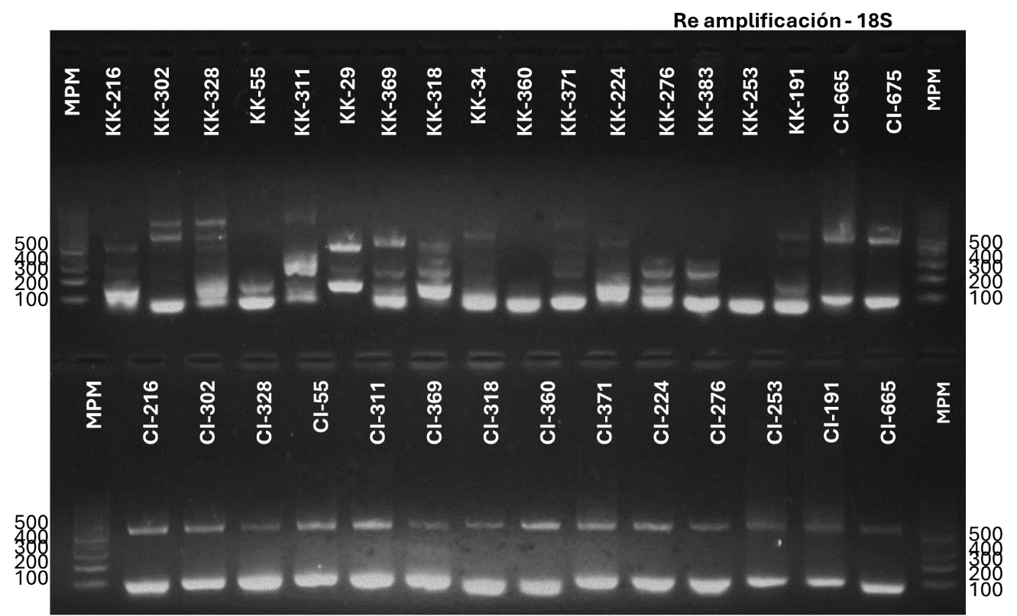

Gel 30. Agarose gel showing PCR products amplified from the small subunit ribosomal RNA gene for the detection of Trypanosoma spp. in bug samples. The expected band (~600 bp) is visible in positive samples.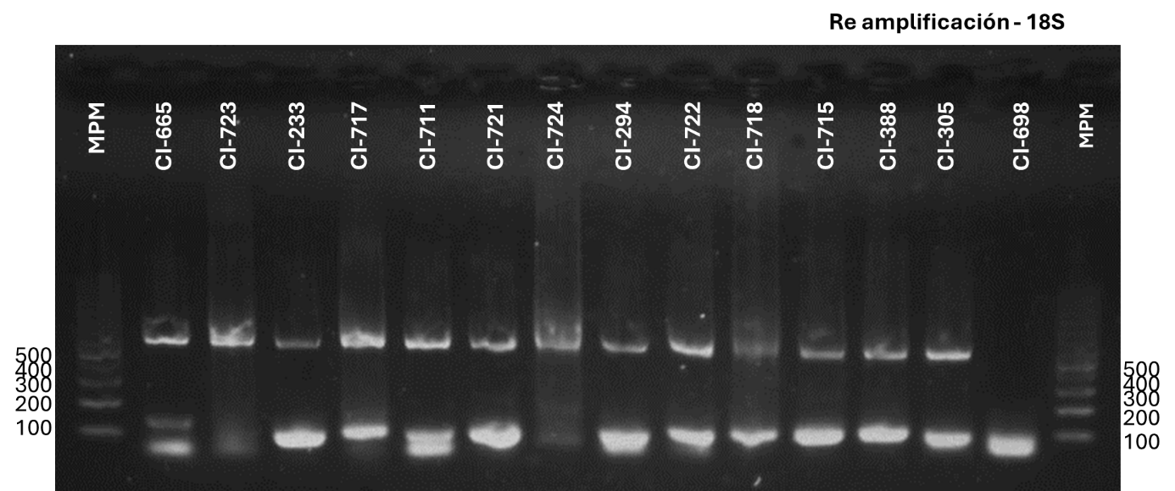

Gel 31. Agarose gel with PCR products amplified using the Miniexon protocol (Fernandes et al., 2001) for the detection of Trypanosoma cruzi in Triatoma dimidiata samples. The gel shows the amplified samples selected for further analysis.
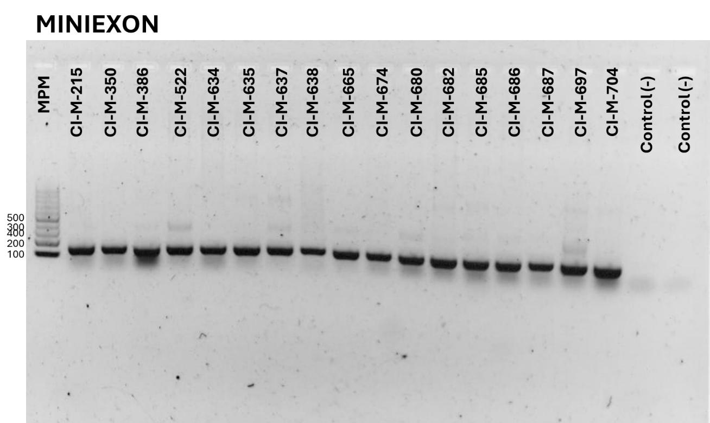

Gel 32. Agarose gel with PCR products amplified using the Miniexon protocol (Fernandes et al., 2001) for the detection of Trypanosoma cruzi in Triatoma dimidiata and mammal samples. The gel shows the amplified samples selected for further analysis.
Clave | Especie
KK399 | Pteronotus davyi
KK405 | Pteronotus davyi
KK410 | Pteronotus davyi
KK316 | Pteronotus parnelli
KK048 | Artibeus jamaicensis
KK340 | Heteromys gaumeri
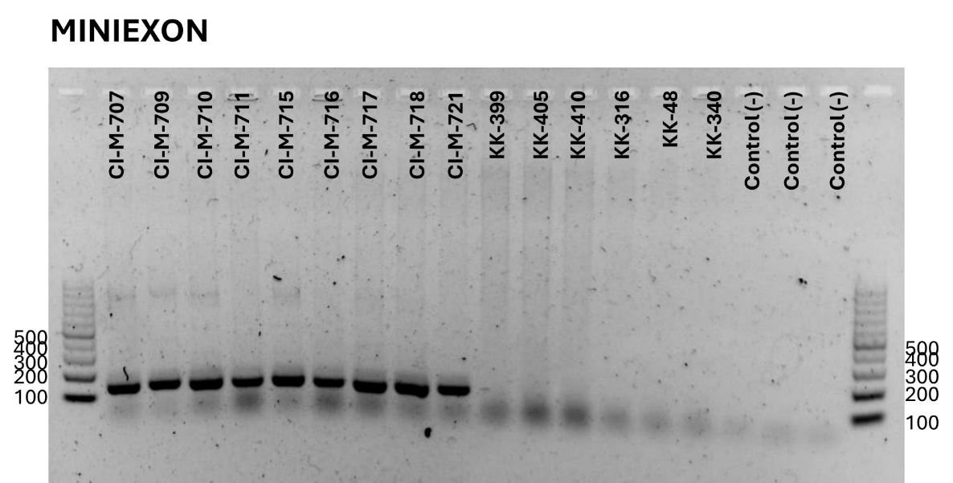

Gel 33. PCR products amplified from the small subunit ribosomal RNA gene for the detection of Trypanosoma spp. in mammals
Code | Species
KK025 | Artibeus jamaicensis
KK032 | Artibeus jamaicensis
KK046 | Artibeus jamaicensis
KK126 | Artibeus jamaicensis
KK205 | Artibeus jamaicensis
KK228 | Desmosus rotundus
KK241 | Artibeus jamaicensis
KK271 | Artibeus jamaicensis
KK274 | Artibeus jamaicensis
KK279 | Artibeus jamaicensis
KK309 | Pteronotus parnelli
KK311 | Artibeus jamaicensis
KK323 | Pteronotus parnelli
KK336 | Pteronotus parnelli
KK349 | Pteronotus parnelli

