 | Welcome to the world of Ganoderma cultivation! whether you're a seasoned mushroom cultivator or a curious enthusiast, this brochure will guide you through the outlined process of growing Ganoderma lucidum mushrooms.  WHY Ganoderma?  Ganoderma, also known as Lingzhi or Reishi, has been used for centuries in traditional medicine for its outstanding health benefits (Sheikisha et al., 2022). From immune support to anti-inflammatory, antioxidant properties, treating of metabolic disorders such as diabetes and obesity (Kadhila, 2012) Ganoderma offers a countless of potential wellness advantages.  Figure 1  Namibian Indigenous Ganoderma mushroom | Soaking and draining  Figure 2: Cultivation process  Figure 3
  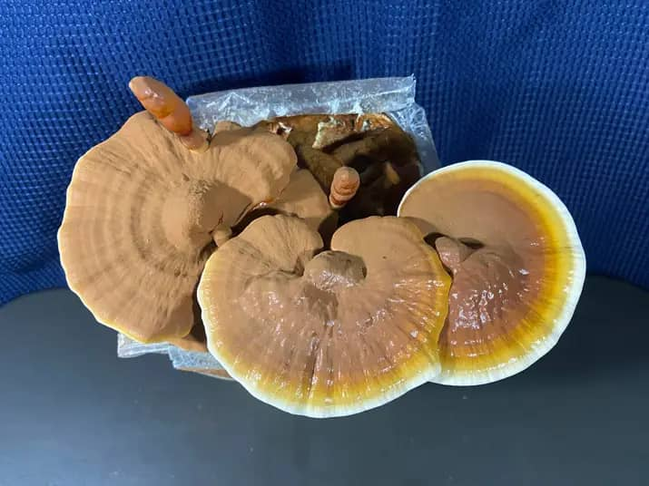
  Figure 4: Ganoderma lucidum
  CULTIVATION OF GANODERMA LUCIDUM
  -Utilization of bush encroachers for Ganoderma mushroom production at Okondjatu.
    - Subtitle
Where does one start?  1. Choosing the Grow room: Select a room that is well-ventilated with indirect sunlight. Ganoderma thrives in a humid environment, factors like temperature and humidity are to be considered.  2. Selecting Lignocellulosic Substrate: Ganoderma can be cultivated on various substrates, including sawdust, wood chips, or wood logs. Ensure the substrate is and that it is suitable for mushroom cultivation.  3. Inoculation: Once you've prepared your substrate, inoculate it with Ganoderma spores, cultures, or spawn. This can be done through methods like grain spawn inoculation or sawdust spawn inoculation.  The Cultivation processes  1. Incubate the substrate in a controlled environment with optimal temperature and humidity for mycelium growth, regularly monitoring for contamination signs and making necessary adjustments.  2. Colonizing and Fruiting: The mycelium spreads throughout a substrate, gradually |  | colonizing it. Once fully colonized (appearance of full white coverage), it begins fruiting by exposing it to fresh air and slightly lower temperatures, resulting in small, reddish-brown bumps developing into mature Ganoderma mushrooms.  Harvesting and beyond.  - Harvesting: Ganoderma mushrooms are harvested when they reach full size and firm texture, using a knife to cut them close to the substrate surface or hands to plug them off the substrate bags.  - Drying: To preserve them for long-term storage, they should be dried using a dehydrator or sun/air-drying in a well-ventilated area.  - Value addition: They can be used in various ways, such as teas, tinctures, culinary dishes, and supplements, to enjoy their benefits. | 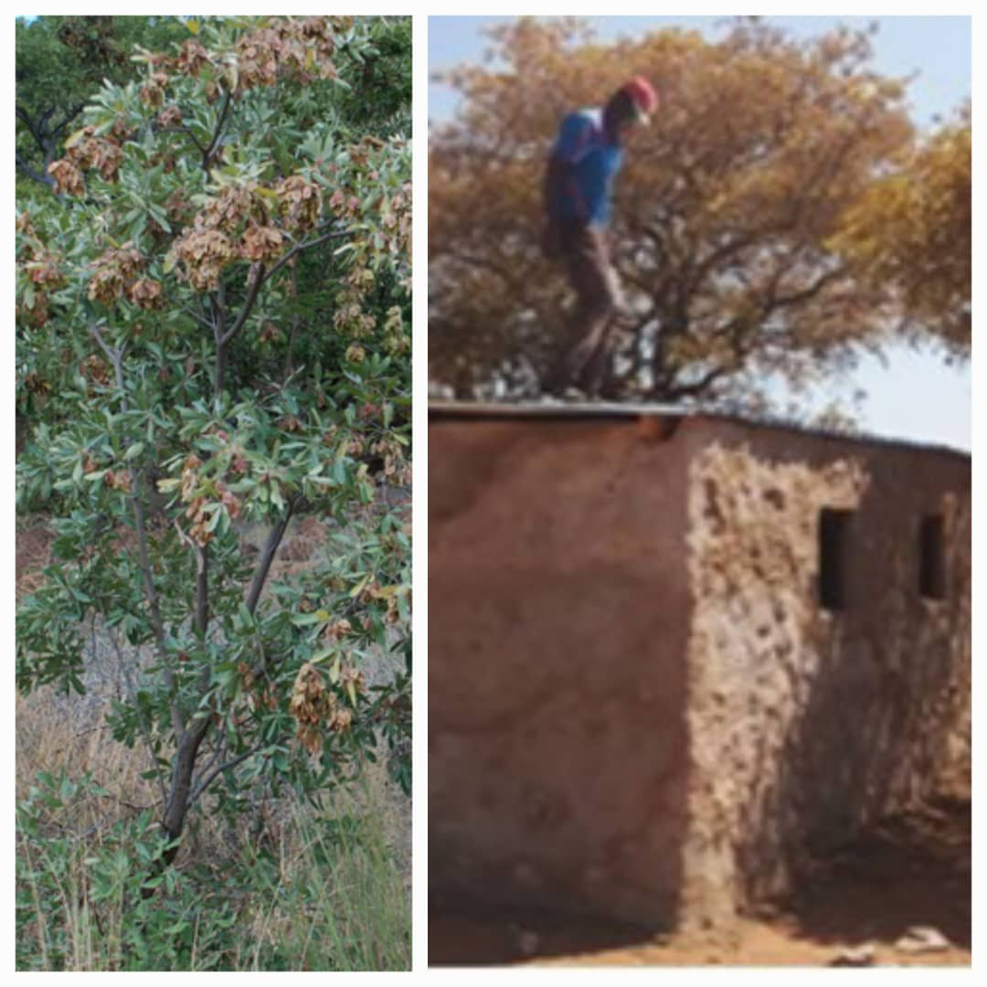  Figure 5:  Encroacher bush (Terminalia sericea) and the mushroom house at Okondjatu  “Congratulations on your Ganoderma cultivation journey! Approach it with curiosity, patience, and admiration for the natural world. This ancient practice connects humanity to the rich traditions of herbal medicine and sustainable agricultural practices, presenting a rewarding skill for personal well-being or marketable endeavors.” -Hilma Nashandi.  Facilitators  Hilma Nashandi (student)  Ms Isabella Ueitele  Mr Urban Ujava  Project PI: Prof N. P Kadhila  Contacts:  0813511465/  0815571595

