Western Blot full membrane scan
The scan image of the internal reference GAPDH in FIG 6.
The scan image of ANKRD1 expression in FIG 6.

The development image of internal reference GAPDH for ANKRD1 overexpression in AGS cell line. FIG 7
The development image showing ANKRD1 overexpression in AGS cell line.
FIG 7

The development image of internal reference GAPDH for KRT80 knockdown in AGS cell line.
FIG 7
The development image showing ANKRD1 knockdown in AGS cell line.
FIG 7

The development image of internal reference GAPDH for ANKRD1 overexpression in MKN-45 cell line. FIG 7
The development image showing ANKRD1 overexpression in MKN-45 cell line.
FIG 7
The development image of internal reference GAPDH for ANKRD1 knockdown in MKN-45 cell line.
FIG 7
The development image showing ANKRD1 knockdown in MKN-45 cell line.
FIG 7

The development image of internal reference GAPDH in AGS and MKN-45 cell lines.
FIG 11
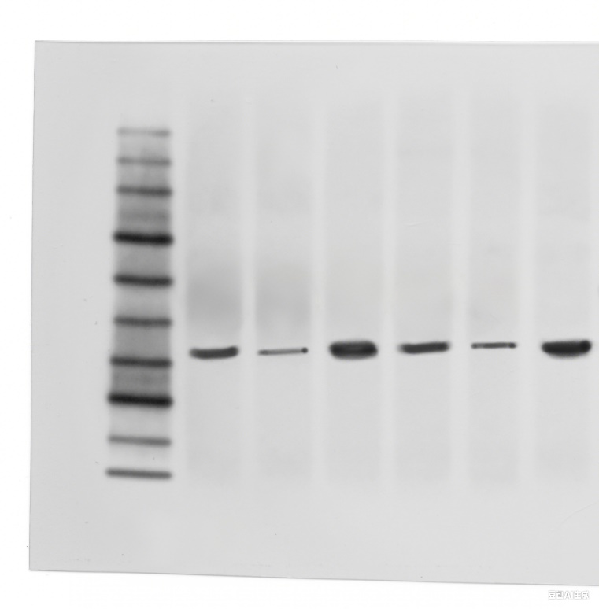
The development image showing ANKRD1 expression in AGS and MKN-45 cell lines. FIG 11
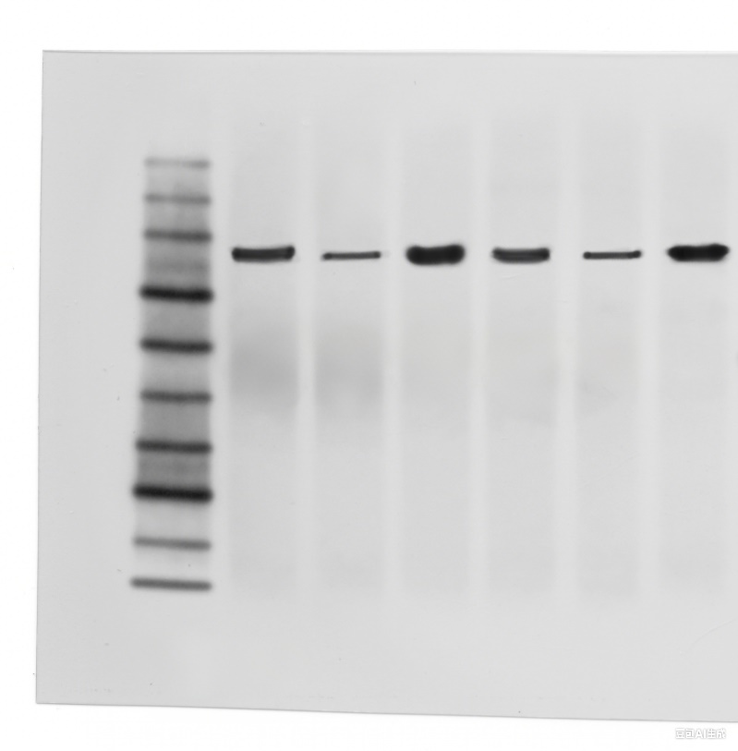
The development image showing p-STAT3 expression in AGS and MKN-45 cell lines. FIG 11
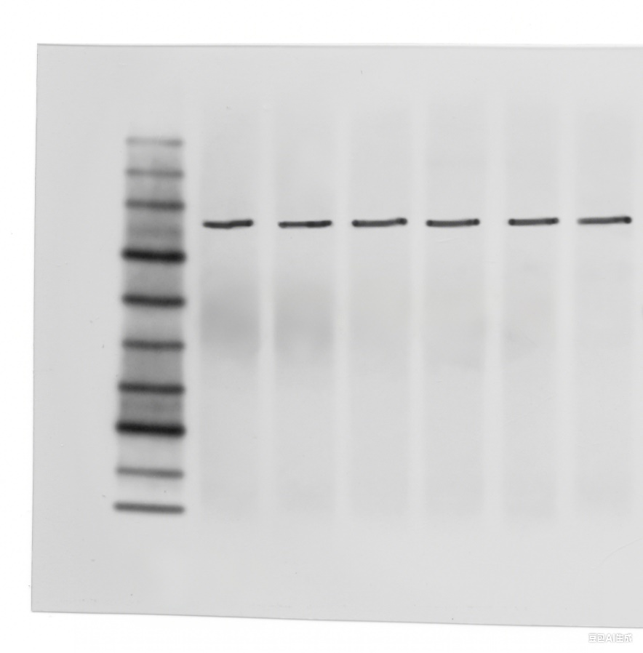
The development image showing STAT3 expression in AGS and MKN-45 cell lines. FIG 11

