Supporting Information
S1. Flory-Huggins Interaction Parameter ($χ$)
The experimental data used to determine the water-to-carbonate ratio as a function of relative humidity was obtained from the study conducted by Shi et al. (2016) (1). In their experiment, a sorbent with a weight of 0.1299 g and a carbonate ion content of 0.247 mmol was used (1). This gives an ion-charge density of 1.90 mmol g⁻¹ at 25 °C. The temperature was maintained at 25°C throughout the experiment (1) .
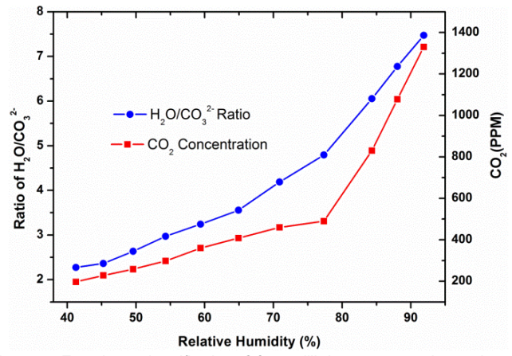
Figure S1. Water to carbonate ions ratio as a function of relative humidity (1)
The water vapor pressure (bar) is obtained by multiplying the water activity (a) with its saturated vapor pressure at 25°C. To calculate the water loading, water-to-carbonate ratio is multiplied with the resin’s ion-charge density. Utilizing the Flory-Huggins model, the volume fraction (Equations S3 and S5) and subsequently the χ parameter (Equation S1) are determined. Table S1 provides the summary of calculated fields to obtain χ, where water activity and the water-to-carbonate ratio are input parameters from experimental data.
While χ, representing the polymer-solvent interaction parameter, is typically influenced by temperature and relative humidity, the limited available experimental data led to the neglect of temperature's effect on χ. Table S1 indicates that χ exhibits a weak dependence on water activity, prompting the use of a single average value of χ (χ_{avg} = 1.08) for calculating water loading as a function of relative humidity using the Flory-Huggins equation.
Table S1. Flory-Huggins interaction parameter ($χ)$ for the Excellion I-200 Sorbent
Water activity (a) | $$H_{2}O/{{CO}_{3}}^{2-}$$ | $$p_{H_{2}O} \left(bar\right)$$ | Water loading (mmol/g) | Volume fraction ($ϕ_{2}$) | FH interaction parameter ($χ)$
0.42 | 2.3 | 0.0133 | 4.37 | 0.073 | 0.96
0.46 | 2.4 | 0.0145 | 4.56 | 0.076 | 1.03
0.49 | 2.65 | 0.0155 | 5.03 | 0.083 | 1.02
0.54 | 3 | 0.0171 | 5.7 | 0.093 | 1.04
0.59 | 3.2 | 0.0187 | 6.08 | 0.099 | 1.09
0.65 | 3.5 | 0.0206 | 6.65 | 0.107 | 1.14
0.71 | 4.2 | 0.0225 | 7.98 | 0.126 | 1.12
0.77 | 4.8 | 0.0244 | 9.12 | 0.141 | 1.14
0.84 | 6.1 | 0.0255 | 11.59 | 0.173 | 1.1
0.88 | 6.8 | 0.0279 | 12.92 | 0.189 | 1.11
0.92 | 7.5 | 0.0292 | 14.25 | 0.204 | 1.12

S2. Water loading using Flory-Huggins model
The Flory-Huggins equation is represented as:
$\ln{a=\ln{ϕ_{2}+\left(1-ϕ_{2}\right)+χ{\left(1-ϕ_{2}\right)}^{2}}}$ (S1)
The volume fraction i.e. $ϕ_{2}$ can be defined as:
$ϕ_{2}=\frac{Vol of water sorbed}{Vol of dry sorbent+Vol of water sorbed}$ (S2)
$ϕ_{2}=\frac{κ}{1+κ}$ (S3)
Where, $κ=\frac{Vol of water sorbed}{Vol of dry sorbent}$
The $κ$ can be further simplified in terms of sorbent water loading ($q_{H_{2}O}$) by considering the mass of water sorbed and the respective densities of water and sorbent. This simplification is needed to relate sorbent water loading to ambient water activity.
$κ=\frac{Vol of water sorbed}{Vol of dry sorbent}=\frac{Mass of water sorbed}{ρ_{water}}*\frac{ρ_{sorbent}}{Mass of sorbent}$ (S4)
$$=Mass of water sorbed*\frac{1}{Mass of sorbent}*\frac{ρ_{sorbent}}{ρ_{water}}$$
$$=\frac{Mass of water sorbed}{Molecular weight of water}*\frac{Molecular weight of water}{Mass of sorbent}*\frac{ρ_{sorbent}}{ρ_{water}}$$
$$=\frac{Moles of water sorbed}{Mass of sorbent}*Molecular weight of water*\frac{ρ_{sorbent}}{ρ_{water}}$$
$$=Sorbent water loading \left(\frac{mol}{kg}\right)* Molecular weight of water*\frac{ρ_{sorbent}}{ρ_{water}}$$
In this equation, $q_{H_{2}O}$ is the sorbent water loading in mol/kg, ${MW}_{H_{2}O}$ is the molecular weight of water in kg, and $ρ$ is the density in kg/m³.
$κ=q_{H_{2}O}*{MW}_{H_{2}O}*\frac{ρ_{sorbent}}{ρ_{water}}$ (S5)
Equation S1, S3, and S5 together produce a non-linear equation to estimate $q_{H_{2}O}$ at a particular water activity (a) when the interaction parameter ($χ$) for Excellion I-200 polymer is known. We use $ρ_{water}=1000 kg m^{-3}$ (25 °C) and $ρ_{sorbent}=1000 kg m^{-3}$ (manufacturer typical); results are insensitive to +/- 10% variations. The non-linear equation is solved for $q_{H_{2}O}$ using fsolve from the scipy.optimize Python library as implemented in the mathematical model uploaded at GitHub(2).

S3. Design Optimization Model for maximizing CO₂ loading
In the capture phase, the sorbent loading can be approximated using an isotherm model, which depends on the type of sorbent used. While sorbents reach equilibrium loading during regeneration conditions, they take a significantly longer time to reach equilibrium during CO₂ capture conditions, as evidenced experimentally and theoretically. Assuming a first-order linear-driving-force (LDF) kinetics closure for CO₂ uptake, the time taken for the sorbent to reach equilibrium loading during capture increases exponentially. This prolonged equilibration time during CO₂ capture poses challenges in terms of system design, as waiting for the sorbent to fully equilibrate is not economically feasible. Additionally, the sorbent's CO₂ loading for each cycle increases linearly with the approach to equilibrium, which is advantageous from a design perspective. There exists a tradeoff between sorption loading and cycle time, with the goal being to maximize sorption loading while minimizing cycle time. Waiting for the sorbent to reach equilibrium loading during the capture cycle is not a practical option. Thus, for each ambient weather condition, an optimum ratio for the approach to equilibrium loading exists, denoted by the dimensionless parameter ψ (pronounced psi), which minimizes capture time while maximizing CO₂ productivity.
Figure S2 illustrates sorbent loading, time, and cycle average productivity for each cycle at a specific weather condition, such as a temperature of 20°C and a wind speed of 5 m/s. The equilibrium ratio or ψ indicates the approach to equilibrium ($ψ∈(0,1)$), signifying how close the actual sorbent loading is to the equilibrium loading. A ratio of 1 indicates that the sorbent's actual loading is equal to the equilibrium loading, while a ratio of 0 suggests that the sorbent's actual loading is negligible. Mathematically, ψ represents the ratio of the net actual loading of the sorbent (q_{act net}) to its net equilibrium loading (q_{eq net}).

$ψ=\frac{q_{act net}}{q_{eq net}}$ (S6)
The sorbent loading increases with an increase in ψ as there is linear dependence given by the following equation:
$m_{CO_{2}}=q_{eq net}*ψ*MW_{CO_{2}}$ (S7)
Here, q_{eq net} represents the equilibrium net CO₂ loading obtained from the sorbent isotherm model; ψ is the optimization parameter obtained from the design optimization model that determines the net actual loading of the sorbent relative to its equilibrium loading; $MW_{CO_{2}}$ represents the molecular weight of CO₂, which is 0.044 kg/mol.
The time taken for sorbent to reach equilibrium for each cycle exhibits an exponential increase with ψ due to logarithmic dependence as given by the following equation:
$t_{cap}=-\frac{\log\left(1-ψ\right)}{k_{rate}}$ (S8)
The CO₂ productivity, which represents the amount of CO₂ captured per unit weight of sorbent over each cycle, is expressed by the following equation:
$r_{CO_{2}}=\frac{m_{CO_{2}}}{\left(t_{cap}+t_{reg}\right)}$ (S9)
$r_{CO_{2}} =\frac{q_{eq net}*ψ*MW_{CO_{2}}}{\left(-\frac{\log\left(1-ψ\right)}{k_{rate}}+t_{reg}\right)}$ (S10)
As observed in Figure S2, sorbent loading demonstrates a linear increase, whereas the time taken exhibits exponential growth as the equilibrium ratio or ψ increases. However, there is an optimal point for the CO₂ productivity that occurs at a specific equilibrium ratio. Achieving maximum CO₂ productivity for each cycle entails maximizing sorbent loading while minimizing cycle time, as this essentially involves finding a balance between the two factors. The substantial fluctuation in the CO₂ productivity concerning the equilibrium ratio underscores the presence of an ideal point for each distinct weather condition.
Figure S2: Plot of Mass per Cycle (kg), Time for Each Cycle (s), and cycle average CO₂ productivity (kg kg⁻¹ h⁻¹) against Varying Equilibrium Ratio at T = 20ºC and Wind Speed = 5 m/s
The design optimization model yields valuable insights into the selection of the optimal ψ value for a given weather condition, thereby enhancing the performance of the CO₂ capture system. Through the fine-tuning of ψ based on the prevailing weather conditions, it becomes feasible to strike an ideal balance between CO₂ capture efficiency and cycle time, resulting in an overall performance enhancement.
The incorporation of this design optimization model signifies a significant stride in optimizing the CO₂ capture process. By considering the unique weather conditions and their impact on sorbent loading kinetics, it becomes possible to customize the system's operation to achieve the highest level of performance across varying weather scenarios.
Ambient T, RH, and $v_{wind}$ are exogenous inputs (from NOAA). For each fixed ambient condition, we maximize $r_{CO_{2}}(ψ;T,RH,v_{wind})$ with respect to $ψ∈(0,1)$. Sorbent/geometry parameters $(q_{max}, c_{rate}, b^{'}, t_{reg}, { p}_{CO_{2} reg})$are held fixed. Implementation uses scipy.optimize to maximize $r_{CO_{2}}$(code in Ref. (2)).

S4. Wind tunnel experimental data conducted at ASU’s Center for Negative Carbon Emissions
A wind tunnel experiment was conducted at 25°C to evaluate the mass transfer rate constant ($k_{rate}$) as a function of wind speed ($v_{wind}$). Figure S3 illustrates the relationship between $k_{rate}$ and $v_{wind}$, assuming a linear dependence over the measured range. Classical external-film correlations often scale as $k∝U^{m}$ with $m≈0.5-0.8 ADDIN ZOTERO_TEMP (6,7)$. Over our measured range, a linearization ($m≈1$) fit the wind-tunnel data, so we adopt Eq. (11) for parsimony. A power-law generalization $k_{rate}=c_{rate}*f\left(T\right)*v_{wind}^{n}$ is straightforward; results were insensitive in the calibrated wind-speed range, so we retain $n=1$. The empirical coefficient ${(c}_{rate})$ was determined from the slope of the plot for the sorbent under investigation (2400 gsm), yielding a value of $1.5*{10}^{-4}m^{-1}$ at 25°C (for which $f(T$)=1). It encapsulates geometry, porosity, incidence angle, and local shielding, and is treated as constant for this module and mounting over the wind-speed range spanned by our calibration.

Figure S3. Plot of mass transfer rate constant ($k_{rate}$) against wind speed ($v_{wind}$) to determine empirical coefficient ${(c}_{rate})$
To account for the effect of ambient temperature variations, a temperature correction factor, $f(T)$, is introduced, analogous to an Arrhenius-type term where $b'$ represents a fit parameter. The preliminary isotherm model, based on a first-order rate equation, provides a framework for determining $f(T)$ and assessing the temperature dependence of the rate constant.
$\frac{q_{net}}{q_{max}}=\frac{K p}{1+K p}$ (S11)
$K=ae^{-\frac{b}{RT}}$ (S12)
Figure S4 presents the experimental data used to derive the fit parameters, where a and b were obtained as 2.65*10⁻¹⁶ Pa⁻¹ and -80,000 m³-Pa/mol, respectively. Since both $k_{rate}$ and $c_{rate}$ were originally determined at 25°C, an Arrhenius factor is incorporated into the rate equation to adjust for temperature variations. Here, $b^{'}$ (equivalent to b/R) serves as an empirical fit parameter based on experimental data for the sorbent, yielding a value of -9600 K⁻¹. Notably, the pre-factor a cancels out when taking the ratio to compute $f(T)$. Simplifying the equation results in:

$f(T)=exp\left[b'*\left(\frac{1}{T_{amb}}-\frac{1}{T_{25}}\right)\right]$ (S13)
Figure S4. Fit of a and b for the temperature correction in the sorption model

S5. Variability Analysis of Temperature and Relative Humidity data
Figure S5 represents the boxplot of the temperature data. This provides the temperature variability of St. Johns weather station in Arizona (AZ) from 2006 to 2022. It is important to note that the weather data includes hourly measurements collected over a 17-year period. These data points are plotted on a month-by-month basis for the entire duration to illustrate the weather variability at the St. Johns site, highlighting the observed variations on a monthly scale. The central line within each box represents the median temperature, while the top and bottom boundaries of the box indicate the 1st and 3rd quartiles, respectively. Conventionally, the whiskers extending from the box represent 1.5 times the interquartile range (IQR) on either side. Data points that lie beyond this range are considered outliers and are depicted as individual dots.
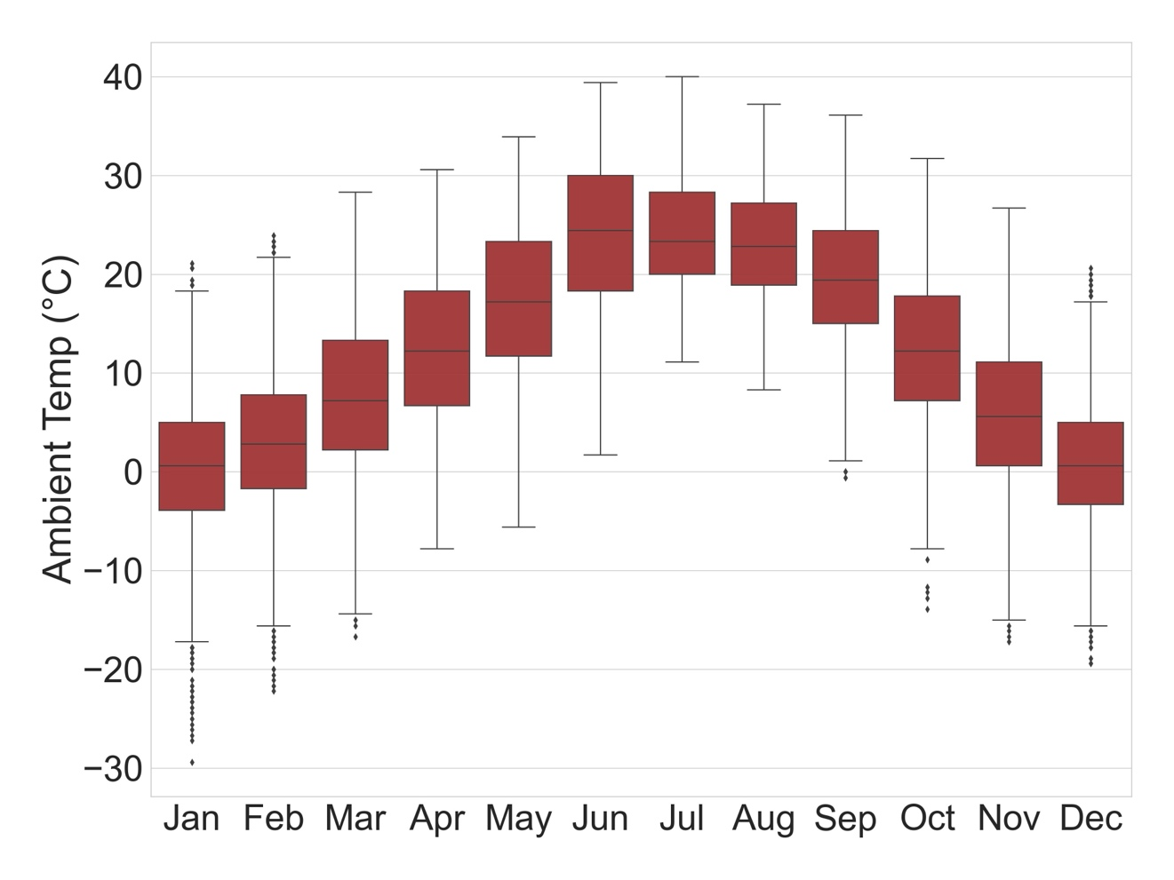
Figure S5. Temperature Distribution for St. Johns, AZ (2006-2022)
The St. Johns site experiences summer months with median temperatures reaching close to 25°C. The winter months exhibit cooler temperatures but typically above 0°C.
The boxplot shown in Figure S6 illustrates the relative humidity variability of St. Johns weather station in Arizona from 2006-2022. St. Johns site experiences higher relative humidity during the winter months and lower relative humidity during the summer months. This observation highlights the contrasting moisture conditions throughout the year. These changes in relative humidity strongly affect the CO₂ capture process with moisture swing sorbents.
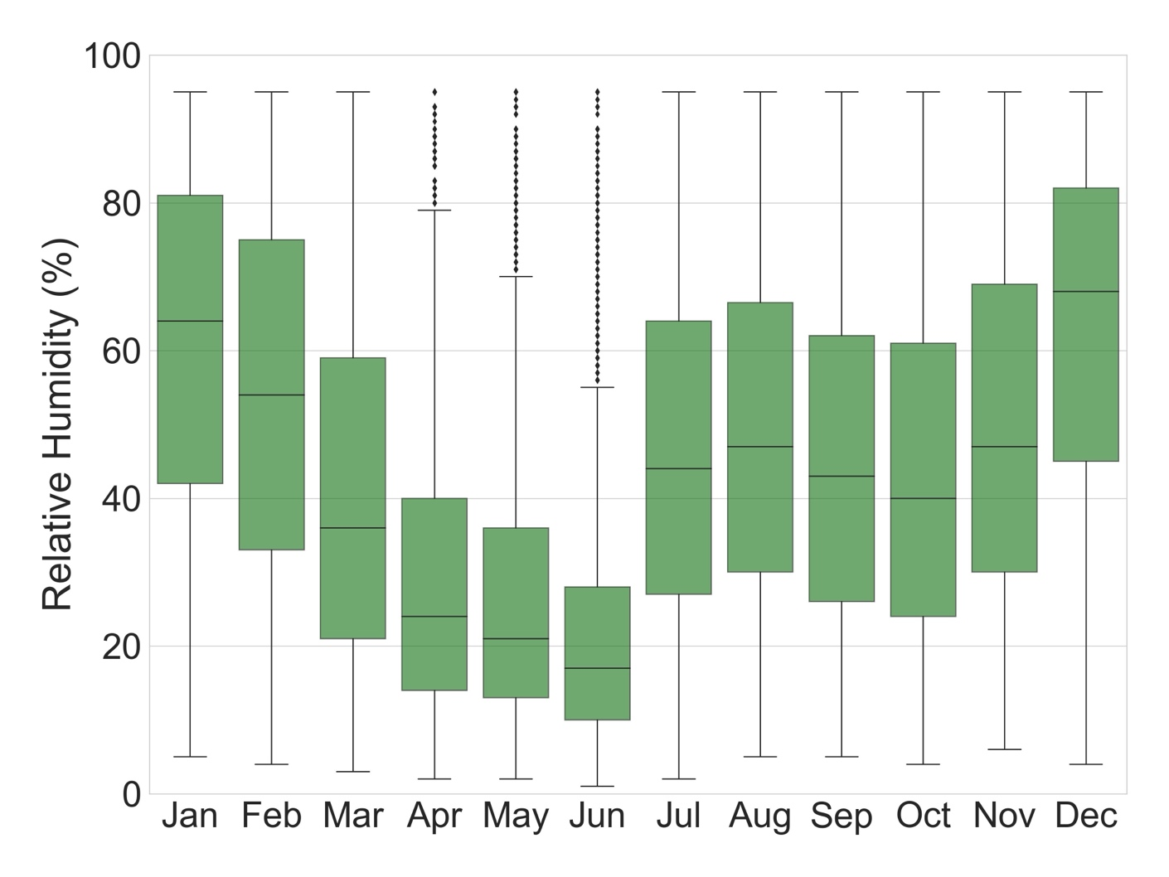
Figure S6. Relative Humidity Distribution for St. Johns, AZ (2006-2022)

S6. Processing of Wind Speed weather data by Monte-Carlo Randomization
The wind speed data reported by NOAA were originally recorded in nautical miles per hour and then converted to miles per hour which was then rounded off to the nearest integer, leading to a significant loss of data (3,4). As a result, the wind speed data exhibits a discrete frequency curve with discontinuities at specific wind speed intervals. This loss of data poses challenges when using the wind speed data for the isotherm model, as it produces artifacts due to the data discontinuities.
To ensure accurate analysis and modeling of wind speed data, smoothing techniques are employed to account for the loss of data resulting from the conversion and rounding-off process. Wind energy has been widely studied, and mathematical models such as the Weibull and Rayleigh distributions have been developed to understand wind speed characteristics and optimize its utilization for various applications (5). In this study, the Weibull model is chosen to fit the wind speed data and obtain the shape and scale parameters necessary to model the wind speed at a particular meteorological site.
The shape and scale parameters of the Weibull distribution are determined by plotting $\ln{v}$ vs $ln⁡[-\ln\left(1-F\right)]$ to estimate the Weibull shape $k$ (slope) and scale $c$ (intercept) as shown in Figure S7. The slope of the line plot provides the shape parameter, while the exponential function of the intercept divided by the slope yields the scale parameter. Table S2 provides the Weibull fit parameters for St. Johns, AZ site.
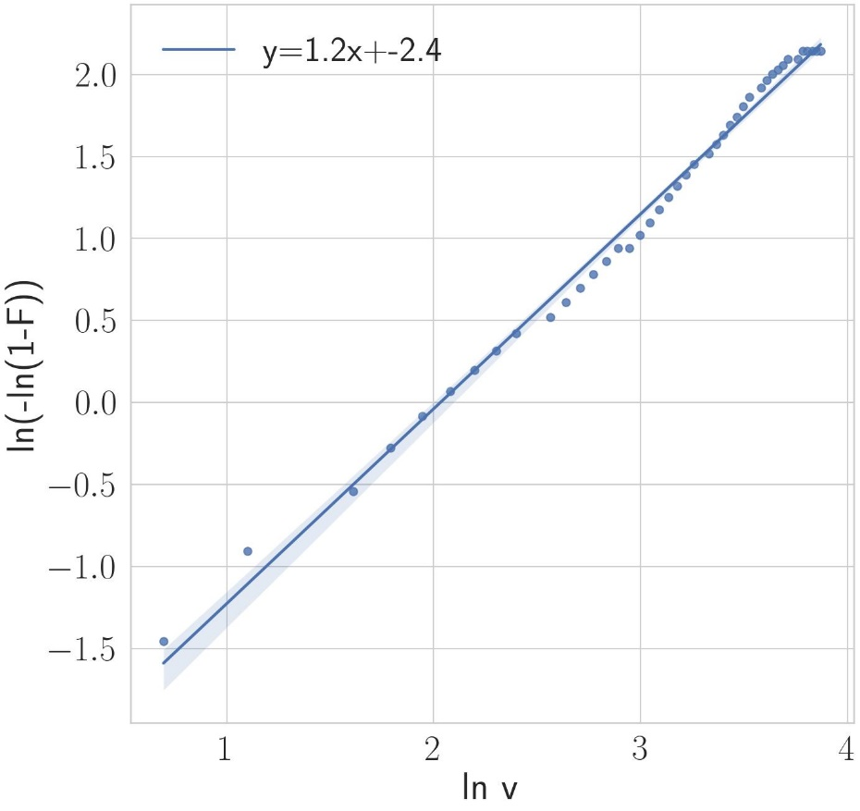
Figure S7. Weibull shape and scale parameters determined based on Wind Speed Distribution

Table S2. Weibull fit parameters for St. Johns, AZ wind speed distribution
Intercept | -2.4102
Shape parameter (k) | 1.1864
Scale parameter (c) | 7.6262
The Python Weibull library from scipy.stats is utilized to generate a probability distribution curve based on the obtained shape and scale parameters. This curve is superimposed on the discrete wind speed bar plot as shown in Figure S8. The resulting Weibull curve reveals that the majority of wind speeds are distributed below 25 mph. Outliers are observed at higher wind speeds, but their occurrence is statistically insignificant.
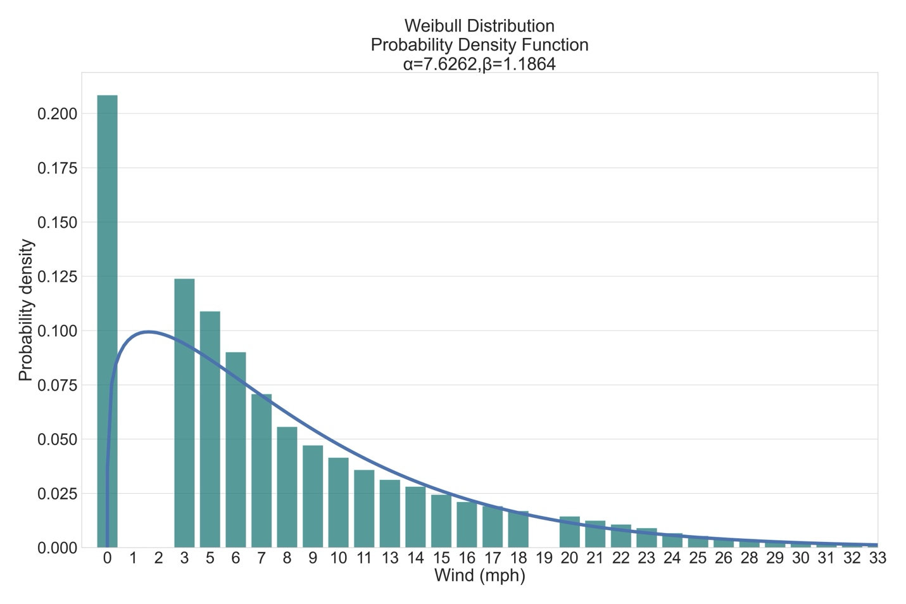
Figure S8. Discontinuous wind speed distribution as obtained from the NOAA website for St. Johns, AZ (2006-2022)
A comparison between the bar plot of the raw wind speed data and the superimposed Weibull curve in Figure S8 highlighted a significant discontinuity in the wind speed due to the rounding-off error discussed earlier. To address this issue, a Monte Carlo randomization method is employed.
The randomization process involves taking a delta value of 1.2, which closely approximates the conversion between nautical miles and miles (1 nautical mile = 1.15 miles). For each integer wind speed data point (x mph), a range of +/- 0.6 mph around the integer value $[x-0.6, x+0.6]$ mph is selected. The wind speed within this range is randomized based on the Weibull distribution specific to that range, effectively converting the discrete data into a continuous form. A delta greater than 1 helps account for the discontinuity in the sample, avoiding overlap in the peak caused by the repetition of any segment across the entire range. This randomization process is computationally intensive due to a large number of data points, totaling around 150,000.
A bar plot is generated to compare the randomized wind speed sample points with the Weibull curve as shown in Figure S9. The bar plot demonstrates an almost identical distribution, indicating a successful recovery of the data lost due to rounding off.
The wind speed smoothing technique described above successfully converted the discrete wind speed data, as shown in Figure S8, into a continuous form, as depicted in Figure S9. The Weibull method modeled the wind speed data representative of St. Johns site in Arizona. By employing the Monte Carlo random sampling method, the wind speed distribution is generated much closer to the Weibull fit, indicating an effective approach for data recovery and curve smoothing. The resulting continuous wind speed curve provides a more accurate representation of the actual wind speed distribution, allowing for improved analysis and modeling of wind energy systems.
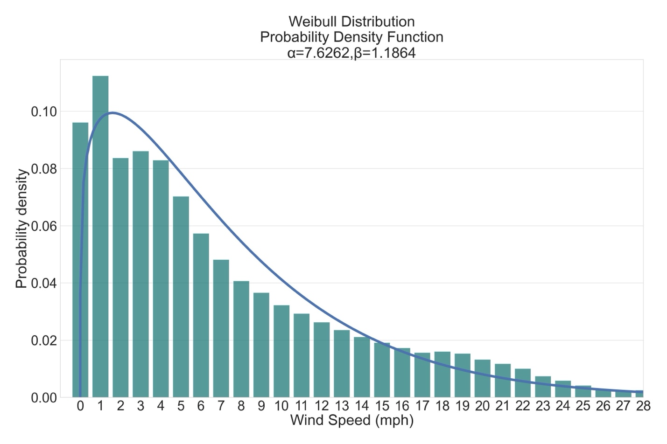
Figure S9. Smoothed wind speed distribution after Monte-Carlo simulation for St. Johns, AZ (2006-2022)
The wind speed distribution revealed that most wind speeds are below 25 mph, with significant distribution lying below 10 mph. Outliers are observed at higher wind speeds, but their occurrence was statistically insignificant. The solid blue line superimposed on the bar plot represents the Weibull curve, which models the wind speed distribution specific to the St. Johns, AZ site.

References
1. Shi X, Xiao H, Chen X, Lackner KS. The Effect of Moisture on the Hydrolysis of Basic Salts. Chemistry A European J. 2016 Dec 19;22(51):18326–30.
2. mdtalhabu/Passive-DAC-Model: Mathematical model for Moisture swing passive DAC process [Internet]. [cited 2025 Mar 2]. Available from: https://github.com/mdtalhabu/Passive-DAC-Model
3. Index of /data/local-climatological-data/access [Internet]. [cited 2024 Mar 3]. Available from: https://www.ncei.noaa.gov/data/local-climatological-data/access/
4. Local Climatological Data Station Details: ST JOHNS INDUSTRIAL AIR PARK, AZ US, WBAN:93027 | Climate Data Online (CDO) | National Climatic Data Center (NCDC) [Internet]. [cited 2024 Mar 3]. Available from: https://www.ncdc.noaa.gov/cdo-web/datasets/LCD/stations/WBAN:93027/detail
5. Dorvlo ASS. Estimating wind speed distribution. Energy Conversion and Management. 2002 Nov 1;43(17):2311–8.
6. Katopodes ND. Chapter 5 - Viscous Fluid Flow. In: Katopodes ND, editor. Free-Surface Flow [Internet]. Butterworth-Heinemann; 2019 [cited 2025 Sept 28]. p. 324–426. Available from: https://www.sciencedirect.com/science/article/pii/B9780128154892000058
7. Cussler EL. Mass Transfer and Diffusion. In: Meyers RA, editor. Encyclopedia of Physical Science and Technology (Third Edition) [Internet]. New York: Academic Press; 2003 [cited 2025 Sept 28]. p. 171–80. Available from: https://www.sciencedirect.com/science/article/pii/B0122274105004075

