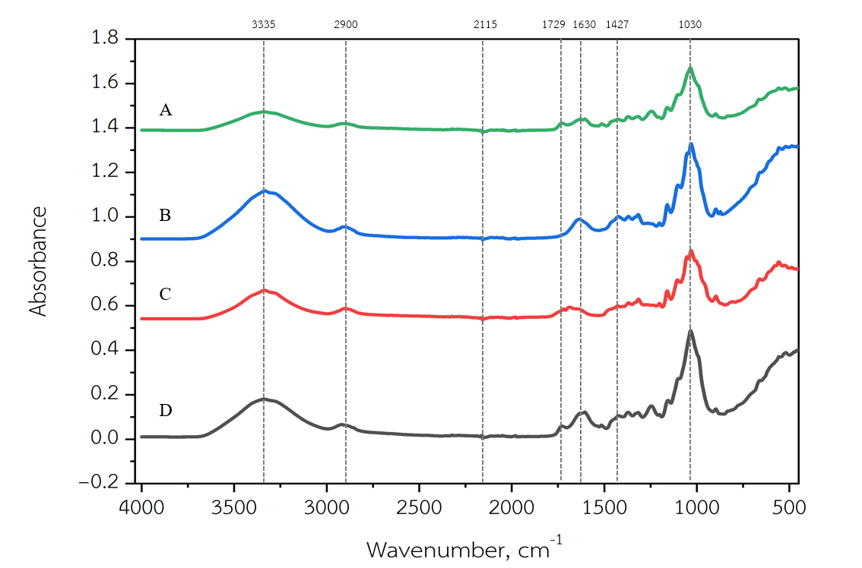
Fig. S2 ATR-FTIR spectra of sequentially treated samples: (A1) raw material; (A2) hydrothermal pretreatment; (A3) pulping with NaOH/H₂O₂; and (A4) nanocellulose obtained by DES extraction (choline chloride/oxalic acid).

