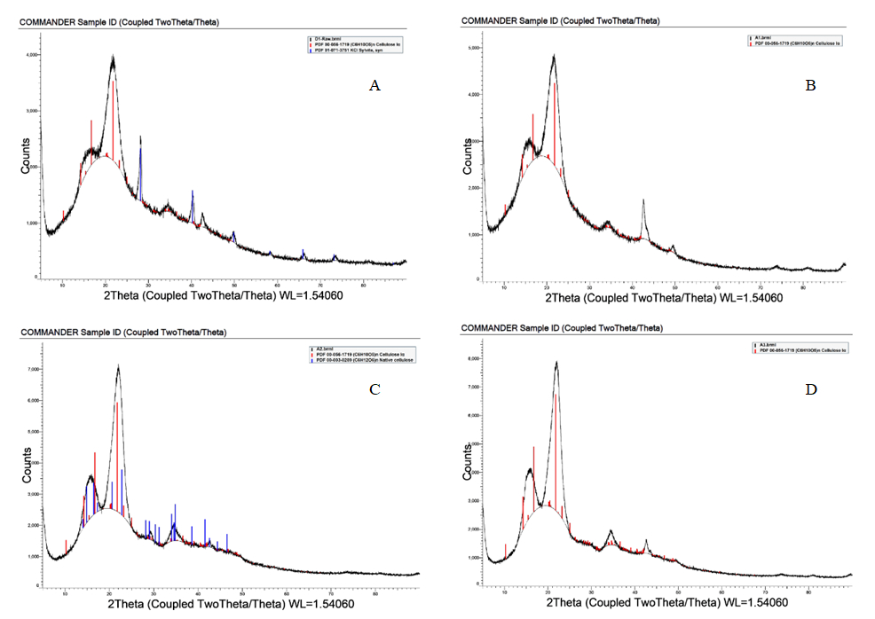

Fig. S1. X-ray diffraction crystallization analysis of raw material (A), hydrothermal treatment with solution NaCl, pretreatment (B), pulping with sodium hydroxide and hydrogen peroxide, pulping (C), extraction is also a nanocellulose material, DES extraction (D).

