Fig. S1 LC−MS spectrum of intermediates formed during the degradation of SMX by S. mizutaii LLE5.
- LC−MS spectrum of sulfanilamide (171 m/z, ESI negative ion mode ).

- LC−MS spectrum of 4-aminothiophenol (124 m/z, ESI negative ion mode ).

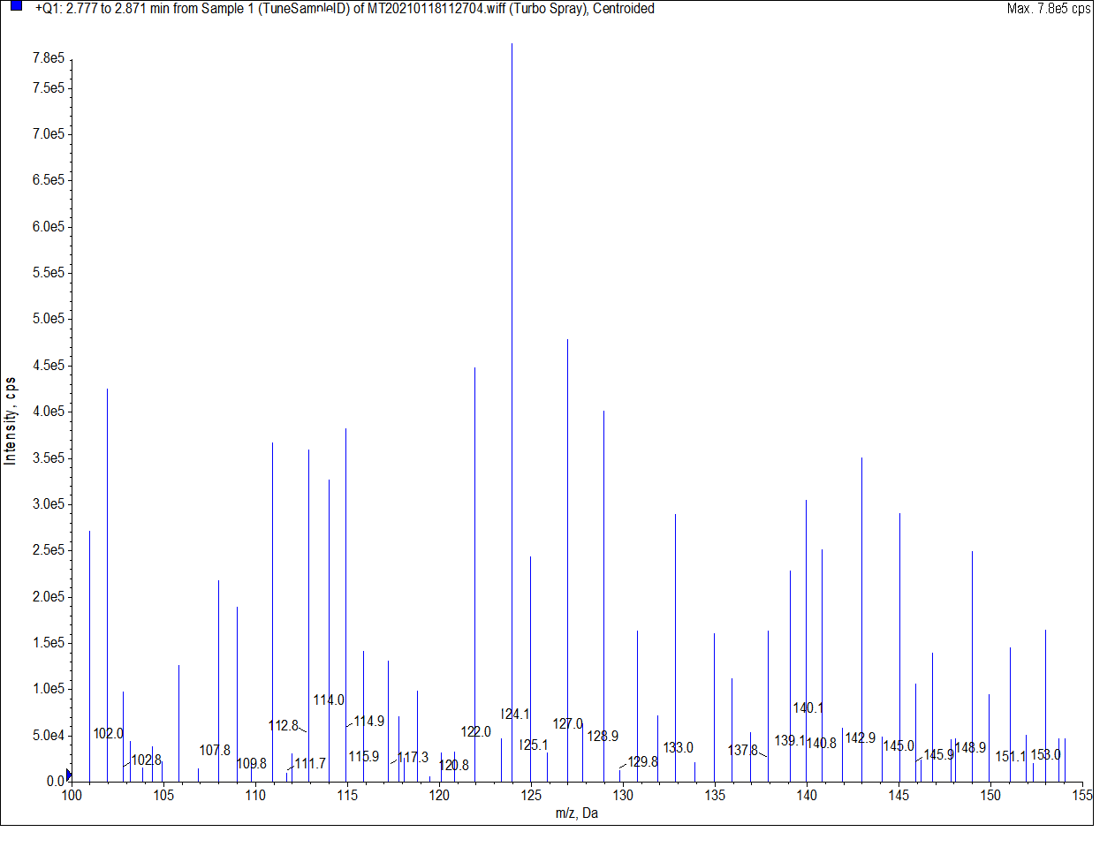

- LC−MS spectrum of 3-amino-5-methylisoxazole (99 m/z, ESI positive ion mode).

- LC−MS spectrum of aniline (92 m/z, ESI negative ion mode )

