Supplementary Materials
Supplementary Table 1. Participant descriptives.
Variable | HBN – NT | HBN – ASD | McGill – ASD
Age (years) | 9.97 ± 3.50 | 11.56 ± 4.02 | 11.41 ± 2.03
SRS-2 T-score | 49.11 ± 7.49 | 67.62 ± 11.52 | 74.15 ± 7.98
CELF score | 18.99 ± 5.54 | 18.57 ± 6.60 | -
Nonverbal IQ:  WISC MR scaled score | 11.12 ± 2.95 | 10.79 ± 3.98 | 10.12 ± 3.43
Verbal IQ:  WISC VC scaled score | 12.42 ± 2.95 | 11.48 ± 3.84 | 10.15 ± 4.14
Self-encoded recall accuracy (%) | - | - | 32.6 ± 18.9
Other-encoded recall accuracy (%) | - | - | 21.3 ± 14.8
Theory of Mind test accuracy (%) | - | - | 89.2 ± 13.5
HBN, Healthy Brain Network; NT, neurotypical; ASD; autism spectrum disorder; SRS-2, Social Responsiveness Scale; SCQ, Social Communication Questionnaire; CELF, Clinical Evaluation of Language Fundamentals; WISC, Wechsler Intelligence Scale for Children; MR, matrix reasoning; VC, vocabulary.

Global functional connectivity measures
Mean FC, mean within- and between-network FC, and FC variance all remained relatively stable across our age range, with a slight decrease seen in mean and between-network FC (Supplementary Figure 1). We found greater accuracy of other-encoded episodic memories associated with more positive deviations in mean functional connectivity (rho = .39, p = .032; did not survive correction for multiple comparisons).
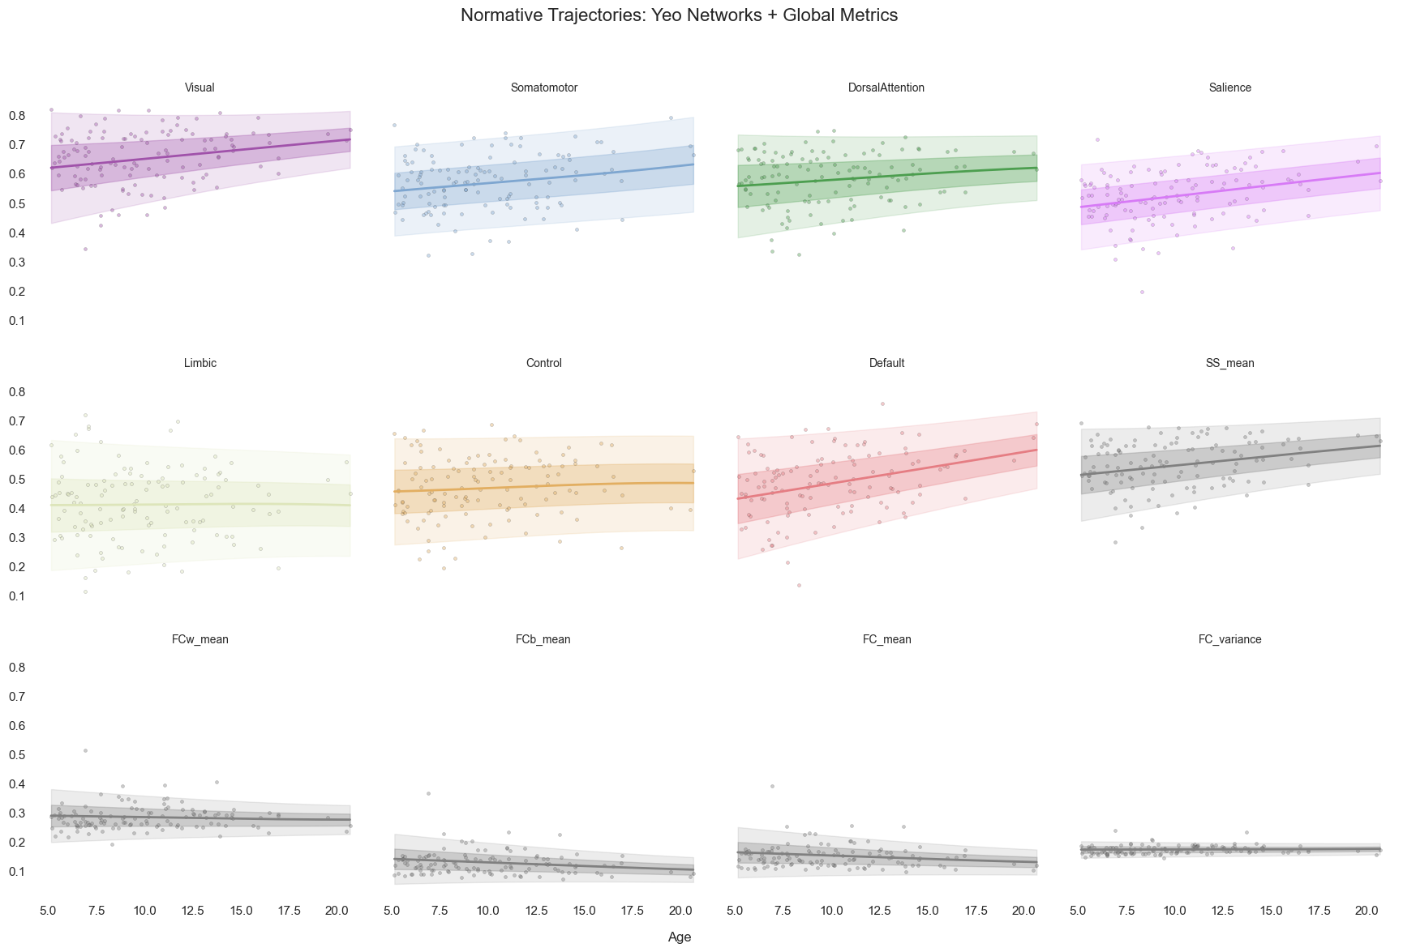
Supplementary Figure 1. Population reference models with centiles of 7 Yeo networks and global connectivity metrics. Plotted points are from the reference population, the non-autistic HBN sample. SS, system segregation; FC, functional connectivity; FCw, FC within-network; FCb, FC between-network.

Supplementary Figure 2. Distribution of HBN-ASD deviations from the population reference models of system segregation. SS, system segregation; HBN, Healthy Brain Network; ASD, autism spectrum disorder.
Extreme deviants exploration
Both the HBN and McGill datasets had several cases of extreme deviants, with |Z| > 1.645. To understand the behavioural profiles of these cases, Table S2 and S3 summarize the results of each subject with an extreme deviation in mean system segregation. In the HBN sample (Table S2), we found that 10 out of 11 deviants were negative. All subjects with deviations in mean system segregation had extreme deviations in at least one other network, mainly in the same direction of deviation as the mean system segregation (ie. negative system segregation deviants had negative deviations in individual networks and vice versa). Half of the negative deviants also had some positive deviations in global FC measures. There was no clear pattern of behaviour apparent for deviants and no notable differences between the positive and negative deviants, except that the positive deviant, subject 7, had the highest CELF score. The subject with the most extreme negative deviations, subject 5, had the highest SRS-2 score and the lowest CELF score.
In the McGill sample (Table S3), all 9 system segregation deviants were in the positive direction. All deviants had positive deviations in 2 to 4 individual networks, with only one subject, subject 3, having an extreme negative deviation in mean within-network FC. This subject had generally low, but not the lowest, memory scores and very high percentiles on 3 out of 4 of the WISC subtests. There was no deviant who clearly had the most extreme deviations, and no apparent behavioural patterns among them.
Supplementary Table 2. Profiles of HBN-ASD subjects with extreme deviations in mean system segregation.
Subject # | 1 | 2 | 3 | 4 | 5 | 6 | 7 | 8 | 9 | 10 | 11
Age (years) | 6.65 | 8.22 | 8.53 | 9.53 | 9.80 | 11.43 | 12.45 | 14.18 | 15.32 | 15.41 | 19.79
Sex | Male | Male | Female | Male | Female | Male | Male | Male | Male | Male | Male
SRS-2 | 55 | 45 | 52 | 80 | 90 | 70 | 73 | 83 | 80 | 72 | -
CELF | 12 | 21 | 18 | 11 | 4 | 27 | 30 | 17 | 19 | 27 | 21
SS mean Z-score | -2.10 | -2.82 | -2.44 | -1.73 | -5.31 | -1.75 | 1.96 | -1.83 | -2.03 | -2.81 | -1.83
Visual SS Z-score | -0.10 | -3.03 | -1.44 | -0.88 | -5.88 | -1.39 | 2.25 | -1.69 | -1.56 | -4.18 | -1.69
Somatomotor SS Z-score | -3.08 | -2.58 | -3.34 | -1.49 | -6.88 | -0.53 | 2.25 | -0.65 | -0.67 | -1.36 | -1.10
Dorsal Attention SS Z-score | -2.69 | -2.31 | -2.59 | -1.12 | -6.82 | -1.31 | 0.71 | -1.98 | -3.23 | -1.71 | -0.80
Salience SS Z-score | -3.43 | -2.44 | -2.96 | -1.60 | -4.17 | -2.55 | -0.08 | -2.03 | -1.10 | -1.65 | -2.86
Limbic SS Z-score | -0.13 | -1.82 | -0.44 | -1.61 | 0.32 | -1.34 | 1.85 | 0.21 | 1.09 | -2.45 | 0.91
Control SS Z-score | -2.34 | -2.00 | -2.11 | -1.52 | -3.45 | -1.05 | 1.98 | -1.22 | -2.02 | -2.33 | -0.99
Default SS Z-score | -2.31 | -2.00 | -1.64 | -2.21 | -3.94 | -1.65 | 1.17 | -2.70 | -3.64 | -1.36 | -1.71
Mean FC Z-score | 3.03 | 2.92 | 1.34 | 0.70 | -0.72 | 1.60 | -1.04 | 1.19 | 1.22 | 2.64 | 2.30
FC variance Z-score | 4.43 | 1.32 | 1.15 | 0.27 | -1.33 | 0.34 | 0.85 | 0.72 | -0.03 | 0.40 | 0.36
Mean FC_{w} Z-score | 2.81 | 2.00 | 0.12 | -0.06 | -3.37 | 1.16 | -0.32 | 0.43 | 0.38 | 1.63 | 2.12
Mean FC_{b} Z-score | 3.07 | 3.01 | 1.42 | 0.86 | -0.27 | 1.67 | -1.27 | 1.29 | 1.39 | 2.73 | 2.32
Subject IDs are arbitrary, ordered by age. Red cells indicate negative deviants (Z < -1.645), while green cells indicate positive deviants (Z > 1.645). SRS-2, Social Responsiveness Scale; SCQ, Social Communication Questionnaire; CELF, Clinical Evaluation of Language Fundamentals; SS, system segregation; FC, functional connectivity; FCw, FC within-network; FCb, FC between-network.

Supplementary Table 3. Profiles of McGill-ASD subjects with extreme deviations in mean system segregation.
Subject # | 1 | 2 | 3 | 4 | 5 | 6 | 7 | 8 | 9
Age (years) | 6.98 | 9.23 | 9.24 | 10.42 | 10.44 | 12.67 | 12.90 | 14.82 | 15.87
Sex | F | M | M | F | M | M | M | M | F
SRS-2 | 74 | 87 | 82 | 66 | 74 | 71 | 70 | 80 | 79
Nonverbal IQ:  WISC MR percentile | 50 | 84 | 95 | 5 | 25 | 16 | 5 | 91 | 50
Verbal IQ: WISC VC percentile | 25 | 95 | 91 | 0 | 50 | 91 | 37 | 37 | 84
Self-encoded recall accuracy (%) | - | 52 | 20 | 47 | 20 | 55 | 4 | 31 | 37
Other-encoded recall accuracy (%) | - | 35 | 5 | 53 | 11 | 23 | 16 | 20 | 20
Theory of mind (%) | 87 | 100 | 89 | 50 | 53 | 100 | 100 | - | -
SS mean Z-score | 1.70 | 1.73 | 1.70 | 1.98 | 1.80 | 1.67 | 1.65 | 1.72 | 1.84
Visual SS Z-score | 1.40 | 1.47 | 2.10 | 1.90 | 1.11 | 1.55 | 1.47 | 0.72 | 1.31
Somatomotor SS Z-score | 1.73 | 1.41 | 1.72 | 2.00 | 2.20 | 2.33 | 1.74 | 1.40 | 1.13
Dorsal Attention SS Z-score | 1.24 | 1.64 | 0.75 | 0.85 | 1.61 | 0.08 | 1.36 | 1.40 | 0.44
Salience SS Z-score | 1.18 | 1.83 | 0.95 | 2.25 | 1.21 | 2.21 | 0.42 | 1.62 | 2.91
Limbic SS Z-score | 1.11 | 1.01 | 0.97 | 1.62 | 1.69 | 0.85 | 1.84 | 1.81 | 0.95
Control SS Z-score | 1.43 | 1.66 | 1.07 | 2.13 | 1.98 | 1.56 | 0.51 | 2.00 | 2.09
Default SS Z-score | 1.99 | 1.48 | 2.06 | 0.90 | 0.83 | 0.96 | 1.93 | 1.43 | 1.19
Mean FC Z-score | -1.36 | -1.27 | -1.58 | -1.09 | -1.45 | -1.19 | -0.96 | -1.40 | -1.33
FC variance Z-score | -0.69 | -0.66 | -1.59 | 0.17 | -1.03 | -0.36 | 0.51 | -1.29 | -0.46
Mean FC_{w} Z-score | -1.24 | -0.84 | -1.75 | -0.25 | -1.13 | -0.89 | -0.23 | -1.06 | -0.80
Mean FC_{b} Z-score | -1.41 | -1.30 | -1.60 | -1.25 | -1.44 | -1.31 | -1.07 | -1.41 | -1.40
Subject IDs are arbitrary, ordered by age. Red cells indicate negative deviants (Z < -1.645), while green cells indicate positive deviants (Z > 1.645). SRS-2, Social Responsiveness Scale; WISC, Wechsler Intelligence Scale for Children; BD, block design; SI, similarities; MR, matrix reasoning; VC, vocabulary. SS, system segregation; FC, functional connectivity; FCw, FC within-network; FCb, FC between-network.

