APPENDIX
Appendix I: American and Chinese Trade Policy
For the products lists:
For aluminum:
- 8 March 2018: https://www.govinfo.gov/content/pkg/FR-2018-03-15/pdf/2018-05477.pdf;
- 22 March 2018: https://www.govinfo.gov/content/pkg/FR-2018-03-28/pdf/2018-06420.pdf
- 30 April 2018: https://www.govinfo.gov/content/pkg/FR-2018-05-07/pdf/2018-09841.pdf
For steel:
- 8 March 2018: https://www.govinfo.gov/content/pkg/FR-2018-03-15/pdf/2018-05478.pdf
- 22 March 2018: https://www.govinfo.gov/content/pkg/FR-2018-03-28/pdf/2018-06425.pdf
- 30 April 2018: https://www.govinfo.gov/content/pkg/FR-2018-05-07/pdf/2018-09841.pdf
USA-China friction
For the US:
- July 6: https://www.govinfo.gov/content/pkg/FR-2018-06-20/pdf/2018-13248.pdf
- August 23: https://www.govinfo.gov/content/pkg/FR-2018-08-16/pdf/2018-17709.pdf
- September, 24: https://www.govinfo.gov/content/pkg/FR-2018-09-21/pdf/2018-20610.pdf
For China:
- July 6: http://gss.mof.gov.cn/zhengwuxinxi/zhengcefabu/201806/P020180616034361843828.pdf
- August 23: http://gss.mof.gov.cn/zhengwuxinxi/zhengcefabu/201806/P020180616034362364988.pdf
- September, 24: http://gss.mof.gov.cn/zhengwuxinxi/zhengcefabu/201808/t20180803_2980950.html

Appendix I1: The USA’s Trade Policy
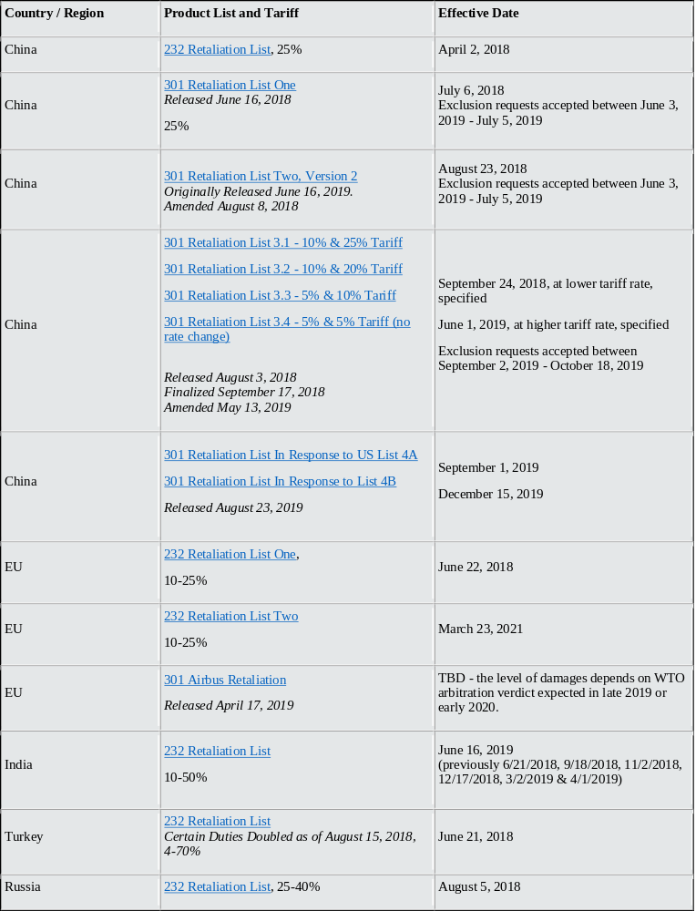 Source: CRS, U.S. Census Bureau, USTR, USITC
Appendix I2: Average Tariff Rate
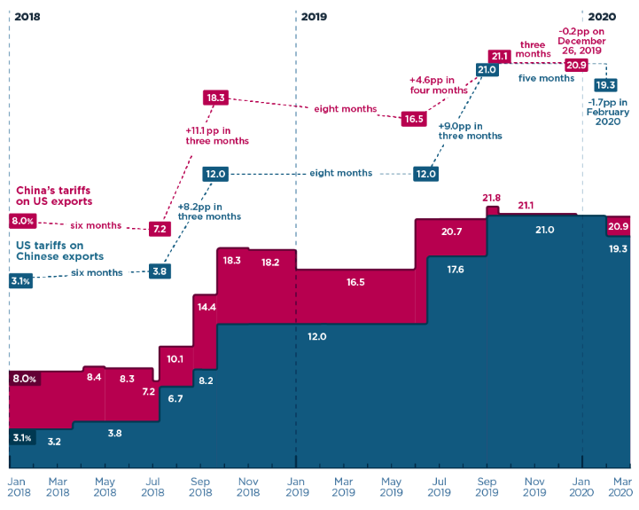
Source: CRS, U.S. Census Bureau, USTR, USITC
Appendix I3: Average Tariff Rate of the USA
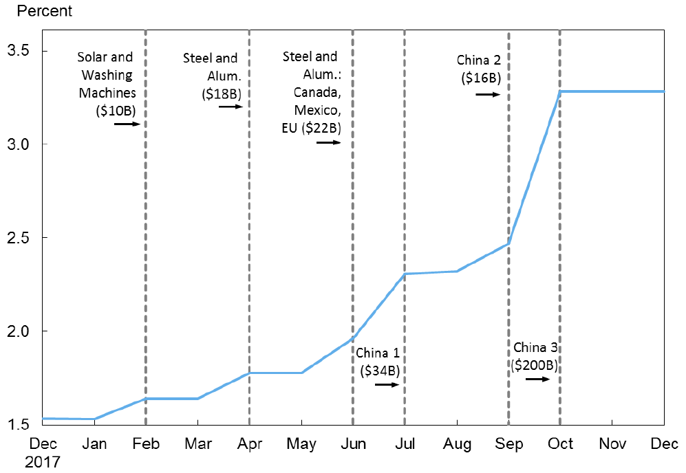
Source: Amiti et al. (2019).
Appendix II: GTAP Output

Appendix II1: Each Agreement Contribution to Welfare, Percentage in Total

Appendix II2: Each Sectoral contribution to the countries in total

Appendix II3: Import Tariff and Export Subsidies
Sectoral Tariff Rate | Japan |  |  |  | EU_28 |  | USA
Sectoral Tariff Rate | Import |  | Export Subs. |  | Import | Export Subs. | Import | Export Subs.
 | USA | EU_28 | USA | EU_28 | Japan | Japan | Japan | Japan
1 GrainsCrops | 22 | 6 | 0 | 0 | 3 | 0 | 2 | 0
2 MeatLstk | 35 | 46 | 0 | 0 | 2 | 0 | 3 | 0
3 Extraction | 0 | 1 | 0 | 0 | 4 | 0 | 0 | 0
4 ProcFood | 10 | 12 | 0 | 0 | 5 | 0 | 3 | 0
5 TextWapp | 7 | 9 | 0 | 0 | 5 | 0 | 5 | 0
6 CmElOpMnfc | 0 | 0 | 0 | 0 | 3 | 0 | 1 | -1
7 EEMnfc | 0 | 0 | 0 | 0 | 6 | 0 | 1 | -1
8 MEMnfc | 0 | 0 | 0 | 0 | 5 | 0 | 1 | -1
9 AutoMnfc | 0 | 0 | 0 | 0 | 6 | 0 | 1 | 0
10 StlAlmMnfc | 2 | 1 | 0 | 0 | 5 | 0 | 2 | 0
11 LightMnfc | 1 | 4 | 0 | 0 | 5 | 0 | 1 | 0
12 HeavyMnfc | 1 | 1 | 0 | 0 | 6 | 0 | 2 | -1
13 Util_Cons | 0 | 0 | 0 | 0 | 0 | 0 | 0 | 0
14 TransComm | 0 | 0 | 0 | 0 | 0 | 0 | 0 | 0
15 OthServices | 0 | 0 | 0 | 0 | 0 | 0 | 0 | 0

Appendix II4: Sectoral Aggregation
Sector | Aggregation Label | GTAP 10 sector
Paddy Rice | Rice | pdr, pcr
Grains and Crops | GrainsCrops | wht, gro, v_f, osd, c_b, pfb, ocr
Livestock and Meat Products | MeatLstk | ctl, oap, rmk, wol, cmt, omt
Mining and Extraction | Extraction | frs, fsh, coa, oil, gas, oxt
Processed Food | ProcFood | vol, mil, sgr, ofd, b_t
Textiles and Clothing | TextWapp | tex, wap
Computer, Elecronic and optic | CmElOpMnfc | ele
Electrical equipment | EEMnfc | eeq
Machinery and Equipment nec. | MEMnfc | ome
Automobile | AutoMnfc | mvh, otn
Steel and Aliminium | StlAlmMnfc | i_s, nfm, fmp
Light Manufacturing | LightMnfc | lea, lum, ppp, omf
Heavy Manufacturing | HeavyMnfc | p_c, chm, bph, rpp, nmm
Trade and Transport | TradeTransp | trd, otp, atp
Utilities and Construction | Util_Cons | ely, gdt, wtr, cns
Transport and Communication | TransComm | afs, wtp, whs, cmn
Other Services | OthServices | ofi, ins, rsa, obs, ros, osg, edu, hht, dwe

Appendix II5: Regional Aggregation
Region | Aggegation Label | GTAP10 regions
Japan | Japan | jpn
United States of America | USA | usa
China | China | chn, hkg
Canada | Canada | can
Turkey | Turkey | tur
Mexico | Mexico | mex
India | India | ind
Russian Federation | Russia | rus
European Union 28 | EU28 | Aut, bel, bgr, hrv, cyp, cze, dnk, est, fln, fra, deu, grc, hun, irl, ita, lva, ltu, lux, mlt, nld, pol, prt, rou, svk, svn, esp, swe, gbr
Oceania | Oceania | Aus, nzl, xoc
East Asia | EastAsia | Kor, mng, twn, xea, brn
Southeast Asia | SEAsia | Khm, idn, lao, mys, phl, sgp, tha, vnm, xse
South Asia | SouthAsia | Bgd, npl, pak, lka, xsa
Latin America | LatinAmer | Arg, bol, bra, chl, col, ecu, pry, per, ury, ven, xsm, cri, gtm, hnd, nic, pan, slv, xca, dom, jam, pri, tto, xcb
The Middle East and North Africa | MENA | Bhr, irn, isr, jor, kwt, omn, qat, sau, are, xws, egy, mar, tun, xnf
Sub-Saharan Africa | SSA | Ben, bfa, cmr, civ, gha, gin, nga, sen, tgo, xwf, xcf, xac, eth, ken, mdg, mwi, mus, moz, rwa, tza, uga, zmb, zwe, xec, bwa, nam, zaf, xsc
Rest of World | RestofWorld | Xna, che, nor, xef, alb, blr, ukr, xee, xer, kaz, kgz, tjk, xsu, arm, aze, geo, xtw

Up-date-line: https://www.piie.com/blogs/trade-investment-policy-watch/trump-trade-war-china-date-guide
https://www.govinfo.gov/content/pkg/FR-2019-03-05/pdf/2019-03935.pdf
More information from 2019 to 2020: https://www.piie.com/blogs/trade-investment-policy-watch/trump-trade-war-china-date-guide.

