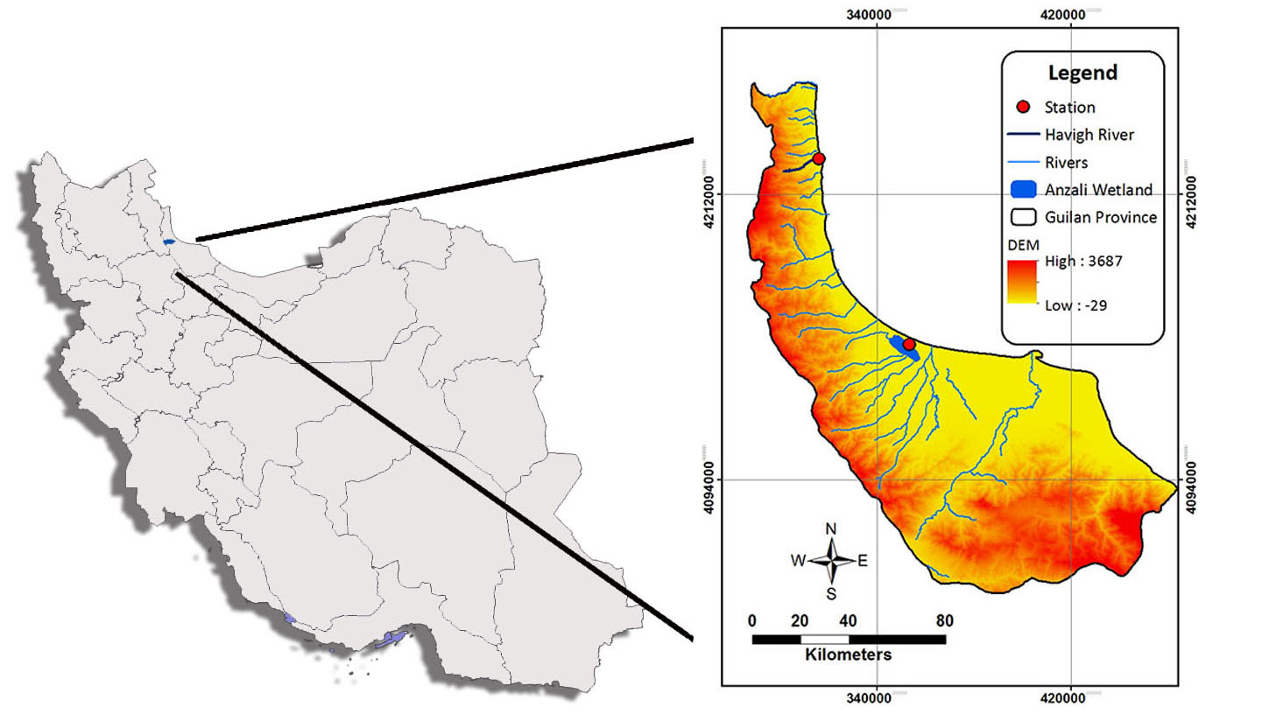
Fig.S1: Sampling stations for R. frisii.

