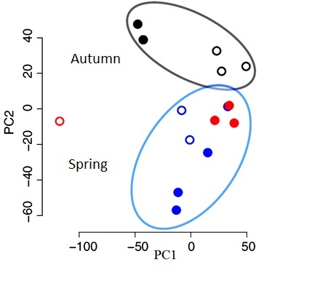
Fig S5: Principal components analysis (PCA) of RNA-seq dataset.

