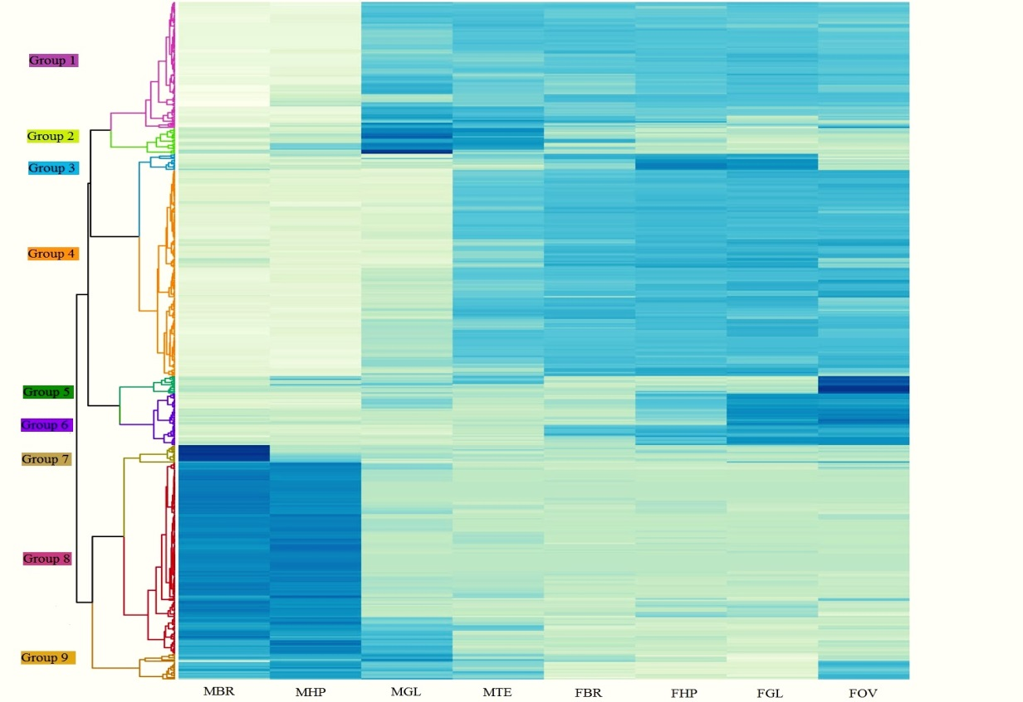
Fig S3: Hierarchical clustering Heatmap of the differentially expressed genes in the tissues investigated. A darker colour shows a greater expression level. Gene expression patterns in each tissue (row) were clustered into different expression groups according to the Pearson correlation coefficient. We used Euclidean distance to group different tissues.

