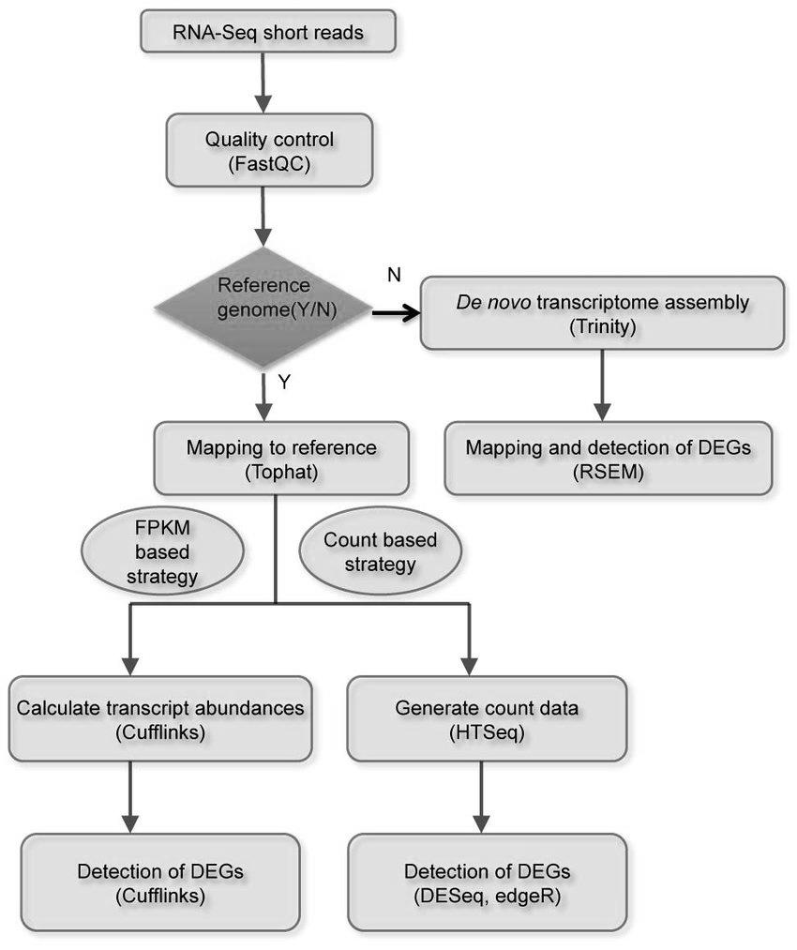
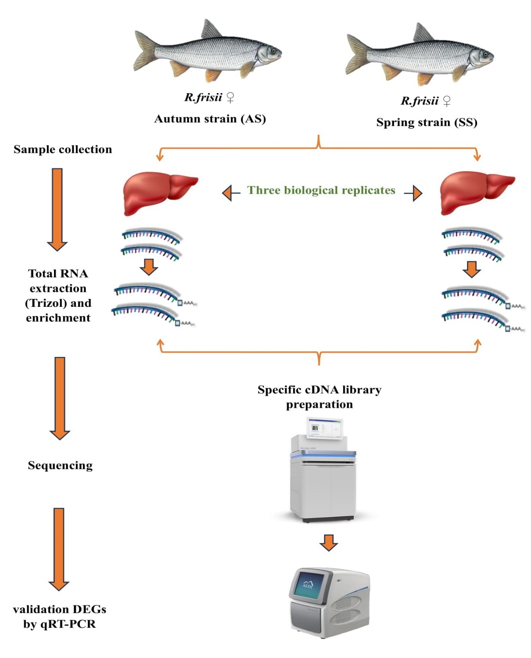
Fig S2. The workflow of de novo transcriptome data analysis for R. frisii.

