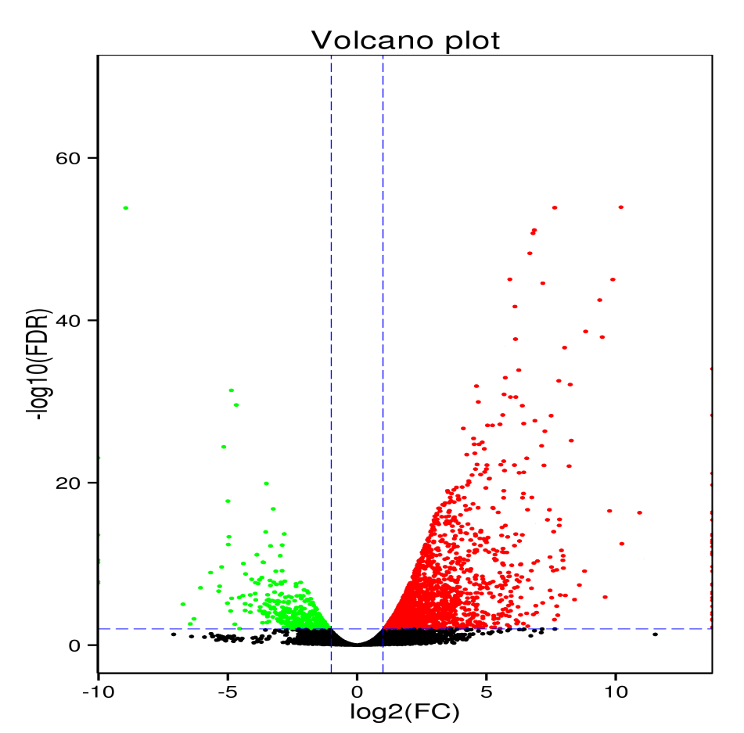

Fig S4: Visualization of RNA-Seq results with Volcano Plot

