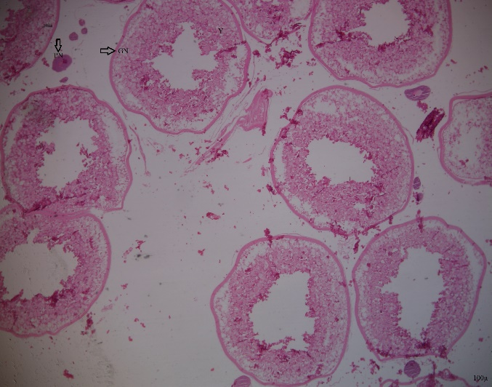
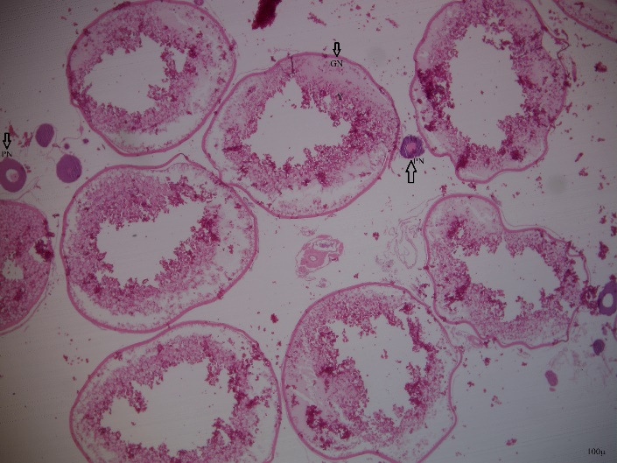
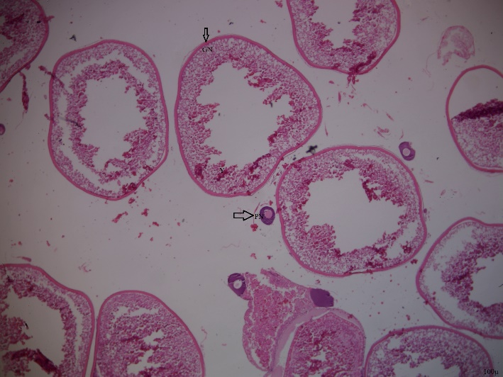
Fig-1: Ovarian histology of R.frisii autumn strain indicating level IV of maturation. (H & E 10x4x). GN: Granulosa cells, Y: Yolk, PN: Peri Nucleolus stage oocyte.

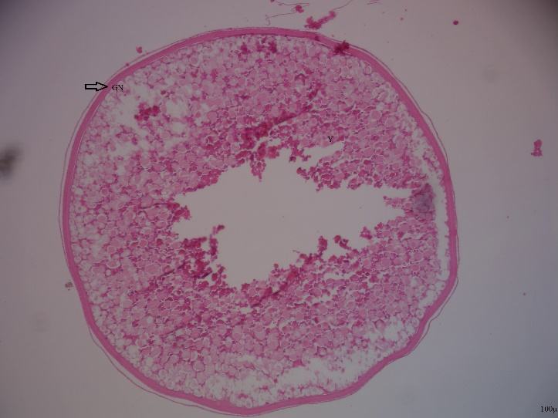
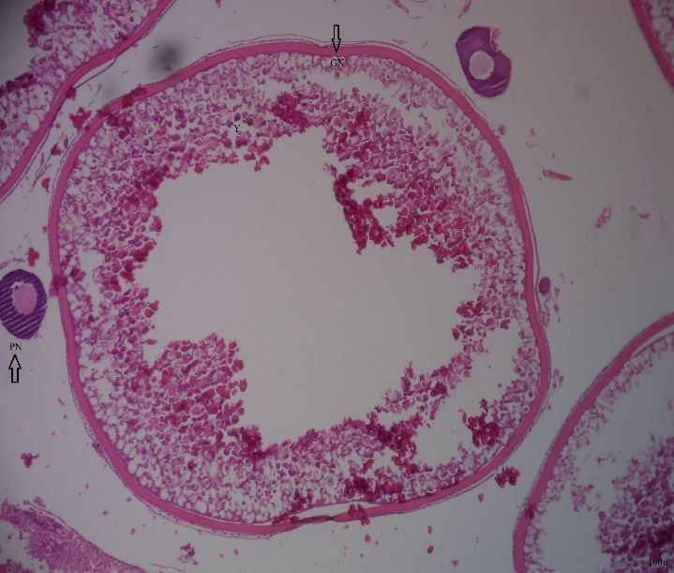
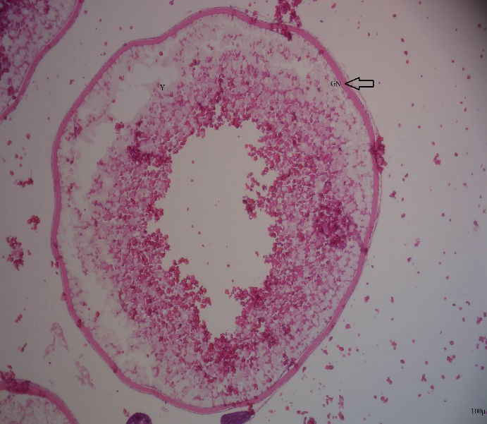
Fig-2: Ovarian histology of R.frisii autumn strain indicating level IV of maturation (H & E 10x10x). GN: Granulosa cells, Y: Yolk, PN: Peri Nucleolus stage oocyte.

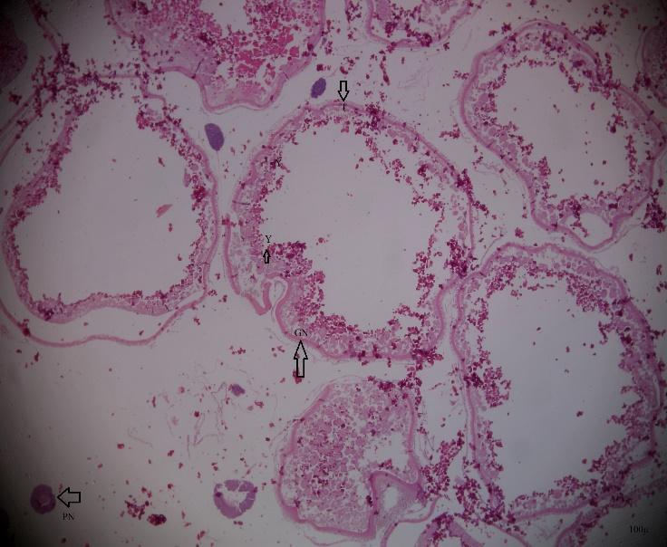
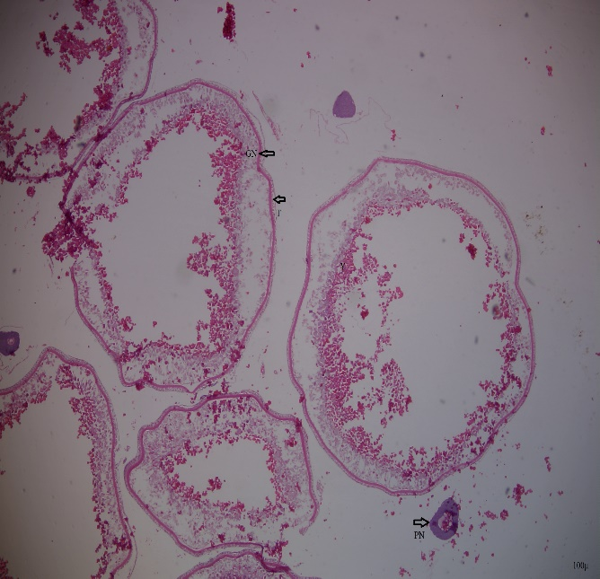
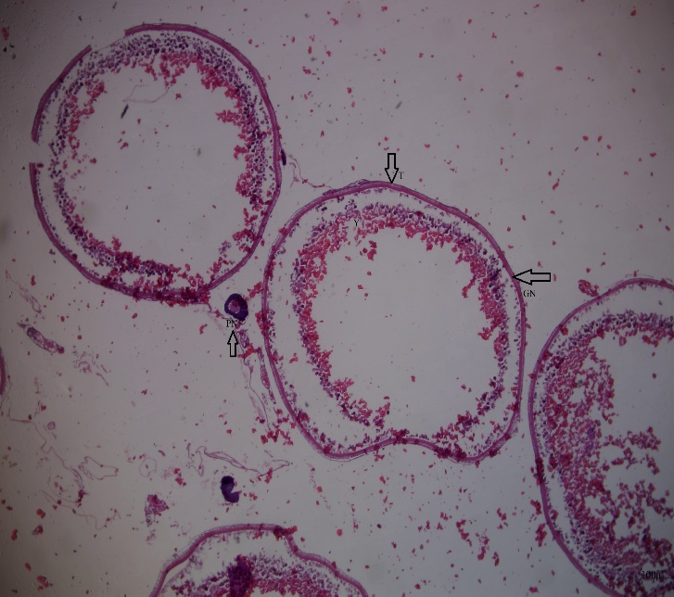
Fig-3: Ovarian histology of R.frisii spring strain with irregular follicular layer indicating level V of maturation. (H & E 10x4x). T: Techa cells, GN: Granulosa cells, Y: Yolk, PN: Peri Nucleolus stage oocyte.

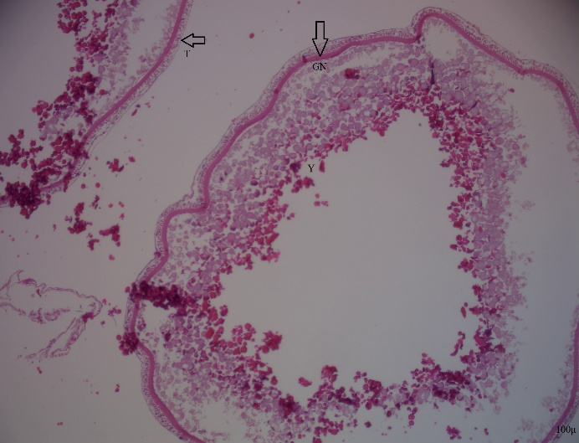
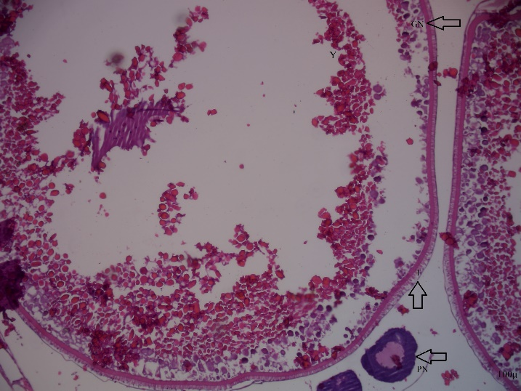
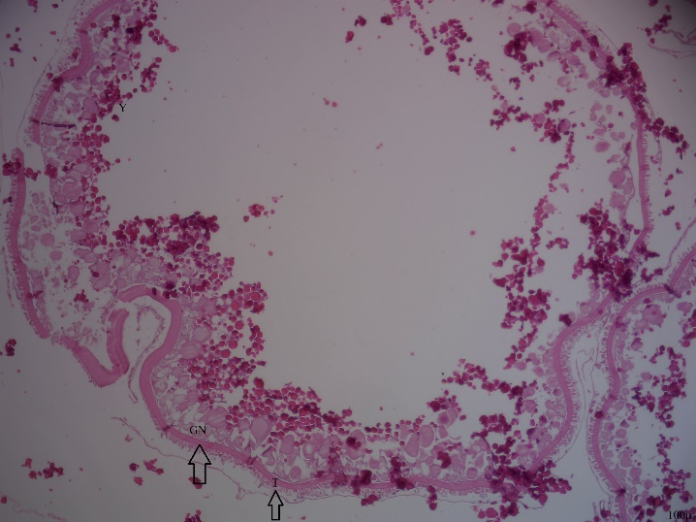
Fig-4: Ovarian histology of R.frisii spring strain with irregular follicular layer indicating level V of maturation. (H & E 10x4x). T: Techa cells, GN: Granulosa cells, Y: Yolk, PN: Peri Nucleolus stage oocyte.

