Supporting Information

Overcoming Chromium Poisoning in Solid Oxide Cells Through Multiscale Perovskite Engineering
Min Li^{a1}, Huixian Liu^{b1}, Yunfei Bu^{b*}, Xiang Wangª, Haoran Wang^{b}, Jiawei Chenª, Jiawei Liª, Yantao Zhao^{c} and Zhibin Yang^{a,b*}
ª China University of Mining and Technology-Beijing, Beijing, 100083, China
^{b} Beijing Huairou Laboratory, Beijing, 101400, China
^{c} Shanxi Research Institute of Huairou Laboratory, Taiyuan, 030024, China
* yunfei.bu@nuist.edu.cn (Yunfei Bu)
yangzhibin0001@163.com (Zhibin Yang)

Experimental section
Powder synthesis
The electrode powder is made by the sol-gel approach. Take La_{0.6}Sr_{0.1}Ba_{0.35}Co_{0.2}Fe_{0.78}Mo_{0.02}O₃₋_{δ} (LSB_{0.35}CFM_{0.02}) as an example. The molar ratios of La(NO₃)₃·6H₂O (99.9%), Sr(NO₃)₂ (99.5%), Ba(NO₃)₂ (99.5%), Co(NO₃)₂·6H₂O (99.9%), Fe(NO₃)₃·9H₂O (99.9%), and (NH₄)₆Mo₇O₂₄·4H₂O (99.9%) were weighed according to the target composition of LSB_{0.35}CFM_{0.02} and were configured as a solution. The citric acid (CA, 99.5%) and ethylenediaminetetraacetic acid (EDTA, 99.5%) were mixed with the molar proportion of EDTA, CA, and metal ions (1:1.5:1). The solution's pH was subsequently raised to ~9. The gel was obtained after continuous heating (90 °C, 10 h), and it was calcined (1000 °C, 5 h) to crystallize the powder.
Cell fabrication and tests
The Ni-YSZ/Ni-SSZ/SSZ/GDC half-cell, SSZ electrolyte and GDC powder are purchased from SOFCMAN. The GDC ink was made by mixing and milling an appropriate amount of GDC powder containing 6 wt.% ethylcellulose, and then it was subsequently sintered (1300 °C, 5 h) on the SSZ electrolyte. The LSB_{0.35}CFM_{0.02} ink was prepared using the same method and then sintered onto the GDC layer, obtaining LSB_{0.35}CFM_{0.02}/GDC/SSZ/GDC/LSB_{0.35}CFM_{0.02} symmetrical half-cell and Ni-YSZ/Ni-SSZ/SSZ/GDC/LSB_{0.35}CFM_{0.02} single-cell. The I–V and EIS of the cells at various conditions were obtained by Autolab workstation. Silver paste was brushed onto the electrode surfaces, followed by the attachment of silver wires. The assembly was then connected to the Autolab workstation, and a current density of 0.5 A·cm⁻² was applied during the test. Cr₂O₃ powder (~10 g) was placed in a separate alumina boat 10 mm from the front of the cell as the Cr source.
Calculations
All spin-polarized periodic density functional theory (DFT) calculations were performed using the Vienna Ab initio Simulation Package (VASP) with the Perdew–Burke–Ernzerhof functional and Grimme's DFT-D3 dispersion correction.¹⁻³ A plane-wave cutoff of 400 eV and a (2 × 2 × 1) k-point mesh were used, with convergence criteria of 1 × 10⁻⁵ eV for energy and 0.03 eV/Å for forces. Effective Hubbard U values of 4, 6.5, 3, and 2 eV were applied to Fe,⁴ Co,⁵ Cr,⁶ and Mo,⁷ respectively. The AO-terminated (100) surfaces of LSCF (La_{0.6}Sr_{0.4}Co_{0.2}Fe_{0.8}O₃₋_{δ}) were modeled using a supercell size of 7.71 Å ×19.27 Å in the xy-plane with eight atomic layers in the z-direction and a 20 Å vacuum gap to prevent spurious interactions. During structural optimization, the bottom four layers were fixed while the others were fully relaxed. The LSBCF (La_{0.6}Sr_{0.1}Ba_{0.3}Co_{0.2}Fe_{0.8}O₃₋_{δ}) surface was created by replacing three-quarters of Sr with Ba in the LSCF lattice, and the LSBCFM (La_{0.6}Sr_{0.1}Ba_{0.3}Co_{0.2}Fe_{0.78}Mo_{0.02}O₃₋_{δ}) surface was further generated by substituting one Fe atom with Mo. The top and side views of the three surface models are shown in Figure S15.

Supplementary Figures
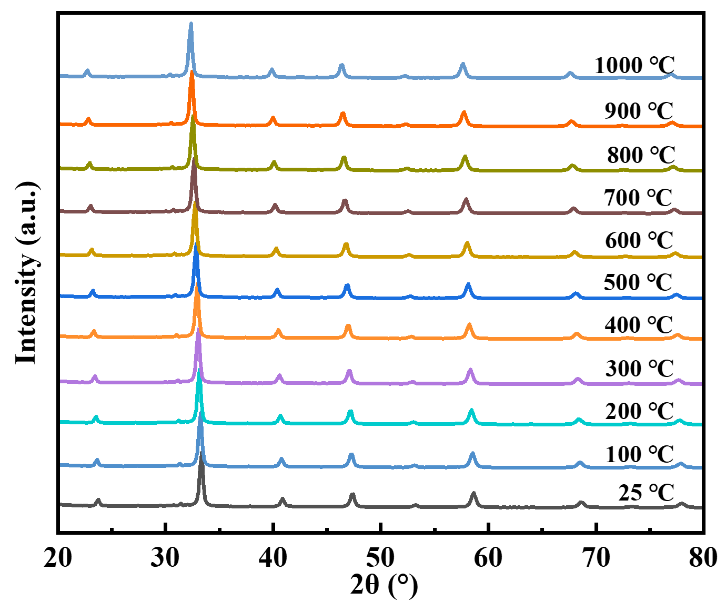
Figure S1. HT-XRD pattern of LSB_{0.35}CFM_{0.02} powder.

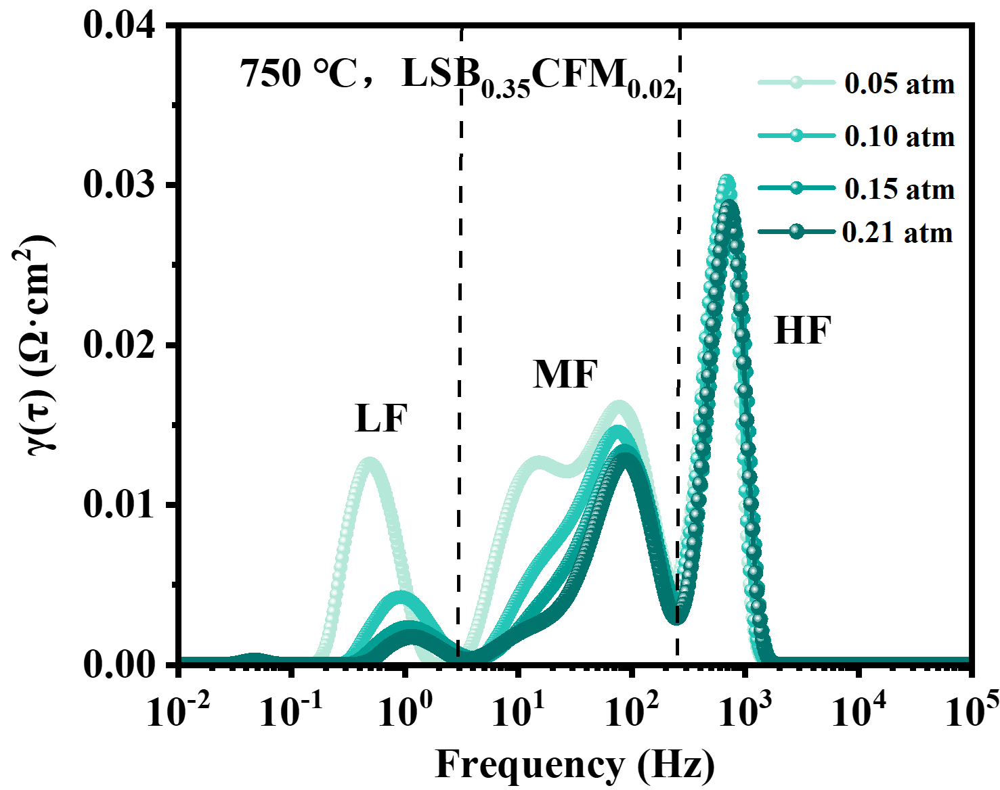
Figure S2. DRT curves of symmetric cells with LSB_{0.35}CFM_{0.02} under various pO₂ at 750 ℃.

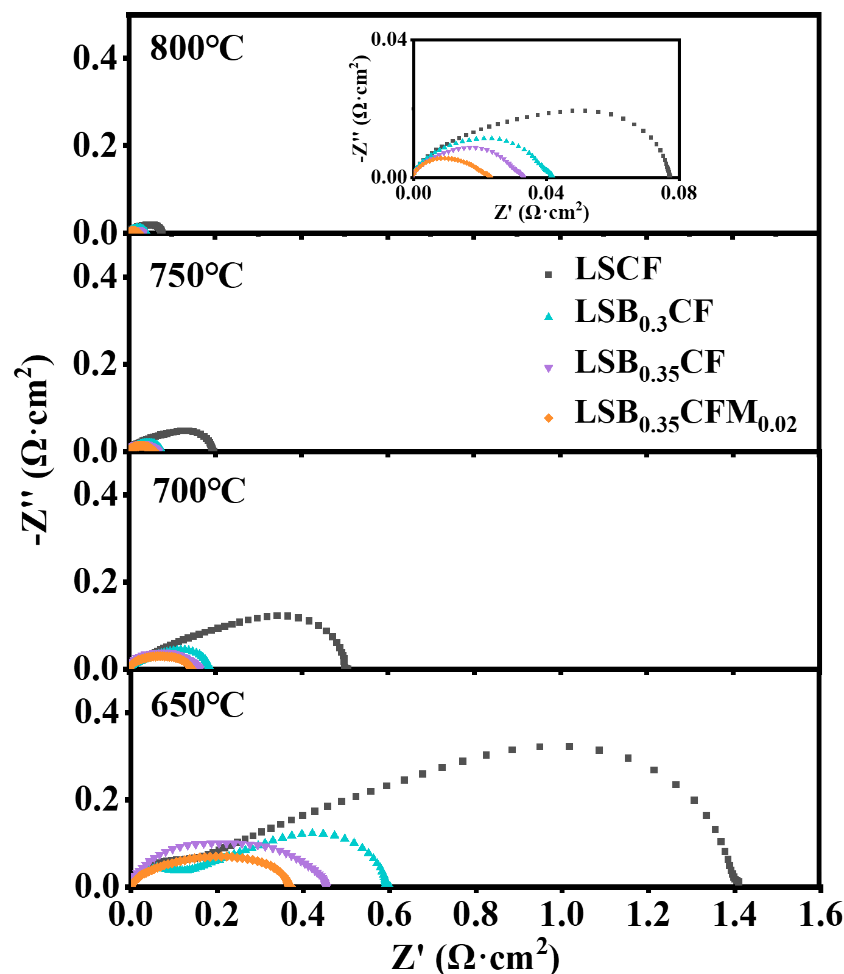
Figure S3. EIS curves of symmetric cells with LSB_{x}CFM_{y} (x=0, 0.3, 0.35; y=0, 0.02) at 650~800 ℃.

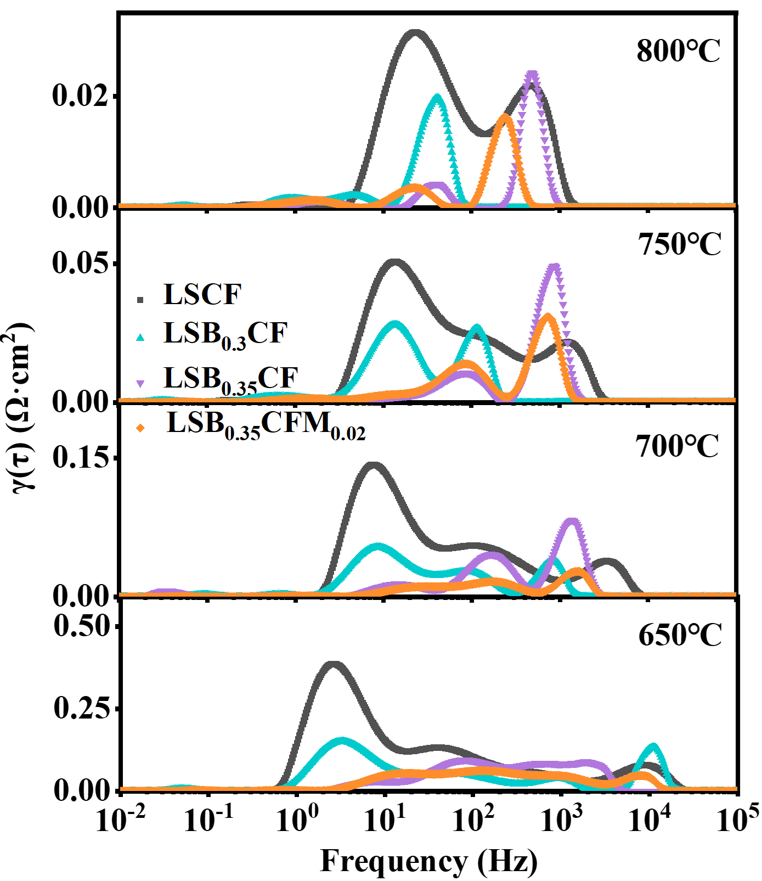
Figure S4. DRT curves of symmetric cells with LSB_{x}CFM_{y} (x=0, 0.3, 0.35; y=0, 0.02) at 650~800 ℃.

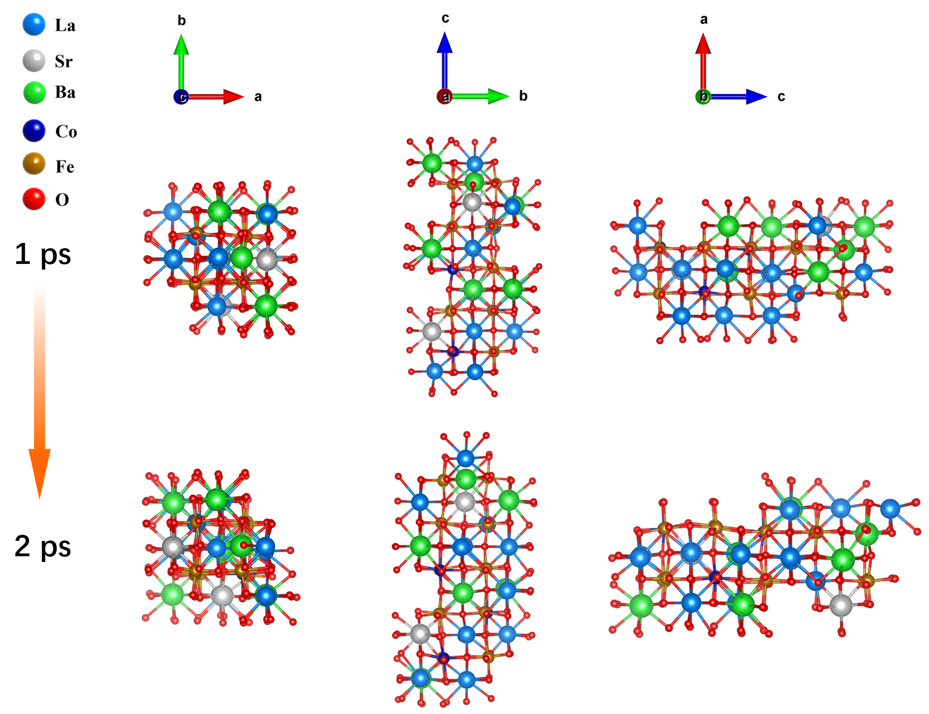
Figure S5. Structure of LSB_{0.3}CF during the Ab Initio Molecular Dynamics (AIMD) simulations (2 ps) at 750 ℃.
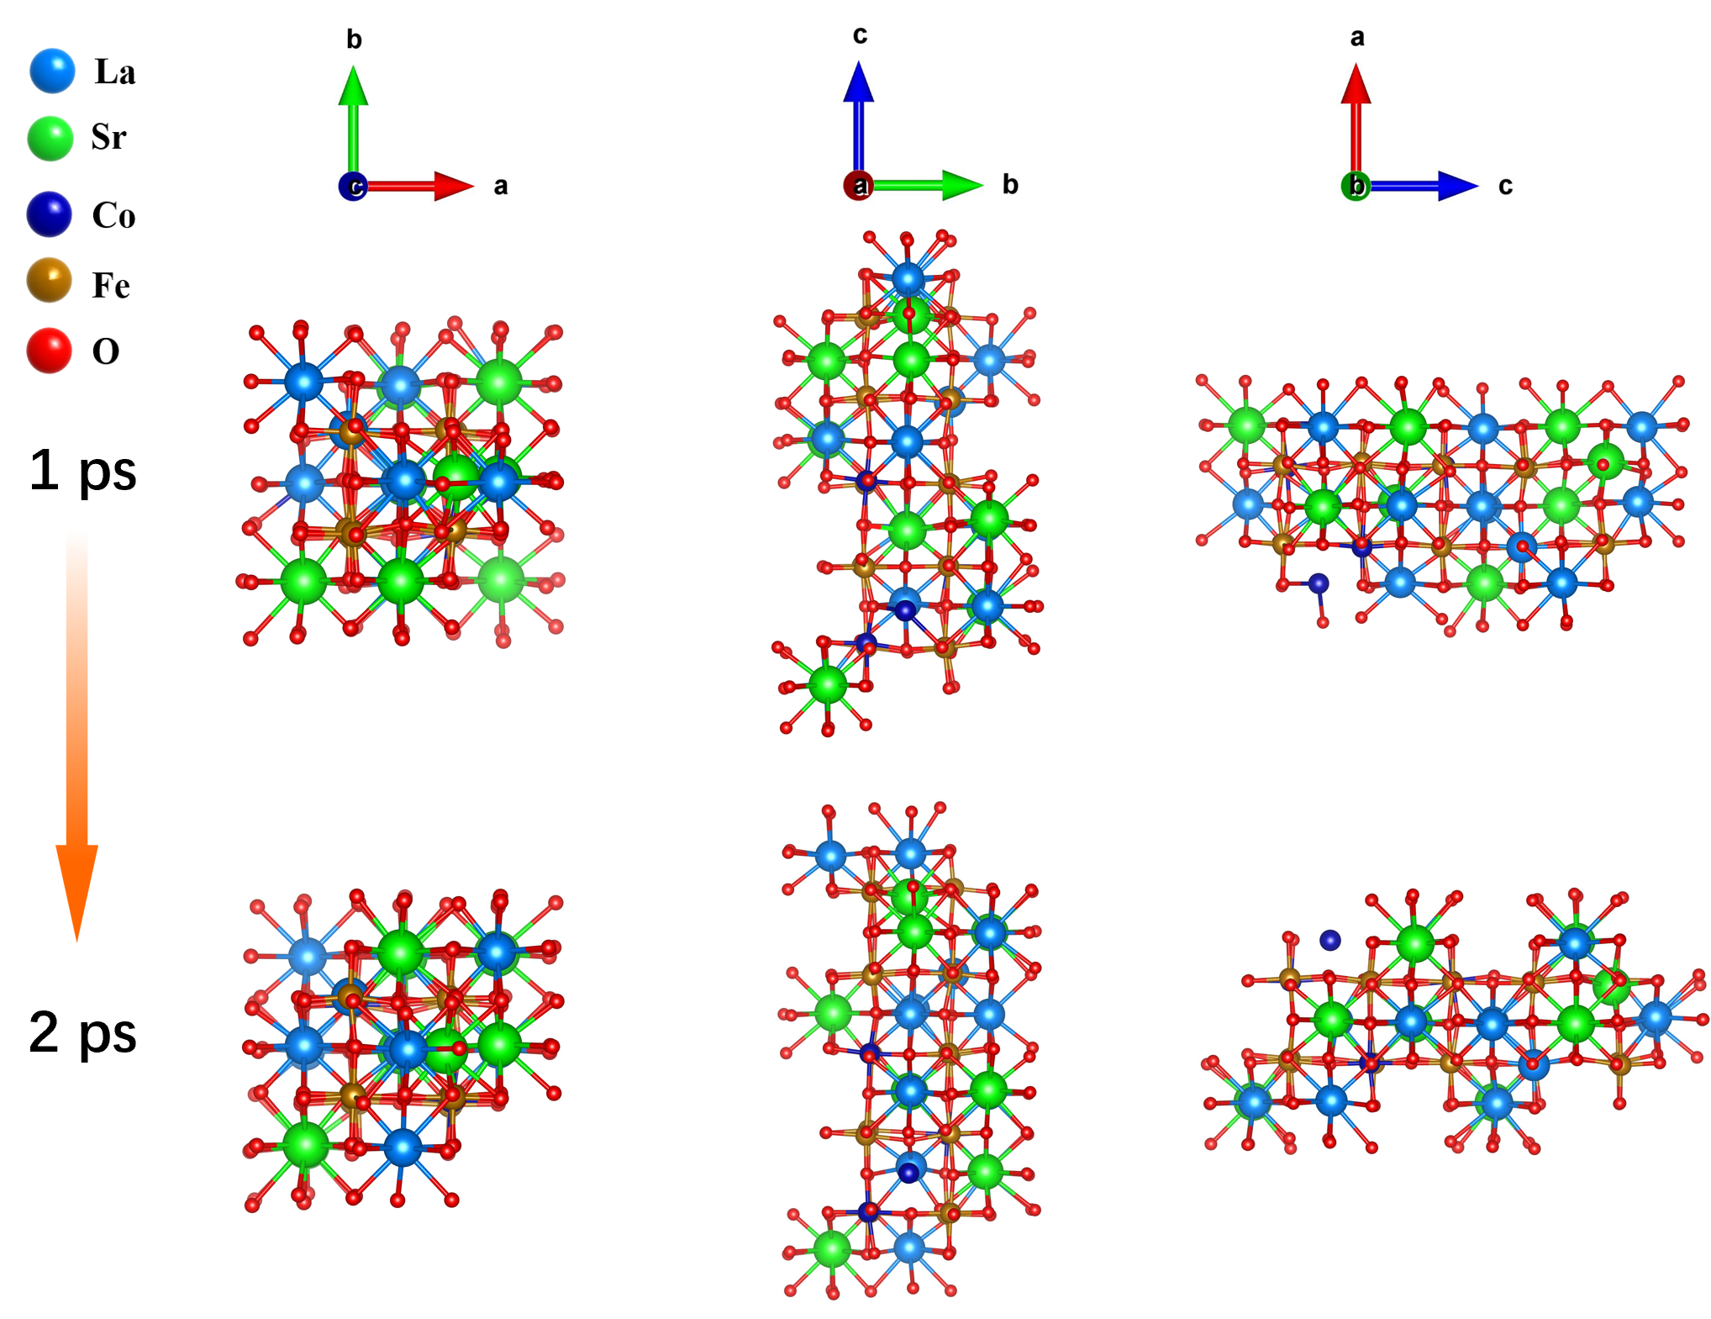
Figure S6. Structure of LSCF during the Ab Initio Molecular Dynamics (AIMD) simulations (2 ps) at 750 ℃.
The structural evolution of LSCF and LSB_{0.3}CF models at 750 °C was investigated by DFT-based AIMD simulations. The simulations were executed by the VASP code within the MedeA environment, utilizing the Projector Augmented-Wave approach and each system was equilibrated for 2 ps.¹⁻³ AIMD simulations quantitatively confirm this stabilization effect: LSB_{0.3}CF exhibits minimal atomic displacement (MSD < 0.2 Å²) and stable A–O coordination (~12), with the system energy converging within ±0.02 eV per atom after 2 ps. In contrast, LSCF shows markedly higher MSD values (>0.4 Å² for Co), reduced A–O coordination, and energy fluctuations exceeding ±0.06 eV per atom, indicative of structural instability and Co segregation (Figure S6).

$t=\frac{r_{A} +{ r}_{X}}{\sqrt{2}\left(r_{B} +{ r}_{X}\right)}$ (S1)
where r_{A}: ionic radii of A-site cation, r_{B}: ionic radii of B-site cation and r_{X}: ionic radii of anion.⁸

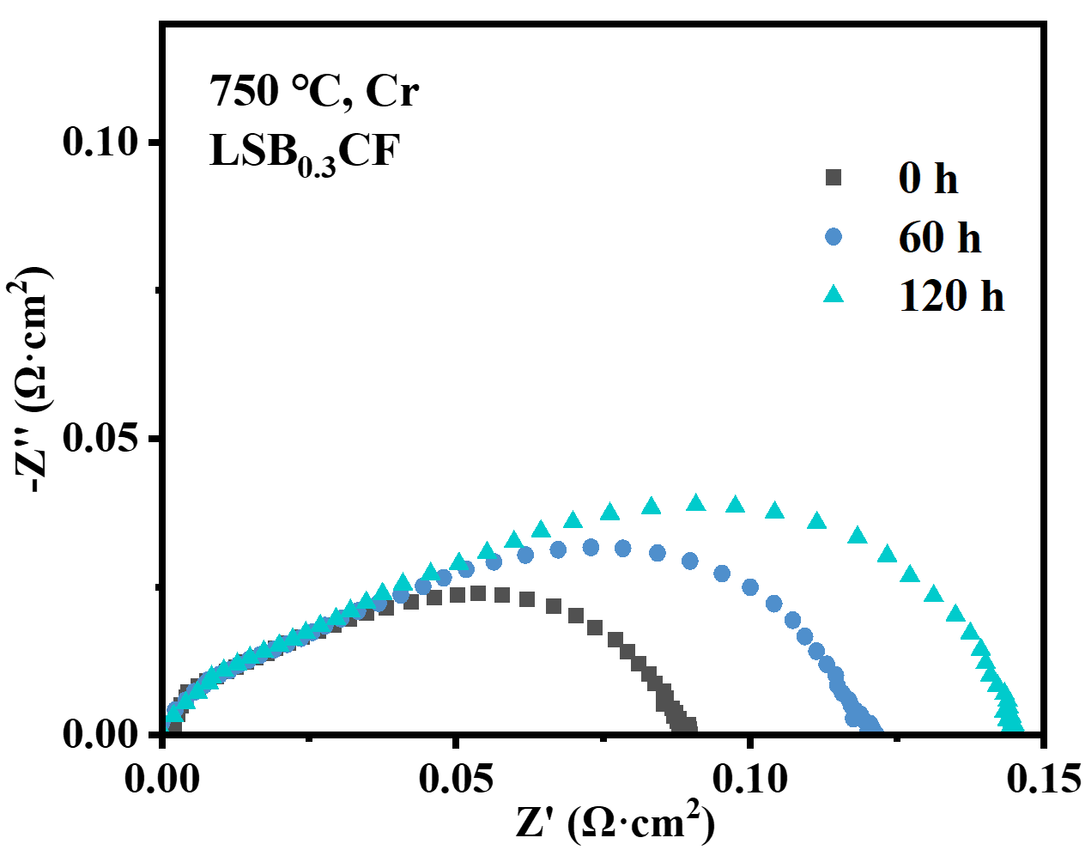
Figure S7. EIS curves of symmetric cells with LSB_{0.3}CF at OCV under Cr poisoning at 750 °C for 120 h.

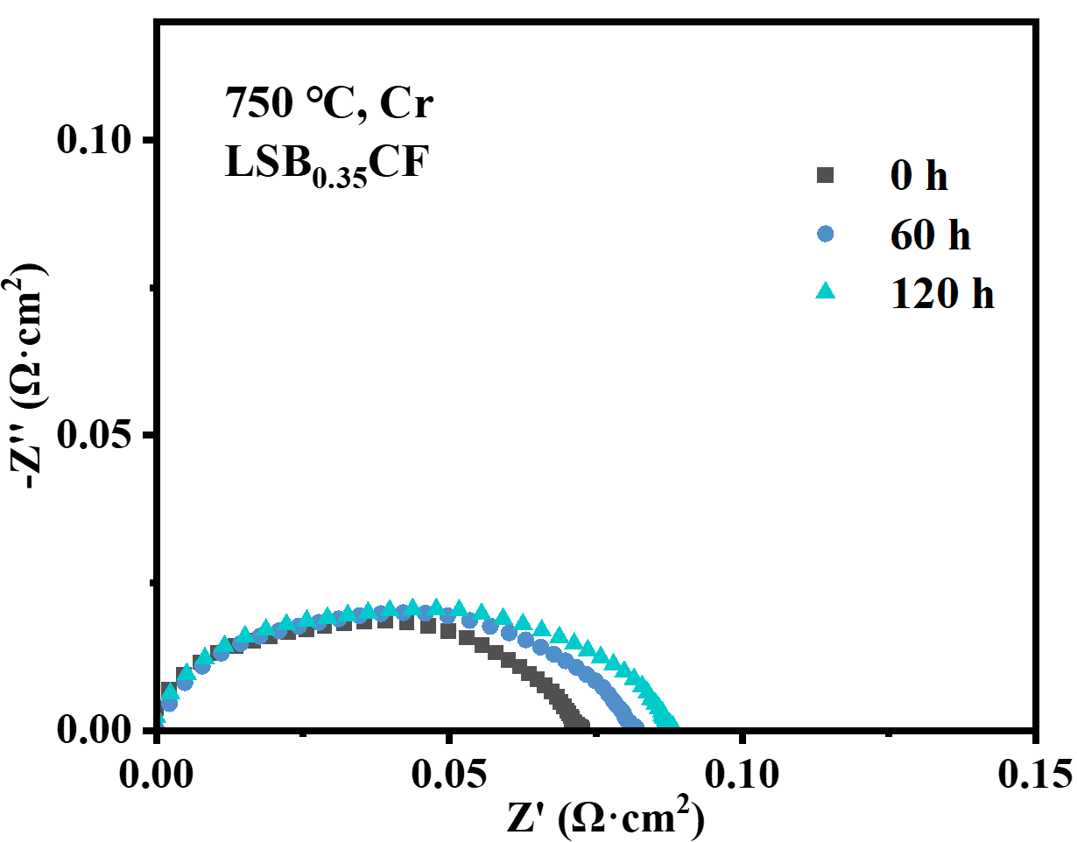
Figure S8. EIS curves of symmetric cells with LSB_{0.35}CF at OCV under Cr₂O₃ exposure at 750 °C for 120 h.

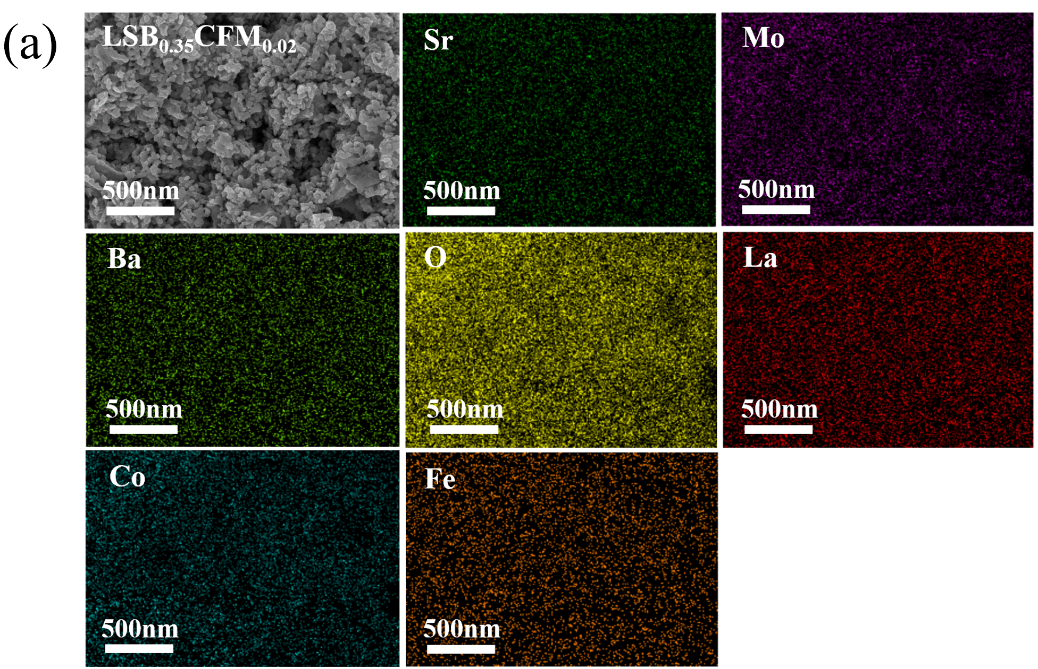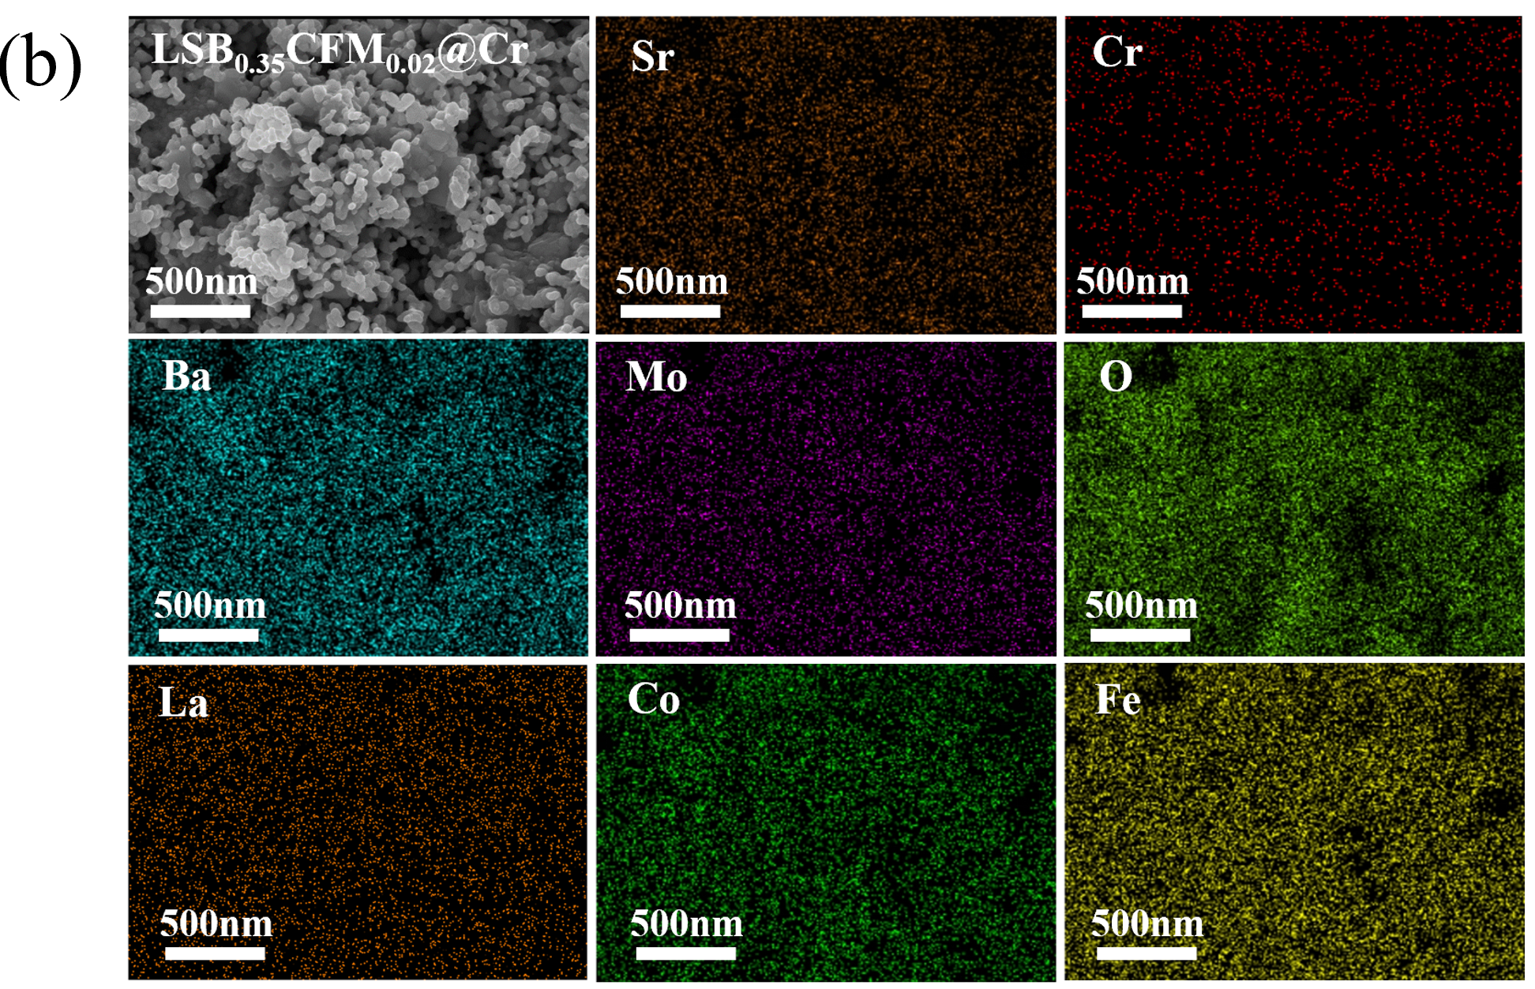
Figure S9. SEM images of LSB_{0.35}CFM_{0.02} cathode at 750 ℃ (a) before and (b) after Cr₂O₃ exposure for 120 h.

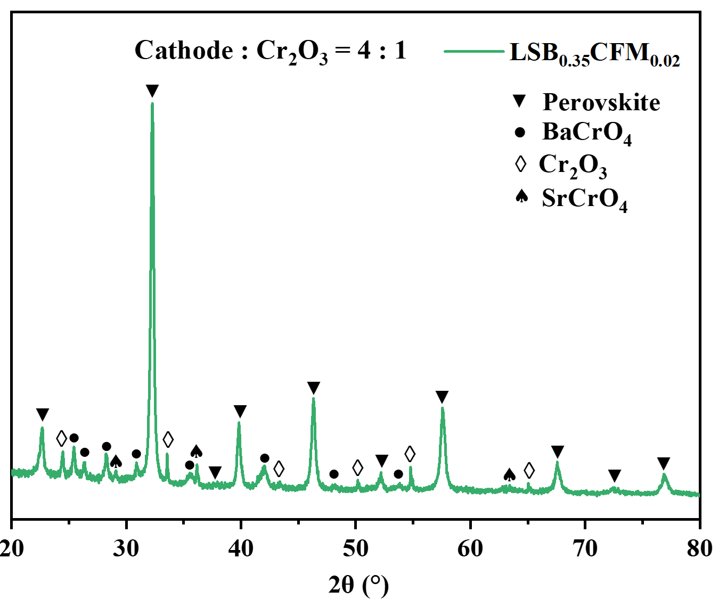
Figure S10. XRD of LSB_{0.35}CFM_{0.02}-Cr₂O₃ mixtures (4:1 weight ratio) after sintering at 750℃ for 5 h.
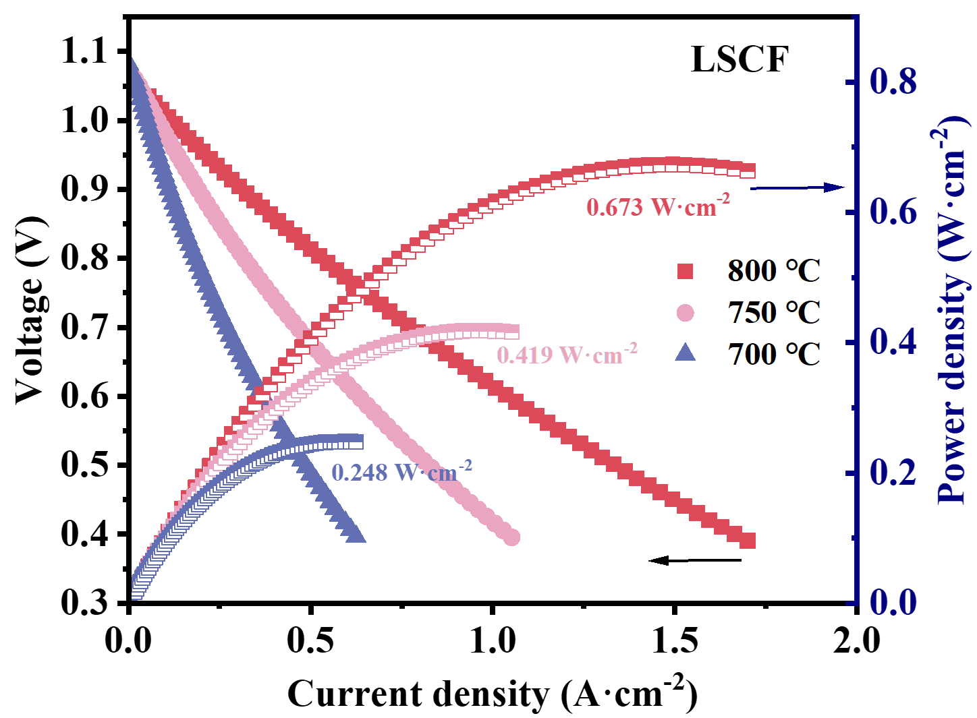
Figure S11. I-V-P curves of LSCF cell in FC mode at 700~800 ℃.

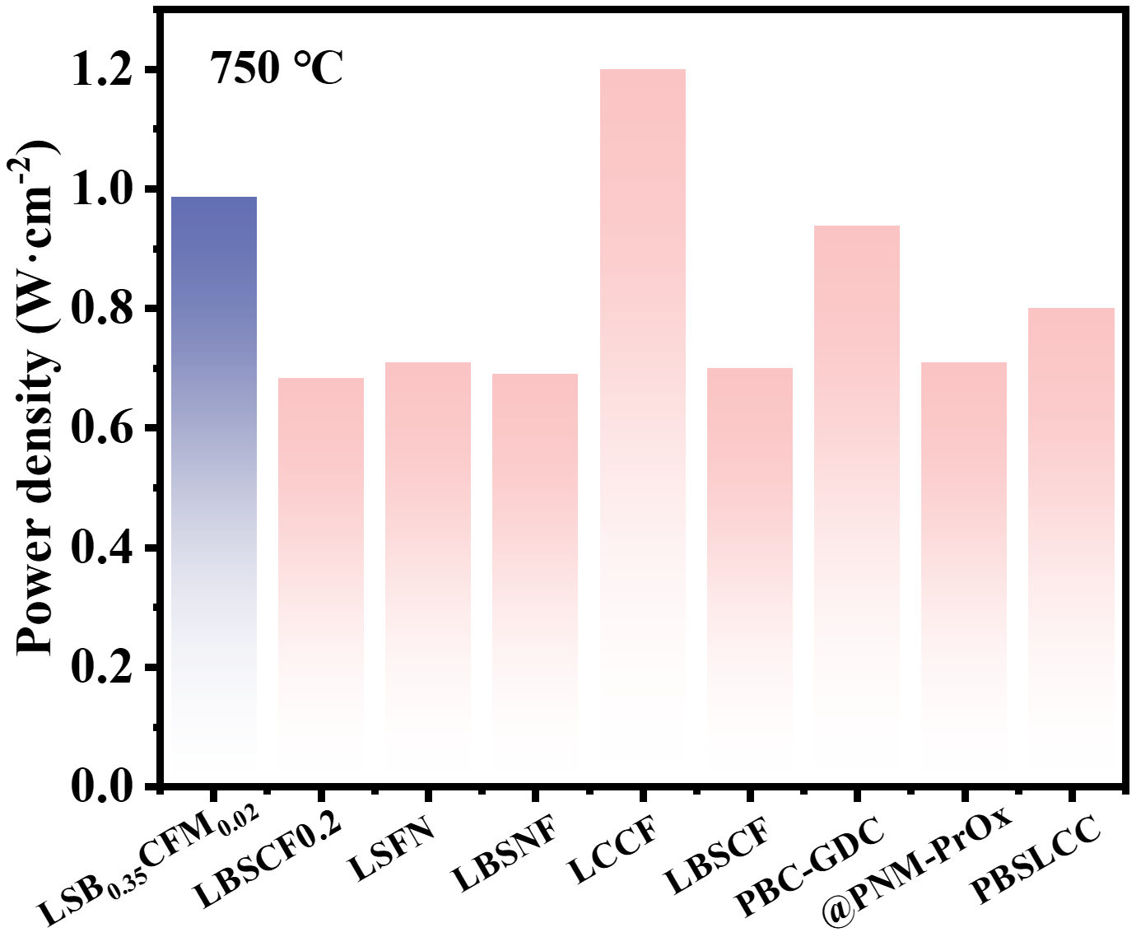
Figure S12. PPD comparison of LSB_{0.35}CFM_{0.02} cell with other literature at 750 ℃.

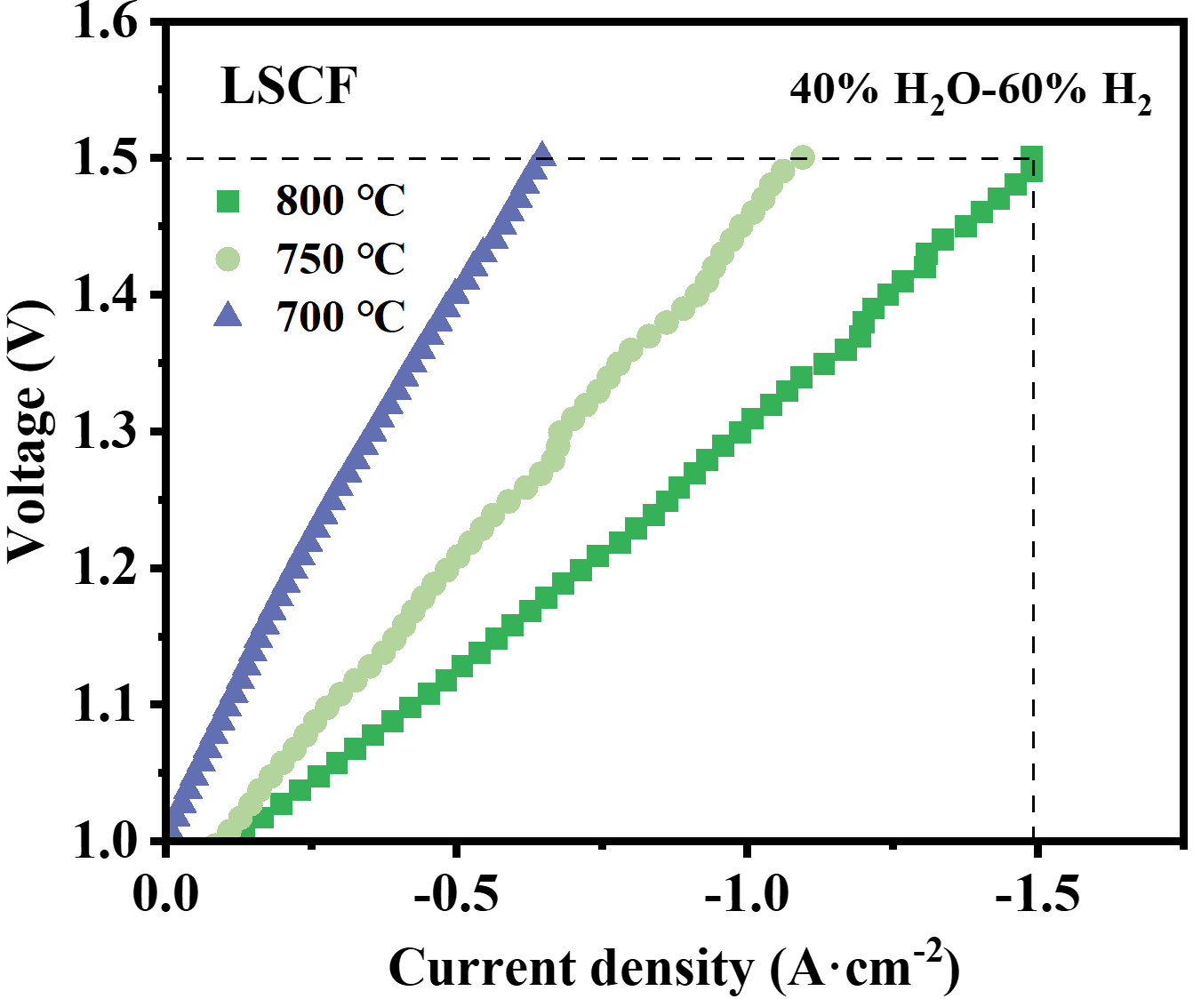
Figure S13. I-V curves of LSCF cell in EC mode at 700~800 ℃.

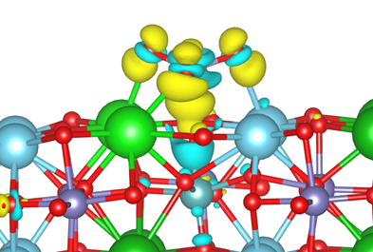
Figure S14. Electron charge density difference isosurface for CrO₃ adsorbed on the LSBCFM surface. Charge depletion and accumulation are represented by blue and yellow regions, respectively. The isosurface value is set to ±0.005 e/Å.

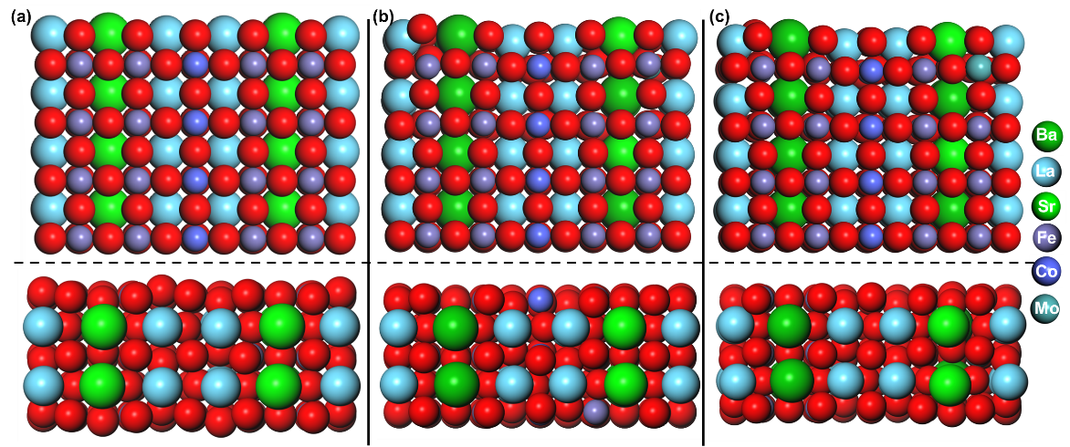
Figure S15. The side (lower) and top (upper) views of (a) LSCF, (b) LSBCF and (c) LSBCFM surface.
The adsorption energy of CrO₃ was defined as E_{ads} = E_{CrO3+surface}– E_{CrO3}–E_{surface}, where E_{CrO3+surface}, E_{CrO3}, and E_{surface} denote the total energies of the adsorbed system, isolated CrO₃ in vacuum, and clean surface, respectively. The adsorption Gibbs free energy was calculated as G_{ads} = E_{ads} + ΔE_{ZPE} – TΔS, where zero-point energy (ΔE_{ZPE}) and entropy (ΔS) contributions were included. All Gibbs free energies were evaluated at 750 °C.

Table S1. Crystal structure parameters of materials obtained from Rietveld XRD refinements.
Material | LSB_{0.35}CFM_{0.02} | BaCoO₃
Phase structure | Pbnm | P63/mmc
a(Å) | 5.4998 | 5.6552
b(Å) | 5.5412 | 5.6552
c(Å) | 7.7923 | 4.9643
V(Å³) | 237.47 | 158.76
Fract(%) | 97.48 | 2.52
Rp | 5.51 | 5.25
Rwp | 6.88 | 6.45
χ² | 3.35 | 3.26

Reference
1 Perdew, J. P., Burke, K. & Ernzerhof, M. Generalized Gradient Approximation Made Simple. Physical Review Letters 77, 3865-3868, doi:10.1103/PhysRevLett.77.3865 (1996).
2 Kresse, G. & Furthmüller, J. Efficient iterative schemes for ab initio total-energy calculations using a plane-wave basis set. Physical Review B 54, 11169-11186, doi:10.1103/PhysRevB.54.11169 (1996).
3 Grimme, S., Antony, J., Ehrlich, S. & Krieg, H. A consistent and accurate ab initio parametrization of density functional dispersion correction (DFT-D) for the 94 elements H-Pu. The Journal of chemical physics 132, 154104, doi:10.1063/1.3382344 (2010).
4 Liu, B. & Zhao, X. The synergetic effect of V and Fe-co-doping in TiO 2 studied from the DFT + U first-principle calculation. Applied Surface Science 399, 654-662, doi:10.1016/j.apsusc.2016.12.075 (2017).
5 Wang, H. et al. Interfacial Coupling Effect on Electron Transport in Hierarchical TaON/Au/ZnCo-LDH Photoanode with Enhanced Photoelectrochemical Water Oxidation. ACS Applied Materials & Interfaces 11, 33062-33073, doi:10.1021/acsami.9b11521 (2019).
6 Qin, Y. et al. Hydroperoxyl-mediated C-H bond activation on Cr single atom catalyst: An alternative to the Fenton mechanism. Journal of Catalysis 417, 323-333, doi:10.1016/j.jcat.2022.12.017 (2023).
7 Agarwal, V. & Metiu, H. Oxygen Vacancy Formation on α-MoO3 Slabs and Ribbons. The Journal of Physical Chemistry C 120, 19252-19264, doi:10.1021/acs.jpcc.6b06589 (2016).
8 Randall, C. A., Bhalla, A. S., Shrout, T. R. & Cross, L. E. Classification and consequences of complex lead perovskite ferroelectrics with regard to B-site cation order. J. Mater. Res. 5, 829-834, doi:10.1557/JMR.1990.0829 (1990).

