Supplementary Information

Ultrathick MoS₂ Films with Exceptionally High Volumetric Capacitance

Zheng Bo^{1,2,★}, Xiangnan Cheng^{1,2}, Huachao Yang^{1,2}, Xinzheng Guo^{1,2}, Jianhua Yan^{1,2}, Kefa Cen^{1,2}, Zhaojun Han^{3,4,5}, Liming Dai⁵

¹State Key Laboratory of Clean Energy Utilization, College of Energy Engineering, Zhejiang University, Hangzhou, Zhejiang 310027, China.
²ZJU-Hangzhou Global Scientific and Technological Innovation Center, Hangzhou, Zhejiang 311200, China.
³School of Chemical Engineering, University of New South Wales, Sydney, NSW 2052, Australia.
⁴CSIRO Manufacturing, 36 Bradfield Road, Lindfield, NSW 2070, Australia.
⁵Australian Carbon Materials Centre (A-CMC), University of New South Wales, Sydney, NSW 2052, Australia.
★Correspondence and requests for materials should be addressed to Z.B. (e-mail: bozh@zju.edu.cn)

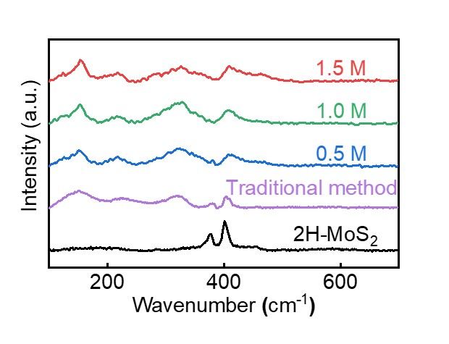
Supplementary Figure 1. Raman measurements of MoS₂ nanosheets prepared by the traditional hydrothermal method and the solvated-ion-intercalated method with different Li⁺ concentrations. In comparison, 2H MoS₂ only shows two Raman peaks at 378 and 401 cm⁻¹.

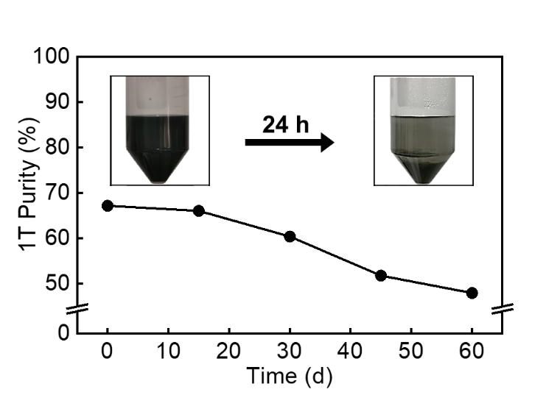
Supplementary Figure 2. The 1T phase stability of MoS₂ aqueous dispersion from traditional hydrothermal method. Inset shows the obvious particle precipitation after 24 hours.

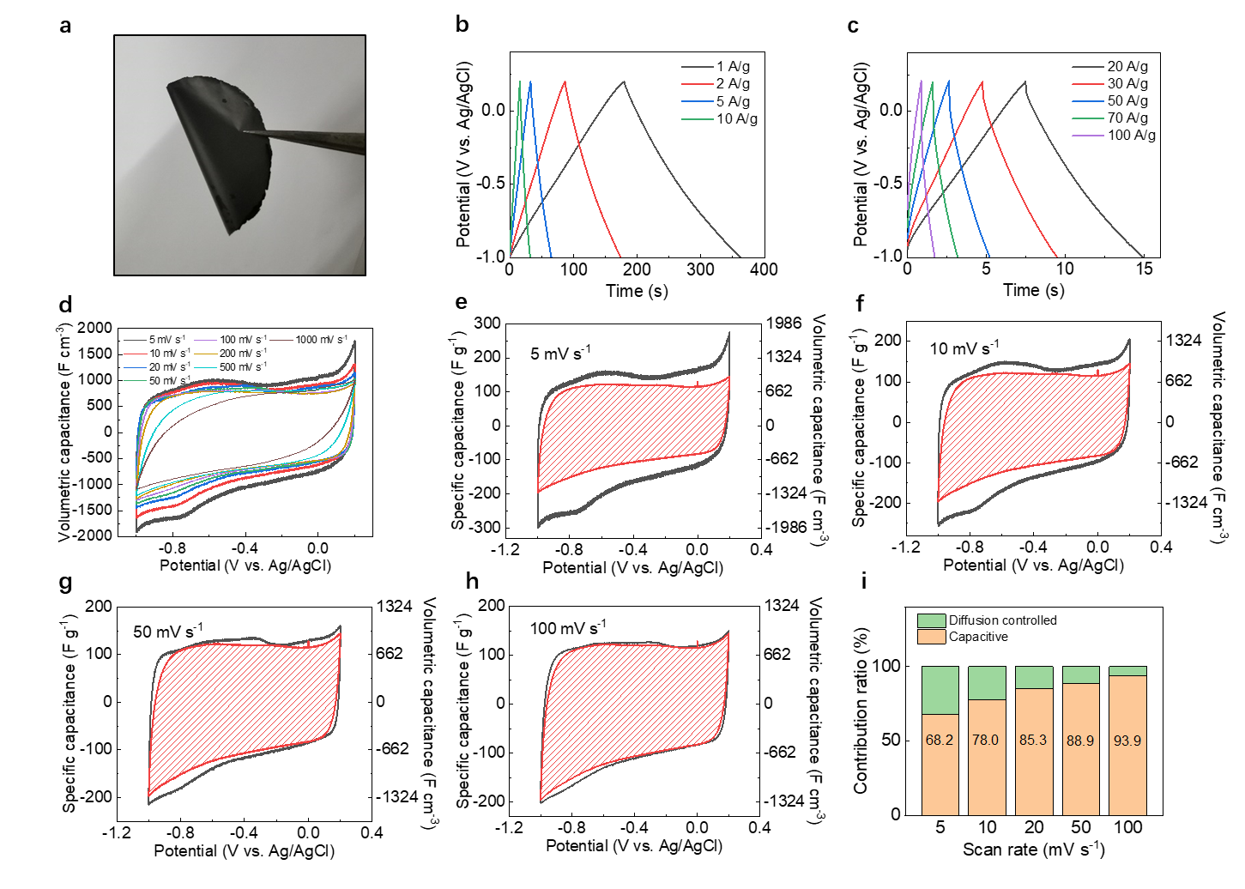
Supplementary Figure 3. (a) Image of the 1.45-μm-thick Li⁺-intercalated MoS₂ film. (b-c) GCD and (d) CV curves of the 1.45-μm-thick MoS₂ film. Surface capacitive and diffusion-limited contributions of the 1.45-μm-thick MoS₂ film at the CV scan rates of (e) 5 mV s⁻¹, (f) 10 mV s⁻¹, (g) 50 mV s⁻¹ and (h) 100 mV s⁻¹, along with (i) their normalized contribution ratios.

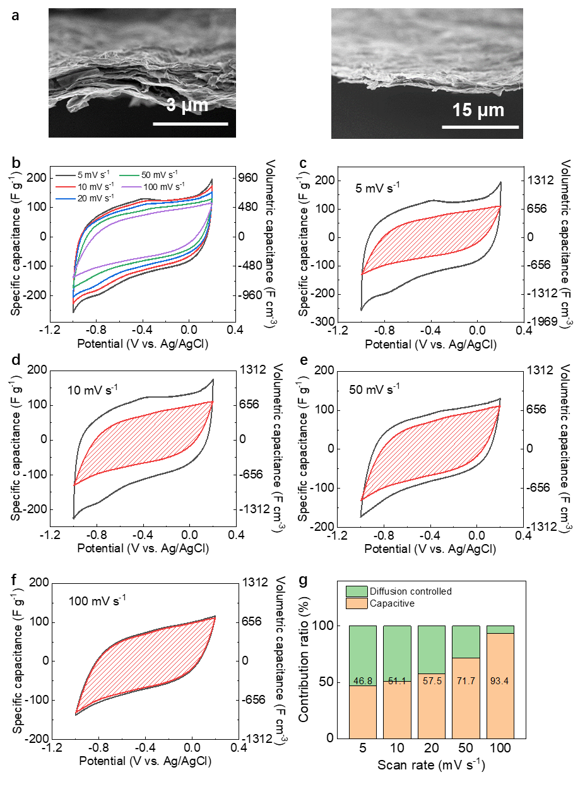
Supplementary Figure 4. (a) SEM images and (b) CV curves of the 1.60-μm-thick MoS₂ film from the traditional hydrothermal method, which shows a volumetric capacitance of 763.9 F cm⁻³ at 5 mV s⁻¹. Surface capacitive and diffusion-limited contributions of the 1.60-μm-thick MoS₂ film at the CV scan rates of (c) 5 mV s⁻¹, (d) 10 mV s⁻¹, (e) 50 mV s⁻¹ and (f) 100 mV s⁻¹, along with (f) their normalized contribution ratios.
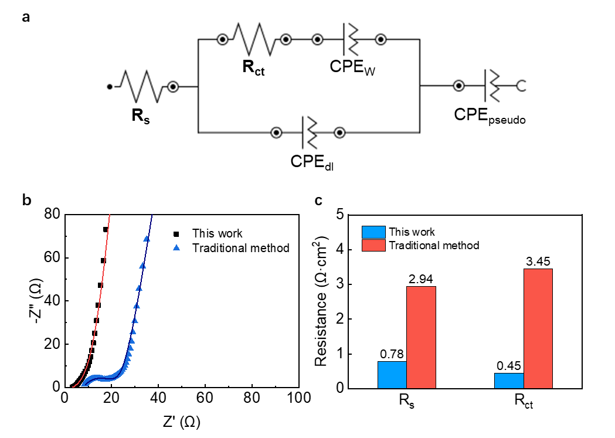
Supplementary Figure 5. (a) Schematic of the equivalent circuit model. In the model, the combined resistance of electrode and electrolyte is represented by reduced equivalent series resistance (R_{s}). Charge-transfer resistance (R_{ct}) is calculated from the semicircle of the Nyquist plot. CPE_{dl} and CPE_{pseudo} represent electric double layer capacitance and possibly-existed pseudocapacitance, respectively. The low-frequency region of the Nyquist plot is related to the diffusion-controlled processes (CPE_{w}). (b) The fitting curves (red line for this work; blue line for the traditional method) and the calculated equivalent series resistance (R_{s}) and charge transfer resistance (R_{ct}) based on the equivalent circuit model.

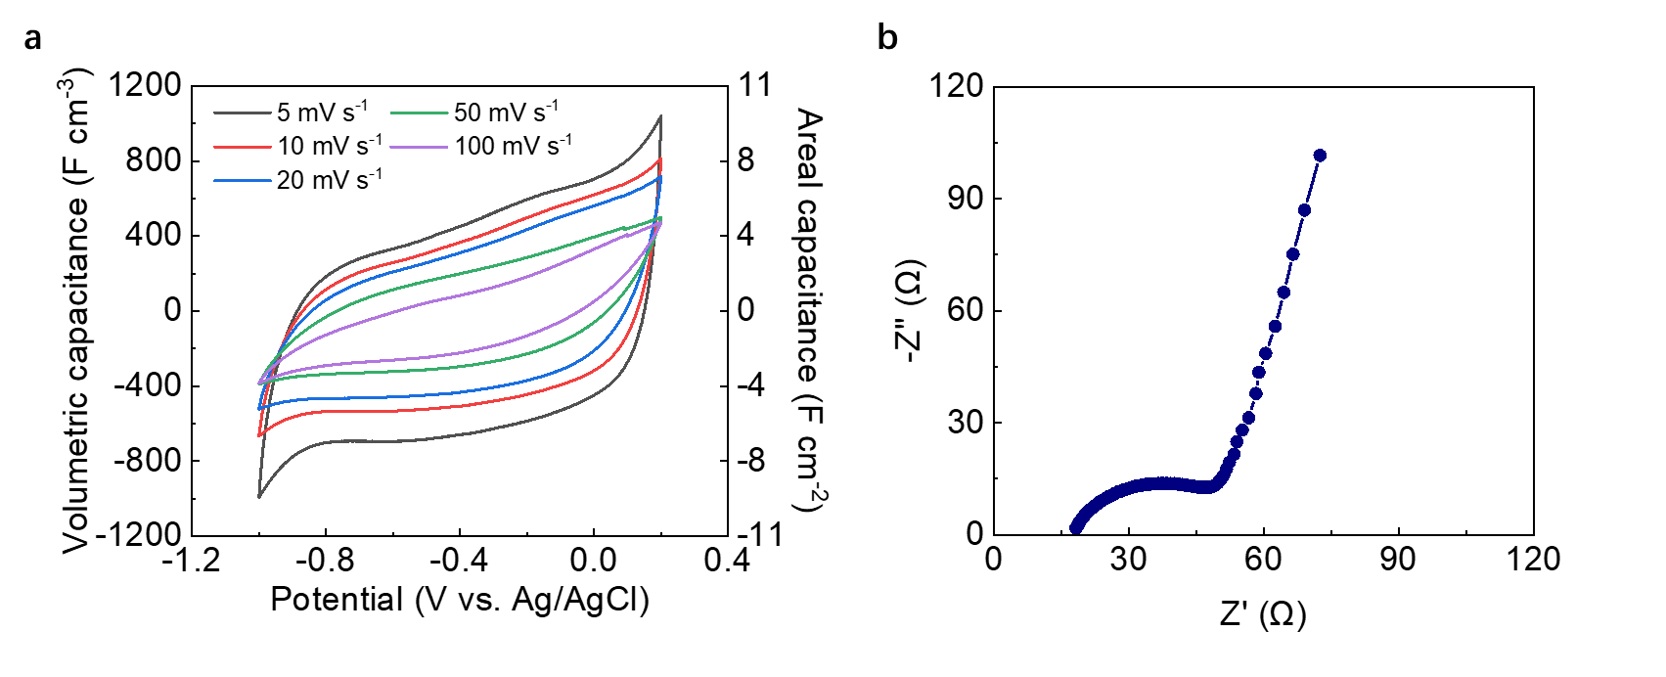
Supplementary Figure 6. (a) CV curves and (b) EIS test of the 94.2-μm-thick MoS₂ film.

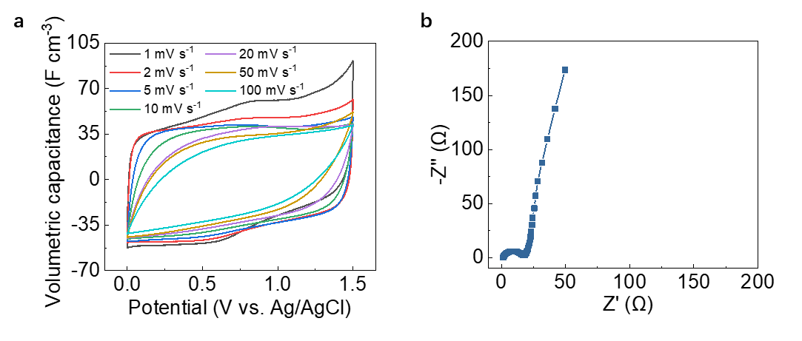
Supplementary Figure 7. CV curves and EIS test of the asymmetric MoS₂||activated carbon supercapacitor.

