Zn²⁺-mediated siRNA-doxorubicin Self-Assembled Nanoparticles amplify immunogenic cell death via aggravating redox dyshomeostasis for cancer therapy
Tab.S1 The results of entrapment efficiency (EE%) (n = 3)
Sample | Mass ratio (m/m) | LE% | EE%
Zn²⁺/DOX | 1:1 | 40.6 ± 0.71 | 99.44 ± 1.38
Zn²⁺/DOX | 1:2 | 73.08 ± 0.79 | 99.42 ± 0.72
Zn²⁺/DOX | 1:4 | 73.34 ± 0.86 | 76.02 ± 1.53

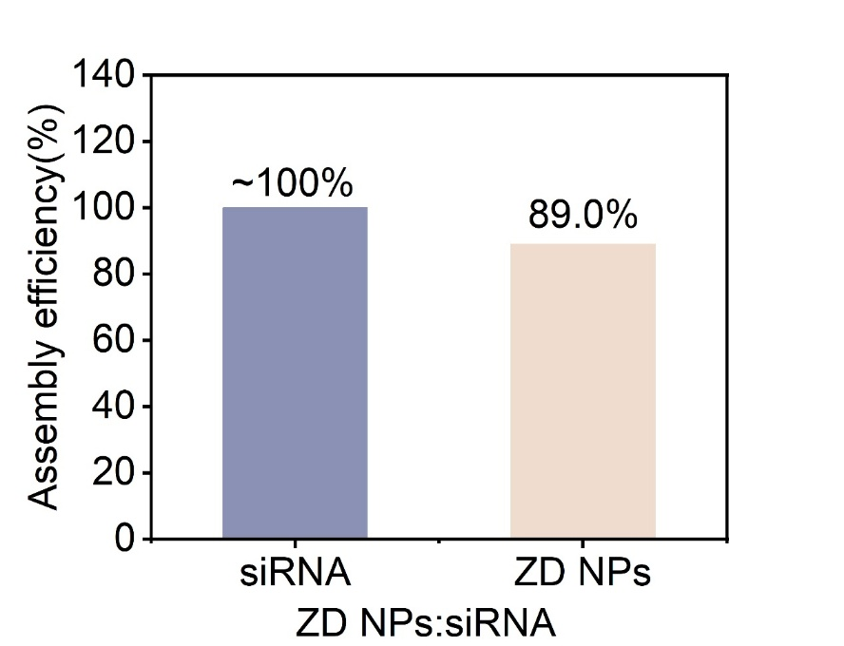
Fig.S1 The assembly efficiencies of ZD NPs and siRNA in the ZD NPs:siRNA.

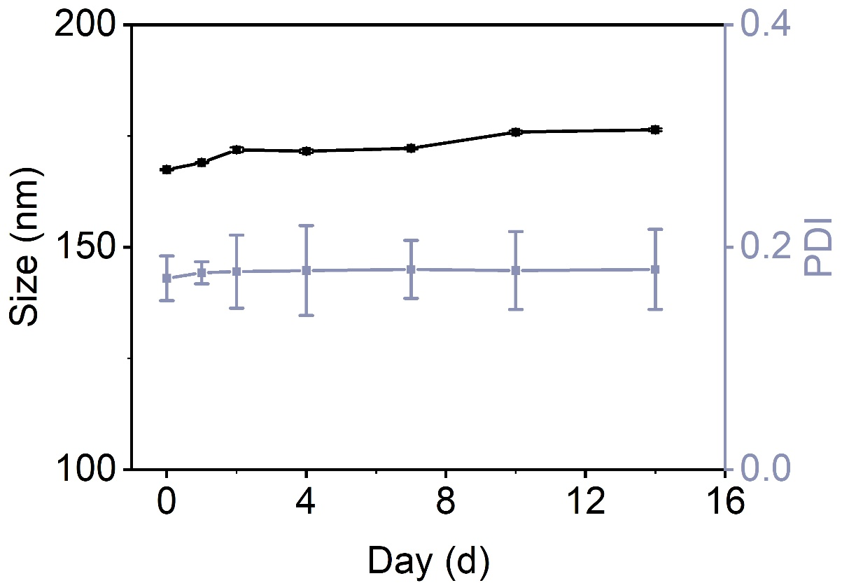
Fig.S2 Serum stability of ZD NPs

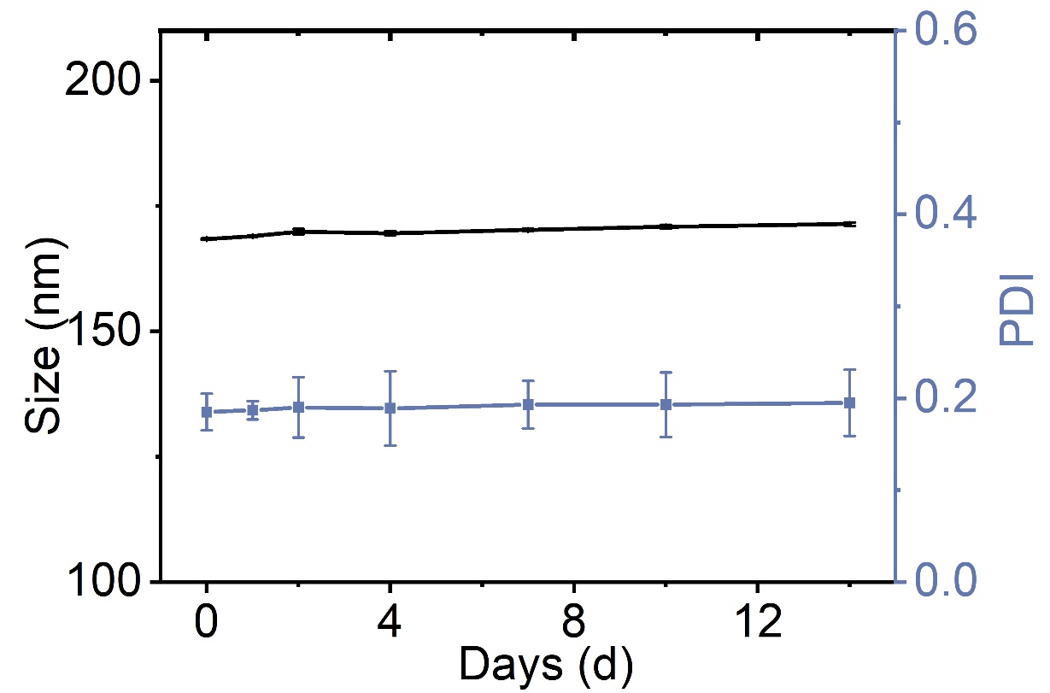
Fig.S3 Serum stability of ZDS NPs

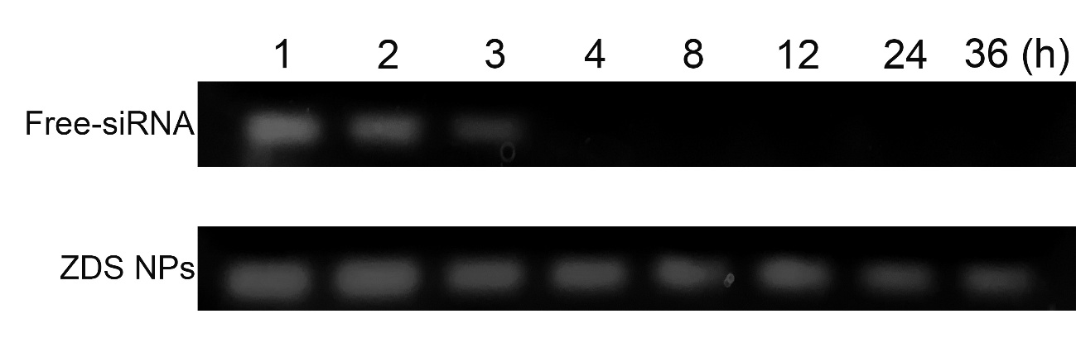
Fig.S4 In vitro serum stability of ZDS NPs determined using agarose gel electrophoresis analysis

Tab.S2 Tumor inhibition rate of 4T1-bearing mice treated with different DOX formulations.
(n = 6, compared to control, ***P < 0.001).
Treatment group | TIR_{V}(%)
Control | -
DOX | 58.7 ± 4.2
Zn²⁺-DOX NPs | 65.3±5.7
Zn²⁺-DOX@siRNA | 86.4± 0.72***

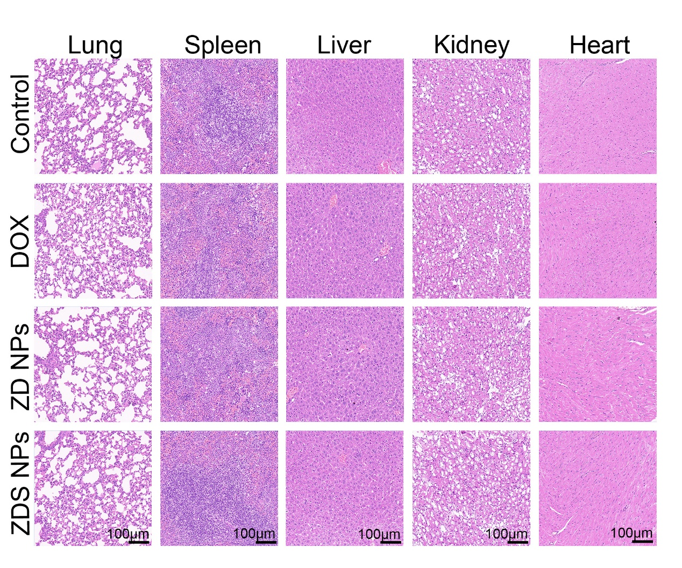
Fig.S5 H&E staining of the heart, liver, spleen, lung, and kidney of major organs scale bars represented 100 μm.

