Supporting Information
High Entropy Effect Induced In-situ Surface Hydroxylation for Robust Electro-Assisted Uranium Mineralization from Real Nuclear Wastewater
Hailin Wu^{1#}, Xiaofang Feng^{1#}, Xiaochuan Deng¹, Xun Yang¹, Wenjie Sun¹, Xue Jiang¹, Liwen Zhou¹, Zicheng Yao¹, Tao Chen^{1,}*, Wenkun Zhu^{1,}*
¹State Key Laboratory of Environment-friendly Energy Materials, National Co-innovation Center for Nuclear Waste Disposal and Environmental Safety, Sichuan Civil-military Integration Institute, School of National Defense of Science and Technology, Southwest University of Science and Technology, Mianyang, 621010, PR China.

#These authors contributed equally.
*Corresponding author: chent@swust.edu.cn (Tao Chen); zhuwenkun@swust.edu.cn (Wenkun Zhu)
Electrochemical Extraction Experiments
For simulated nuclear wastewater, all electrochemical experiments were performed in a 100 mg L⁻¹ UO₂²⁺ and 30 g L⁻¹ F⁻ solution if not otherwise stated. KF·2H₂O was used to simulate high concentrations of fluoride ions in nuclear wastewater. The linear sweep voltammetry (LSV) measurement ranges from 0 V to -1.5 V (vs. Ag/AgCl). As a comparison, the uranium extraction performance of La(CrFeCoNiCu)O₃, La(CrCoNi)O₃ and LaCrO₃ was studied carefully. In the cyclability experiments, a constant positive potential of 1 V (vs. Ag/AgCl) was applied to the working electrode after uranium extraction in a 0.1 M HNO₃ electrolyte until completely desorbed. Then place the desorbed working electrode in a simulated solution under the same conditions for experiments and repeat the above steps. The performance of uranium extraction under different pH was tested by adding NH₃·H₂O or HNO₃ directly to adjust the pH of the simulated solution. The interference experiments were carried out by adding 0.1 g L⁻¹ interfering ions (SO₄²⁻, NO₃⁻, NH₄⁺, CO₃²⁻, Cl⁻, C₂O₄²⁻).
The real nuclear waste water comes from cleaning the containers of the uranium enrichment plant. The self-assembly device with triple tandem electrolytic cell used in the real nuclear wastewater experiment is composed of a corrosion-resistant polytetrafluoroethylene (PTFE) lining and a radiation shielding shell. The electrochemical parameters (current, voltage, electrolysis time, etc.) can be preset through the automatic control system. The preparation method of working electrode is similar to that in simulated solution. Specifically, 400 mg of materials were loaded on three 5×5cm carbon paper. After the electrolysis, the uranium products at the bottom of the electrode and electrolytic cell can be easily collected by ultrasonic and centrifugal purification.
Calculation of Extraction Efficiency and Economic Feasibility
The uranium concentration in simulated wastewater was measured using a UV-vis transmittance spectra (PE Lambda 650 UV vis NIR spectrophotometer), while the uranium concentration in real nuclear wastewater was determined by inductively coupled plasma mass spectrometry (ICP-MS Agilent 7700).
The extraction efficiency of U(Ⅵ) (n, %), extraction capacity (q_{t}, mg g⁻¹), and economic feasibility (f, kW·h) were calculated by the following equations:
n = (C₀-C_{t})/C₀×100% (1)
In the above equation, C₀ (mg mL⁻¹) and C_{t} (mg mL⁻¹) are the initial concentration of U(VI) and the real-time concentration of U(VI), respectively.
q_{t} = (C₀-C_{t})V/m (2)
In the above equation, C₀ (mg mL⁻¹), C_{t} (mg mL⁻¹), V (mL), and m (g) are the initial concentration of U(VI), the real-time concentration of U(VI), the volume of the electrolyte and the mass of the sample catalyst, respectively.
${\text{m}}_{\text{2}}\text{=}\frac{{\text{m}}_{\text{1}}}{\text{666.2}}\text{×}\frac{\text{2}}{\text{3}}\text{×842}$ (3)
$\text{f}\text{=}\frac{\text{I}\text{×}\text{U}\text{×}\text{T}}{{\text{10}}^{\text{3}}\text{×}{\text{m}}_{\text{2}}}$ (4)
In equation (3), m₁ and m₂ (Kg) are the mass of K₂U₂O₇, U₃O₈, respectively. The mass of K₂U₂O₇ is converted into U₃O₈ with the same mass of uranium by equation (3).
In equation (4), I (A), U (V), T (h), and m₂ (Kg) are the electric current, voltage, power-on time, and mass (U₃O₈), respectively.

Supplementary Fig. 1 Optimized structural models of La(CrFeCoNiCu)O₃ and LaCrO₃.
Supplementary Fig. 2 ELF mappings and corresponding cross-sectional position. (a) ELF mapping of La(CrFeCoNiCu)O₃. (b-d) The cross-sectional positions corresponding to the ELF mapping of LaCrO₃, La(CrFeCoNiCu)O₃, and La(CrFeCoNiCu)O₃-OH.
Supplementary Fig. 3 Optimized adsorption models and adsorption energy of UO₂²⁺ on (a) LaCrO₃ and (b) La(CrFeCoNiCu)O₃-OH.
Supplementary Fig. 4 Optimized adsorption models and adsorption energy of UO₂F⁺ on (a) LaCrO₃ and (b) La(CrFeCoNiCu)O₃-OH.
Supplementary Fig. 5 The cross-sectional positions corresponding to the ELF mapping of UO₂F⁺ adsorption on (a) LaCrO₃ and (b) La(CrFeCoNiCu)O₃-OH.
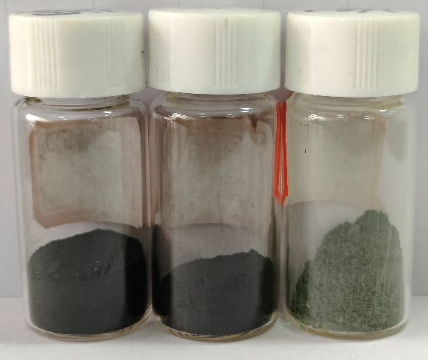
Supplementary Fig. 6 Digital photos of La(CrFeCoNiCu)O₃, La(CrCoNi)O₃, and LaCrO₃ from left to right.
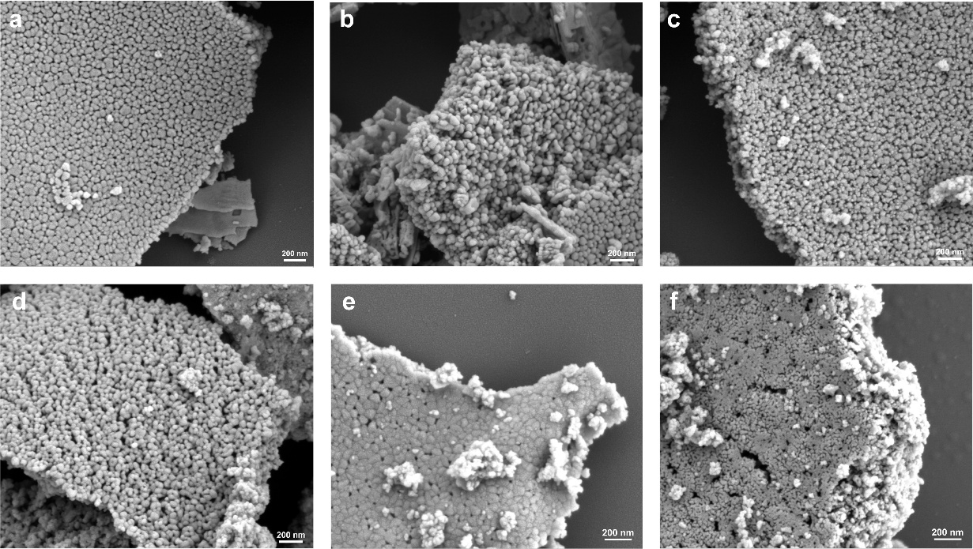
Supplementary Fig. 7 The morphology of (a-b)LaCrO₃, (c-d)La(CrCoNi)O₃ and (e-f)La(CrFeCoNiCu)O₃.
Supplementary Fig. 8 The specific surface area of La(CrFeCoNiCu)O₃, La(CrCoNi)O₃, and LaCrO₃.
Supplementary Fig. 9 EDS elemental mapping images of LaCrO₃.
Supplementary Fig. 10 EDS elemental mapping images of La(CrCoNi)O₃.
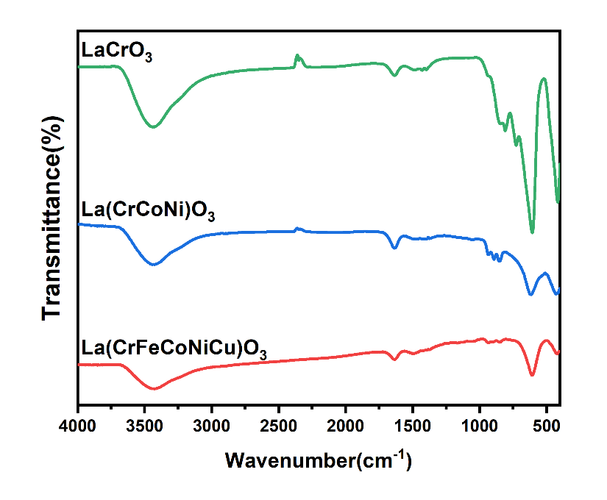
Supplementary Fig. 11 FT-IR spectra of LaCrO₃, La(CrCoNi)O₃ and La(CrFeCoNiCu)O₃.

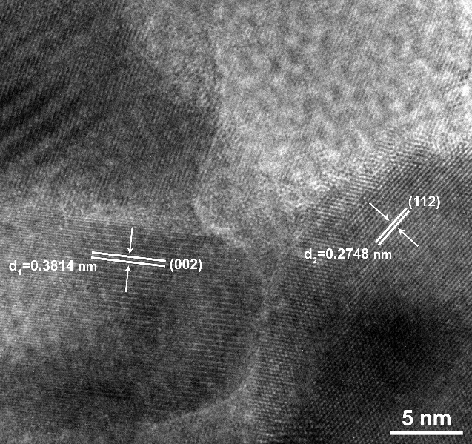
Supplementary Fig. 12 HRTEM image of La(CrFeCoNiCu)O₃.
Supplementary Fig. 13 XPS spectra of (a)La, (b)Cr, (c)Co, (d)Ni, (e)Fe, (f)Cu.
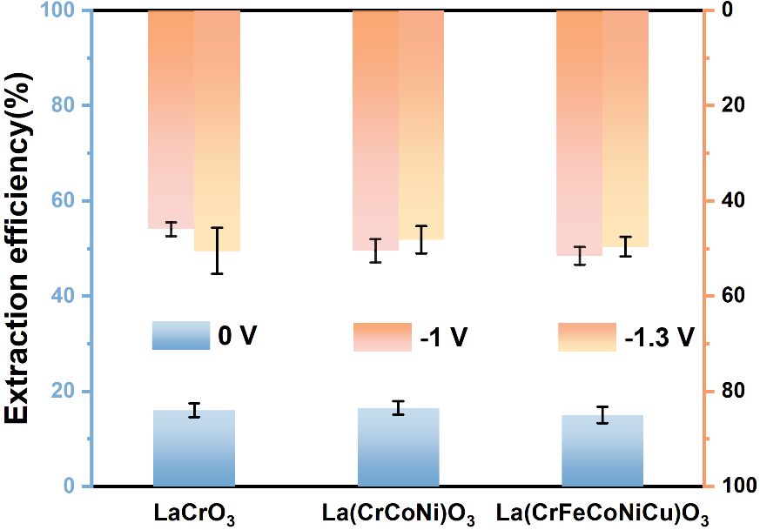
Supplementary Fig. 14 Uranium extraction efficiency of LaCrO₃, La(CrCoNi)O₃, and La(CrFeCoNiCu)O₃ under different voltages.
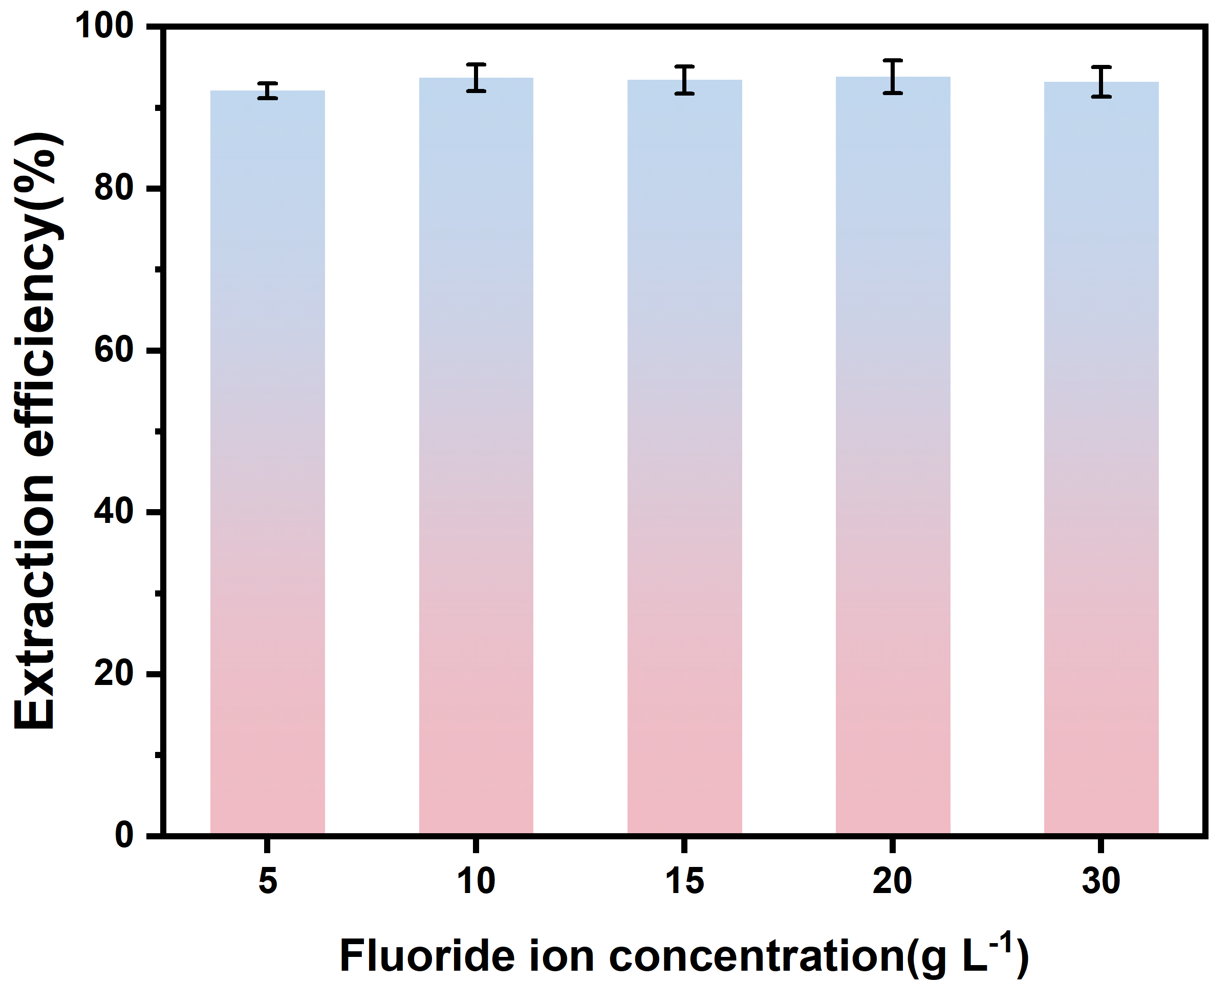
Supplementary Fig. 15 Extraction efficiency of La(CrFeCoNiCu)O₃ at different fluoride ion concentrations.

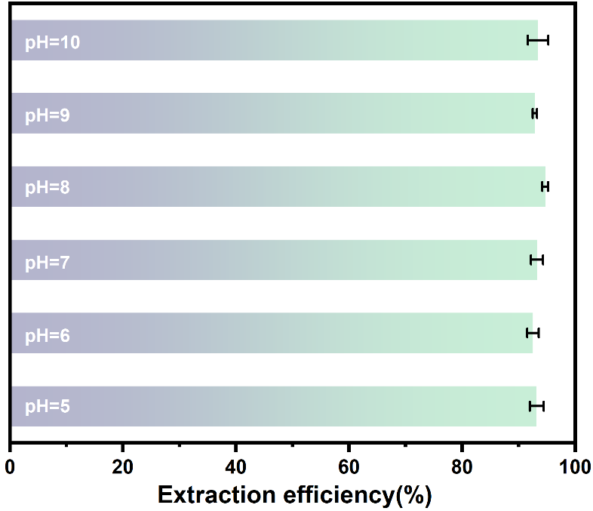
Supplementary Fig. 16 Extraction efficiency of La(CrFeCoNiCu)O₃ at different pH values.

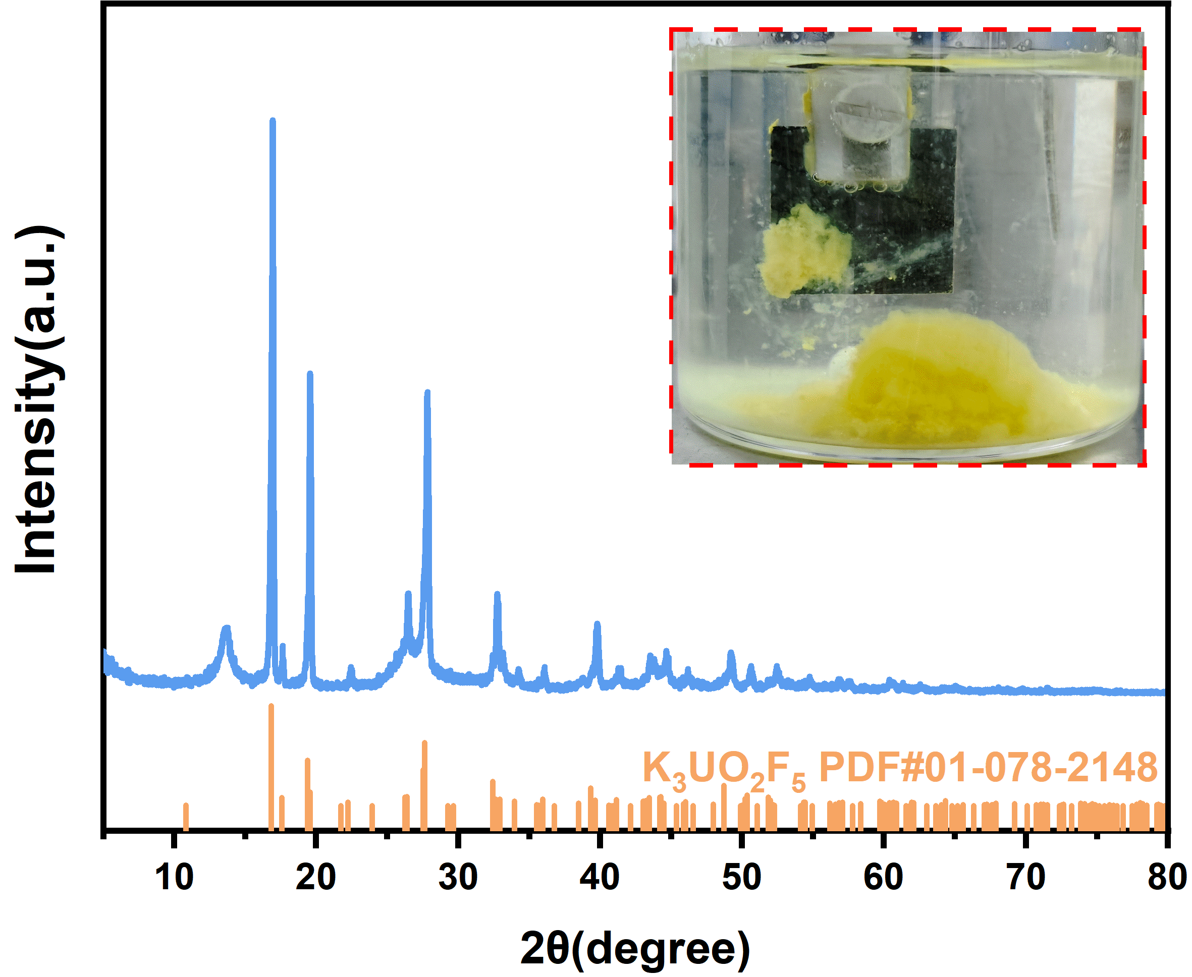
Supplementary Fig. 17 XRD pattern of uranium products (inset: digital photograph of uranium products under high concentration).

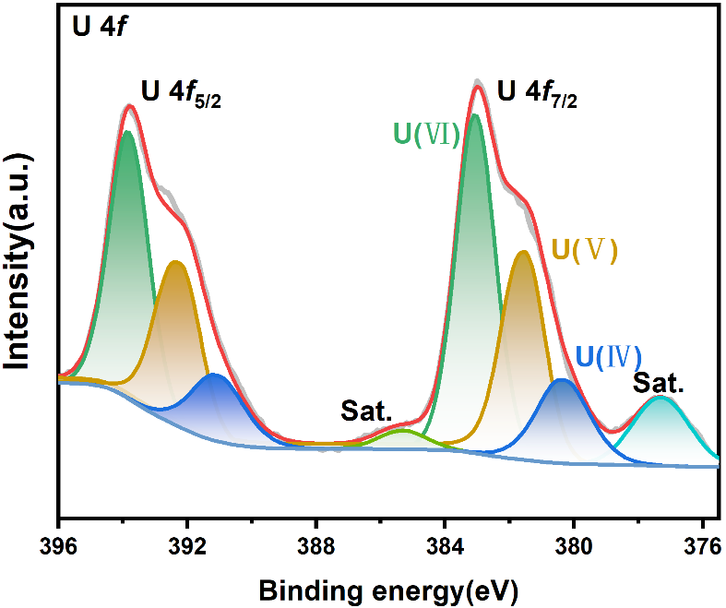
Supplementary Fig. 18 XPS spectrum of uranium products.
Supplementary Fig. 19 In-situ ESR signal of ·O₂⁻ (a) and ·OH＆CO₃⁻· (b) for La(CrFeCoNiCu)O₃ in simulated nuclear wastewater.
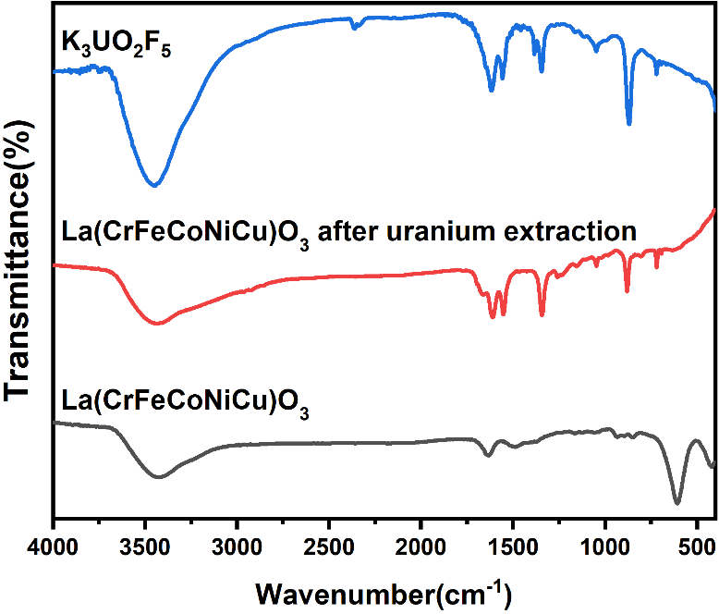
Supplementary Fig. 20 FT-IR spectra of K₃UO₂F₅, La(CrFeCoNiCu)O₃ after uranium extraction and La(CrFeCoNiCu)O₃.

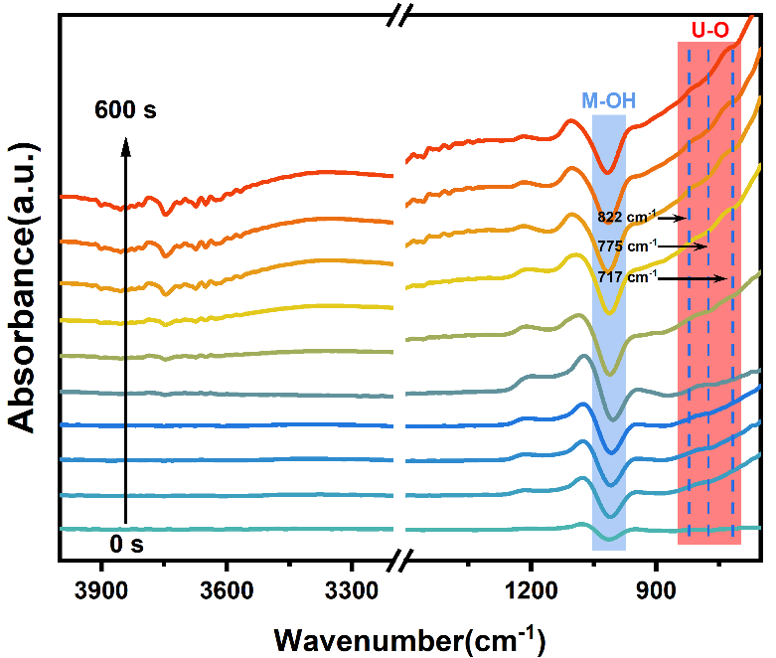
Supplementary Fig. 21 In situ ATR-SEIRAS of La(CrFeCoNiCu)O₃ in uranium-only solution (containing 0.5 M Na₂SO₄ to increase conductivity).

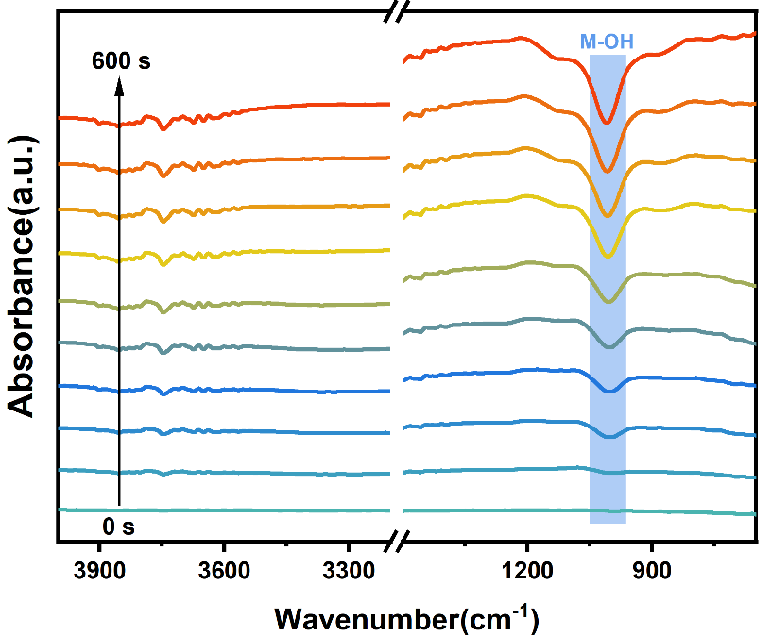
Supplementary Fig. 22 In situ ATR-SEIRAS of La(CrFeCoNiCu)O₃ in fluoride-only solution.

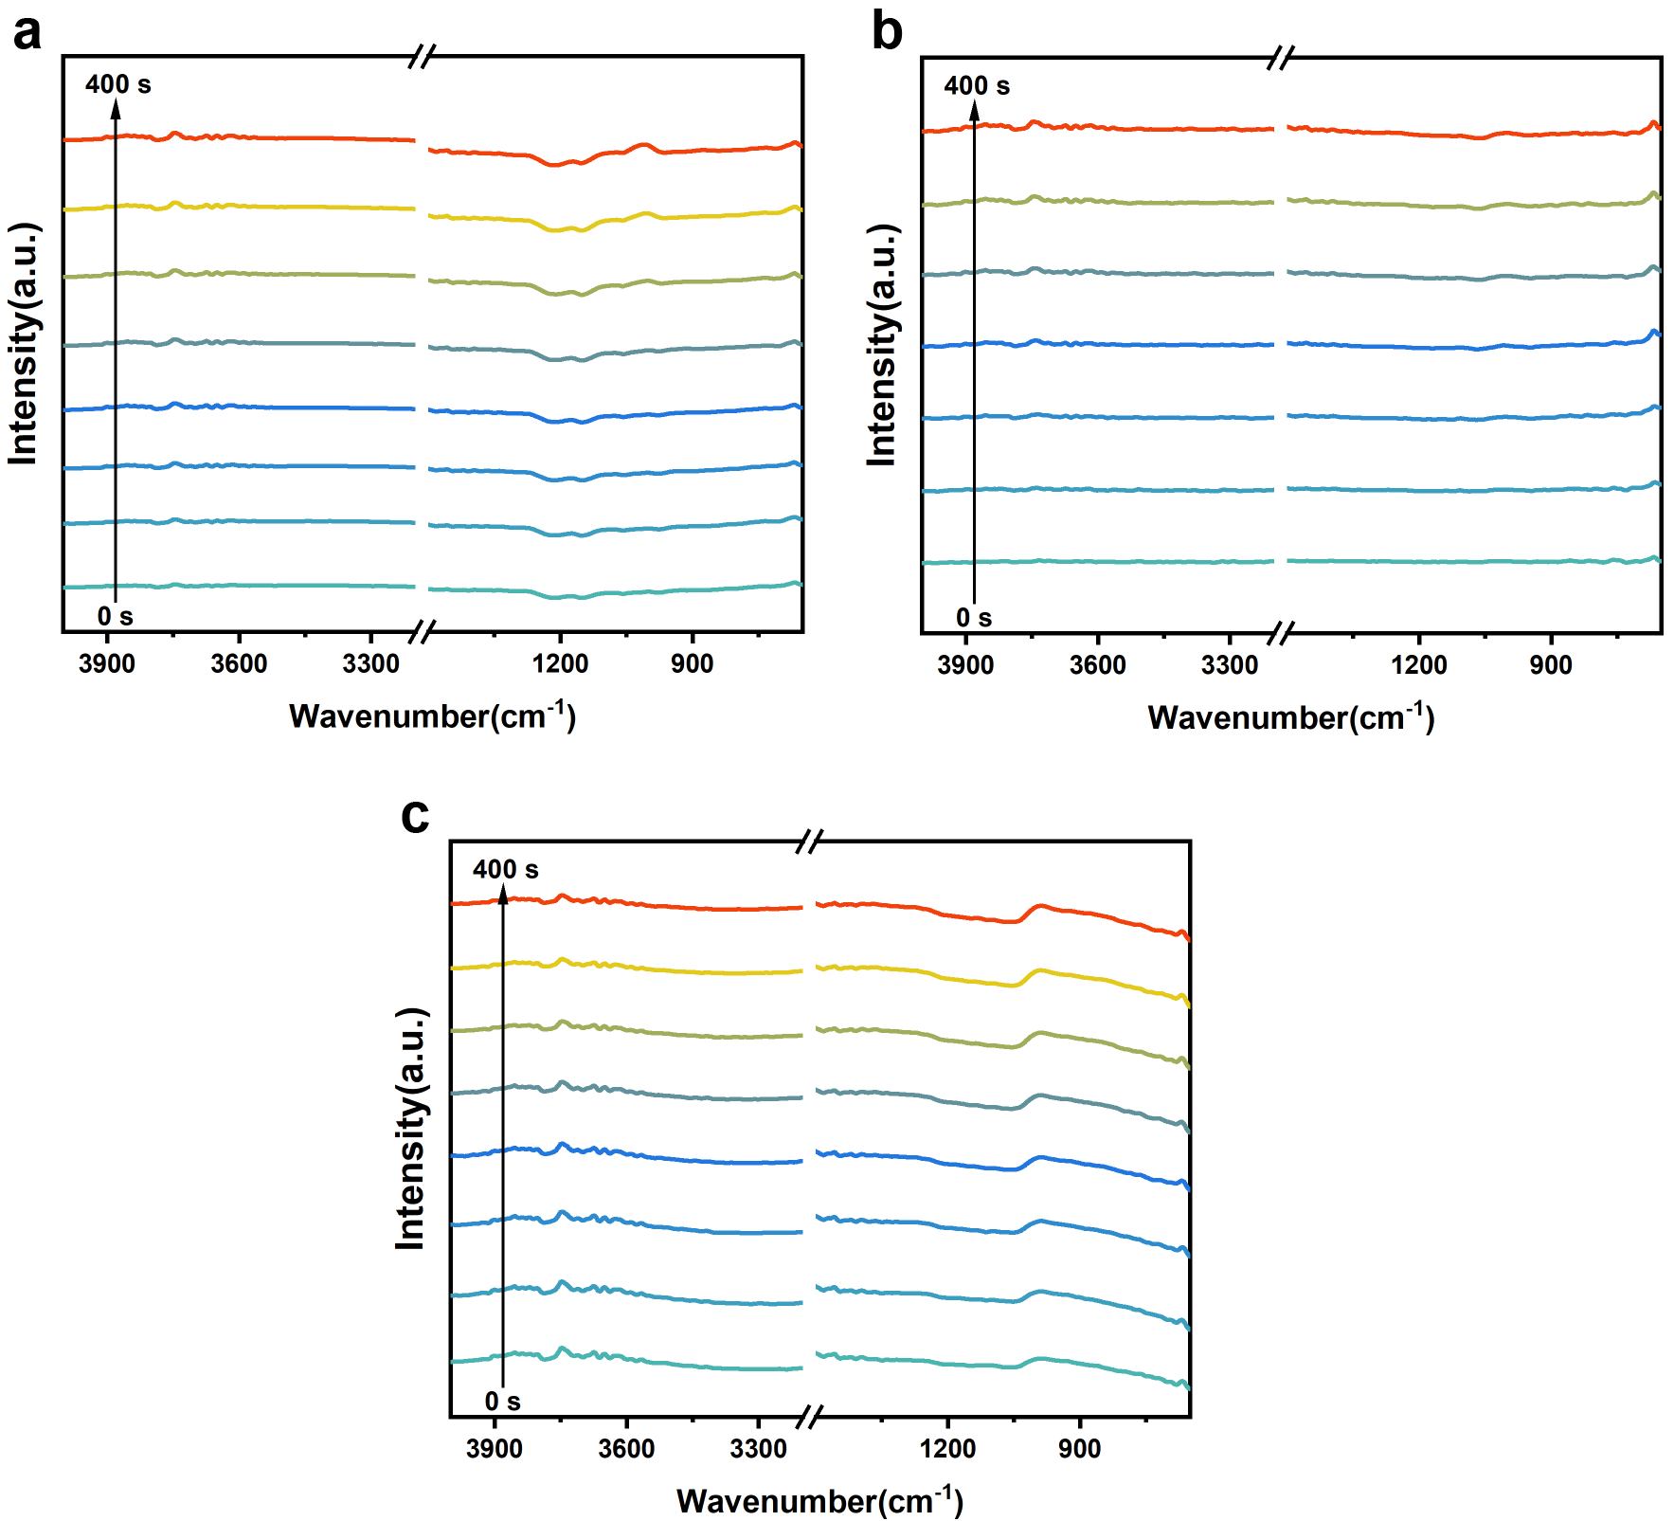
Supplementary Fig. 23 In situ ATR-SEIRAS of LaCrO₃. (a) solution containing 250 mg L⁻¹ U(Ⅵ) and 30 g L⁻¹ F. (b) uranium-only solution (containing 0.5M Na₂SO₄ to increase conductivity). (c) fluoride-only solution.

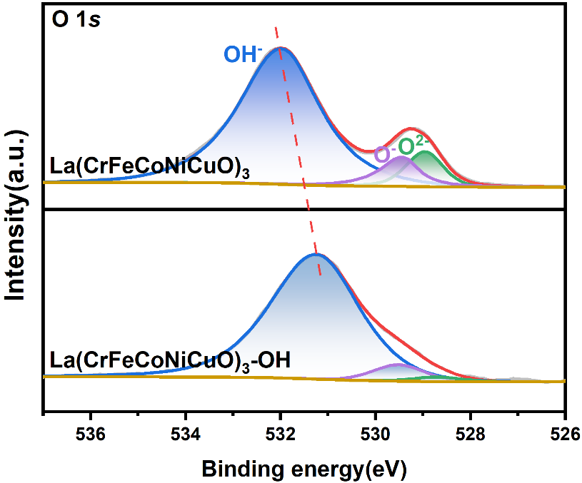
Supplementary Fig. 24 The XPS spectra of La(CrFeCoNiCu)O₃ and La(CrFeCoNiCu)O₃-OH.

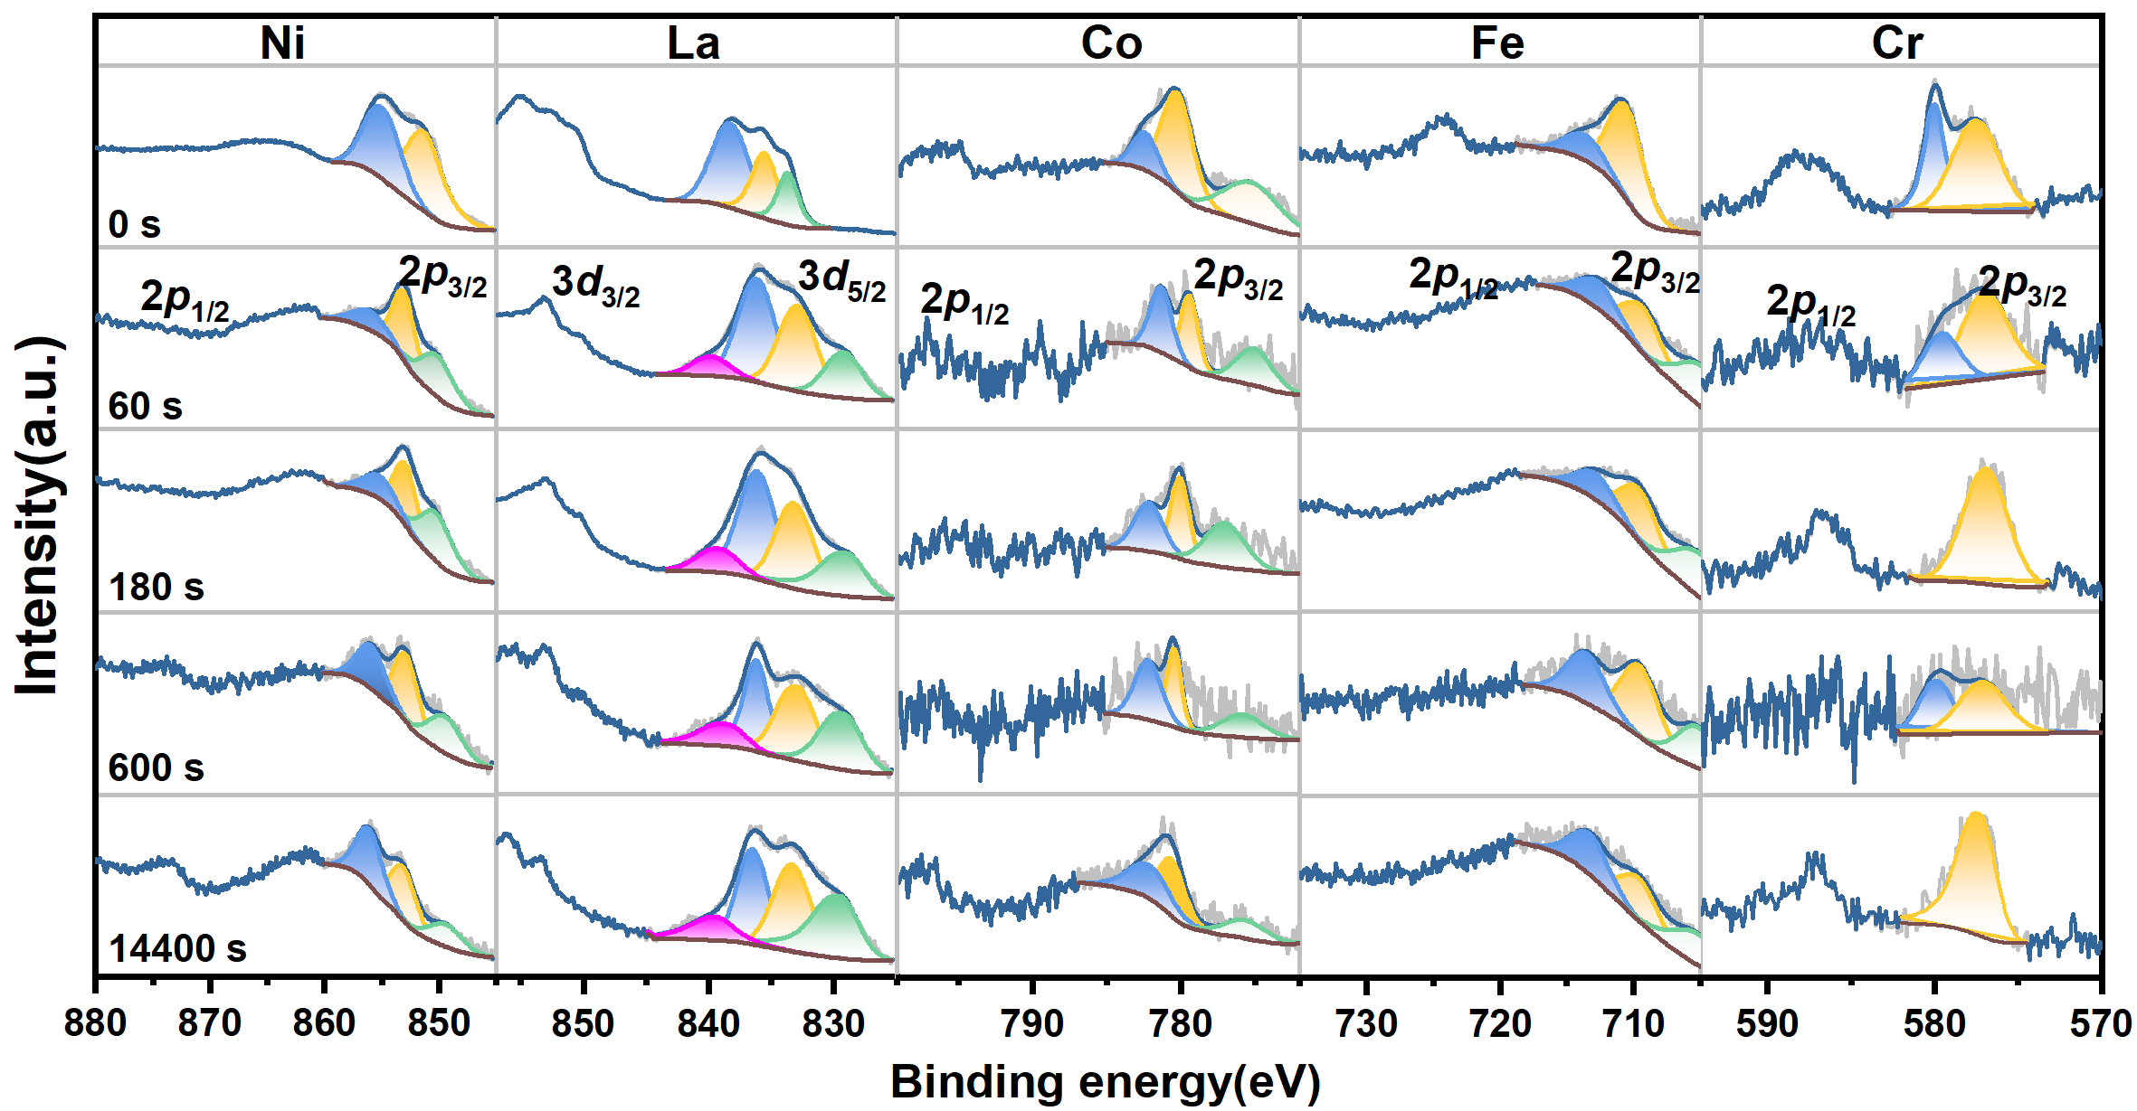
Supplementary Fig. 25 The XPS spectra of different metals in La(CrFeCoNiCu)O₃ during reaction.

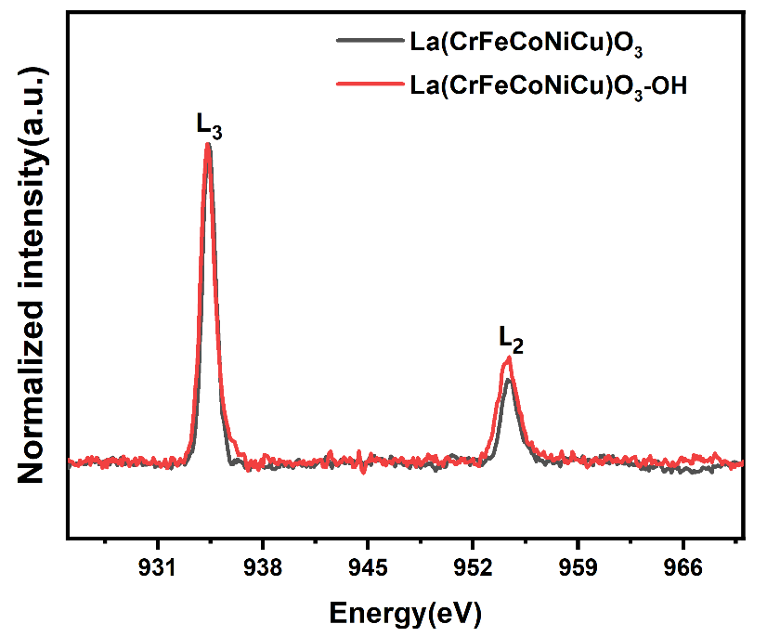
Supplementary Fig. 26 The XAS spectra of Cu in La(CrFeCoNiCu)O₃ and La(CrFeCoNiCu)O₃-OH.s

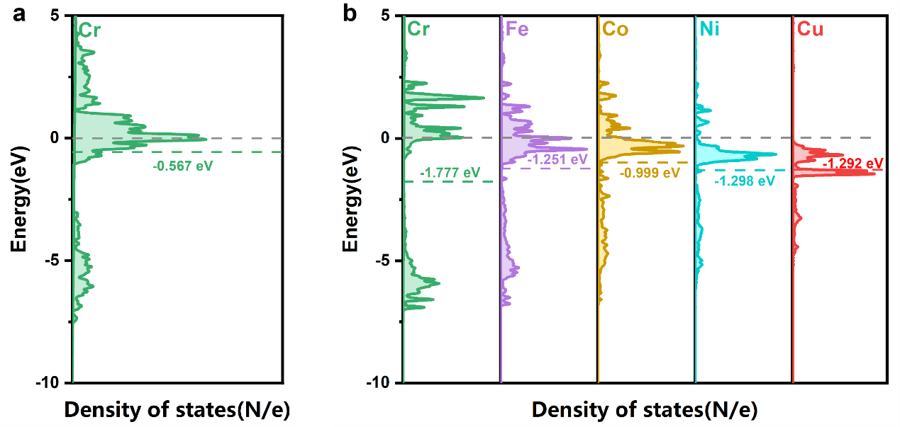
Supplementary Fig. 27 (a) d-band center of Cr in LaCrO₃. (b) d-band center of Cr, Fe, Co, Ni, Cu in La(CrFeCoNiCu)O₃.
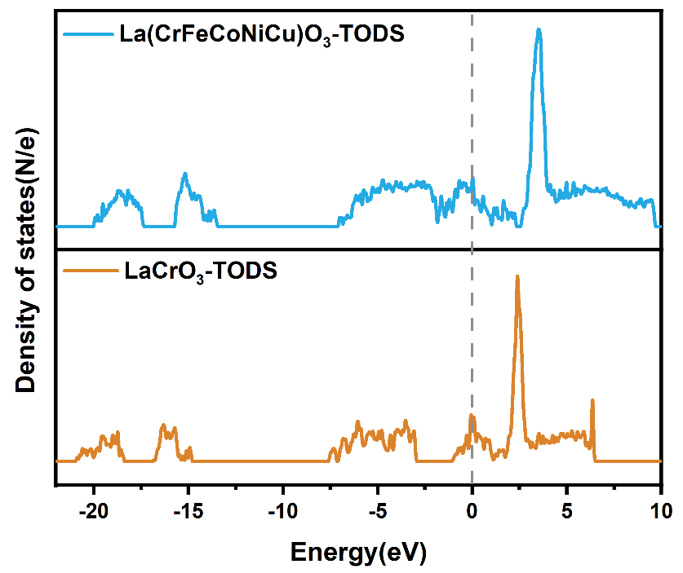
Supplementary Fig. 28 The PDOS of La(CrFeCoNiCu)O₃ and LaCrO₃.
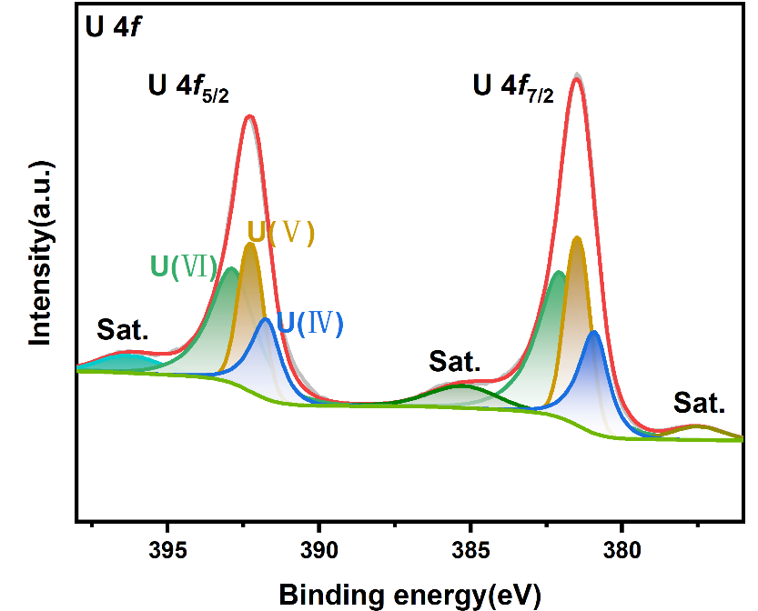
Supplementary Fig. 29 The XPS spectra of the MUP.
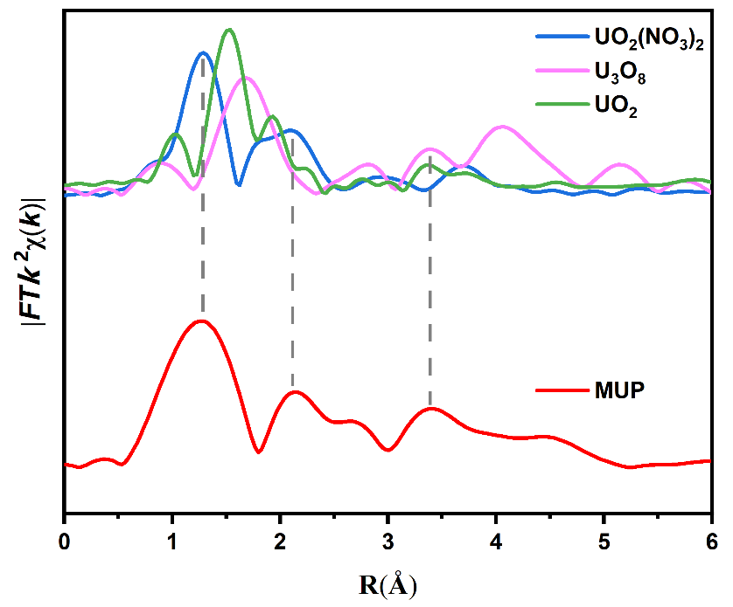
Supplementary Fig. 30 The FT k² -weighted EXAFS spectra of the MUP.

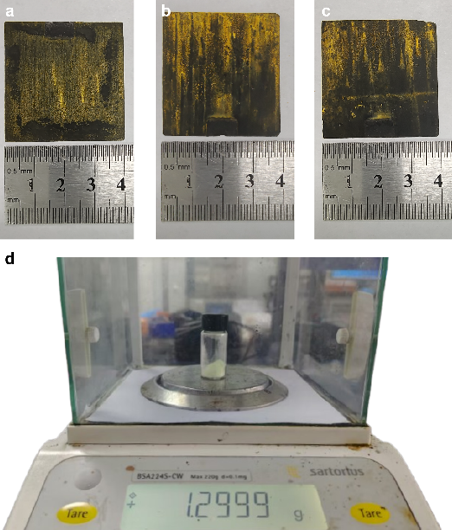
Supplementary Fig. 31 (a-c) digital photographs of electrodes after extraction with tandem electrolytic cell and (d) uranium products.

Supplementary References
(1) Chen, T.; Liu, T.; Zhou, L.; Li, M.; Meng, Q.; Yu, K.; Lian, J.; Zhu, W. Ternary Boron Carbon Nitrides Hollow Nanotubes with Tunable P-NHomojunction for Photo-Assisted Uranium Extraction: A Combined Batch, EXAFS and DFT Calculations. Appl. Catal. B Environ. 2022, 318, 121815.
(2) Chen, T.; He, P.; Liu, T.; Zhou, L.; Li, M.; Yu, K.; Meng, Q.; Lian, J.; Zhu, W. MXene-Derived 3D Defect-Rich TiO₂@Reduced Graphene Oxide Aerogel with Ultrafast Carrier Separation for Photo-Assisted Uranium Extraction: A Combined Batch, X-Ray Absorption Spectroscopy, and Density Functional Theory Calculations. Inorg. Chem. 2022, 61 (32), 12759–12771.
(3) Liu, X.; Xie, Y.; Hao, M.; Li, Y.; Chen, Z.; Yang, H.; Waterhouse, G. I. N.; Wang, X.; Ma, S. Secondary Metal Ion-Induced Electrochemical Reduction of U(VI) to U(IV) Solids. Nat. Commun. 2024, 15 (1), 7736.
(4) Feng, C.; Zhou, Y.; Chen, M.; Zou, L.; Li, X.; An, X.; Zhao, Q.; Xiaokaiti, P.; Abudula, A.; Yan, K.; Guan, G. High-Entropy Spinel (FeCoNiMnAl)₃O₄with Three-Dimensional Microflower Structure for Stable Seawater Oxidation. Appl. Catal. B Environ. Energy 2024, 349, 123875.
(5) Zhang, C.; Wang, Z.; Ma, R.; Cao, J.; Ruan, X.; Cao, D.; Song, Y.; Chen, S.; Song, Y.; Wang, F.; Yuan, Y.; Yang, Y.; Zhu, G. Overcoming Chemical Dissociation Processes: Electrochemical Modulation of High‐Affinity Binding Sites for Rapid Uranium Extraction from Seawater. Adv. Funct. Mater. 2025, 35 (2), 2412712.
(6) Li, Y.; Ma, Y.; Liao, Y.; Ji, L.; Zhao, R.; Zhu, D.; Hu, X.; Qin, G.; Rong, H.; Zhang, X. High‐Entropy‐Alloy‐Nanoparticles Enabled Wood Evaporator for Efficient Photothermal Conversion and Sustainable Solar Desalination. Adv. Energy Mater. 2022, 12 (47), 2203057.
(7) Li, W.; Zhao, Z.; Zhao, J.; Wang, Y.; Wang, X. High Entropy La(Cr_{0.2}Mn_{0.2}Fe_{0.2}Co_{0.2}Ni_{0.2})O₃ with Tailored Eg Occupancy and Transition Metal-Oxygen Bond Properties for Oxygen Reduction Reaction. J. Mater. Sci. Technol. 2024, 194, 236–246.
(8) Raj, S. K.; Carrier, A. J.; Youden, B. C.; Servos, M. R.; Oakes, K. D.; Zhang, X. Electrochemical Techniques for Uranium Extraction from Water. Chem. Eng. J. 2024, 492, 152341.
(9) Pan, K.; Yang, C.; Hu, J.; Yang, W.; Liu, B.; Yang, J.; Liang, S.; Xiao, K.; Hou, H. Oxygen Vacancy Mediated Surface Charge Redistribution of Cu-Substituted LaFeO₃ for Degradation of Bisphenol A by Efficient Decomposition of H2O2. J. Hazard. Mater. 2020, 389, 122072.
(10) Liu, J.; Zhang, K.; Shang, R.; Zhang, H.; Shen, J.; Liu, H.; Tressel, J.; Bao, Y.; Hui, A.; Xie, H.; Chen, S. Theory-Guided Doping of LaCoO₃ Nanoparticles for Enhanced Antimicrobial Performance. Chem. Eng. J. 2023, 464, 142710.
(11) Kumar, R.; Singh, K. D.; Kumar, R. Effect of Sr Substitution on Structural Properties of LaCrO₃ Perovskite. J. Mater. Sci. Mater. Electron. 2022, 33 (15), 12039–12052.
(12) Chen, C.; Xu, Z.; Hai, G.; Huang, W.; Pao, C.; Li, H.; Jiang, K.; Zhang, N.; Liu, T. Tailoring the d‑Band Center of High‐Entropy Perovskite Oxide Nanotubes for Enhanced Nitrate Electroreduction. Small 2025, 21 (2), 2407964.
(13) Chen, Y.; Chen, C.; Huang, W.-H.; Pao, C.-W.; Chang, C.-C.; Mao, T.; Wang, J.; Fu, H.; Lai, F.; Zhang, N.; Liu, T. Charge Redistribution in High-Entropy Perovskite Oxide Porous Nanotubes Boosts Nitrate Electroreduction to Ammonia. ACS Nano 2024, 18 (31), 20530–20540.
(14) Zheng, H.; Zhang, Y.; Wang, Y.; Wu, Z.; Lai, F.; Chao, G.; Zhang, N.; Zhang, L.; Liu, T. Perovskites with Enriched Oxygen Vacancies as a Family of Electrocatalysts for Efficient Nitrate Reduction to Ammonia. Small 2023, 19 (5), 2205625.
(15) Sun, H.; Song, J.; Shi, P.; Cheng, Z.; Tian, L.; Zhou, M.; Qi, T. Selective Detection of NO Using the Perovskite-Type Oxide LaMO₃ (M = Cr, Mn, Fe, Co, and Ni) as the Electrode Material for Yttrium-Stabilized Zirconia-Based Electrochemical Sensors. J. Mater. Chem. A 2024, 12 (29), 18234–18247.
(16) Nguyen, T. X.; Liao, Y.; Lin, C.; Su, Y.; Ting, J. Advanced High Entropy Perovskite Oxide Electrocatalyst for Oxygen Evolution Reaction. Adv. Funct. Mater. 2021, 31 (27), 2101632.
(17) Toby, B. H.; Von Dreele, R. B. GSAS-II : The Genesis of a Modern Open-Source All Purpose Crystallography Software Package. J. Appl. Crystallogr. 2013, 46 (2), 544–549.

