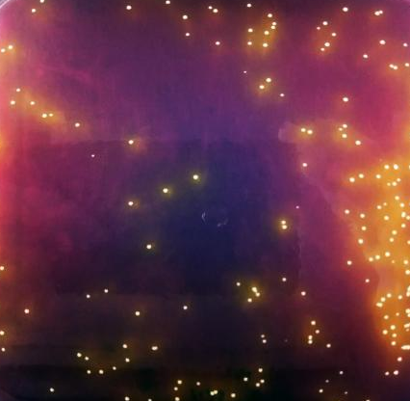
Figure S1 Acid Production Reaction of the Strain with Bromocresol Purple

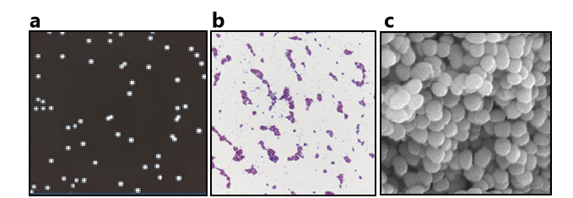
Figure S2 Morphological identification of SSF2. (a) Colony appearance (b) Gram staining of the strain (c) Electron micrograph of the strain.
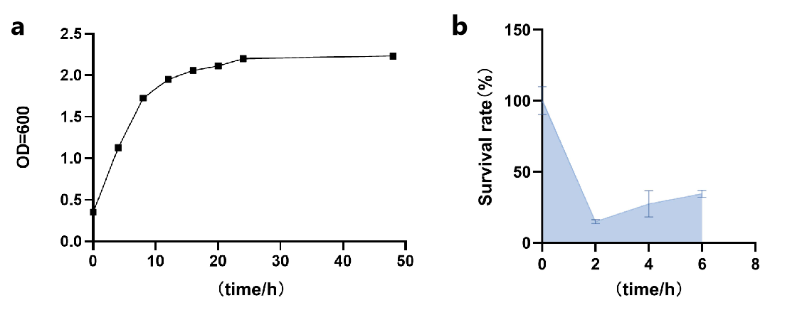
Figure S3 Evaluation of the biological functions of SSF2. (a) Growth performance;(b) Tolerance to simulated intestinal fluid.
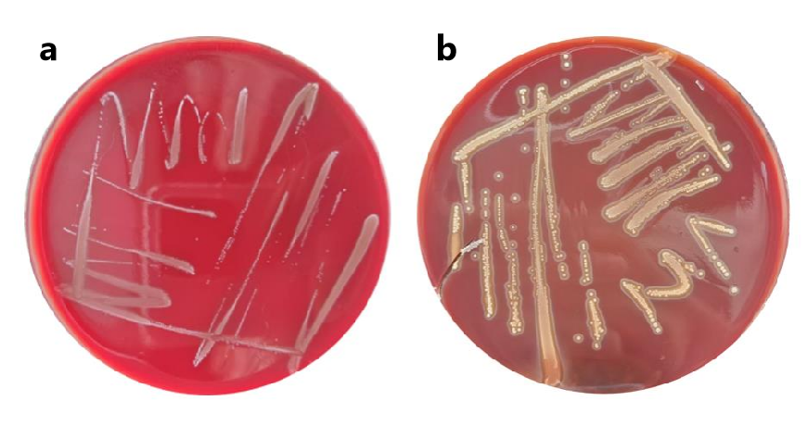
Figue S4 Hemolytic activity assay of the strains:(a) Results for SSF2, (b) Results for
Staphylococcus aureus.

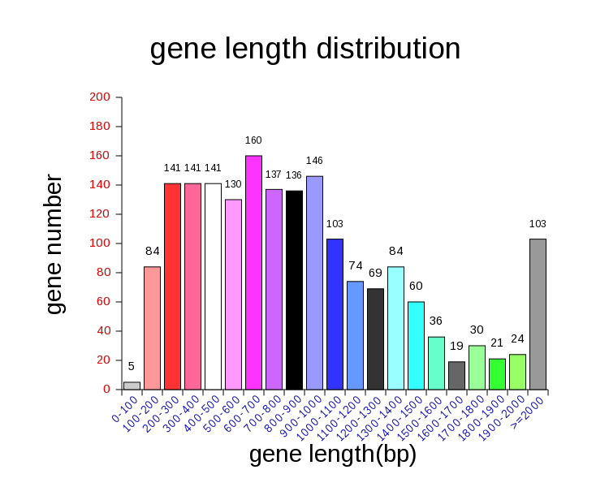
Figue S5 Length distribution of coding gene sequence

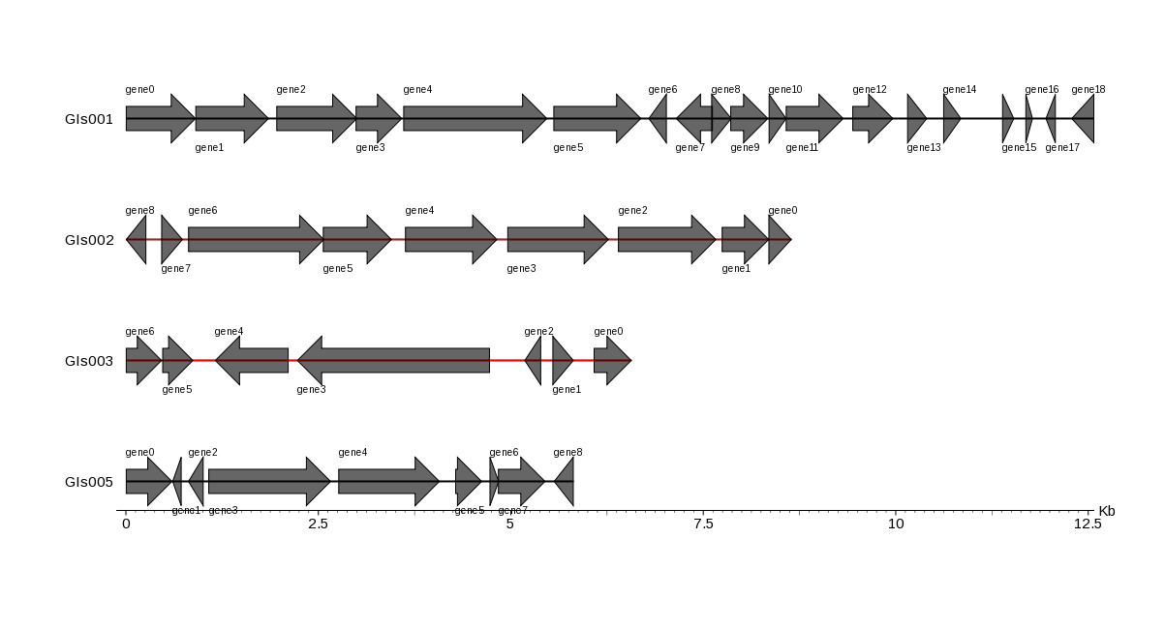
Figue S6 Statistical map of gene distribution in gene island.
Note: The x-axis represents the length scale (genomic islands shorter than 15 kb are shown in the figure).
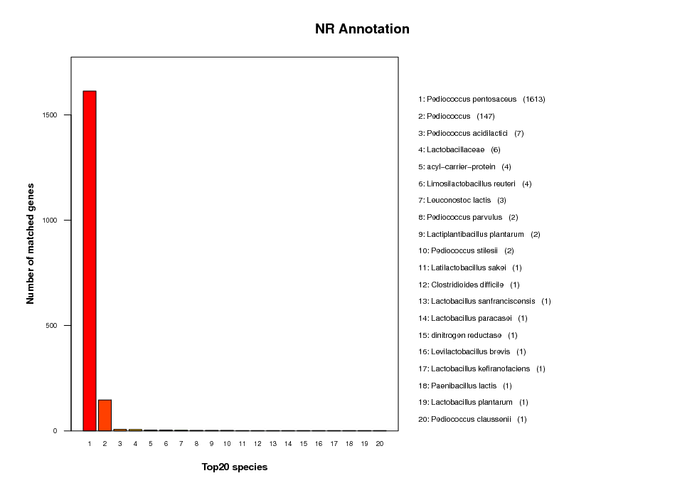

Figue S7 Nr Database Annotated Species Statistics Chart.

Note: The horizontal axis represents species IDs, and the vertical axis represents the number of annotated genes.

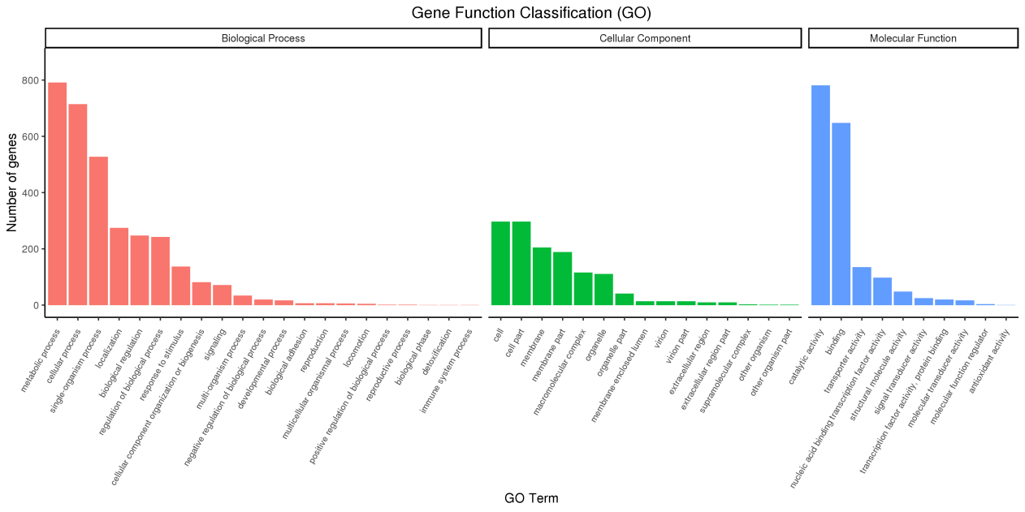
Figue S8 Gene Function Annotation GO Functional Classification Map
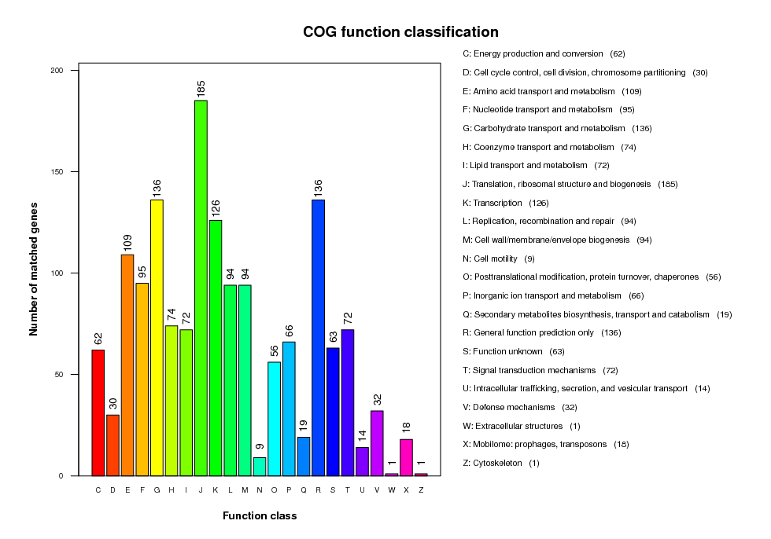
Figue S9 Gene Function Annotation COG Functional Classification Map.

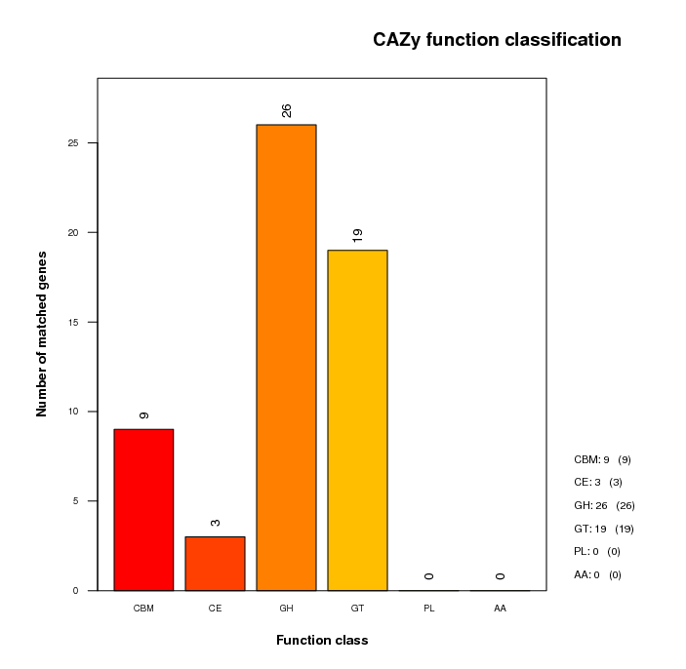
Figue S10 Functional Classification of CAZy And Statistical Map Of Corresponding Gene Guantity

