Supplementary Material for:
EEG Correlates of Social-Communication Difficulties in Typically Developing Individuals: Functional Connectivity and Frequency-Domain Insights
Muhammad Zakir Ullah¹, Liu Fulin¹, and Dongchuan Yu^{1,2, *}
¹ Key Laboratory of Child Development and Learning Science of Ministry of Education, School of Biological Science and Medical Engineering, Southeast University, Nanjing, China
² Henan Provincial Medical Key Lab of Child Developmental Behavior and Learning, The Third Affiliated Hospital of Zhengzhou University, Zhengzhou, Henan, China
*Correspondence: Key Laboratory of Child Development and Learning Science of Ministry of Education, School of Biological Science and Medical Engineering, Southeast University, Nanjing, China
Email addresses: dcyu@seu.edu.cn (Yu Dongchuan)
Mirroring the analytical approach applied to power spectra of five frequency band EEG features, we first conducted unadjusted Welch’s t-tests to compare (high and low) AQ groups on each of the four global GNM EEG features across the five frequency bands (delta, theta, alpha, beta, gamma) for all three FC connectivity measures: PLV, PLI, and WPLI. To increase statistical power and account for potential confounding effects, we additionally fitted multiple linear regression models using the full sample, treating AQ as a continuous predictor and including age and gender as covariates. This approach was applied separately for each FC measure, frequency band, and GNM feature. Full results are reported in the Supplementary Materials: PLI-based GNM features: Welch’s t-test results in Table S(1), regression results in Figure S(1); PLV-based GNM features: Welch’s t-test results in Table S(2), regression results in Figure S(2); WPLI-based GNM features: Welch’s t-test results in Table S(3), regression results in Figure S(3). Significant findings from the unadjusted group comparisons (Welch’s t-tests) are summarized in main manuscript: Table 4 (please refer to: main manuscript), while results from the covariate-adjusted regression models are presented in Figure 10 (please refer to: main manuscript).
- Functional connectivity analyses
  - Functional connectivity PLI measure for GNM EEG features
    - Group Analysis for PLI connectivity measure based GMNs
(1) A significant between-group difference was observed in the gamma band for PLI connectivity in the PLI-AC: (t_{(36.991)} = −2.242, p = 0.031, Cohen’s d = −0.664); (2) A significant between-group difference was observed in theta-band PLI-M: (t_{(35.454)} = 2.766, p = 0.008, Cohen’s d = 0.830); (3) A significant between-group difference was observed in theta-band PLI-T: (t_{(45.880)} = −2.850, p = 0.006, Cohen’s d = −0.780). All other comparisons across alpha, beta, delta, theta (except above), and gamma bands for PLI (AC, GE, MM, and T) were non-significant (p > 0.05), as demonstrated in Table S(1).
Table S(1). PLI-based connectivity analysis of GMNs derived EEG features in high and low AQ groups. Descriptive statistics and results of independent-samples t-tests are presented for: (A) PLI-AC, (B) PLI-GE, (C) PLI-MM, and (D) PLI-T, across frequency-domain EEG features
(A) PLI-AC
Band | High (M$±$SD) | Low (M$±$ SD) | T(df) | P-Value | Cohen’s D
Alpha | -0.025$±$0.018 | -0.023$±$0.016 | -0.406 (36.52) | 0.687 | -0.121
Beta | -0.023$±$0.025 | -0.028$±$0.017 | 0.782 (28.55) | 0.441 | 0.250
Delta | -0.034$±$0.011 | -0.034 $±$0.019 | -0.009 (46.48) | 0.993 | -0.002
Theta | -0.040$±$ 0.021 | -0.053 $±$0 .027 | 2.008 (44.80) | 0.051 | 0.557
Gamma | -0.038 ± 0.014 | -0.028 ± 0.014 | -2.242 (36.99) | 0.031 | -0.664
(B) PLI-GE
Alpha | 0.077 $±$0.039 | 0.072$±$ 0.020 | 0.516 (23.83) | 0.611 | 0.174
Beta | 0.050$±$ 0.016 | 0.051$±$ 0.014 | -0.209 (34.79) | 0.836 | -0.063
Delta | 0.085$±$0.023 | 0.091$±$0.041 | -0.751 (46.42) | 0.456 | -0.195
Theta | 0.192 $±$0.001 | 0.225$±$0.096 | -1.902 (29.00) | 0.067 | -0.442
Gamma | 0.050$±$0.012 | 0.051 $±$0.016 | -0.209 (45.89) | 0.836 | -0.057
(C) PLI-MM
Alpha | 0.090 $±$0.020 | 0.086$±$ 0.017 | 0.764 (33.04) | 0.450 | 0.234
Beta | 0.094$±$0.019 | 0.100$±$0.022 | -0.878 (43.00) | 0.385 | -0.248
Delta | 0.079$±$0.022 | 0.083$±$0.020 | -0.630 (35.51) | 0.533 | -0.189
Theta | 0.070 ± 0.020 | 0.054 ± 0.018 | 2.766 (35.45) | 0.008 | 0.830
Gamma | 0.095$±$ 0.015 | 0.090$±$0.023 | 0.964 (46.94) | 0.340 | 0.258
(D) PLI-T
Alpha | 0.054$±$ 0.035 | 0.049$±$0.017 | 0.555 (23.41) | 0.584 | 0.188
Beta | 0.033$±$0.014 | 0.031$±$0.008 | 0.550 (26.46) | 0.587 | 0.179
Delta | 0.059$±$0.018 | 0.064$±$0.033 | -0.616 (46.47) | 0.541 | -0.160
Theta | 0.116 ± 0.064 | 0.179 ± 0.088 | -2.850 (45.88) | 0.006 | -0.780
Gamma | 0.034$±$ 0.011 | 0.036$±$0.012 | -0.513 (44.83) | 0.610 | -0.155
Note: Mean$±$SD reported. Cohen’s d indicate effect size for group difference.

    - Regression analysis of GNM-based PLI functional connectivity EEG features
Multiple linear regression models revealed significant associations between AQ scores and the following PLI-based GNM features(1) PLI-gamma (AC): $β$ = −<0.001, p = 0.014, [model: F_{(3,45)} = 2.565, p = 0.066, $R²$ = 0.146, adj. $R²$ = 0.089]; (2) PLI-theta (MM): $β$ = <0.001, p = 0.007, [model: F_{(3,45)} = 3.177, p = 0.033, $R²$ = 0.175, adj. $R²$ = 0.119]; (3) PLI-theta (T): $β$ = −0.003, p = 0.022, [model: F_{(3,45)} = 2.392, p = 0.081, $R²$ = 0.138, adj. $R²$ = 0.080]. Age and gender were non-significant in all models (all p > 0.05). All other PLI-GNM band combinations (alpha, beta, delta, gamma, theta across AC, GE, MM, T) were tested and showed no significant association with AQ (all p > 0.05); full results are shown in Fig. S(1).
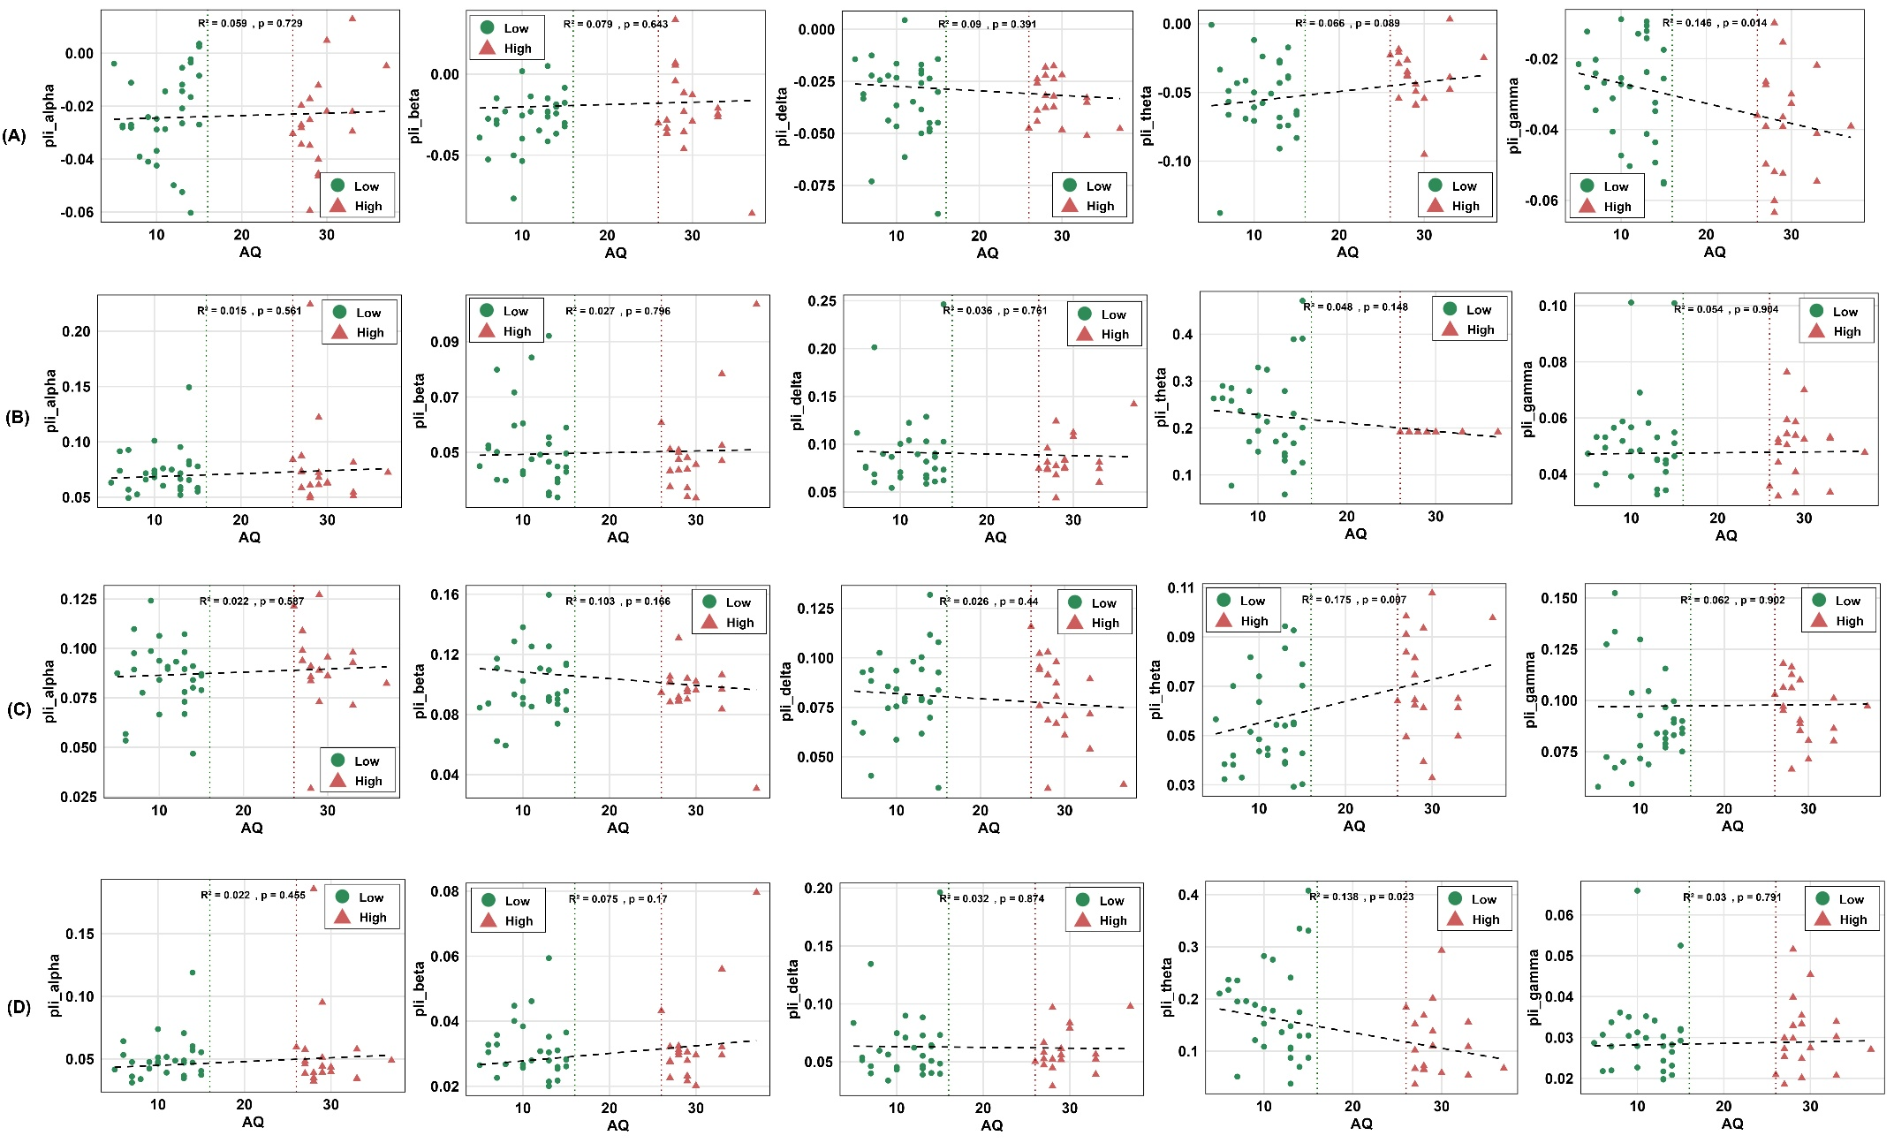
Fig. S(1) PLI-based connectivity analysis of GNM-derived EEG features. Results of multiple linear regression models are shown for: (A) PLI-AC, (B) PLI-GE, (C) PLI-MM, and (D) PLI-T across frequency bands (alpha, beta, delta, theta, and gamma bands, respectively).
  - Functional Connectivity PLV measure for GNM EEG Features
    - Group Analysis for PLV connectivity measure based GMNs
(1) A significant between-group difference was observed in delta PLV-GE: (t_{(46.989)} = −2.040, p = 0.046, Cohen’s d = −0.542); (2) A significant between-group difference was observed in theta PLV-GE: (t_{(42.406)} = −3.636, p < 0.001, Cohen’s d = −1.032); (3) A significant between-group difference was observed in theta PLV-M: (t_{(44.173)} = 3.278, p = 0.002, Cohen’s d = 0.915); (4) A significant between-group difference was observed in theta PLV-T: (t_{(43.949)} = −3.664, p < 0.001, Cohen’s d = −1.025). All other comparisons across alpha, beta, delta (except above), gamma, and theta (except above) bands for PLV (AC, GE, MM, and T) were non-significant (p > 0.05), as suggested in Table S(2).
Table S(2). PLV-based connectivity analysis of GMNs derived EEG features in high and low AQ groups. Descriptive statistics and results of independent-samples t-tests are presented for: (A) PLV-AC, (B) PLV-GE, (C) PLV-MM, and (D) PLV-T, across frequency-domain EEG features
(A) PLV-AC
Band | High (M$±$SD) | Low (M$±$SD) | T-Value (df) | P-Value | Cohen’s D
Alpha | 0.054 $±$ 0.027 | 0.045$±$ 0.037 | 1.017 (45.99) | 0.315 | 0.278
Beta | 0.038 $±$0.030 | 0.032$±$ 0.035 | 0.610 (43.07) | 0.545 | 0.172
Delta | 0.074$±$0.016 | 0.072$±$0.022 | 0.446 (45.73) | 0.658 | 0.122
Theta | 0.089$±$0.034 | 0.092$±$ 0.032 | -0.334 (36.69) | 0.740 | -0.099
Gamma | 0.031$±$0.030 | 0.029$±$0.038 | 0.163 (44.66) | 0.871 | 0.045
(B) PLV-GE
Alpha | 0.357 $±$ 0.041 | 0.349$±$0.030 | 0.700 (29.95) | 0.489 | 0.220
Beta | 0.301$±$0.024 | 0.291$±$ 0.028 | 1.280 (42.50) | 0.207 | 0.363
Delta | 0.385 ± 0.024 | 0.403 ± 0.037 | -2.040 (46.98) | 0.046 | -0.542
Theta | 0.446 ± 0.061 | 0.516 ± 0.071 | -3.636 (42.40) | <0.001 | -1.032
Gamma | 0.255$±$ 0.039 | 0.237$±$ 0.036 | 1.578 (35.87) | 0.123 | 0.472
(C) PLV-MM
Alpha | 0.137 $±$0.013 | 0.140$±$0.008 | -1.123 (26.91) | 0.272 | -0.364
Beta | 0.141$±$ 0.012 | 0.138$±$ 0.012 | 0.720 (38.82) | 0.476 | 0.211
Delta | 0.137$±$ 0.011 | 0.133$±$0.017 | 0.984 (46.72) | 0.330 | 0.265
Theta | 0.114 ± 0.023 | 0.090 ± 0.028 | 3.278 (44.17) | 0.002 | 0.915
Gamma | 0.130$±$ 0.023 | 0.124$±$0.019 | 0.939 (33.20) | 0.354 | 0.287
(D) PLV-T
Alpha | 0.291$±$0.048 | 0.280$±$0.031 | 0.915 (27.57) | 0.368 | 0.295
Beta | 0.240 $±$ 0.023 | 0.230$±$0.027 | 1.370 (42.61) | 0.178 | 0.388
Delta | 0.313$±$0.025 | 0.336$±$0.052 | -2.005 (44.73) | 0.051 | -0.510
Theta | 0.398 ± 0.080 | 0.493 ± 0.099 | -3.664 (43.94) | <0.001 | -1.025
Gamma | 0.210 $±$0.039 | 0.194$±$0.036 | 1.469 (36.17) | 0.151 | 0.439
Note: Mean$±$SD reported. Cohen’s d indicate effect size for group difference.
    - Regression analysis of GNM-based PLV functional connectivity EEG features
Multiple linear regression models revealed significant associations between AQ scores and the following PLV-based GNM features: (1) PLV-theta (GE): $β$ = −0.003, p = 0.002, [model: F_{(3,45)} = 3.630, p = 0.019, $R²$ = 0.194, adj. $R²$ = 0.141]; (2) PLV-theta (MM): $β$ = 0.001, p = 0.006, [model: F_{(3,45)} = 3.055, p = 0.037, $R²$ = 0.169, adj. $R²$ = 0.113]; (3) PLV-theta (T): $β$ = −0.004, p = 0.002, [model: F_{(3,45)} = 3.601, p = 0.020, $R²$ = 0.191, adj. $R²$ = 0.139]. Age and gender were non-significant in all models (all p > 0.05). All other PLV-GNM band combinations (alpha, beta, delta, gamma, theta across AC, GE, MM, T) were tested and showed no significant association with AQ (all p > 0.05); full results are shown in Fig. S(2).
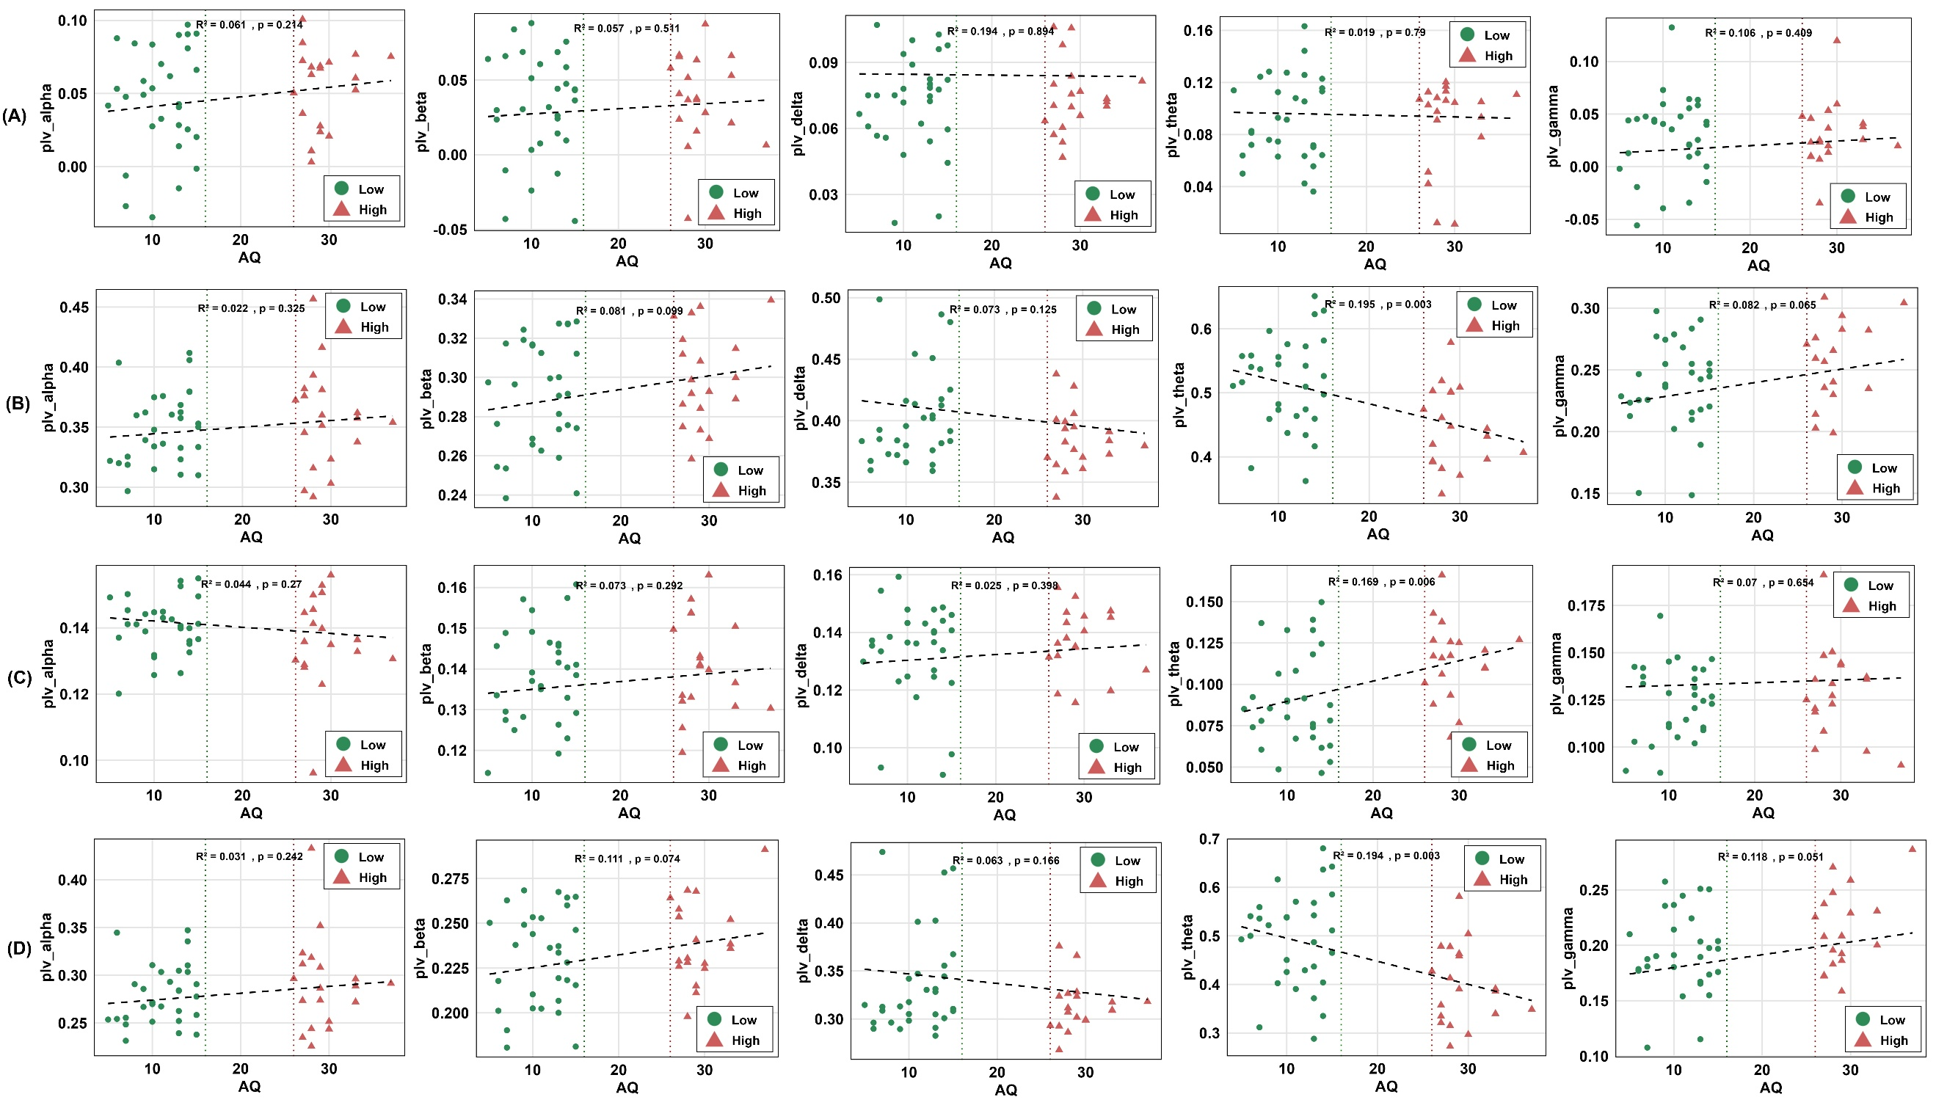
Figu. S(2) PLV-based connectivity analysis of GNM-derived EEG features. Results of multiple linear regression models are shown for: (A) PLV-AC, (B) PLV-GE, (C) PLV-MM, and (D) PLV-T across frequency bands (alpha, beta, delta, theta, and gamma bands, respectively).
  - Functional Connectivity WPLI measure for GNMs EEG Features
    - Group Difference for WPLI connectivity measure based GMNs
(1) A significant between-group difference was observed in theta WPLI-GE: (t_{(39.227)} = −2.810, p = 0.007, Cohen’s d = −0.818); (2) A significant between-group difference was observed in theta WPLI-M: (t_{(29.756)} = 3.291, p = 0.002, Cohen’s d = 1.038); (3) A significant between-group difference was observed in theta WPLI-T: (t_{(39.696)} = −2.661, p = 0.011, Cohen’s d = −0.772). All other comparisons across alpha, beta, delta, gamma, and theta (except above) bands using WPLI connectivity for (AC, GE, MM, and T) were non-significant (p > 0.05), as demonstrated in Table S(3).
Table S(3). WPLI-based connectivity analysis of GMNs derived EEG features in high and low AQ groups. Descriptive statistics and results of independent-samples t-tests are presented for: (A) WPLI-AC, (B) WPLI-GE, (C) WPLI-MM, and (D) WPLI-T, across frequency-domain EEG features
(A) WPLI-AC
Band | High (M$±$SD) | Low (M$±$SD) | T(df) | P-Value | Cohen’s D
Alpha | -0.030$±$0.013 | -0.026$±$0.017 | -0.738 (44.93) | 0.464 | -0.205
Beta | -0.030$±$0.023 | -0.030$±$0.017 | -0.003 (30.73) | 0.998 | -0.001
Delta | -0.039$±$0.021 | -0.038$±$0.025 | -0.141 (43.61) | 0.889 | -0.040
Theta | -0.046$±$0.027 | -0.061$±$0.033 | 1.694 (43.90) | 0.097 | 0.474
Gamma | -0.041$±$0.018 | -0.039$±$0.014 | -0.537 (32.39) | 0.595 | -0.165
(B) WPLI-GE
Alpha | 0.142 $±$0.067 | 0.136$±$0.039 | 0.320 (25.87) | 0.752 | 0.105
Beta | 0.104$±$0.037 | 0.099$±$0.028 | 0.455 (30.99) | 0.652 | 0.142
Delta | 0.160$±$0.041 | 0.173$±$0.073 | -0.770 (46.54) | 0.445 | -0.200
Theta | 0.279 ± 0.127 | 0.385 ± 0.131 | -2.810 (39.22) | 0.007 | -0.818
Gamma | 0.105$±$0.025 | 0.106$±$0.032 | -0.162 (45.01) | 0.872 | -0.045
(C) WPLI-MM
Alpha | 0.094$±$0.022 | 0.088$±$ 0.022 | 0.914 (37.41) | 0.367 | 0.270
Beta | 0.098$±$0.025 | 0.103$±$ 0.020 | -0.768 (33.30) | 0.448 | -0.235
Delta | 0.082$±$0.027 | 0.081$±$0.021 | 0.113 (31.56) | 0.911 | 0.035
Theta | 0.071 ± 0.025 | 0.049 ± 0.018 | 3.291 (29.75) | 0.002 | 1.038
Gamma | 0.102$±$0.021 | 0.092$±$0.026 | 1.381 (44.00) | 0.174 | 0.386
(D) WPLI-T
Alpha | 0.102$±$0.062 | 0.095$±$0.035 | 0.400 (25.36) | 0.692 | 0.132
Beta | 0.069$±$0.032 | 0.061$±$0.018 | 0.960 (24.94) | 0.346 | 0.319
Delta | 0.115$±$0.035 | 0.124$±$0.060 | -0.618 (46.70) | 0.539 | -0.162
Theta | 0.218 ± 0.122 | 0.315 ± 0.128 | -2.661 (39.69) | 0.011 | -0.772
Gamma | 0.063$±$0.018 | 0.063$±$0 .019 | 0.055 (40.05) | 0.956 | 0.016
Note: Mean$±$SD reported. Cohen’s d indicate effect size for group difference.
    - Regression analysis of GNM-based WPLI functional connectivity EEG features
Multiple linear regression models revealed significant associations between AQ scores and the following WPLI-based GNM features: (1) WPLI-theta (GE): $β$ = −0.005, p = 0.017, [model: F_{(3,45)} = 3.151, p = 0.033, $R²$ = 0.173, adj. $R²$ = 0.118]; (2) WPLI-theta (MM): $β$ = 0.001, p = 0.003, [model: F_{(3,45}) = 4.199, p = 0.010, $R²$ = 0.218, adj. $R²$ = 0.166]; and (3) WPLI-theta (T): $β$ = −0.004, p = 0.026, [model: F_{(3,45)} = 2.911, p = 0.044, $R²$ = 0.162, adj. $R²$ = 0.106]. Age and gender were non-significant in all models (all p > 0.05). All other WPLI–GNM band combinations (alpha, beta, delta, gamma, theta across AC, GE, MM, T) were tested and showed no significant association with AQ (all p > 0.05); full results are shown in Fig. S(3).
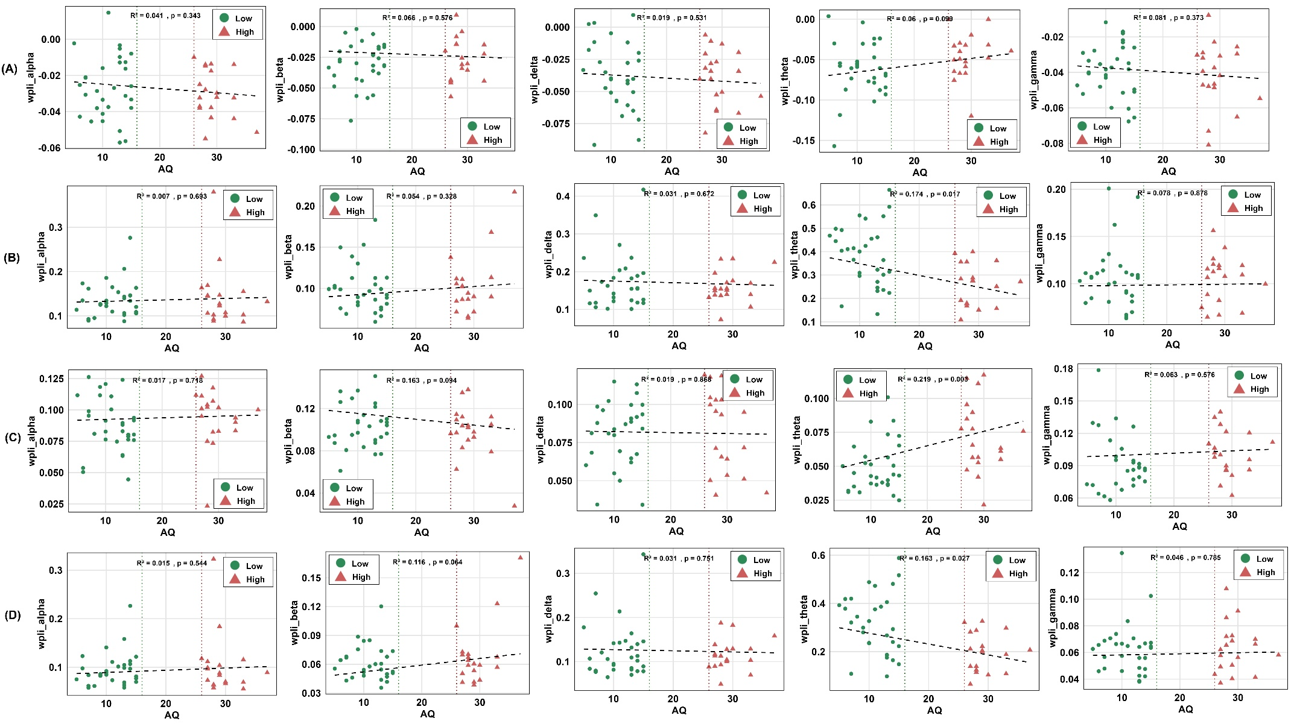
Fig. S(3) WPLI-based connectivity analysis of GNM-derived EEG features. Results of multiple linear regression models are shown for: (A) WPLI-AC, (B) WPLI-GE, (C) WPLI-MM, and (D) WPLI-T across frequency bands (alpha, beta, delta, theta, and gamma bands, respectively).

