Supplementary Information

Soft Active EMG Interface for Machine Learning-Enabled Silent Speech Recognition
Yuta Kurotaki^{1,2}, Shunsuke Yamakoshi¹, Reitaro Yoshida², Yutaka Isoda¹, Tamami Takano¹, Yuji Isano¹, Yusuke Miyake², Kentaro Kuribayashi², Hiroki Ota^{1*}

¹Department of Mechanical Engineering, Yokohama National University, 79-5, Tokiwadai, Hodogaya-Ku, Yokohama, Kanagawa 240-8501, Japan
²Pepabo Research and Development Institute, GMO Pepabo, Inc., 26-1, Sakuragaoka, Shibuya Ward, Tokyo 150-8512, Japan
*Corresponding author: Hiroki Ota, ota-hiroki-xm@ynu.ac.jp

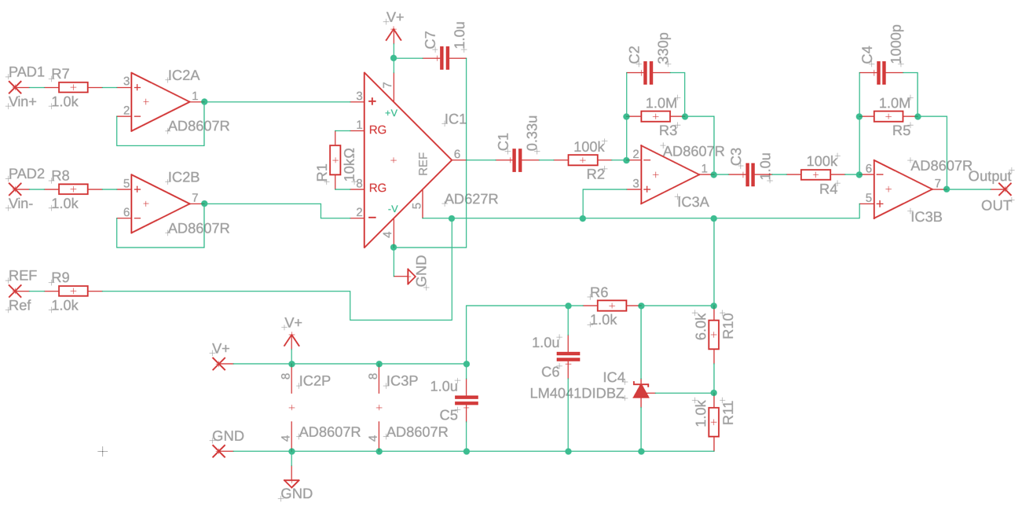
Supplementary Figure 1: Circuit diagram of the EMG amplification system. A voltage follower (AD8607, Analog Devices) was placed after the electrode; this was followed by a differential amplifier (AD627, Analog Devices) with a gain of 25. EMG signals were further amplified to 2,500 through subsequent operational amplifiers. Four identical circuits were integrated into the device.

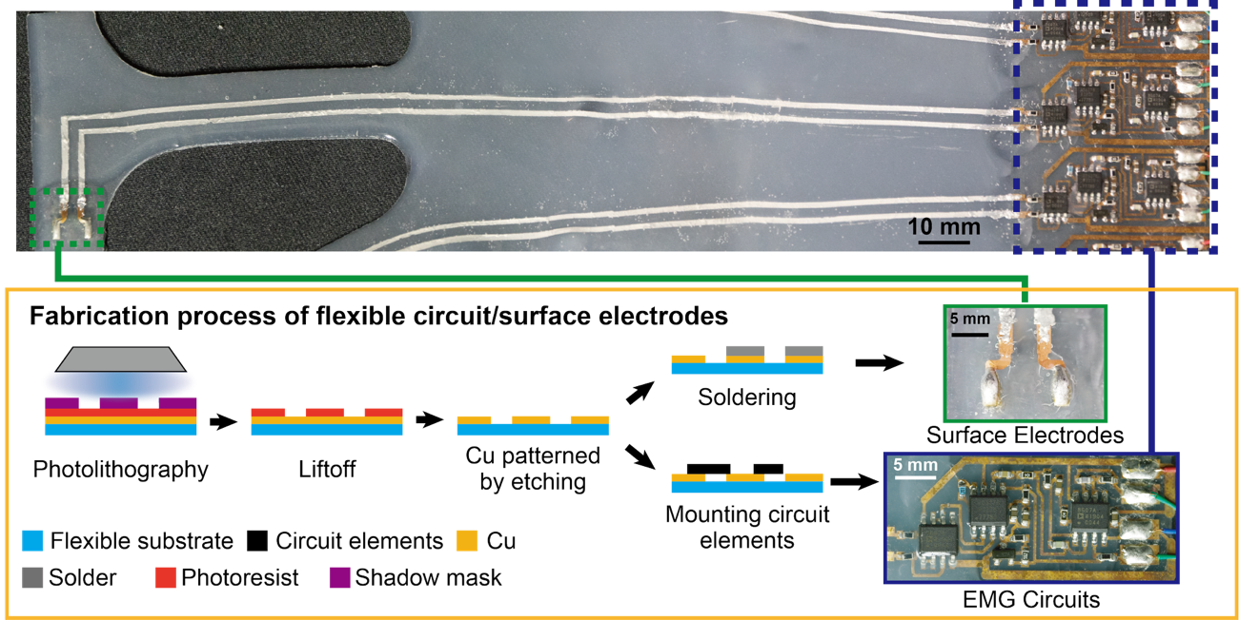
Supplementary Figure 2: Fabrication process for the electrodes and circuit. A transparent polyimide substrate covered on one side with copper foil (L71KTS 1012EDR T10, Arisawa Mfg. Co., Ltd.) was used. AZ photoresist was spin-coated and dried on a hot plate at 100 °C to form the mask. The circuit pattern was then exposed and developed via etching to define the traces. Solder was applied to the electrode pads, and the EMG amplification circuit was populated with the required components.

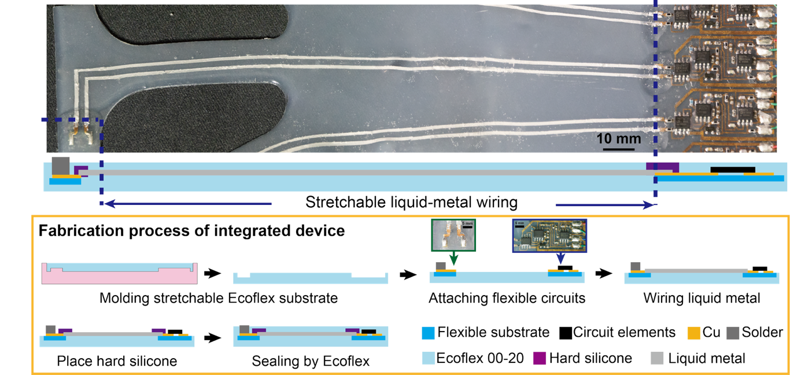
Supplementary Figure 3: Fabrication process for the liquid-metal wiring. A mold produced via 3D printing was filled with silicone rubber Ecoflex 00-20, A:B = 1:1 weight ratio, Smooth-On). The Ecoflex was then cured in an oven. The EMG amplification circuit board was fixed using adhesive (Sil-Poxy, Smooth-On). Fingertip electrodes were attached in the same manner. A polyimide film was cut with a laser marker (Keyence) to form a stencil mask for liquid-metal (LM) wiring. LM paste was applied through the stencil, and after mask removal, wiring connections between the fingertip electrodes and the EMG circuit were formed. The connection areas between the circuit board and the LM wiring were sealed with silicone rubber (KE-1606, Shin-Etsu Chemical) and cured. Finally, Ecoflex was coated over the entire structure and cured in an oven to encapsulate the device.

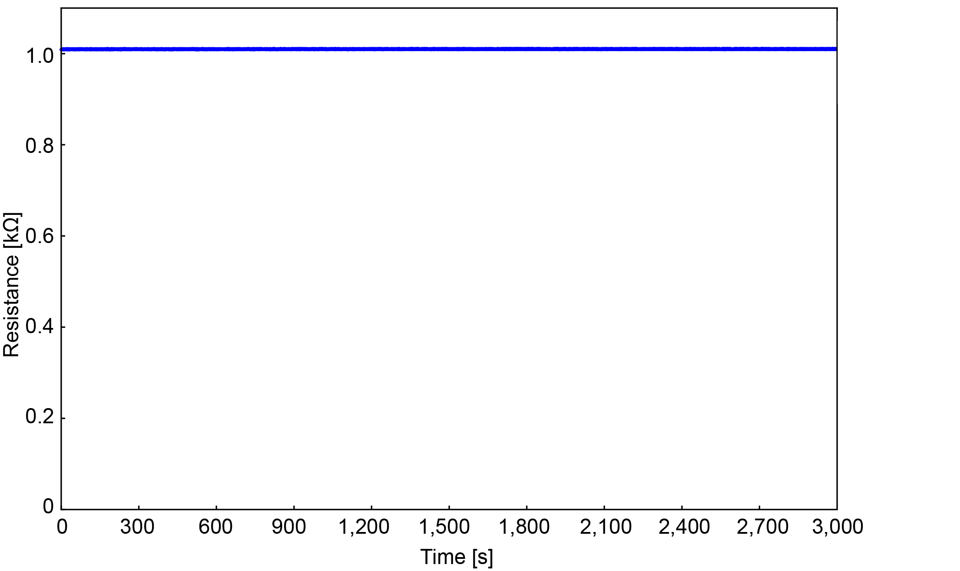
Supplementary Figure 4: Resistance change during tensile testing of the electrodes. Tensile tests were performed 1,000 times using a tensile testing machine and an LCR meter, with resistance values measured at 1-s intervals.

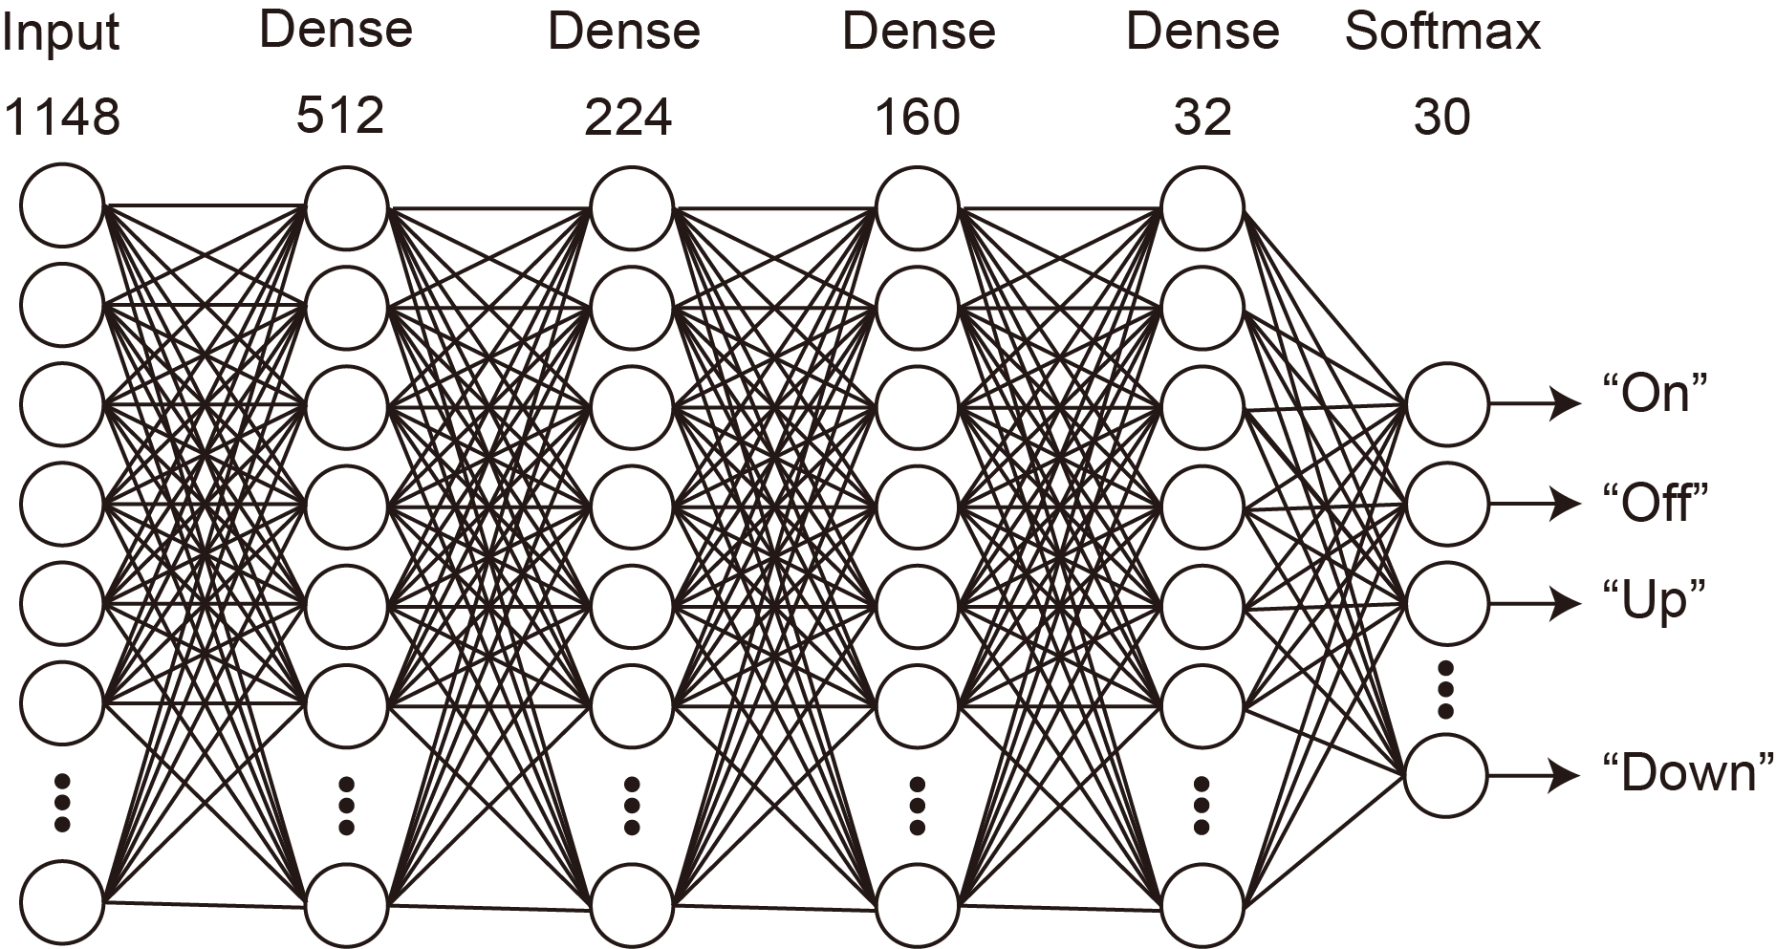
Supplementary Figure 5: DNN model used in this study. A fully connected DNN was employed, which classified words using the softmax function.

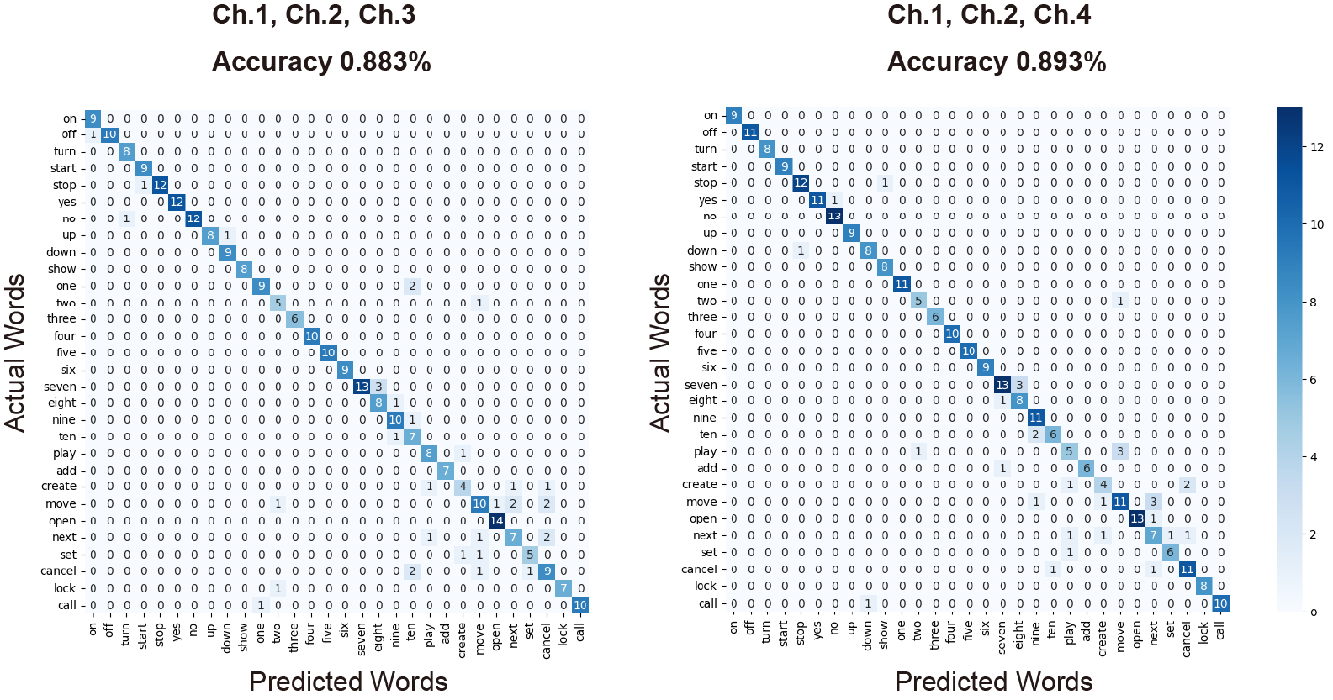
Supplementary Figure 6: Comparison of confusion matrices for three-channel configurations. The combination of Ch1, Ch2, and Ch3 yielded an accuracy of 88.3%, whereas the combination of Ch1, Ch2, and Ch4 yielded an accuracy of 89.3%.

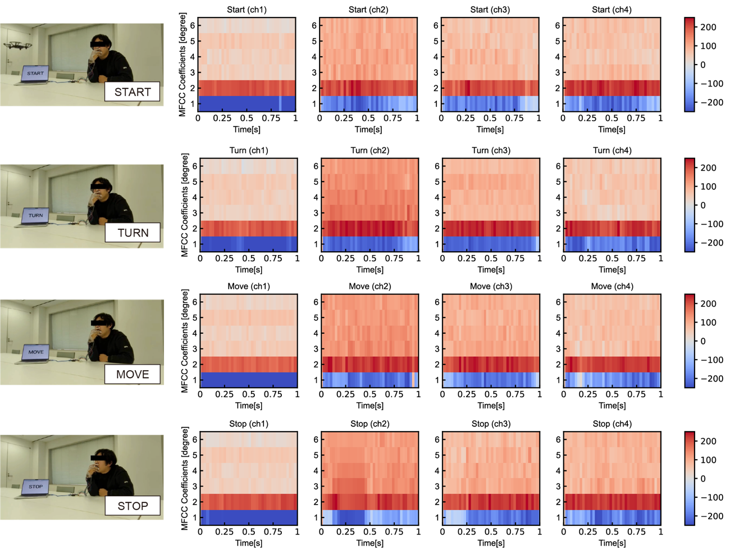
Supplementary Figure 7: MFCCs for each word articulation. MFCCs for each channel were calculated over 1-s intervals for four words (“START,” “TURN,” “MOVE,” and “STOP”).

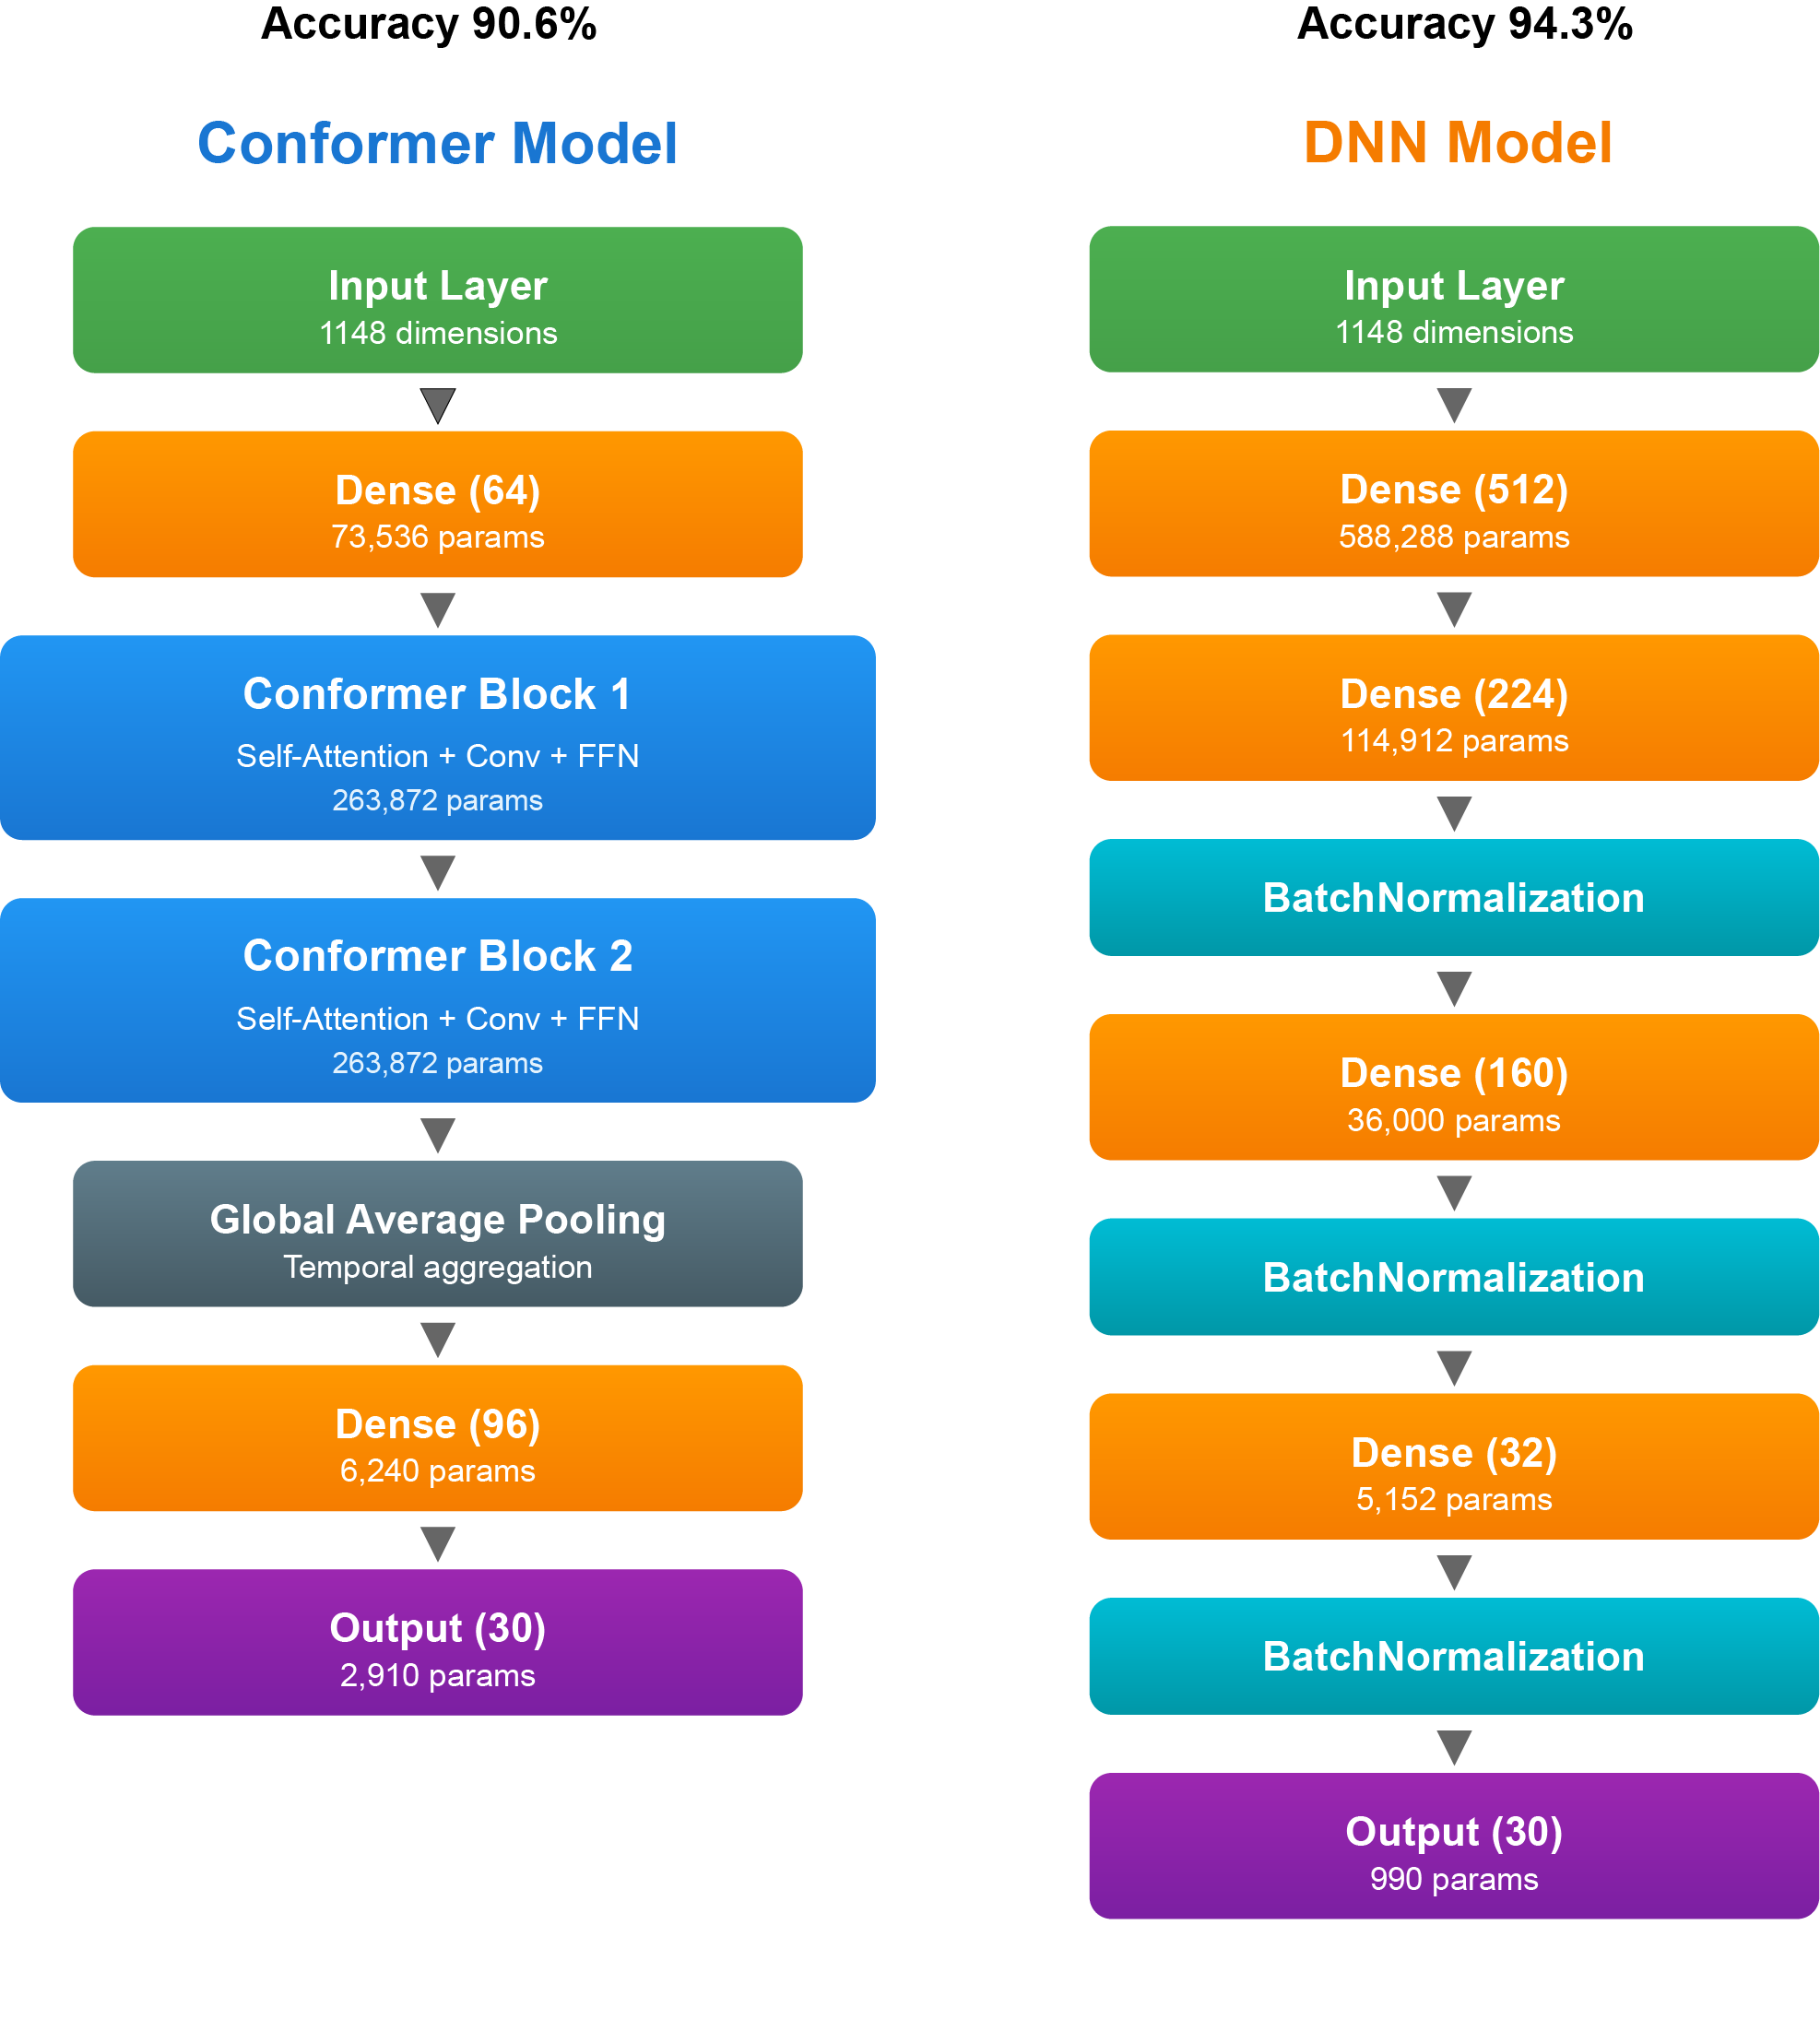
Supplementary Figure 8: Comparison of Conformer and DNN models. The Conformer and DNN models achieved classification accuracies of 90.6% and 94.3%, respectively.

Supplementary Table 1: Comparison of accuracy by channel combination.
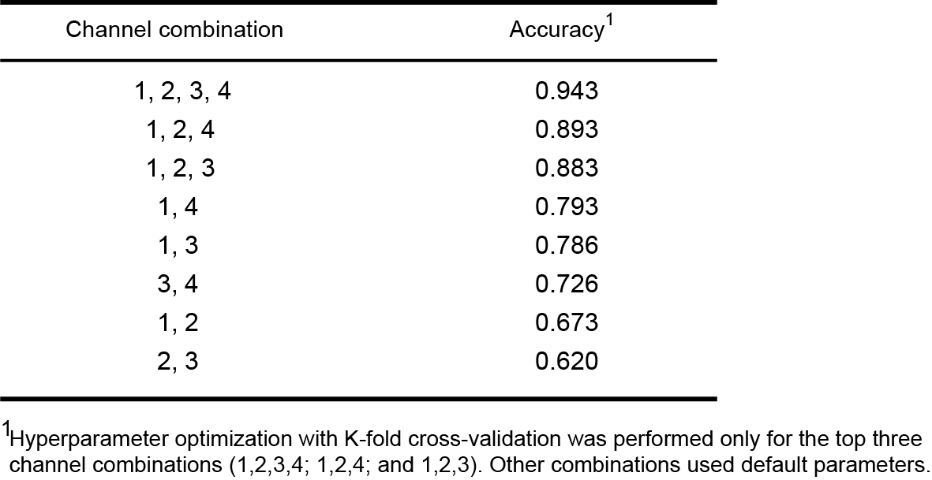

Supplementary Table 2: Comparison of silent speech recognition devices and their performance.
