Table 1: Summary of pathogenic microbiota and the related signaling pathways
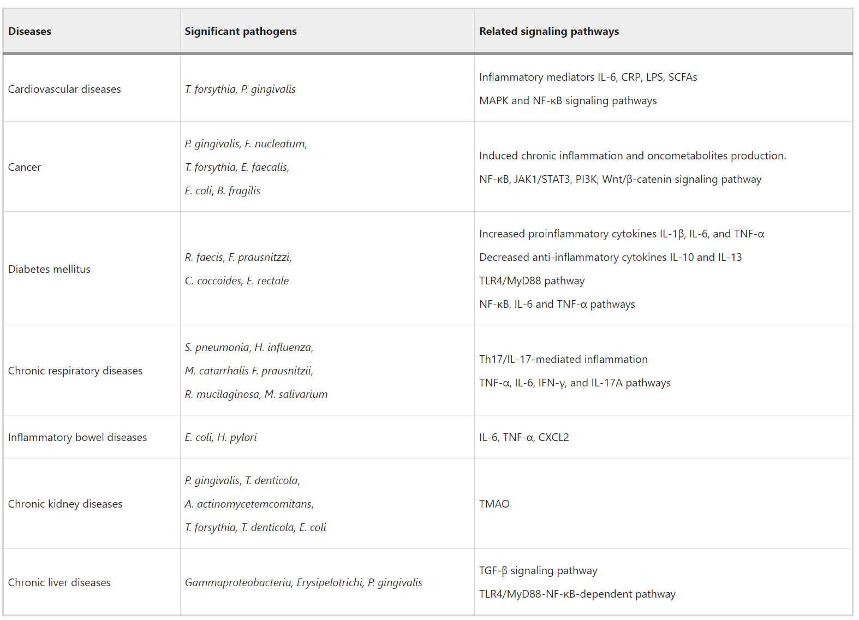
Table 2: Shannon and Simpson Indices Across 10 Samples
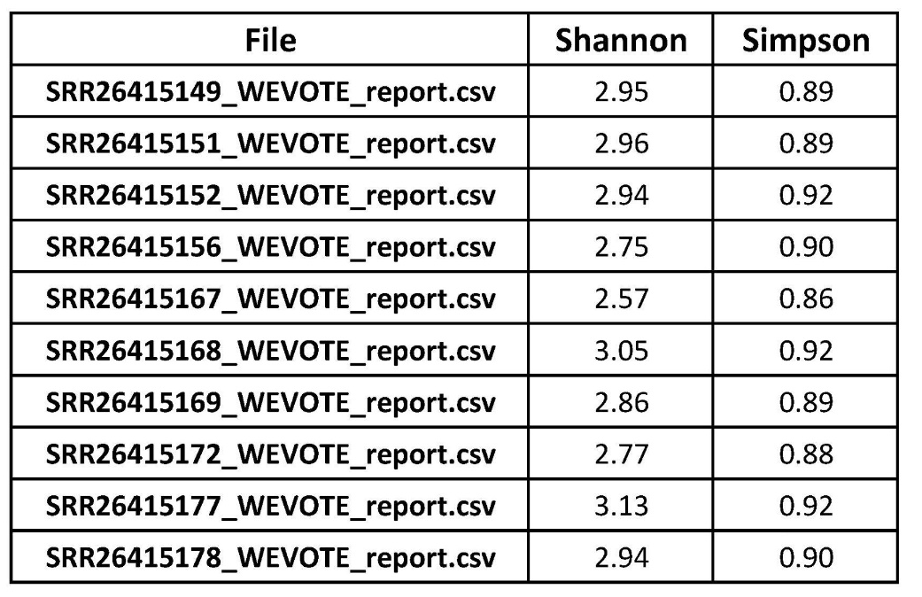

Table 3: Pathogen Species Table
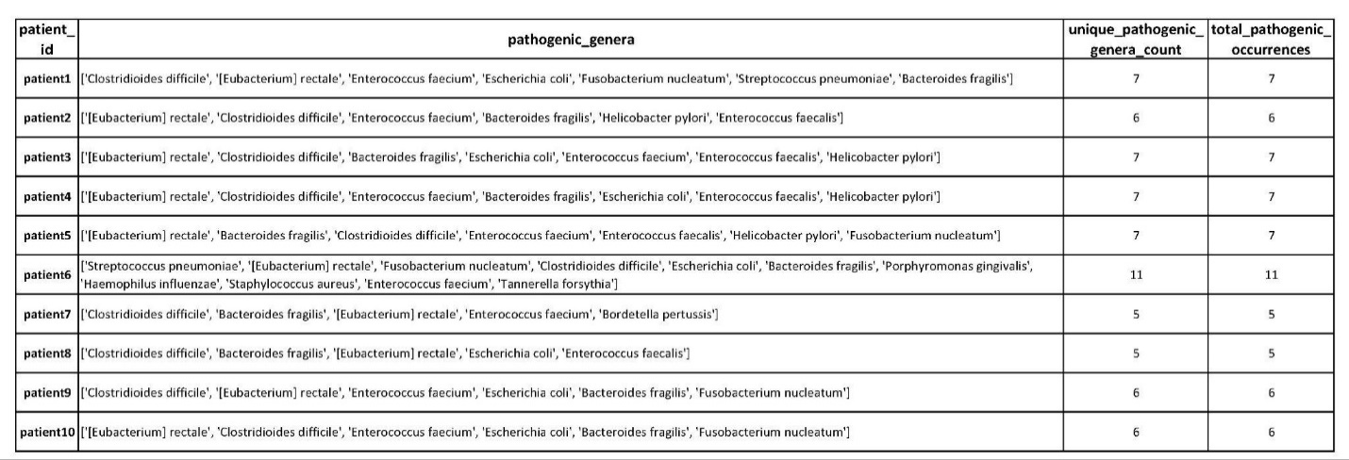

Table 4: Patients - Disease Pathogen Table
