Supplemental Information

Mechanistic characterization of microbiome shifts under methanogenesis inhibition reveals pathways for circular carbon valorization

Jorge L. Rico¹, Rebecca A. Daly², Reed Woyda², Parsa Ghadermazi³, Laura G. Schaerer², Kristen Otto⁴, Jessica L. Metcalf⁴, Siu Hung Joshua Chan³, Kelly C. Wrighton², Kenneth F. Reardon³, Susan K. De Long¹

¹Department of Civil and Environmental Engineering, Colorado State University
²Department of Soil and Crop Sciences, Colorado State University
³Department of Chemical and Biological Engineering, Colorado State University
⁴Department of Animal Sciences, Colorado State University

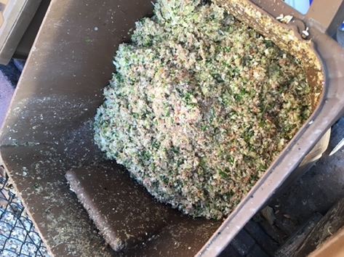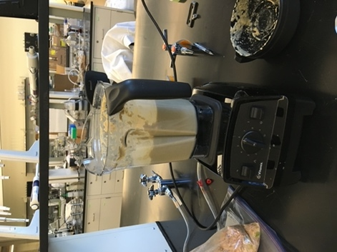

Figure S1. Food waste collection and homogenization.

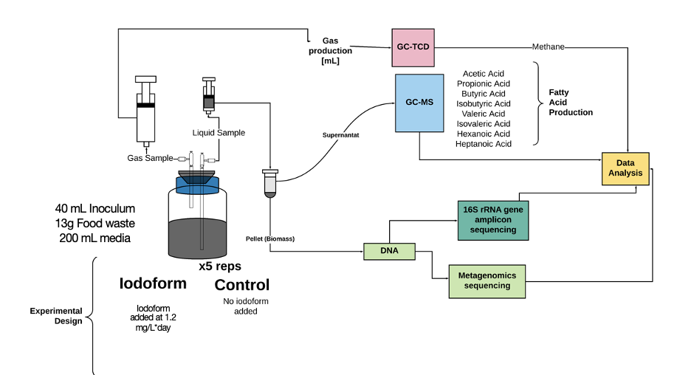
Iodoform added at 1.2 mg/L*day
Figure S2. Experimental design and analytical methods.

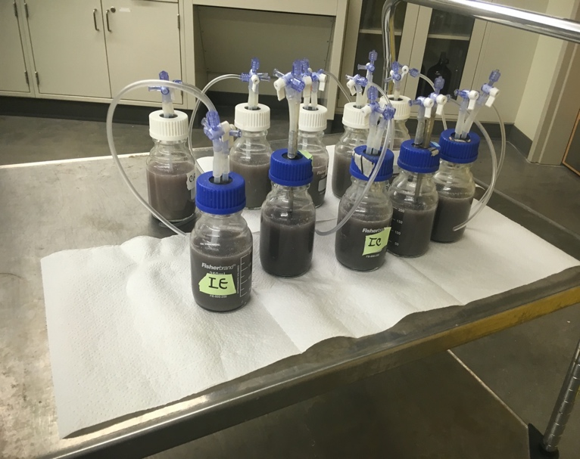

Figure S3. Bioreactor bottle set up.
Figure S4. DNA concentrations over time.

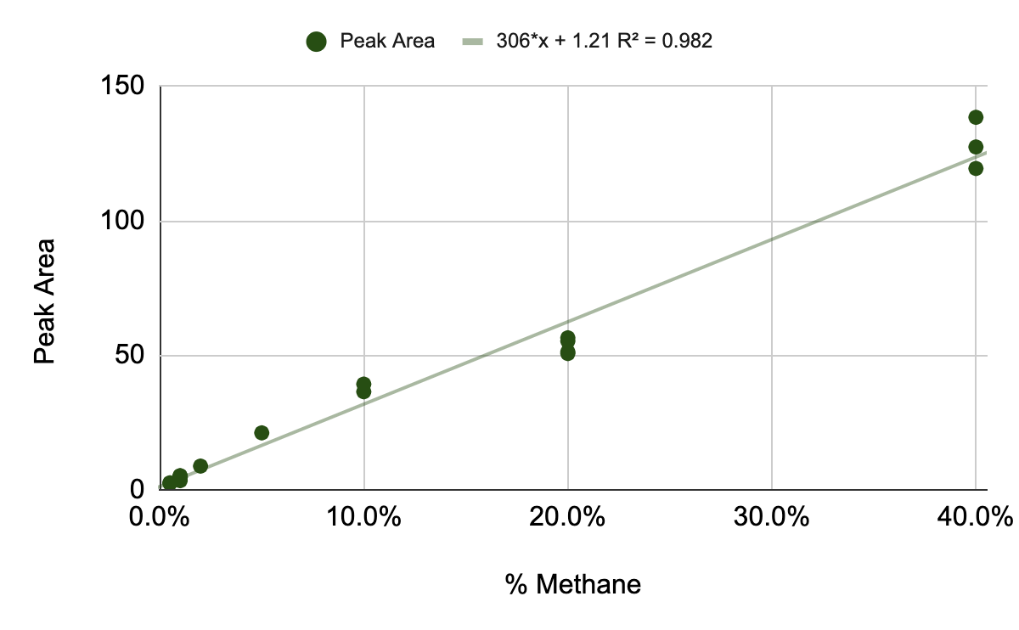

Regression Statistics
Multiple R | 1.0 |  | Intercept | 1.2
R Square | 1.0 |  | Slope | 306.4
Adjusted R Square | 1.0
Standard Error | 5.8 |  | LOD | 0.06245 | % v/v
Observations | 23 |  | LOD | 625 | ppm Methane

Figure S5. Calibration curve and limit of detection (LOD) for methane quantification. Percentages are normalized based on 50-µL injections.

LOD = 3.3*Standard Error / Slope.
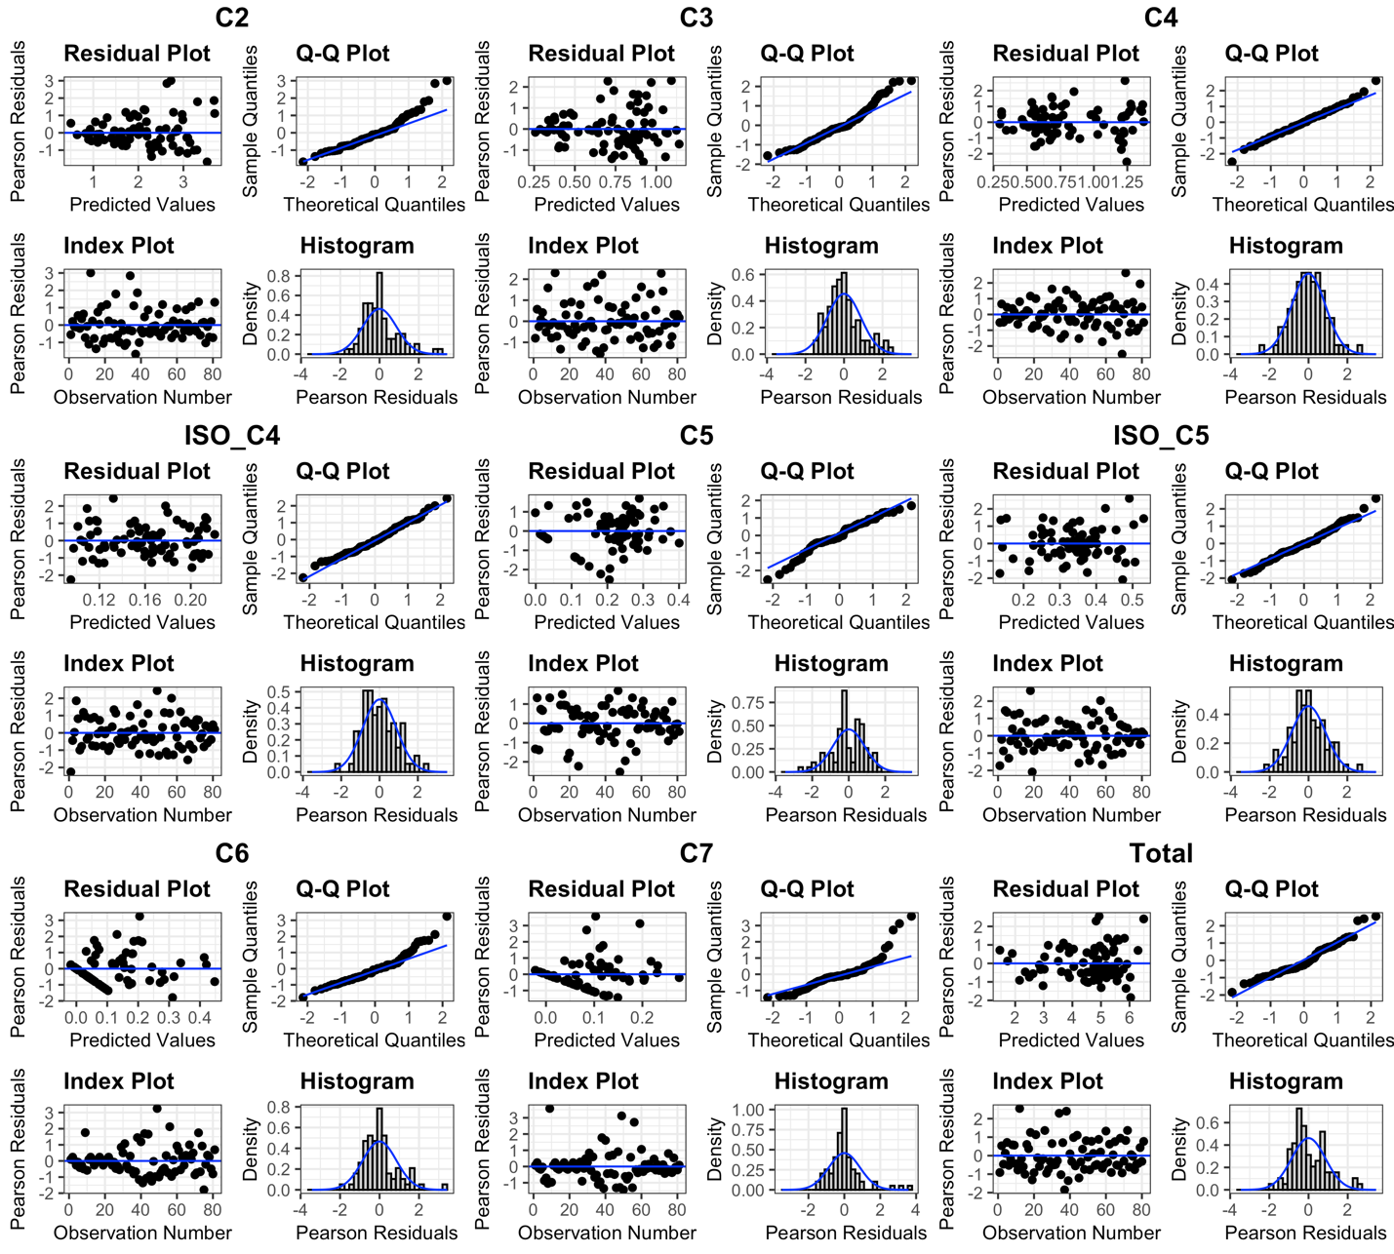

Figure S6. Model Diagnostic Plots for Linear Mixed Effects Models (Formula: Fatty Acid Concentration ~ Treatment * Day + (1 | Treatment:Replicate). Diagnostic plots include residuals vs. fitted values, Q-Q plots, index plots, and histograms of residuals. Model Diagnostic Plots were made to evaluate model assumptions including normality, homoscedasticity, and independence of residuals.

Table S1. Linear mixed effects models summaries. Fixed effects in the model include treatment, day, and their interaction (Treatment × Day). The random effects include Treatment by Replicate. Fatty Acid Concentration ~ Treatment * Day + (1 | Treatment:Replicate).

Predictor |  | C2 | C3 | C4 | C5 | C6 | C7 | ISO_C4 | ISO_C5 | Total
(Intercept) | Estimate | 0.9 | 0.4 | 0.3 | 0.1 | 0 | 0 | 0.1 | 0.1 | 1.9
(Intercept) | Standard Error | (0.30) | (0.10) | (0.10) | - | - | - | - | - | (0.50)
(Intercept) | p-value | (0.00) | (<0.001) | (<0.001) | (0.01) | (1.00) | (1.00) | (<0.001) | (<0.001) | (<0.001)
TreatmentIodoform | Estimate | 0.2 | 0 | 0.3 | 0.2 | 0.2 | 0.1 | 0 | 0.1 | 1.1
TreatmentIodoform | Standard Error | (0.40) | (0.10) | (0.10) | (0.10) | (0.10) | (0.10) | - | (0.10) | (0.70)
TreatmentIodoform | p-value | (0.52) | (0.76) | (0.05) | (<0.001) | (0.01) | (0.28) | (0.72) | (0.08) | (0.09)
Day0.4 | Estimate | 1.1 | 0.5 | 0.2 | -0.1 | 0 | 0.1 | 0.1 | 0.2 | 2.2
Day0.4 | Standard Error | (0.30) | (0.10) | (0.10) | (0.10) | - | (0.10) | - | - | (0.60)
Day0.4 | p-value | (0.002) | (<0.001) | (0.177) | (0.126) | (0.427) | (0.143) | (0.002) | (<0.001) | (<0.001)
Day0.8 | Estimate | 1.8 | 0.7 | 0.3 | -0.1 | 0 | 0 | 0.1 | 0.2 | 3
Day0.8 | Standard Error | (0.30) | (0.10) | (0.10) | (0.10) | - | (0.10) | - | - | (0.60)
Day0.8 | p-value | (<0.001) | (<0.001) | (0.014) | (0.075) | (1.000) | (1.000) | (<0.001) | (<0.001) | (<0.001)
Day1.1 | Estimate | 1.9 | 0.5 | 0.4 | 0 | 0 | 0 | 0.1 | 0.3 | 3.3
Day1.1 | Standard Error | (0.30) | (0.10) | (0.10) | (0.10) | - | (0.10) | - | - | (0.60)
Day1.1 | p-value | (<0.001) | (<0.001) | (0.002) | (0.515) | (1.000) | (1.000) | (<0.001) | (<0.001) | (<0.001)
Day1.6 | Estimate | 1.7 | 0.6 | 0.4 | 0.1 | 0 | 0 | 0.1 | 0.3 | 3.3
Day1.6 | Standard Error | (0.30) | (0.10) | (0.10) | (0.10) | - | (0.10) | - | - | (0.60)
Day1.6 | p-value | (<0.001) | (<0.001) | (0.001) | (0.088) | (1.000) | (1.000) | (<0.001) | (<0.001) | (<0.001)
Day2.1 | Estimate | 2.2 | 0.5 | 0.4 | 0.1 | 0 | 0.1 | 0.1 | 0.2 | 3.7
Day2.1 | Standard Error | (0.30) | (0.10) | (0.10) | (0.10) | - | (0.10) | - | - | (0.60)
Day2.1 | p-value | (<0.001) | (<0.001) | (0.003) | (0.023) | (0.378) | (0.076) | (0.039) | (<0.001) | (<0.001)
Day2.7 | Estimate | 2 | 0.4 | 0.3 | 0.1 | 0 | 0 | 0 | 0.2 | 3.1
Day2.7 | Standard Error | (0.30) | (0.10) | (0.10) | (0.10) | - | (0.10) | - | - | (0.60)
Day2.7 | p-value | (<0.001) | (0.007) | (0.040) | (0.010) | (0.418) | (0.443) | (0.158) | (0.001) | (<0.001)
Day4.4 | Estimate | 2.6 | 0.5 | 0.3 | 0.2 | 0.1 | 0.1 | 0.1 | 0.2 | 4.1
Day4.4 | Standard Error | (0.30) | (0.10) | (0.10) | (0.10) | - | (0.10) | - | - | (0.60)
Day4.4 | p-value | (<0.001) | (<0.001) | (0.020) | (0.001) | (0.160) | (0.068) | (0.006) | (<0.001) | (<0.001)
TreatmentIodoform × Day0.4 | Estimate | -1.2 | -0.6 | -0.2 | 0 | 0 | 0 | -0.1 | -0.2 | -2.3
TreatmentIodoform × Day0.4 | Standard Error | (0.50) | (0.20) | (0.20) | (0.10) | (0.10) | (0.10) | - | (0.10) | (0.90)
TreatmentIodoform × Day0.4 | p-value | (0.016) | (0.002) | (0.323) | (0.866) | (0.498) | (0.944) | (0.066) | (0.012) | (0.009)
TreatmentIodoform × Day0.8 | Estimate | -1.3 | -0.7 | 0.2 | 0 | 0 | 0 | -0.1 | -0.2 | -2.2
TreatmentIodoform × Day0.8 | Standard Error | (0.50) | (0.20) | (0.20) | (0.10) | (0.10) | (0.10) | - | (0.10) | (0.80)
TreatmentIodoform × Day0.8 | p-value | (0.007) | (<0.001) | (0.375) | (0.859) | (0.479) | (0.841) | (0.011) | (0.011) | (0.012)
TreatmentIodoform × Day1.1 | Estimate | -1.2 | -0.1 | 0.3 | -0.1 | 0 | 0 | 0 | -0.2 | -1.4
TreatmentIodoform × Day1.1 | Standard Error | (0.50) | (0.20) | (0.20) | (0.10) | (0.10) | (0.10) | - | (0.10) | (0.90)
TreatmentIodoform × Day1.1 | p-value | (0.013) | (0.590) | (0.114) | (0.302) | (0.655) | (0.785) | (0.268) | (0.017) | (0.109)
TreatmentIodoform × Day1.6 | Estimate | -1.2 | -0.2 | 0.2 | -0.2 | -0.1 | -0.1 | 0 | 0 | -1.5
TreatmentIodoform × Day1.6 | Standard Error | (0.50) | (0.20) | (0.20) | (0.10) | (0.10) | (0.10) | - | (0.10) | (0.90)
TreatmentIodoform × Day1.6 | p-value | (0.015) | (0.229) | (0.156) | (0.025) | (0.368) | (0.533) | (0.673) | (0.914) | (0.079)
TreatmentIodoform × Day2.1 | Estimate | -1.5 | -0.2 | 0.3 | -0.2 | 0 | 0 | 0 | -0.1 | -1.9
TreatmentIodoform × Day2.1 | Standard Error | (0.50) | (0.20) | (0.20) | (0.10) | (0.10) | (0.10) | - | (0.10) | (0.90)
TreatmentIodoform × Day2.1 | p-value | (0.002) | (0.274) | (0.085) | (0.003) | (0.812) | (0.857) | (0.848) | (0.256) | (0.033)
TreatmentIodoform × Day2.7 | Estimate | -0.8 | -0.2 | 0.4 | -0.2 | 0.1 | 0.1 | 0 | 0 | -0.9
TreatmentIodoform × Day2.7 | Standard Error | (0.50) | (0.20) | (0.20) | (0.10) | (0.10) | (0.10) | - | (0.10) | (0.90)
TreatmentIodoform × Day2.7 | p-value | (0.083) | (0.381) | (0.025) | (0.003) | (0.380) | (0.480) | (0.911) | (0.528) | (0.308)
TreatmentIodoform × Day4.4 | Estimate | -1.6 | -0.3 | 0 | -0.1 | 0.2 | 0.1 | 0 | -0.1 | -2
TreatmentIodoform × Day4.4 | Standard Error | (0.50) | (0.20) | (0.20) | (0.10) | (0.10) | (0.10) | - | (0.10) | (0.90)
TreatmentIodoform × Day4.4 | p-value | (0.001) | (0.121) | (0.951) | (0.084) | (0.016) | (0.519) | (0.592) | (0.104) | (0.019)
SD (Intercept TreatmentReplicate) |  | 0.3 | 0.1 | 0.1 | 0 | 0 | 0 | 0 | 0 | 0.5
SD (Observations) |  | 0.5 | 0.2 | 0.2 | 0.1 | 0.1 | 0.1 | 0 | 0.1 | 1
Num.Obs. |  | 81 | 81 | 81 | 81 | 81 | 81 | 81 | 81 | 81
R2 Marg. |  | 0.611 | 0.501 | 0.677 | 0.509 | 0.584 | 0.328 | 0.395 | 0.506 | 0.505
R2 Cond. |  | 0.692 | 0.54 | 0.717 | 0.578 | 0.7 | 0.405 | 0.43 | 0.562 | 0.597
AIC |  | 171.7 | 54.3 | 38.6 | -72.9 | -77.9 | -57 | -162.4 | -79.5 | 248.7
BIC |  | 214.8 | 97.4 | 81.7 | -29.8 | -34.8 | -13.9 | -119.3 | -36.4 | 291.8
ICC |  | 0.2 | 0.1 | 0.1 | 0.1 | 0.3 | 0.1 | 0.1 | 0.1 | 0.2
RMSE |  | 0.45 | 0.19 | 0.17 | 0.07 | 0.06 | 0.08 | 0.04 | 0.07 | 0.82

Table S2. Statistical analysis of fatty acid production using estimated marginal means. The Contrast column shows the group comparison, Day indicates the time point, Estimate provides the effect size, SE represents the standard error, df refers to the degrees of freedom, t.ratio gives the t-statistic, p.value shows the statistical significance (p.values < 0.05 are highlighted), and Response specifies fatty acid being tested.

Contrast | Day | estimate | SE | df | t.ratio | p.value | response
Control - Iodoform | 0 | -0.2 | 0.4 | 51.2 | -0.6 | 5.2E-01 | C2
Control - Iodoform | 0.4 | 0.9 | 0.4 | 51.2 | 2.5 | 1.7E-02 | C2
Control - Iodoform | 0.8 | 1.0 | 0.4 | 50.1 | 2.9 | 5.2E-03 | C2
Control - Iodoform | 1.1 | 1.0 | 0.4 | 51.2 | 2.6 | 1.3E-02 | C2
Control - Iodoform | 1.6 | 0.9 | 0.4 | 51.2 | 2.5 | 1.6E-02 | C2
Control - Iodoform | 2.1 | 1.3 | 0.4 | 51.2 | 3.4 | 1.2E-03 | C2
Control - Iodoform | 2.7 | 0.6 | 0.4 | 51.2 | 1.6 | 1.2E-01 | C2
Control - Iodoform | 4.4 | 1.3 | 0.4 | 51.2 | 3.5 | 8.7E-04 | C2
Control - Iodoform | 0 | 0.0 | 0.1 | 62.6 | -0.3 | 7.5E-01 | C3
Control - Iodoform | 0.4 | 0.6 | 0.1 | 62.6 | 4.0 | 1.6E-04 | C3
Control - Iodoform | 0.8 | 0.6 | 0.1 | 62.4 | 4.6 | 2.0E-05 | C3
Control - Iodoform | 1.1 | 0.1 | 0.1 | 62.6 | 0.4 | 6.8E-01 | C3
Control - Iodoform | 1.6 | 0.2 | 0.1 | 62.6 | 1.3 | 1.9E-01 | C3
Control - Iodoform | 2.1 | 0.2 | 0.1 | 62.6 | 1.2 | 2.4E-01 | C3
Control - Iodoform | 2.7 | 0.1 | 0.1 | 62.6 | 0.9 | 3.8E-01 | C3
Control - Iodoform | 4.4 | 0.3 | 0.1 | 62.6 | 1.8 | 7.3E-02 | C3
Control - Iodoform | 0 | -0.3 | 0.1 | 59.2 | -2.0 | 5.2E-02 | C4
Control - Iodoform | 0.4 | -0.1 | 0.1 | 59.2 | -0.7 | 5.1E-01 | C4
Control - Iodoform | 0.8 | -0.4 | 0.1 | 58.7 | -3.3 | 1.7E-03 | C4
Control - Iodoform | 1.1 | -0.5 | 0.1 | 59.2 | -4.1 | 1.3E-04 | C4
Control - Iodoform | 1.6 | -0.5 | 0.1 | 59.2 | -3.9 | 2.6E-04 | C4
Control - Iodoform | 2.1 | -0.6 | 0.1 | 59.2 | -4.3 | 6.5E-05 | C4
Control - Iodoform | 2.7 | -0.7 | 0.1 | 59.2 | -5.0 | 5.1E-06 | C4
Control - Iodoform | 4.4 | -0.2 | 0.1 | 59.2 | -1.9 | 6.2E-02 | C4
Control - Iodoform | 0 | -0.2 | 0.1 | 57.7 | -3.6 | 6.3E-04 | C5
Control - Iodoform | 0.4 | -0.2 | 0.1 | 57.7 | -3.8 | 3.1E-04 | C5
Control - Iodoform | 0.8 | -0.2 | 0.1 | 57.1 | -4.0 | 1.8E-04 | C5
Control - Iodoform | 1.1 | -0.1 | 0.1 | 57.7 | -2.3 | 2.8E-02 | C5
Control - Iodoform | 1.6 | 0.0 | 0.1 | 57.7 | -0.6 | 5.4E-01 | C5
Control - Iodoform | 2.1 | 0.0 | 0.1 | 57.7 | 0.5 | 6.5E-01 | C5
Control - Iodoform | 2.7 | 0.0 | 0.1 | 57.7 | 0.5 | 6.5E-01 | C5
Control - Iodoform | 4.4 | -0.1 | 0.1 | 57.7 | -1.3 | 1.9E-01 | C5
Control - Iodoform | 0 | -0.2 | 0.1 | 44.0 | -2.7 | 8.6E-03 | C6
Control - Iodoform | 0.4 | -0.1 | 0.1 | 44.0 | -1.9 | 6.0E-02 | C6
Control - Iodoform | 0.8 | -0.1 | 0.1 | 42.5 | -2.0 | 5.4E-02 | C6
Control - Iodoform | 1.1 | -0.1 | 0.1 | 44.0 | -2.2 | 3.2E-02 | C6
Control - Iodoform | 1.6 | -0.1 | 0.1 | 44.0 | -1.7 | 1.0E-01 | C6
Control - Iodoform | 2.1 | -0.2 | 0.1 | 44.0 | -3.0 | 4.0E-03 | C6
Control - Iodoform | 2.7 | -0.2 | 0.1 | 44.0 | -3.8 | 4.2E-04 | C6
Control - Iodoform | 4.4 | -0.3 | 0.1 | 44.0 | -5.7 | 8.5E-07 | C6
Control - Iodoform | 0 | -0.1 | 0.1 | 60.0 | -1.1 | 2.8E-01 | C7
Control - Iodoform | 0.4 | -0.1 | 0.1 | 60.0 | -1.0 | 3.3E-01 | C7
Control - Iodoform | 0.8 | -0.1 | 0.1 | 59.6 | -1.4 | 1.7E-01 | C7
Control - Iodoform | 1.1 | 0.0 | 0.1 | 60.0 | -0.7 | 4.8E-01 | C7
Control - Iodoform | 1.6 | 0.0 | 0.1 | 60.0 | -0.2 | 8.0E-01 | C7
Control - Iodoform | 2.1 | -0.1 | 0.1 | 60.0 | -0.8 | 4.0E-01 | C7
Control - Iodoform | 2.7 | -0.1 | 0.1 | 60.0 | -2.0 | 4.7E-02 | C7
Control - Iodoform | 4.4 | -0.1 | 0.1 | 60.0 | -1.9 | 5.7E-02 | C7
Control - Iodoform | 0 | 0.0 | 0.0 | 63.6 | -0.4 | 7.2E-01 | ISO_C4
Control - Iodoform | 0.4 | 0.1 | 0.0 | 63.6 | 2.2 | 3.1E-02 | ISO_C4
Control - Iodoform | 0.8 | 0.1 | 0.0 | 63.5 | 3.3 | 1.6E-03 | ISO_C4
Control - Iodoform | 1.1 | 0.0 | 0.0 | 63.6 | 1.2 | 2.5E-01 | ISO_C4
Control - Iodoform | 1.6 | 0.0 | 0.0 | 63.6 | 0.2 | 8.3E-01 | ISO_C4
Control - Iodoform | 2.1 | 0.0 | 0.0 | 63.6 | -0.1 | 9.2E-01 | ISO_C4
Control - Iodoform | 2.7 | 0.0 | 0.0 | 63.6 | -0.5 | 6.1E-01 | ISO_C4
Control - Iodoform | 4.4 | 0.0 | 0.0 | 63.6 | 0.4 | 7.1E-01 | ISO_C4
Control - Iodoform | 0 | -0.1 | 0.1 | 60.1 | -1.8 | 7.8E-02 | ISO_C5
Control - Iodoform | 0.4 | 0.1 | 0.1 | 60.1 | 1.7 | 1.0E-01 | ISO_C5
Control - Iodoform | 0.8 | 0.1 | 0.1 | 59.7 | 1.7 | 9.4E-02 | ISO_C5
Control - Iodoform | 1.1 | 0.1 | 0.1 | 60.1 | 1.5 | 1.5E-01 | ISO_C5
Control - Iodoform | 1.6 | -0.1 | 0.1 | 60.1 | -1.7 | 1.0E-01 | ISO_C5
Control - Iodoform | 2.1 | 0.0 | 0.1 | 60.1 | -0.3 | 7.9E-01 | ISO_C5
Control - Iodoform | 2.7 | 0.0 | 0.1 | 60.1 | -1.0 | 3.5E-01 | ISO_C5
Control - Iodoform | 4.4 | 0.0 | 0.1 | 60.1 | 0.4 | 6.9E-01 | ISO_C5
Control - Iodoform | 0 | -1.1 | 0.7 | 53.5 | -1.7 | 9.1E-02 | Total
Control - Iodoform | 0.4 | 1.1 | 0.7 | 53.5 | 1.7 | 9.6E-02 | Total
Control - Iodoform | 0.8 | 1.0 | 0.6 | 52.6 | 1.6 | 1.2E-01 | Total
Control - Iodoform | 1.1 | 0.2 | 0.7 | 53.5 | 0.4 | 7.2E-01 | Total
Control - Iodoform | 1.6 | 0.4 | 0.7 | 53.5 | 0.6 | 5.8E-01 | Total
Control - Iodoform | 2.1 | 0.7 | 0.7 | 53.5 | 1.1 | 2.9E-01 | Total
Control - Iodoform | 2.7 | -0.3 | 0.7 | 53.5 | -0.4 | 6.8E-01 | Total
Control - Iodoform | 4.4 | 0.9 | 0.7 | 53.5 | 1.3 | 1.8E-01 | Total

Table S3. Permutational analysis of variance (PERMANOVA) on Bray-Curtis distances.

Group 1 | Group 2 | Sample size | Permutations | pseudo-F | p-value | q-value
Day_0.4_Control | Day_0.4_Iodoform | 10 | 999 | 53 | 0.009 | 0.013
Day_0.4_Control | Day_0.8_Control | 10 | 999 | 20 | 0.007 | 0.013
Day_0.4_Control | Day_0.8_Iodoform | 10 | 999 | 61 | 0.012 | 0.013
Day_0.4_Control | Day_0_Control | 10 | 999 | 129 | 0.010 | 0.013
Day_0.4_Control | Day_0_Iodoform | 10 | 999 | 124 | 0.008 | 0.013
Day_0.4_Control | Day_1.1_Control | 10 | 999 | 29 | 0.006 | 0.013
Day_0.4_Control | Day_1.1_Iodoform | 10 | 999 | 64 | 0.008 | 0.013
Day_0.4_Control | Day_1.6_Control | 10 | 999 | 38 | 0.005 | 0.013
Day_0.4_Control | Day_1.6_Iodoform | 10 | 999 | 55 | 0.012 | 0.013
Day_0.4_Control | Day_2.1_Control | 10 | 999 | 64 | 0.009 | 0.013
Day_0.4_Control | Day_2.1_Iodoform | 10 | 999 | 77 | 0.012 | 0.013
Day_0.4_Control | Day_2.7_Control | 10 | 999 | 59 | 0.007 | 0.013
Day_0.4_Control | Day_2.7_Iodoform | 10 | 999 | 51 | 0.012 | 0.013
Day_0.4_Control | Day_4.4_Control | 10 | 999 | 57 | 0.010 | 0.013
Day_0.4_Control | Day_4.4_Iodoform | 10 | 999 | 59 | 0.010 | 0.013
Day_0.4_Iodoform | Day_0.8_Control | 10 | 999 | 49 | 0.011 | 0.013
Day_0.4_Iodoform | Day_0.8_Iodoform | 10 | 999 | 24 | 0.006 | 0.013
Day_0.4_Iodoform | Day_0_Control | 10 | 999 | 77 | 0.006 | 0.013
Day_0.4_Iodoform | Day_0_Iodoform | 10 | 999 | 70 | 0.006 | 0.013
Day_0.4_Iodoform | Day_1.1_Control | 10 | 999 | 50 | 0.010 | 0.013
Day_0.4_Iodoform | Day_1.1_Iodoform | 10 | 999 | 34 | 0.007 | 0.013
Day_0.4_Iodoform | Day_1.6_Control | 10 | 999 | 45 | 0.012 | 0.013
Day_0.4_Iodoform | Day_1.6_Iodoform | 10 | 999 | 30 | 0.007 | 0.013
Day_0.4_Iodoform | Day_2.1_Control | 10 | 999 | 70 | 0.010 | 0.013
Day_0.4_Iodoform | Day_2.1_Iodoform | 10 | 999 | 40 | 0.007 | 0.013
Day_0.4_Iodoform | Day_2.7_Control | 10 | 999 | 54 | 0.011 | 0.013
Day_0.4_Iodoform | Day_2.7_Iodoform | 10 | 999 | 29 | 0.011 | 0.013
Day_0.4_Iodoform | Day_4.4_Control | 10 | 999 | 51 | 0.012 | 0.013
Day_0.4_Iodoform | Day_4.4_Iodoform | 10 | 999 | 33 | 0.007 | 0.013
Day_0.8_Control | Day_0.8_Iodoform | 10 | 999 | 57 | 0.011 | 0.013
Day_0.8_Control | Day_0_Control | 10 | 999 | 113 | 0.013 | 0.014
Day_0.8_Control | Day_0_Iodoform | 10 | 999 | 112 | 0.009 | 0.013
Day_0.8_Control | Day_1.1_Control | 10 | 999 | 10 | 0.007 | 0.013
Day_0.8_Control | Day_1.1_Iodoform | 10 | 999 | 63 | 0.003 | 0.013
Day_0.8_Control | Day_1.6_Control | 10 | 999 | 25 | 0.004 | 0.013
Day_0.8_Control | Day_1.6_Iodoform | 10 | 999 | 54 | 0.009 | 0.013
Day_0.8_Control | Day_2.1_Control | 10 | 999 | 40 | 0.008 | 0.013
Day_0.8_Control | Day_2.1_Iodoform | 10 | 999 | 74 | 0.011 | 0.013
Day_0.8_Control | Day_2.7_Control | 10 | 999 | 43 | 0.012 | 0.013
Day_0.8_Control | Day_2.7_Iodoform | 10 | 999 | 49 | 0.007 | 0.013
Day_0.8_Control | Day_4.4_Control | 10 | 999 | 42 | 0.009 | 0.013
Day_0.8_Control | Day_4.4_Iodoform | 10 | 999 | 58 | 0.007 | 0.013
Day_0.8_Iodoform | Day_0_Control | 10 | 999 | 81 | 0.010 | 0.013
Day_0.8_Iodoform | Day_0_Iodoform | 10 | 999 | 68 | 0.005 | 0.013
Day_0.8_Iodoform | Day_1.1_Control | 10 | 999 | 47 | 0.010 | 0.013
Day_0.8_Iodoform | Day_1.1_Iodoform | 10 | 999 | 4 | 0.017 | 0.018
Day_0.8_Iodoform | Day_1.6_Control | 10 | 999 | 37 | 0.006 | 0.013
Day_0.8_Iodoform | Day_1.6_Iodoform | 10 | 999 | 12 | 0.010 | 0.013
Day_0.8_Iodoform | Day_2.1_Control | 10 | 999 | 57 | 0.011 | 0.013
Day_0.8_Iodoform | Day_2.1_Iodoform | 10 | 999 | 17 | 0.011 | 0.013
Day_0.8_Iodoform | Day_2.7_Control | 10 | 999 | 47 | 0.002 | 0.013
Day_0.8_Iodoform | Day_2.7_Iodoform | 10 | 999 | 11 | 0.007 | 0.013
Day_0.8_Iodoform | Day_4.4_Control | 10 | 999 | 44 | 0.010 | 0.013
Day_0.8_Iodoform | Day_4.4_Iodoform | 10 | 999 | 14 | 0.012 | 0.013
Day_0_Control | Day_0_Iodoform | 10 | 999 | 22 | 0.017 | 0.018
Day_0_Control | Day_1.1_Control | 10 | 999 | 77 | 0.013 | 0.014
Day_0_Control | Day_1.1_Iodoform | 10 | 999 | 79 | 0.006 | 0.013
Day_0_Control | Day_1.6_Control | 10 | 999 | 55 | 0.011 | 0.013
Day_0_Control | Day_1.6_Iodoform | 10 | 999 | 57 | 0.017 | 0.018
Day_0_Control | Day_2.1_Control | 10 | 999 | 76 | 0.007 | 0.013
Day_0_Control | Day_2.1_Iodoform | 10 | 999 | 66 | 0.007 | 0.013
Day_0_Control | Day_2.7_Control | 10 | 999 | 48 | 0.007 | 0.013
Day_0_Control | Day_2.7_Iodoform | 10 | 999 | 43 | 0.010 | 0.013
Day_0_Control | Day_4.4_Control | 10 | 999 | 45 | 0.006 | 0.013
Day_0_Control | Day_4.4_Iodoform | 10 | 999 | 47 | 0.013 | 0.014
Day_0_Iodoform | Day_1.1_Control | 10 | 999 | 84 | 0.011 | 0.013
Day_0_Iodoform | Day_1.1_Iodoform | 10 | 999 | 65 | 0.008 | 0.013
Day_0_Iodoform | Day_1.6_Control | 10 | 999 | 64 | 0.011 | 0.013
Day_0_Iodoform | Day_1.6_Iodoform | 10 | 999 | 46 | 0.007 | 0.013
Day_0_Iodoform | Day_2.1_Control | 10 | 999 | 89 | 0.008 | 0.013
Day_0_Iodoform | Day_2.1_Iodoform | 10 | 999 | 48 | 0.011 | 0.013
Day_0_Iodoform | Day_2.7_Control | 10 | 999 | 61 | 0.009 | 0.013
Day_0_Iodoform | Day_2.7_Iodoform | 10 | 999 | 32 | 0.018 | 0.018
Day_0_Iodoform | Day_4.4_Control | 10 | 999 | 58 | 0.011 | 0.013
Day_0_Iodoform | Day_4.4_Iodoform | 10 | 999 | 31 | 0.010 | 0.013
Day_1.1_Control | Day_1.1_Iodoform | 10 | 999 | 48 | 0.007 | 0.013
Day_1.1_Control | Day_1.6_Control | 10 | 999 | 12 | 0.017 | 0.018
Day_1.1_Control | Day_1.6_Iodoform | 10 | 999 | 38 | 0.004 | 0.013
Day_1.1_Control | Day_2.1_Control | 10 | 999 | 18 | 0.004 | 0.013
Day_1.1_Control | Day_2.1_Iodoform | 10 | 999 | 49 | 0.010 | 0.013
Day_1.1_Control | Day_2.7_Control | 10 | 999 | 24 | 0.008 | 0.013
Day_1.1_Control | Day_2.7_Iodoform | 10 | 999 | 35 | 0.009 | 0.013
Day_1.1_Control | Day_4.4_Control | 10 | 999 | 23 | 0.007 | 0.013
Day_1.1_Control | Day_4.4_Iodoform | 10 | 999 | 43 | 0.003 | 0.013
Day_1.1_Iodoform | Day_1.6_Control | 10 | 999 | 29 | 0.008 | 0.013
Day_1.1_Iodoform | Day_1.6_Iodoform | 10 | 999 | 5 | 0.014 | 0.015
Day_1.1_Iodoform | Day_2.1_Control | 10 | 999 | 50 | 0.007 | 0.013
Day_1.1_Iodoform | Day_2.1_Iodoform | 10 | 999 | 10 | 0.009 | 0.013
Day_1.1_Iodoform | Day_2.7_Control | 10 | 999 | 39 | 0.011 | 0.013
Day_1.1_Iodoform | Day_2.7_Iodoform | 10 | 999 | 7 | 0.007 | 0.013
Day_1.1_Iodoform | Day_4.4_Control | 10 | 999 | 36 | 0.008 | 0.013
Day_1.1_Iodoform | Day_4.4_Iodoform | 10 | 999 | 11 | 0.010 | 0.013
Day_1.6_Control | Day_1.6_Iodoform | 10 | 999 | 24 | 0.011 | 0.013
Day_1.6_Control | Day_2.1_Control | 10 | 999 | 7 | 0.009 | 0.013
Day_1.6_Control | Day_2.1_Iodoform | 10 | 999 | 30 | 0.009 | 0.013
Day_1.6_Control | Day_2.7_Control | 10 | 999 | 9 | 0.008 | 0.013
Day_1.6_Control | Day_2.7_Iodoform | 10 | 999 | 23 | 0.006 | 0.013
Day_1.6_Control | Day_4.4_Control | 10 | 999 | 7 | 0.012 | 0.013
Day_1.6_Control | Day_4.4_Iodoform | 10 | 999 | 28 | 0.009 | 0.013
Day_1.6_Iodoform | Day_2.1_Control | 10 | 999 | 35 | 0.009 | 0.013
Day_1.6_Iodoform | Day_2.1_Iodoform | 10 | 999 | 2 | 0.019 | 0.019
Day_1.6_Iodoform | Day_2.7_Control | 10 | 999 | 30 | 0.010 | 0.013
Day_1.6_Iodoform | Day_2.7_Iodoform | 10 | 999 | 5 | 0.007 | 0.013
Day_1.6_Iodoform | Day_4.4_Control | 10 | 999 | 27 | 0.009 | 0.013
Day_1.6_Iodoform | Day_4.4_Iodoform | 10 | 999 | 8 | 0.011 | 0.013
Day_2.1_Control | Day_2.1_Iodoform | 10 | 999 | 41 | 0.010 | 0.013
Day_2.1_Control | Day_2.7_Control | 10 | 999 | 7 | 0.010 | 0.013
Day_2.1_Control | Day_2.7_Iodoform | 10 | 999 | 29 | 0.007 | 0.013
Day_2.1_Control | Day_4.4_Control | 10 | 999 | 10 | 0.006 | 0.013
Day_2.1_Control | Day_4.4_Iodoform | 10 | 999 | 39 | 0.007 | 0.013
Day_2.1_Iodoform | Day_2.7_Control | 10 | 999 | 32 | 0.012 | 0.013
Day_2.1_Iodoform | Day_2.7_Iodoform | 10 | 999 | 2 | 0.093 | 0.093
Day_2.1_Iodoform | Day_4.4_Control | 10 | 999 | 30 | 0.006 | 0.013
Day_2.1_Iodoform | Day_4.4_Iodoform | 10 | 999 | 6 | 0.012 | 0.013
Day_2.7_Control | Day_2.7_Iodoform | 10 | 999 | 23 | 0.009 | 0.013
Day_2.7_Control | Day_4.4_Control | 10 | 999 | 3 | 0.018 | 0.018
Day_2.7_Control | Day_4.4_Iodoform | 10 | 999 | 27 | 0.011 | 0.013
Day_2.7_Iodoform | Day_4.4_Control | 10 | 999 | 20 | 0.010 | 0.013
Day_2.7_Iodoform | Day_4.4_Iodoform | 10 | 999 | 2 | 0.076 | 0.077
Day_4.4_Control | Day_4.4_Iodoform | 10 | 999 | 23 | 0.008 | 0.013

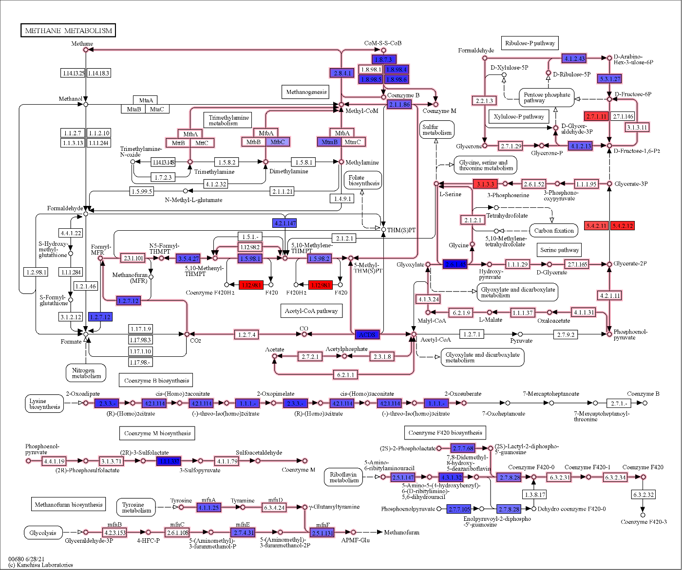

Figure S7. Effects of iodoform in methanogenesis pathways. Colored boxes highlight genes significantly impacted (MaAsLin2 analysis, p-value<0.05). Red indicates a positive coefficient (increased gene abundances relative to iodoform treatment). Blue indicates a negative coefficient (decreased gene abundances relative to iodoform treatment).
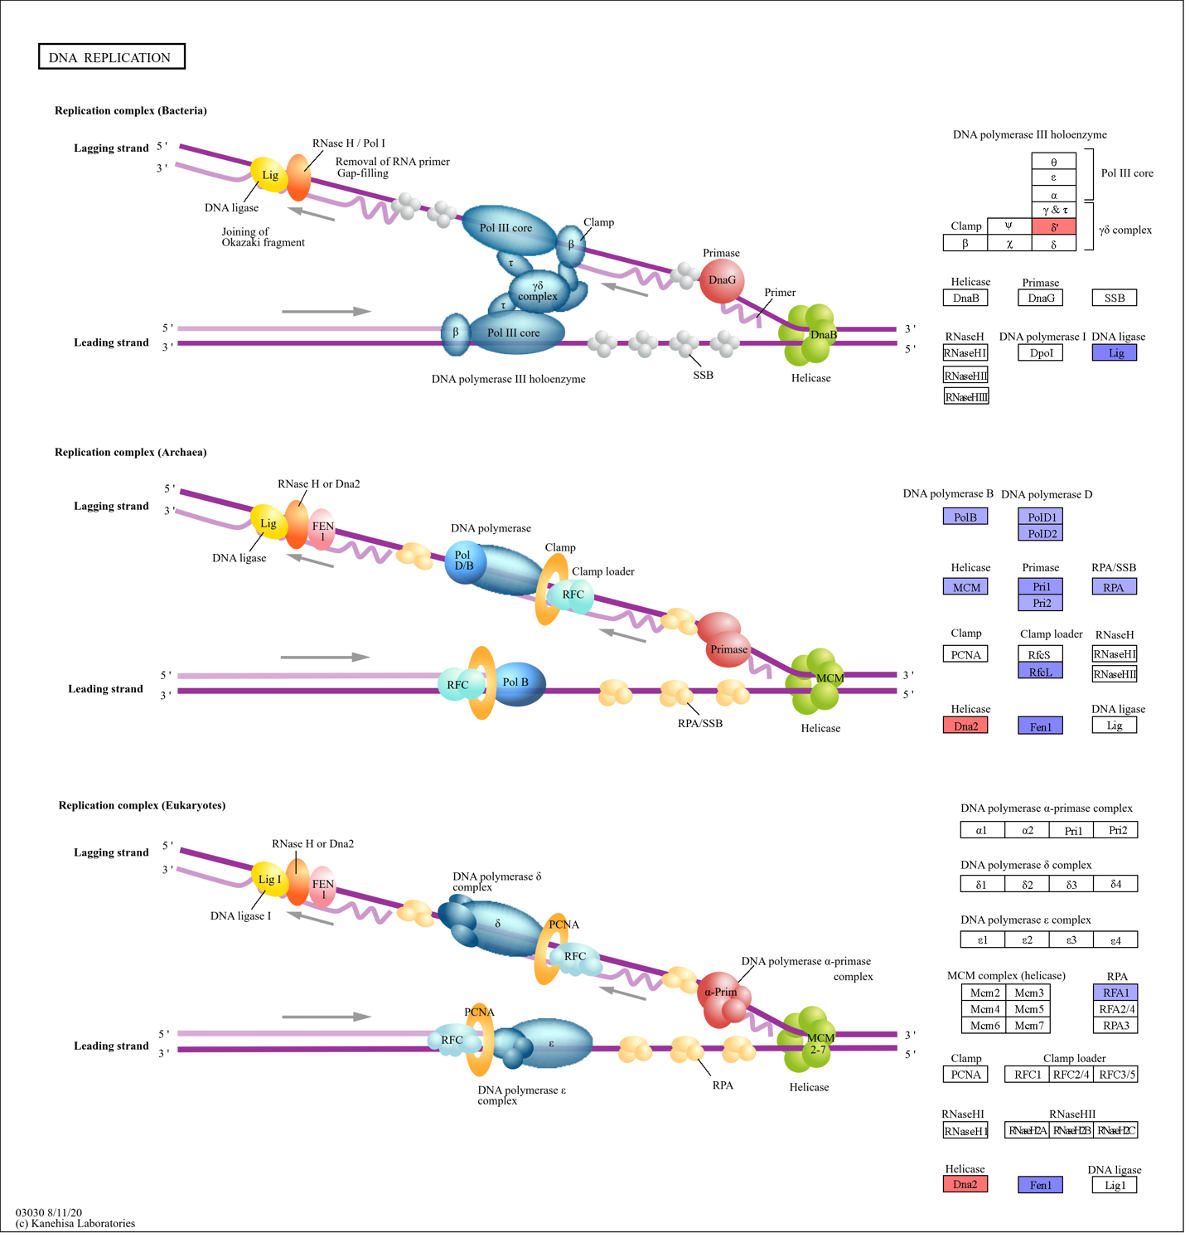

Figure S8. Effects of iodoform on DNA replication. Colored boxes highlight genes significantly impacted (MaAsLin2 analysis, p-value<0.05). Red indicates a positive coefficient (increased gene abundances relative to iodoform treatment). Blue indicates a negative coefficient (decreased gene abundances relative to iodoform treatment).

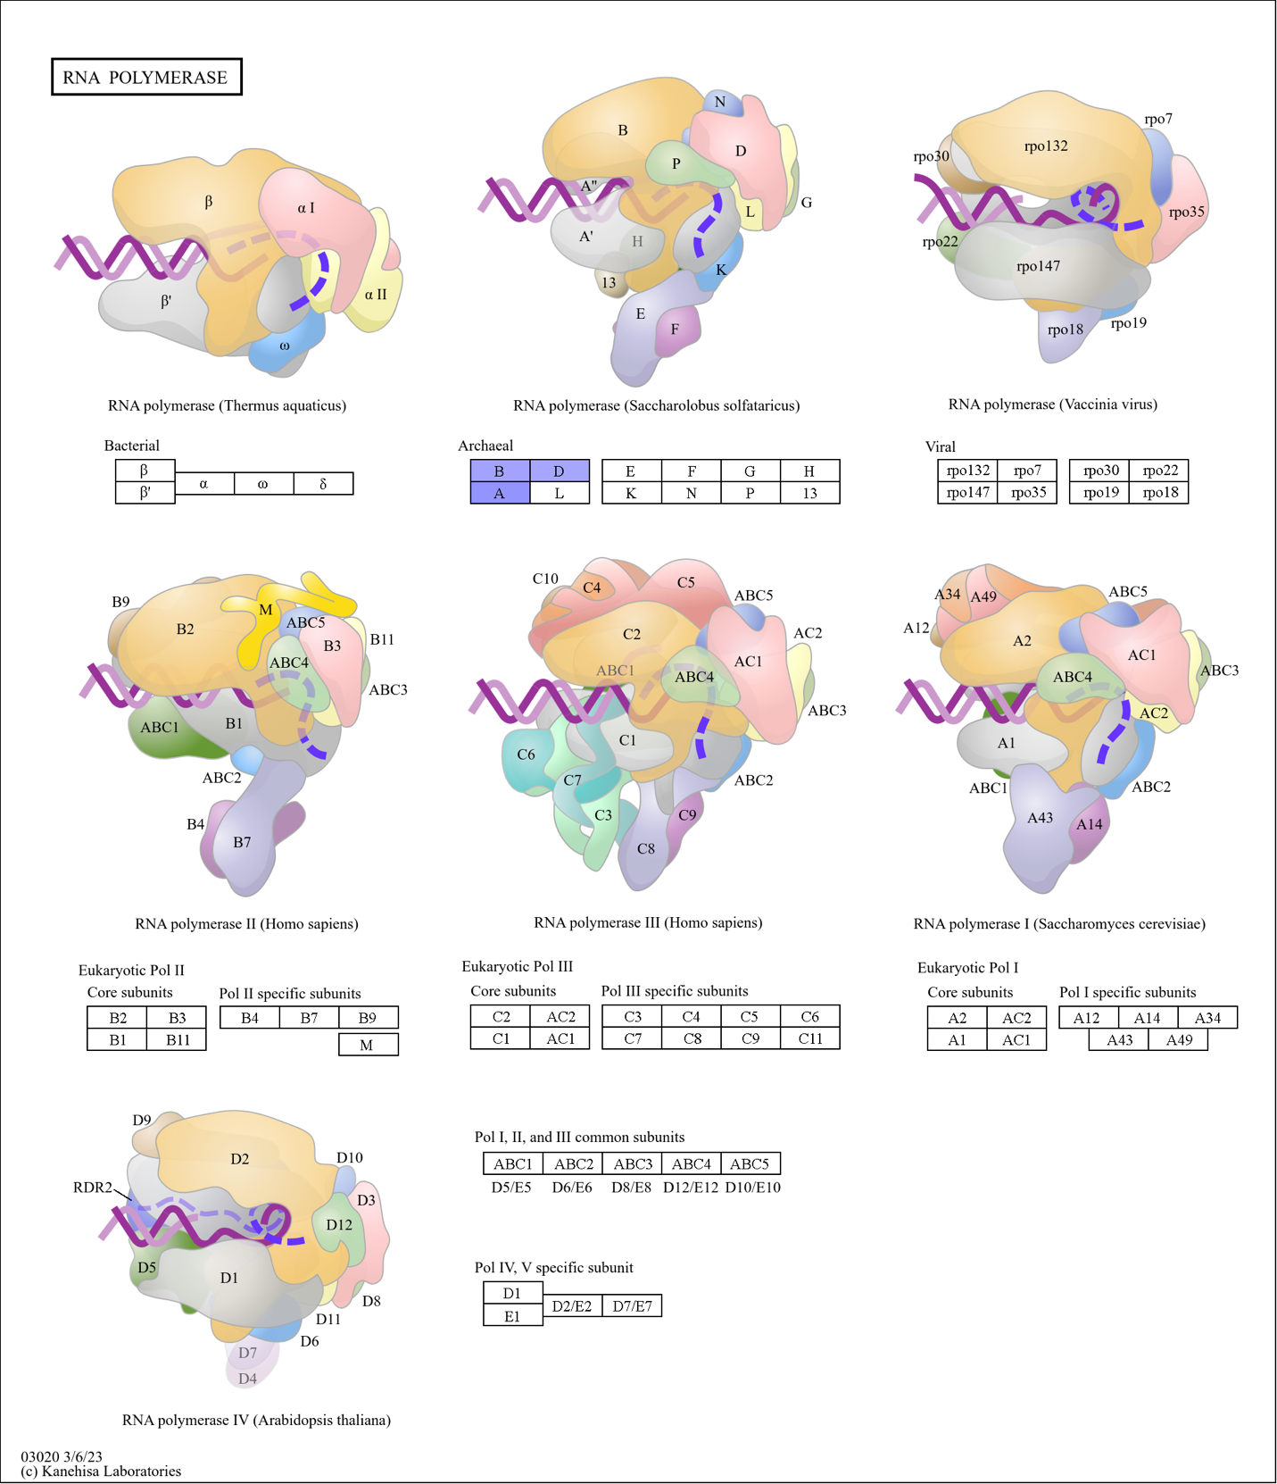
Figure S9. Effects of iodoform on RNA polymerase. Colored boxes highlight genes significantly impacted (MaAsLin2 analysis, p-value<0.05). Red indicates a positive coefficient (increased gene abundances relative to iodoform treatment). Blue indicates a negative coefficient (decreased gene abundances relative to iodoform treatment).

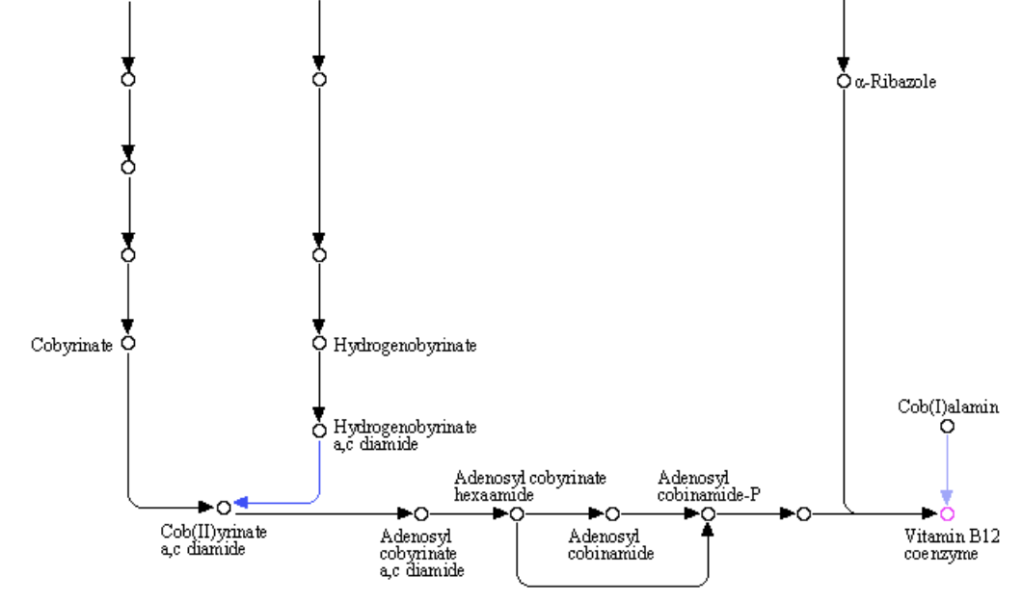
Figure S10. Iodoform impacts on vitamin B12 coenzyme biosynthesis pathways. Colored arrows highlight genes significantly impacted (MaAsLin2 analysis, p-value<0.05). Red indicates a positive coefficient (increased gene abundances relative to iodoform treatment). Blue indicates a negative coefficient (decreased gene abundances relative to iodoform treatment).

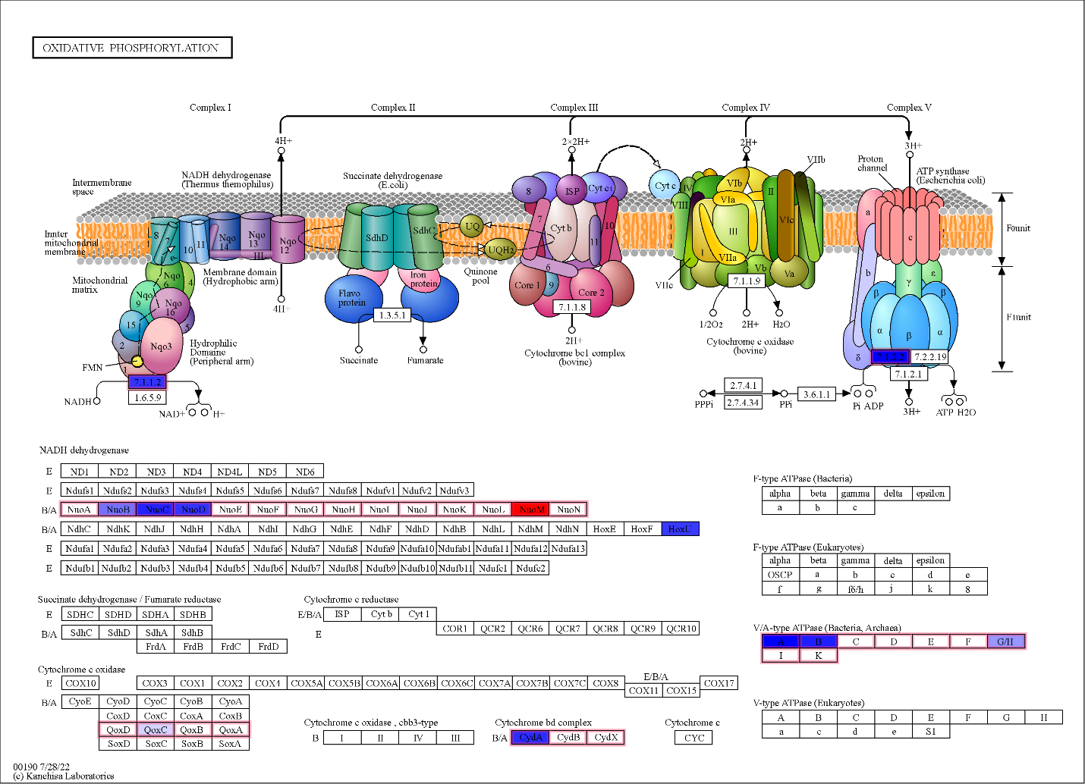
Figure S11. Iodoform impacts in oxidative phosphorylation. Colored boxes highlight genes significantly impacted (MaAsLin2 analysis, p-value<0.05). Red indicates a positive coefficient (increased gene abundances relative to iodoform treatment). Blue indicates a negative coefficient (decreased gene abundances relative to iodoform treatment).

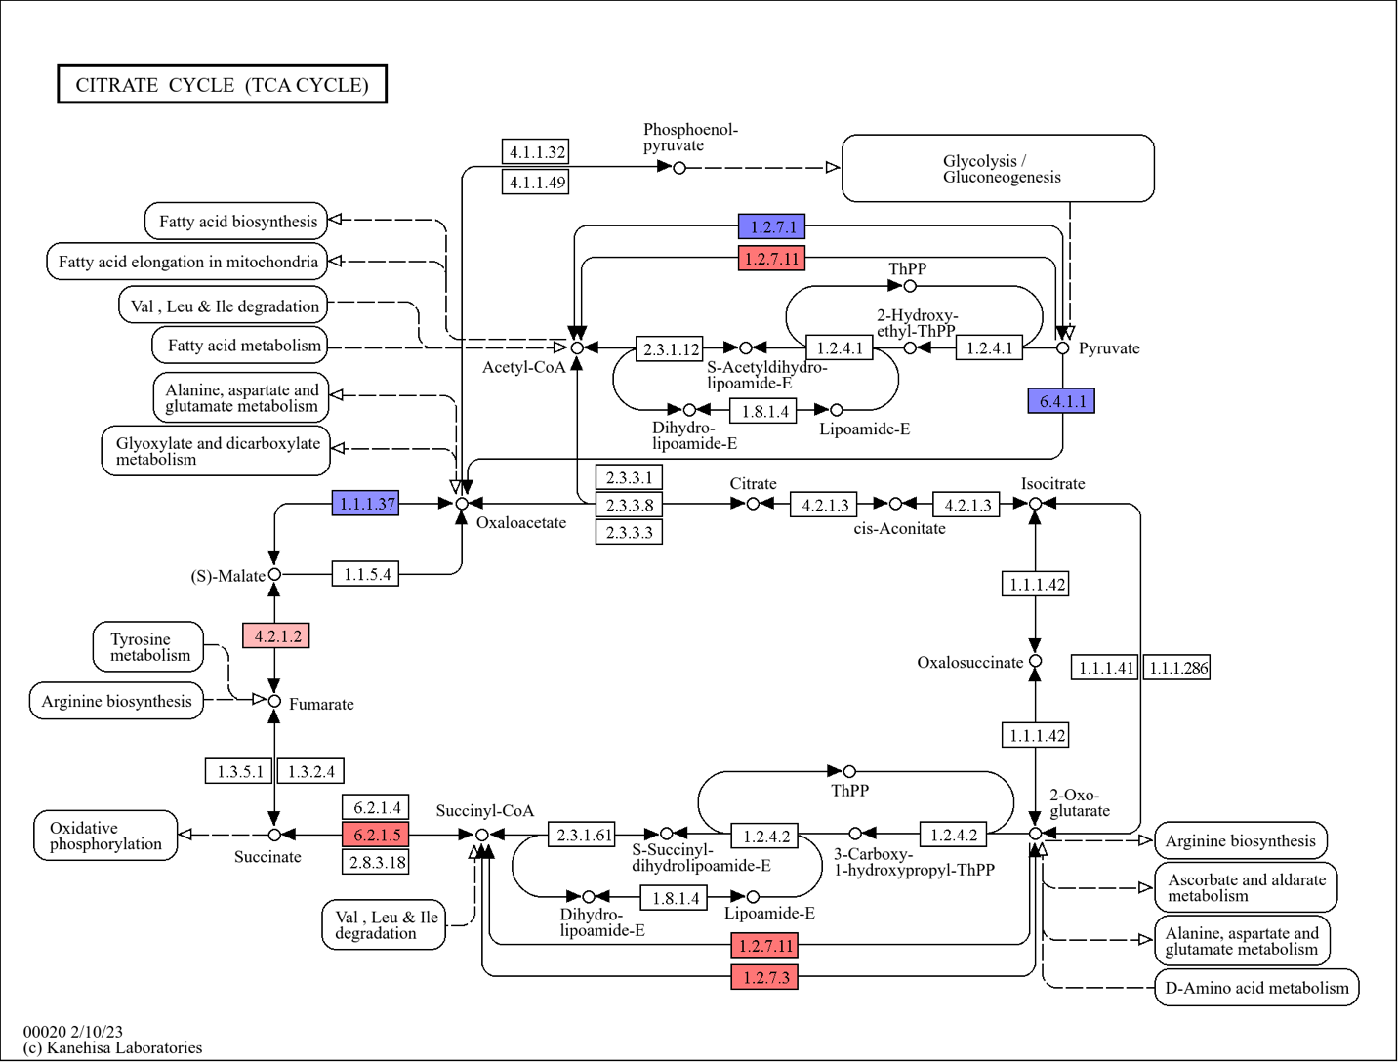
Figure S12. Iodoform impacts in TCA cycle. Colored boxes represent genes significantly impacted based on MaAsLin2 analysis. Red indicates a positive coefficient, associated with increased gene abundances relative to iodoform treatment. Blue indicates a negative coefficient, associated with decreased gene abundances relative to iodoform treatment.

Figure S13. Heatmap showing normalized gene abundances in NADH metabolism (right). Statistical analysis was performed using MaAsLin2; coefficient indicates the effect size relative to iodoform (left).
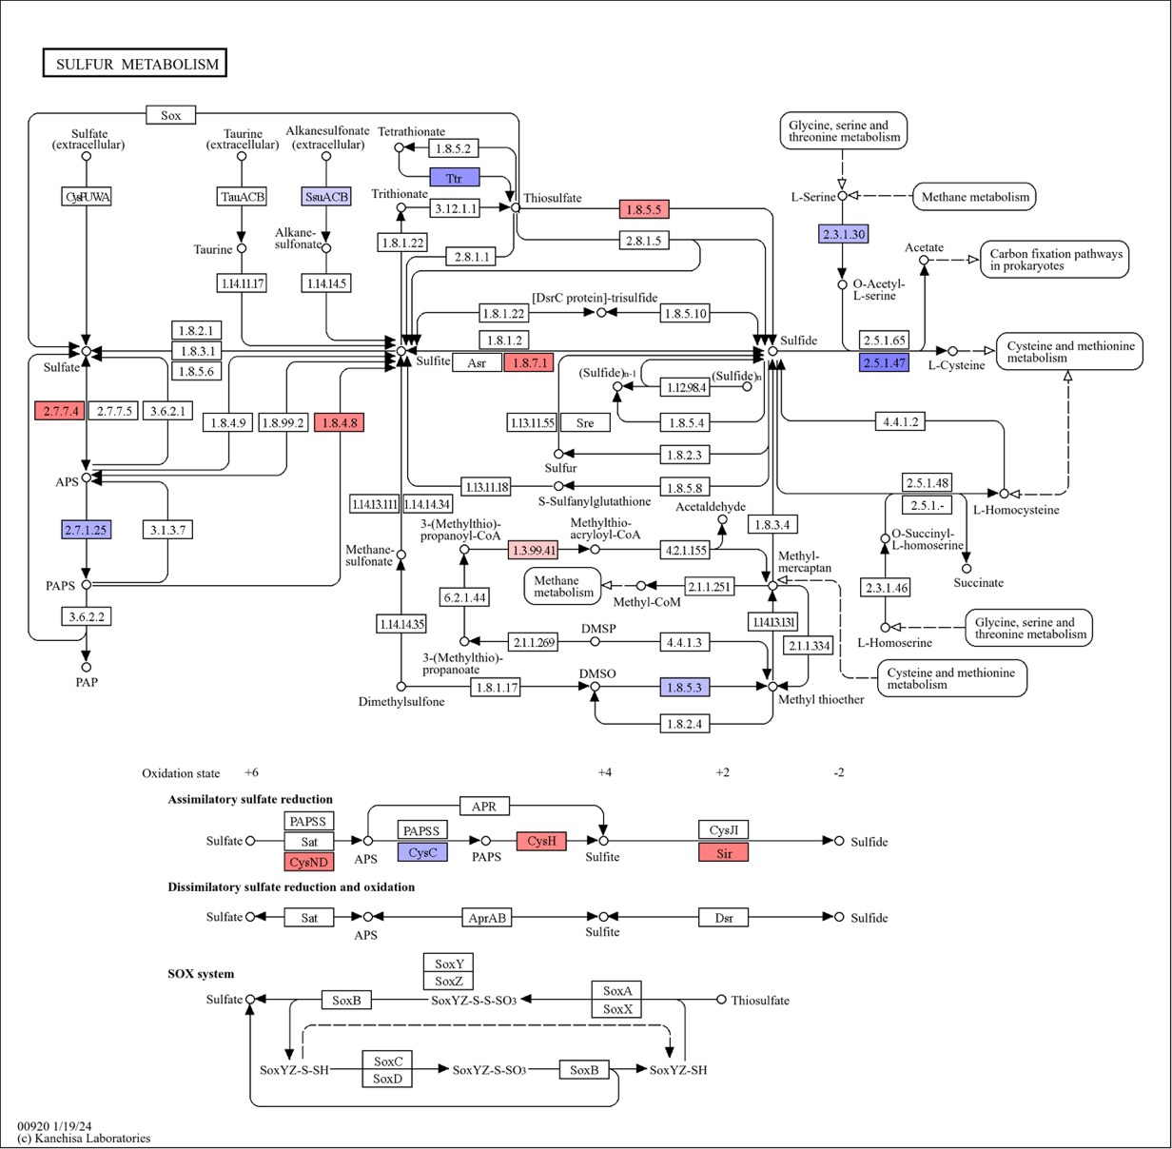

Figure S14a. Iodoform impacts on sulfur metabolism (pathways). Colored boxes represent genes significantly impacted based on MaAsLin2 analysis. Red indicates a positive coefficient, associated with increased gene abundances relative to iodoform treatment. Blue indicates a negative coefficient, associated with decreased gene abundances relative to iodoform treatment.

Figure S14b. Boxplots showing MaAsLin2 results for the assimilatory and dissimilatory sulfate reduction modules. The MaAsLin2 linear model coefficient (effect size) and Benjamini-Hochberg corrected q-value (FDR) are reported for each module. This analysis was performed specifically on samples from the last two timepoints (n=4).

Figure S15. Heatmap showing normalized gene abundances in amino acid metabolism (cysteine, methionine and branched chain) (right). Statistical analysis was performed using MaAsLin2; coefficient indicates the effect size relative to iodoform (left).

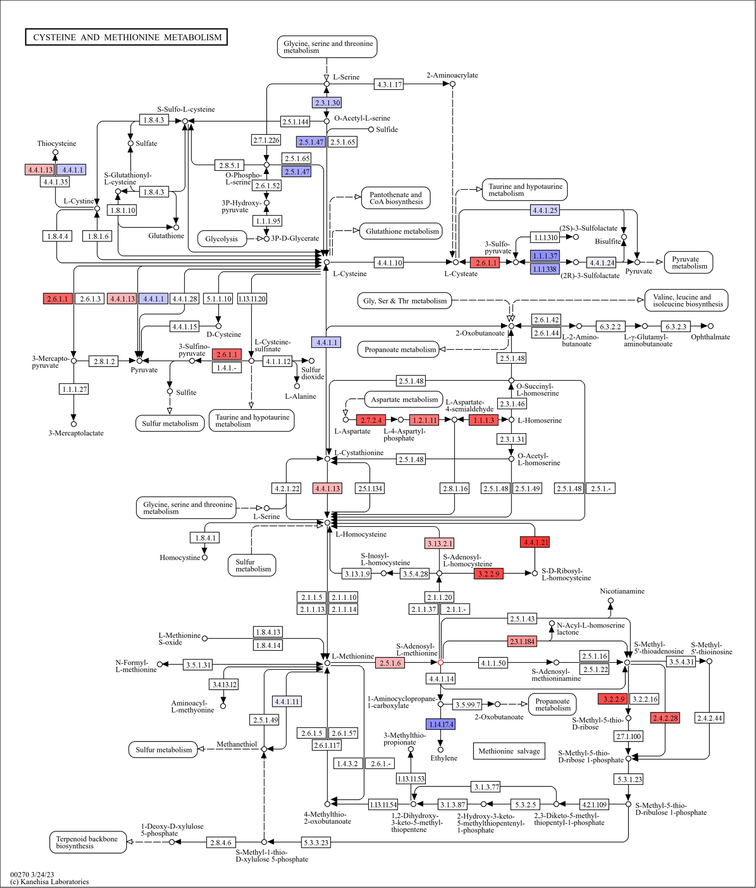
Figure S16. Iodoform impacts in cysteine and methionine metabolism. Colored boxes represent genes significantly impacted based on MaAsLin2 analysis. Red indicates a positive coefficient, associated with increased gene abundances relative to iodoform treatment. Blue indicates a negative coefficient, associated with decreased gene abundances relative to iodoform treatment.

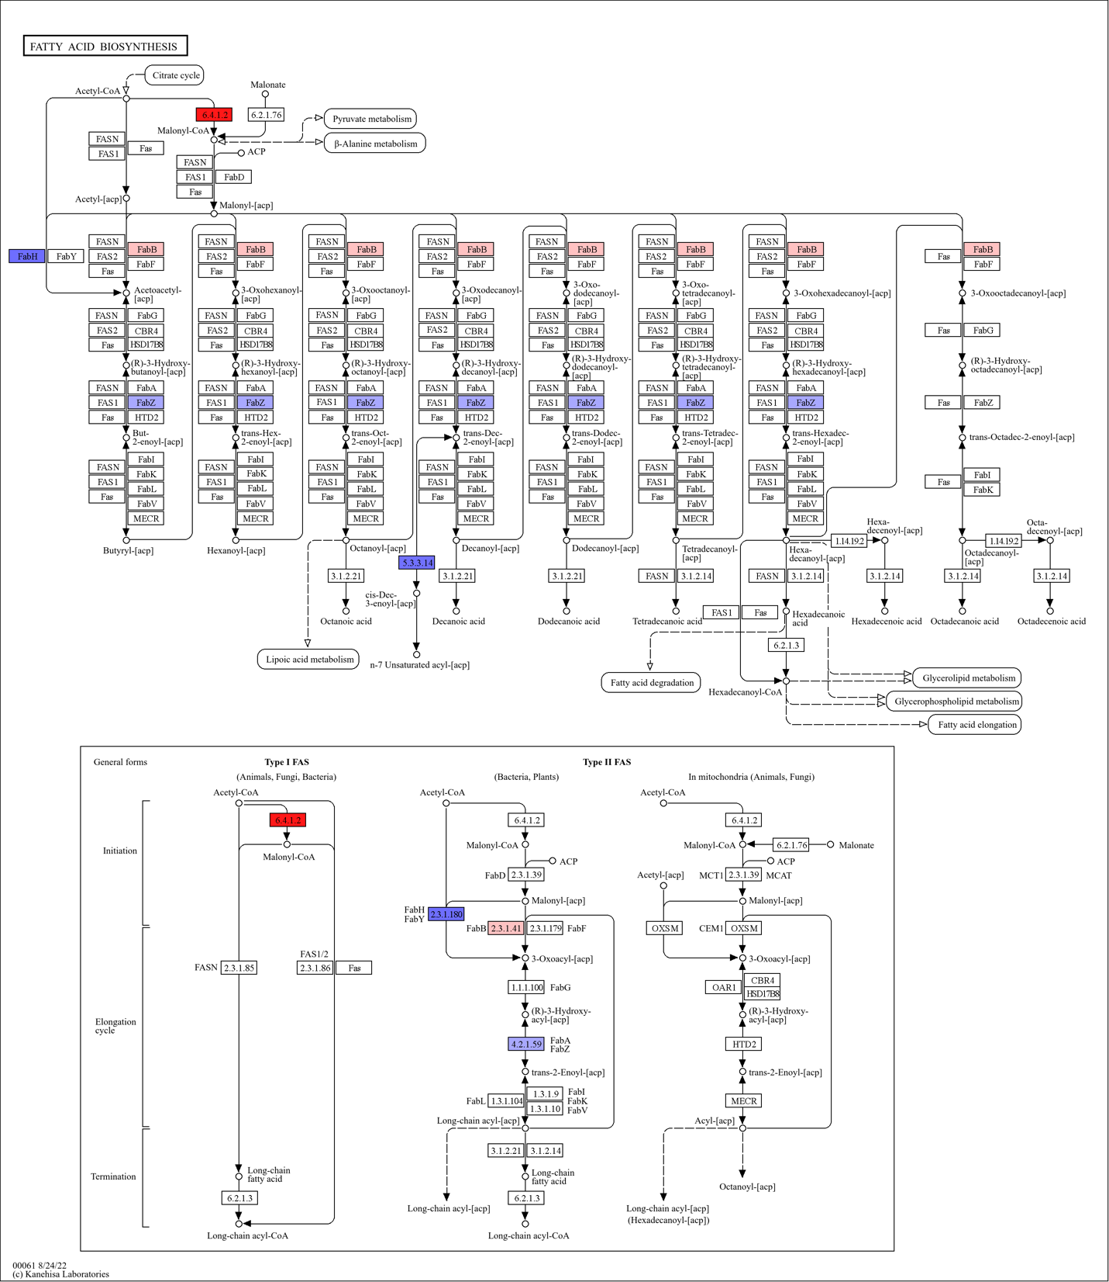
Figure S17. Iodoform impacts in fatty acid biosynthesis pathway. Colored boxes represent genes significantly impacted based on MaAsLin2 analysis. Red indicates a positive coefficient, associated with increased gene abundances relative to iodoform treatment. Blue indicates a negative coefficient, associated with decreased gene abundances relative to iodoform treatment.

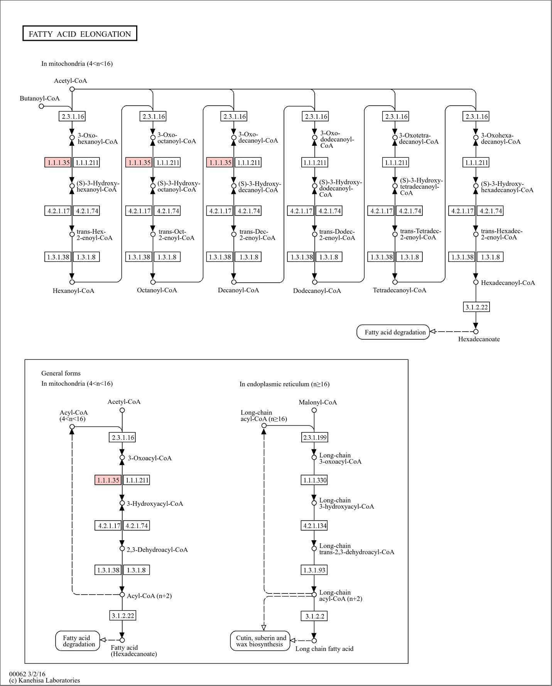
Figure S18. Iodoform impacts on fatty acid elongation pathway. Colored boxes represent genes significantly impacted based on MaAsLin2 analysis. Red indicates a positive coefficient, associated with increased gene abundances relative to iodoform treatment. Blue indicates a negative coefficient, associated with decreased gene abundances relative to iodoform treatment.

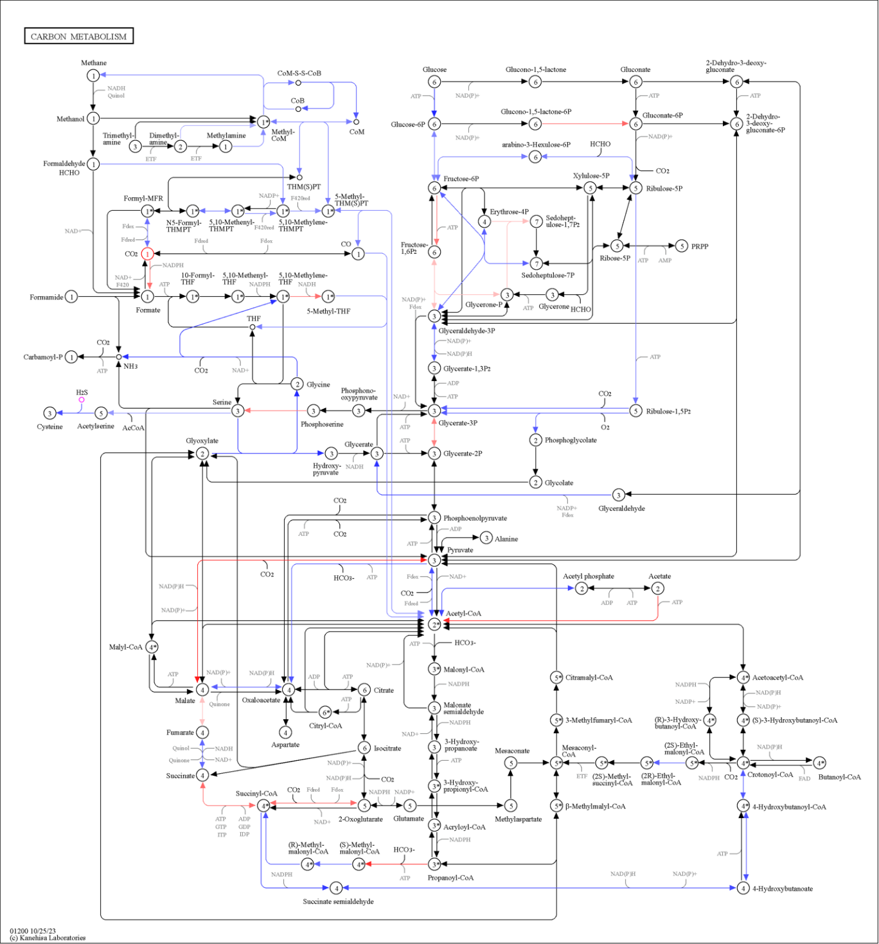
Figure S19. Iodoform impacts on carbon metabolism. Colored arrows represent genes significantly impacted based on MaAsLin2 analysis. Red indicates a positive coefficient, associated with increased gene abundances relative to iodoform treatment. Blue indicates a negative coefficient, associated with decreased gene abundances relative to iodoform treatment.

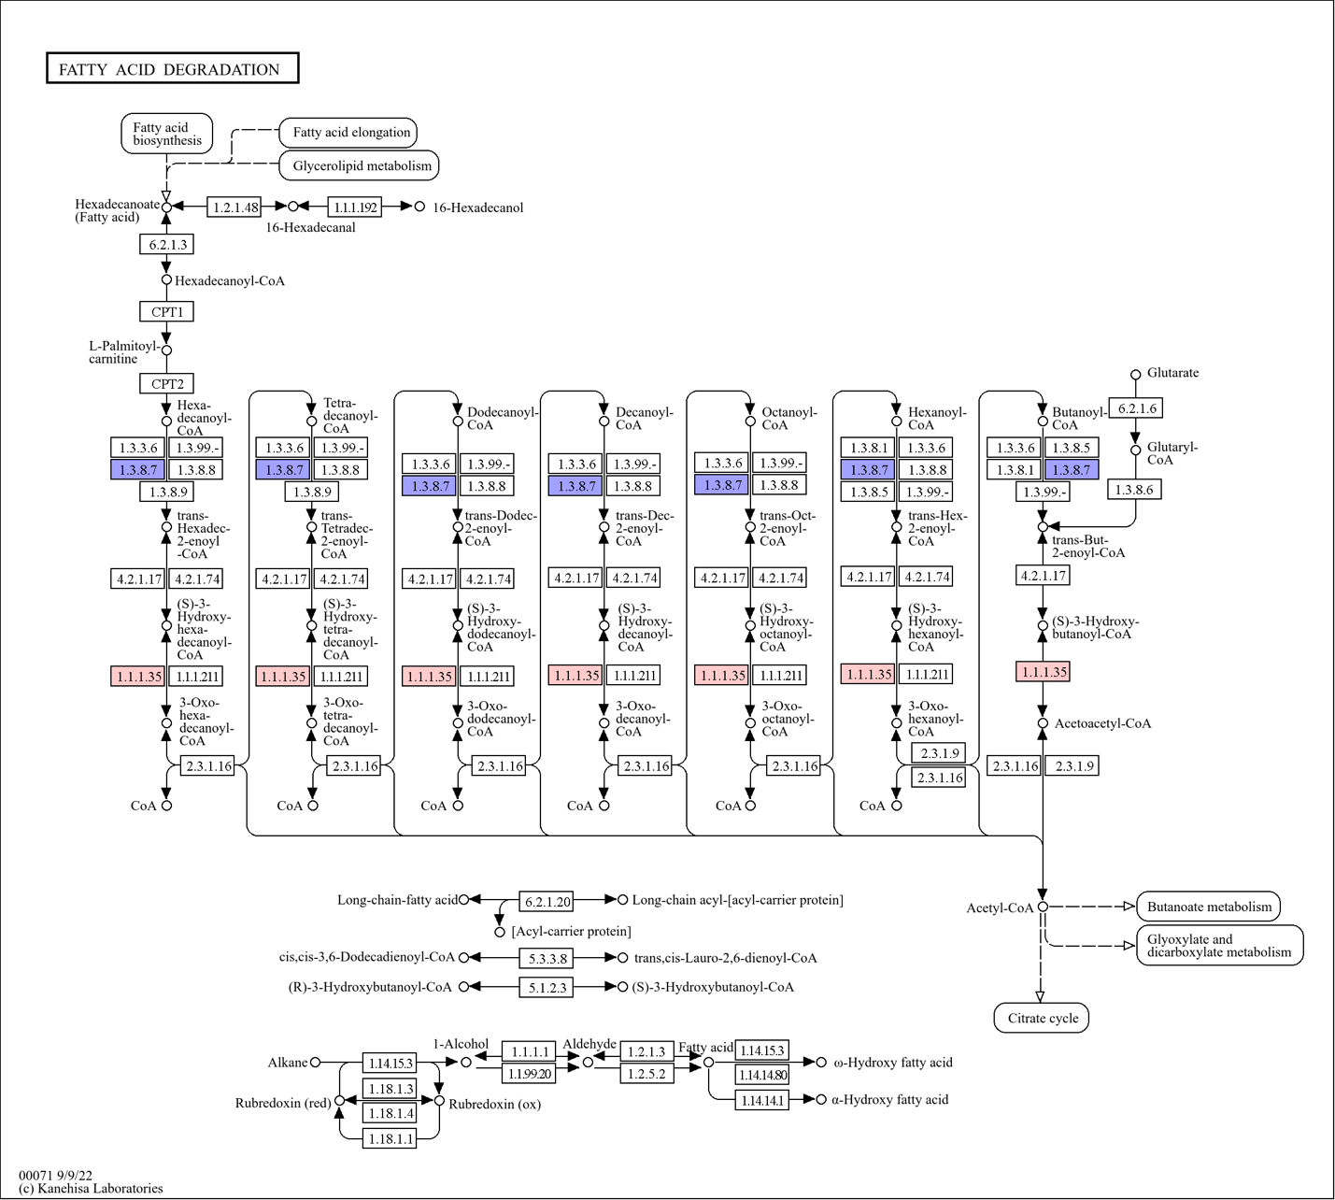
Figure S20. Iodoform impacts on fatty acid degradation pathway. Colored boxes represent genes significantly impacted based on MaAsLin2 analysis. Red indicates a positive coefficient, associated with increased gene abundances relative to iodoform treatment. Blue indicates a negative coefficient, associated with decreased gene abundances relative to iodoform treatment.
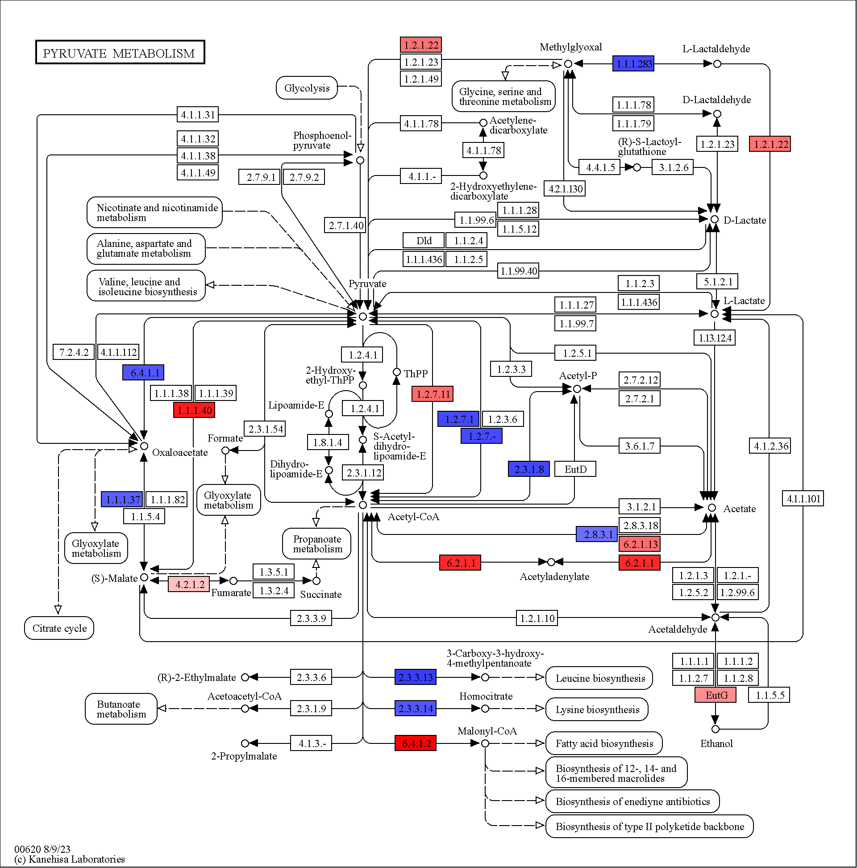

Figure S21. Iodoform impacts on pyruvate metabolism. Colored boxes represent genes significantly impacted based on MaAsLin2 analysis. Red indicates a positive coefficient, associated with increased gene abundances relative to iodoform treatment. Blue indicates a negative coefficient, associated with decreased gene abundances relative to iodoform treatment.

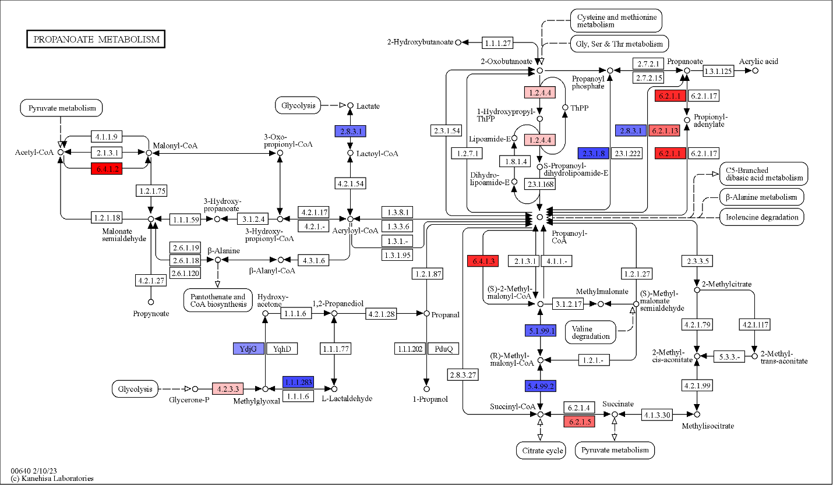
Figure S22. Iodoform impacts in propionate metabolism. Colored boxes represent genes significantly impacted based on MaAsLin2 analysis. Red indicates a positive coefficient, associated with increased gene abundances relative to iodoform treatment. Blue indicates a negative coefficient, associated with decreased gene abundances relative to iodoform treatment.
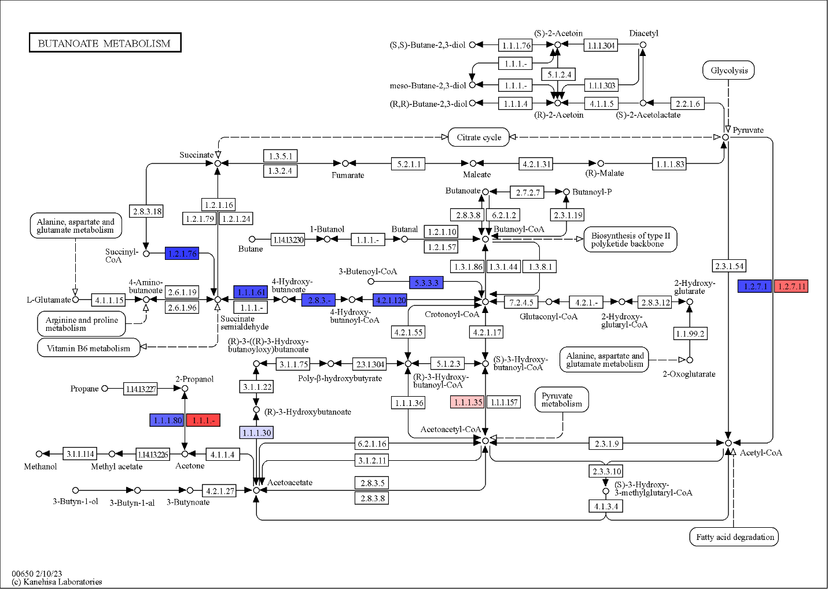
Figure S23. Iodoform impacts in butanoate metabolism. Colored boxes represent genes significantly impacted based on MaAsLin2 analysis. Red indicates a positive coefficient, associated with increased gene abundances relative to iodoform treatment. Blue indicates a negative coefficient, associated with decreased gene abundances relative to iodoform treatment.
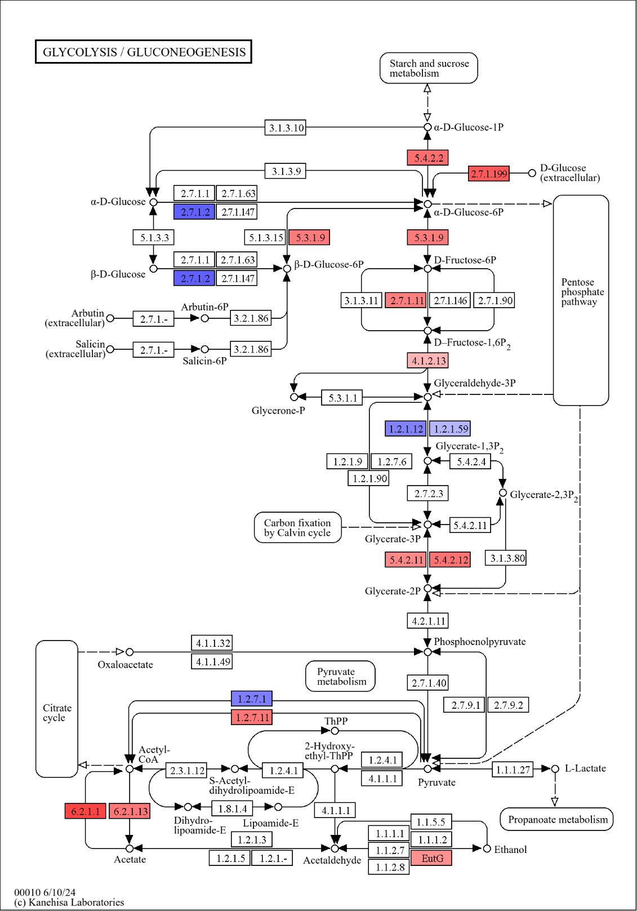
Figure S24. Iodoform impacts in glycolysis pathways. Colored boxes represent genes significantly impacted based on MaAsLin2 analysis. Red indicates a positive coefficient, associated with increased gene abundances relative to iodoform treatment. Blue indicates a negative coefficient, associated with decreased gene abundances relative to iodoform treatment.

