Supplemental Figure 1: Quantitative analysis of the number of astrocytes and microglia show no significant changes in the number of each cell type in aged CCD negative and positive canines. Three brain regions were analyzed for the number of astrocytes (GFAP) and microglia (Iba1) in the hippocampus (A, D), frontal cortex (C, E) and thalamus (C,F). N= 3 for Aged group and 4 for CCD positive group
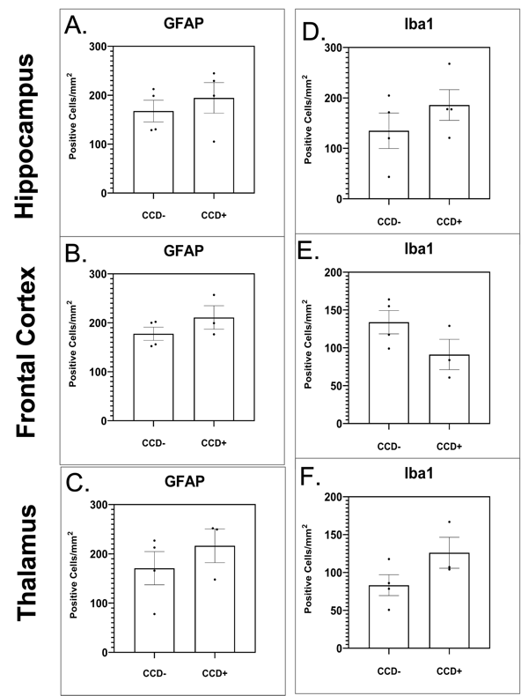

Supplemental Figure 2. Quantitative analysis phosphorylation of tau shows no significant changes in the number of cells positive for P-217 or P231 in aged CCD negative and positive canines. Three brain regions were analyzed for the number of cells positive for P-Tau 217 or P-Tau 231 in the hippocampus (A, D), frontal cortex (C, E) and thalamus (C,F). N= 3 for Aged group and 4 for CCD positive group
