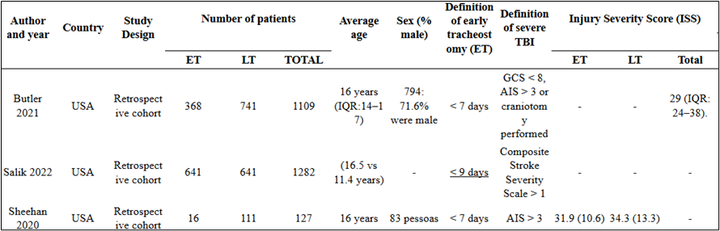
Table 1 Baseline characteristics of the included studies and the population

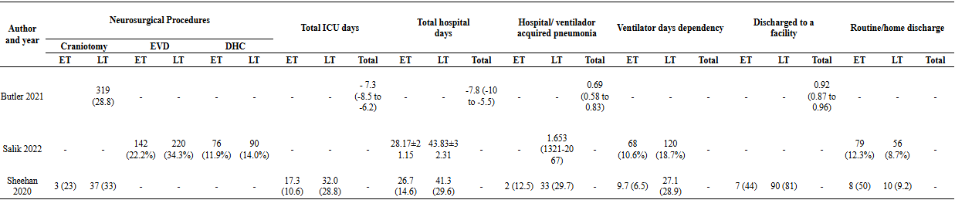
Table 2 Clinical outcomes of the included studies

