Supporting information
Comparison of dual-target and monotarget strips for the detection of fentanyl and xylazine
Hirudini Fernando, Anita Amate, Marya Lieberman

Table of contents
Figure S1. Screenshots showing commercial dual test strip products
Figure S2. Photos of test strips used in this study
Figure S3. Scorecard used for the classification of test strip results with ImageJ line intensities
Table S1. Xylazine line of DSG V1 strip LOD pictures and line intensities
Table S2. Fentanyl and fentanyl analogs tested with DSG Version 1
Table S3. Xylazine line intensities for DSG Version 1, BTNX, and WHPM xylazine strips
Table S4. Fentanyl test strip results for selected fentanyl analogs at 100 ng/mL
Table S5. Cis-tramadol shows false positive for the fentanyl line on DSG v1 test strips
Table S6. Lidocaine shows false positive for xylazine line on DSG v1 test strips
Table S7. False positive for PCP
Table S8. False positive for diphenhydramine
Table S9. Nitazene and nitazene analogs tested on DSG, WHPM, BTNX test strips
Figure S4. Xylazine test strip [ DSG v1] performance at 1000 and 2000 ng/mL
Figure S5. False positive test results for DSG V2
Table S10. Composition of artificial urine

Figure S1. Screenshots showing commercial dual test strip products

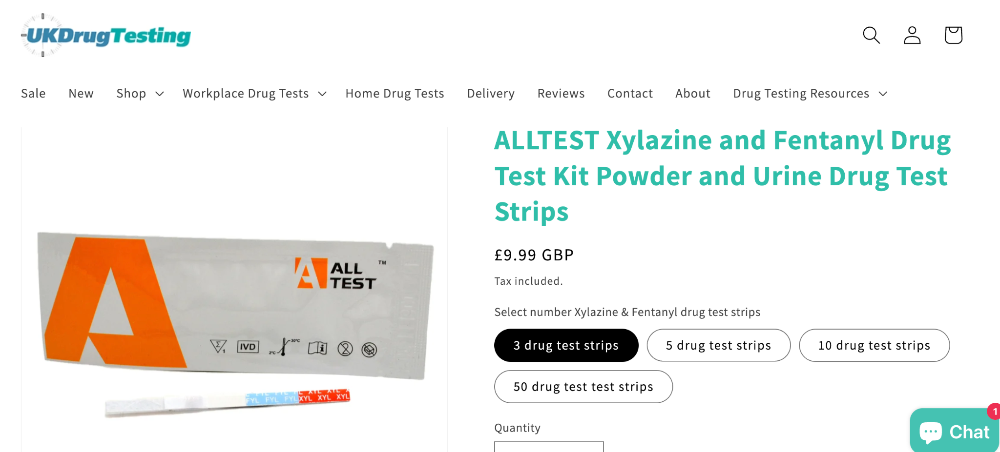

Accessed on 6 August 2025: Alltest Xylazine and Fentanyl test strips
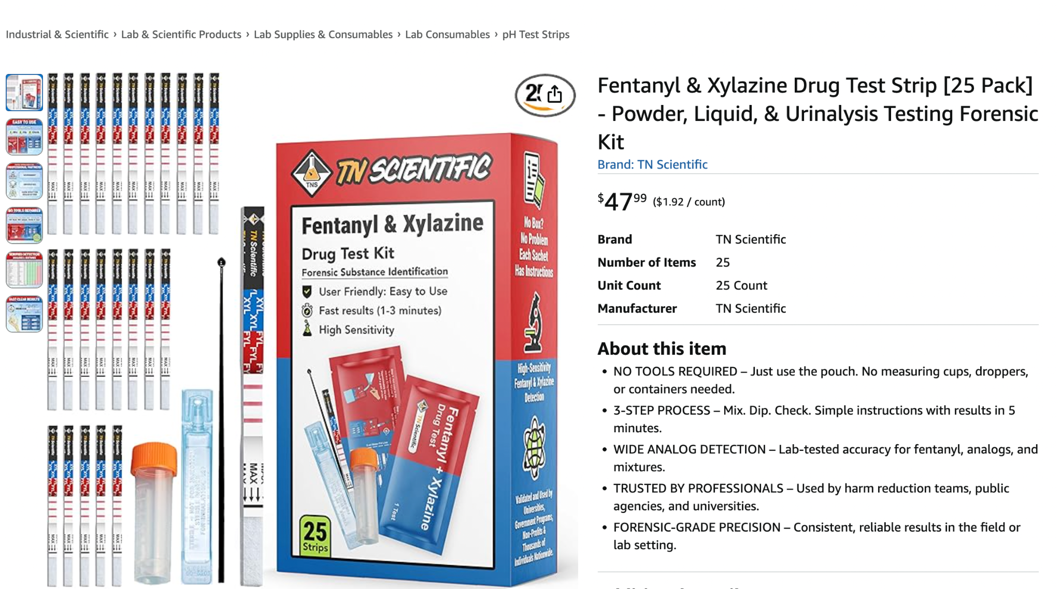
Accessed on 6 August 2025: TN scientific Fentanyl and Xylazine test strips

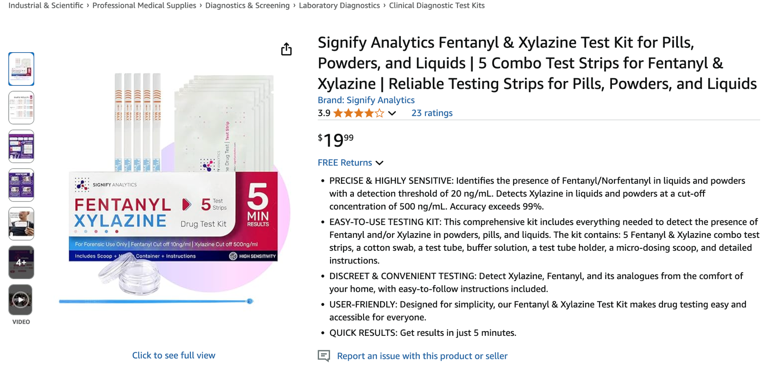
Accessed on 6 August 2025: Signify Analytics Fentanyl and Xylazine test strips
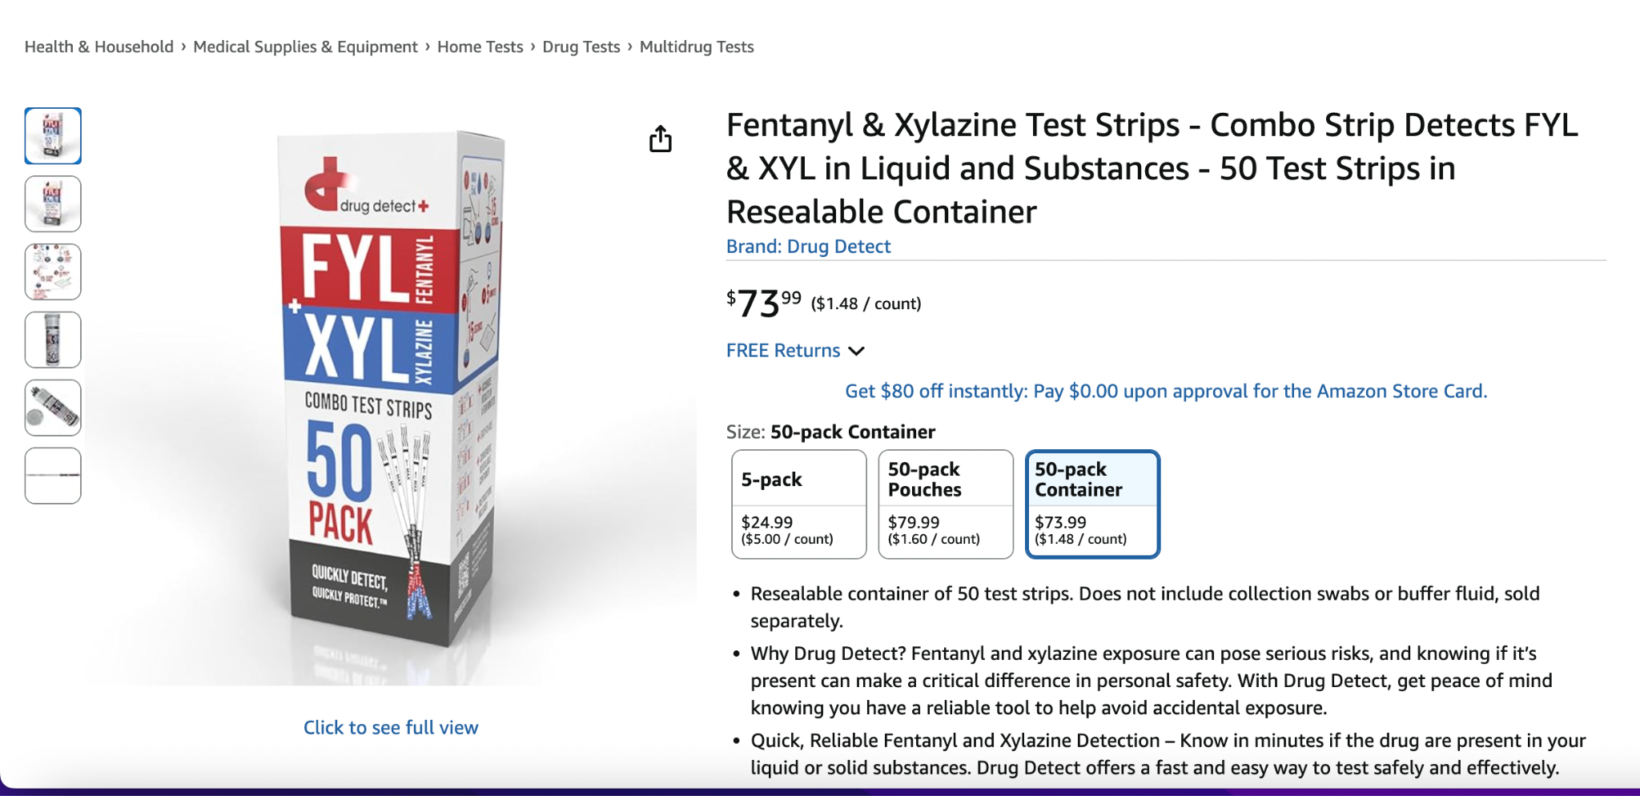
Accessed on 11 August 2025: Drug Detect Fentanyl and Xylazine test strips

Figure S2. Photos of test strips used in this study
1] HarmGuard FX multi-analyte rapid test strip [DSG version 1], 2] Rapid Response fentanyl test strip [BTNX], 3]DanceSafe fentanyl test strip [WHPM], 4]xylazine test strip [WHPM], 5] Rapid Response xylazine test strip [BTNX], 6] HarmGuard FX multi-analyte rapid test strip [DSG version 2]
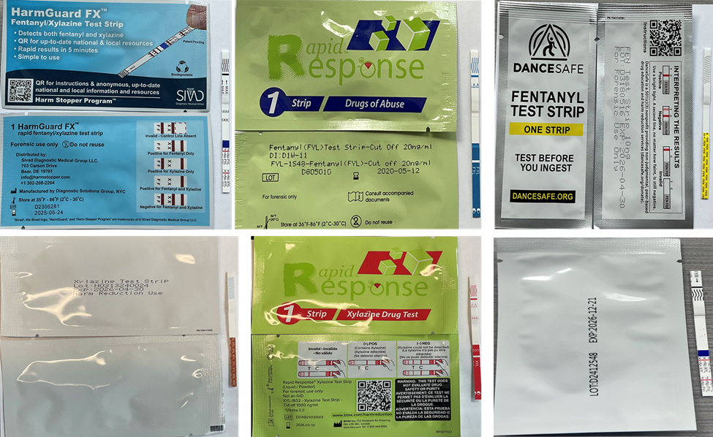

Figure S3. Scorecard used for the classification of Test Strip results with ImageJ line intensities
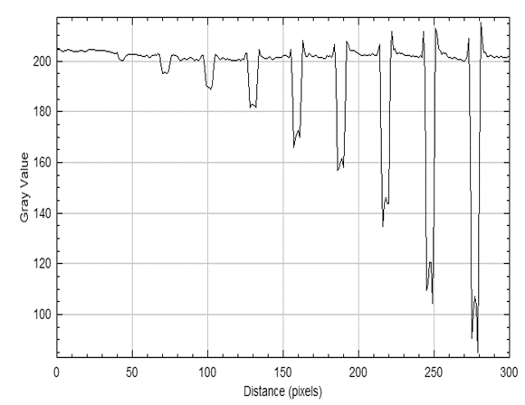
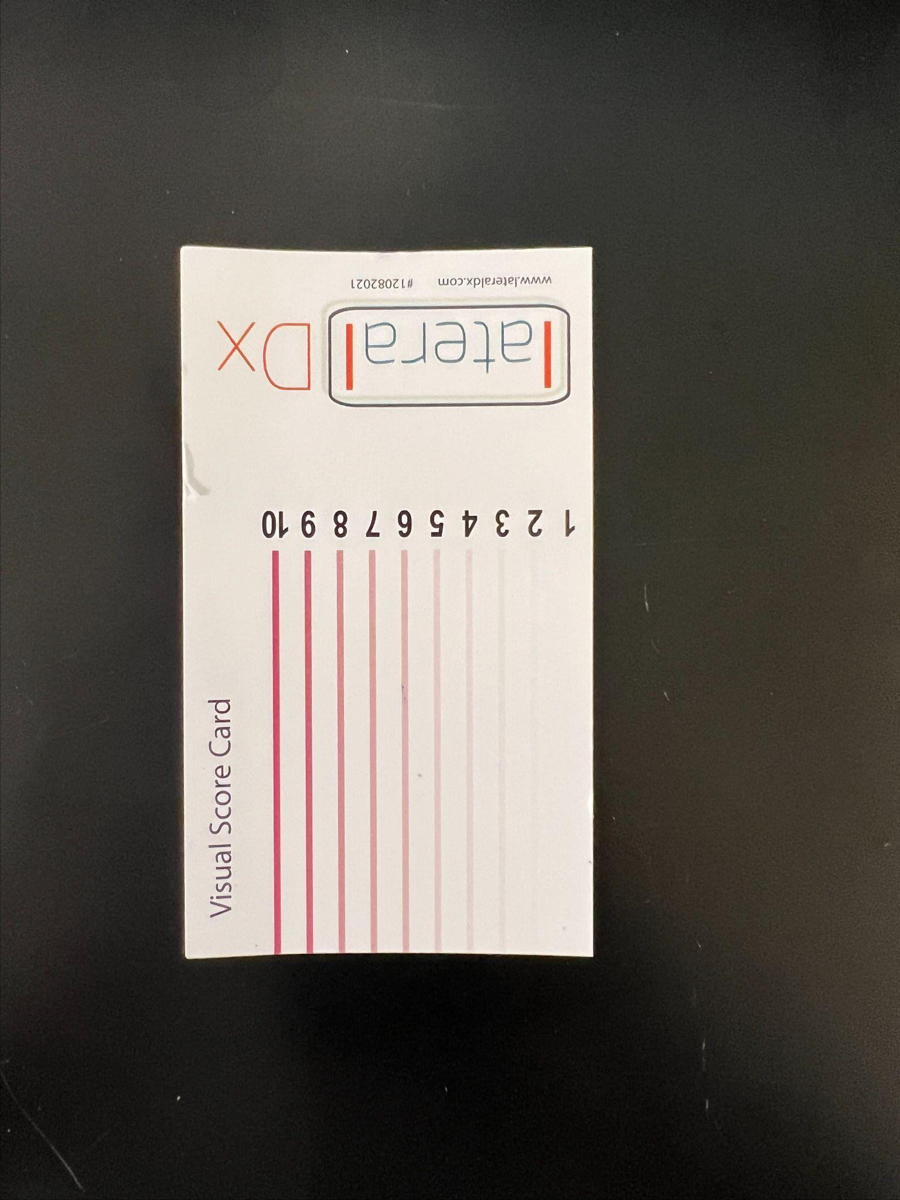

Table S1. Xylazine line of DSG V1 strip LOD pictures and line intensities

Analyte | Conc (ng/ml) | Results |  | Intensity  (Fent) | Intensity (xyl) | Pictures of Test Strips
Analyte | Conc (ng/ml) | Fent | Xyl | Intensity  (Fent) | Intensity (xyl) | Pictures of Test Strips
Xylazine  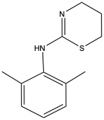 | 2500 | - - - | +++ | 888 | 000 | 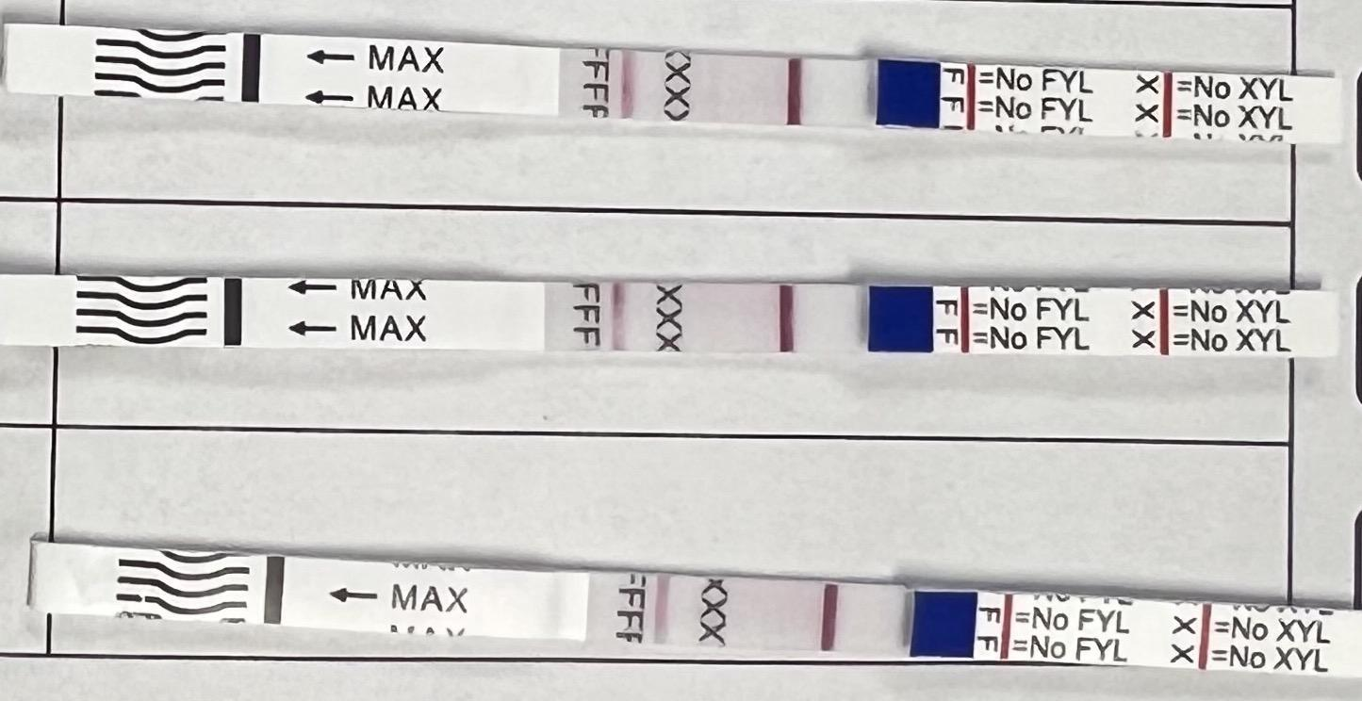
 | 2100 | - - - | ++- | 888 | 200 | 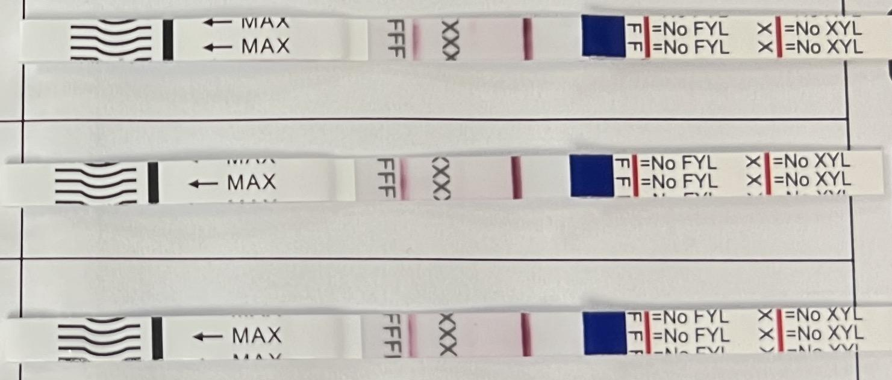
 | 2000 | - - - | ++- | 887 | 200 | 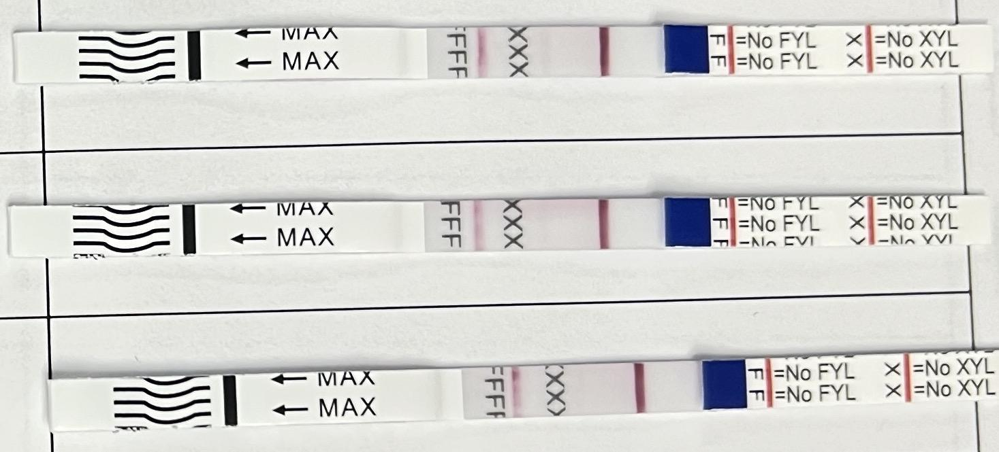
 | 1000 | - - - | ++- | 888 | 200 | 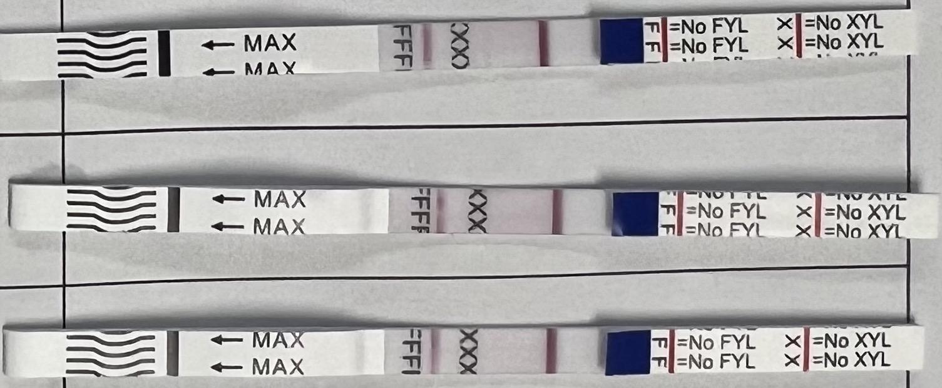
 | 800 | - - - | +-- | 887 | 320 | 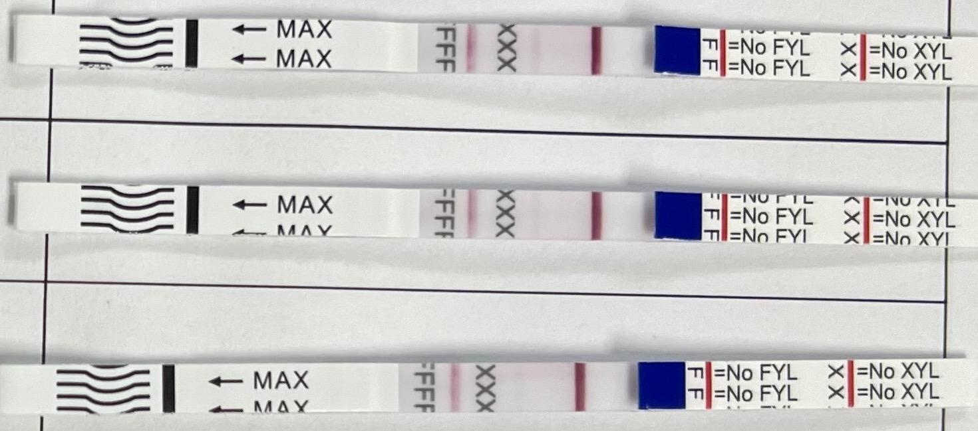
 | 750 | - - - | - - - | 877 | 222 | 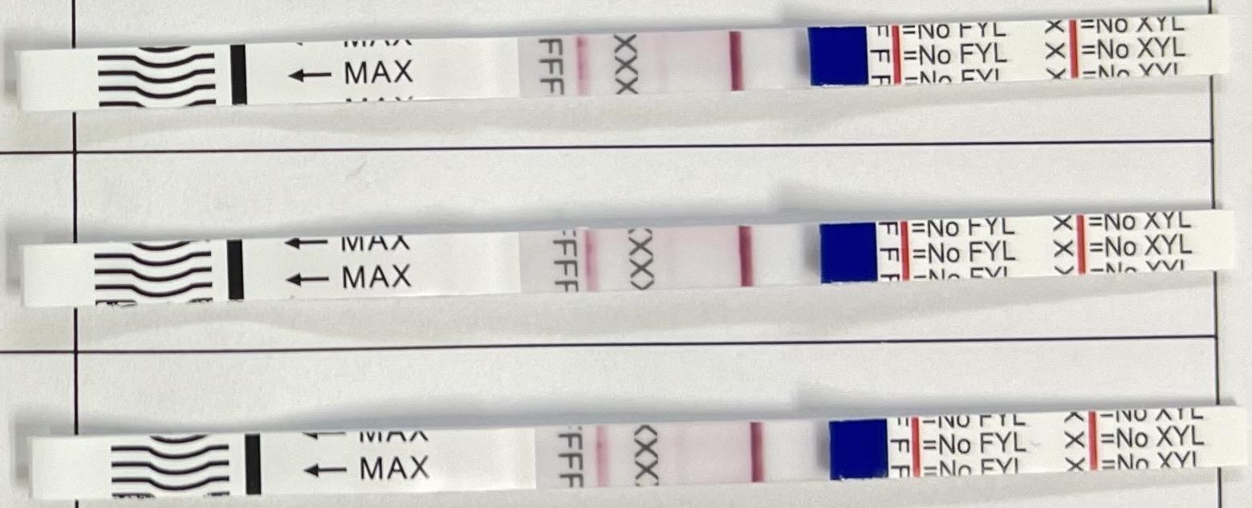

Table S2. Fentanyl and fentanyl analogs tested with DSG Version 1
We tested these compounds on Dual Test Strips (DSG lot D2306281), which detect fentanyl and xylazine, starting from high concentrations and gradually decreasing to lower concentrations. For the lower concentrations, we tested three strips for each concentration. The next column lists the intensity values based on a visual scorecard and images of the test strips for each concentration.
Analyte | Conc ng/ml | Results  Fent Xyl |  | Intensity (Fen) | Intensity (Xyl) | Pictures of Test Strips
Fentanyl HCL | 500000 | + | - | 0 | 7
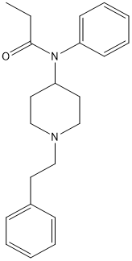 | 50000 | + | - | 0 | 7
 | 5000 | + | - | 0 | 8
 | 500 | + | - | 0 | 7
 | 300 | + | - | 0 | 6
 | 200 | +++ | - | 000 | 555 | 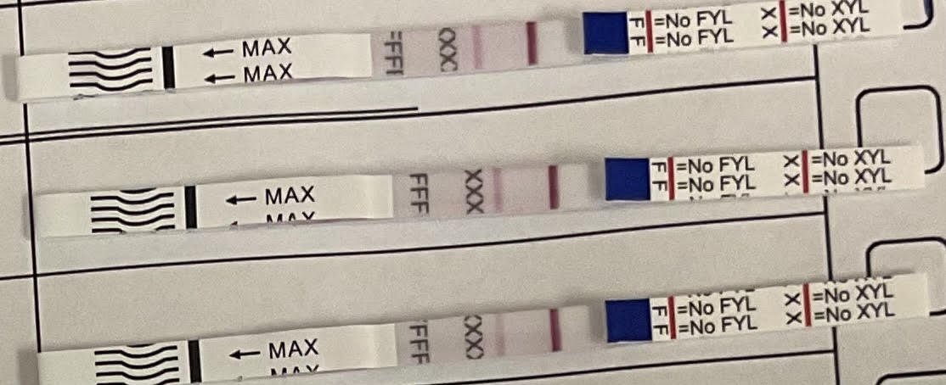
 | 100 | +++ | - | 000 | 556 | 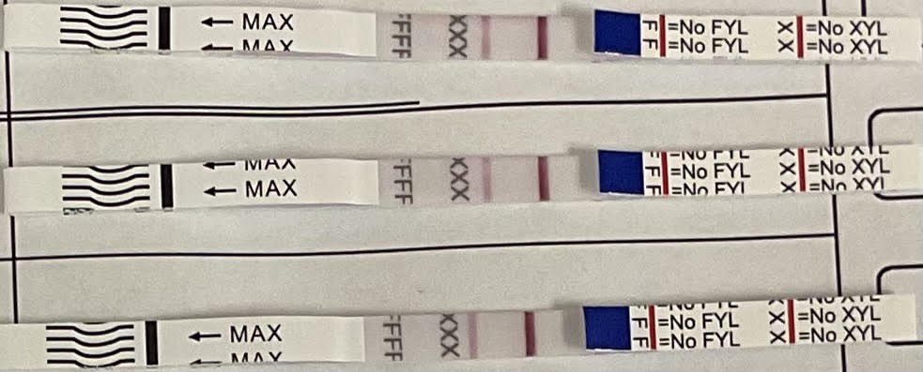
 | 90 | -++ | - | 200 | 667 | 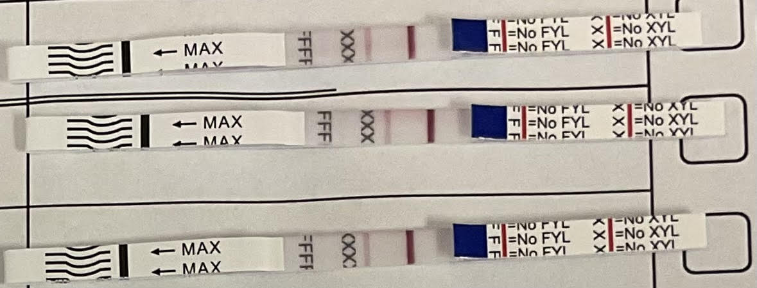
 | 80 | - - + | - | 110 | 666 | 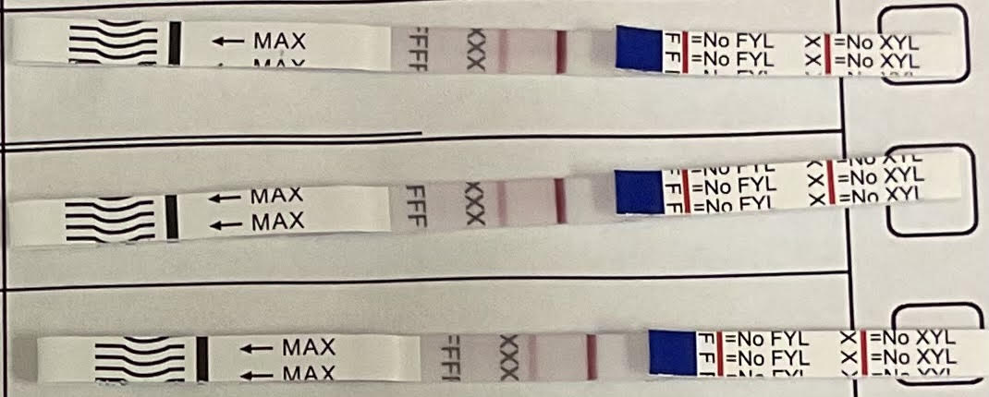
 | 75 | -+- | - | 101 | 667 | 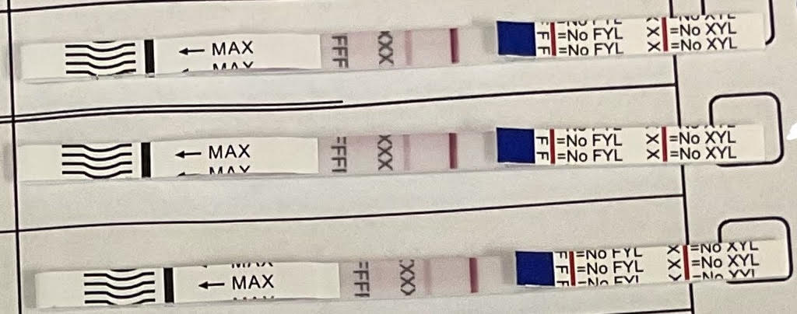
 | 50 | - - - | - | 111 | 667 | 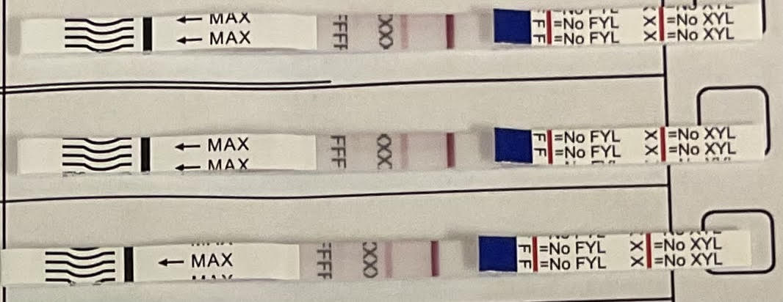
 | 25 | - - - | - | 222 | 555 | 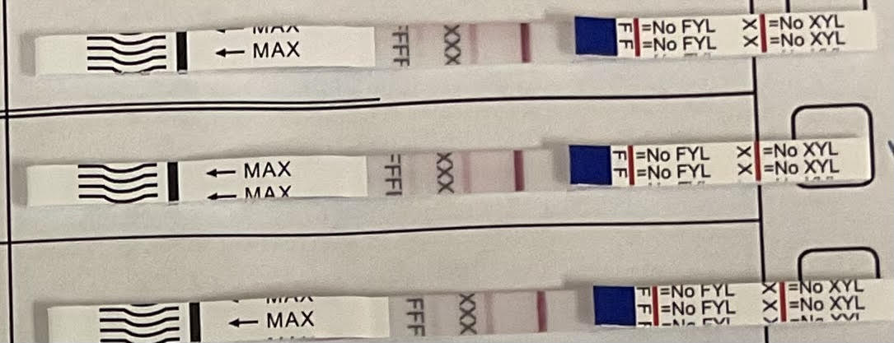
 | 10 | - - - | - | 555 | 556 | 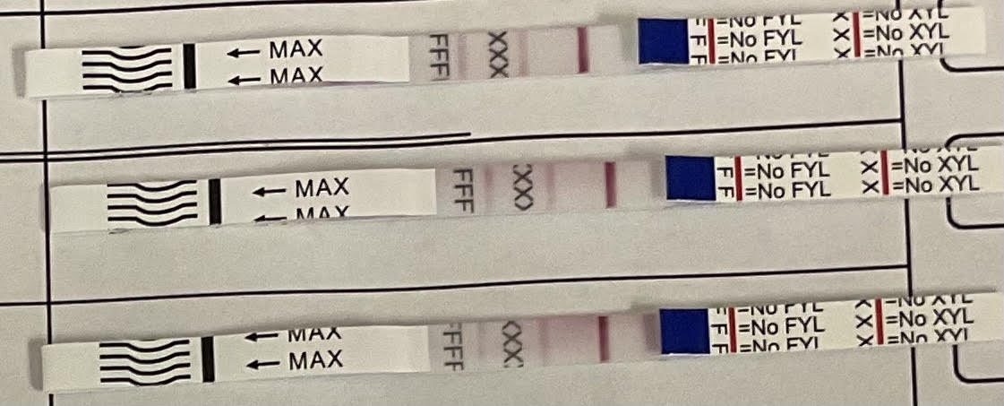
Furanyl Fentanyl | 500000 | + | - | 0 | 7
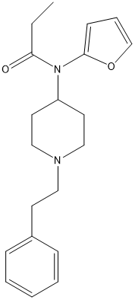 | 50000 | + | - | 0 | 8
 | 5000 | + | - | 0 | 8
 | 500 | + | - | 0 | 7
 | 200 | --- | --- | 111 | 667 | 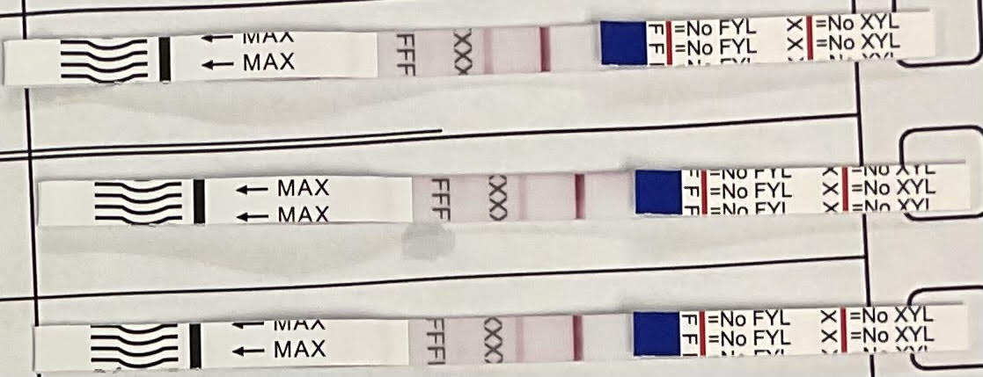
 | 150 | --- | --- | 222 | 666 | 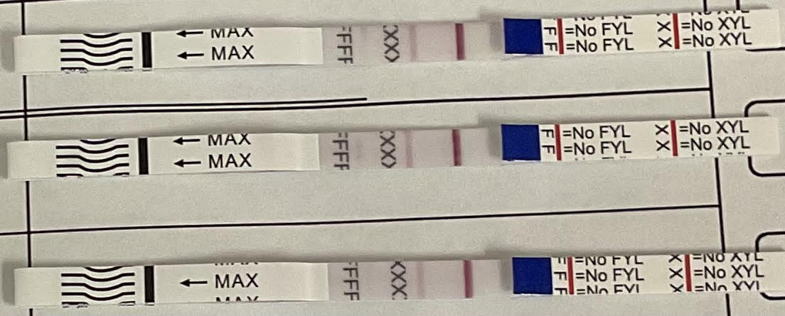
 | 100 | --- | --- | 222 | 656 | 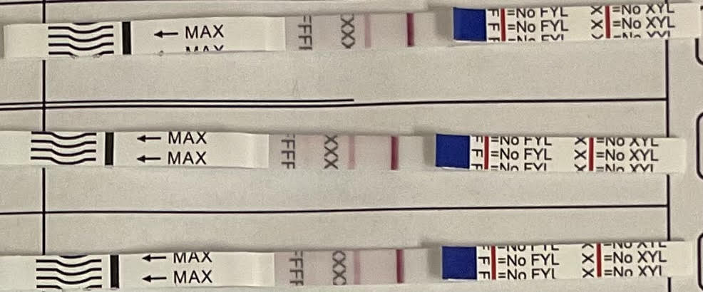
Butyryl Fentanyl | 500000 | + | - | 0 | 7
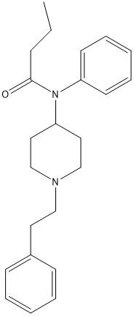 | 50000 | + | - | 0 | 8 | 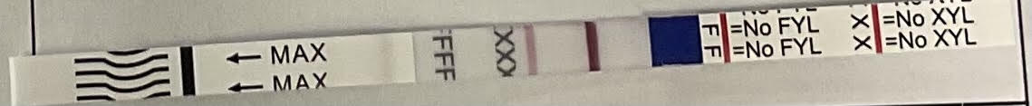
 | 5000 | + | - | 0 | 8
 | 500 | + | - | 0 | 8
 | 200 | +++ | --- | 000 | 767 | 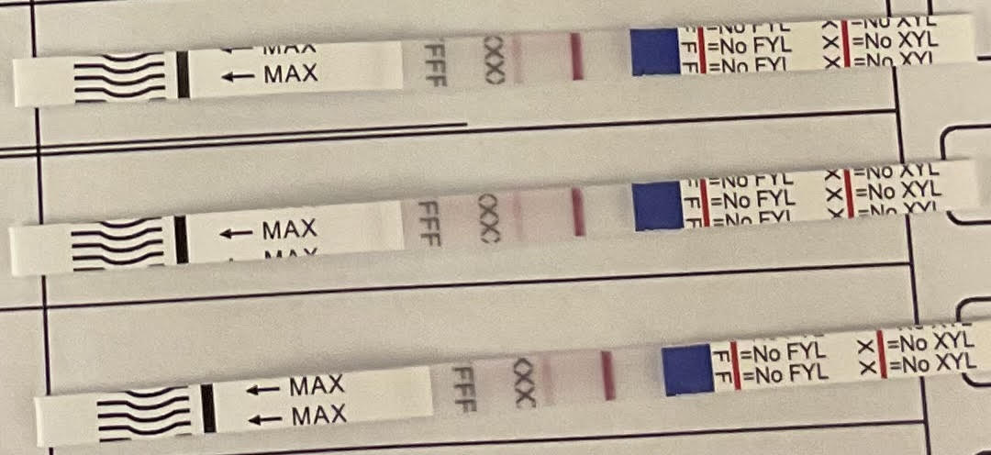
 | 150 | +++ | --- | 000 | 878 | 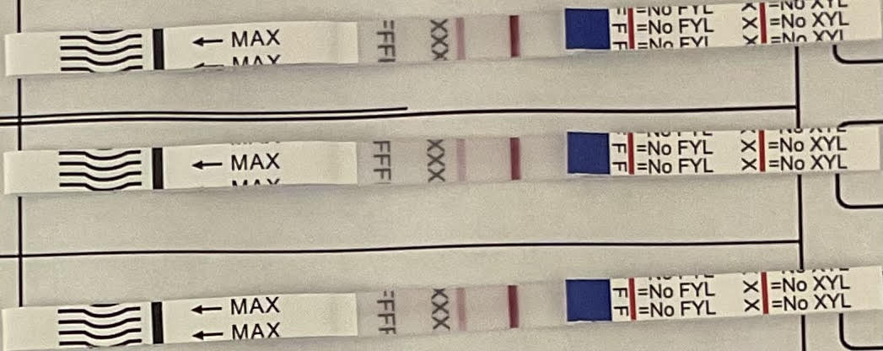
 | 100 | +-- | --- | 011 | 677 | 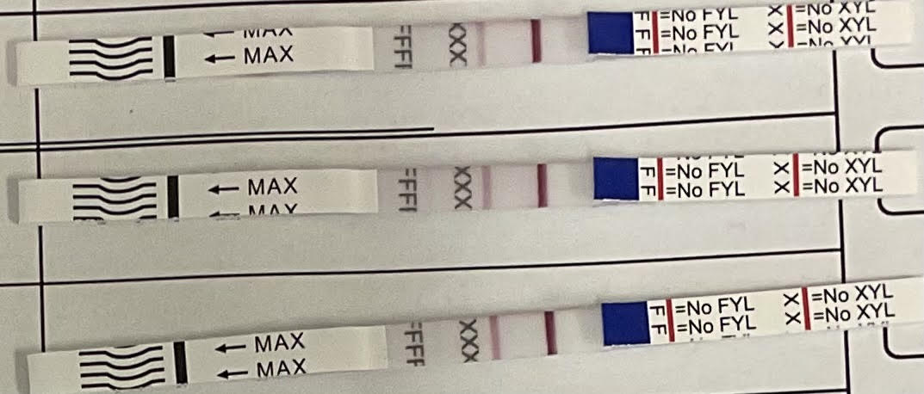
B-hydroxy Fentanyl | 500000 | + | - | 0 | 6
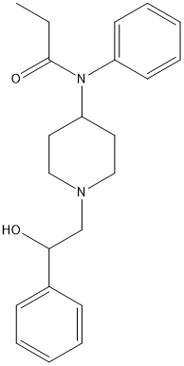 | 50000 | + | - | 0 | 7
 | 5000 | + | - | 0 | 8
 | 500 | + | - | 0 | 8
 | 200 | +++ | --- | 000 | 766 | 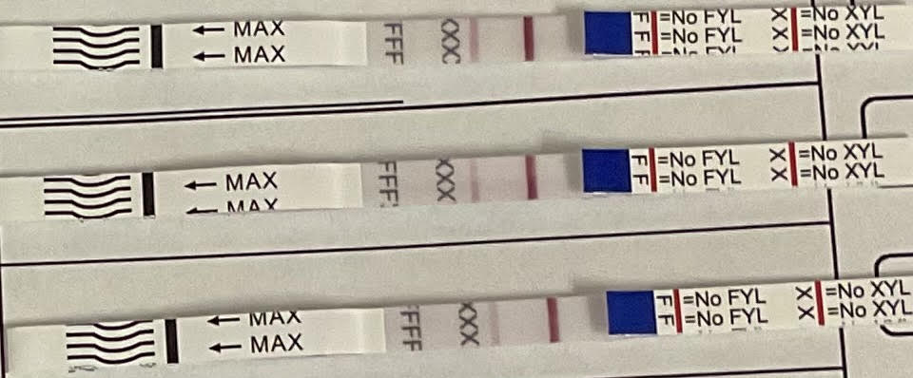
 | 150 | +++ | --- | 000 | 877 | 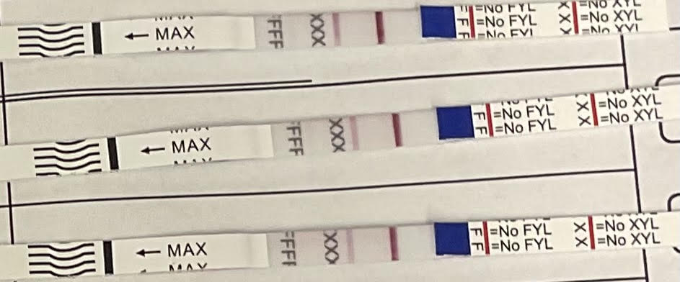
 | 100 | +++ | --- | 000 | 666 | 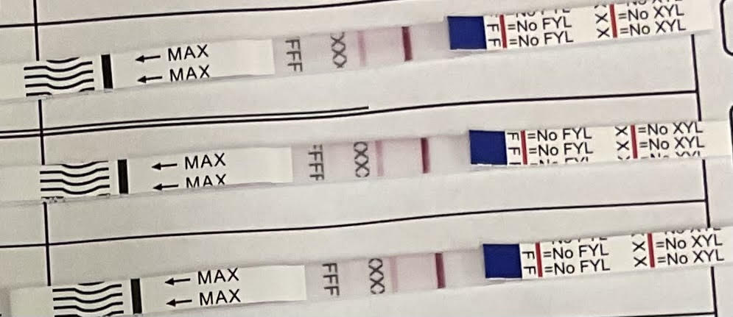
Acetyl Fentanyl | 500000 | + | - | 0 | 7
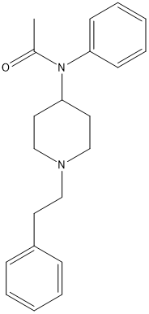 | 50000 | + | - | 0 | 8 | 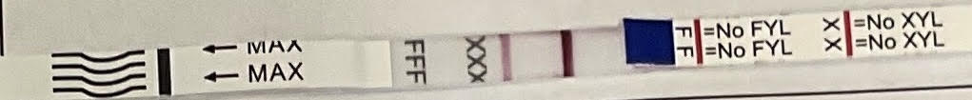
 | 5000 | + | - | 0 | 8
 | 500 | + | - | 0 | 8
 | 200 | +++ | --- | 000 | 666 | 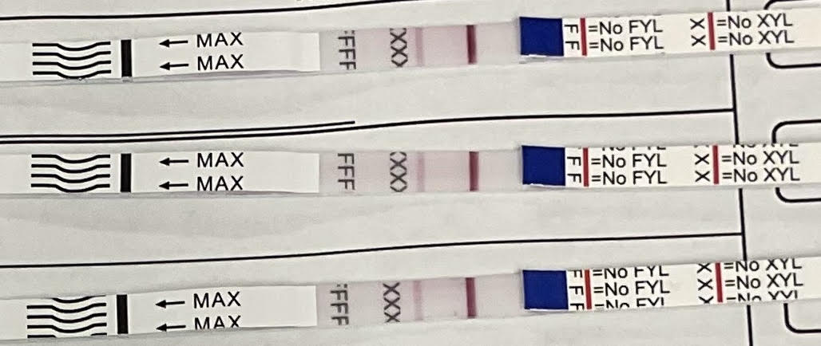
 | 150 | +++ | --- | 000 | 666 | 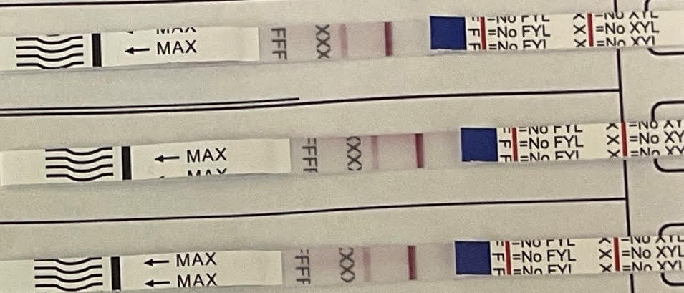
 | 100 | +++ | --- | 000 | 666 | 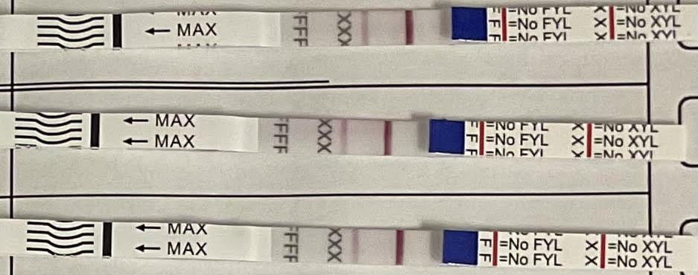
Acryl Fentanyl | 500000 | + | - | 0 | 6 | 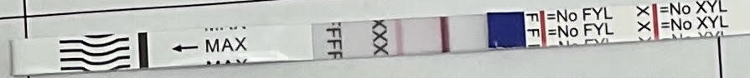
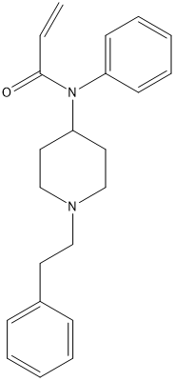 | 50000 | + | - | 0 | 6
 | 5000 | + | - | 0 | 7
 | 500 | + | - | 0 | 7 | 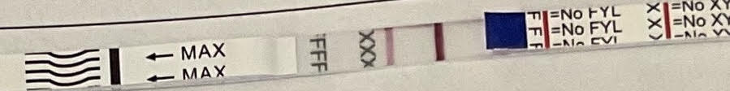
 | 200 | +++ | --- | 000 | 666 | 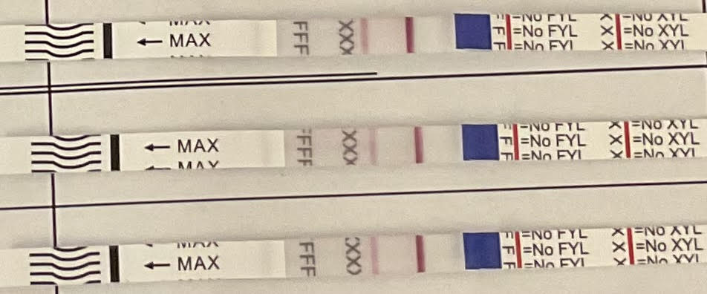
 | 150 | --- | --- | 111 | 766 | 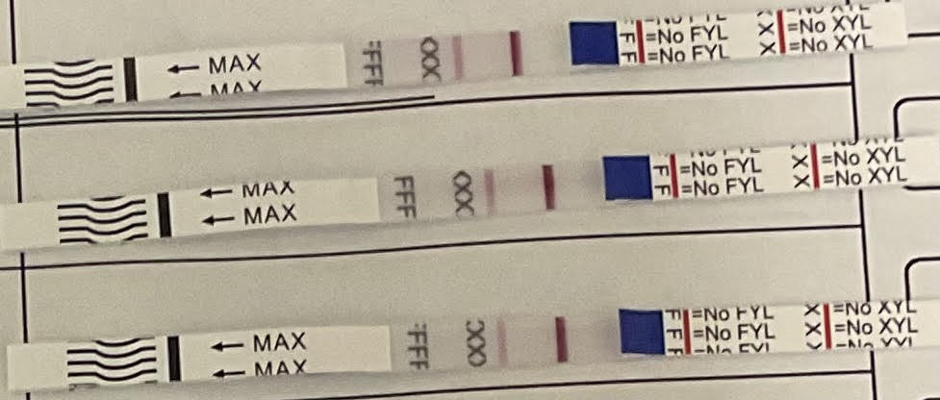
 | 100 | -++ | --- | 100 | 766 | 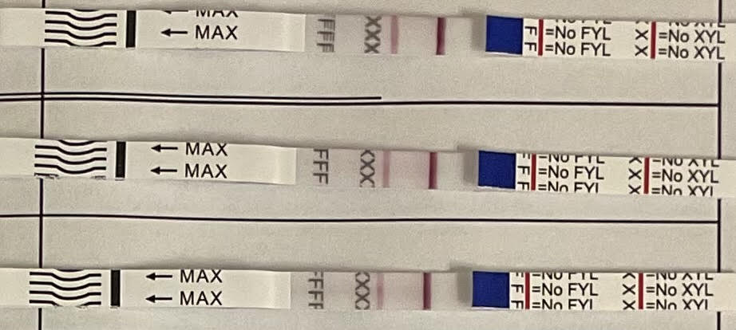
4-FluoroFentanyl | 500000 | + | - | 0 | 7 | 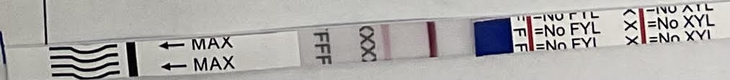
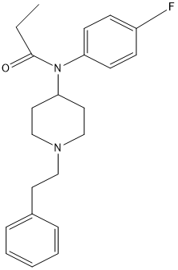 | 50000 | + | - | 0 | 8
 | 5000 | + | - | 0 | 8
 | 500 | + | - | 0 | 8
 | 200 | +++ | --- | 000 | 777 | 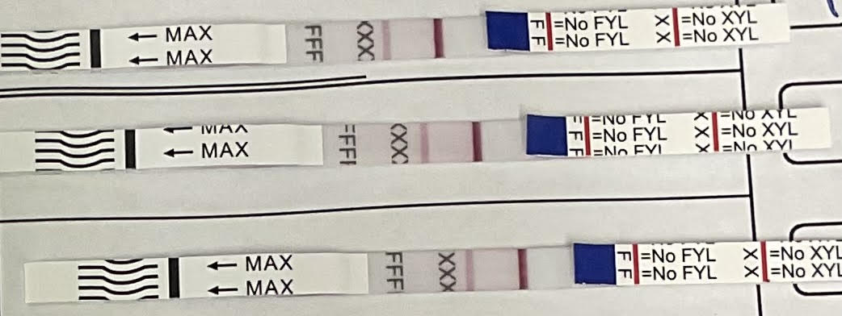
 | 150 | --- | --- | 111 | 666 | 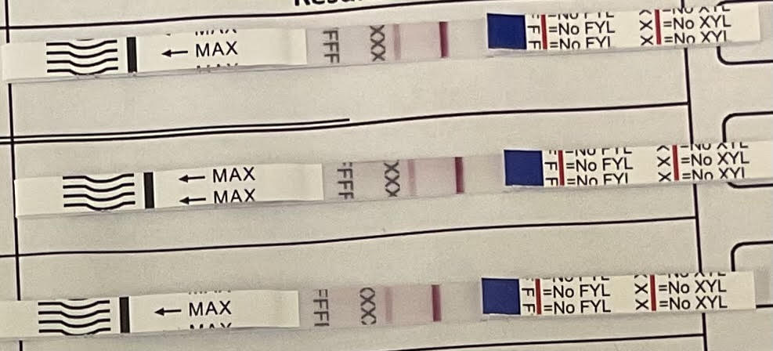
 | 100 | --- | --- | 111 | 677 | 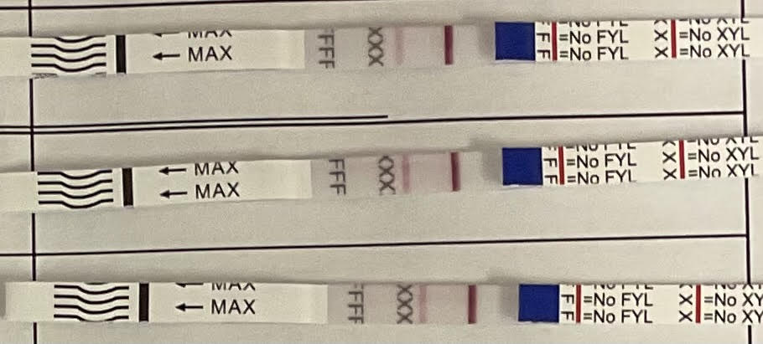
Valeryl Fentanyl | 500000 | + | - | 0 | 6
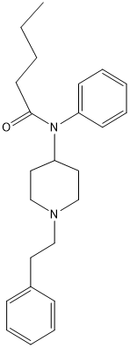 | 50000 | + | - | 0 | 8
 | 5000 | + | - | 0 | 8
 | 500 | + | - | 0 | 8
 | 200 | --- | --- | 222 | 766 | 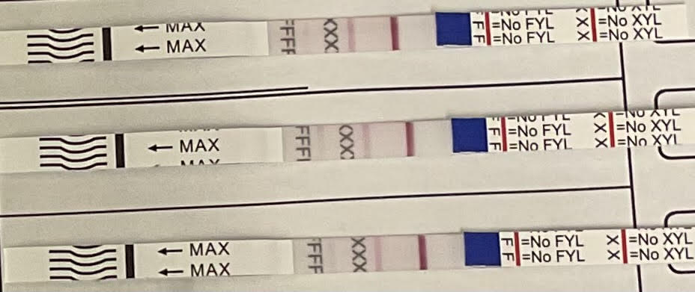
 | 150 | --- | --- | 222 | 677 | 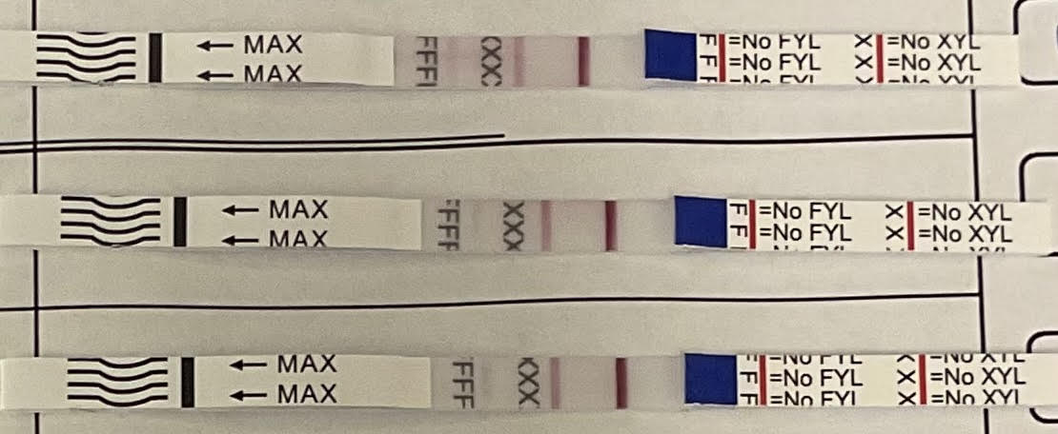
 | 100 | --- | --- | 211 | 888 | 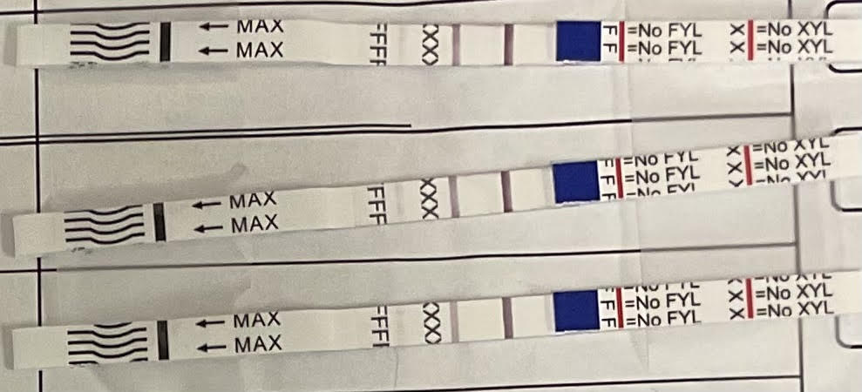

Table S3. Xylazine line intensities for DSG Version 1, BTNX, and WHPM xylazine strips

Line intensities for the xylazine test line in 18 MΩ water using the visual score card (Fig S3) for DSG dual Fentanyl/xylazine strip, BTNX Xylazine test strip, and WHPM Xylazine test strip

Test strip Brand/ Manufacturer | Xylazine Concentration (ng/mL) | Line Intensity
DSG V1 | 750 | N - 2 | N - 2 | N - 2
DSG V1 | 800 | N - 3 | N - 2 | P - 0
DSG V1 | 1000 | N - 2 | P - 0 | P - 0
DSG V1 | 1250 | N - 2 | P - 0 | P - 0
DSG V1 | 2000 | N - 2 | P - 0 | P - 0
DSG V1 | 2100 | N - 2- fainter than 2000 | P - 0 | P - 0
DSG V1 | 2250 (estimated cutoff) | P - 0 | P - 0 | P - 0
DSG V1 | 2500 | P - 0 | P - 0 | P - 0
BTNX XTS | 1000 | N - 1 | N - 1 | N - 1
BTNX XTS | 1250 | N - 1 | N - 1 | N - 1
BTNX XTS | 1500 | N - 1 | N - 1 | P - 0
BTNX XTS | 1750 | N - 1 | N - 1 | P - 0
BTNX XTS | 2000 | P - 0 | P - 0 | P - 0
BTNX XTS | 2500 | P - 0 | P - 0 | P - 0
WHPM XTS | 2500 | N - 3 | N - 2 | N - 1
WHPM XTS | 3000 | N - 3 | N - 2 | N - 1
WHPM XTS | 3250 | N - 3 | N - 2 | N - 1
WHPM XTS | 3500 | N - 2 | N - 1 | N - 1
WHPM XTS | 3750 | P - 0 | P - 0 | P - 0
WHPM XTS | 4000 | P - 0 | P - 0 | P - 0
WHPM XTS | 5000 | P - 0 | P - 0 | P - 0

N | Indicates a Negative Result
P | Indicates a Positive Result

Table S4. Fentanyl Test Strip Results for selected fentanyl analogs at 100 ng/mL
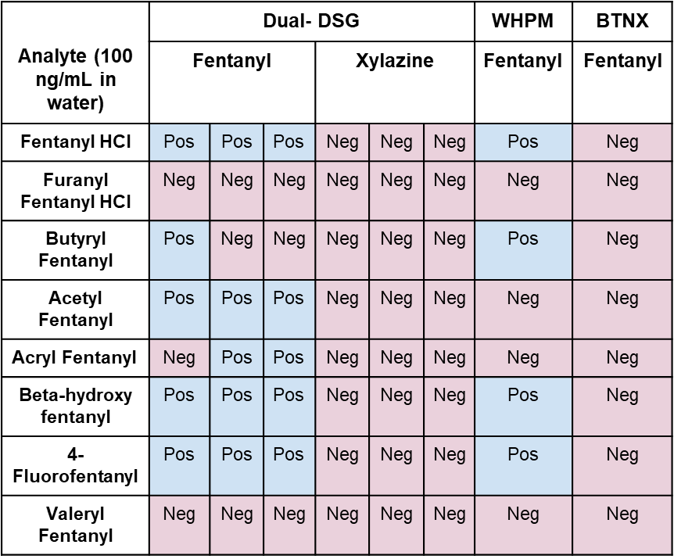

Table S5. Cis-tramadol shows false positive for the Fentanyl line on DSG v1 test strips
Analyte | Concentration | Result |  | Intensity | Picture
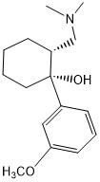 |  | Fen | Xyl
 | 2mg/ml | Pos | Neg | 0 | 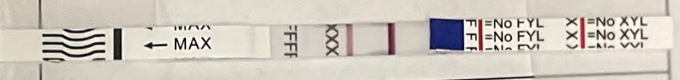
 | 0.7mg/ml | Pos | Neg | 0 | 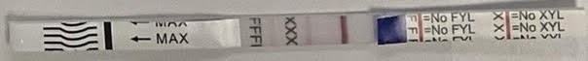
 | 0.2mg/ml | Neg | Neg | 4 | 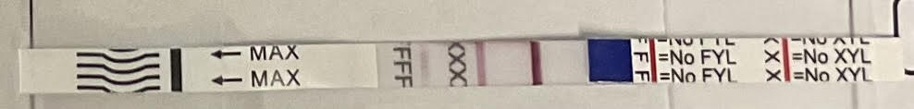

Table S6. Lidocaine shows false positive for xylazine line on DSG v1 test strips
Analyte | Conc | Result |  | Intensity | Picture
 |  | Fen | Xyl
 | 2mg/ml | Neg | Pos | 0 | 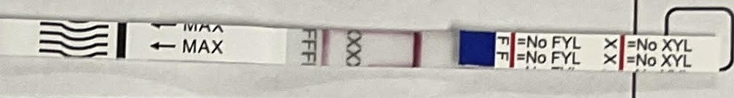
 | 0.2mg/ml | Neg | Pos | 0 | 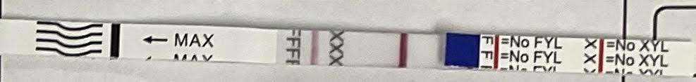
 | 0.02mg/ml | Neg | Pos | 0 | 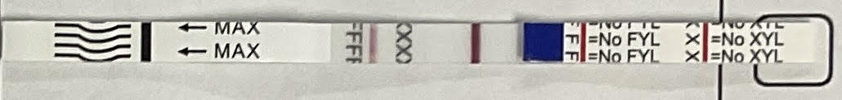
 | 0.002mg/ml | Neg | Neg | 2 | 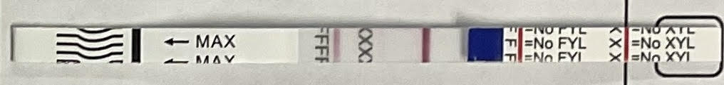
 | 500 ng/ml | Neg | Neg | 5 | 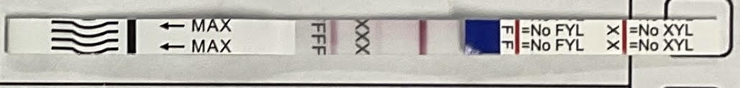

Table S7. False positive for PCP

Structure of Phencyclidine (PCP) | Concentration (mg/mL) | Result | Intensity | Picture
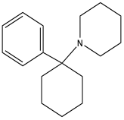 | 2.0 | POS | 0 | 
 | 0.7 | POS | 0 | 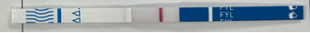
 | 0.2 | POS | 0
 | 0.1 | NEG | 2 | 
 | 0.05 | NEG | 2

Table S8. False Positive For Diphenhydramine
Diphenhydramine | Concentration | WHPM And BTNX | Result
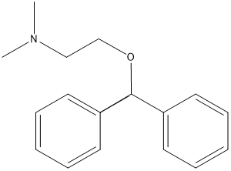 | 2mg/ml |  | Pos  Pos
 | 1mg/ml |  | Pos  Neg (1)
 | 0.7 mg/ml |  | Pos  Neg (2)
 | 0.2 mg/ml |  | Pos  Neg (5)
 | 0.1 mg/ml |  | Neg (2)  Neg (6)

Table S9. Nitazene and Nitazene Analog tested on DSG, WHPM, BTNX test strips
We tested Nitrazine and Nitrazine Analog on Dual DSG, WHPM, and BTNX brand test strips at three different concentrations: 0.5 mg/ml, 0.05 mg/ml, and 0.005 mg/ml. In all cases, the test strips yielded negative results at all three concentrations.

Analyte | DSG V1 |  | WHPM | BTNX
Nitazene | Neg | Neg | Neg | Neg
Menitazine | Neg | Neg | Neg | Neg
Methylenedioxy benzene | Neg | Neg | Neg | Neg
5-methyl Etonitazene | Neg | Neg | Neg | Neg
4-hydroxy nitazene | Neg | Neg | Neg | Neg
3- methoxy metodesnitrazine | Neg | Neg | Neg | Neg
N-Piperidinyl 4-hydroxy nitazene | Neg | Neg | Neg | Neg
N-Pyrrolidino protonitazene | Neg | Neg | Neg | Neg
5-Aminoisotonitazene | Neg | Neg | Neg | Neg

Figure S4. Xylazine test strip[ DSG v1] performance at 1000 and 2000 ng/mL, with at least 20 strips tested per concentration
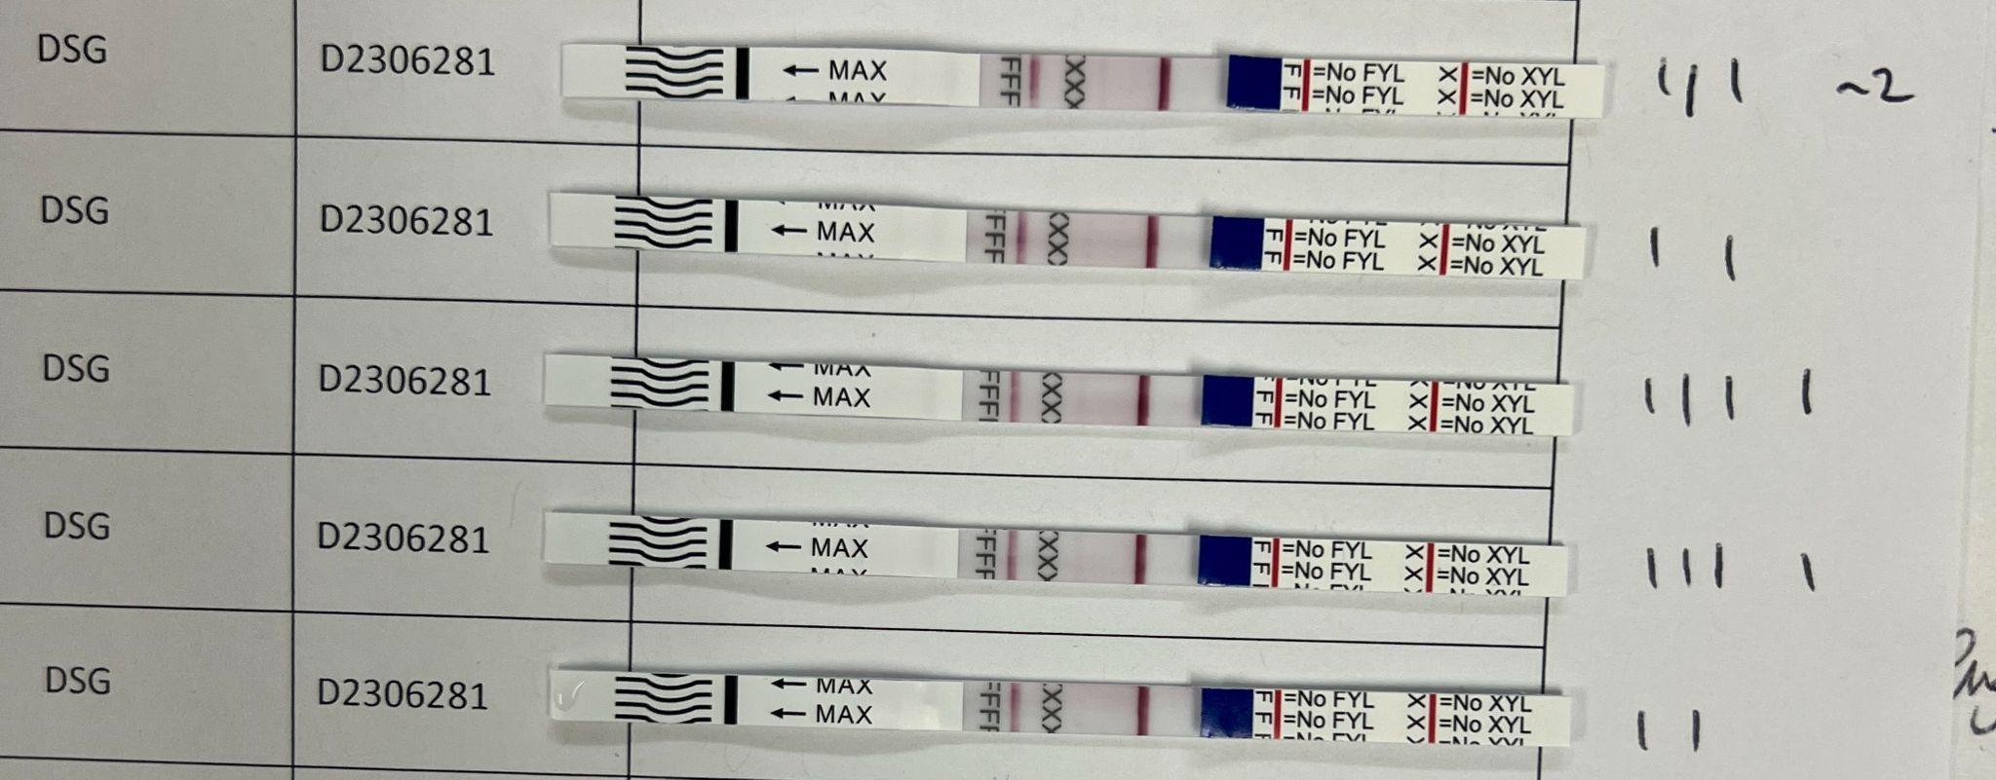
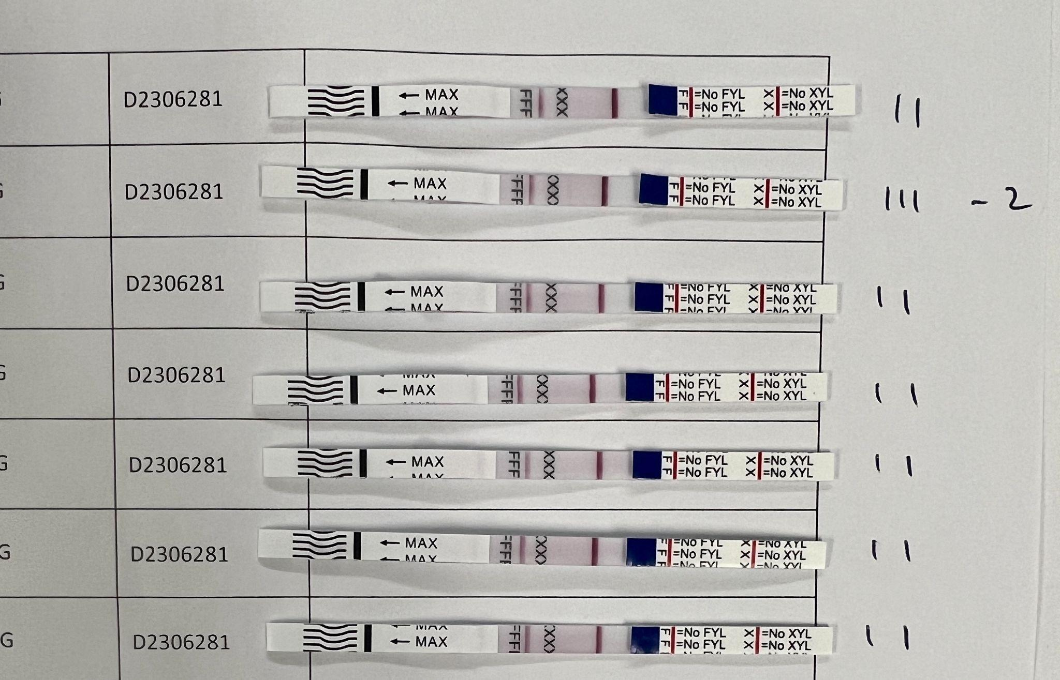
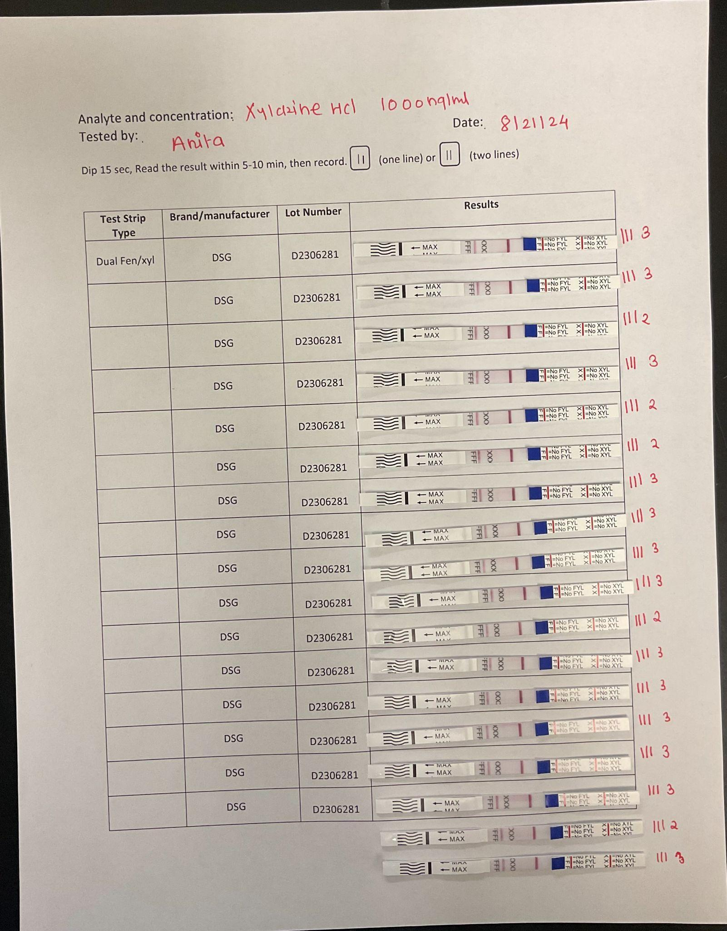
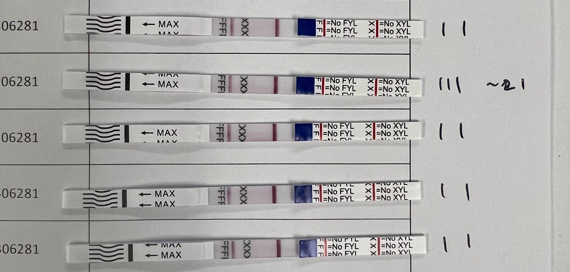
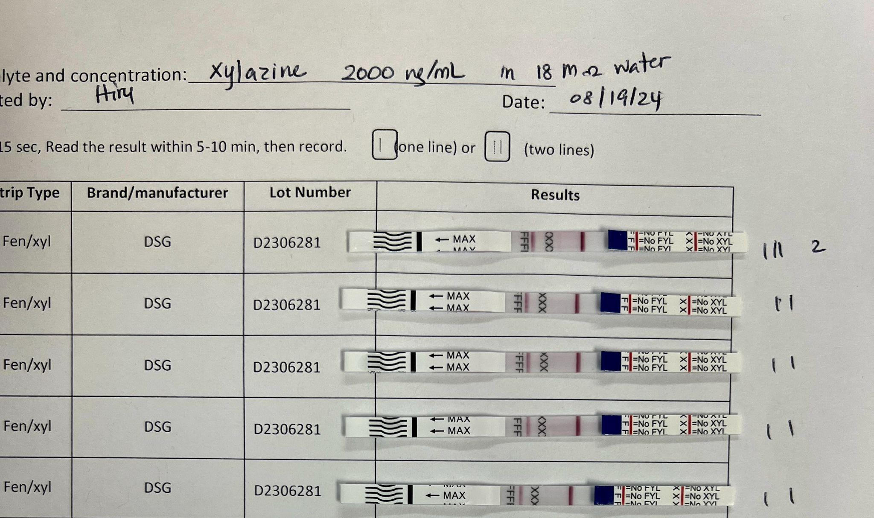
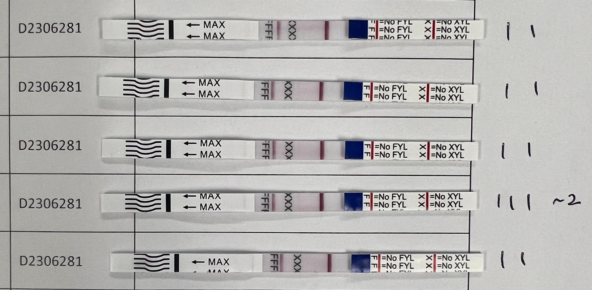

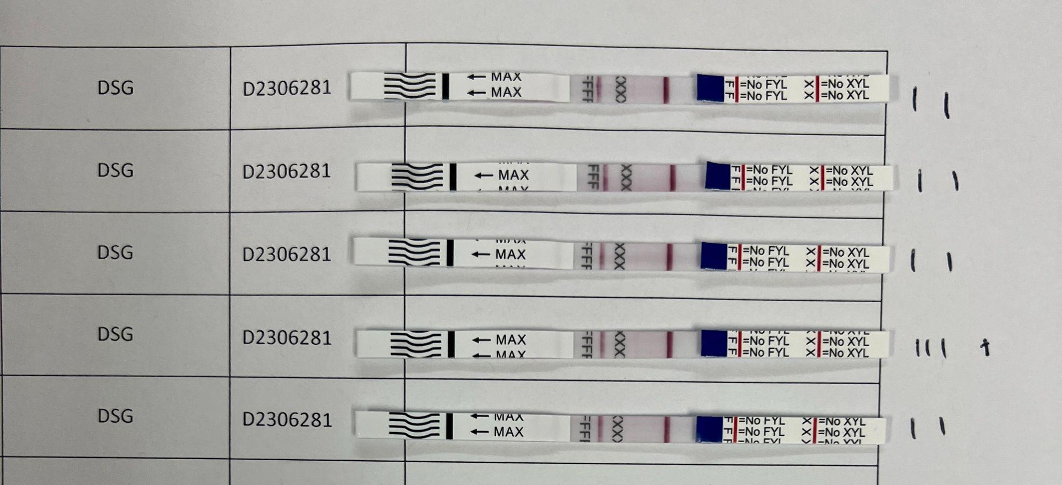
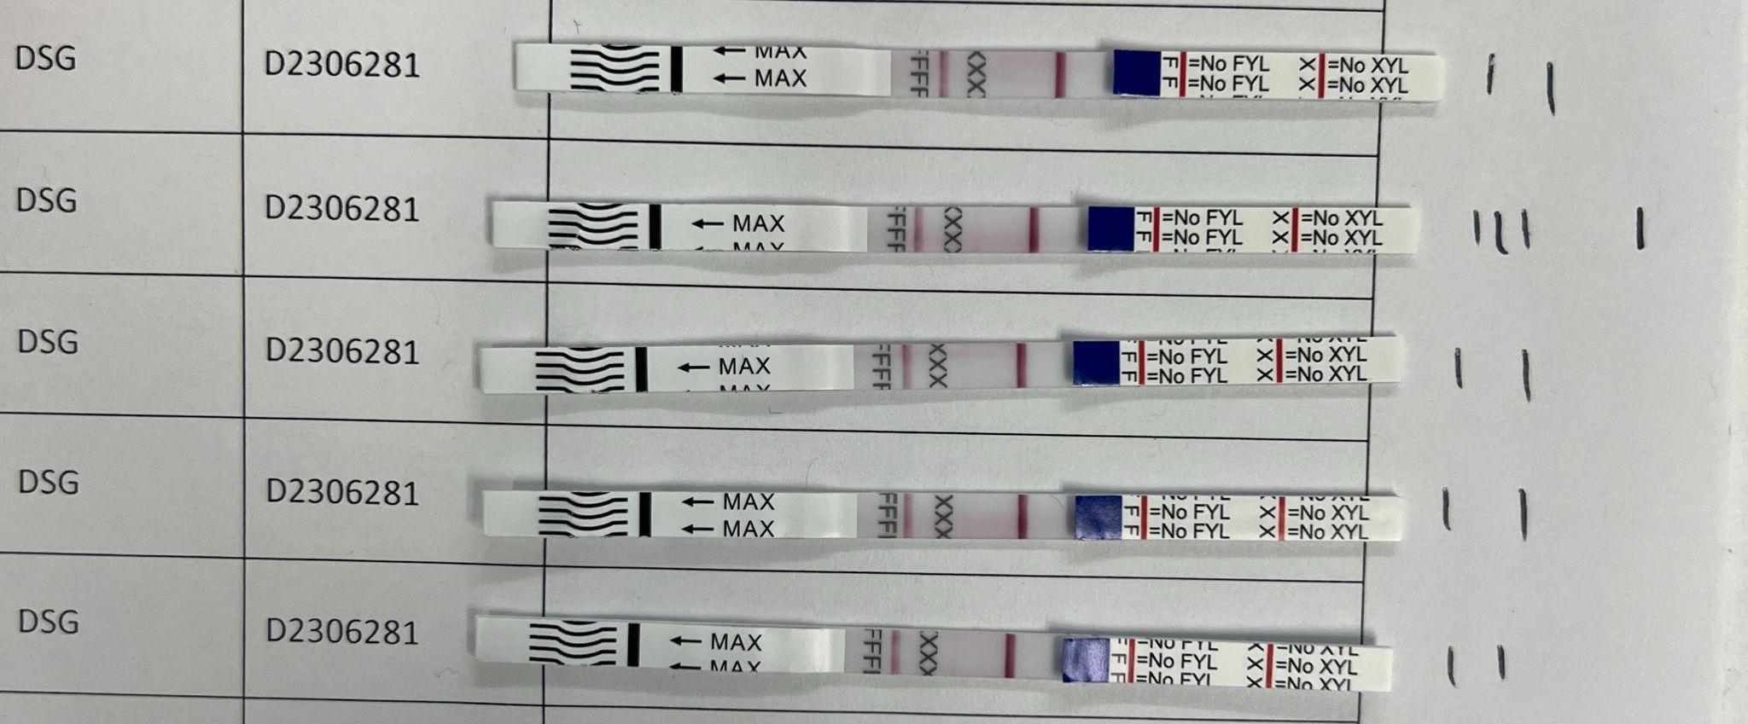
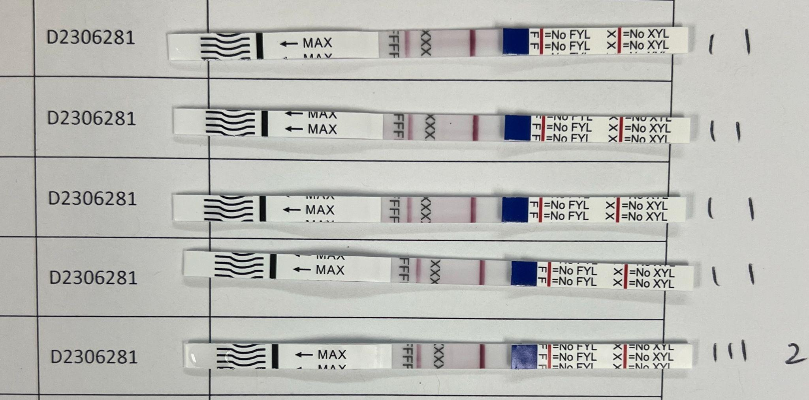
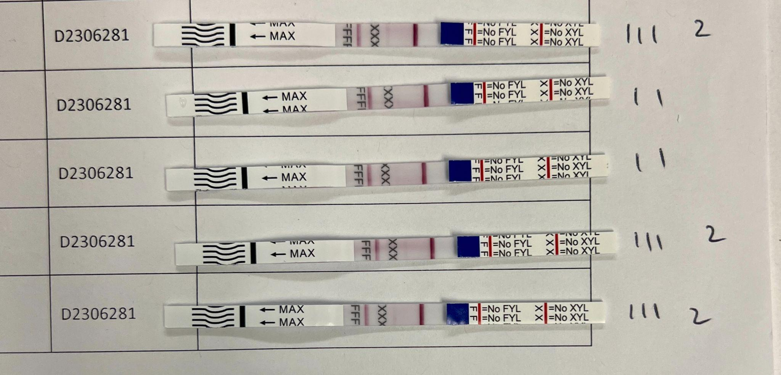

Figure S5. False positive test results for DSG V2
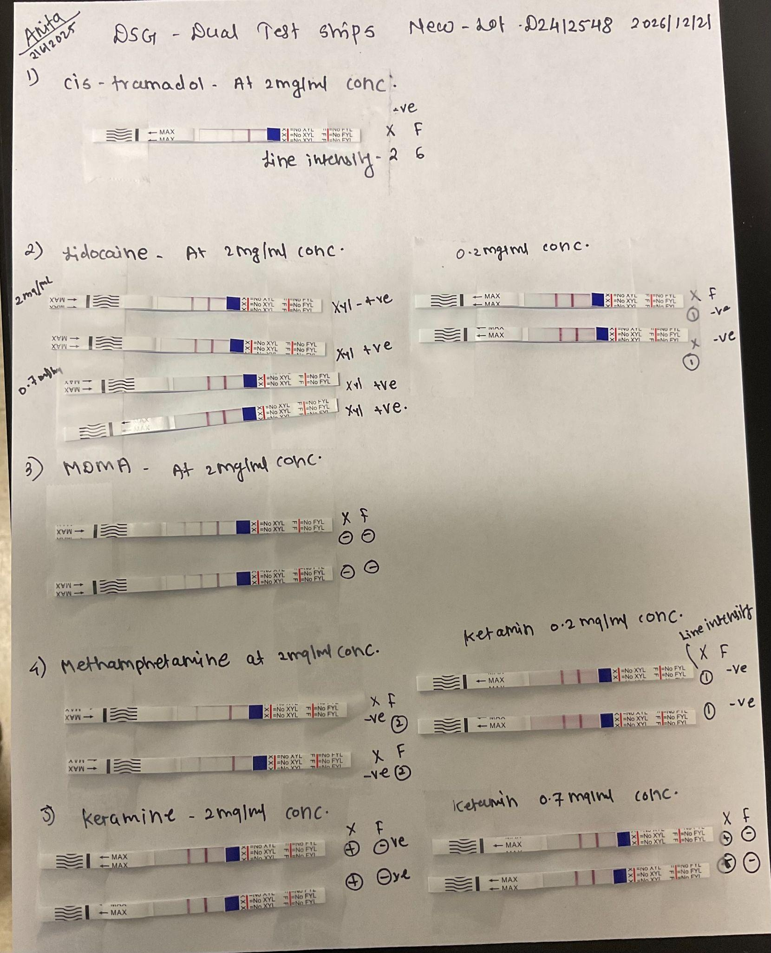

Table S10. Composition of artificial urine

Compound Name | Quantity (g/100 mL)
Sodium sulfate | 0.17
Uric acid | 0.03
Trisodium citrate dihydrate | 0.07
Creatinine | 0.09
Urea | 1.50
Potassium chloride | 0.23
Sodium chloride | 0.18
Calcium chloride | 0.02
Ammonium chloride | 0.13
Epsomite | 0.11
Sodium dihydrogen phosphate dihydrate | 0.29
Sodium hydrogen phosphate dihydrate | 0.08

