Table 1. Quantitative Compounds Identified from the Ethanolic Extract of M. sylvatica by GC-MS/MS Analysis.

Sl. No. | Compound Name | Molecular Formula | Molecular Weight | R. Time | Area % | m/z | Structure
1 | Squalene | C₃₀H₅₀ | 410.7 | 30.025 | 13.91 | 69 | 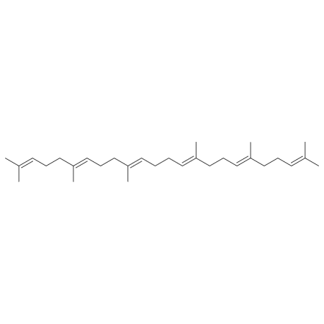
2 | Isopropyl myristate | C₁₇H₃₄O₂ | 270.5 | 14.373 | 12.29 | 60 | 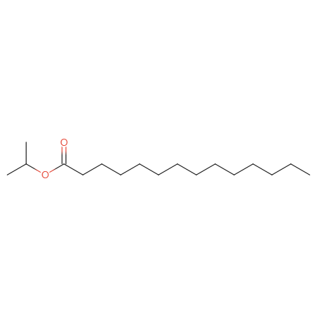
3 | 24-Noroleana-3,12-diene | C₂₉H₄₆ | 394.7 | 38.216 | 7.22 | 203 | 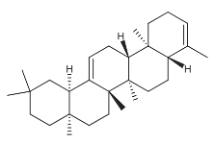
4 | D-Friedoolean-14-en-3-one | C₃₀H₄₈O | 424.7 | 37.812 | 6.47 | 133 | 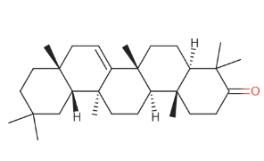
5 | Lup-20(29)-en-3-one | C₃₀H₄₈O | 424.7 | 39.246 | 5.97 | 95 | 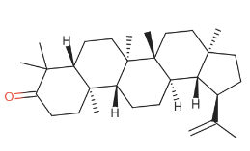
6 | Lup-20(29)-en-3-ol, acetate, | C₃₂H₅₂O₂ | 468.8 | 38.499 | 5.89 | 204 | 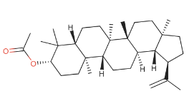
7 | .beta.-Sitosterol acetate | C₃₁H₅₂O₂ | 456.7 | 34.019 | 4.49 | 147 | 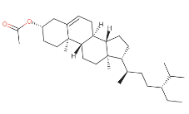
8 | Neophytadiene | C₂₀H₃₈ | 278.5 | 14.568 | 4.46 | 68 | 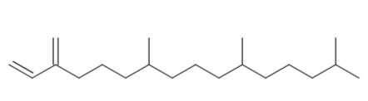
9 | .gamma.-Sitosterol | C₂₉H₅₀O | 414.7 | 37.932 | 3 | 145 | 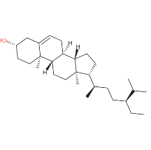
10 | 24-Norursa-3,12-diene | C₂₉H₄₆ | 394.7 | 38.876 | 2.87 | 218 | 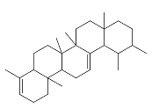
11 | Vitamin E | C₃₁H₅₂O3 | 472.7 | 34.55 | 2.15 | 165 | 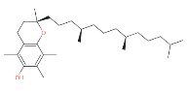
12 | Lupeol | C₃₀H₅₀O | 426.7 | 39.915 | 2.14 | 95 | 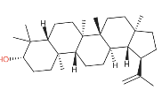
13 | 3,7,11,15-Tetramethyl-2-hexadecen-1-ol | C₂₀H₄₀O | 296.5 | 15.193 | 1.6 | 81 | 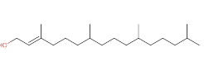
14 | Cholest-5-en-3-ol, carbonochloridate | C₂₈H₄₅ClO₂ | 449.1 | 32.754 | 1.53 | 81 | 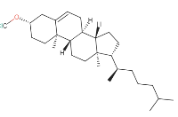
15 | Hexadecanoic acid, 3,7,11,15-tetramethyl-2-hexadecenyl ester | - | - | 14.913 | 1.26 | 81 | 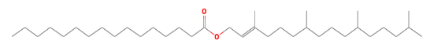
16 | 6-Octadecenoic acid, methyl ester, | C₁₉H₃₆O₂ | 296.5 | 18.682 | 1.1 | 55 | 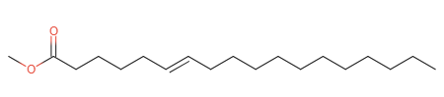
17 | Benzene, (1-propyloctyl) | C₁₇H₂₈ | 232.4 | 12.208 | 1.05 | 91 | 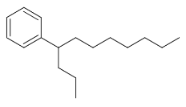
18 | 9-Retinol | C₂₀H₃₀O | 286.5 | 36.456 | 1.01 | 422 | 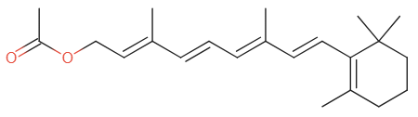
19 | Stigmasta-5,22-dien-3-ol, acetate, | C₃₁H₅₀O₂ | 454.7 | 33.136 | 1 | 81 | 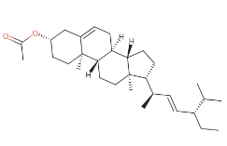
20 | Campesterol | C₂₈H₄₈O | 400.7 | 36.277 | 0.88 | 105 | 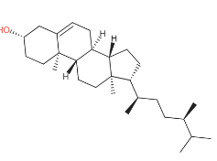
21 | 1-Isopropyl-4,7-dimethyl-1,2,3,5,6,8a-hexahydronaphthalene | C₁₅H₂₄ | 204.35 | 11.066 | 0.82 | 119 | 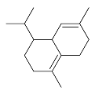
22 | 1-Dodecanol, 3,7,11-trimethyl | C₁₅H₃₂O | 228.41 | 13.113 | 0.82 | 57 | 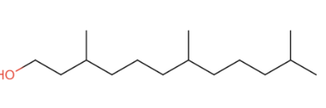
23 | Cholesta-4,6-dien-3-ol, | C₂₇H₄₄O | 384.6 | 32.484 | 0.78 | 145 | 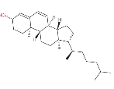
24 | Ascorbic acid 2,6-dihexadecanoate | C₃₈H₆₈O₈ | 652.9 | 16.482 | 0.77 | 149 | 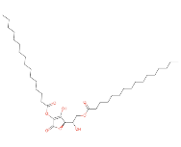
25 | 1-Naphthalenepropanol, .alpha.-ethenyldecahydro-5-(hydroxymethyl)-.alpha.,5,8a-trimethyl-2-methylene | C₂₀H₃₄O₂ | 306.5 | 30.783 | 0.75 | 419 | 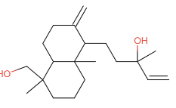
26 | Benzene, (1-ethyldecyl) | C₁₈H₃₀ | 246.4 | 13.719 | 0.69 | 91 | 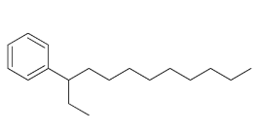
27 | 6,10,14,18,22-Tetracosapentaen-2-ol, 3-bromo-2,6,10,15,19,23-hexamethyl | C₃₀H₅₁BrO | 507.6 | 29.922 | 0.68 | 81 | 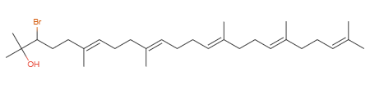
28 | beta. Carotene | C₄₀H₅₆ | 536.9 | 32.838 | 0.68 | 69 | 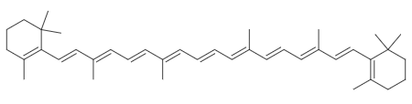
29 | 9,10-Secochola-5,7,10(19)-trien-24-al, 3-hydroxy | C₂₄H₃₆O₂ | 356.5 | 33.7 | 0.68 | 135 | 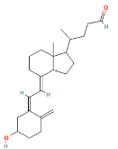
30 | Pregn-5-en-20-one, 3,21-bis(acetyloxy) | C₂₅H₃₆O₅ | 416.5 | 33.94 | 0.68 | 145 | 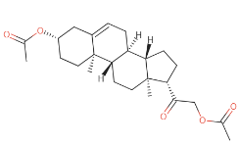
31 | Benzene, (1-pentyloctyl) | C₁₉H₃₂ | 260.5 | 14.465 | 0.65 | 91 | 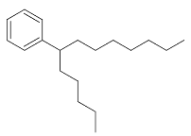
32 | 3,7,11,15-Tetramethylhexadeca-1,3,6,10,14-pentaene | C₂₀H₃₂ | 272.5 | 30.387 | 0.65 | 69 | 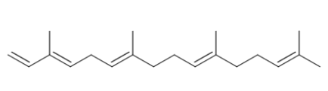
33 | Benzene, (1-propylnonyl) | C₁₈H₃₀ | 246.4 | 13.402 | 0.61 | 91 | 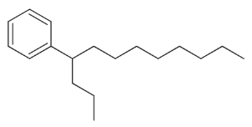
34 | Benzene, (1-pentylhexyl) | C₁₇H₂₈ | 232.4 | 12.046 | 0.59 | 91 | 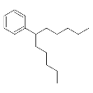
35 | 9-Octadecenamide | C₁₈H₃₅NO | 281.5 | 23.128 | 0.56 | 59 | 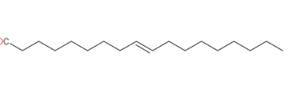
36 | Stigmasterol | C₂₉H₄₈O | 412.7 | 36.724 | 0.55 | 55 | 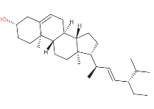
37 | Betulinaldehyde | C₃₀H₄₈O₂ | 440.7 | 39.097 | 0.55 | 119 | 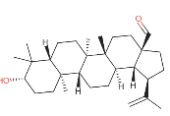
38 | Supraene | C₃₀H₅₀ | 410.7 | 32.654 | 0.52 | 69 | 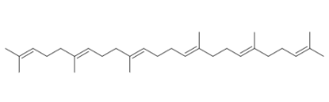
39 | Benzene, (1-methyldecyl) | C₁₇H₂₈ | 232.4 | 12.932 | 0.51 | 105 | 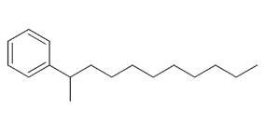
40 | Ledene oxide | C₁₅H₂₄O | 220.35 | 33.07 | 0.45 | 107 | 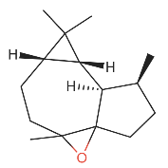
41 | Methyl 9-octadecadienoate | C₁₉H₃₄O₂ | 294.5 | 18.579 | 0.43 | 67 | 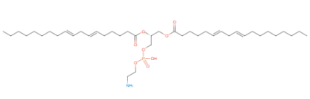
42 | Lupeol, trifluoroacetate | C₃₂H₄₉F₃O₂ | 522.7 | 31.765 | 0.43 | 121 | 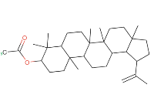
43 | 8,10-Hexadecadien-1-ol | C₁₆H₃₀O | 238.41 | 14.674 | 0.39 | 109 | 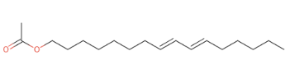
44 | Ergosta-5,22-dien-3-ol, | C₂₈H₄₆O | 398.7 | 31.333 | 0.39 | 69 | 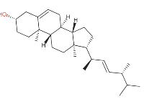
45 | Amberonne | C₁₆H₂₆O | 234.2 | 12.583 | 0.36 | 83 | 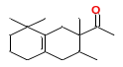
46 | Phytol | C₂₀H₄₀O | 296.5 | 18.844 | 0.36 | 71 | 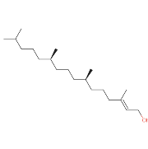
47 | Diethylene glycol monododecyl ether | C₁₆H₃₄O₃ | 274.44 | 16.992 | 0.33 | 57 | 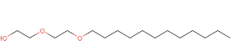
48 | 1,1,3,3,5,5-Hexamethyl-1,5-bis(2-methylpropoxy)trisiloxane | C₁₄H₃₆O₄Si₃ | 352.69 | 5.874 | 0.3 | 207 | 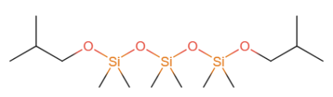
49 | Benzene, (1-methylundecyl) | C₁₈H₃₀ | 246.4 | 14.263 | 0.3 | 91 | 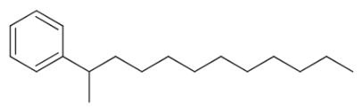
50 | Cyclopentaneacetic acid, 3-oxo-2-pentyl-, methyl ester | C₁₃H₂₂O₃ | 226.31 | 12.355 | 0.29 | 83 | 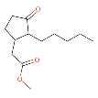
51 | Bicyclo[3.1.1]hept-2-ene-2-ethanol, 6,6-dimethyl- | C₁₁H₁₈O | 166.26 | 15.734 | 0.29 | 105 | 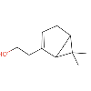
52 | Benzene, (1-propylheptyl) | C₁₆H₂₆ | 218.38 | 11.219 | 0.27 | 91 | 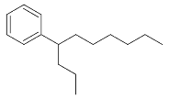
53 | γ-Tocopherol | C₂₈H₄₈O₂ | 416.7 | 33.405 | 0.26 | 151
54 | Pentadecafluorooctanoic acid, undecyl ester | C₁₉H₂₃F₁₅O₂ | 568.4 | 10.66 | 0.25 | 57 | 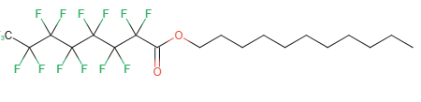
55 | Benzene, (1-propyldecyl) | C₁₉H₃₂ | 260.5 | 14.758 | 0.25 | 91 | 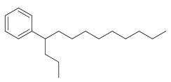
56 | 4-Methylbenzylamine, N-tert-butyldimethylsilyl | C₁₄H₂₅NSi | 235.44 | 3.9 | 0.23 | 149 | 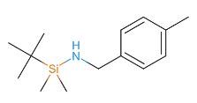
57 | Caryophyllene | C₁₅H₂₄ | 204.35 | 10.219 | 0.23 | 91 | 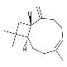
58 | Benzene, (1-butylhexyl) | C₁₆H₂₆ | 218.38 | 11.122 | 0.23 | 91 | 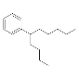
59 | 1,3,6,10-Cyclotetradecatetraene, 3,7,11-trimethyl-14-(1-methylethyl) | C₂₀H₃₂ | 272.5 | 31.505 | 0.22 | 105 | 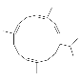
60 | Phenol, 4-(methoxymethyl) | C₈H₁₀O₂ | 138.16 | 3.745 | 0.2 | 107 | 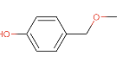
61 | 9,19-Cyclolanost-24-en-3-ol, acetate, | C₃₂H₅₂O₂ | 468.8 | 31.978 | 0.2 | 69 | 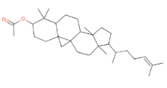
62 | Carbonic acid, decyl 2-ethylhexyl ester | C₁₉H₃₈O₃ | 314.5 | 21.967 | 0.17 | 57 | 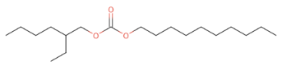
63 | Benzene, (1-methyl-1-propylpentyl) | C₁₅H₂₄ | 204.35 | 11.915 | 0.16 | 91 | 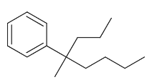
64 | 2,6-Dihydroxybenzoic acid, | C₁₆H₃₀O₄Si₃ | 370.66 | 21.468 | 0.14 | 73 | 