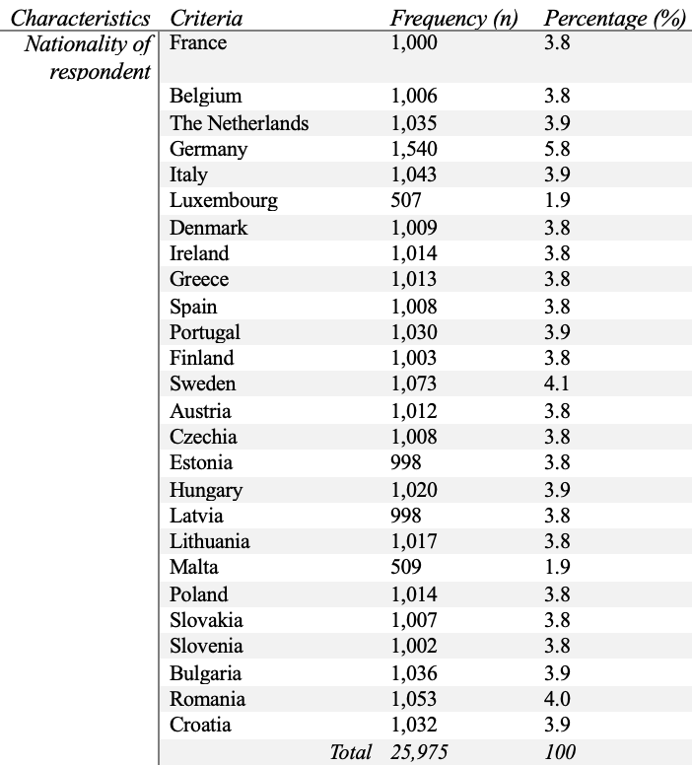

Table 1: Eurobarometer Sample Description (1)

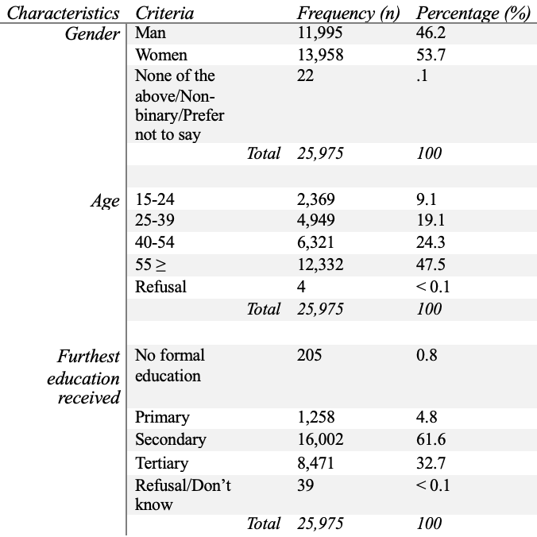

Table 2: Eurobarometer Sample Description (2)
Model | Adjusted R² | Individualism (β, p) | Control Variable (β, p) | Model Sig. (p)
Carbon Emissions | 0.304 | -0.562, 0.003 | 0.259, 0.136 | 0.006
Mean Years of Schooling | 0.239 | -0.515, 0.010 | -0.086, 0.644 | 0.017
GDP | 0.280 | -0.592, 0.003 | 0.217, 0.227 | 0.009
Table 3: Regression models of control variables in the relationship between individualism and support for intra-EU disaster relief

