Supplemental experimental procedures
Table 1: Antibodies list. Related to Fig. 2 and 3
Primary antibodies
Antibody name | Company and cat. | Dilution
Mouse anti-Human Immunodeficiency Virus 1 (HIV-1) p24 Monoclonal (71-31) | NIH AIDS Reagent program, ARP-530, contributed by Dr. Susan Zolla-Pazner. | 1:500
Mouse anti-GAPDH | Fitzgerald Industries | 1:10000
Rabbit anti-Homer 1 b/c | Synaptic Systems 160 023 | 1:500
Rat anti-CD11B Monoclonal (M1/70) | Abcam ab8878 | 1:250
Rabbit anti-HuD+ HuC Monoclonal (EPR19098) | Abcam ab184267 | 1:1000

Secondary antibodies
Antibody name | Company and cat. | Dilution
Goat anti-mouse IgG-HRP | Santa Cruz Biotechnology sc-2005 | 1:1000
Donkey anti-rabbit 633 IgG Alexa 633-labeled monoclonal antibody | Thermo Fisher A11008 | 1:500
Donkey anti-mouse 488 IgG Alexa 488-labeled monoclonal antibody | Thermo Fisher A11004 | 1:500
Goat anti-Mouse IgG (H+L) Superclonal™ Secondary Antibody, Alexa Fluor™ 488 | Thermo Fisher A28175 | 1:1000
Goat anti-Rabbit IgG (H+L) Cross-Adsorbed Secondary Antibody, Alexa Fluor™ 635 | Thermo Fisher A31576 | 1:1000
Goat anti-mouse IgG Alexa 546-labeled monoclonal antibody | Thermo Fisher A11030 | 1:1000

Table 2: RT-qPCR primer sequences
mRQ 3’ primer | Supplied by miR-X miRNA fast strand synthesis kit (Takara, cat. 638315)
U6 5’ primer | Supplied by miR-X miRNA fast strand synthesis kit (Takara, cat. 638315)
cel-miR-39-3p (MIMAT 0000010) | AGCTGATTTCGTCTTGGTAATA
hsa-miR-10a-5p (MIMAT0000253); | TACCCTGTAGATCCGAATTTGTG
hsa-miR-30e-5p (MIMAT0000692) | TGTAAACATCCTTGACTGGAAG
hsa-miR-186-5p (MIMAT 0000456) | CAAAGAATTCTCCTTTTGGGCT
hsa-miR-132-3p (MIMAT0000426) | TAACAGTCTACAGCCATGGTCG
hsa-miR-134-5p (MIMAT0000447) | TGTGACTGGTTGACCAGAGGGG
hsa-miR-138-5p (MIMAT0000430) | AGCTGGTGTTGTGAATCAGGCCG
hsa-miR-148a-3p (MIMAT 0000243) | TCAGTGCACTACAGAACTTTGT
hsa-miR-361-5p (MIMAT0000703) | TTATCAGAATCTCCAGGGGTAC
hsa-miR-532-3p (MIMAT0004780) | CCTCCCACACCCAAGGCTTGCA
hsa-miR-181-a-3p (MIMAT0000270) | ACCATCGACCGTTGATTGTACC

i³ iPSCs and mESCs neuronal differentiation
As described by Fernandopulle et al., 2018⁵⁰, i³ iPSCs (passages 13-18) were seeded onto Matrigel-coated culture flasks (Corning, CLS354277) at a density of 150,000 cells/cm² and cultured in mTeSR1 complete stem cell medium (StemCell Technologies, cat. 85850), with daily medium changes. For neuronal induction, iPSCs dissociated with Accutase (StemPro, cat.A1110501) were treated with doxycycline (Sigma, D9891, 2 µg/mL) for 3 days at a density of 200,000 cells/cm² in T150 flasks coated with Matrigel. The induction medium consisted of DMEM/F12 (Gibco, cat. 11330032) supplemented with 1X N2 supplement (Gibco, cat. 17502048), 2 mM L glutamine, and 1X non-essential amino acids (NEAA, Gibco, cat. 11140050). Pre-differentiated neural precursors were then subplated at a density of 100,000 cells/cm² on Geltrex-coated plates (Gibco, cat. A1569601) and maintained in a maturation medium containing BrainPhys Neuronal Medium (StemCell Technologies, cat# 05790), 0.5X B27 supplement, mouse laminin (Gibco, cat. 23017015, 0.2 µg/mL), brain-derived neurotrophic factor (BDNF, PeproTech, cat. 450-02, 10 ng/mL), and neurotrophin-3 (NT3, PeproTech, cat. 450-03, 10 ng/mL). Half of the medium was replaced twice weekly. Culturing was performed until mature polarity was observed (4 weeks in vitro, as previously described by Wang et al.). The Rho kinase inhibitor Y-27632 (ApeXBio, cat. A3008) was added after each cell dissociation and removed the following day.
mESCs were cultured according to the procedure described by Bertacchi et al., 2013⁵¹, and Lupo et al., 2014⁵². Specifically, mESCs (passages 25-38) were cultured on gelatin-coated dishes at a density of 40,000 cells/cm². The ESC medium, which was replaced daily, contained Glasgow’s MEM (GMEM, Sigma-Aldrich), 10% FBS, 2 mM L-glutamine, 1 mM sodium pyruvate, 1 mM non-essential amino acids, 0.05 mM β-mercaptoethanol, 100 U/mL penicillin/streptomycin, and 1,000 U/mL recombinant mouse LIF (Invitrogen). Cells were passaged using trypsin dissociation and re-plated at a 1:3 dilution to avoid confluency and maintain pluripotency. For differentiation, mESCs were seeded on gelatin-coated dishes at a density of 65,000 cells/cm² (DIV0) and cultured in chemically defined minimal medium (CDMM) as described by Terrigno et al. 2013, consisting of DMEM/F12 supplemented with N2/B27, 2.5 µM Wnt inhibitor (53AH), and 0.25 µM BMP inhibitor (LDN193189) for three days. At DIV3, cells were dissociated and reseeded at 65,000 cells/cm² on dishes coated with poly-ornithine and natural mouse laminin. Cells were then cultured for an additional 4 days in CDMM. At DIV7, cells were dissociated again and seeded at a density of 125,000 cells/cm² on poly-ornithine and laminin-coated wells. Cortical cultures were maintained in CDMM with Wnt and BMP inhibitors until DIV10. At DIV11, the medium was switched from DMEM/F12 to Neurobasal A and B-27 Supplement (minus Vitamin A 50x) to prevent glutamate-induced excitotoxicity. At DIV20, medium was switched from Neurobasal A to Neurobasal-A (Gibco, 0888022) with the addiction of 0.2mM Ascorbic Acid (Vit. C), B-27 Supplement 50x (Gibco, 17504044), and 20 ng/ml recombinant human BDNF protein (Novus Biologicals, NBP2-52006). Cells were cultured until they reached full maturation, typically by DIV28.
Lentiviral transduction of i³ Neurons and mESC-derived neurons
Lentiviral particles were produced using HEK-293T cells seeded in 10-cm tissue culture dishes at a density of 5 × 10⁶ cells per dish and incubated at 37 °C, 5% CO2. The following day, cells were co-transfected with 20 μg of lentiviral transfer plasmid (pBOB-EF-1-Gag, pBOB-EF-1-Gag-DLS, pBOB-EF-1-Gag-TRBP, or pBOB-EF-1-GAG-TRBP-DLS), 25 μg of the psPAX2 packaging vector (Addgene, cat. 12260), and 5 μg of the Vesicular Stomatitis Virus G protein (VSV-G) envelope plasmid. Plasmid DNA was mixed at a 4:5:1 mass ratio in 20% (v/v) serum-free DMEM Low Glucose, and polyethylenimine (PEI; Sigma-Aldrich, cat. 408719). PEI-DNA complexes were allowed to form for 10 minutes at room temperature before being added to packaging cells, which were maintained overnight in Opti Mem medium. The viral supernatant was harvested at 48 and 72 hours post-transfection, centrifuged at 1200 rpm for 5 minutes and filtered with a 0,45 μm PES filter. Lentiviral particles were concentrated approximately 100-fold through ultracentrifugation on a 20% (w/v) sucrose cushion in phosphate buffered saline (PBS) and resuspended in 1% FBS in sterile PBS. Viral titer, expressed as transducing units per milliliter (TU/mL), was determined by infecting HEK-293T cells with ten-fold serial dilutions of the viral suspension, followed by quantification of puromycin-resistant colonies 48 hours after transduction.
Neuronal progenitors were transduced with HEK-293T-packaged pBOB-EF-1-Gag lentiviral vectors either after 3 days of doxycycline induction (for i³ neurons) or between DIV7-DIV10 (for mESC-derived neurons). In both models, concentrated lentivirus was diluted to a final titer of 1 × 10⁶ TU/mL in either complete neuronal medium (for i³ neurons) or CDMM (for mouse neurons), supplemented with 10 μg/mL polybrene. Transduction was performed for approximately 20 hours (i³ neurons) or 6 hours (mouse neurons) at 37 °C with 5% CO₂. After incubation, the medium containing viral particles was replaced with fresh differentiation medium, and cells were maintained under standard culture conditions.
Determination of SNaP RNA packaging efficiency
The RNA packaging efficiency of SNaP particles was calculated using aliquots from the same nanoparticle production batch, according to the following formula:
$$RNA packaging efficiency = \frac{Total cargo RNA concentration (ng/μl)}{p24 antigen concentration ( pg/μl)}$$
Electrophoretic profiling of SNaP cargo RNA
Cargo RNA electrophoresis was performed using the Agilent 2100 Bioanalyzer with the Small RNA kit (Agilent Technologies), according to the manufacturer’s instructions.
Electropherograms were evaluated using Agilent 2100 Expert Software. For samples meeting quality control criteria for RNA integrity and purity, miRNA concentration was determined by calculating the area under the curve (AUC) corresponding to RNA fragments between 10 and 40 nucleotides in length. miRNA abundance was expressed as the percentage of miRNA concentration relative to the total RNA concentration in the sample.
SNaP miRNA Recovery Efficiency vs synaptosome
The efficiency of miRNA recovery in SNaP particles was validated by benchmarking the miRNA expression profiles against those observed in synaptosomes and whole brain lysates from healthy human brain samples, as reported in a publicly available microarray dataset (Kumar et al., 2017³⁴). Raw microarray data were processed using the Transcriptome Analysis Console (TAC; ThermoFisher Scientific), with analyses restricted to the subset of miRNAs that were also quantified in SNaP cargo RNA by RT-qPCR in this study. Following the analytical approach established in Kumar et al., 2017, differences in miRNA expression levels between synaptosomes and whole brain lysates were defined as log₂ fold changes. To enable quantitative comparison between the two methodologies, the miRNA recovery efficiency of each target miRNA (as defined in the main text, Materials and Methods section) was finally expressed as a fraction of the total detected miRNA abundance in the combined synaptosome and SNaP nanoparticles datasets.
Western Blotting
Following SNaP particle collection, packaging HEK-293T cells were pelleted by centrifugation at 1200 rpm for 5 minutes. Protein extraction was carried out using a buffer containing 20 mM Tris-HCl (pH 8.1), 20 mM NaCl, 10% glycerol, 1% NP-40, 10 mM EDTA, along with protease and phosphatase inhibitors (Roche). Extracted proteins were clarified by centrifugation at 16,000 rcf for 15 minutes at 4°C, and protein concentration was determined by the Bradford assay.
For Western Blot analysis, 20 μg of cell extracts and 30 μL of concentrated SNaP VLPs were used. Samples were reduced and denatured in 4X Laemmli buffer at 95°C for 5 minutes, separated by 10% Tris-glycine SDS-PAGE (Bio-Rad), and transferred to nitrocellulose membranes (Amersham Biosciences). Membranes were blocked with 5% skimmed milk (Millipore) in Tris-buffered saline containing 0.1% Tween-20 (TBS-T) and incubated overnight at 4°C with primary antibodies diluted in 1% skimmed milk in TBS-T. The next day, membranes were incubated with horseradish peroxidase (HRP)-conjugated secondary antibodies for 1 hour at room temperature and washed three times with TBS-T for 5 minutes each. Blots were visualized using the Immobilon Western Chemiluminescent HRP substrate (Millipore) or Cytiva ECL reagent (GE Healthcare) and captured with a ChemiDoc Imaging system (Bio-Rad). Details of the antibodies used are provided in Supplementary Information, Table 1.
Cell viability assessment
HEK-293T cells were seeded in 6-well plates at a density of 70,000 cells per well and incubated overnight in standard culture conditions. The next day, cells were transfected with 1 μg of either the pGag-eGFP, pGag-TRBP, or mock constructs using Lipofectamine 2000 (ThermoFisher), following the manufacturer’s protocol. After 24 hours, the culture medium was refreshed, and cells were maintained for an additional 48 hours. Following this incubation period, cells were pelleted by centrifugation at 1200 g for 5 minutes at room temperature. The resulting cell pellets were resuspended in Dulbecco’s Phosphate Buffered Saline (PBS; Gibco) pre-equilibrated to room temperature. Cell viability was then determined using the Scepter 2.0 automated cell counter (Millipore), with the viability gate manually set between 5 μm and 17 μm to reflect the size range characteristic of viable HEK-293T cells.
Transmission electron Microscopy (TEM)
A suspension of SNaP-eGFP and SNaP-TRBP VLPs were deposited onto formvar carbon coated copper grids (200-mesh). Samples were stained by applying five drops of a 2.5% (w/v) uranyl acetate solution and incubated at room temperature for 2 minutes. Excess stain was removed by gently touching the edge of each grid to filter paper, followed by air drying for 30 minutes. Observations were carried out using a Jeol 100 SX transmission electron microscope.

Supplementary Figures
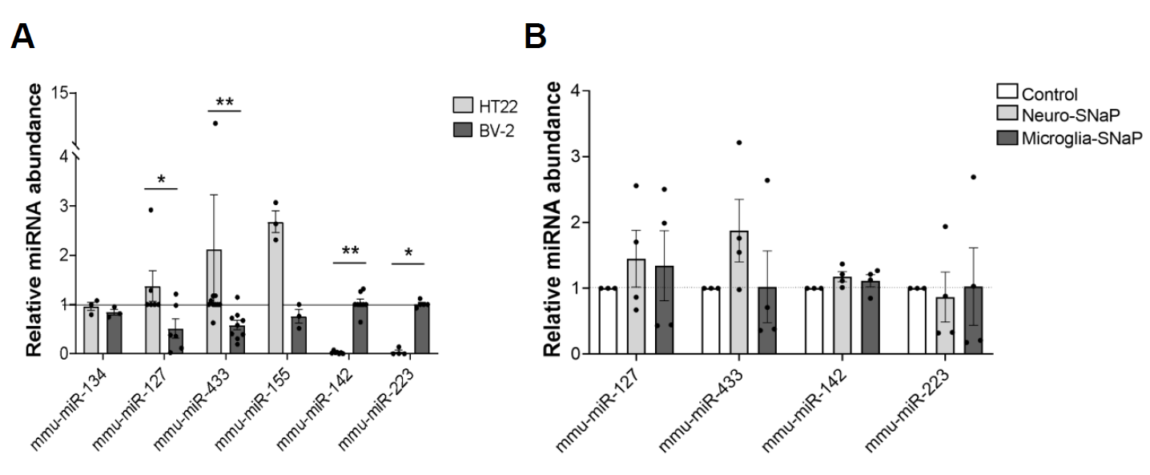
Supplementary Fig. 1: SNaP-CSP is efficient at packaging neuronal or microglial miRNAs within a heterogeneous brain cell co-culture system. A) Comparative analysis of miRNA expression in individually cultured HT22 (hippocampal) and BV-2 (microglial) immortalized cell lines, as determined by qPCR. Data presented as fold change relative to the cell line in which the target is predicted to be enriched. Results shown as bar charts (mean fold change ± SEM). Non-parametric Mann-Whitney U test: mmu-miR-134, p= 0.40, U= 2, not significant; mmu-miR-127, p= 0.023, U= 4; mmu-miR-433, p= 0.0026, U= 10; mmu-miR-155, p= 0.10, U= 0, not significant; mmu-miR-142, p= 0.003, U= 0; mmu-miR-223, p= 0.015, U= 0. B) Relative expression levels of target miRNAs in co-cultures transfected with SNaP constructs (CaMKIIα or Iba1) versus a mock transfection (Control). Results shown as bar charts (mean fold change ± SEM). Non-parametric Kruskal-Wallis test: mmu-miR-127, p=0.93, statistic=0.18, not significant; mmu-miR-433, p= 0.244, statistic= 2.96, not significant; mmu-miR-142, p= 0.17, statistic= 3.64, not significant; mmu-miR-223, p= 0.81, statistic= 0.507, not significant.

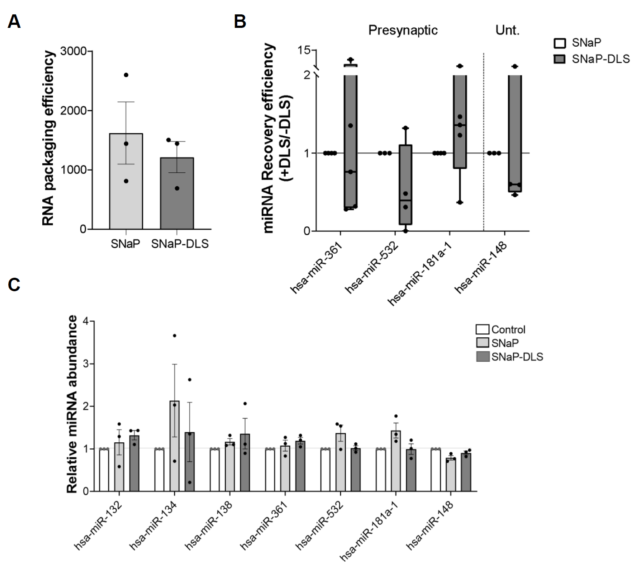
Supplementary Fig. 2: SNaP-DLS displays enhanced spatial resolution in postsynaptic miRNA profiling while reducing non-dendiritic background signals. A) Comparative analysis of RNA packaging efficiency between SNaP and SNaP-DLS nanoparticles packaged in human cortical glutamatergic neurons. Data plotted as mean ± SEM from n= 3 independent VLP productions per group. Non-parametric, two-tailed Mann-Whitney U test: p>0.99, U= 4 (not significant). B) Comparative analysis of miRNA recovery efficiency in SNaP-DLS versus SNaP-only particles for three miRNAs displaying presynaptic localization (hsa-miR-361, hsa-miR-532, hsa-miR-181a, left) and the unlocalized hsa-miR-148 (right). The definition of miRNA recovery efficiency is highlighted in Material and Methods, main text. Data represented as boxplot (median + range from n= 3-5 replicates per group). Mann-Whitney U test: hsa-miR-361 p= 0.701, U= 8; hsa-miR-532 p= 0.701, U= 8; hsa-miR-181a p= 0.1594, U= 4; hsa-miR-148 p= 0.183, U= 3. C) Endogenous expression levels of target miRNAs in i³ neurons transfected with either SNaP constructs (+/- DLS) relative to a mock transduction (Control). Data presented as mean ± SEM for n= 3 VLP productions per group. Non-parametric Kruskal-Wallis test: hsa-miR-132 p=0.26, statistic= 2.851; hsa-miR-134 p= 0.71, statistic=0.82; hsa-miR-138 p=0.335, statistic= 2.583; hsa-miR-361 p= 0.175, statistic= 3.954; hsa-miR-532 p= 0.3679, statistic= 2.483; hsa-miR-181a p= 0.103, statistic= 4.78.

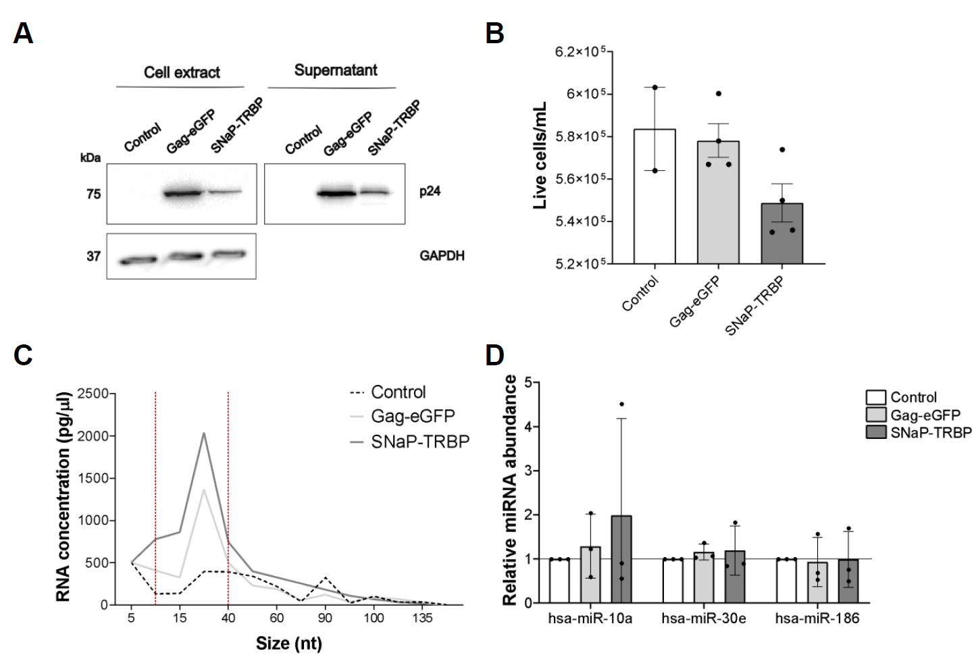
Supplementary Fig. 3: Preliminary characterization of SNaP-TRBP nanoparticles and cargo RNA. A) Representative immunoblot for the p24 antigen, confirming the expression of chimeric Gag-eGFP and SNaP-TRBP constructs in total protein extracts from packaging cells (left) and corresponding supernatants (right). B) Comparative assessment of vital cell counts among packaging cells transfected with Gag-eGFP, SNaP-TRBP, or mock-transfected cells (Control). Data plotted as mean ± SEM from n= 2–4 independent experiments. Kruskal-Wallis test: p= 0.1676, not significant. C) Averaged electrophoretic profile of small RNA content within Gag-eGFP and SNaP-TRBP nanoparticles from n= 5 VLP productions per group. The background profile represents total RNA extracted from the culture medium of mock-transfected HEK-293T cells (control). D) Endogenous expression levels of target miRNAs in HEK-293T cells transfected with Gag-eGFP, SNaP-TRBP relative to mock-transfected cells (Control). Data plotted as mean ± SEM from n= 3 independent replicates. Non-parametric Kruskal-Wallis test: hsa-miR-10a p= 0.69, statistic= 0.8370; hsa-miR-30e p= 0.3679, statistic= 2.483; hsa-miR-186 p= 0.8179, statistic= 0.6437.

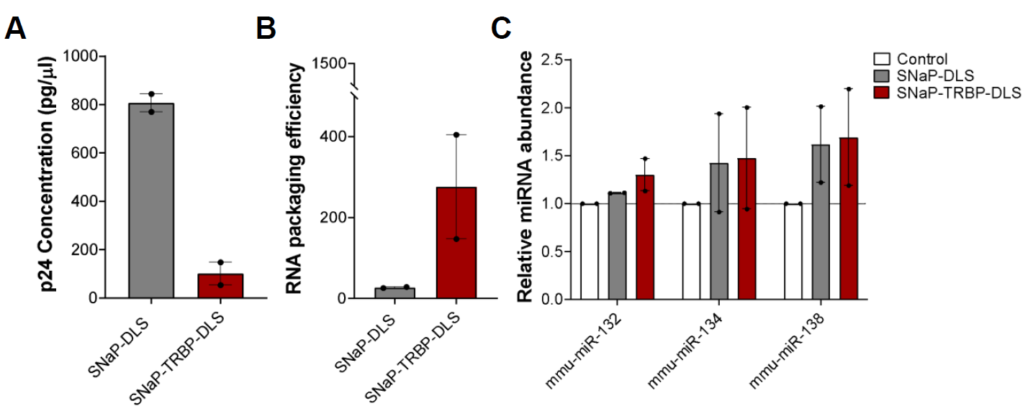

Supplementary Fig. 4: Scalable production of single and dual-engineered SNaP in mouse embryonic stem cell-derived neurons. A) Quantification of p24 levels in the supernatants of mature mouse neurons (DIV28 post-mESC neural induction) stably expressing SNaP-DLS or SNaP-TRBP-DLS constructs. Data presented as mean ± SEM from n= 2 independent experiments per group. B) Comparative analysis of RNA packaging efficiency between single (SNaP-DLS) and dual-engineered (SNaP-TRBP-DLS) particles. Data plotted as mean ± SEM from n= 2 VLP production experiments per group. C) Endogenous expression levels of target miRNAs in mESC-derived neurons transduced with SNaP constructs (+DLS, +TRBP-DLS) relative to mock-transduced neurons (control).

