SUPPLEMENTARY INFORMATION

Eleflai: Towards primary care-centered AI-driven mobile otoscope

Contents

Supplementary Table 1 | 2 | Supplementary Figure 1 | 17
Supplementary Table 2 | 3 | Supplementary Figure 2 | 18
Supplementary Table 3 | 4 | Supplementary Figure 3 | 19
Supplementary Table 4 | 5 | Supplementary Figure 4 | 20
Supplementary Table 5 | 6 | Supplementary Figure 5 | 21
Supplementary Table 6 | 7 | Supplementary Figure 6 | 22
Supplementary Table 7 | 8 | Supplementary Figure 7 | 23
Supplementary Table 8 | 9 | Supplementary Figure 8 | 24
Supplementary Table 9 | 10 | Supplementary Note 1 | 25
Supplementary Table 10 | 11 | Supplementary Note 2 | 27
Supplementary Table 11 | 12 | Supplementary Note 3 | 28
Supplementary Table 12 | 13-15 | Supplementary Note 4 | 29
Supplementary Table 13 | 16
Supplementary Table 14 | 25
Supplementary Table 15 | 26
Supplementary Table 16 | 26
Supplementary Table 17 | 27

Supplementary Table 1. The average IOU (mean ± standard deviation) of all the bounding boxes for each abnormality on inter-annotator agreement.
 | TM | SPM | TMC | CE | BE | TMP | ACTM | HE | FG | SE | PF
S1 Vs S2 | 0.972±0.033 | 0.960±0.020 | 0.925±0.040 | 0.919±0.106 | 0.918±0.066 | 0.966±0.036 | 0.925±0.035 | 0.906±0.067 | 0.919±0.059 | 0.911±0.115 | 0.961±0.021
S1 Vs S3 | 0.976±0.031 | 0.955±0.017 | 0.911±0.043 | 0.887±0.096 | 0.908±0.074 | 0.934±0.042 | 0.868±0.076 | 0.860±0.083 | 0.889±0.066 | 0.880±0.108 | 0.957±0.018
S1 Vs S4 | 0.970±0.033 | 0.957±0.017 | 0.910±0.058 | 0.897±0.096 | 0.904±0.057 | 0.946±0.044 | 0.890±0.065 | 0.917±0.035 | 0.909±0.050 | 0.885±0.117 | 0.959±0.016
S1 Vs S5 | 0.967±0.032 | 0.947±0.025 | 0.912±0.049 | 0.915±0.086 | 0.921±0.060 | 0.957±0.039 | 0.911±0.041 | 0.938±0.033 | 0.927±0.043 | 0.907±0.103 | 0.947±0.022
S1 Vs S6 | 0.956±0.035 | 0.951±0.023 | 0.909±0.044 | 0.917±0.090 | 0.910±0.063 | 0.959±0.036 | 0.899±0.052 | 0.899±0.063 | 0.904±0.058 | 0.906±0.109 | 0.950±0.025
S1 Vs S7 | 0.959±0.034 | 0.964±0.013 | 0.928±0.043 | 0.907±0.093 | 0.925±0.068 | 0.953±0.040 | 0.922±0.035 | 0.931±0.043 | 0.928±0.051 | 0.904±0.109 | 0.967±0.013
S1 Vs S8 | 0.964±0.034 | 0.958±0.015 | 0.915±0.046 | 0.886±0.106 | 0.897±0.089 | 0.941±0.046 | 0.878±0.069 | 0.860±0.068 | 0.900±0.057 | 0.878±0.117 | 0.959±0.018
S2 Vs S3 | 0.978±0.033 | 0.959±0.015 | 0.911±0.045 | 0.892±0.090 | 0.903±0.073 | 0.937±0.040 | 0.878±0.072 | 0.856±0.084 | 0.871±0.073 | 0.889±0.099 | 0.961±0.016
S2 Vs S4 | 0.972±0.035 | 0.962±0.015 | 0.920±0.046 | 0.902±0.091 | 0.919±0.054 | 0.946±0.044 | 0.901±0.050 | 0.906±0.056 | 0.901±0.043 | 0.900±0.101 | 0.963±0.014
S2 Vs S5 | 0.965±0.032 | 0.953±0.024 | 0.913±0.048 | 0.923±0.077 | 0.912±0.057 | 0.958±0.034 | 0.931±0.023 | 0.927±0.059 | 0.915±0.056 | 0.921±0.089 | 0.951±0.025
S2 Vs S6 | 0.956±0.035 | 0.954±0.022 | 0.920±0.045 | 0.924±0.079 | 0.906±0.071 | 0.964±0.029 | 0.911±0.040 | 0.887±0.075 | 0.909±0.063 | 0.920±0.093 | 0.952±0.023
S2 Vs S7 | 0.958±0.033 | 0.972±0.012 | 0.931±0.042 | 0.912±0.090 | 0.913±0.065 | 0.958±0.034 | 0.948±0.026 | 0.926±0.064 | 0.927±0.049 | 0.915±0.094 | 0.973±0.012
S2 Vs S8 | 0.964±0.034 | 0.963±0.013 | 0.907±0.050 | 0.890±0.095 | 0.887±0.085 | 0.938±0.048 | 0.888±0.063 | 0.867±0.075 | 0.888±0.060 | 0.884±0.112 | 0.965±0.013
S3 Vs S4 | 0.974±0.033 | 0.959±0.019 | 0.893±0.060 | 0.894±0.089 | 0.891±0.077 | 0.927±0.049 | 0.862±0.085 | 0.862±0.078 | 0.876±0.072 | 0.891±0.084 | 0.960±0.022
S3 Vs S5 | 0.969±0.031 | 0.946±0.020 | 0.897±0.055 | 0.915±0.073 | 0.896±0.078 | 0.937±0.043 | 0.867±0.076 | 0.868±0.077 | 0.885±0.062 | 0.919±0.062 | 0.945±0.022
S3 Vs S6 | 0.957±0.034 | 0.951±0.019 | 0.898±0.059 | 0.908±0.078 | 0.890±0.093 | 0.934±0.048 | 0.874±0.077 | 0.840±0.087 | 0.871±0.074 | 0.911±0.070 | 0.947±0.019
S3 Vs S7 | 0.960±0.032 | 0.967±0.017 | 0.907±0.050 | 0.903±0.080 | 0.893±0.083 | 0.931±0.055 | 0.879±0.073 | 0.865±0.075 | 0.880±0.064 | 0.902±0.078 | 0.967±0.018
S3 Vs S8 | 0.965±0.033 | 0.963±0.021 | 0.898±0.058 | 0.885±0.094 | 0.892±0.092 | 0.925±0.063 | 0.860±0.090 | 0.840±0.093 | 0.865±0.081 | 0.884±0.099 | 0.961±0.024
S4 Vs S5 | 0.963±0.032 | 0.947±0.020 | 0.906±0.050 | 0.914±0.071 | 0.912±0.057 | 0.950±0.045 | 0.894±0.053 | 0.946±0.030 | 0.920±0.042 | 0.911±0.070 | 0.945±0.021
S4 Vs S6 | 0.954±0.036 | 0.952±0.019 | 0.906±0.049 | 0.912±0.076 | 0.905±0.071 | 0.950±0.036 | 0.882±0.065 | 0.897±0.055 | 0.899±0.042 | 0.908±0.077 | 0.949±0.017
S4 Vs S7 | 0.956±0.034 | 0.969±0.012 | 0.915±0.053 | 0.904±0.087 | 0.891±0.069 | 0.940±0.047 | 0.899±0.052 | 0.935±0.026 | 0.918±0.044 | 0.904±0.084 | 0.969±0.014
S4 Vs S8 | 0.962±0.035 | 0.963±0.018 | 0.897±0.060 | 0.887±0.098 | 0.892±0.079 | 0.925±0.058 | 0.871±0.082 | 0.861±0.069 | 0.888±0.055 | 0.888±0.096 | 0.965±0.022
S5 Vs S6 | 0.952±0.035 | 0.944±0.027 | 0.907±0.051 | 0.938±0.053 | 0.926±0.061 | 0.958±0.036 | 0.903±0.047 | 0.907±0.056 | 0.909±0.047 | 0.937±0.053 | 0.948±0.027
S5 Vs S7 | 0.957±0.035 | 0.955±0.020 | 0.914±0.049 | 0.928±0.063 | 0.906±0.061 | 0.947±0.044 | 0.927±0.031 | 0.954±0.020 | 0.937±0.030 | 0.930±0.065 | 0.953±0.020
S5 Vs S8 | 0.959±0.034 | 0.948±0.019 | 0.899±0.049 | 0.901±0.083 | 0.902±0.074 | 0.939±0.048 | 0.881±0.064 | 0.874±0.070 | 0.903±0.042 | 0.898±0.083 | 0.947±0.018
S6 Vs S7 | 0.948±0.037 | 0.958±0.015 | 0.911±0.055 | 0.921±0.069 | 0.897±0.076 | 0.950±0.042 | 0.908±0.044 | 0.904±0.058 | 0.911±0.047 | 0.922±0.076 | 0.954±0.014
S6 Vs S8 | 0.951±0.037 | 0.953±0.017 | 0.890±0.053 | 0.901±0.081 | 0.889±0.091 | 0.931±0.054 | 0.877±0.078 | 0.847±0.076 | 0.882±0.062 | 0.894±0.093 | 0.948±0.016
S7 Vs S8 | 0.953±0.036 | 0.972±0.016 | 0.912±0.060 | 0.895±0.087 | 0.887±0.098 | 0.934±0.053 | 0.890±0.063 | 0.866±0.071 | 0.904±0.042 | 0.893±0.097 | 0.974±0.016

Supplementary Table 2. The average IOU (mean ± standard deviation) of all the bounding boxes for each feature on intra-annotator agreement.
 | TM | SPM | TMC | CE | BE | TMP | ACTM | HE | FG | SE | PF
S1 Vs S1+ | 0.950±0.038 | 0.971±0.013 | 0.933±0.036 | 0.934±0.061 | 0.937±0.042 | 0.969±0.030 | 0.940±0.038 | 0.932±0.051 | 0.939±0.032 | 0.926±0.066 | 0.973±0.011
S2 Vs S2+ | 0.953±0.037 | 0.956±0.019 | 0.938±0.033 | 0.941±0.051 | 0.941±0.037 | 0.942±0.053 | 0.945±0.031 | 0.967±0.020 | 0.940±0.038 | 0.943±0.062 | 0.961±0.018
S3 Vs S3+ | 0.956±0.034 | 0.942±0.026 | 0.939±0.036 | 0.929±0.075 | 0.924±0.056 | 0.945±0.054 | 0.940±0.031 | 0.936±0.037 | 0.928±0.035 | 0.932±0.063 | 0.953±0.025
S4 Vs S4+ | 0.97±0.0320 | 0.973±0.014 | 0.936±0.040 | 0.923±0.077 | 0.919±0.052 | 0.956±0.036 | 0.946±0.027 | 0.926±0.046 | 0.931±0.050 | 0.935±0.064 | 0.975±0.009
S5 Vs S5+ | 0.967±0.033 | 0.959±0.016 | 0.938±0.047 | 0.957±0.036 | 0.925±0.048 | 0.974±0.024 | 0.931±0.034 | 0.923±0.035 | 0.916±0.051 | 0.953±0.049 | 0.972±0.010
S6 Vs S6+ | 0.973±0.031 | 0.947±0.024 | 0.941±0.031 | 0.900±0.095 | 0.919±0.041 | 0.947±0.042 | 0.948±0.025 | 0.913±0.048 | 0.929±0.032 | 0.938±0.047 | 0.972±0.010
S7 Vs S7+ | 0.975±0.035 | 0.968±0.016 | 0.934±0.032 | 0.922±0.072 | 0.934±0.038 | 0.965±0.032 | 0.924±0.038 | 0.931±0.031 | 0.920±0.044 | 0.943±0.056 | 0.949±0.020
S8 Vs S8+ | 0.954±0.036 | 0.955±0.016 | 0.958±0.028 | 0.931±0.066 | 0.928±0.050 | 0.951±0.043 | 0.927±0.043 | 0.934±0.030 | 0.951±0.025 | 0.930±0.062 | 0.972±0.011

Supplementary Table 3. The number of bounding boxes with IoU=0 for each feature on inter-annotator agreement.
 | TM | SPM | TMC | CE | BE | TMP | ACTM | HE | FG | SE | PF
S1 Vs S2 | 0 | 0 | 0 | 2 | 0 | 0 | 0 | 0 | 0 | 0 | 0
S1 Vs S3 | 0 | 0 | 1 | 1 | 0 | 0 | 0 | 0 | 1 | 0 | 0
S1 Vs S4 | 0 | 0 | 0 | 1 | 0 | 0 | 0 | 0 | 0 | 0 | 0
S1 Vs S5 | 0 | 0 | 0 | 1 | 0 | 0 | 0 | 0 | 0 | 0 | 0
S1 Vs S6 | 0 | 0 | 0 | 1 | 0 | 0 | 0 | 1 | 0 | 0 | 0
S1 Vs S7 | 0 | 0 | 0 | 1 | 0 | 0 | 1 | 0 | 0 | 1 | 0
S1 Vs S8 | 0 | 0 | 0 | 1 | 0 | 0 | 0 | 0 | 0 | 0 | 0
S2 Vs S3 | 0 | 0 | 1 | 1 | 0 | 0 | 0 | 0 | 1 | 0 | 0
S2 Vs S4 | 0 | 0 | 0 | 1 | 0 | 0 | 0 | 0 | 0 | 0 | 0
S2 Vs S5 | 0 | 0 | 0 | 1 | 0 | 0 | 0 | 0 | 0 | 0 | 0
S2 Vs S6 | 0 | 0 | 0 | 1 | 0 | 0 | 0 | 1 | 0 | 0 | 0
S2 Vs S7 | 0 | 0 | 0 | 1 | 0 | 0 | 1 | 0 | 0 | 1 | 0
S2 Vs S8 | 0 | 0 | 0 | 1 | 0 | 0 | 0 | 0 | 0 | 0 | 0
S3 Vs S4 | 0 | 0 | 1 | 0 | 0 | 0 | 0 | 0 | 1 | 0 | 0
S3 Vs S5 | 0 | 0 | 1 | 0 | 0 | 0 | 0 | 0 | 1 | 0 | 0
S3 Vs S6 | 0 | 0 | 1 | 0 | 0 | 0 | 0 | 1 | 1 | 0 | 0
S3 Vs S7 | 0 | 0 | 1 | 0 | 0 | 0 | 1 | 0 | 1 | 1 | 0
S3 Vs S8 | 0 | 0 | 1 | 0 | 0 | 0 | 0 | 0 | 1 | 0 | 0
S4 Vs S5 | 0 | 0 | 0 | 0 | 0 | 0 | 0 | 0 | 0 | 0 | 0
S4 Vs S6 | 0 | 0 | 0 | 0 | 0 | 0 | 0 | 1 | 0 | 0 | 0
S4 Vs S7 | 0 | 0 | 0 | 0 | 0 | 0 | 1 | 0 | 0 | 1 | 0
S4 Vs S8 | 0 | 0 | 0 | 0 | 0 | 0 | 0 | 0 | 0 | 0 | 0
S5 Vs S6 | 0 | 0 | 0 | 0 | 0 | 0 | 0 | 1 | 0 | 0 | 0
S5 Vs S7 | 0 | 0 | 0 | 0 | 0 | 0 | 1 | 0 | 0 | 1 | 0
S5 Vs S8 | 0 | 0 | 0 | 0 | 0 | 0 | 0 | 0 | 0 | 0 | 0
S6 Vs S7 | 0 | 0 | 0 | 0 | 0 | 0 | 1 | 1 | 0 | 1 | 0
S6 Vs S8 | 0 | 0 | 0 | 0 | 0 | 0 | 0 | 1 | 0 | 0 | 0
S7 Vs S8 | 0 | 0 | 0 | 0 | 0 | 0 | 1 | 0 | 0 | 0 | 0

Supplementary Table 4. The number of bounding boxes with IoU=0 for each feature on intra-annotator agreement.
 | TM | SPM | TMC | CE | BE | TMP | ACTM | HE | FG | SE | PF
S1 Vs S1+ | 0 | 0 | 0 | 1 | 0 | 0 | 0 | 0 | 0 | 0 | 0
S2 Vs S2+ | 0 | 0 | 0 | 0 | 0 | 0 | 1 | 0 | 1 | 0 | 0
S3 Vs S3+ | 0 | 0 | 1 | 1 | 0 | 0 | 0 | 0 | 0 | 1 | 0
S4 Vs S4+ | 0 | 0 | 0 | 0 | 0 | 0 | 0 | 0 | 0 | 0 | 0
S5 Vs S5+ | 0 | 0 | 0 | 0 | 1 | 0 | 0 | 0 | 0 | 1 | 0
S6 Vs S6+ | 0 | 0 | 0 | 0 | 0 | 0 | 0 | 1 | 0 | 0 | 0
S7 Vs S7+ | 0 | 0 | 0 | 1 | 0 | 0 | 0 | 0 | 1 | 0 | 0
S8 Vs S8+ | 0 | 0 | 0 | 0 | 0 | 0 | 0 | 0 | 0 | 0 | 0

Supplementary Table 5. The number of images and patients used in self-supervised pretraining.
Number | SZH Dataset | ZSH Dataset | FSH Dataset | SSH Dataset | NFH Dataset
Ear images | 43,352  (n=11,583) | 80,459  (n=18,375) | 64,763  (n=11,810) | 46,974  (n=8,891) | 5,277  (n=1,912)
Nose images | 398,722  (n=43,796) | 419,387  (n=49,294) | 281,560  (n=27,821) | 192,550  (n=19,305) | 94,510  (n=9,927)
Throat images | 36,305  (n=5,548) | 41,408  (n=6,372) | 15,143  (n=3,015) | 23,567  (n=3,134) | 30,839  (n=3,836)

Supplementary Table 6. The number of images and bounding boxes in each dataset. “bboxes” means bounding boxes.
 | Train Set |  | Val Set |  | Test Set |  | FSH set |  | SSH set |  | NFH set
Class | Images | bboxes | Images | bboxes | Images | bboxes | Images | bboxes | Images | bboxes | Images | bboxes
ALL | 76,785 | 339,828 | 12,797 | 54,680 | 22,252 | 85,266 | 21,930 | 83,053 | 17,794 | 74,980 | 15,234 | 65,305
TM | 55,656 | 55,656 | 11,209 | 11,209 | 21,403 | 21,403 | 20,564 | 20,564 | 13,657 | 13,657 | 13,646 | 13,646
SPM | 49,958 | 49,958 | 9,811 | 9,811 | 20,083 | 20,083 | 18,945 | 18,945 | 9,535 | 9,535 | 12,482 | 12,482
TMC | 11,776 | 18,180 | 880 | 1,345 | 1,273 | 2,057 | 1,573 | 2,420 | 2,045 | 3,404 | 2,582 | 3,938
CE | 42,425 | 94,783 | 7,736 | 18,062 | 9,948 | 24,563 | 8,496 | 20,139 | 9,374 | 20,004 | 6,403 | 15,515
BE | 4,802 | 6,272 | 328 | 396 | 525 | 754 | 371 | 537 | 1,023 | 1,441 | 489 | 630
TMP | 9,186 | 9,673 | 692 | 699 | 1,348 | 1,402 | 2,377 | 2,416 | 1,575 | 1,656 | 1,995 | 2,034
ACTM | 10,464 | 13,194 | 1,919 | 2,426 | 2,884 | 3,677 | 4,201 | 5,304 | 3,923 | 4,664 | 1,850 | 2,262
HE | 14,882 | 14,882 | 1,421 | 1,421 | 1,194 | 1,194 | 2,387 | 2,387 | 4,223 | 4,223 | 2,009 | 2,009
FG | 8,275 | 10,633 | 1,159 | 1,684 | 517 | 818 | 1,491 | 2,329 | 2,746 | 3,278 | 1,070 | 1,382
SE | 34,962 | 59,582 | 3,810 | 7,039 | 4,281 | 8,189 | 3,726 | 7,252 | 7,266 | 11,573 | 5,477 | 9,824
PF | 7,015 | 7,015 | 588 | 588 | 1,126 | 1,126 | 760 | 760 | 1,545 | 1,545 | 1,583 | 1,583

 | YOLOV8 |  | YOLOV9 |  | YOLOV10
Class Name | Precision | Recall | Precision | Recall | Precision | Recall
Overall | 0.700  (0.697-0.703) | 0.673  (0.670-0.676) | 0.682  (0.679-0.686) | 0.661  (0.658-0.664) | 0.706  (0.703-0.709) | 0.662  (0.658-0.665)
TM | 0.967  (0.965-0.969) | 0.971  (0.969-0.973) | 0.973  (0.971-0.975) | 0.976  (0.974-0.978) | 0.969  (0.967-0.972) | 0.979  (0.977-0.981)
SPM | 0.882  (0.878-0.887) | 0.918  (0.914-0.922) | 0.856  (0.851-0.861) | 0.921  (0.917-0.924) | 0.816  (0.811-0.821) | 0.933  (0.930-0.937)
TMC | 0.674  (0.653-0.693) | 0.686  (0.666-0.706) | 0.647  (0.626-0.668) | 0.642  (0.621-0.662) | 0.693  (0.673-0.712) | 0.700  (0.679-0.719)
CE | 0.656  (0.650-0.662) | 0.617  (0.611-0.623) | 0.648  (0.642-0.655) | 0.617  (0.611-0.624) | 0.666  (0.660-0.672) | 0.622  (0.616-0.628)
BE | 0.689  (0.652-0.725) | 0.569  (0.533-0.604) | 0.695  (0.656-0.731) | 0.531  (0.495-0.566) | 0.696  (0.658-0.731) | 0.556  (0.520-0.591)
TMP | 0.758  (0.736-0.779) | 0.812  (0.791-0.832) | 0.786  (0.764-0.807) | 0.777  (0.755-0.798) | 0.768  (0.746-0.789) | 0.795  (0.773-0.815)
ACTM | 0.686  (0.669-0.702) | 0.565  (0.549-0.581) | 0.647  (0.630-0.663) | 0.586  (0.570-0.602) | 0.677  (0.661-0.693) | 0.589  (0.573-0.604)
HE | 0.579  (0.552-0.604) | 0.675  (0.648-0.701) | 0.525  (0.499-0.550) | 0.654  (0.627-0.681) | 0.570  (0.542-0.596) | 0.613  (0.585-0.640)
FG | 0.739  (0.700-0.774) | 0.484  (0.450-0.518) | 0.677  (0.638-0.714) | 0.482  (0.448-0.516) | 0.742  (0.700-0.779) | 0.424  (0.391-0.458)
SE | 0.612  (0.597-0.626) | 0.317  (0.307-0.328) | 0.607  (0.592-0.622) | 0.298  (0.289-0.308) | 0.635  (0.620-0.650) | 0.302  (0.292-0.312)
PF | 0.462  (0.439-0.484) | 0.786  (0.761-0.809) | 0.445  (0.423-0.467) | 0.783  (0.758-0.806) | 0.531  (0.506-0.555) | 0.765  (0.739-0.789)
Supplementary Table 7. The precision and recall values (95% confidence interval) of YOLO models on internal test set.

Supplementary Table 8. The precision and recall values (95% confidence interval) of YOLO models with SSL
performance on internal test set.
 | YOLOV8-SSL |  | YOLOV9-SSL |  | YOLOV10-SSL
Class Name | Precision | Recall | Precision | Recall | Precision | Recall
Overall | 0.758  (0.755-0.761) | 0.728  (0.725-0.731) | 0.728  (0.725-0.731) | 0.715  (0.712-0.718) | 0.756  (0.753-0.759) | 0.712  (0.709-0.715)
TM | 0.993  (0.991-0.994) | 0.995  (0.994-0.996) | 0.979  (0.977-0.981) | 0.982  (0.980-0.983) | 0.983  (0.981-0.984) | 0.986  (0.984-0.987)
SPM | 0.903  (0.899-0.907) | 0.921  (0.917-0.925) | 0.887  (0.882-0.891) | 0.924  (0.920-0.927) | 0.868  (0.863-0.873) | 0.927  (0.923-0.930)
TMC | 0.744  (0.725-0.762) | 0.743  (0.724-0.762) | 0.729  (0.709-0.747) | 0.734  (0.715-0.753) | 0.737  (0.717-0.755) | 0.742  (0.723-0.760)
CE | 0.730  (0.725-0.736) | 0.674  (0.668-0.680) | 0.699  (0.693-0.705) | 0.663  (0.657-0.668) | 0.728  (0.723-0.734) | 0.668  (0.663-0.674)
BE | 0.734  (0.699-0.766) | 0.640  (0.604-0.673) | 0.752  (0.716-0.784) | 0.606  (0.571-0.640) | 0.800  (0.766-0.831) | 0.615  (0.580-0.649)
TMP | 0.828  (0.808-0.847) | 0.859  (0.840-0.876) | 0.818  (0.797-0.837) | 0.840  (0.820-0.858) | 0.792  (0.770-0.812) | 0.838  (0.818-0.856)
ACTM | 0.739  (0.723-0.754) | 0.624  (0.609-0.640) | 0.709  (0.693-0.724) | 0.625  (0.609-0.640) | 0.724  (0.708-0.739) | 0.647  (0.631-0.662)
HE | 0.643  (0.617-0.669) | 0.708  (0.681-0.733) | 0.552  (0.526-0.577) | 0.698  (0.671-0.723) | 0.631  (0.604-0.657) | 0.680  (0.653-0.706)
FG | 0.774  (0.739-0.806) | 0.567  (0.533-0.601) | 0.740  (0.705-0.774) | 0.559  (0.524-0.592) | 0.744  (0.706-0.779) | 0.494  (0.460-0.528)
SE | 0.709  (0.696-0.721) | 0.457  (0.446-0.468) | 0.666  (0.653-0.679) | 0.418  (0.408-0.429) | 0.700  (0.688-0.713) | 0.446  (0.435-0.457)
PF | 0.539  (0.516-0.563) | 0.817  (0.793-0.839) | 0.483  (0.460-0.505) | 0.817  (0.793-0.839) | 0.613  (0.587-0.637) | 0.793  (0.768-0.816)

Supplementary Table 9. The precision and recall values (95% confidence interval) of YOLO models with SSL
performance on FSH dataset.
 | YOLOV8-SSL |  | YOLOV9-SSL |  | YOLOV10-SSL
Class Name | Precision | Recall | Precision | Recall | Precision | Recall
Overall | 0.732  (0.729-0.735) | 0.706  (0.703-0.709) | 0.718  (0.715-0.721) | 0.707  (0.703-0.710) | 0.726  (0.723-0.729) | 0.685  (0.681-0.688)
TM | 0.974  (0.972-0.976) | 0.981  (0.979-0.983) | 0.975  (0.972-0.977) | 0.981  (0.979-0.983) | 0.963  (0.960-0.965) | 0.971  (0.969-0.974)
SPM | 0.864  (0.859-0.869) | 0.904  (0.900-0.908) | 0.850  (0.845-0.855) | 0.903  (0.899-0.907) | 0.858  (0.853-0.863) | 0.926  (0.922-0.930)
TMC | 0.763  (0.746-0.780) | 0.778  (0.761-0.794) | 0.767  (0.750-0.783) | 0.782  (0.765-0.798) | 0.762  (0.745-0.778) | 0.801  (0.784-0.816)
CE | 0.734  (0.728-0.740) | 0.724  (0.718-0.730) | 0.724  (0.718-0.730) | 0.724  (0.718-0.730) | 0.730  (0.724-0.736) | 0.699  (0.693-0.706)
BE | 0.579  (0.531-0.624) | 0.454  (0.413-0.497) | 0.561  (0.514-0.607) | 0.453  (0.411-0.495) | 0.594  (0.546-0.641) | 0.445  (0.404-0.487)
TMP | 0.844  (0.828-0.858) | 0.814  (0.798-0.829) | 0.861  (0.846-0.874) | 0.802  (0.786-0.818) | 0.811  (0.794-0.826) | 0.769  (0.752-0.785)
ACTM | 0.767  (0.754-0.779) | 0.612  (0.599-0.625) | 0.746  (0.733-0.759) | 0.640  (0.627-0.653) | 0.741  (0.728-0.754) | 0.615  (0.602-0.628)
HE | 0.724  (0.706-0.741) | 0.764  (0.746-0.780) | 0.672  (0.653-0.689) | 0.732  (0.714-0.750) | 0.702  (0.683-0.721) | 0.667  (0.647-0.685)
FG | 0.699  (0.676-0.720) | 0.498  (0.477-0.518) | 0.697  (0.675-0.719) | 0.496  (0.476-0.517) | 0.639  (0.615-0.661) | 0.454  (0.434-0.474)
SE | 0.663  (0.650-0.676) | 0.462  (0.450-0.473) | 0.643  (0.630-0.655) | 0.472  (0.461-0.484) | 0.653  (0.639-0.666) | 0.418  (0.407-0.429)
PF | 0.443  (0.416-0.470) | 0.772  (0.741-0.801) | 0.402  (0.377-0.427) | 0.787  (0.756-0.814) | 0.534  (0.504-0.563) | 0.764  (0.733-0.793)

Supplementary Table 10. The precision and recall values (95% confidence interval) of YOLO models with SSL
performance on SSH set.
 | YOLOV8-SSL |  | YOLOV9-SSL |  | YOLOV10-SSL
Class Name | Precision | Recall | Precision | Recall | Precision | Recall
Overall | 0.764  (0.761-0.768) | 0.715  (0.712-0.719) | 0.758  (0.754-0.761) | 0.694  (0.691-0.698) | 0.750  (0.747-0.753) | 0.722  (0.719-0.725)
TM | 0.931  (0.927-0.935) | 0.983  (0.980-0.985) | 0.922  (0.917-0.926) | 0.974  (0.972-0.977) | 0.938  (0.933-0.941) | 0.992  (0.990-0.993)
SPM | 0.754  (0.746-0.762) | 0.933  (0.927-0.937) | 0.770  (0.762-0.778) | 0.933  (0.928-0.938) | 0.728  (0.720-0.736) | 0.954  (0.949-0.958)
TMC | 0.741  (0.725-0.756) | 0.680  (0.664-0.695) | 0.734  (0.718-0.749) | 0.673  (0.657-0.689) | 0.726  (0.711-0.742) | 0.686  (0.670-0.701)
CE | 0.705  (0.698-0.711) | 0.682  (0.675-0.688) | 0.728  (0.721-0.734) | 0.677  (0.670-0.683) | 0.717  (0.711-0.723) | 0.712  (0.705-0.718)
BE | 0.710  (0.683-0.736) | 0.561  (0.535-0.586) | 0.727  (0.700-0.752) | 0.563  (0.538-0.589) | 0.636  (0.610-0.661) | 0.605  (0.580-0.630)
TMP | 0.848  (0.830-0.865) | 0.827  (0.808-0.845) | 0.817  (0.797-0.835) | 0.796  (0.776-0.815) | 0.828  (0.809-0.846) | 0.833  (0.815-0.851)
ACTM | 0.744  (0.730-0.758) | 0.591  (0.577-0.605) | 0.760  (0.746-0.773) | 0.617  (0.603-0.631) | 0.753  (0.740-0.766) | 0.661  (0.648-0.675)
HE | 0.751  (0.737-0.764) | 0.742  (0.728-0.755) | 0.682  (0.667-0.697) | 0.599  (0.585-0.614) | 0.650  (0.635-0.664) | 0.659  (0.645-0.674)
FG | 0.866  (0.853-0.878) | 0.760  (0.745-0.774) | 0.852  (0.838-0.864) | 0.746  (0.731-0.761) | 0.885  (0.873-0.897) | 0.714  (0.698-0.729)
SE | 0.727  (0.716-0.738) | 0.394  (0.385-0.403) | 0.699  (0.687-0.710) | 0.371  (0.362-0.380) | 0.709  (0.698-0.719) | 0.441  (0.432-0.450)
PF | 0.631  (0.608-0.653) | 0.717  (0.694-0.739) | 0.643  (0.619-0.666) | 0.686  (0.663-0.709) | 0.681  (0.658-0.704) | 0.687  (0.663-0.709)

Supplementary Table 11. The precision and recall values (95% confidence interval) of YOLO models with SSL
performance on NFH set.
 | YOLOV8-SSL |  | YOLOV9-SSL |  | YOLOV10-SSL
Class Name | Precision | Recall | Precision | Recall | Precision | Recall
Overall | 0.741  (0.737-0.744) | 0.729  (0.726-0.733) | 0.743  (0.739-0.746) | 0.713  (0.710-0.717) | 0.722  (0.719-0.726) | 0.719  (0.716-0.722)
TM | 0.965  (0.962-0.968) | 0.984  (0.982-0.986) | 0.969  (0.966-0.972) | 0.983  (0.981-0.985) | 0.927  (0.923-0.931) | 0.946  (0.942-0.949)
SPM | 0.844  (0.837-0.850) | 0.934  (0.930-0.938) | 0.846  (0.839-0.852) | 0.933  (0.928-0.937) | 0.763  (0.756-0.770) | 0.933  (0.929-0.938)
TMC | 0.714  (0.700-0.728) | 0.725  (0.711-0.739) | 0.665  (0.650-0.679) | 0.681  (0.666-0.695) | 0.687  (0.672-0.701) | 0.726  (0.712-0.739)
CE | 0.697  (0.690-0.705) | 0.730  (0.723-0.737) | 0.671  (0.663-0.678) | 0.680  (0.673-0.687) | 0.663  (0.656-0.670) | 0.739  (0.732-0.746)
BE | 0.638  (0.599-0.677) | 0.589  (0.550-0.627) | 0.630  (0.589-0.670) | 0.547  (0.509-0.586) | 0.655  (0.617-0.692) | 0.633  (0.595-0.670)
TMP | 0.773  (0.755-0.790) | 0.836  (0.820-0.852) | 0.838  (0.822-0.854) | 0.826  (0.809-0.842) | 0.769  (0.751-0.787) | 0.817  (0.799-0.833)
ACTM | 0.730  (0.709-0.749) | 0.620  (0.600-0.640) | 0.744  (0.724-0.763) | 0.636  (0.616-0.655) | 0.675  (0.654-0.694) | 0.647  (0.627-0.666)
HE | 0.625  (0.604-0.644) | 0.685  (0.665-0.705) | 0.660  (0.639-0.680) | 0.675  (0.654-0.695) | 0.618  (0.597-0.639) | 0.634  (0.613-0.655)
FG | 0.810  (0.786-0.831) | 0.682  (0.657-0.706) | 0.887  (0.867-0.904) | 0.692  (0.668-0.716) | 0.872  (0.849-0.891) | 0.629  (0.603-0.654)
SE | 0.688  (0.676-0.700) | 0.421  (0.411-0.431) | 0.634  (0.622-0.646) | 0.381  (0.372-0.391) | 0.629  (0.617-0.640) | 0.412  (0.402-0.421)
PF | 0.666  (0.645-0.687) | 0.814  (0.794-0.832) | 0.627  (0.606-0.648) | 0.812  (0.792-0.830) | 0.686  (0.665-0.707) | 0.793  (0.773-0.813)

Supplementary Table 12. Definition and annotation principles of ear features.
Feature Name | Feature Definition | Annotation principles | Labeling difficulty
Tympanic membrane contour | The tympanic membrane contour refers to the entire area that includes the tympanic membrane (pars tense and pars flaccid) and the annulus. | Use a single bounding box to annotate features. When annotating, the annotator needs to annotate along the outer side of the tympanic anulus (the side close to the external auditory canal) to ensure that the bounding box completely covers the tympanic membrane area (including the pars tense and pars flaccid). In actual annotation, due to the limitations of shooting angle, shooting depth and lens, some areas of the feature are sometimes not completely included in the image. To prevent irrelevant background noise from affecting the model’s learning and detection of physiological structure features, the tympanic membrane contour is not labeled in this situation. | Low
Pars flaccid | The pars flaccida is a specific area of ​​the tympanic membrane that is located above the pars tense and opposite the short process of the malleus and is approximately 1/4 the size of the tympanic membrane. | Use a single bounding box to annotate features. Use a minimal outer rectangle to cover the entire pars flaccid. In actual annotation, due to the limitations of shooting angle, shooting depth and lens, some areas of the feature are sometimes not completely included in the image. To prevent irrelevant background noise from affecting the model’s learning and detection of physiological structure features, the pars flaccid is not labeled in this situation. | Middle
The short process of the malleus | A specific part of the malleus, located medial to the pars tensa of the tympanic membrane, is the area where the malleus joins the incus. | Use a single bounding box to annotate features. The bounding box should be the smallest outer rectangle that accurately covers the handle of the short process of the malleus. In actual annotation, due to the limitations of shooting angle, shooting depth and lens, some areas of the feature are sometimes not completely included in the image. To prevent irrelevant background noise from affecting the model’s learning and detection of physiological structure features, the short process of the malleus is not labeled in this situation. | Middle
Tympanic membrane calcification | Opaque and white patches on the surface of the tympanic membrane. | Use single or multiple bounding boxes to annotate features. Annotators should use the smallest outer rectangle to annotate tympanic membrane calcifications. If the calcifications are close together and appear over a large area, annotators can use a single bounding box to annotate the entire feature. | Low
Abnormal color of tympanic membrane | The color change of the tympanic membrane caused by middle ear effusion. It usually appears amber, light red, or light yellow, and may be accompanied by bubbles. | Use single or multiple bounding boxes to annotate features. The annotator needs to use the smallest external rectangle and annotate the features along their edges. If there are multiple adjacent features and the overall range of the features is large, a bounding box can be used to label the features. | High
Cerumen | Cerumen, commonly known as earwax, is a hydrophobic and protective waxy substance in the ear canal, typically appearing as the light yellow flakes or viscous substances. | Use single or multiple bounding boxes to annotate features. The annotator needs to use the smallest external rectangle and annotate the features along their edges. If there are multiple adjacent features and the overall range of the features is large, a bounding box can be used to label the features. Note that do not annotate extremely tiny and punctate cerumen fragments. | Low
Bleeding | Bleeding can occur in the external auditory canal, tympanic membrane, and middle ear. Under endoscopic examination, blood spots, blood scabs, and purulent blood can be observed. | Use single or multiple bounding boxes to annotate features. The annotator needs to use the smallest external rectangle and annotate the features along their edges. If there are multiple adjacent features and the overall range of the features is large, a bounding box can be used to label the features. | Low
Secretion | Viscous substances, aqueous exudate, bloody exudate, yellow exudate, milky white exudate secreted by the ceruminous gland. | Use single or multiple bounding boxes to annotate features. The annotator needs to use the smallest external rectangle and annotate the features along their edges. If there are multiple adjacent features and the overall range of the features is large, a bounding box can be used to label the features. | High
Hyperemia | Hyperemia refers to diffuse vasodilation, which appears bright red or dark red. | The hyperemia usually covers a large area of ​​the tympanic membrane and external auditory canal. Use single bounding box to annotate features. The annotator needs to use the smallest external rectangle and annotate the features along their edges. | High
Tympanic membrane perforation and tympanic membrane healing perforation | 1) Tympanic membrane perforation refers to the hole-like features of the tympanic membrane, and its common shapes include fusiform, slit-shaped, round or quasi-round.  2) Tympanic membrane healing perforation refers to the self-repair of the tympanic membrane perforation, and its appearance is thin and transparent. | Use a single bounding box or multiple bounding boxes to annotate the perforations. Annotators should use the smallest bounding box to annotate the perforations. Annotators should ensure that there is one annotated box for each perforation. If multiple perforations are connected, annotators should use one bounding box. | Low
Fungus | Lesions caused by fungal invasion. Its color can be off-white, milky white, gray-yellow, gray-black and yellow-green. Its shape often appears as membranous, filamentous, powdery and fluffy. | Use single or multiple bounding boxes to annotate features. The annotator needs to use the smallest external rectangle and annotate the features along their edges. If there are multiple adjacent features and the overall range of the features is large, a bounding box can be used to label the features. | Middle

Supplementary Table 13. The number of images and bounding boxes of each category in the human-machine comparison test set.
Category | Bounding boxes
TM | 2020
SPM | 1884
TMC | 220
CE | 2226
BE | 85
TMP | 128
ACTM | 365
HE | 117
FG | 57
SE | 785
PF | 83

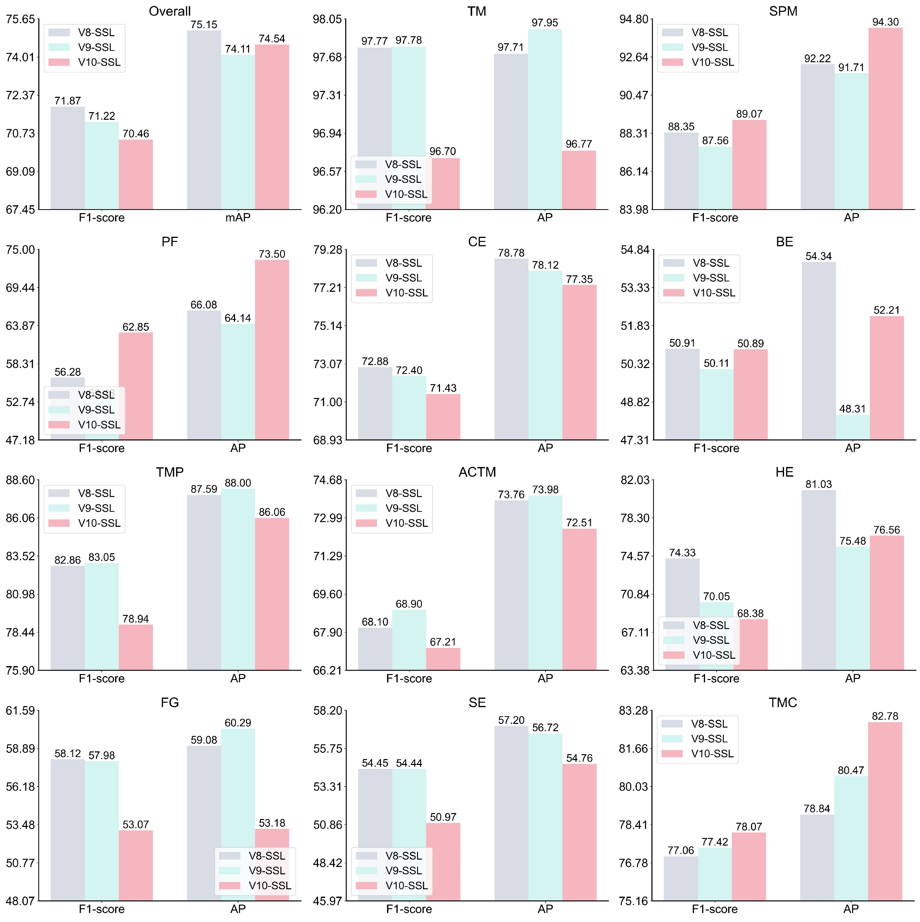
Supplementary Figure 1. The F1-score and AP values of the YOLO models on FSH dataset.

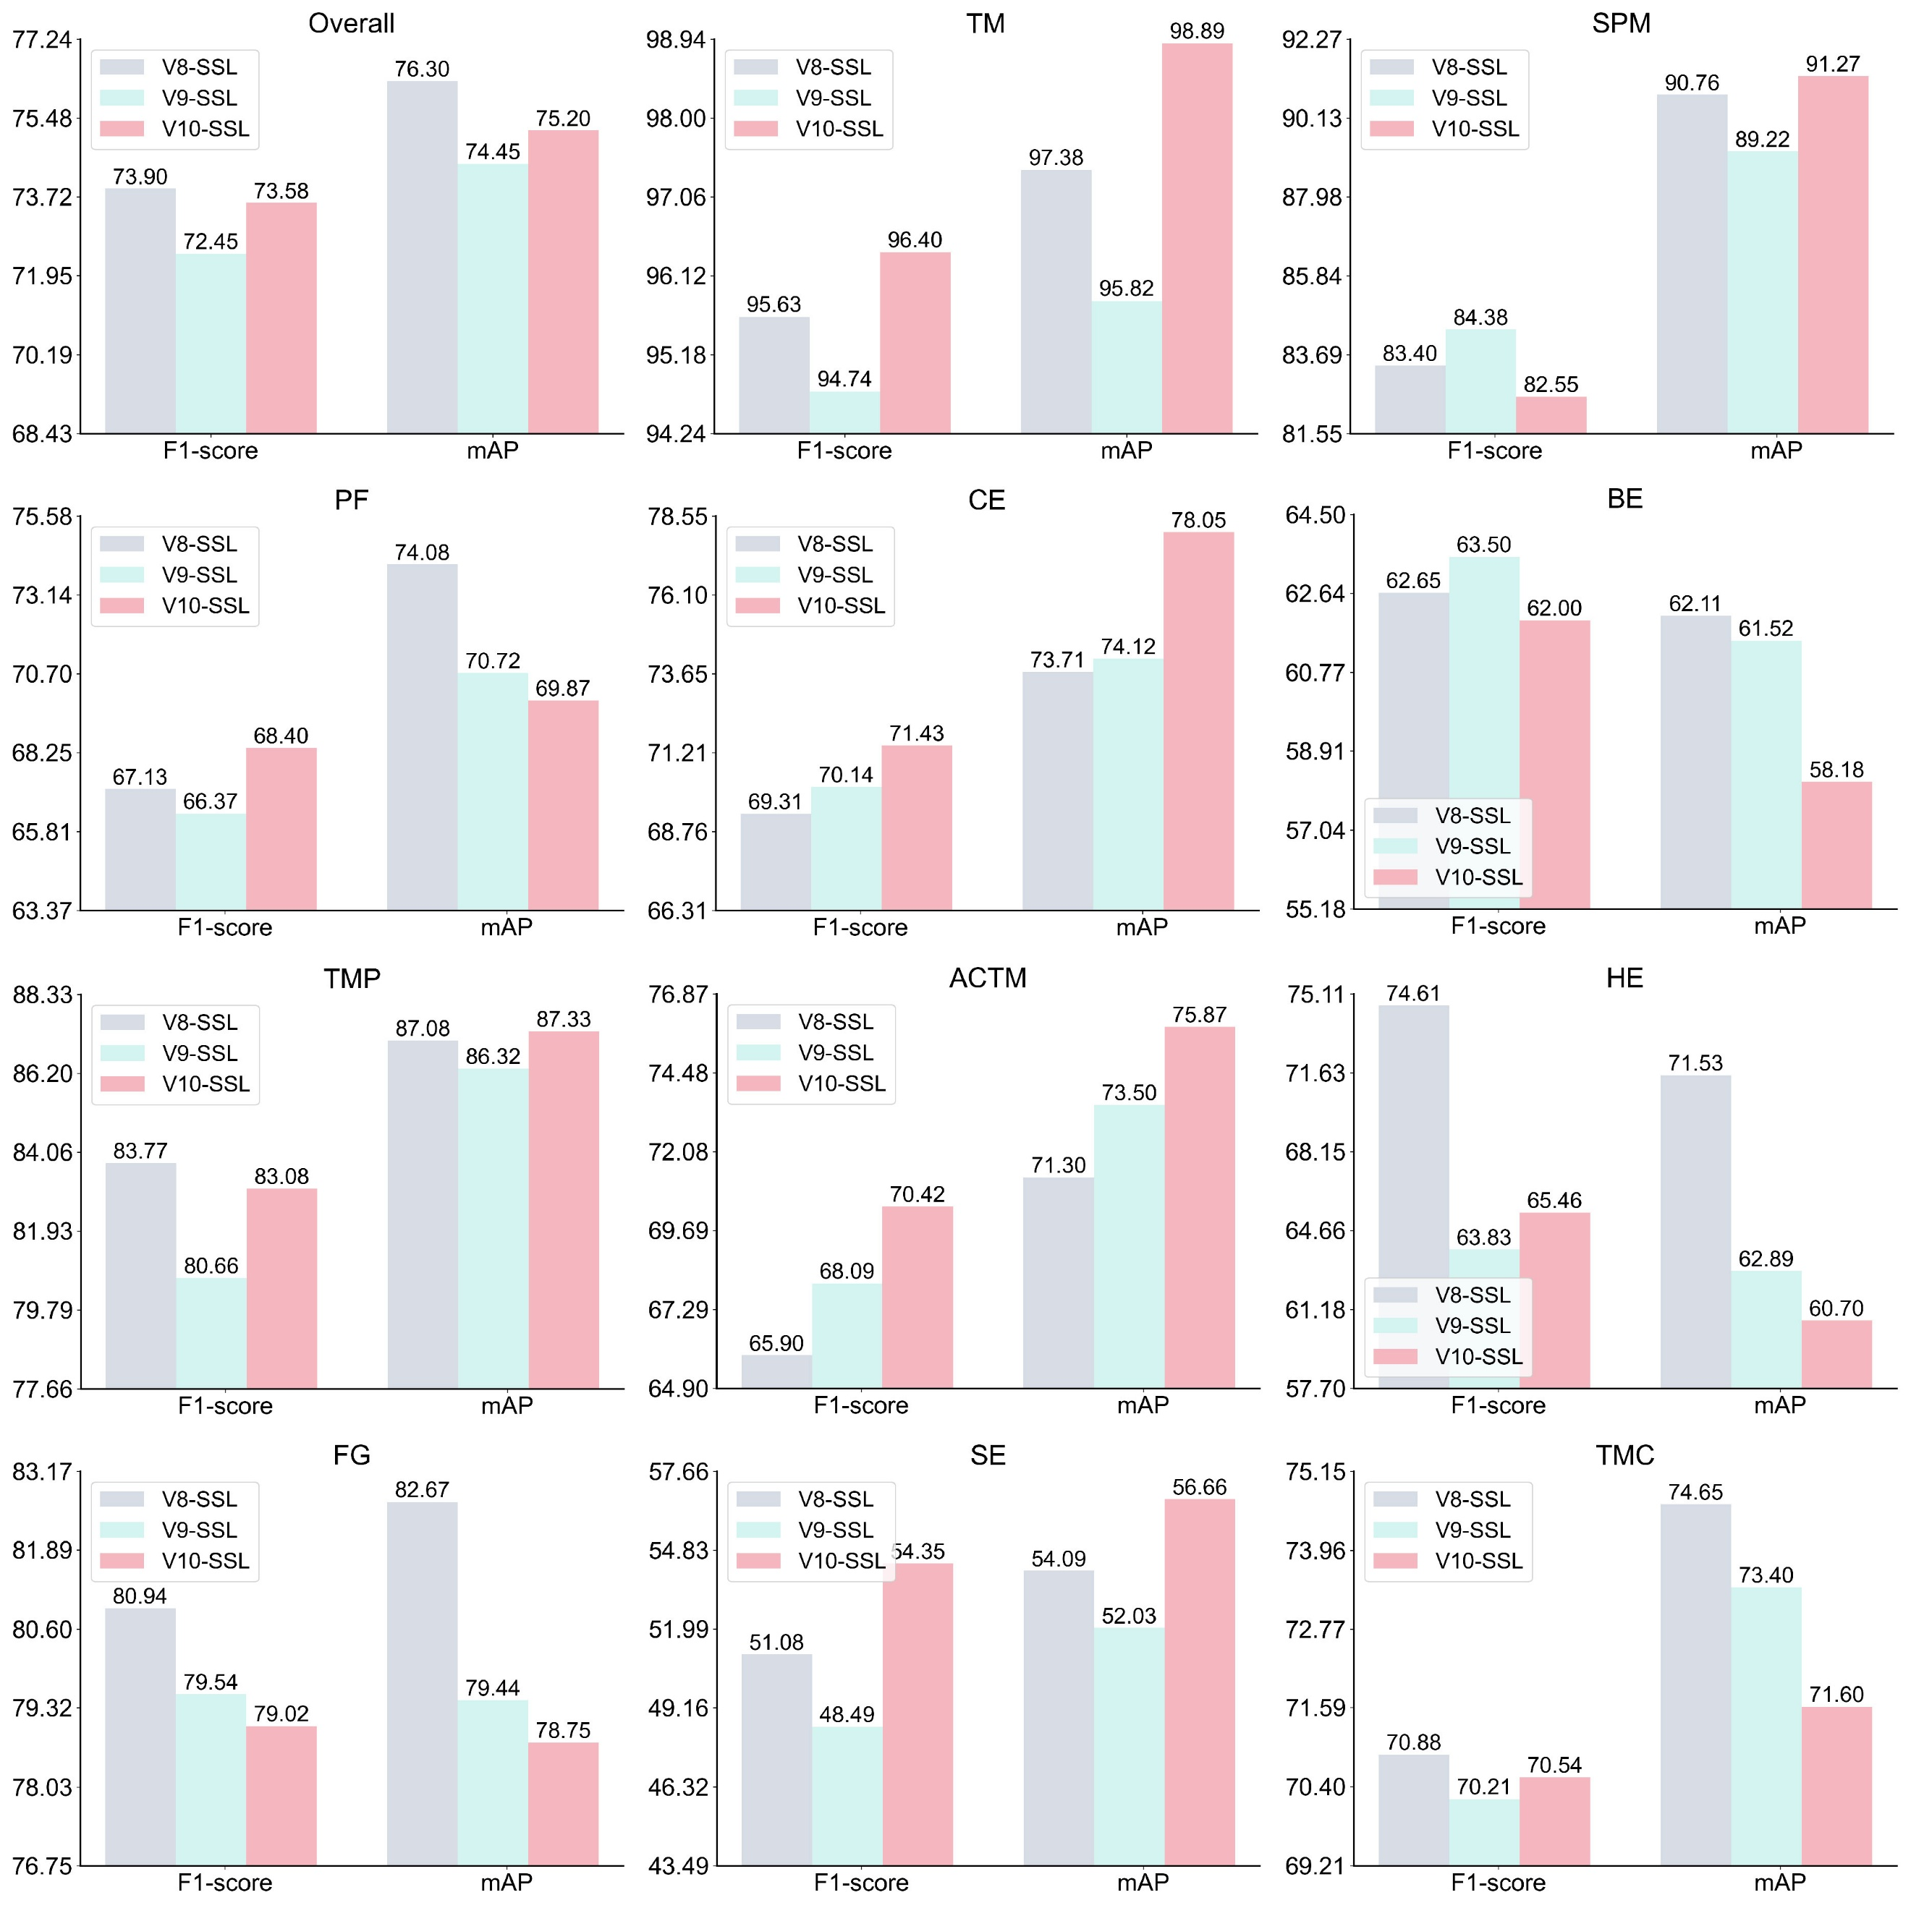
Supplementary Figure 2. The F1-score and AP values of the YOLO models on SSH dataset.
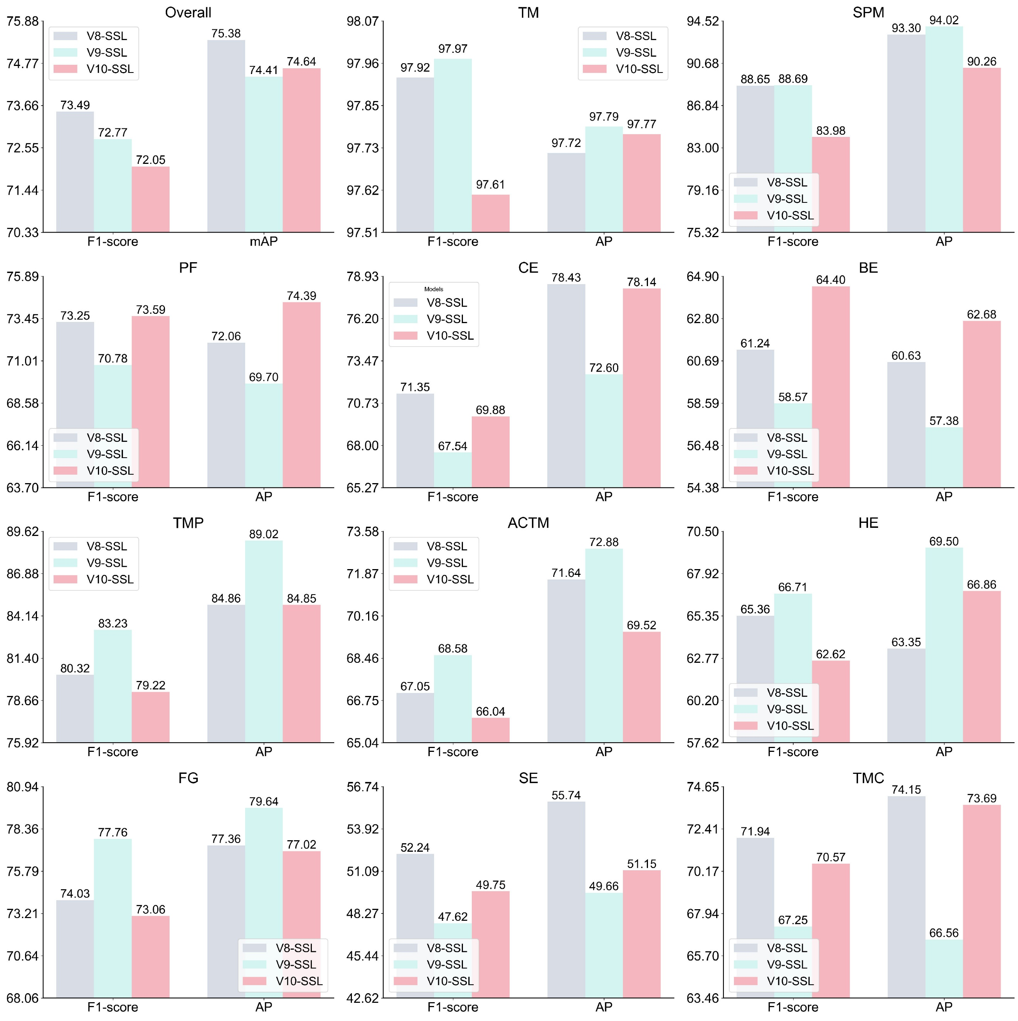
Supplementary Figure 3. The F1-score and AP values of the YOLO models on NFH dataset.

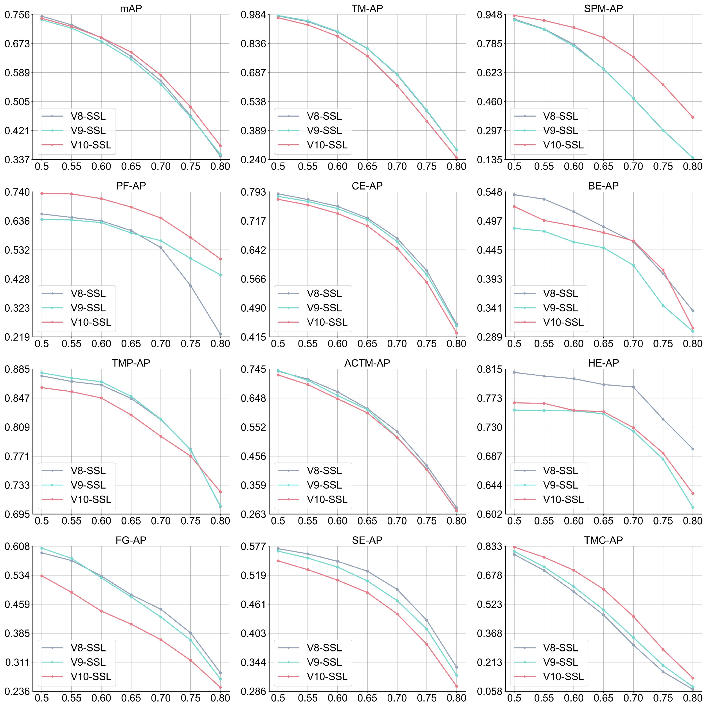
Supplementary Figure 4. The mAP/AP values of three SSL models for each feature on the FSH dataset at different IOU thresholds.
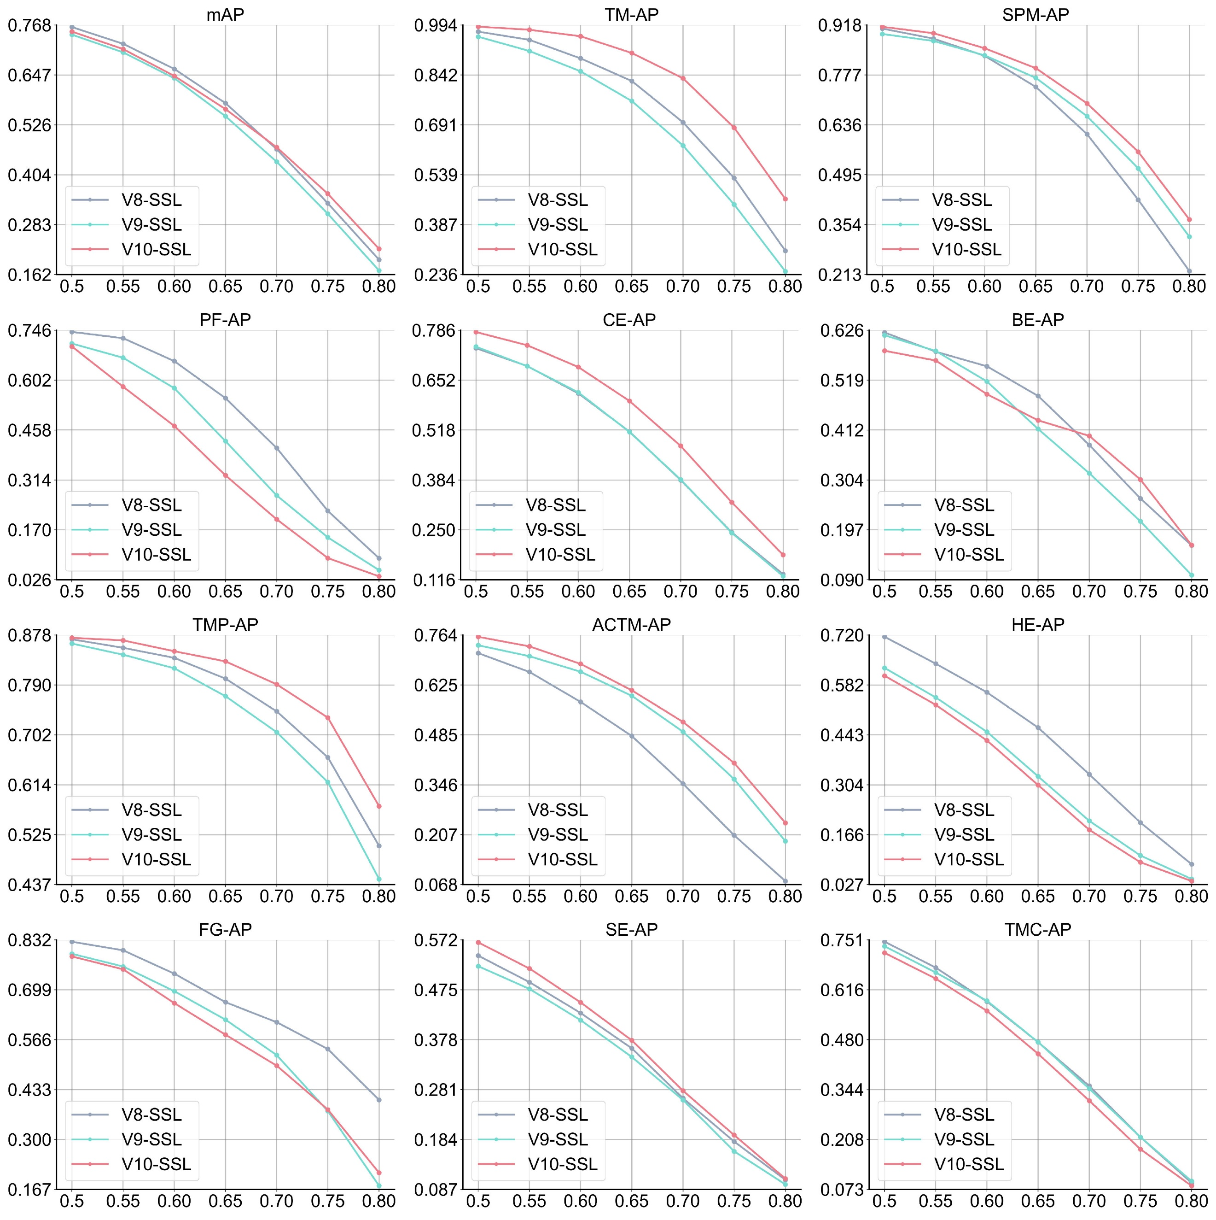
Supplementary Figure 5. The mAP/AP values of three SSL models for each feature on the SSH dataset at different IOU thresholds.
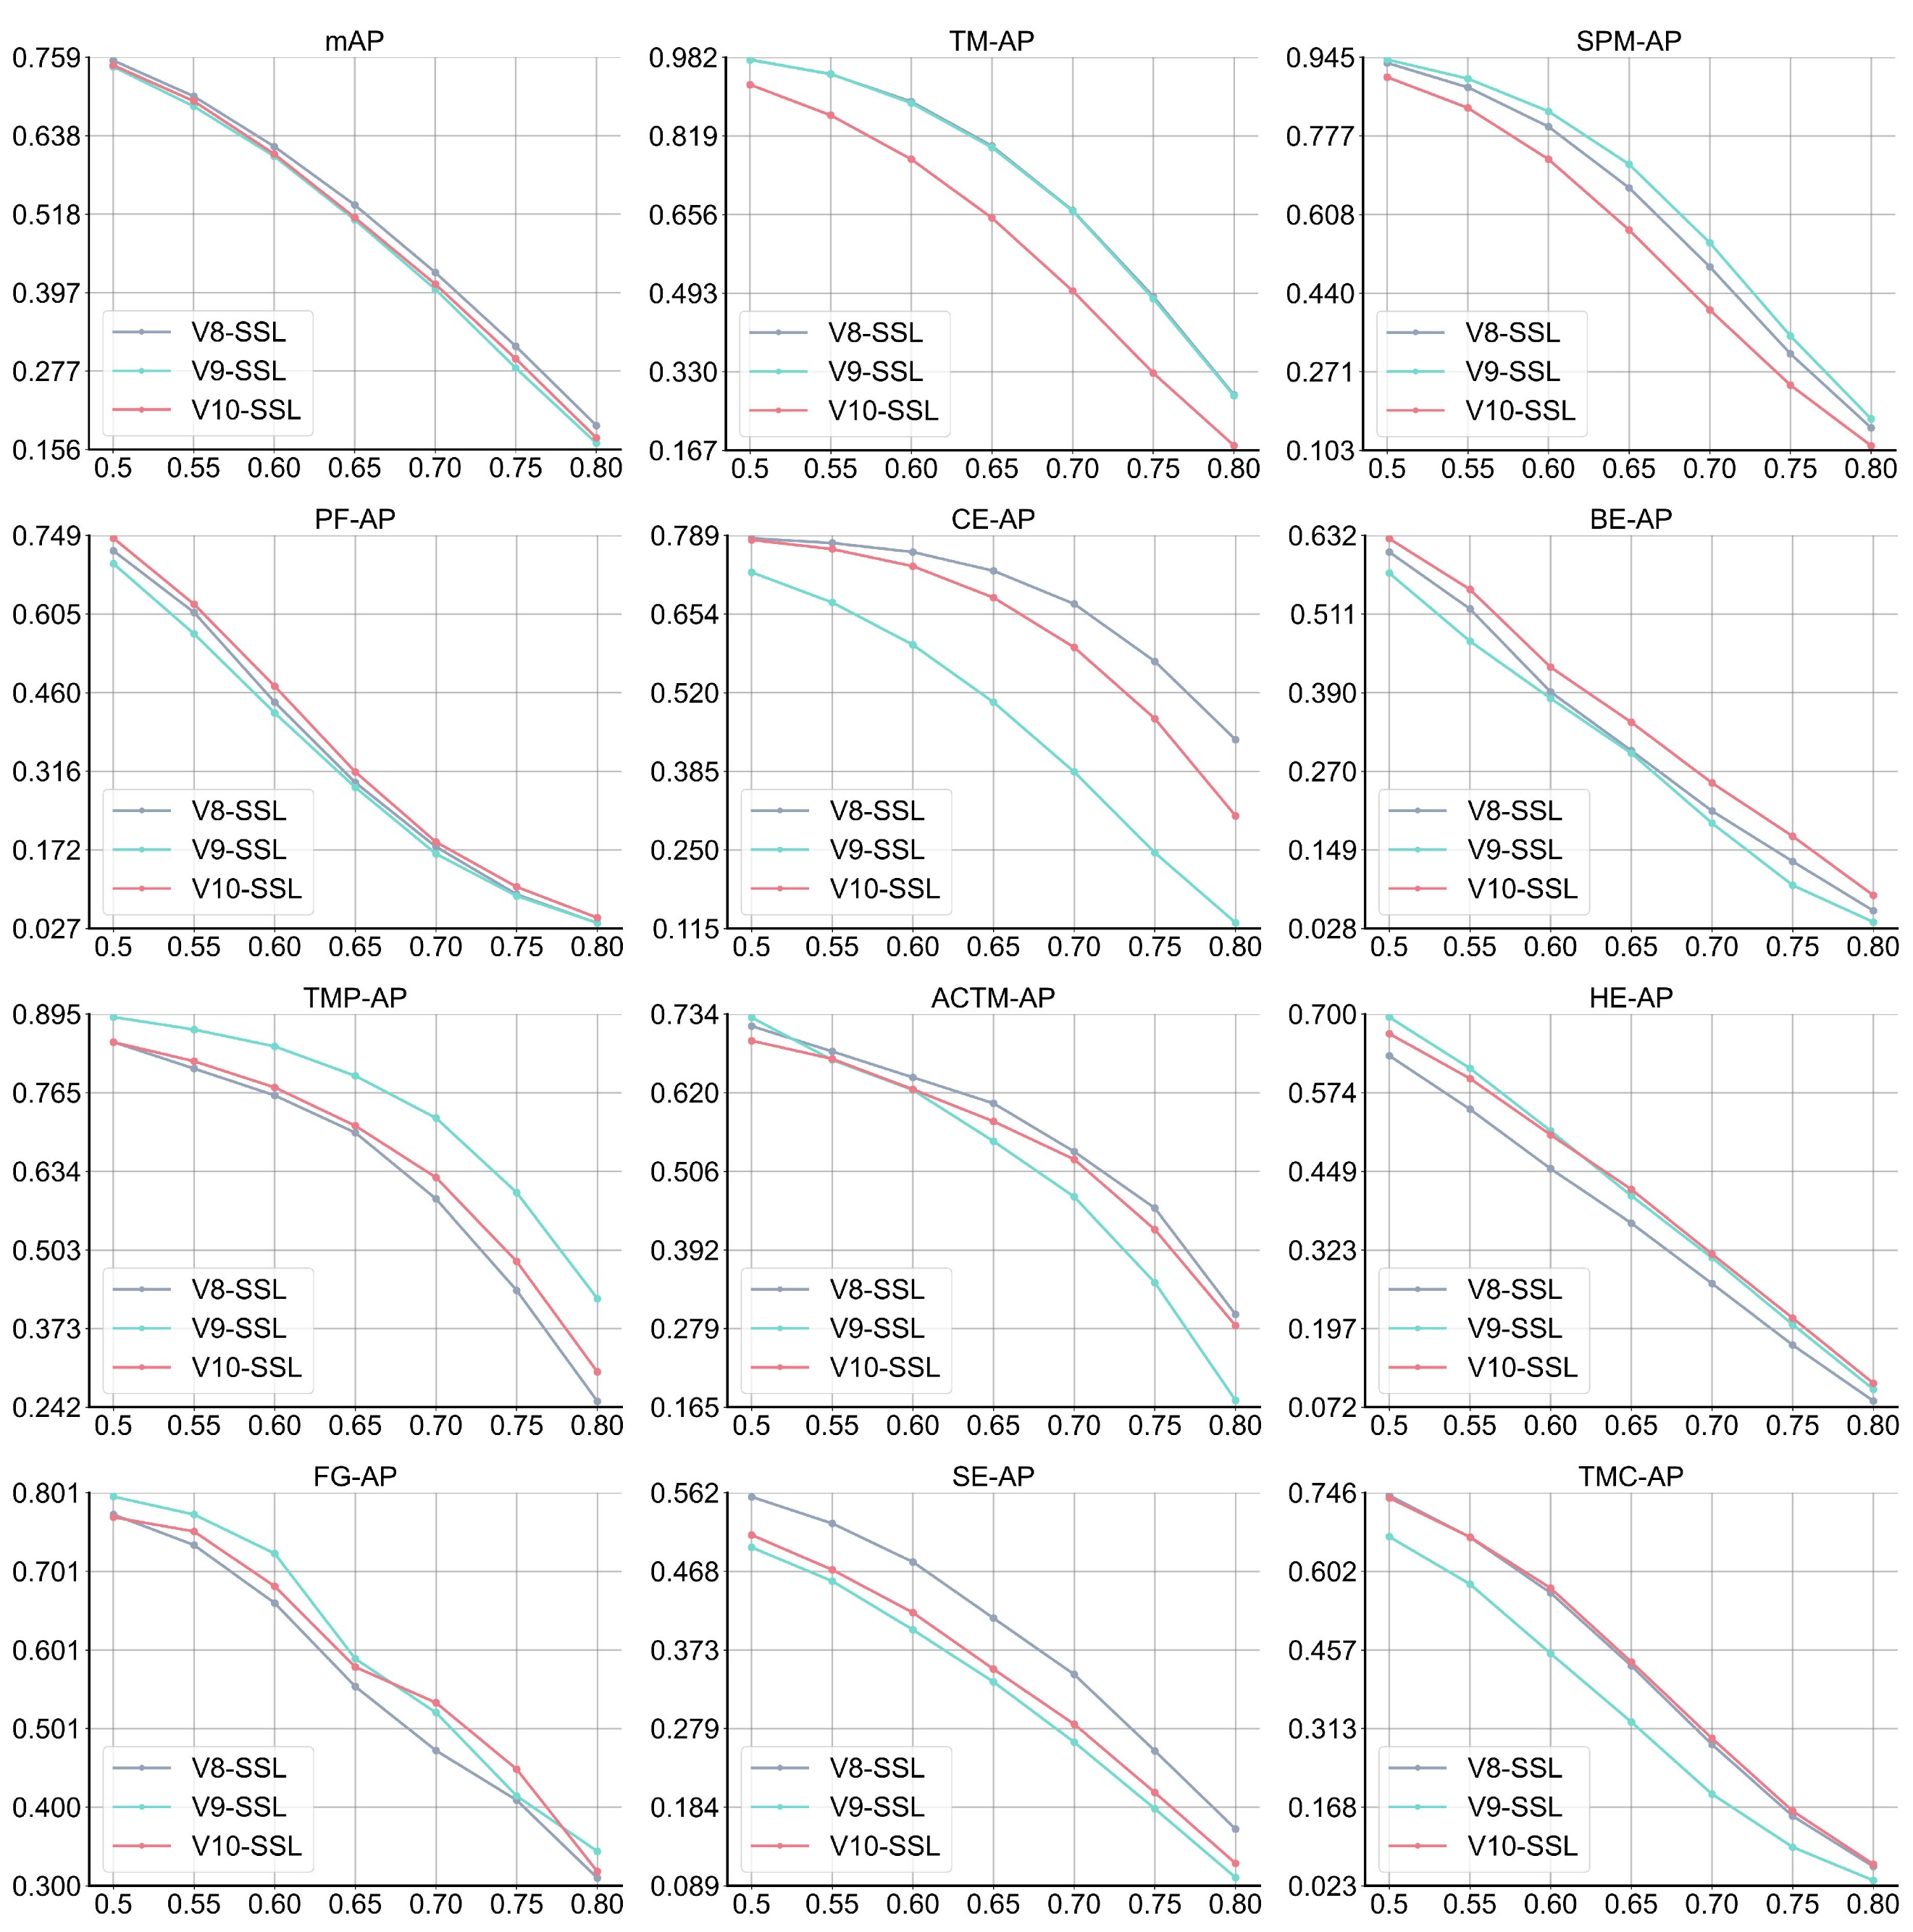
Supplementary Figure 6. The mAP/AP values of three SSL models for each feature on the NFH dataset at different IOU thresholds.

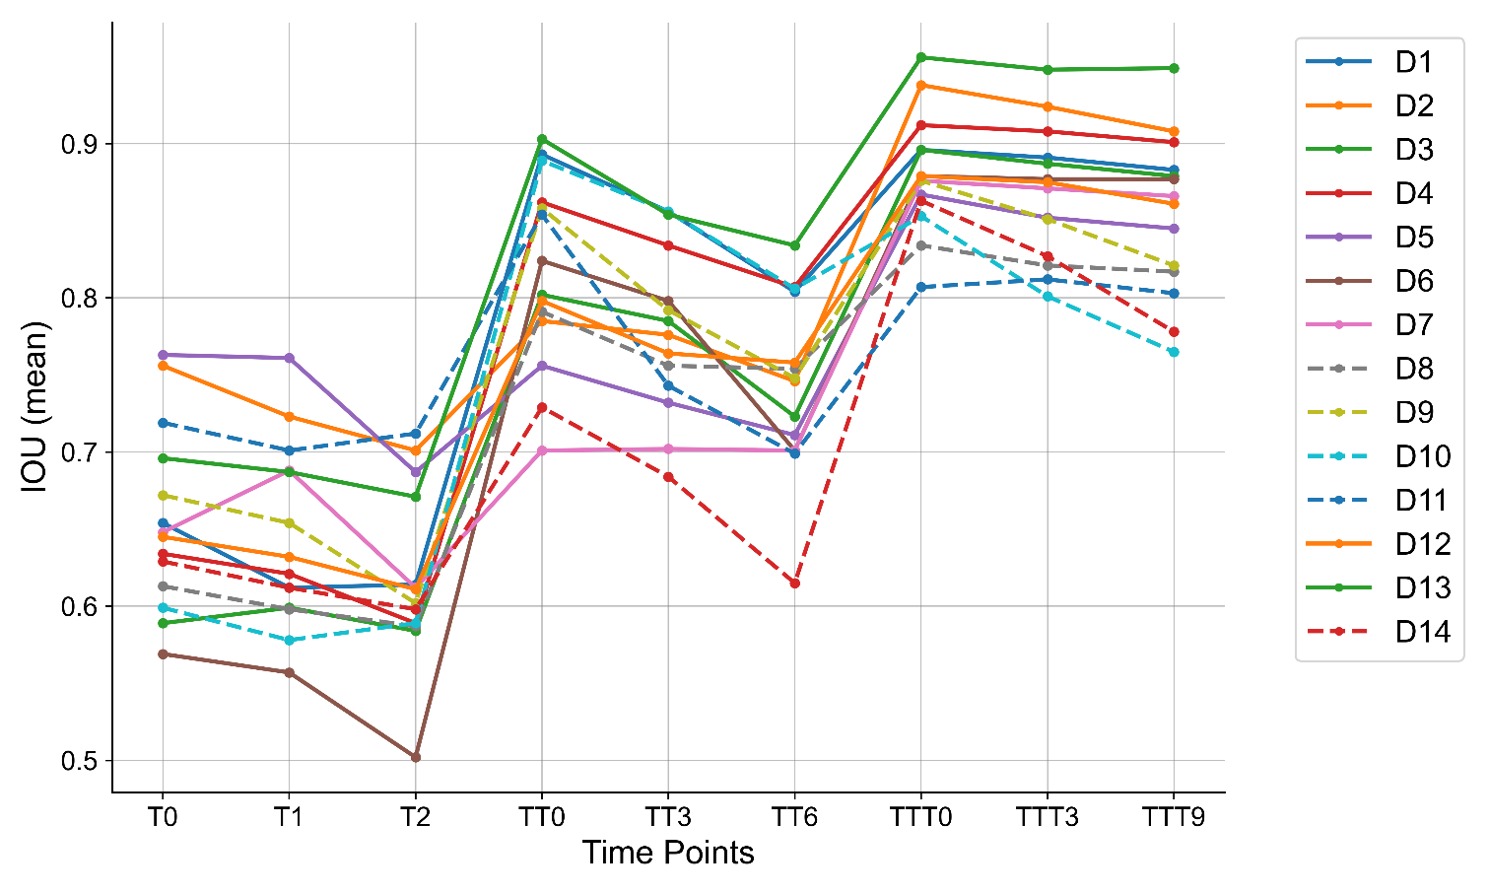
Supplementary Figure 7. The IoU results of various PCPs as training progresses. T0, TT0, and TTT0 represent the first, second, and third trainings. The PCPs were tested on the first and second days after the first training. The PCPs were tested on the third and sixth days after the second training. The PCPs were tested on the third and ninth days after the third training. The solid and dotted lines in the figure represent qualified and unqualified PCPs, respectively.

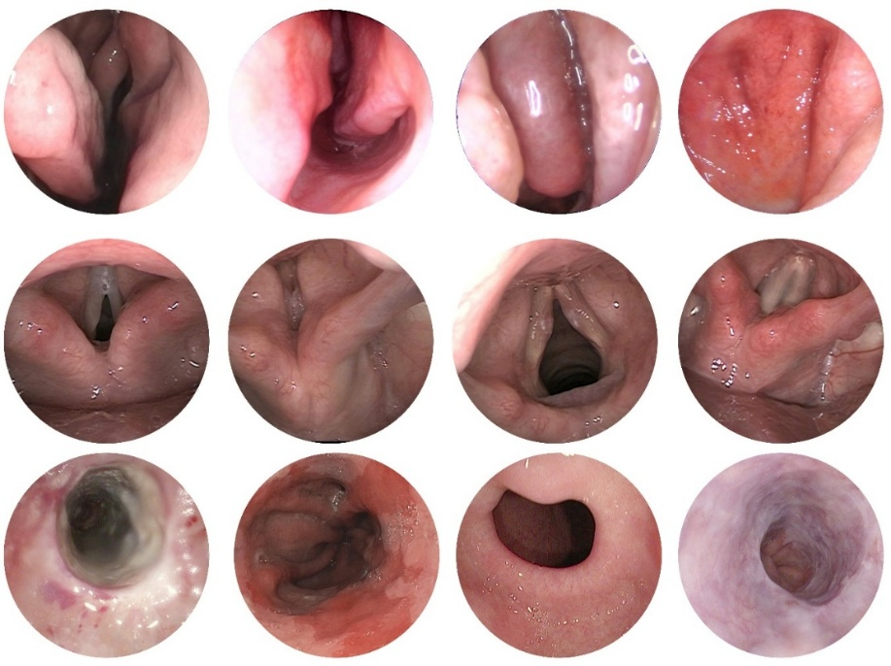
Supplementary Figure 8. Classic endoscopic images used for self-supervised pre-training, from top to bottom, showing the nose, throat, and gastrointestinal of HyperKvasir.

Supplementary Note 1: Ear Health Status Scoring Model
To facilitate intuitive use by individuals without medical backgrounds during primary ear canal and tympanic membrane healthcare, we designed an Ear Health Status Scoring (EHSS) model. Considering that the morphological and dimensional characteristics of abnormal features observed via otoscopy significantly influence the diagnosis, we propose a pixel-based scoring model termed Pixel-EHSS.
,
,
where, represents a structural health enhancement factor, awarding points based on the visual clarity of healthy anatomical structures, defined by parameters V_{i} and α_{i} as presented in Supplementary Table 14. Conversely, functions as a abnormal penalty term, applying nonlinear penalties based on pixel ratios, determined by R_{i} and β_{i} outlined in Supplementary Table 15. The entropy modulation factor, , penalizes overlapping pathologies, where the coefficient δ is set to −3 to indicate synergistic penalization for multiple simultaneous abnormal features. The constant adjustment factor k is set at 0.8, with R₀ at 0.35, triggering an exponential penalty when the total abnormal pixel ratio exceeds 35%. The mechanism and specific values for parameters λ_{i} are described in Supplementary Table 16.
The final Ear Health Status Score is calculated as follows:
，
where, a score of 70 is set as an optimal threshold. In practice, a score of 70 distinguishes healthy from sub-healthy conditions: when the preliminary score (P_{Score}) is ≥70, the final score accelerates towards 100, signifying healthy status. Conversely, when the P_{Score} falls below 70, it converges toward 35, indicating suboptimal or sub-healthy conditions. The baseline score of 35 primarily functions as a psychological threshold, reflecting the generally good ear health status observed in populations undergoing routine primary screening and healthcare.

Supplementary Table 14. The parameters V_{i} and α_{i} take their values.
Parameters | Physiological structure
V_{i} | TM | SPM | PF
α_{i} | 15 | 10 | 5

Supplementary Table 15. The parameters R_{j} and β_{i} take their values.
Parameters | Abnormal features
R_{j} | TMC | CE | BE | TMP | ACTM | HE | FG | SE
β_{i} | 1.5 | 1.2 | 3.0 | 4.0 | 2.0 | 2.5 | 3.5 | 1.8

Supplementary Table 16. Values and descriptions of the parameters λ_{i}.
Abnormal  features | λi | Mechanism of action
TMP | 0.25 | The increase of perforation area roughly accelerated hearing loss.
FG | 0.40 | There was an exponential relationship between  hyphal density and infection risk.
BE | 0.15 | The incidence of complications increased with the expansion of bleeding.
Others | 0.10 | Linear-bisection attenuation model for conventional lesions.

Supplementary Note 2: Tympanic membrane health scoring model
Given the critical importance of tympanic membrane health during evaluations of ear canal and membrane status, we developed a specialized scoring model for assessing tympanic membrane condition, as follows:
,
Here, η_{TM} is a baseline pixel proportion, set to 0.15, representing the average proportion (15%) of pixels occupied by the tympanic membrane within the otoscopic visual field. The term H_{TM} =denotes an entropy-based coefficient measuring disorder associated with concurrent pathological features. The entropy exponent δ, set at 1.5, provides an additional penalty for synergistic pathologies. The parameter β_{j} represents the weighted severity of each pathology, with specific values detailed in Supplementary Table 17.
Supplementary Table 17. The parameters R_{j} and β_{i} of TM take their values.
TM pathology | R_{j} | β_{j}
TMC |  | 1.5
TMP |  | 4.0
ACTM |  | 2.0
BE |  | 3.0

Supplementary Note 3: Cerumen index scoring model
Cerumen is a common secretion within the ear canal and tympanic membrane region and is frequently targeted for removal. Therefore, we established a quantitative scoring model, the Cerumen Index (CI), defined as:
,
here, β_{CE} represents the baseline weighting factor for cerumen, set to 1.0 to reflect its fundamental impact. The nonlinear exponent coefficient, λ, is set at 0.5, serving as an adjustment factor for exponential severity growth associated with cerumen impaction. Here, R_{CE} is the ratio of cerumen pixels to total pixels (R_{CE} =CE pixels / Total pixels), indicating cerumen coverage within the otoscopic view. The final Cerumen Index is standardized by the formula CI_{final} = min{100, CI}，∈[0,100], ensuring it falls within a normalized range from 0 to 100.

Supplementary Note 4: The development details of Eleflai
The front end uses XML+ViewModel to build the UI, and calls the API based on the self-developed OAuth2.0 service; the back end uses the Laravel framework to provide a RESTful interface, combined with JWT authentication. MySQL is used to store user data, and file information is saved through Alibaba Cloud OSS. The otoscope recognition module scanned and connected to the otoscope device through Android WifiManager, and achieves stable communication based on the Socket/MQTT protocol. The images taken by the otoscope are compressed and uploaded after being optimized by CameraX/OpenCV. The AI ​​model is deployed on the cloud GPU server to analyze the ear condition in real time and return the AI ​​detection results. The application can automatically generate structured reports and support historical information comparison. The front end uses MPAndroidChart to visualize data. Personal reports are stored in the cloud and can be accessed at any time. The application uses HTTPS encrypted communication and combines Redis cache to optimize performance. Eleflai realizes a complete closed loop from hardware connection, intelligent analysis to health management, providing users with efficient and convenient ECS. In terms of hardware, the otoscope uses a high-resolution optical camera and a wifi module based on the IEEE802.11b/g protocol to achieve real-time image acquisition and transmission through low-power design. In addition, to ensure the reliability and portability of the device in various application environments, we fully consider energy consumption issues in the hardware design to ensure that the device is easy to operate and has sufficient battery life.

