[Supportive Care in Cancer]
Appendix to the manuscript

Title: Posttraumatic growth and resilience among survivors of cancer in young adulthood in Switzerland: a report from the Adolescent and Young Adult (AYA) Psychosocial Health Study

Céline Bolliger¹, Luzius Mader², Mohsen Mousavi³, Beat Müller⁴, Marcus Vetter⁵, Katharina Roser^{1*}

¹ Faculty of Health Sciences and Medicine, University of Lucerne, Lucerne, Switzerland
² Cancer Registry Bern and Solothurn, Bern, Switzerland
³ Cancer Registry of Eastern Switzerland, St.Gallen, Switzerland
⁴ Department for Medical Oncology, Cantonal Hospital of Lucerne, Lucerne, Switzerland
⁵ Center for Oncology and Hematology, Cancer Center Baselland, Cantonal Hospital Baselland Liestal, Switzerland

* Correspondence: katharina.roser@unilu.ch; Tel.: +41 41 229 59 56

Overview
Supplementary Information 1 – Table S1: Comparison of YACS participants and the Swiss YA population with cancer
Supplementary Information 2 – Figure S1: Study flow chart
Supplementary Information 3 – Figure S2: Proportion of participants endorsing the PTG items
Supplementary Information 4 – Figure S3: Proportion of participants endorsing the resilience items
Supplementary Information 5 – Table S2: Explorative univariable regression

Supplementary Information 1 – Table S1: Comparison of YACS participants and the Swiss 2-year YACS population
Table S1. Comparison of the YACS population of the Psychosocial health study and the Swiss 2-year YACS population.
 | Young adult cancer survivors (YACS)
 | YACS Population of the Psychosocial Health Studyª |  | YACS 2-year Population of Switzerland^{b} |  |  |  | Chi² test
 | Observed  N=131 |  | Observed^{c}  N=13’290 |  | Estimated^{d}  N=15’603.3
 | n | % | n | % | n | % | p-value
Sex  Male  Female | 50  81 | 38.2  61.8 | 5’704 7’586 | 42.9  57.1 | 6708.1  8895.1 | 43.0  57.0 | 0.267
Age at diagnosis  20-24ª  25-29  30-34  35-39 | 16  27  49  39 | 12.2  20.6  37.4  29.7 | 1’245  2’504  4’011  5’530 | 9.4  18.8  30.2  41.6 | 1’476.2  2’948.6  4’692.4  6’486.0 | 9.5  18.930.141.6 | 0.048
Diagnosis (according to Barr et al. 2020)  - Leukemias and related disorders  - Lymphomas  - CNS and other intracranial/intraspinal neoplasms  - Sarcomas  - Blood and lymphatic vessel tumor^{e}  - Nerve sheath tumors  - Gonadal and related tumors  - Melanoma, malignant  - Carcinomas  - Miscellaneous specified neoplasms^{e}  - Unspecified malignant neoplasms except CNS^{e} | 5  23  6  3  -  1  31  10  52  -  - | 3.8  17.5  4.6  2.3  -  0.8  23.6  7.6  39.7  -  - | 541  1’412  1’121  440  79  153  2’605  1’923  5’500  24  32 | 4.1  10.6  8.4  3.3  0.6  1.2  15.5  14.5  41.4  0.2  0.2 | 633.9  1’651.7  1’326.4  516.7  92.2  1’81.3  2’443.4  2’248.7  6’443.0  28.2  37.8 | 4.1  10.6  8.5  3.3  0.6  1.2  15.7  14.4  41.3  0.2  0.2 | 0.011
Treatment^{f}  Surgery only  Chemotherapy  Radiotherapy  Stem cell transplantation | 30  43  49  9 | 22.9  32.8  37.4  6.9 | 5’277  2’101  2’832  101 | 39.7  15.8  21.3  0.8 | 6’253  2’491  3’326  118 | 40.1  16.0  21.3  0.8 | p<0.001
Second cancer^{d}  No  Yes | 122  9 | 93.1  6.9 | 12’876  202 | 98.5  1.5 | 15129.3  231.3 | 98.5  1.5 | p<0.001

Abbreviations: YACS = Young adult cancer survivor; CNS = Central nervous system

Note: We conducted Chi-square tests with the estimated number of cancer cases in the YA population of Switzerland.

Note: Bold font indicates statistically significant results (p<0.05).

ª The YA population from the psychosocial health study includes individuals diagnosed between the ages of 21 to 39 years (inclusion criteria)
^{b} The YA population of Switzerland includes individuals diagnosed with cancer between the ages of 20-39 years, and the initial cancer diagnosis was between 1980 and 2019. Data covers the whole of Switzerland, and participants were registered in the Swiss Childhood Cancer Registry (ChCR, age 15-19 years) and at the National Agency for Cancer Registration (NACR, age 20-39 years), respectively. Furthermore, the YA population was restricted to at least 2 years after diagnosis.
^{c} Observed: number of cancer cases collected by the ChCR and/or the NACR. Covered 63% of the AYA cancers diagnosed in Switzerland between 1980-2019.
^{d} Estimated: number of cases after extrapolation of the observed cancer cases to the whole of Switzerland to acquire 100% coverage. Characteristic-specific totals don’t necessarily add up to the same estimated column total.
^{e} Cancer cases in these three cancer categories from Barr et al. 2020 – (5) Blood and lymphatic vessel tumors, (10) Miscellaneous specified neoplasms, and (11) Unspecified malignant neoplasms except CNS –have been recorded under different categories.
^{f} Hierarchically coded: chemotherapy may include surgery, radiotherapy may include surgery and/or chemotherapy, stem cell transplantation may include surgery and/or chemotherapy and/or radiotherapy. Those don’t add up to the column total for the populations of the epidemiological study, because of cancer cases that received other treatments or had unknown treatment.

Supplementary Information 2 – Figure S1: Study flow chart
Contacted survivors of young adult cancer
n = 678 (100%)
No response
n = 442 (65.2%)
Contacted

Returned (e.g. wrong address, deceased)
n = 50 (7.4%)

Refusal to participate
n = 11 (1.6%)
Responses
n = 236 (34.8%)

Missing informed consent
n=27 (4%)

Missing questionnaire
n= 7 (1%)

Did not meet inclusion criteria (e.g., not diagnosed two years ago, did not live in Switzerland)
n=7 (1.2%)

No data on PTG and resilience
n= 3 (0.6%)
Positive responses
n = 175 (25.8%)
Response

Study participants included survivors of young adult cancer
n = 131 (19.3%)

Included

Figure S1. Study flow chart: Recruitment of study participants.

Supplementary Information 3 – Figure S2: Proportion of participants endorsing the posttraumatic growth items
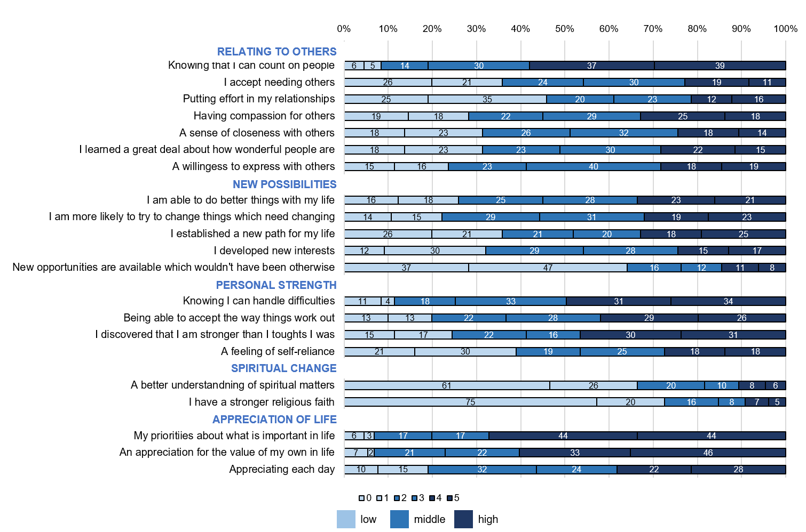
Figure S2. Proportion of participants endorsing the posttraumatic growth (PTG) items measured by the Posttraumatic Growth Inventory (PTGI) at low (0,1), middle (2,3) or high (4,5) level. Each PTGI item is rated using a 6-point Likert scale (0=not at all, 1=barley, 2=a little, 3 =moderately, 4=very much, 5=extremely).
Supplementary Information 4 – Figure S3: Proportion of participants endorsing the resilience items
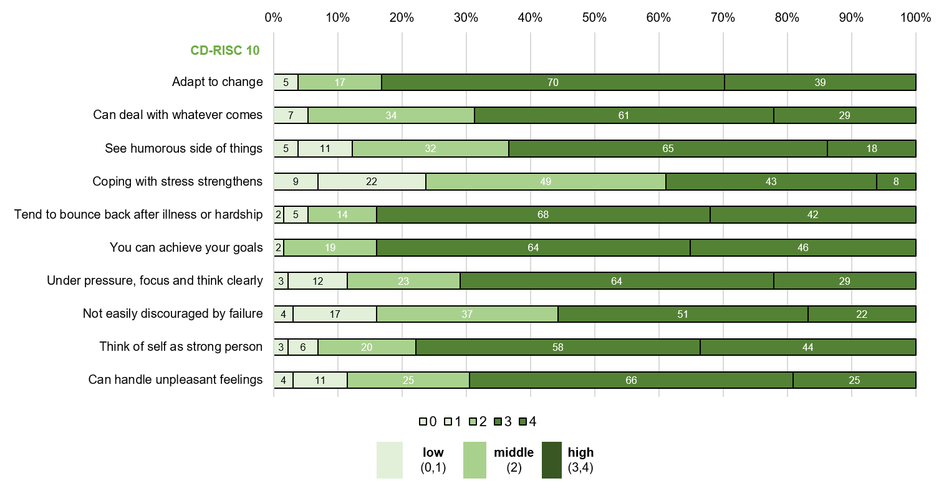
Figure S3. Proportion of participants endorsing the resilience items measured by the CD-RISC 10 at low (0,1), middle (2), or high (3,4) level. Each CD-RISC 10 item is rated using a 5-point Likert scale (0=not at all, 1=rarely true, 2=sometimes true, 3=often true, 4=almost always true).

Supplementary Information 5 – Table S2: Explorative analysis of the resilience items in relation to PTG
Table S2: Explorative analysis investigating the associations of the resilience items with the PTG sum score.
 | Univariable linear regression
 | Coeff. | 95% CI | p value

CD-RISC 10
Adapt to change | 5.60 | 0.40 - 10.78 | 0.035
Can deal with whatever comes | 2.22 | -2.63 - 7.07 | 0.367
See humorous side of things | 4.59 | 0.48 - 8.70 | 0.029
Coping with stress strengthens | 0.23 | -3.78 - 4.23 | 0.911
Tend to bounce back after illness or hardship | 1.86 | -2.86 - 6.60 | 0.436
You can achieve your goals | 0.48 | -5.02 - 5.98 | 0.863
Under pressure, focus and think clearly | -1.36 | -5.51 - 2.77 | 0.515
Not easily discouraged by failure | -0.04 | -3.98 - 3.90 | 0.983
Think of self as strong person | 2.30 | -1.94 - 6.54 | 0.285
Can handle unpleasant feelings | -1.65 | -5.79 - 2.49 | 0.433

Abbreviations: CI= confidence interval, Coeff. = coefficient, Ref. = reference category.

Note: Bold font indicates statistically significant results (p<0.05).

