Supplementary Table 1: Kinases that did not express in P. pastoris or expressed with low purity and/or high aggregation

Protein construct |  | Tags |  | Mwt (Kda) | pI | P. pastoris expression
 |  | N-term | C-term | Mwt (Kda) | pI | Agg. | Yield | % Purity
CycD2 |  | Strep | ----- | 36.3 | 4.96 | Insoluble
CDK4 |  | His6 | ----- | 36.8 | 6.31 | N | V low | 5%
 |  | Strep | ----- | 37.0 | 6.08 | N | V low | 5%
CDK6 |  | Strep | ----- | 40.2 | 5.74 | No expression
HER2 (705-1029) | V956R | His10 | Strep | 41.8 | 6.06 | Y | Low | 20%
 | V956R | ----- | Strep | 40.4 | 5.42 | Y | Low | 20%

Supplementary Figure 1: Expression trials of indicated kinase targets in P. pastoris to pick the transformant with the best protein expression levels.
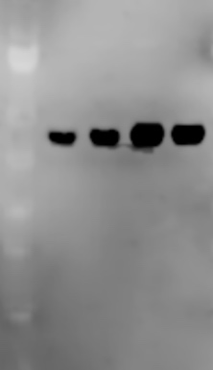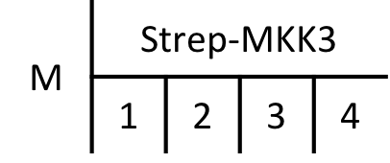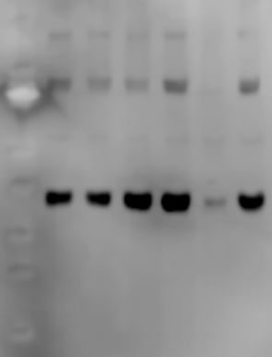
α-Strep
αStrep
αStrep
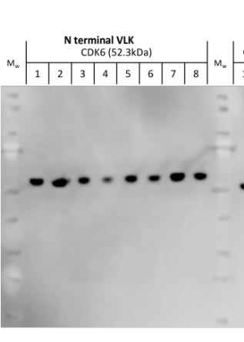

αStrep

αStrep
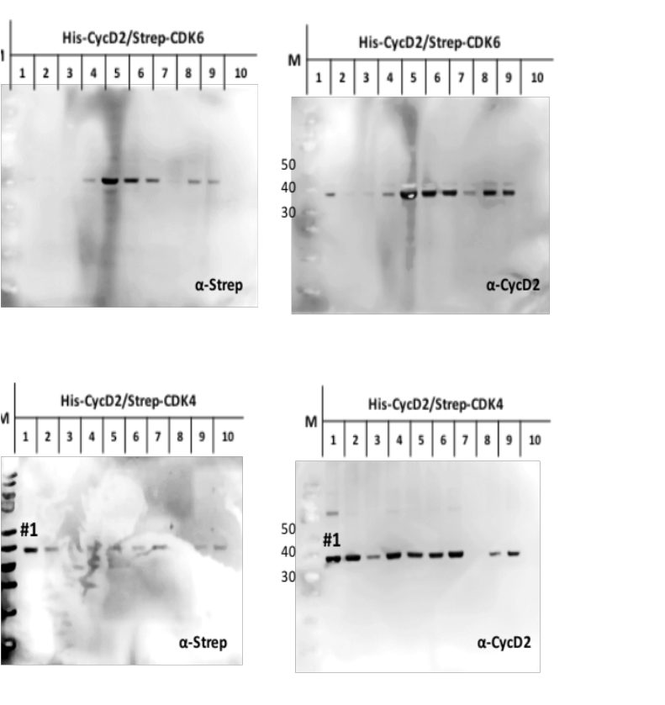
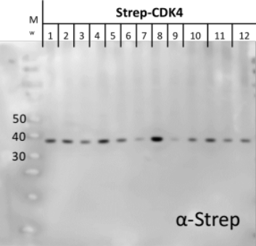

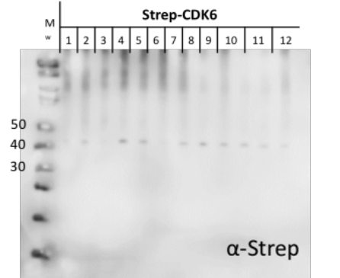

Supplementary Figure 2: A) time series analysis to assess protein production for target kinases. B) Induction temperature for 1L cultures assessed for optimization of CDK4/CycD2 complex purification.
A.
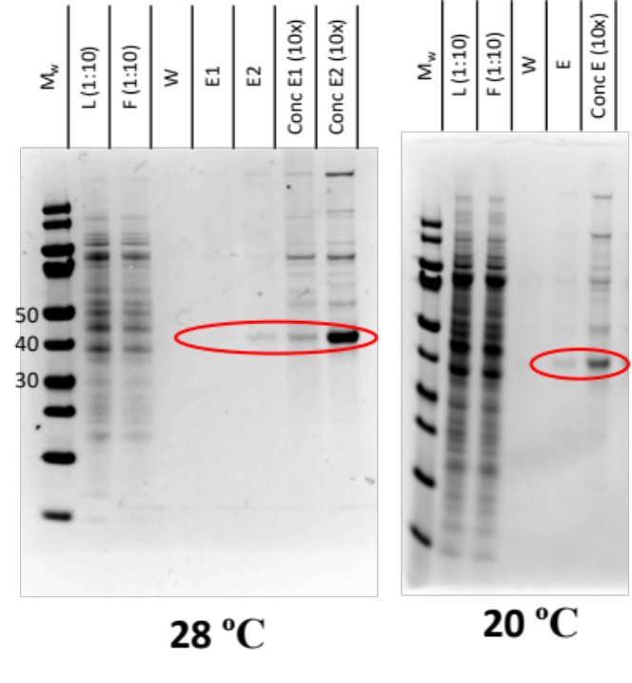
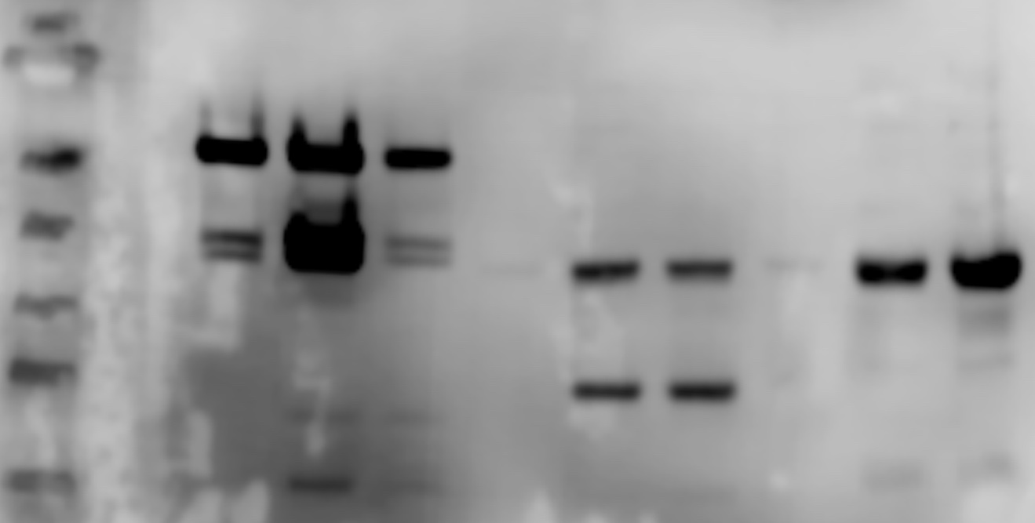
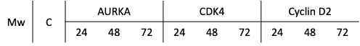
B.
α-His
40
50
30

Supplementary Figure 3: Comparison of AurKA expression in three different systems. A) Western blot for expression trial in SF9 insect cell versus S. cerevisiae, B and C) Coomassie stained gels comparing purification trials through Strep-Trap column under the same purification conditions for cell lysate from S. cerevisiae and P. pastoris, respectively. M is molecular weight marker, C is control, L is the clarified lysate loaded to the column, Fr is the filtrate from the concentrated lysate, FT is the flow through, W is the wash and E is the pooled column elution or its separate fractions.

C.
B.
A.
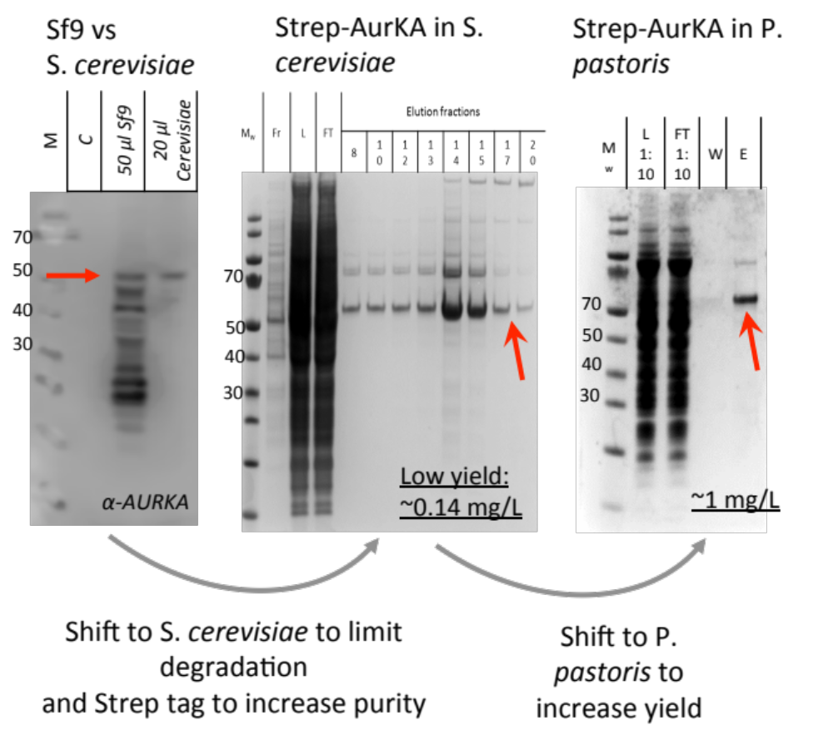

Supplementary Figure 4: Expression of the short constructs of HER2 (705-1029) in P. pastoris. A) Chromatogram, B) Coomassie stain and C) Western blot of the Strep elution for His10-HER2-Strep, D) chromatogram, E) Coomassie stain and F) Western blot of the Strep elution for the same construct without the His10 tag. Figure abbreviations same as in Figure 2.

C.
B.

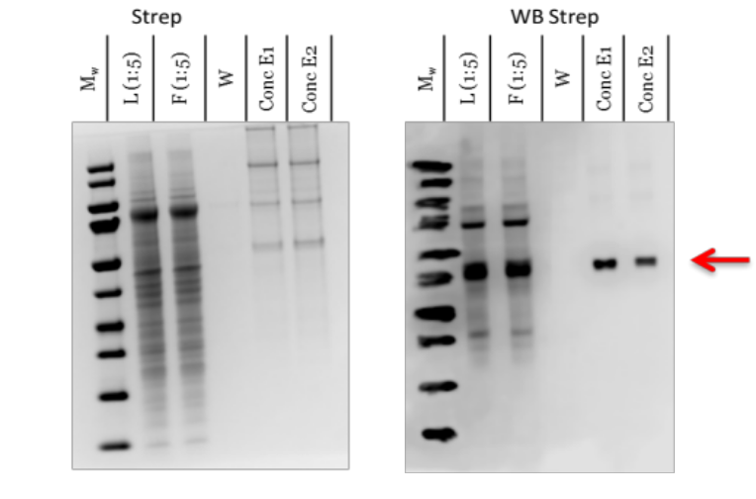
A.

E2

E1

F.
E.
D.
