Supplementary Content
Preconception, prenatal and postnatal air pollution exposure and risk of neurodevelopmental disorders among Medicaid recipients
Matthew Shupler, PhDª, Xinye Qiu, PhD^{b,c,d}, Krista F. Huybrechts, PhDe, Sonia Hernandez-Diaz, MD, DrPHª, Wanyu Huang, PhD^{b}, Hayon Michelle Choi, PhD^{b}, Michael Leung, PhD^{b}, Yaguang Wei, PhD^{f}, Joel Schwartz, PhD.^{a,b}, Brent Coull, PhD^{g}, Evgenia Papatheodorou, MD^{h}, Christopher J McDougle, MD^{i,j}, Antonella Zanobetti, PhD^{b}, Marc Weisskopf, PhD, ScD,^{a,b}, Stefania Papatheodorou, MD, PhD^{k}
a. Department of Epidemiology, Harvard T.H. Chan School of Public Health, Boston, Massachusetts, USA
b. Department of Environmental Health, Harvard T.H. Chan School of Public Health, Boston, Massachusetts, USA
c. Cardiovascular Institute, Beth Israel Deaconess Medical Center, Boston, MA, USA
d. Department of Medicine, Harvard Medical School, Boston, MA, USA.
e. Division of Pharmacoepidemiology and Pharmacoeconomics, Brigham and Women’s Hospital, Boston, Massachusetts, USA
f. Department of Environmental Medicine, Icahn School of Medicine at Mount Sinai, New York, New York, USA
g. Department of Biostatistics, Harvard T.H. Chan School of Public Health, Boston, Massachusetts, USA
h. University Hospital of Ioannina, Department of Psychiatry, Ioannina, Greece
i. Lurie Center for Autism, Massachusetts General Hospital, Lexington, MA, USA
j. Department of Psychiatry, Harvard Medical School, Boston, MA, USA
k. Department of Biostatistics and Epidemiology, Rutgers School of Public Health, Piscataway, New Jersey, USA

eTable 1. Definition of neurodevelopmental disorders
eTable 2. Definition of select individual and area-level covariates

eResults 1. Average daily PM_{2.5} concentrations across the US during the study period (2001-2013)
eResults 2. Exposure-response relationship between prenatal PM_{2.5} exposure and risk of autism spectrum disorder
eResults 3. Exposure-response relationship between postnatal PM_{2.5} exposure and risk of developmental coordination disorder
eResults 4. Hazard ratio for the association between average annual postnatal PM_{2.5} exposure (10 μg/m³ increase) and risk of neurodevelopmental disorders at cumulative lag (0-3 years), controlling for average prenatal and preconception exposure
eResults 5. Hazard ratio [95% CI] for cumulative association between PM_{2.5} exposure and risk of neurodevelopmental disorders during each year of follow up in the postnatal period
eResults 6. Hazard ratios [95% CI] for association between average weekly preconception and prenatal PM_{2.5} exposure (10 μg/m³ increase) and risk of neurodevelopmental disorders at the cumulative lag (12 weeks preconception and 37 weeks prenatal) from models stratified by sex.
eResults 7. Hazard ratios [95% CI] for association between average weekly preconception and prenatal PM_{2.5} exposure (10 μg/m³ increase) and risk of neurodevelopmental disorders at the cumulative lag from models stratified by urbanicity (> or < 500 residents per zip code)
eResults 8. Hazard ratios [95% CI] for association between average weekly preconception and prenatal PM_{2.5} exposure (10 μg/m³ increase) and risk of neurodevelopmental disorders at the cumulative lag from models stratified by US region
eResults 9. Hazard ratios [95% CI] for association between average annual postnatal PM_{2.5} exposure (10 μg/m³ increase) and risk of neurodevelopmental disorders (controlling for prenatal and preconception PM_{2.5} exposure) at cumulative lag (0-3 years) from models stratified by sex
eResults 10. Hazard ratios [95% CI] for association between average annual postnatal PM_{2.5} exposure (10 μg/m³ increase) and risk of neurodevelopmental disorders (controlling for prenatal and preconception PM_{2.5} exposure) at cumulative lag (0-3 years) from models stratified by urbanicity (> or < 500 residents per zip code)
eResults 11. Cumulative hazard ratios [95% CI] for association between average weekly preconception and prenatal PM_{2.5} exposure (10 μg/m³ increase) and risk of neurodevelopmental disorders (12 weeks preconception and 37 weeks prenatal) at different lag times
eResults 12. Lag-response relationship between PM_{2.5} concentration (10 μg/m³ increase) and NDD during preconception and prenatal period (adjusted for temperature, relative humidity, individual and area-level covariates) at different lag times
eResults 13. Hazard ratios [95% CI] for the association between average weekly preconception and prenatal PM_{2.5} exposure (10 μg/m³ increase) and risk of neurodevelopmental disorders among children diagnosed at age 3 or later
eResults 14. Hazard ratios [95% CI] for the association between average weekly preconception and prenatal PM_{2.5} exposure (10 μg/m³ increase) and risk of neurodevelopmental disorders at the cumulative lag (12 weeks preconception and 37 weeks prenatal and 0-3 years postnatal), controlling for average cumulative NO₂ concentration
eResults 15. Hazard ratios [95% CI] for association between average weekly preconception and prenatal PM_{2.5} exposure (10 μg/m³ increase) and risk of neurodevelopmental disorders at the cumulative lag (12 weeks preconception and 37 weeks prenatal and 0-3 years postnatal), accounting for inverse probability of censoring weights

eTable 1. Definition of neurodevelopmental disorders
Outcome | Algorithm
Autism Spectrum Disorder | At ≥ 1 year of age: ≥ 2 dates with ICD-9 Dx 299.xx (except 299.1x)
Attention Deficit Hyperactivity Disorder | At ≥ 2 years of age, any of the following:  • ≥ 2 dates with ICD-9 Dx 314.xx  • ≥ 2 dispenses of atomoxetine, clonidine, guanfacine, (dextro/lisdex) amphetamine, (dex)methylphenidate  • ≥ 1 Dx 314.xx & ≥ 1 dispensing
Learning Difficulty | At ≥ 2 years of age: ≥ 1 ICD-9 Dx 315.0x, 315.1, 315.2
Developmental Speech or Language Disorder | At ≥ 1.5 years of age: ≥ 2 dates with ICD-9 Dx 315.3x (except 315.34)
Intellectual disability | At ≥ 2 years of age: ≥ 2 dates with ICD-9 Dx 317, 318.x, 319
Developmental Coordination Disorder | ≥ 2 dates with ICD-9 Dx 315.4 (any age)
Behavioral Disorder | At ≥ 2 years of age: ≥ 2 dates with ICD-9 Dx 312.xx, 313.xx

eTable 2. Definition of select individual and area-level covariates
Variable | Level | Coding
Substance abuse | Individual | Binary (yes/no). Whether mother had used opioids, cannabis, sedatives, cocaine, other stimulants, hallucinogens, nicotine, inhalant abuse, and other psychoactive drugs
Smoking | Individual | Binary (yes/no). Whether mother did tobacco smoking, chewing, or nicotine
Alcohol abuse | Individual | Binary (yes/no). Whether mother abused alcohol or had alcohol-related diseases (e.g., alcoholic fatty liver, alcohol-induced mental disorders).
Poor nutrition | Individual | Binary (yes/no). Whether mother was deficient in nutritional elements (e.g., vitamins, zinc, calcium, selenium).
Folate intake | Individual | Binary (yes/no). Whether mother had a prescription for folic acid during pregnancy
Normalized Difference Vegetation Index (NDVI) | Area-level | Numeric. An indicator of vegetation health and density quantified by the ratio of near-infrared to visible light, which ranges between values of -1 to 1 (1 signals high green space, values close to 0 represent no green space, and -1 are generally water bodies). NDVI data were obtained from Landsat 7 and Landsat 8, with images generated every 16 days at 30m resolution, aggregated by zip code and year, and linked to each participant’s zip code.
Distance to nearest hospital | Area-level | Numeric. Quantifies the distance from the centroid of each zip code tabulation area to the nearest hospital of each individual’s residential zip code using the Dartmouth Atlas of Health Care
Population density | Area-level | Numeric. ~1 km resolution obtained from NASA’s Gridded Population of the World, aggregated by zip code and year, and linked to each participant’s zip code.
Household income | Area-level | Numeric. Total income of all residents within a household who are 15+ years of age. This includes income from various sources like wages, salaries, and pensions.
Value of owner-occupied housing | Area-level | Numeric. An estimate of the selling price of the owner-occupied home
Percentage living below the poverty level | Area-level | Numeric. The poverty level is a federal measure of income set by the U.S. Census Bureau and adjusted annually for inflation using the Consumer Price Index (CPI). It varies by family size and composition. In 2021, the poverty threshold for a single person was $13,788 per year.
Percentage with less than high school education | Area-level | Numeric. Proportion of individuals whose highest education level is below a high school diploma or its equivalent (e.g. GED).
Percentage of owner-occupied housing units | Area-level | Numeric. Proportion of occupied housing units where the owner (or one of co-owners) lives in the unit (i.e. homeownership rate).

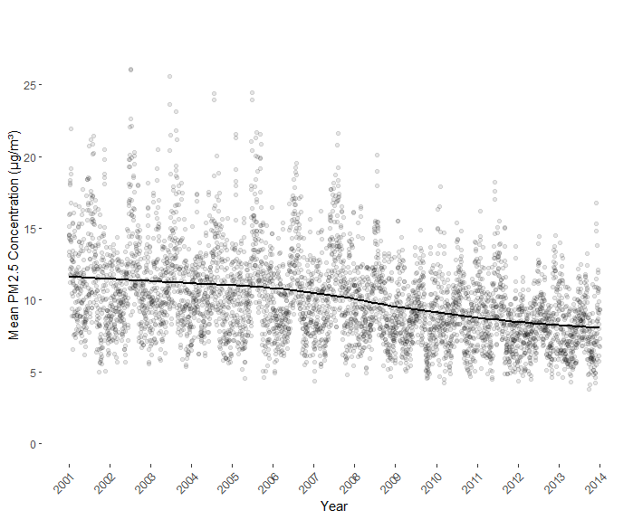
eResults 1. Average daily PM_{2.5} concentrations across the US during the study period (2001-2013)

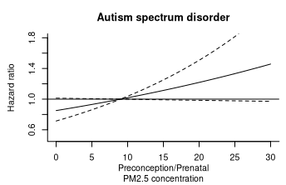
eResults 2. Exposure-response relationship between preconception and prenatal PM_{2.5} exposure and risk of autism spectrum disorder
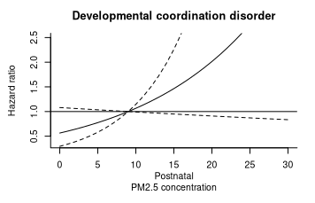
eResults 3. Exposure-response relationship between postnatal PM_{2.5} exposure and risk of developmental coordination disorder
eResults 4. Hazard ratio for the association between average annual postnatal PM_{2.5} exposure (10 μg/m³ increase) and risk of neurodevelopmental disorders at cumulative lag (0-3 years), controlling for average prenatal and preconception exposure
Condition | Postnatal PM_{2.5} exposure (not controlling for average prenatal and preconception exposure) | Postnatal PM_{2.5} exposure (controlling for average prenatal and preconception exposure)
Autism spectrum disorder | 1.15 [0.90, 1.47] | 1.16 [0.82, 1.65]
Attention deficit hyperactivity disorder | 0.87 [0.75, 1.00] | 1.10 [0.92, 1.31]
Learning difficulty | 0.81 [0.58, 1.12] | 0.77 [0.52, 1.16]
Developmental speech or language disorder | 0.81 [0.70, 0.94] | 0.82 [0.68, 0.98]
Developmental coordination disorder | 1.45 [0.81, 2.60] | 1.77 [0.93, 3.40]
Intellectual disability | 0.83 [0.52, 1.30] | 1.16 [0.59, 2.28]
Behavioral disorder | 1.00 [0.86, 1.16] | 0.97 [0.81, 1.17]

eResults 5. Hazard ratio [95% CI] for cumulative association between PM_{2.5} exposure and NDD during follow up in the postnatal period
Condition | Year 1 | Year 2 | Year 3
Autism spectrum disorder | 1.06 [0.75, 1.51] | 1.30 [0.93, 1.80] | 0.91 [0.67, 1.24]
Attention deficit hyperactivity disorder | 1.18 [0.99,1.41] | 1.02 [0.87, 1.20] | 0.88 [0.73, 1.05]
Learning difficulty | 0.94 [0.61, 1.45] | 0.99 [0.64, 1.54] | 0.79 [0.51, 1.21]
Developmental speech or language disorder | 0.95 [0.79, 1.14] | 1.00 [0.87, 1.16] | 1.02 [0.89, 1.17]
Developmental coordination disorder | 1.49 [0.82, 2.70] | 1.03 [0.64, 1.65] | 1.67 [1.13, 2.47]
Intellectual disability | 0.96 [0.46, 1.98] | 1.96 [1.08, 3.55] | 0.90 [0.51, 1.60]
Behavioral disorder | 0.93 [0.77, 1.13] | 1.04 [0.87, 1.24] | 0.96 [0.79, 1.15]

eResults 6. Hazard ratios [95% CI] for association between average weekly preconception and prenatal PM_{2.5} exposure (10 μg/m³ increase) and risk of neurodevelopmental disorders at the cumulative lag (12 weeks preconception and 37 weeks prenatal) from models stratified by sex.
Condition | Preconception |  |  | Prenatal
Condition | Overall | Male | Female | Overall | Male | Female
Autism spectrum disorder | 1.02 [0.94, 1.11] | 1.01 [0.92, 1.10] | 1.08 [0.91, 1.30] | 1.17 [1.00, 1.37] | 1.15 [0.97, 1.37] | 1.28 [0.93, 1.76]
Attention deficit hyperactivity disorder | 1.03 [0.99, 1.08] | 1.04 [0.99, 1.09] | 1.00 [0.93, 1.08] | 0.90 [0.83, 0.99] | 0.94 [0.85, 1.03] | 0.82 [0.71, 0.95]
Learning difficulty | 1.03 [0.94, 1.14] | 1.03 [0.91, 1.17] | 1.01 [0.86, 1.18] | 0.92 [0.75, 1.13] | 1.02 [0.78, 1.33] | 0.73 [0.53, 0.99]
Developmental speech or language disorder | 0.98 [0.94, 1.02] | 0.97 [0.92, 1.02] | 1.01 [0.95, 1.08] | 0.96 [0.88, 1.05] | 0.94 [0.85, 1.04] | 0.99 [0.87, 1.13]
Developmental coordination disorder | 1.05 [0.92, 1.20] | 1.06 [0.91, 1.24] | 1.03 [0.84, 1.27] | 1.04 [0.76, 1.44] | 1.11 [0.76, 1.61] | 0.91 [0.56, 1.47]
Intellectual disability | 0.88 [0.76, 1.02] | 0.89 [0.74, 1.07] | 0.90 [0.71, 1.14] | 0.93 [0.70, 1.24] | 0.87 [0.62, 1.22] | 1.11 [0.68, 1.81]
Behavioral disorder | 0.98 [0.94, 1.01] | 0.96 [0.92, 1.01] | 1.01 [0.94, 1.08] | 1.03 [0.95, 1.11] | 1.04 [0.94, 1.15] | 0.99 [0.87, 1.12]

eResults 7. Hazard ratios [95% CI] for association between average weekly preconception and prenatal PM_{2.5} exposure (10 μg/m³ increase) and risk of neurodevelopmental disorders at the cumulative lag from models stratified by urbanicity (> or < 500 residents per zip code)
Condition | Preconception |  |  | Prenatal
Condition | Urban (>500 people/zip code) | Suburban/Rural (<500 people/zip code) | Overall | Urban (>500 people/zip code) | Suburban/Rural (<500 people/zip code) | Overall
Autism spectrum disorder | 1.08 [0.97, 1.21] | 0.99 [0.87,1.14] | 1.02 [0.94, 1.11] | 1.35 [1.06, 1.72] | 1.11 [0.85, 1.46] | 1.17 [1.00, 1.37]
Attention deficit hyperactivity disorder | 1.01 [0.95, 1.06] | 1.06 [0.99, 1.13] | 1.03 [0.99, 1.08] | 0.77 [0.67, 0.88] | 1.04 [0.91, 1.20] | 0.90 [0.83, 0.99]
Learning difficulty | 1.01 [0.88, 1.16] | 1.05 [0.89, 1.24] | 1.03 [0.94, 1.14] | 0.92 [0.68, 1.26] | 0.85 [0.61, 1.20] | 0.92 [0.75, 1.13]
Developmental speech or language disorder | 0.97 [0.92,1.02] | 1.00 [0.94, 1.07] | 0.98 [0.94, 1.02] | 0.94 [0.85, 1.04] | 0.98 [0.85, 1.15] | 0.96 [0.88, 1.05]
Developmental coordination disorder | 1.06 [0.86, 1.27] | 1.01 [0.81, 1.25] | 1.05 [0.92, 1.20] | 1.31 [0.82, 2.07] | 0.75 [0.47, 1.19] | 1.04 [0.76, 1.44]
Intellectual disability | 0.97 [0.79, 1.19] | 0.75 [0.58, 0.97] | 0.88 [0.76, 1.02] | 0.89 [0.51, 1.22] | 0.95 [0.60, 1.40] | 0.93 [0.70, 1.24]
Behavioral disorder | N/A | 1.03 [0.97, 1.10] | 0.98 [0.94, 1.01] | N/A | 1.23 [1.07, 1.40] | 1.03 [0.95, 1.11]
N/A=not applicable; model didn’t converge (low sample size)

eResults 8. Hazard ratios [95% CI] for association between average weekly preconception and prenatal PM_{2.5} exposure (10 μg/m³ increase) and risk of neurodevelopmental disorders at the cumulative lag from models stratified by US region
Preconception
Condition | Overall | Northeast | Southeast | Midwest | West | Southwest
Autism spectrum disorder | 1.02 [0.94, 1.11] | 0.91 [0.70, 1.18] | 1.03 [0.76, 1.40] | 1.02 [0.81, 1.28] | 0.98 [0.87, 1.11] | 1.16 [0.45, 3.00]
Attention deficit hyperactivity disorder | 1.03 [0.99, 1.08] | 1.11 [0.79, 1.56] | 1.10 [1.00, 1.22] | 0.99 [0.90, 1.09] | 0.97 [0.90, 1.03] | 0.91 [0.59, 1.38]
Learning difficulty | 1.03 [0.94, 1.14] | 1.08 [0.77, 1.52] | 0.92 [0.62, 1.35] | 1.03 [0.77, 1.39] | 1.02 [0.87, 1.19] | 0.37 [0.16, 0.87]
Developmental speech or language disorder | 0.98 [0.94, 1.02] | 1.00 [0.89, 1.12] | 0.90 [0.81, 1.01] | 1.01 [0.92, 1.10] | 0.96 [0.89, 1.02] | 1.18 [0.86, 1.61]
Developmental coordination disorder | 1.05 [0.92, 1.20] | 1.01 [0.79, 1.30] | 0.72 [0.49, 1.07] | 1.21 [0.89, 1.64] | 1.09 [0.82, 1.44] | 0.85 [0.38, 1.91]
Intellectual disability | 0.88 [0.76, 1.02] | 0.62 [0.38, 1.00] | 0.74 [0.45, 1.22] | 0.90 [0.60, 1.36] | 0.85 [0.68, 1.07] | 2.53 [0.18, 36.24]
Behavioral disorder | 0.98 [0.94, 1.01] | 1.20 [0.86, 1.69] | 0.97 [0.85, 1.11] | 0.97 [0.87, 1.09] | 0.99 [0.94, 1.05] | 1.04 [0.66, 1.65]
Prenatal
Condition | Overall | Northeast | Southeast | Midwest | West | Southwest
Autism spectrum disorder | 1.17 [1.00, 1.37] | 1.41 [0.79, 2.52] | 1.42 [0.74, 2.76] | 1.11 [0.64, 1.94] | 1.21 [0.99, 1.47] | 1.50 [0.28, 8.05]
Attention deficit hyperactivity disorder | 0.90 [0.83, 0.99] | 0.42 [0.20, 0.89] | 0.82 [0.65, 1.05] | 1.01 [0.81, 1.25] | 0.91 [0.90, 1.05] | 0.99 [0.47, 2.09]
Learning difficulty | 0.92 [0.75, 1.13] | 0.72 [0.34, 1.52] | 1.04 [0.43, 2.50] | 1.15 [0.61, 2.15] | 0.86 [0.65, 1.15] | 0.16 [0.02, 1.02]
Developmental speech or language disorder | 0.96 [0.88, 1.05] | 1.23 [0.96, 1.59] | 0.79 [0.62, 1.01] | 1.14 [0.94, 1.39] | 0.87 [0.76, 1.00] | 1.36 [0.83, 2.21]
Developmental coordination disorder | 1.04 [0.76, 1.44] | 1.75 [0.97, 3.18] | 0.66 [0.29, 1.50] | 0.97 [0.49, 1.90] | 1.16 [0.58, 2.32] | 0.67 [0.17, 2.73]
Intellectual disability | 0.93 [0.70, 1.24] | 0.78 [0.24, 2.48] | 1.21 [0.44, 3.36] | 0.64 [0.25, 1.64] | 1.01 [0.72, 1.42] | 0.16 [0.01, 9.10]
Behavioral disorder | 1.03 [0.95, 1.11] | 0.96 [0.80, 1.14] | 1.24 [0.95, 1.62] | 1.34 [1.05, 1.71] | 0.99 [0.89, 1.11] | 1.52 [0.68, 3.44]

eResults 9. Hazard ratios [95% CI] for association between average annual postnatal PM_{2.5} exposure (10 μg/m³ increase) and risk of neurodevelopmental disorders (controlling for prenatal and preconception PM_{2.5} exposure) at cumulative lag (0-3 years) from models stratified by sex
Condition | Male | Female | Overall
Autism spectrum disorder | 1.07 [0.73, 1.58] | 1.58 [0.76, 3.28] | 1.16 [0.79, 1.70]
Attention deficit hyperactivity disorder | 1.12 [0.91, 1.37] | 1.06 [0.78, 1.43] | 1.10 [0.92, 1.31]
Learning difficulty | 0.92 [0.52, 1.64] | 0.52 [0.26, 1.03] | 0.77 [0.51, 1.16]
Developmental speech or language disorder | 0.86 [0.70, 1.06] | 0.76 [0.56, 1.02] | 0.82 [0.68, 0.98]
Developmental coordination disorder | 1.50 [0.69, 3.28] | 2.38 [0.92, 6.11] | 1.77 [0.93, 3.34]
Intellectual disability | 1.11 [0.52, 2.34] | 1.76 [0.56, 5.49] | 1.16 [0.59, 2.28]
Behavioral disorder | 0.96 [0.77, 1.19] | 1.02 [0.76, 1.36] | 0.97 [0.81, 1.17]

eResults 10. Hazard ratios [95% CI] for association between average annual postnatal PM_{2.5} exposure (10 μg/m³ increase) and risk of neurodevelopmental disorders (controlling for prenatal and preconception PM_{2.5} exposure) at cumulative lag (0-3 years) from models stratified by urbanicity (> or < 500 residents per zip code)
Condition | Urban (>500 people/zip code) | Suburban/Rural (<500 people/zip code) | Overall
Autism spectrum disorder | 1.57 [0.96, 2.55] | 1.12 [0.67, 1.87] | 1.16 [0.79, 1.70]
Attention deficit hyperactivity disorder | 1.07 [0.83, 1.39] | 1.41 [1.09, 1.81] | 1.10 [0.92, 1.31]
Learning difficulty | 0.65 [0.35, 1.20] | 0.76 [0.38, 1.51] | 0.71 [0.52, 1.16]
Developmental speech or language disorder | 0.88 [0.67, 1.15] | 0.78 [0.59, 1.03] | 0.82 [0.68, 0.98]
Developmental coordination disorder | 4.96 [1.98, 12.48] | 0.56 [0.23, 1.37] | 1.77 [0.93, 3.40]
Intellectual disability | 1.17 [0.39, 3.50] | 0.76 [0.27, 2.13] | 1.16 [0.59, 2.28]
Behavioral disorder | 0.86 [0.66, 1.13] | 1.26 [0.94, 1.68] | 0.97 [0.81, 1.17]

eResults 11. Hazard ratios [95% CI] for association between average weekly preconception and prenatal PM_{2.5} exposure (10 μg/m³ increase) and risk of neurodevelopmental disorders at the cumulative lag (12 weeks preconception and 37 weeks prenatal) at different lag times
Condition | 37 weeks | 30 weeks | 26 weeks
Autism spectrum disorder | 1.19 [0.98, 1.45] | 1.15 [0.97, 1.37] | 1.05 [0.89, 1.22]
Attention deficit hyperactivity disorder | 0.93 [0.83, 1.04] | 0.94 [0.86, 1.04] | 1.01 [0.92, 1.10]
Learning difficulty | 0.95 [0.75, 1.22] | 1.04 [0.84, 1.28] | 1.05 [0.87, 1.28]
Developmental speech or language disorder | 0.93 [0.84, 1.04] | 0.95 [0.87, 1.04] | 0.96 [0.88, 1.05]
Developmental coordination disorder | 1.10 [0.73, 1.64] | 1.27 [0.89, 1.80] | 1.24 [0.91, 1.69]
Intellectual disability | 0.82 [0.57, 1.18] | 0.82 [0.59, 1.14] | 0.85 [0.63, 1.15]
Behavioral disorder | 1.00 [0.91, 1.11] | 1.00 [0.92, 1.09] | 1.00 [0.93, 1.08]

eResults 12. Lag-response relationship between PM_{2.5} concentration (10 μg/m³ increase) and NDD during preconception and prenatal period (adjusted for temperature, relative humidity, individual and area-level covariates) at different lag times.
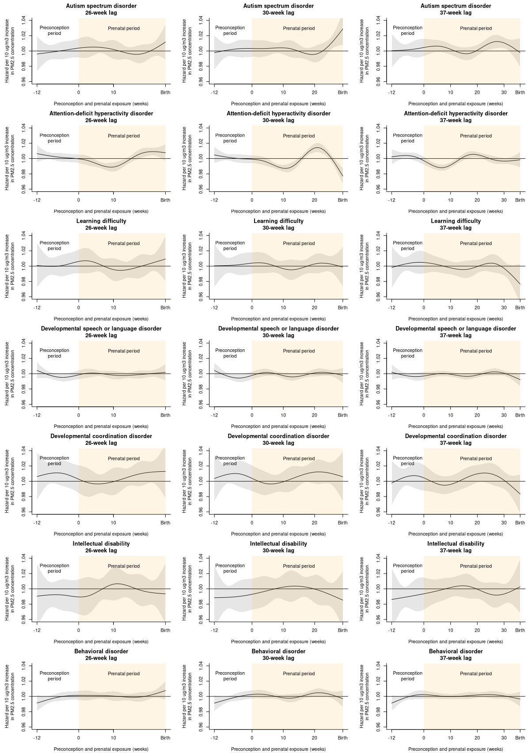

eResults 13. Hazard ratios [95% CI] for association between average weekly preconception and prenatal PM_{2.5} exposure (10 μg/m³ increase) and risk of neurodevelopmental disorders among children diagnosed at age 3 years or later
Condition | Preconception and prenatal PM_{2.5} exposure |  | Postnatal PM_{2.5} exposure
Condition | All diagnoses | Diagnosed at age 3 or later | All diagnoses | Diagnosed at age 3 or later
Autism spectrum disorder | 1.19 [0.98, 1.45] | 1.15 [0.92, 1.44] | 1.16 [0.79, 1.70] | 1.28 [0.83, 1.97]
Attention deficit hyperactivity disorder | 0.93 [0.83, 1.04] | 0.98 [0.88, 1.09] | 1.10 [0.92, 1.31] | 1.00 [0.83, 1.20]
Learning difficulty | 0.95 [0.75, 1.22] | 0.90 [0.69, 1.16] | 0.77 [0.52, 1.16] | 0.72 [0.46, 1.14]
Developmental speech or language disorder | 0.93 [0.84, 1.04] | 0.87 [0.75, 1.00] | 0.82 [0.68, 0.98] | 0.73 [0.56, 0.96]
Developmental coordination disorder | 1.10 [0.73, 1.64] | 1.31 [0.71, 2.43] | 1.77 [0.93, 3.40] | 0.84 [0.28, 2.55]
Intellectual disability | 0.82 [0.57, 1.18] | 0.82 [0.55, 1.21] | 1.16 [0.59, 2.28] | 1.12 [0.50, 2.51]
Behavioral disorder | 1.00 [0.91, 1.11] | 1.03 [0.93, 1.15] | 0.97 [0.81, 1.17] | 1.01 [0.82, 1.25]

eResults 14. Hazard ratios [95% CI] for association between average weekly preconception and prenatal PM_{2.5} exposure (10 μg/m³ increase) and risk of neurodevelopmental disorders at the cumulative lag (12 weeks preconception and 37 weeks prenatal and 0-3 years postnatal), controlling for average cumulative NO₂ concentration
Condition | Preconception and prenatal PM_{2.5} exposure |  | Postnatal PM_{2.5} exposure
Condition | Not controlling for NO₂ concentration | Controlling for NO₂ concentration | Not controlling for NO₂ concentration | Controlling for NO₂ concentration
Autism spectrum disorder | 1.19 [0.98, 1.45] | 1.13 [0.91, 1.41] | 1.16 [0.79, 1.70] | 0.98 [0.71, 1.36]
Attention deficit hyperactivity disorder | 0.93 [0.83, 1.04] | 0.99 [0.88, 1.11] | 1.10 [0.92, 1.31] | 1.15 [0.95, 1.39]
Learning difficulty | 0.95 [0.75, 1.22] | 0.90 [0.69, 1.18] | 0.77 [0.52, 1.16] | 0.65 [0.40, 1.05]
Developmental speech or language disorder | 0.93 [0.84, 1.04] | 0.93 [0.83, 1.04] | 0.82 [0.68, 0.98] | 0.85 [0.70, 1.03]
Developmental coordination disorder | 1.10 [0.73, 1.64] | 1.15 [0.77, 1.72] | 1.77 [0.93, 3.40] | 1.90 [0.97, 3.73]
Intellectual disability | 0.82 [0.57, 1.18] | 0.68 [0.45, 1.02] | 1.16 [0.59, 2.28] | 1.11 [0.54, 2.26]
Behavioral disorder | 1.00 [0.91, 1.11] | 1.00 [0.90, 1.11] | 0.97 [0.81, 1.17] | 0.98 [0.80, 1.20]

eResults 15. Hazard ratios [95% CI] for the association between average preconception, prenatal and postnatal PM_{2.5} exposure (10 μg/m³ increase) and risk of neurodevelopmental disorders, accounting for inverse probability of censoring weights
 | Preconception | Prenatal | Postnatal
ASD
adjusted main analysis | 1.00 (0.90-1.09) | 1.08 (1,01-1.16) | 1.13 (0.85-1.42)
accounting for censoring weights | 0.98(0.89-1.11) | 1.06 (1.00-1.18) | 1.10 (0.88-1.47)
ADHD
adjusted main analysis | 1.01 (0.99-1.10) | 0.95 (0.80-1.10) | 1.10 (0.90-1.27)
accounting for censoring weights | 0.98 (0.93-1.15) | 0.99 (0.85-1.12) | 1.11 (0.92-1.30)
Learning difficulty
adjusted main analysis | 1.01 (0.90 -1.09) | 1.00 (0.72-1.21) | 0.73 (0.50-1.20)
accounting for censoring weights | 1.00 (0.93-1.11) | 0.98 (0.85-1.18) | 0.72 (0.52-1.18)
Developmental speech or language disorder
adjusted main analysis | 1.01 (0.90-1.20) | 1.00 (0.80-1.18) | 0.80 (0.65-1.08)
accounting for censoring weights | 1.03 (0.93-1.22) | 1.00 (0.81-1.18) | 0.83 (0.70-1.10)
Developmental Coordination Disorder
adjusted main analysis | 1.03 (0.90-1.25) | 1.02 (0.88-1.23) | 1.32 (0.92-2,00)
accounting for censoring weights | 1.02 (0.93-1.28) | 1.01 (0.90-1.20) | 1.30 (0.94-2.04)
Intellectual disability
adjusted main analysis | 0.84 (0.74-1.10) | 1.00 (0.75-1.25) | 1.08 (0.63-2.00)
accounting for censoring weights | 0.82 (0.75-1.09) | 1.02 (0.73-1.27) | 1.06 (0.60-1.98)
Behavioral disorder
adjusted main analysis | 1.00 (0.95-1.10) | 1.05 (0.95-1.18) | 1.00 (0.70-1.65)
accounting for censoring weights | 0.99 (0.90-1.12) | 1.02 (0.92-1.20) | 0.99 (0.81-1.40)

