Supplementary File
Figure S1: Figure S1. Hierarchical visualization of the 60 InflAIM MLTC conditions. A fully interactive version is available at https://inflaim-study.github.io/Inflaim_MLTC_paper/Supplementary%20figures/Fig_S1/ (archived at Zenodo, DOI: 10.5281/zenodo.17153086).
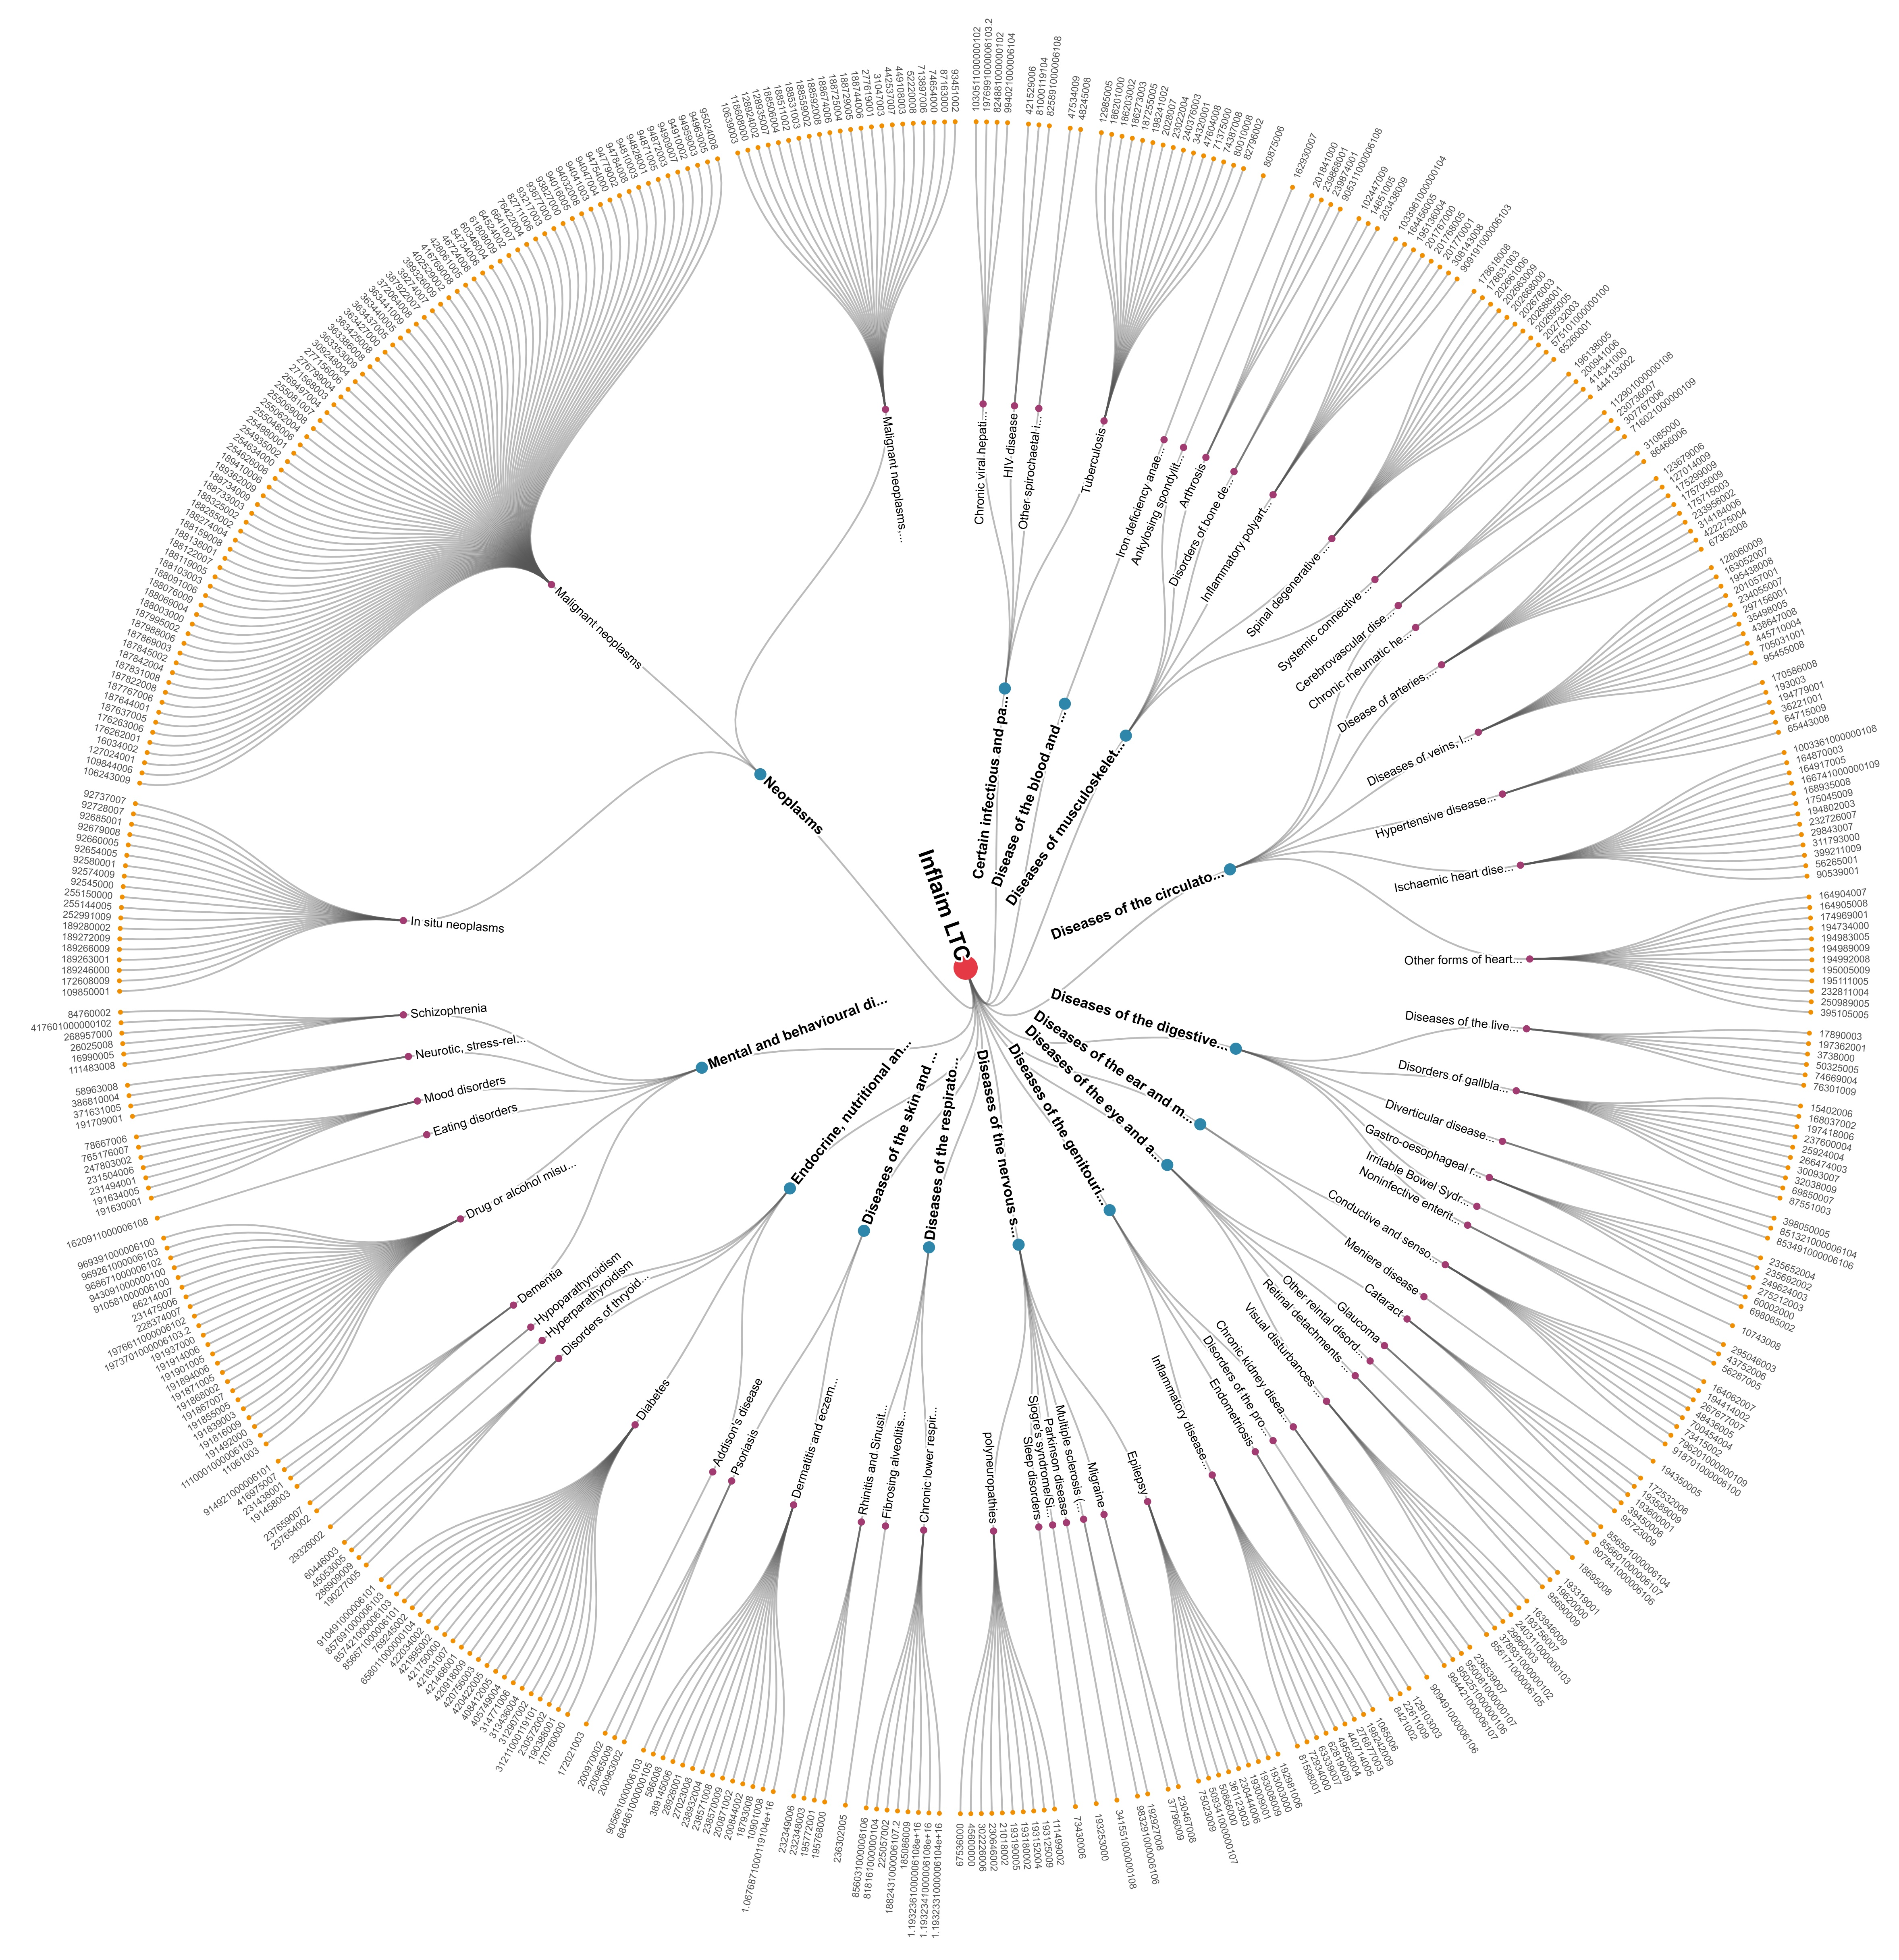
*The hierarchy is delineated from high-level International Classification of Diseases (ICD-10) chapters (blue nodes) down to the 60 specific LTCs (purple nodes). Each condition terminates in its constituent SNOMED CT codes, a 10% representative sample of which is displayed to demonstrate the distribution of code lists across all the conditions while maintaining visual clarity.

