Table 1 Location type of windmills
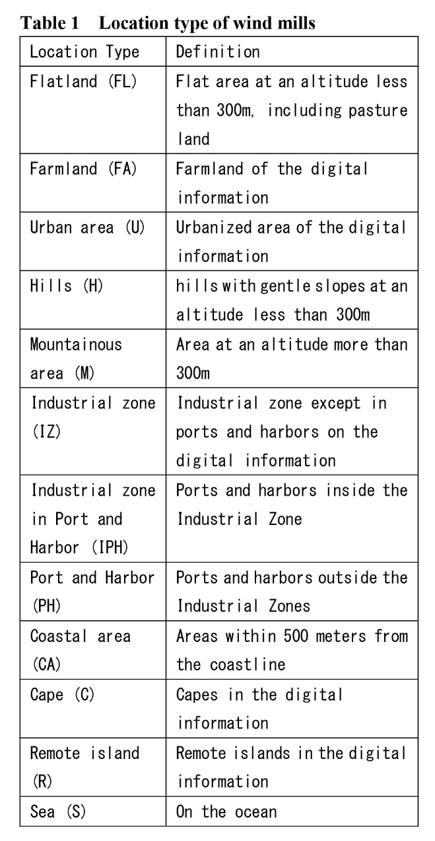

Table 2 Distribution of Wind Turbines by Land-Use Regulation Zone
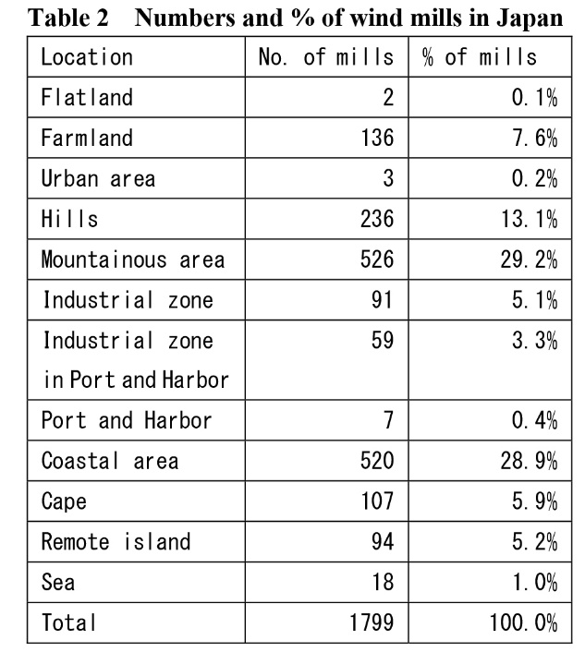

Table 4 Location type and land use regulation of windmills
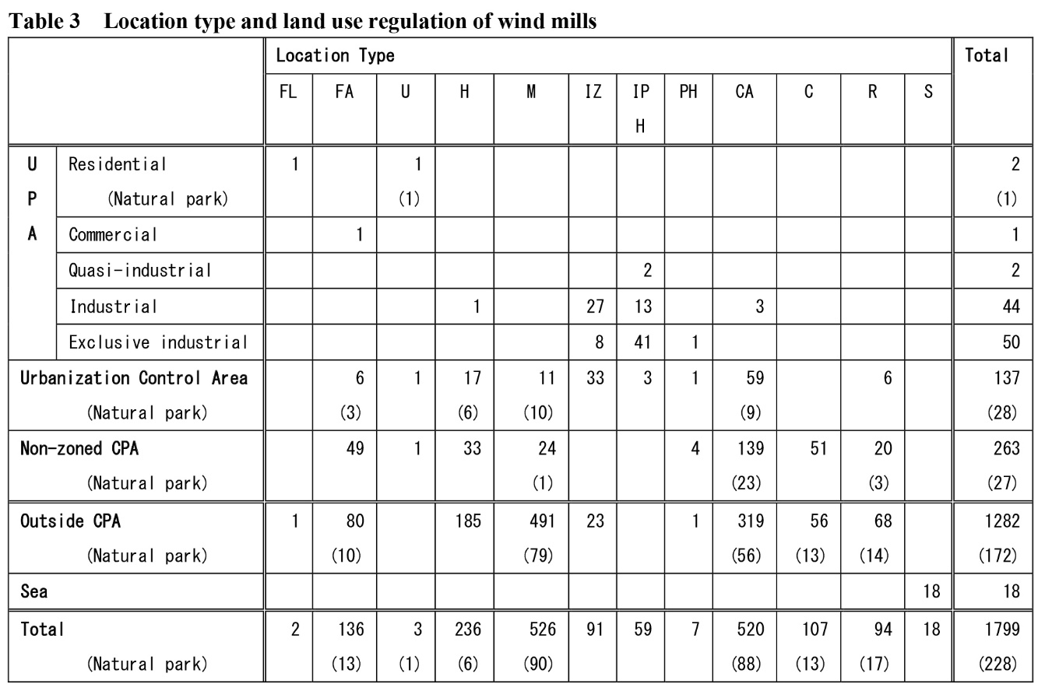

Table 7 Prefectures and municipalities that have an original guideline
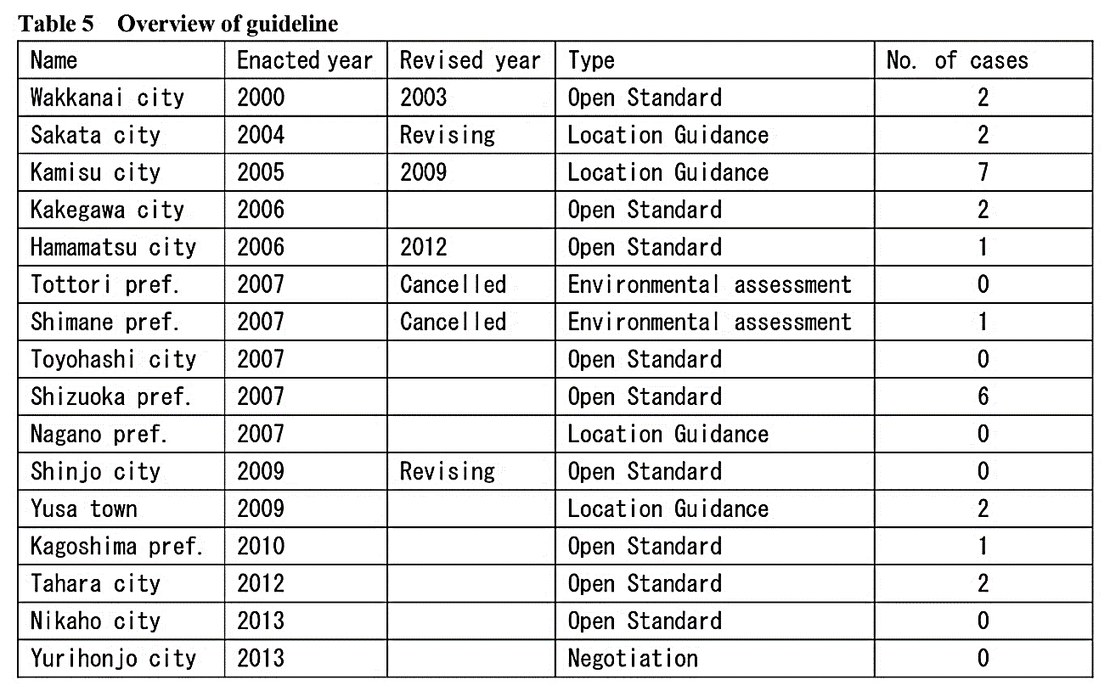

Table 8 Overview of guideline
