Supplementary
Table S1
Mean, Standard Deviation and Range of the Study Variables
Variables | N | M (SD) | Range
Automatic Emotional Responses
Feelings Trigger Action | 859 | 2.78 (.72) | 1-5
Pervasive Influence of Feelings | 859 | 2.93 (.89) | 1-5
Lack of Emotional Knowledge | 896 | 2.31 (.99) | 1-5
Difficulties with Strategies | 885 | 2.22 (1.08) | 1-5
Impulsivity | 886 | 2.31 (1.22) | 1-5
Non-acceptance of Emotions | 883 | 2.30 (1.14) | 1-5
Difficulties with Completing Goals | 889 | 3.05 (1.23) | 1-5
Rumination | 893 | 3.07 (.96) | 1-5
Deliberate Emotional Responses
Cognitive Reappraisal | 860 | 2.83 (.88) | 1-5
Emotional Awareness | 896 | 2.88 (.90) | 1-5
Adjusting | 881 | 2.96 (.99) | 1-5
Concealing | 884 | 3.23 (.86) | 1-5
Tolerating | 881 | 3.01 (.93) | 1-5
Internalizing Symptoms
I feel sad | 852 | 1.65 (1.30) | 0-4
I feel bad about myself or do not like myself | 847 | 1.76 (1.43) | 0-4
I feel down or depressed | 846 | 1.43 (1.32) | 0-4
I feel nervous and scared | 851 | 1.51 (1.32) | 0-4
I am scared that bad things will happen | 848 | 1.50 (1.34) | 0-4
I think sad or scary thoughts | 848 | 1.49 (1.37) | 0-4
Externalizing Symptoms
I talk back or argue with parents or other adults | 846 | 1.44 (1.30) | 0-4
I refuse to do what adults tell me to do | 846 | 1.01 (1.07) | 0-4
I do things that I am not allowed to do | 845 | 1.09 (1.21) | 0-4
I am impolite or disrespectful towards others | 847 | .76 (1.02) | 0-4
I fight with others | 850 | 1.09 (1.08) | 0-4
I break rules at home or at school | 845 | .85 (1.08) | 0-4
Thought Problems
I brood intensely about myself and the world | 848 | 1.67 (.69) | 1-3
Myself or the world around me feels unreal and strange | 843 | 1.49 (.63) | 1-3
Strange, weird and disturbing thoughts suddenly appear in my head | 850 | 1.72 (.75) | 1-3
Note. Lower values indicate less or no symptom experiences, never or rarely using automatic or deliberate responses. Higher values indicate more symptom experiences and often or always using automatic or deliberate responses.

Table S2
Unstandardized Strength Centrality Estimates from Strongest to Weakest
Nodes | Strength
Adjusting | 1.68
INT 2 I feel down or depressed | 1.67
Impulsivity | 1.67
Difficulties with Strategies | 1.58
INT 3 I feel bad or don’t like myself | 1.56
Pervasive Influence of Feelings | 1.53
Non-Acceptance | 1.38
Feelings Trigger Actions | 1.34
Rumination | 1.31
Difficulties with Completing Goals | 1.14
EXT 11 I fight with other people | 1.12
INT 6 I think sad or scary thoughts | 1.12
Concealing | 1.01
EXT 12 I break rules at home or at school | .99
EXT 8 I refuse to do what adults tell me to do | .98
EXT 7 I talk back or argue with my parents or other adults | .98
Awareness | .86
INT 5 I worry about bad things happening | .85
TP 1 I brood intensely about myself or the world | .80
Cognitive Reappraisal | .79
Lack of Emotional Knowledge | .75
TP 2 Myself or the world around, me feels strange and unreal | .74
Tolerating | .60
Note. INT = Internalizing, EXT = Externalizing, TP = Thought problems.
Table S3
Standardized Bridge Centrality Estimates
Nodes | Bridge Strength | Bridge EI (One-step) | Bridge EI (Two-step)
Rumination | 1.27 | 1.00 | .63
Lack of Emotional Knowledge | -.93 | -.50 | -.36
Non-Acceptance | .46 | .85 | .72
Difficulties with Goals | -.68 | -.56 | -.53
Impulsivity | -.08 | -1.17 | -.95
Difficulties with Strategies | .43 | -.26 | -.05
Feelings Trigger Action | .14 | .16 | -.10
Pervasive Influence of Feelings | -.59 | -.31 | .15
Awareness | -.65 | -.17 | -.41
Adjusting | .99 | -2.93 | -2.80
Tolerating | -1.45 | -1.06 | -1.30
Concealing | .58 | 1.25 | .64
Cognitive Reappraisal | -1.00 | -.75 | -1.24
INT 2 I feel down or depressed | 2.60 | .99 | 1.24
INT 3 I feel bad or don’t like myself | 1.92 | 1.31 | 1.20
INT 5 I worry about bad things happening | -.55 | .56 | .66
INT 6 I think sad or scary thoughts | -.37 | .77 | 1.19
EXT 7 I talk back or argue with my parents or other adults | -.14 | .22 | .15
EXT 8 I refuse to do what adults tell me to do | -1.46 | -.47 | -.24
EXT 11 I fight with other people | .05 | -.32 | -.37
EXT 12 I break rules at home or at school | -.63 | -.47 | -.48
TP 1 I brood intensely about myself or the world | .16 | 1.37 | 1.48
TP 2 Myself or the world around me feels strange and unreal | -.07 | .50 | .79

Figure S1
All Significant Edge Weights
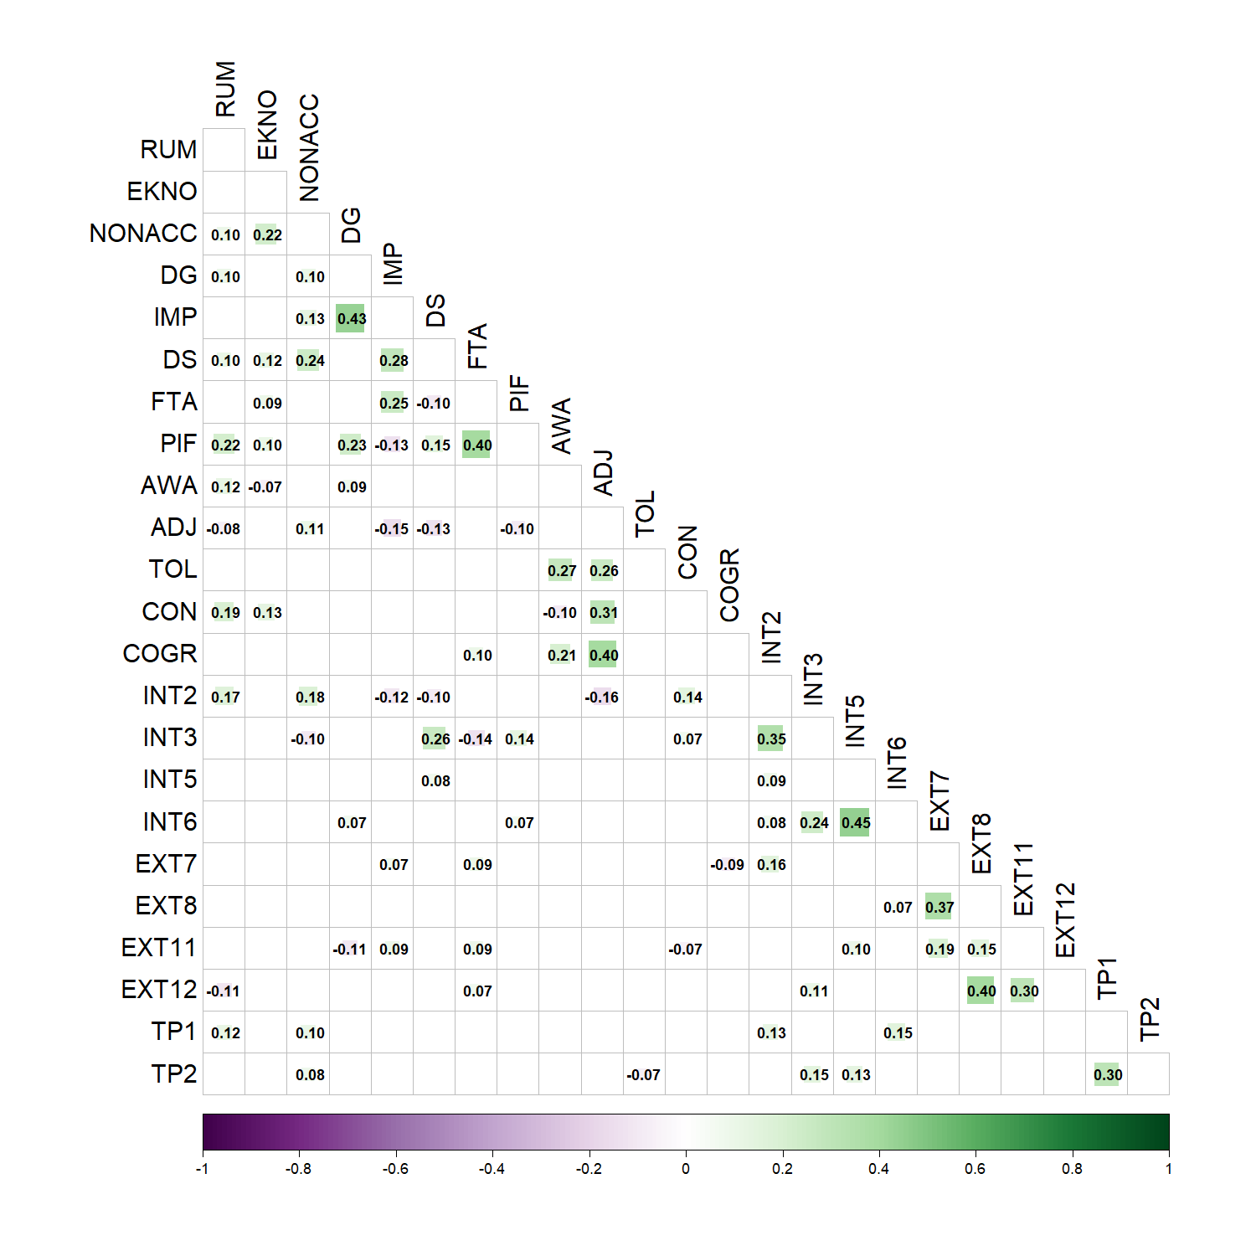
Note. RUM = Rumination, EKNO = Lack of emotional knowledge, NONACC = Non-acceptance of emotions, DG = Difficulties with completing goals, IMP = Impulsivity, DS = Difficulties with strategies, FTA = Feelings trigger action, PIF = Pervasive influence of feelings, AWA = Awareness of emotions, ADJ = Adjusting to emotions, TOL = Tolerating emotions, CON = Concealing emotions, COGR = Cognitive Reappraisal, INT1-6 = Internalizing symptoms, EXT7-12 = Externalizing symptoms, and TP1-2 = Thought problems.
Figure S2
Edge weight stability
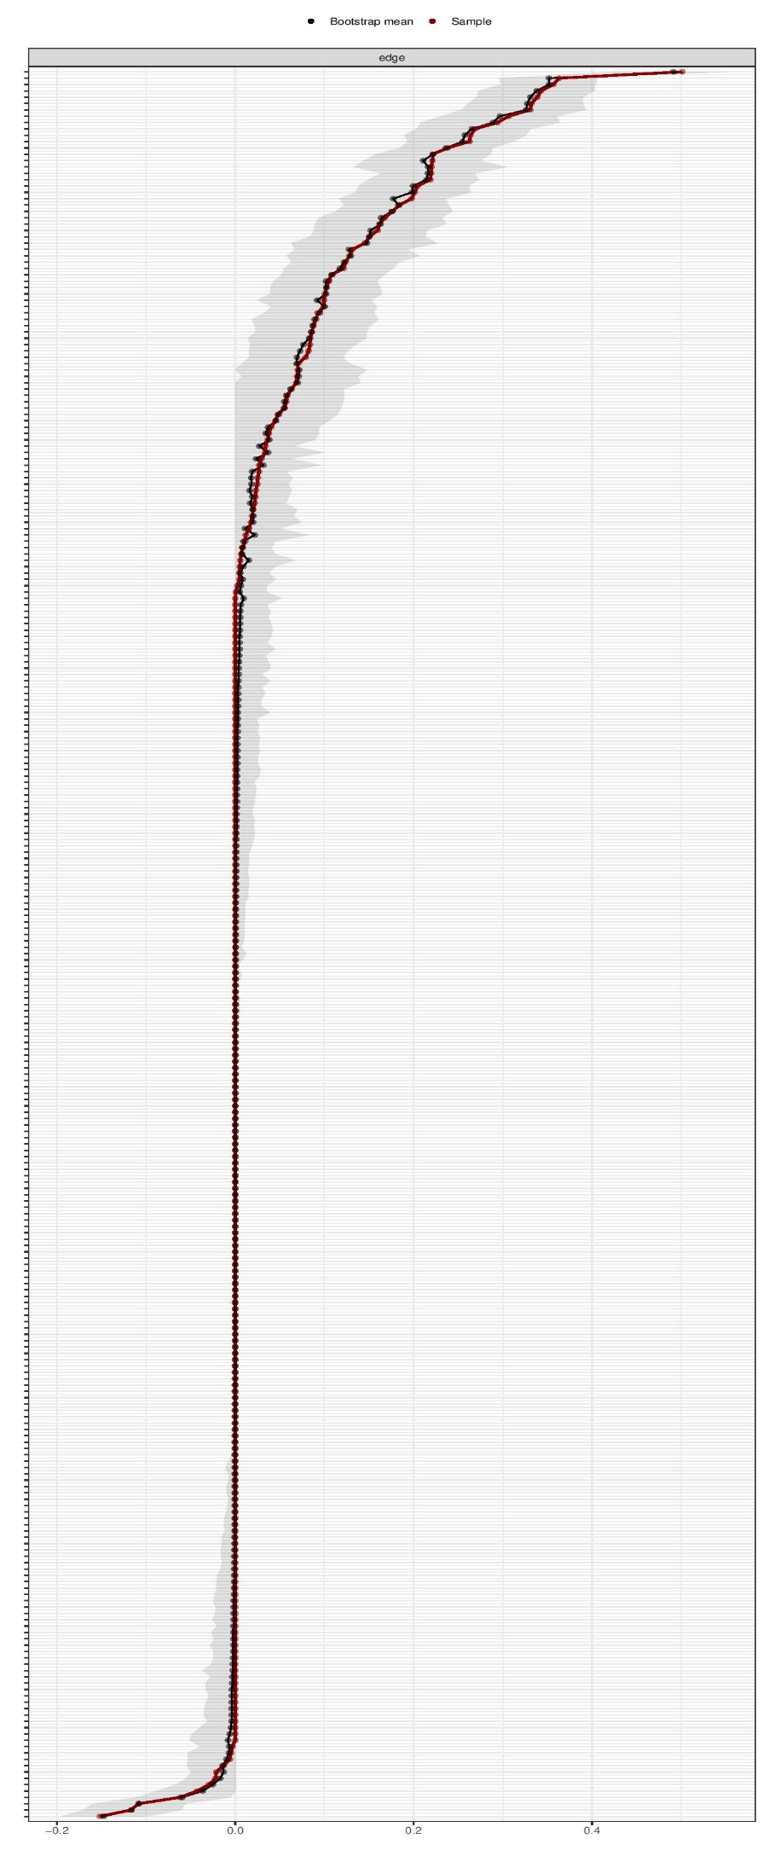
Figure S3
Stability of the Centrality Indices
