Supplementary Materials
Tables and figures of Contents for Supporting Information
Xingwang Leng ^{1, †}, Sicheng Wang ^{2, †}, Anqi Wang ¹, Bin Li ¹, Lidong Cheng ³, Yixing Qiu ¹, Jisheng Liu ¹, Jiao Cui ⁴, Xiaoping Nie ⁴, Wei Wang ¹, Xueli Bai ², Hanwen Yuan ^{1,} *, Caiyun Peng ^{1,} *
¹TCM and Ethnomedicine Innovation & Development International Laboratory, School of Pharmacy, Hunan University of Chinese Medicine, Changsha, China
²The First Affiliated Hospital, School of Medicine, Zhejiang University, Hangzhou, Zhejiang, China;
³Hunan Yirentang Chinese Herbal Pieces Co., Ltd., Changsha, China
⁴The Second Affiliated Hospital of Hunan University of Chinese Medicine, Changsha, China

†These authors contributed equally to this work
* Correspondence: Hanwyuan@hnucm.edu.cn (H. Yuan), Caiyunpeng @hnucm.edu.cn (C. Peng);

SUPPORTING FIGURES AND TABLES
Fig.S1 Characteristic fingerprint for XYS.
Fig.S2 Characteristic fingerprint for RS.
Fig.S3 Characteristic fingerprint for SQ.
Fig.S4 Characteristic fingerprint for BSQ.
Fig. S5 Fingerprint and characteristic spectrum of SQ , BSQ , RS , XYS.
Fig.S6 The MS² spectrum of some compounds in Four Panax species. .a:Protopanaxadiol，b:Protopanaxatriol, c:Oleanolic acid,d:Octillol,e:C17 side-chain varied.
Table S1 Souce information of SQ , BSQ, XYS, RS.
Table S2 Method validation of HPLC fingerprint analysis.
Table S3 Similarity in fingerprints of XYS.
Table S4 Similarity in fingerprints of RS.
Table S5 Similarity in fingerprints of SQ.
Table S6 Similarity in fingerprints of BSQ.
Table S7 Content of 13 Compounds in Four Panax Medicinal Herbs

Fig.S1 Characteristic fingerprint for XYS.
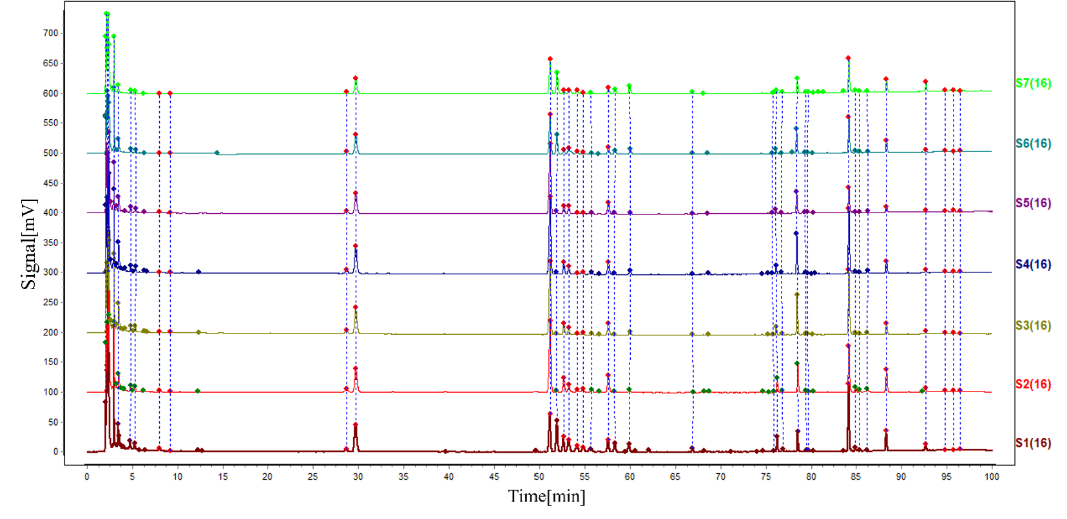
Fig.S2 Characteristic fingerprint for RS.
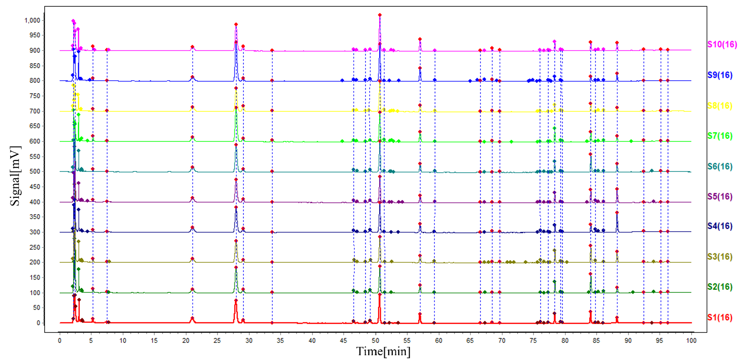
Fig.S3 Characteristic fingerprint for SQ.
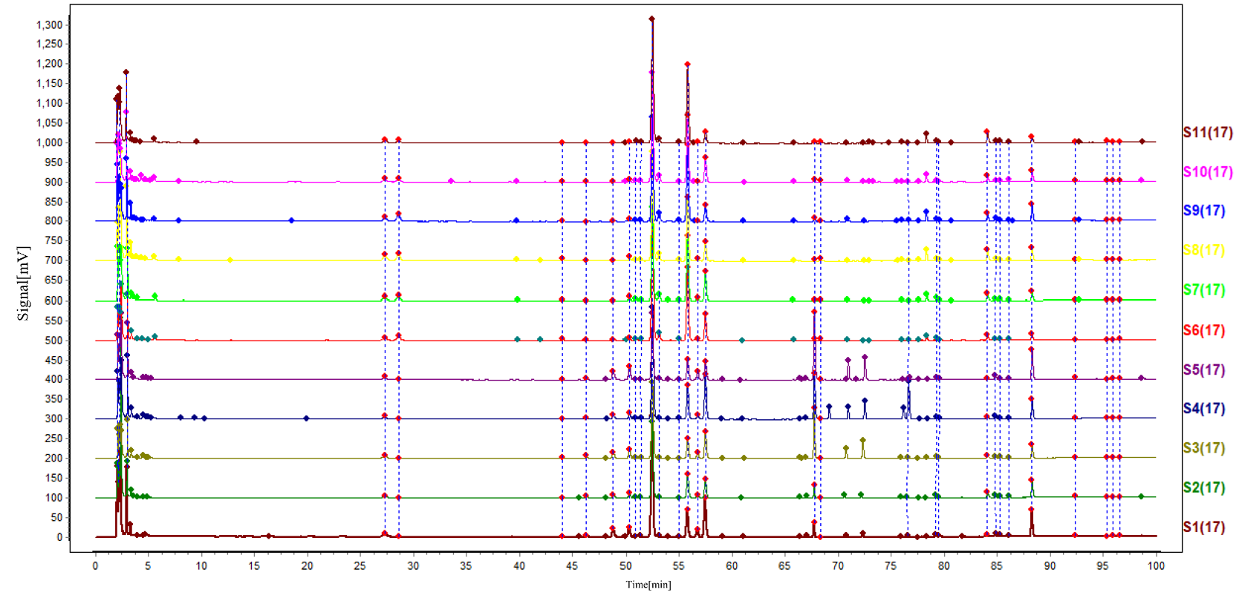
Fig.S4 Characteristic fingerprint for BSQ.
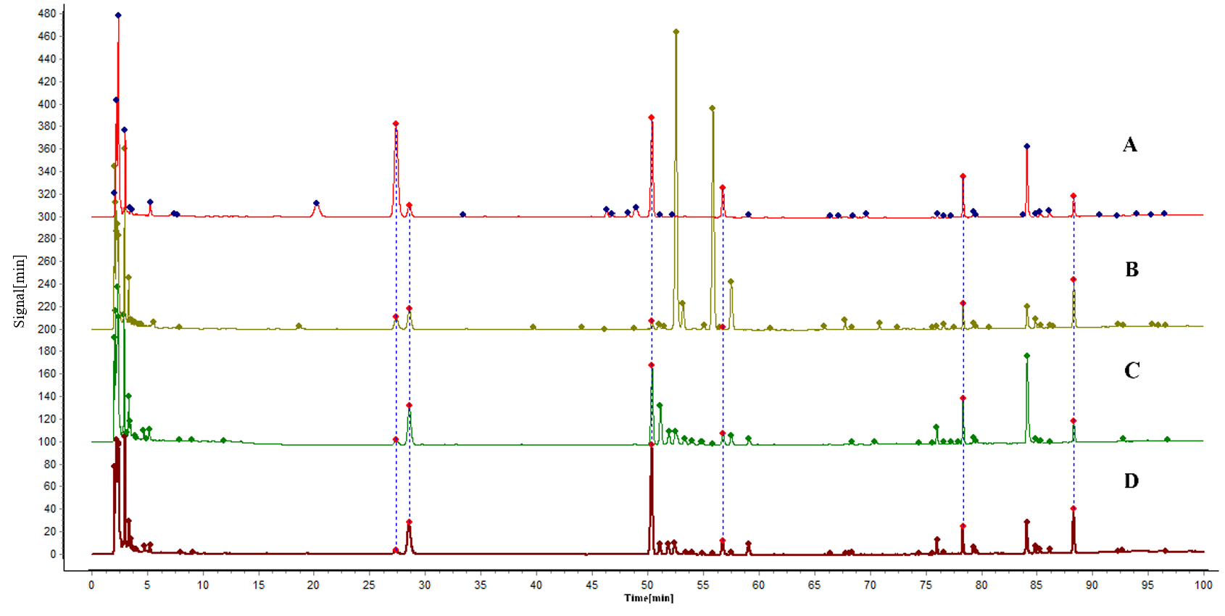
Fig. S5 Fingerprint and characteristic spectrum of SQ , BSQ , RS , XYS.

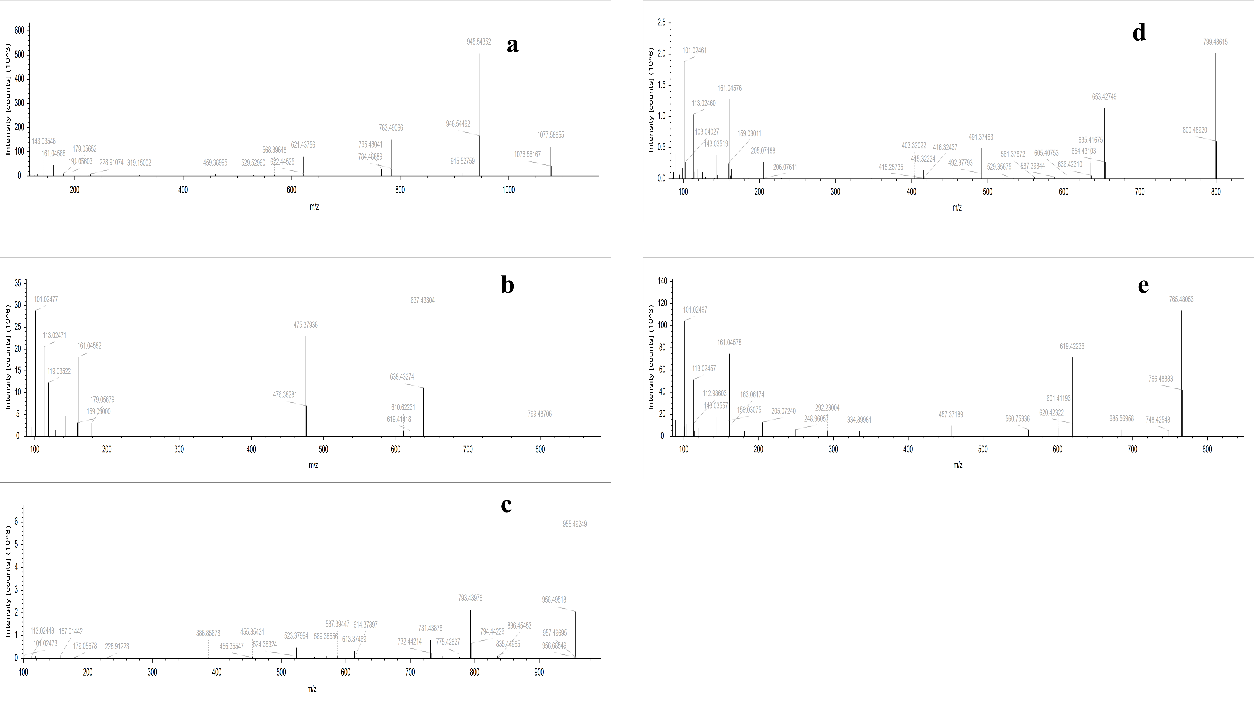
Fig.S6 The MS² spectrum of some compounds in Four Panax species. .a:Protopanaxadiol，b:Protopanaxatriol, c:Oleanolic acid,d:Octillol,e:C17 side-chain varied

Table S1 Souce information of SQ, BSQ, XYS, RS.
Sample name | Name | Origin | Sample name | Name | Origin
SQ-1 | Panax notoginseng | Yunnan | XYS-1 | Panax quinquefolius | Jilin
SQ-2 | Panax notoginseng | Yunnan | XYS-2 | Panax quinquefolius | Jilin
SQ-3 | Panax notoginseng | Yunnan | XYS-3 | Panax quinquefolius | Canada
SQ-4 | Panax notoginseng | Yunnan | XYS-4 | Panax quinquefolius | Canada
SQ-5 | Panax notoginseng | Yunnan | XYS-5 | Panax quinquefolius | Jilin
SQ-6 | Panax notoginseng | Yunnan | XYS-6 | Panax quinquefolius | Jilin
SQ-7 | Panax notoginseng | Yunnan | XYS-7 | Panax quinquefolius | Canada
SQ-8 | Panax notoginseng | Yunnan | XYS-8 | Panax quinquefolius | Canada
SQ-9 | Panax notoginseng | Yunnan | XYS-9 | Panax quinquefolius | Jilin
SQ-10 | Panax notoginseng | Yunnan | XYS-10 | Panax quinquefolius | Canada
BSQ-1 | Panax japonicus | Yunnan | RS-1 | Panax ginseng | Jilin
BSQ-2 | Panax japonicus | Yunnan | RS-2 | Panax ginseng | Jilin
BSQ-3 | Panax japonicus | Yunnan | RS-3 | Panax ginseng | Jilin
BSQ-4 | Panax japonicus | Yunnan | RS-4 | Panax ginseng | Jilin
BSQ-5 | Panax japonicus | Yunnan | RS-5 | Panax ginseng | Jilin
BSQ-6 | Panax japonicus | Hunan | RS-6 | Panax ginseng | Jilin
BSQ-7 | Panax japonicus | Hunan | RS-7 | Panax ginseng | Jilin
BSQ-8 | Panax japonicus | Hunan | RS-8 | Panax ginseng | Jilin
BSQ-9 | Panax japonicus | Hubei | RS-9 | Panax ginseng | Jilin
BSQ-10 | Panax japonicus | Hubei | RS-10 | Panax ginseng | Jilin
BSQ-11 | Panax japonicus | Hubei

Table S2 Method validation of HPLC fingerprint analysis
Analytes | RSD (%) | Precision | Repeatability | Stability
1 | RRT | 0.34 | 4.11 | 0.49
1 | RPA | 2.17 | 2.88 | 2.3
2 | RRT | 0.18 | 2.11 | 0.27
2 | RPA | 0.34 | 2.82 | 0.78
3 | RRT | 0.16 | 1.83 | 0.23
3 | RPA | 0.42 | 0.43 | 0.81
4 | RRT | 0.09 | 0.87 | 0.06
4 | RPA | 0.21 | 2.48 | 0.95
5 | RRT | 0.61 | 0.69 | 0.07
5 | RPA | 1.43 | 2.75 | 1.61
6 | RRT | 0.07 | 0.6 | 0.06
6 | RPA | 0.59 | 2.05 | 0.85
7 | RRT | 0.09 | 0.7 | 0.00
7 | RPA | 2.55 | 2.6 | 3.3
8 | RRT | 0.08 | 0.66 | 0.06
8 | RPA | 1.48 | 2.68 | 3.19
9 | RRT | 0.07 | 0.62 | 0.05
9 | RPA | 0.35 | 2.46 | 1.01
10 | RRT | 0.08 | 0.69 | 0.06
10 | RPA | 0.44 | 1.88 | 2.55
11 | RRT | 0.07 | 0.63 | 0.05
11 | RPA | 0.17 | 1.98 | 1.29
12 | RRT | 0.01 | 0.06 | 0.00
12 | RPA | 0.37 | 1.1 | 0.82
13 | RRT | 0.00 | 0.03 | 0.00
13 | RPA | 0.31 | 1.56 | 0.9

Table S3 Similarity in fingerprints of XYS.
NO. | XYS-1 | XYS-2 | XYS-3 | XYS-4 | XYS-5 | XYS-6 | XYS-7 | XYS-8 | XYS-9 | XYS-10 | Contrast
XYS-1 | 1 | 0.942 | 0.944 | 0.99 | 0.987 | 0.986 | 0.905 | 0.964 | 0.972 | 0.939 | 0.91
XYS-2 | 0.942 | 1 | 0.955 | 0.979 | 0.919 | 0.939 | 0.963 | 0.999 | 0.986 | 0.904 | 0.991
XYS-3 | 0.944 | 0.955 | 1 | 0.997 | 0.923 | 0.939 | 0.93 | 0.934 | 0.921 | 0.919 | 0.928
XYS-4 | 0.99 | 0.979 | 0.997 | 1 | 0.926 | 0.938 | 0.964 | 0.995 | 0.927 | 0.944 | 0.958
XYS-5 | 0.987 | 0.919 | 0.923 | 0.926 | 1 | 0.984 | 0.936 | 0.96 | 0.945 | 0.938 | 0.934
XYS-6 | 0.986 | 0.939 | 0.939 | 0.938 | 0.984 | 1 | 0.939 | 0.978 | 0.972 | 0.969 | 0.948
XYS-7 | 0.905 | 0.963 | 0.93 | 0.964 | 0.936 | 0.939 | 1 | 0.961 | 0.991 | 0.987 | 0.941
XYS-8 | 0.964 | 0.999 | 0.934 | 0.995 | 0.96 | 0.978 | 0.961 | 1 | 0.943 | 0.907 | 0.954
XYS-9 | 0.972 | 0.986 | 0.921 | 0.927 | 0.945 | 0.972 | 0.991 | 0.943 | 1 | 0.97 | 0.925
XYS-10 | 0.939 | 0.904 | 0.919 | 0.944 | 0.938 | 0.969 | 0.987 | 0.907 | 0.97 | 1 | 0.955
Contrast | 0.91 | 0.991 | 0.928 | 0.958 | 0.934 | 0.948 | 0.941 | 0.954 | 0.925 | 0.955 | 1
Table S4 Similarity in fingerprints of RS.
NO. | RS-1 | RS-2 | RS-3 | RS-4 | RS-5 | RS-6 | RS-7 | RS-8 | RS-9 | Contrast
RS-1 | 1 | 0.971 | 0.987 | 0.986 | 0.974 | 0.942 | 0.962 | 0.927 | 0.93 | 0.985
RS-2 | 0.971 | 1 | 0.972 | 0.971 | 0.917 | 0.957 | 0.921 | 0.96 | 0.91 | 0.985
RS-3 | 0.987 | 0.972 | 1 | 1 | 0.92 | 0.975 | 0.928 | 0.918 | 0.987 | 0.974
RS-4 | 0.986 | 0.971 | 1 | 1 | 0.916 | 0.976 | 0.926 | 0.916 | 0.985 | 0.972
RS-5 | 0.974 | 0.917 | 0.92 | 0.916 | 1 | 0.922 | 0.965 | 0.914 | 0.931 | 0.957
RS-6 | 0.942 | 0.957 | 0.975 | 0.976 | 0.628 | 1 | 0.947 | 0.966 | 0.994 | 0.926
RS-7 | 0.962 | 0.921 | 0.928 | 0.926 | 0.965 | 0.947 | 1 | 0.938 | 0.987 | 0.973
RS-8 | 0.927 | 0.96 | 0.918 | 0.916 | 0.914 | 0.966 | 0.938 | 1 | 0.957 | 0.976
RS-9 | 0.93 | 0.91 | 0.987 | 0.985 | 0.931 | 0.994 | 0.987 | 0.957 | 1 | 0.963
Contrast | 0.985 | 0.985 | 0.974 | 0.972 | 0.957 | 0.926 | 0.973 | 0.976 | 0.963 | 1
Table S5 Similarity in fingerprints of SQ.
NO. | SQ-1 | SQ-2 | SQ-3 | SQ-4 | SQ-5 | SQ-6 | SQ-7 | SQ-8 | SQ-9 | SQ-10 | Contrast
SQ-1 | 1 | 0.923 | 0.979 | 0.931 | 0.908 | 0.934 | 0.938 | 0.941 | 0.937 | 0.932 | 0.955
SQ-2 | 0.923 | 1 | 0.982 | 0.965 | 0.987 | 0.993 | 0.948 | 0.929 | 0.937 | 0.931 | 0.983
SQ-3 | 0.979 | 0.982 | 1 | 0.951 | 0.992 | 0.978 | 0.989 | 0.982 | 0.982 | 0.988 | 0.954
SQ-4 | 0.931 | 0.965 | 0.951 | 1 | 0.98 | 0.979 | 0.958 | 0.952 | 0.962 | 0.961 | 0.988
SQ-5 | 0.908 | 0.987 | 0.992 | 0.98 | 1 | 0.99 | 0.927 | 0.92 | 0.922 | 0.925 | 0.978
SQ-6 | 0.934 | 0.993 | 0.978 | 0.979 | 0.99 | 1 | 0.955 | 0.95 | 0.947 | 0.952 | 0.991
SQ-7 | 0.938 | 0.948 | 0.989 | 0.958 | 0.927 | 0.955 | 1 | 0.972 | 0.99 | 0.974 | 0.98
SQ-8 | 0.941 | 0.929 | 0.982 | 0.952 | 0.92 | 0.95 | 0.972 | 1 | 0.975 | 0.992 | 0.975
SQ-9 | 0.937 | 0.937 | 0.982 | 0.962 | 0.922 | 0.947 | 0.99 | 0.975 | 1 | 0.981 | 0.978
SQ-10 | 0.932 | 0.931 | 0.988 | 0.961 | 0.925 | 0.952 | 0.974 | 0.992 | 0.981 | 1 | 0.977
Contrast | 0.955 | 0.983 | 0.954 | 0.988 | 0.978 | 0.991 | 0.98 | 0.975 | 0.978 | 0.977 | 1

Table S6 Similarity in fingerprints of BSQ.
NO. | BSQ-1 | BSQ-2 | BSQ-3 | BSQ-4 | BSQ-5 | BSQ-6 | BSQ-7 | BSQ-8 | BSQ-9 | BSQ-10 | BSQ-11 | Contrast
BSQ-1 | 1 | 0.917 | 0.934 | 0.95 | 0.973 | 0.925 | 0.921 | 0.931 | 0.976 | 0.911 | 0.965 | 0.967
BSQ-2 | 0.917 | 1 | 0.919 | 0.964 | 0.953 | 0.94 | 0.936 | 0.911 | 0.965 | 0.987 | 0.935 | 0.989
BSQ-3 | 0.934 | 0.919 | 1 | 0.936 | 0.914 | 0.966 | 0.965 | 0.951 | 0.935 | 0.966 | 0.925 | 0.925
BSQ-4 | 0.95 | 0.964 | 0.936 | 1 | 0.998 | 0.995 | 0.993 | 0.989 | 0.951 | 0.984 | 0.936 | 0.946
BSQ-5 | 0.973 | 0.953 | 0.914 | 0.998 | 1 | 0.972 | 0.979 | 0.906 | 0.942 | 0.96 | 0.908 | 0.962
BSQ-6 | 0.925 | 0.94 | 0.966 | 0.995 | 0.972 | 1 | 0.993 | 0.974 | 0.979 | 0.987 | 0.971 | 0.983
BSQ-7 | 0.921 | 0.936 | 0.965 | 0.993 | 0.979 | 0.993 | 1 | 0.969 | 0.98 | 0.984 | 0.961 | 0.981
BSQ-8 | 0.931 | 0.911 | 0.951 | 0.989 | 0.906 | 0.974 | 0.969 | 1 | 0.951 | 0.956 | 0.928 | 0.978
BSQ-9 | 0.976 | 0.965 | 0.935 | 0.951 | 0.942 | 0.979 | 0.98 | 0.951 | 1 | 0.99 | 0.983 | 0.961
BSQ-10 | 0.911 | 0.987 | 0.966 | 0.984 | 0.96 | 0.987 | 0.984 | 0.956 | 0.99 | 1 | 0.987 | 0.976
BSQ-11 | 0.965 | 0.935 | 0.925 | 0.936 | 0.908 | 0.971 | 0.961 | 0.928 | 0.983 | 0.987 | 1 | 0.948
Contrast | 0.967 | 0.989 | 0.925 | 0.946 | 0.962 | 0.983 | 0.981 | 0.978 | 0.961 | 0.976 | 0.948 | 1

Table S7 Content of 13 Compounds in Four Panax Medicinal Herbs
NO. | notoginsenoside R1 | ginsenoside Rg1 | ginsenoside Re | ginsenoside Rb1 | ginsenoside Rc | ginsenoside Ro | ginsenoside Rb2 | ginsenoside Rb3 | chikusetsusaponin IV | ginsenoside Rd | chikusetsusaponin IVa | panaxydol | panaxynol
SQ1 | 8.23 | 28.57 | 4.36 | 26.70 | ND | ND | ND | ND | ND | 6.96 | ND | 1.23 | 0.01
SQ2 | 6.33 | 29.84 | 4.25 | 24.59 | ND | ND | ND | ND | ND | 5.99 | ND | 1.37 | 0.04
SQ3 | 7.15 | 25.43 | 3.45 | 24.07 | ND | ND | ND | ND | ND | 5.37 | ND | 1.51 | 0.26
SQ4 | 8.60 | 28.55 | 4.49 | 28.10 | ND | ND | ND | ND | ND | 6.74 | ND | 0.86 | 0.85
SQ5 | 7.49 | 25.13 | 3.88 | 23.97 | ND | ND | ND | ND | ND | 5.21 | ND | 1.27 | 0.43
SQ6 | 9.30 | 28.52 | 3.72 | 28.47 | ND | ND | ND | ND | ND | 6.49 | ND | 1.37 | 0.08
SQ7 | 8.37 | 35.67 | 4.31 | 27.35 | ND | ND | ND | ND | ND | 7.69 | ND | 1.64 | 0.06
SQ8 | 7.87 | 23.50 | 6.67 | 28.40 | ND | ND | ND | ND | ND | 4.95 | ND | 0.80 | 0.01
SQ9 | 8.12 | 39.96 | 3.82 | 34.80 | ND | ND | ND | ND | ND | 10.11 | ND | 0.55 | 0.03
SQ10 | 6.97 | 27.19 | 5.73 | 34.00 | ND | ND | ND | ND | ND | 8.89 | ND | 1.11 | 0.07
BSQ1 | ND | 2.87 | 0.35 | 87.06 | ND | 9.61 | ND | ND | 13.46 | 4.24 | 3.52 | 0.20 | 0.98
BSQ2 | ND | 1.60 | 0.37 | 53.86 | ND | 4.70 | ND | ND | 11.32 | 1.74 | 1.38 | 0.06 | 0.47
BSQ3 | ND | 2.88 | 0.26 | 53.48 | ND | 8.64 | ND | ND | 9.77 | 3.68 | 3.04 | 0.06 | 0.24
BSQ4 | ND | 2.68 | 0.41 | 80.22 | ND | 6.28 | ND | ND | 16.40 | 1.87 | 2.07 | 0.07 | 0.56
BSQ5 | ND | 2.92 | 0.23 | 46.89 | ND | 13.44 | ND | ND | 9.51 | 4.84 | 4.03 | 0.24 | 1.11
BSQ6 | ND | 2.04 | 5.61 | 85.60 | ND | 2.63 | ND | ND | 35.35 | 0.69 | 0.48 | 0.44 | 0.03
BSQ7 | ND | 3.40 | 5.05 | 66.35 | ND | 3.44 | ND | ND | 31.26 | 1.86 | 1.48 | 0.56 | 0.09
BSQ8 | ND | 5.04 | 7.30 | 78.58 | ND | 4.27 | ND | ND | 31.23 | 1.23 | 9.31 | 3.15 | 0.86
BSQ9 | ND | 3.50 | 7.50 | 74.26 | ND | 3.04 | ND | ND | 37.70 | 0.41 | 8.04 | 2.72 | 0.42
BSQ10 | ND | 2.40 | 3.59 | 78.84 | ND | 1.46 | ND | ND | 32.64 | 0.53 | 11.86 | 4.01 | 0.14
BSQ11 | ND | 2.16 | 3.20 | 89.58 | ND | 1.46 | ND | ND | 38.04 | 0.44 | 5.60 | 1.90 | 0.05
XYS1 | ND | 0.97 | 15.10 | 34.84 | 2.30 | 4.16 | 1.36 | 1.74 | ND | 6.52 | ND | 2.79 | 0.04
XYS2 | ND | 0.84 | 12.02 | 34.84 | 0.62 | 5.22 | 1.33 | 1.35 | ND | 3.58 | ND | 0.76 | 0.31
XYS3 | ND | 2.21 | 20.06 | 43.73 | 1.10 | 13.40 | 1.76 | 4.18 | ND | 10.09 | ND | 2.07 | 0.67
XYS4 | ND | 1.60 | 19.33 | 39.57 | 2.04 | 6.63 | 1.40 | 1.81 | ND | 6.41 | ND | 1.46 | 0.06
XYS5 | ND | 1.44 | 15.80 | 25.18 | 3.34 | 4.35 | 1.83 | 2.34 | ND | 4.04 | ND | 0.96 | 0.23
XYS6 | ND | 0.96 | 12.68 | 26.80 | 0.52 | 4.68 | 1.07 | 1.05 | ND | 3.04 | ND | 0.94 | 0.36
XYS7 | ND | 0.65 | 16.97 | 30.02 | ND | 9.93 | 0.72 | 0.00 | ND | 2.60 | ND | 1.14 | 0.02
XYS8 | ND | 1.50 | 23.44 | 30.22 | 0.21 | 4.50 | 1.14 | 0.66 | ND | 2.60 | ND | 3.21 | 0.01
XYS9 | ND | 0.27 | 7.64 | 26.69 | 0.45 | 2.26 | 1.45 | 0.63 | ND | 3.91 | ND | 0.68 | 0.03
XYS10 | ND | 0.57 | 13.56 | 34.84 | 3.95 | 9.88 | 1.78 | 1.14 | ND | 3.32 | ND | 2.23 | 0.03
RS1 | ND | 1.52 | 18.65 | 16.89 | 3.57 | 9.86 | 4.41 | 4.11 | ND | 4.95 | ND | 4.42 | 0.24
RS2 | ND | 1.46 | 15.70 | 33.56 | 3.06 | 4.64 | 1.33 | 2.23 | ND | 6.66 | ND | 1.83 | 0.31
RS3 | ND | 1.43 | 16.49 | 34.47 | 2.29 | 4.86 | 0.81 | 1.79 | ND | 4.63 | ND | 2.53 | 0.12
RS4 | ND | 1.46 | 16.97 | 36.51 | 2.36 | 5.23 | 0.83 | 1.82 | ND | 4.92 | ND | 2.54 | 0.10
RS5 | ND | 0.89 | 12.24 | 32.54 | 1.03 | 5.39 | 0.62 | 1.10 | ND | 4.44 | ND | 1.33 | 0.03
RS6 | ND | 0.81 | 11.35 | 17.54 | 0.03 | 5.32 | 2.19 | 1.23 | ND | 2.74 | ND | 1.52 | 0.93
RS7 | ND | 0.74 | 9.15 | 14.91 | 0.56 | 3.87 | 2.44 | 1.05 | ND | 1.72 | ND | 0.87 | 0.01
RS8 | ND | 1.99 | 10.04 | 7.86 | 2.27 | 12.19 | 4.56 | 6.11 | ND | 2.80 | ND | 1.50 | 1.41
RS9 | ND | 1.79 | 10.49 | 9.83 | 2.50 | 12.69 | 5.49 | 6.61 | ND | 2.49 | ND | 1.89 | 0.08
RS10 | ND | 0.92 | 13.95 | 20.36 | 0.01 | 12.33 | 4.31 | 2.69 | ND | 3.30 | ND | 1.18 | 0.44
Note: ND indicates not detecte

