Supplemental Table 3: Observed L(r)-r functions for each guild/stand/year combination. Patterns not shown contained less than five attacked trees. Panels for each point pattern correspond to different null hypotheses of the underlying spatial distribution of available host trees. We provide our interpretation of whether each pattern exhibits significant aggregation or inhibition in the right hand columns.
Stand | Year | Mountain Pine Beetle | Aggregation | Inhibition
A | 2000 | 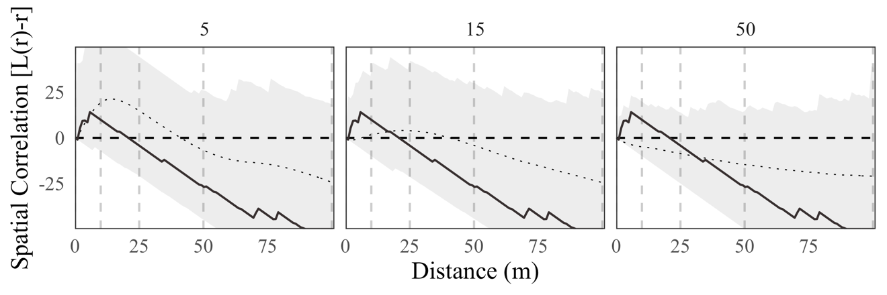 | No | No
 | 2001 | 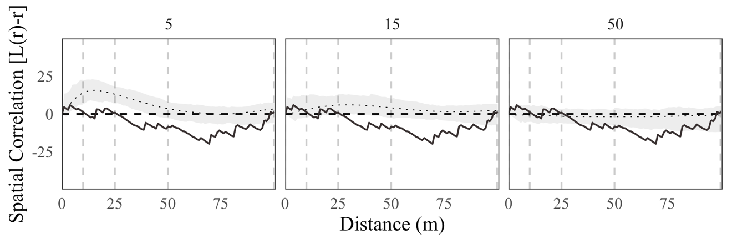 | No | Yes
 | 2002 | 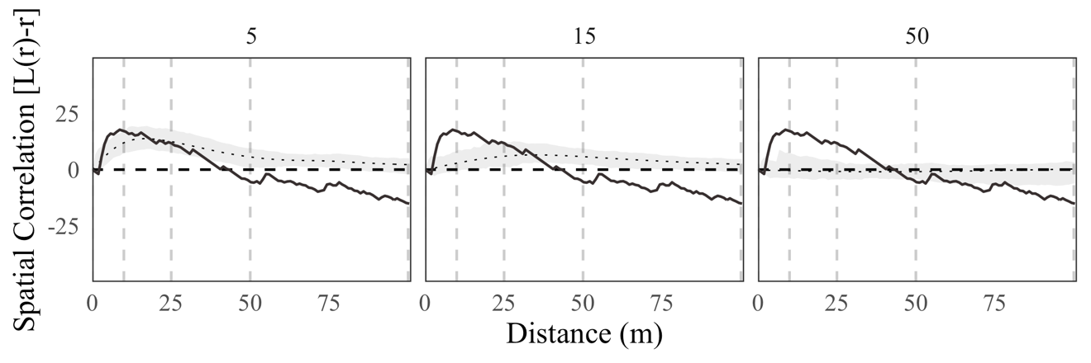 | Yes | Yes
 | 2003 | 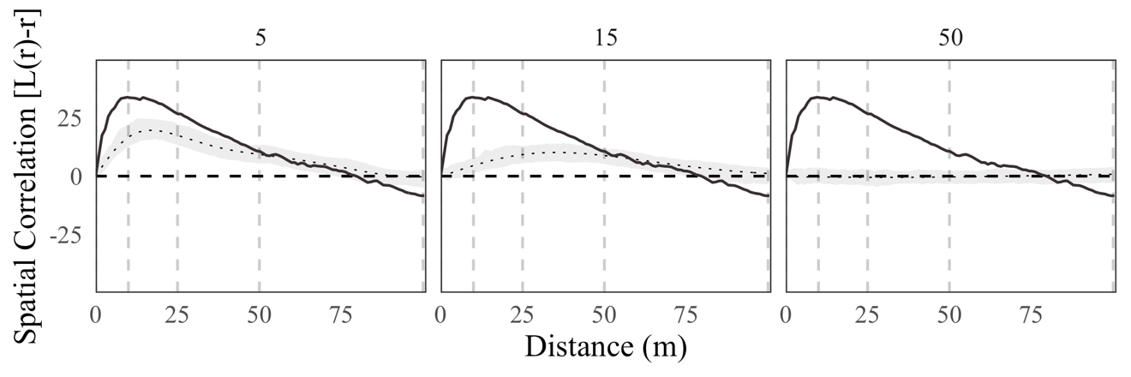 | Yes | Yes
 | 2004 | 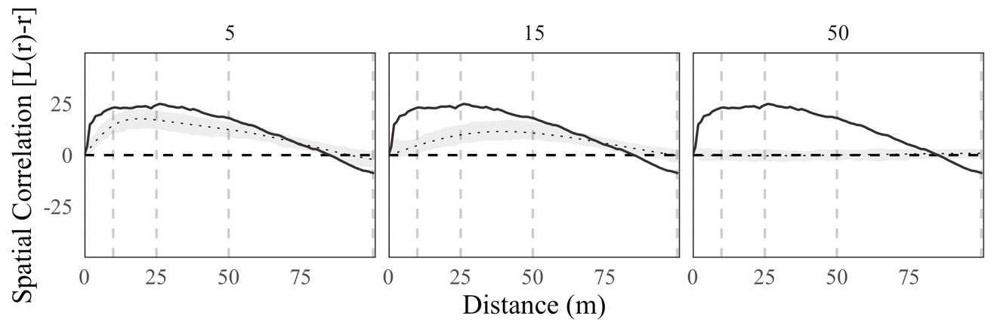 | Yes | Yes
 | 2005 | 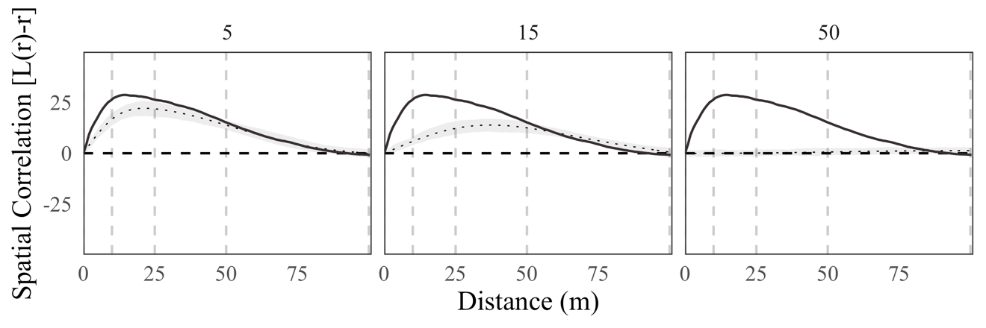 | Yes | Nos
B | 2000 | 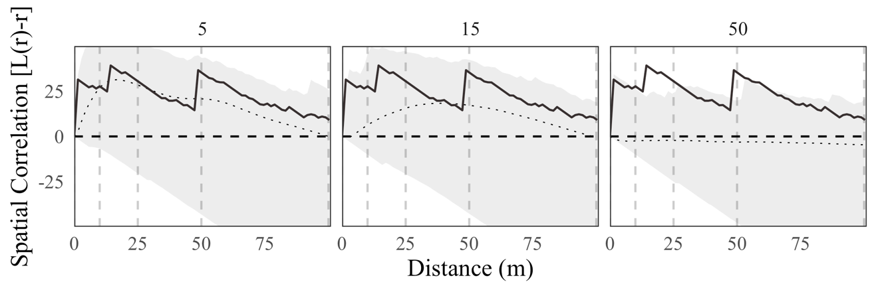 | X | X
 | 2001 | 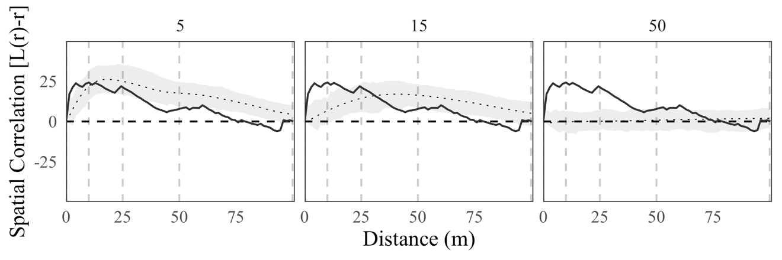 | Yes | Weak
 | 2002 | 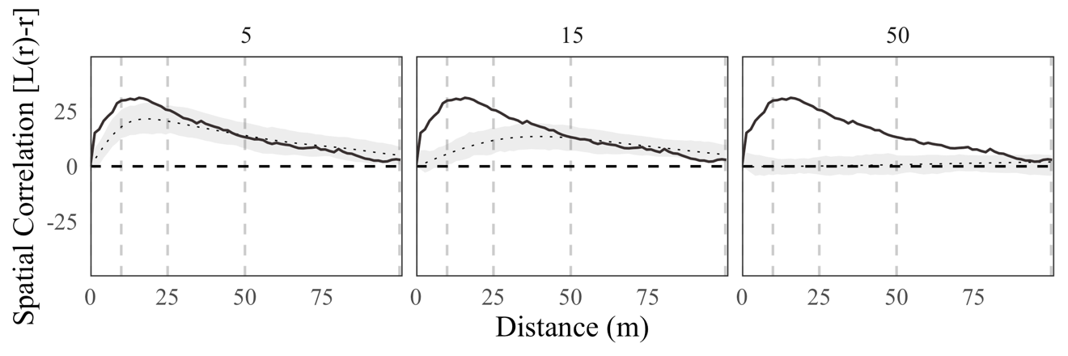 | Yes | No
 | 2003 | 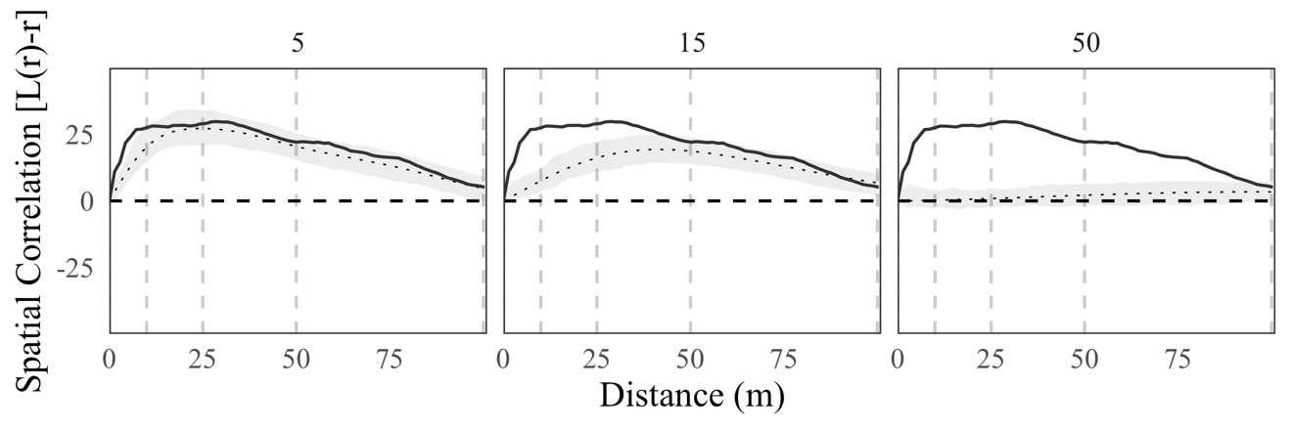 | Yes | No
 | 2004 | 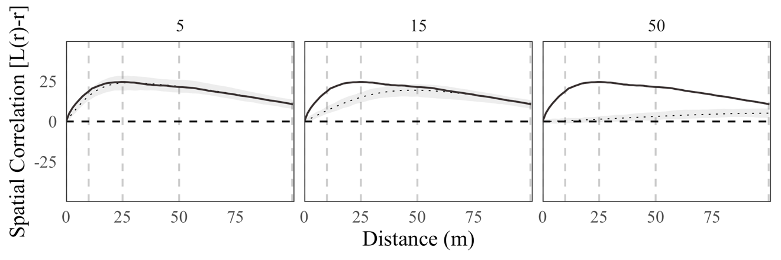 | Yes | No
 | 2005 | 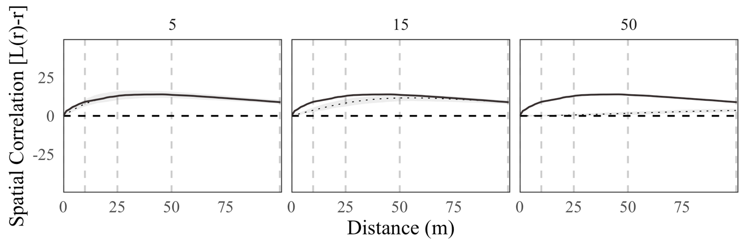 | Yes | No
D | 2002 | 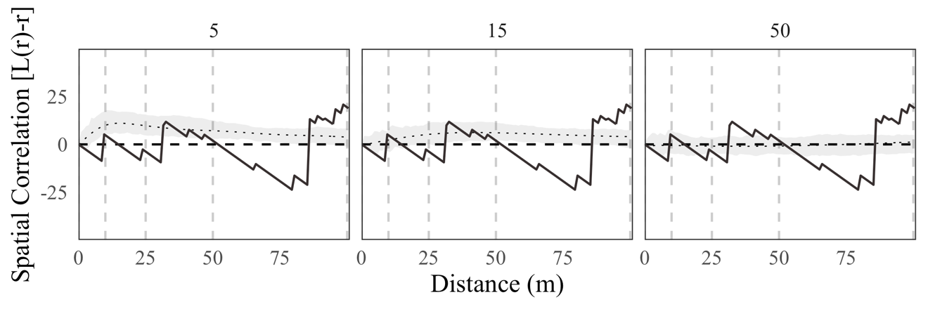 | X | X
 | 2003 | 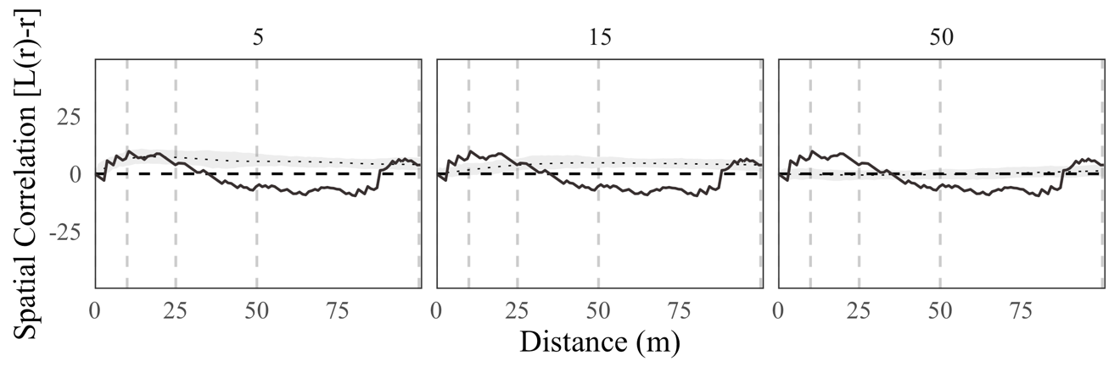 | Weak | Weak
 | 2004 | 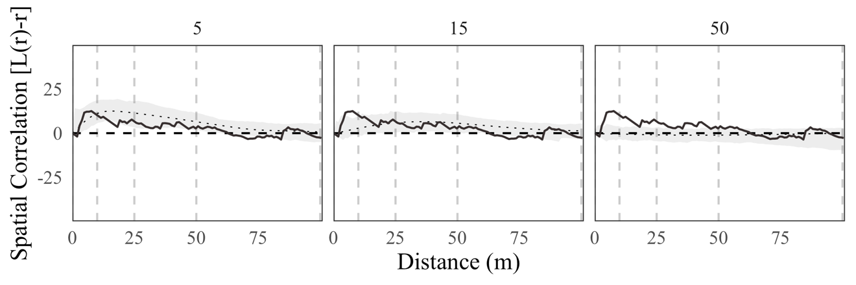 | Weak | No
 | 2005 | 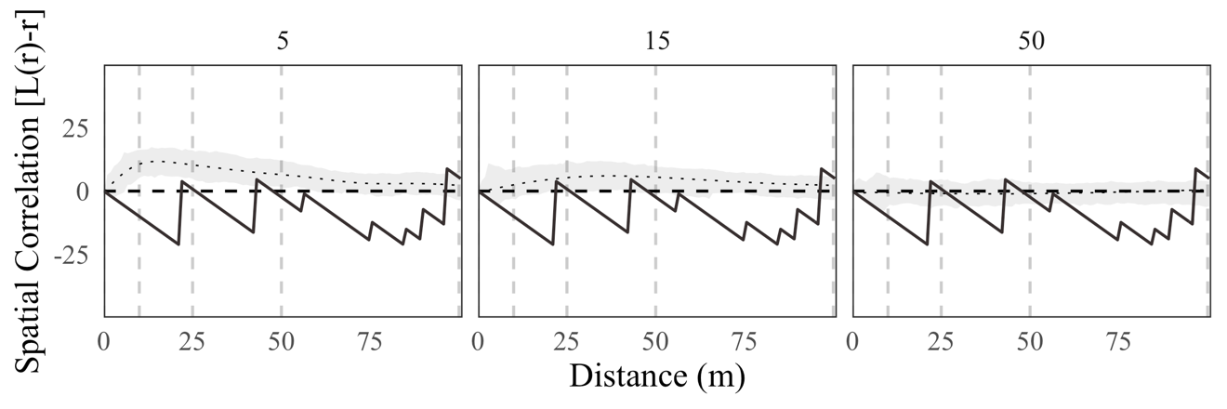 | X | X
E | 2001 | 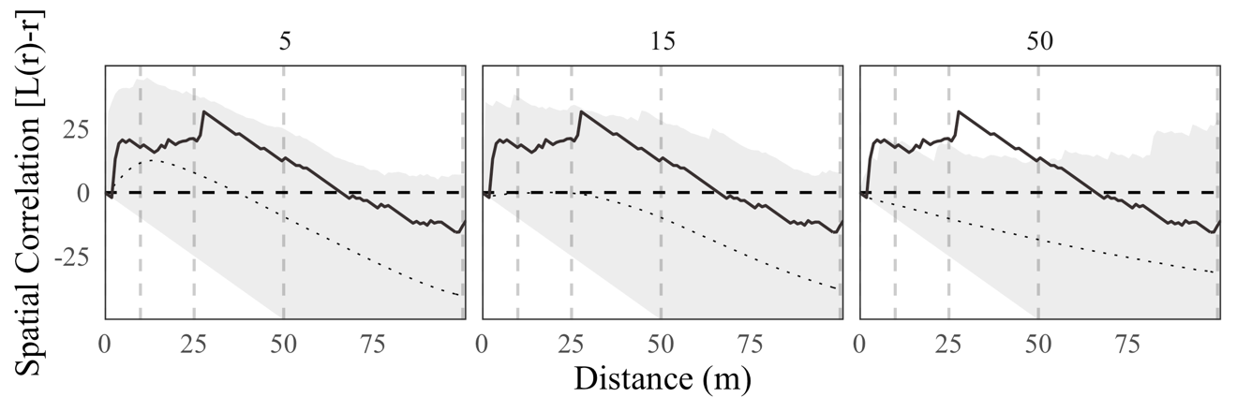 | No | No
 | 2002 | 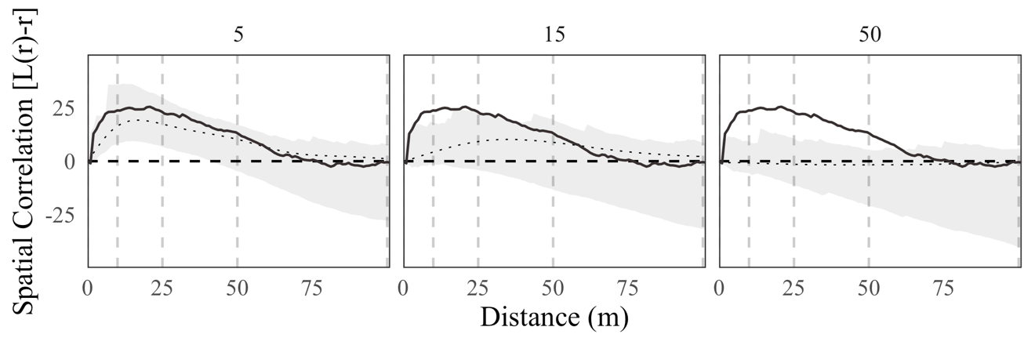 | Weak | No
 |  | 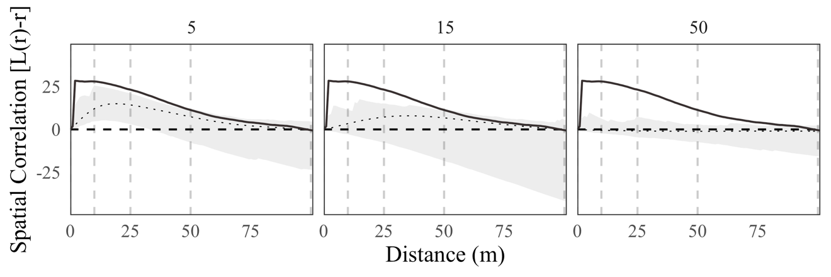 | Yes | No
F | 2002 | 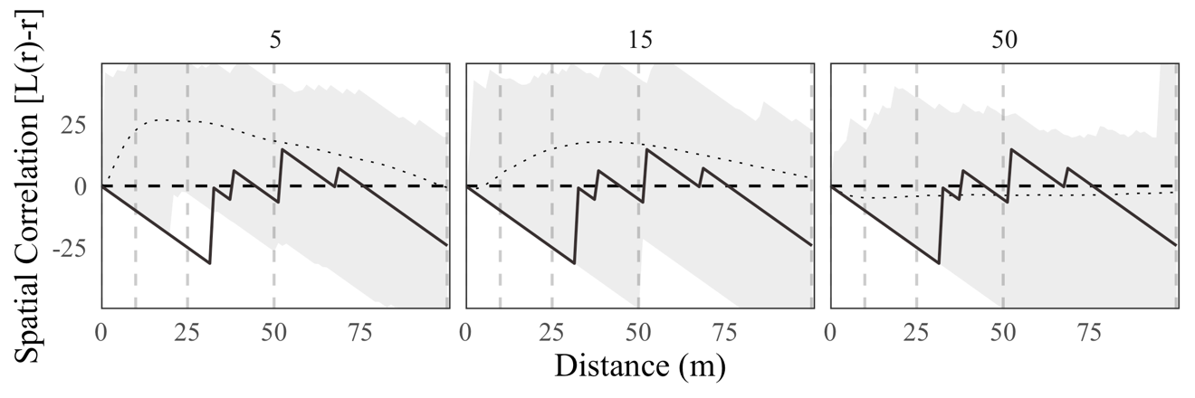 | X | X
 | 2003 | 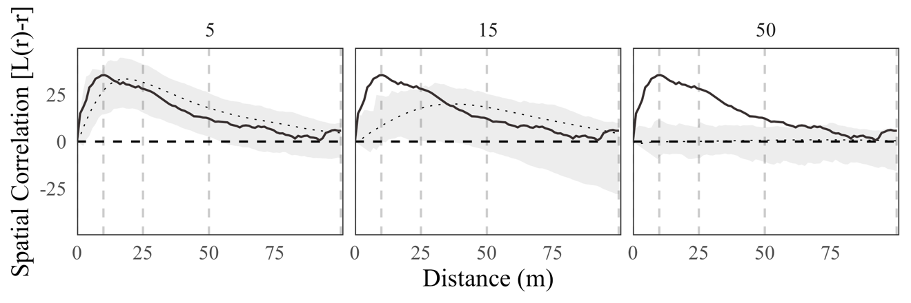 | Yes | No
 | 2004 | 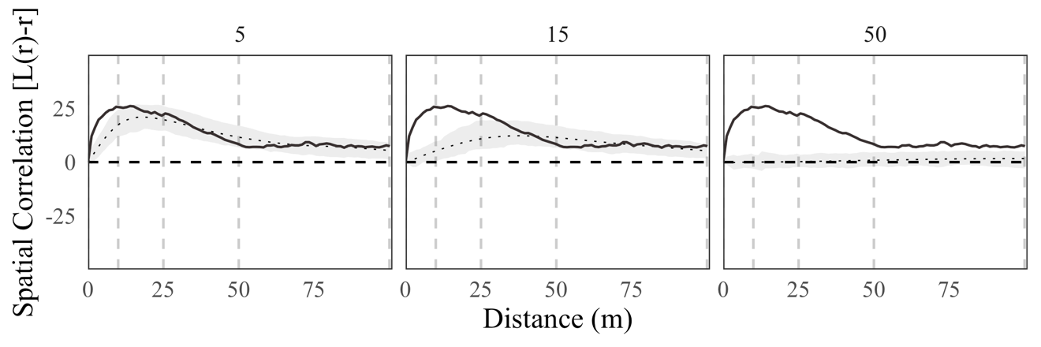 | Yes | No
 | 2005 | 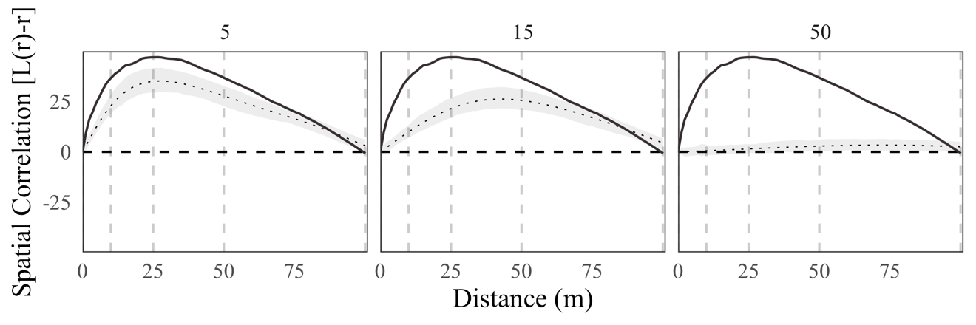 | Yes | No
G | 2002 | 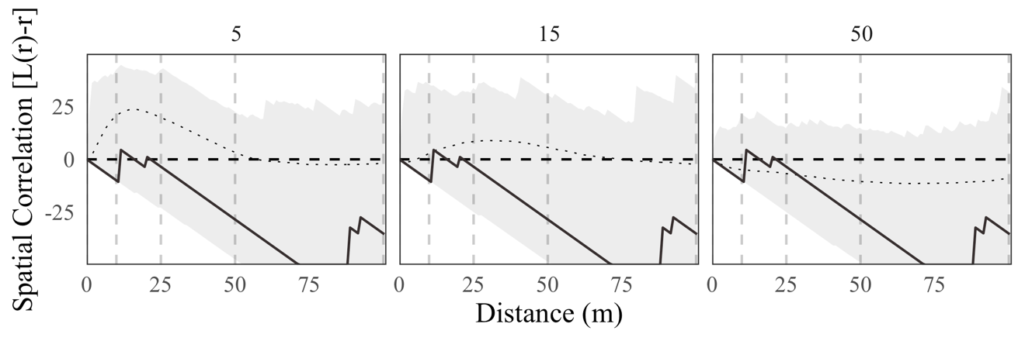 | X | X
 | 2003 | 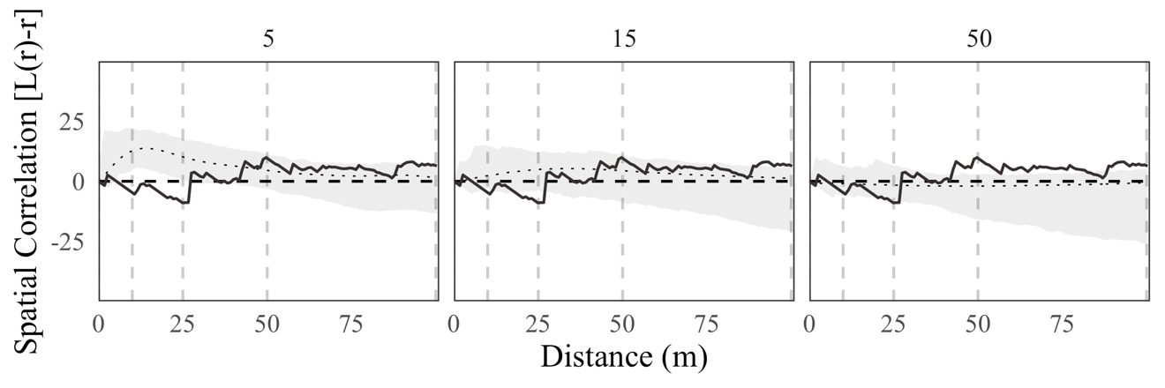 | No | No
 | 2004 | 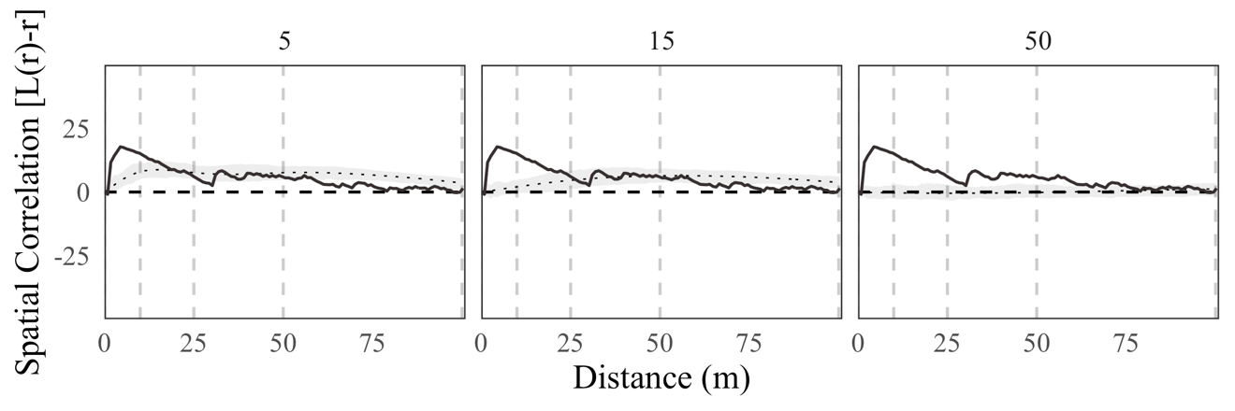 | Yes | No
 | 2005 | 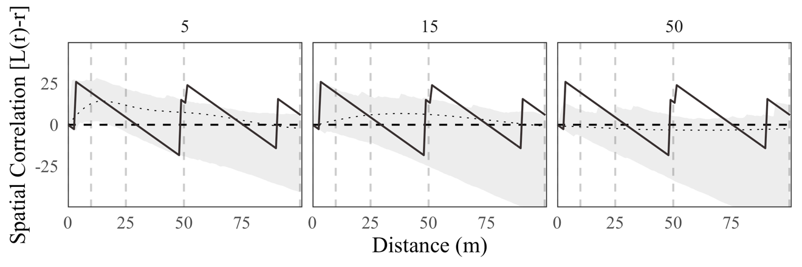 | X | X
 |  | Lower-Stem
A | 2000 | 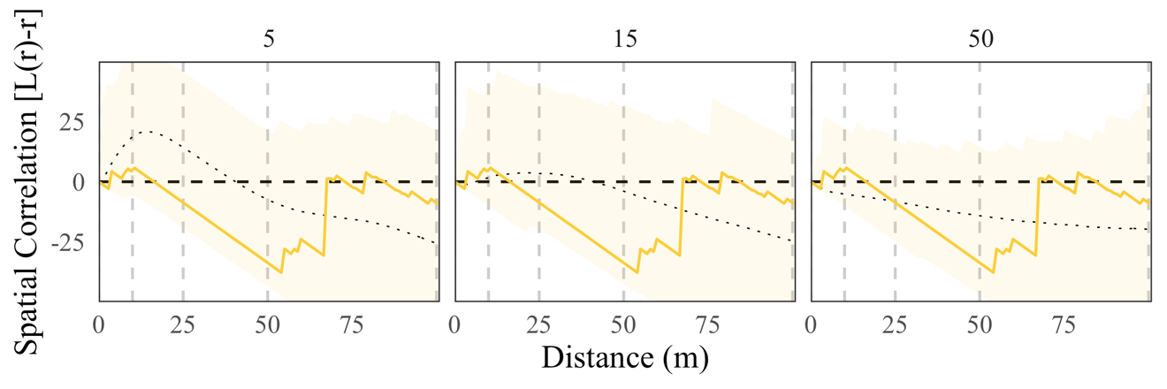 | No | No
 | 2001 | 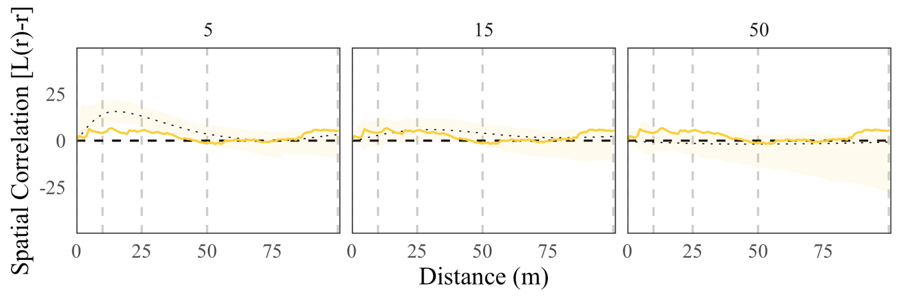 | No | No
 |  | 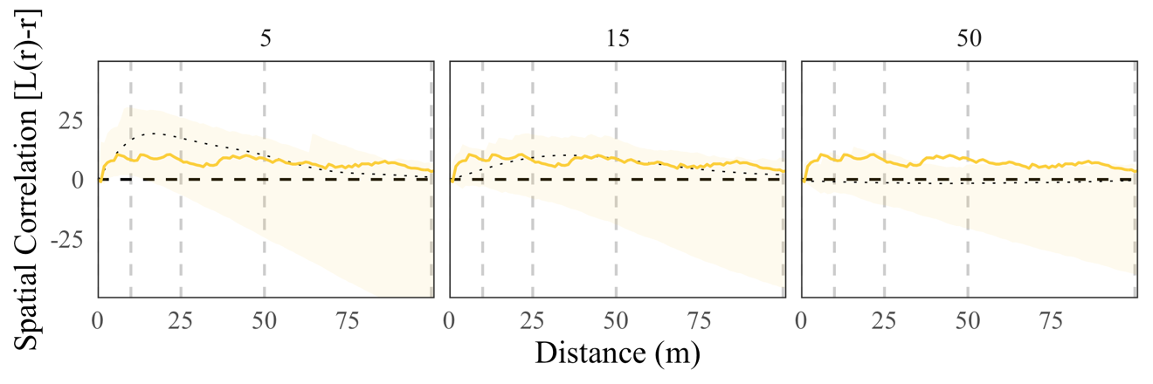 | No | No
 |  | 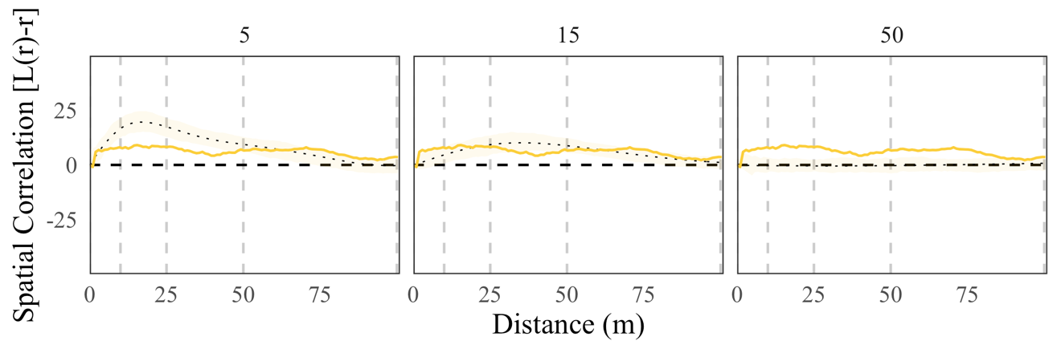 | No | No
 |  | 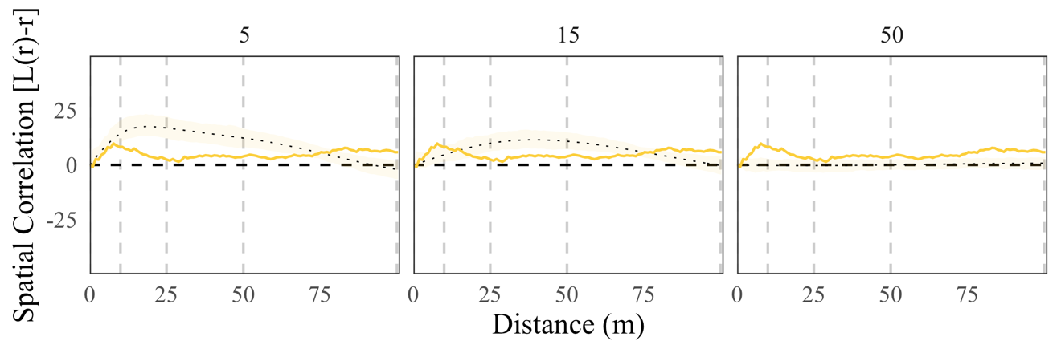 | No | No
 |  | 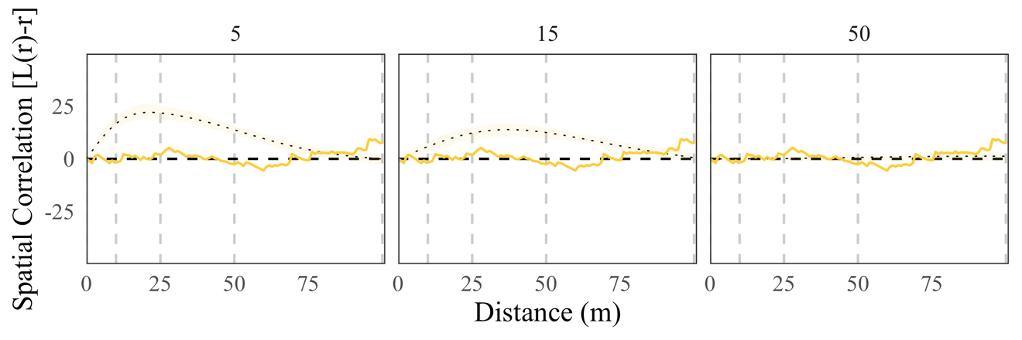 | No | No
B | 2000 | 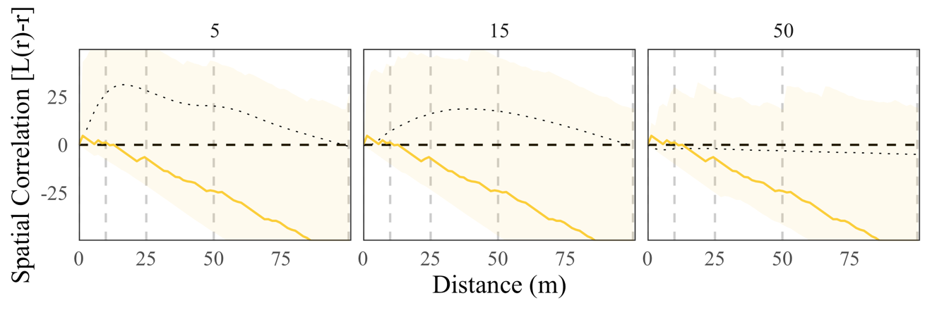 | No | No
 |  | 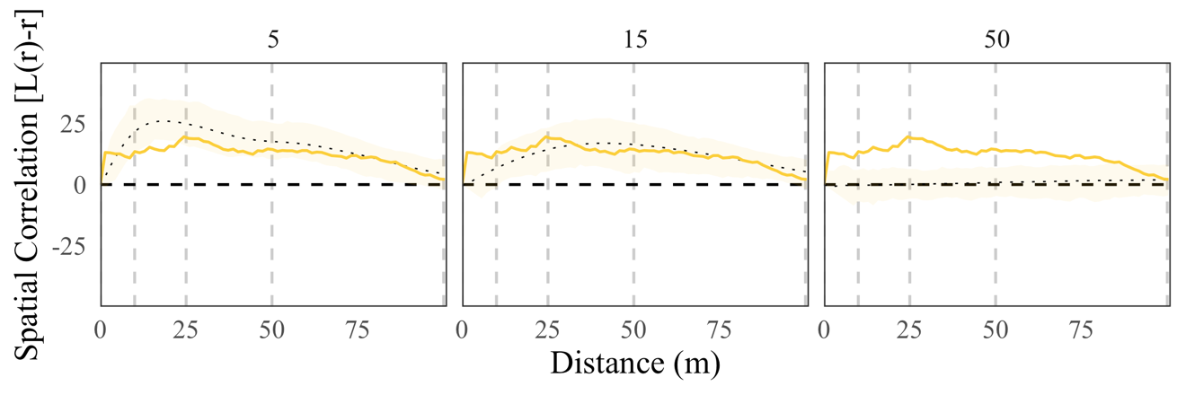 | No | No
 |  | 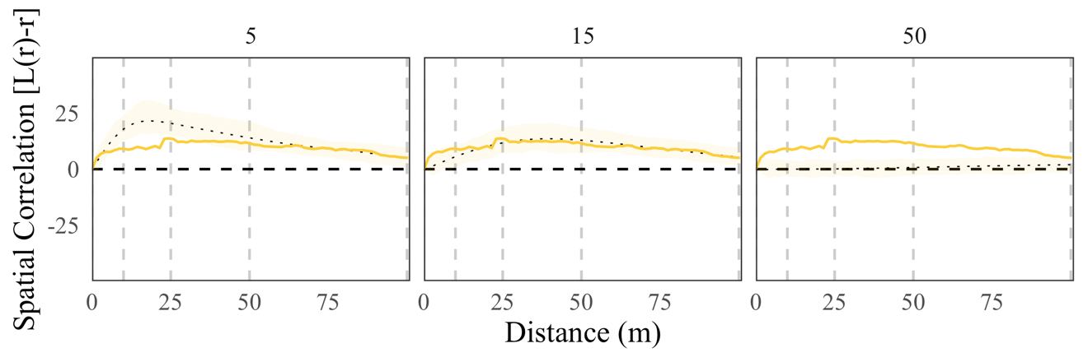 | No | No
 |  | 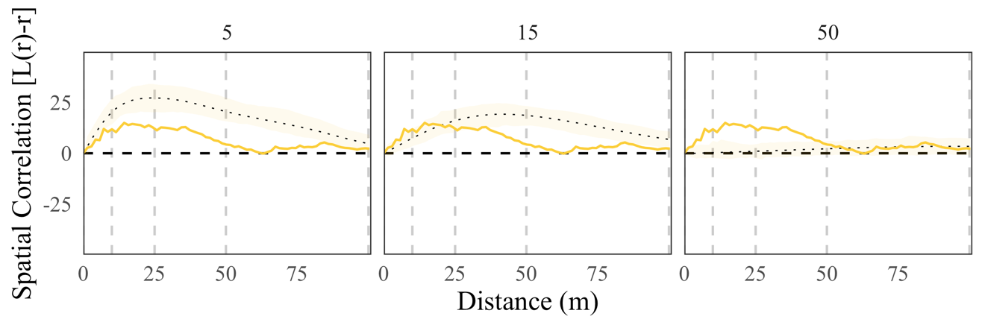 | No | No
D | 2001 | 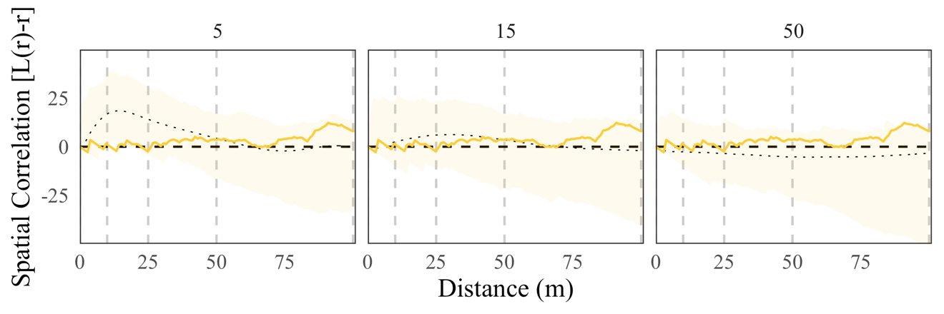 | No | No
 | 2002 | 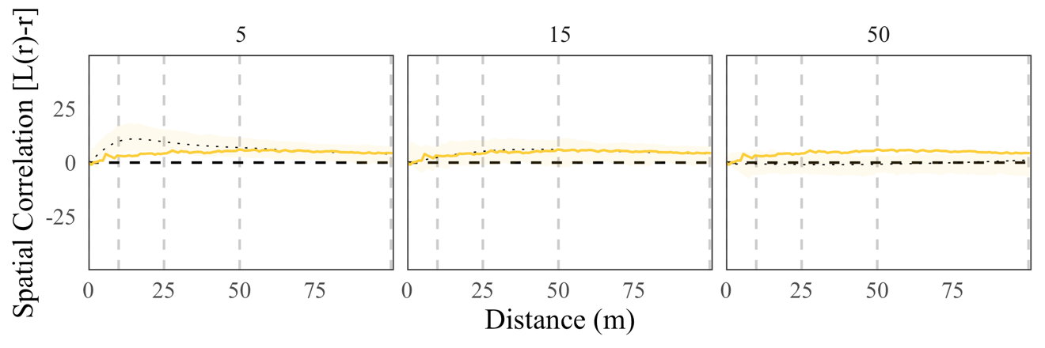 | No | No
 | 2003 | 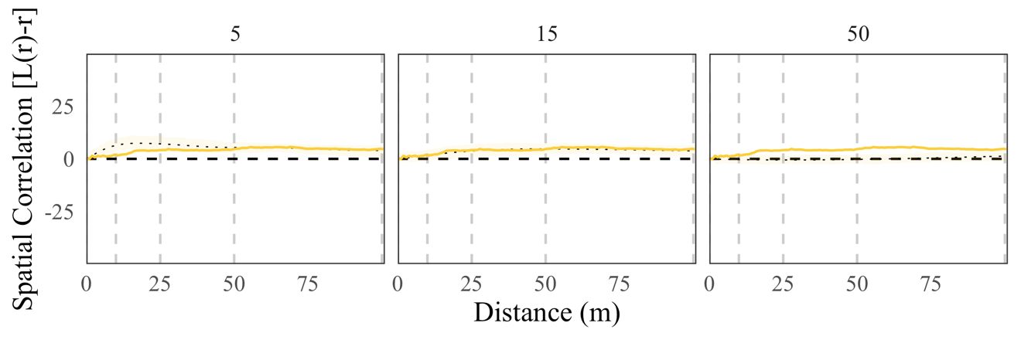 | No | No
 |  | 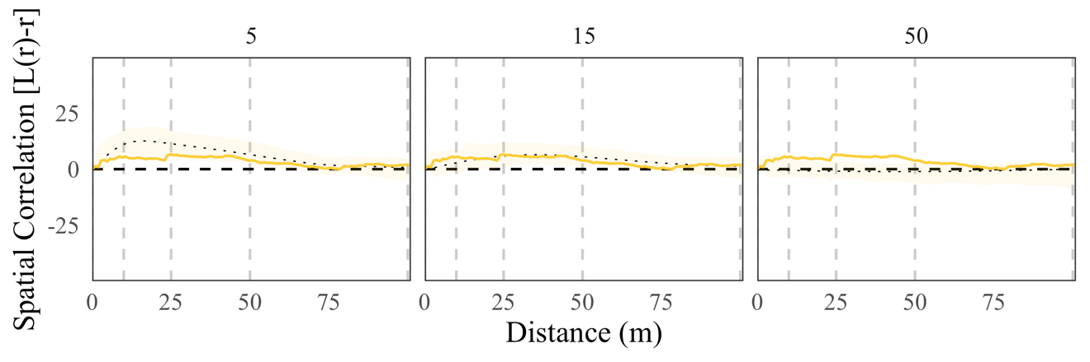 | No | No
 |  | 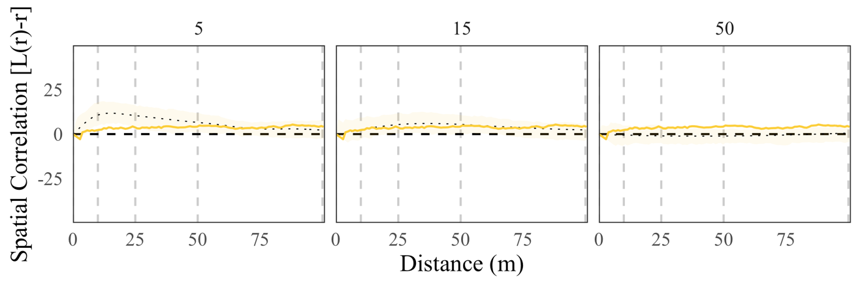 | No | No
E | 2001 | 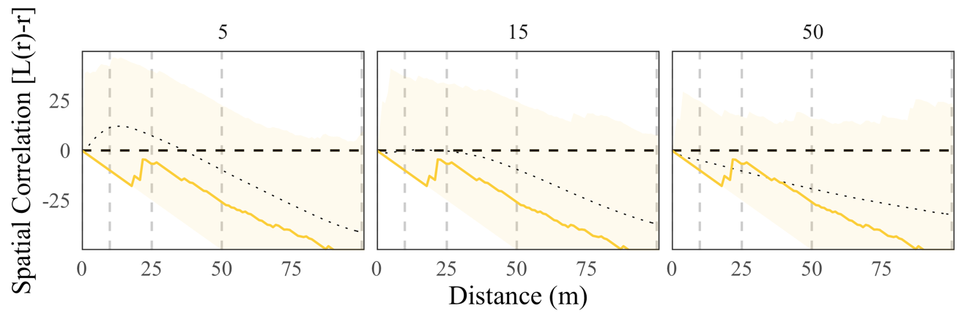 | No | No
 | 2002 |  | No | No
 | 2003 | 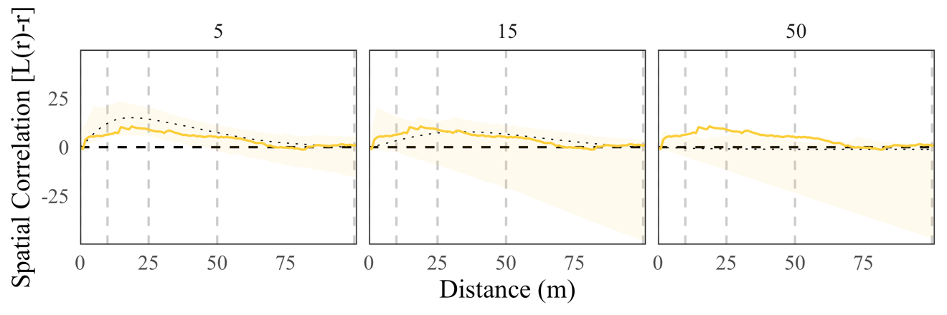 | No | No
F | 2002 | 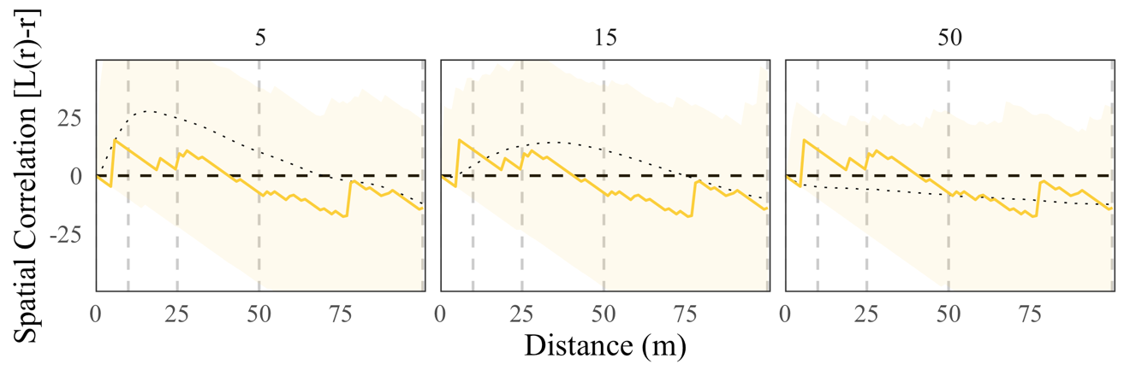 | No | No
 | 2003 | 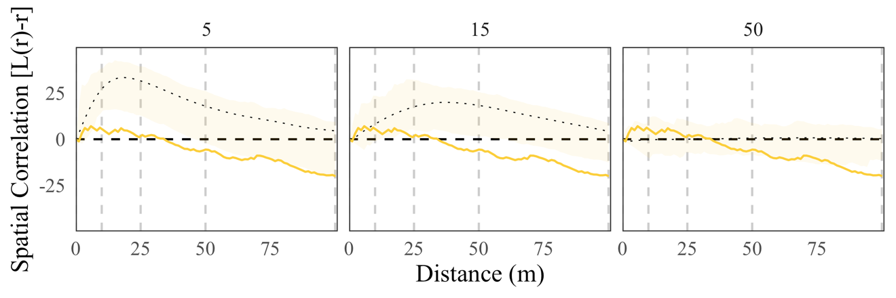 | No | No
 | 2004 | 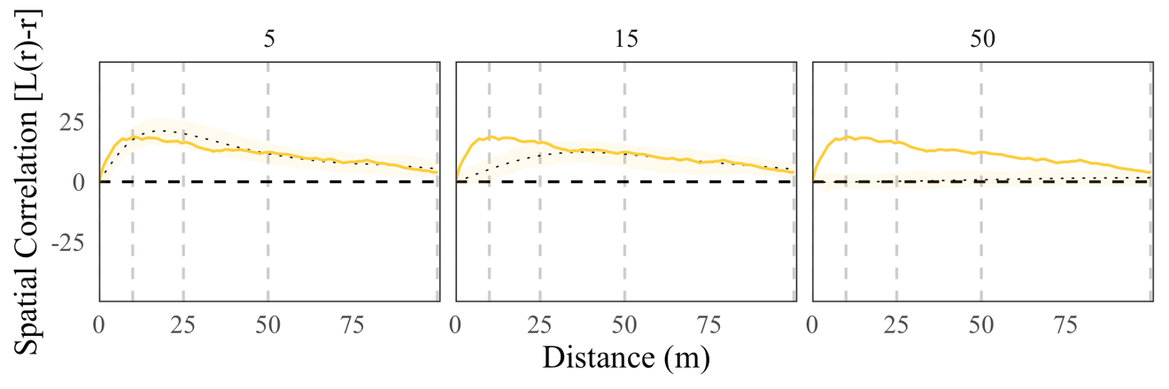 | Weak | Weak
 | 2005 | 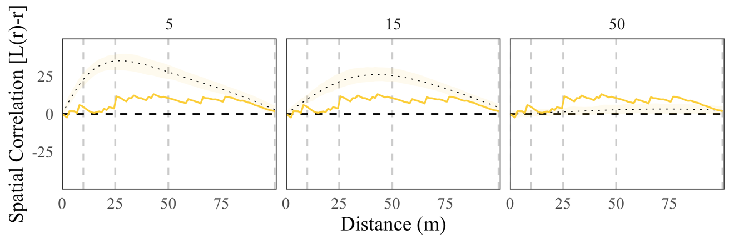 | No | No
G | 2002 | 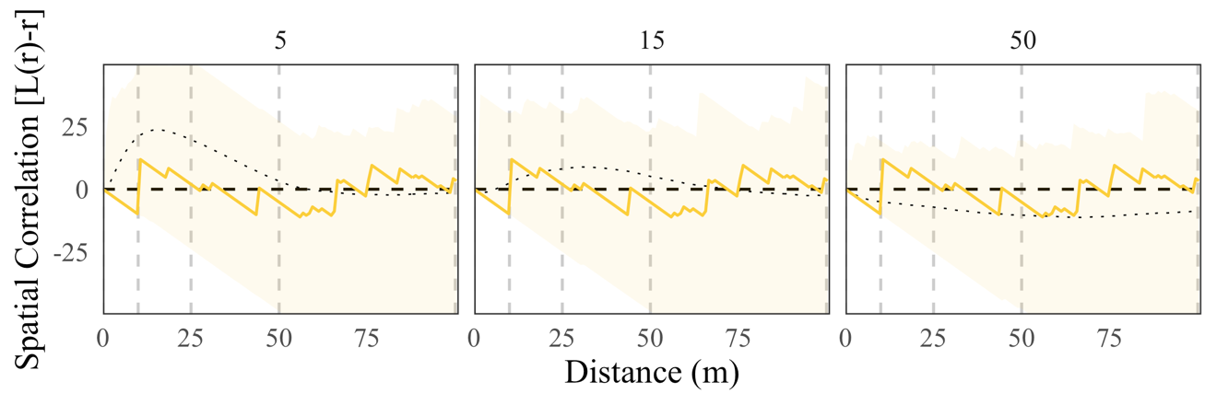 | No | No
 | 2003 | 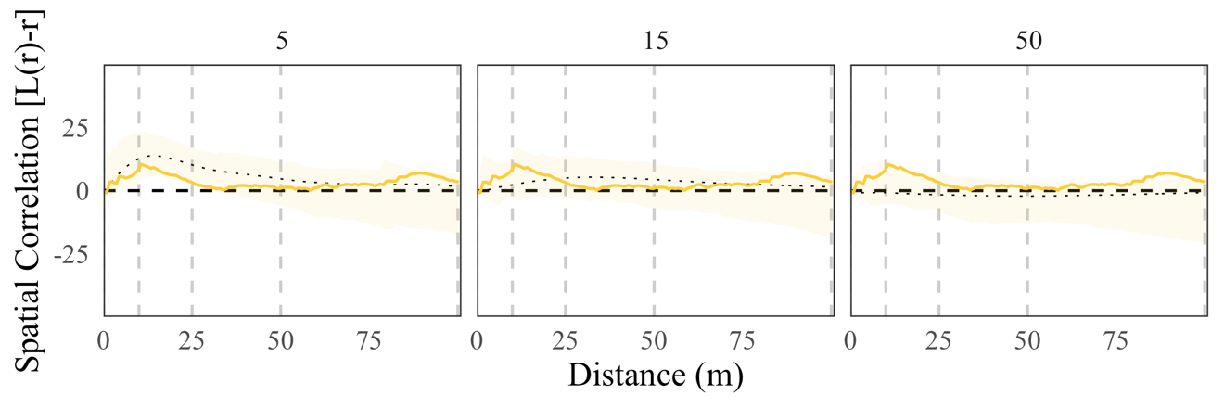 | No | No
 | 2004 | 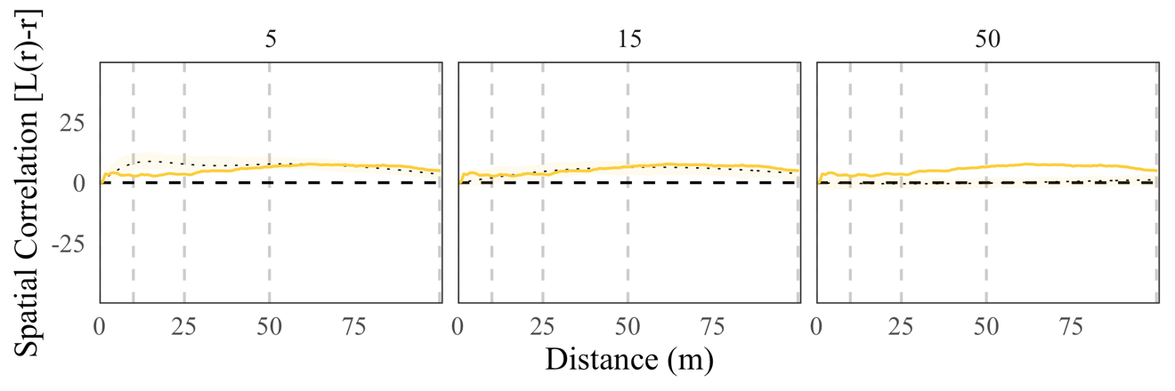 | No | No
 | 2005 | 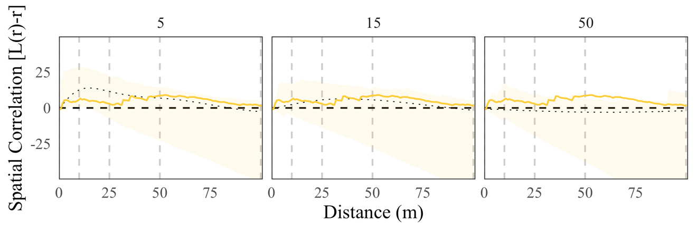 | No | No
 |  | Pulse-Driven
A | 2001 | 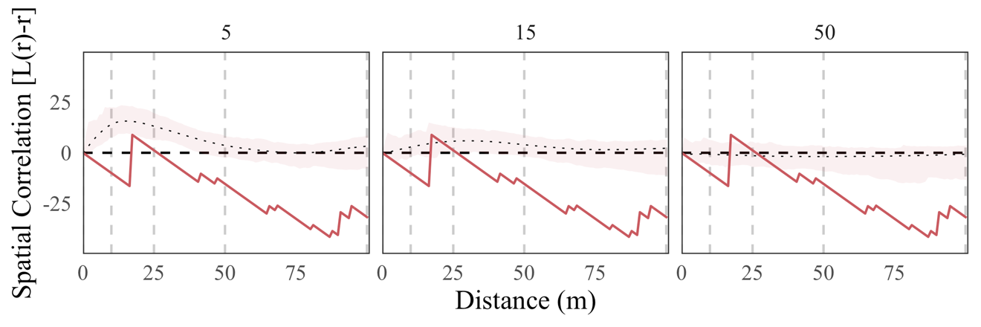 | X | X
 | 2002 | 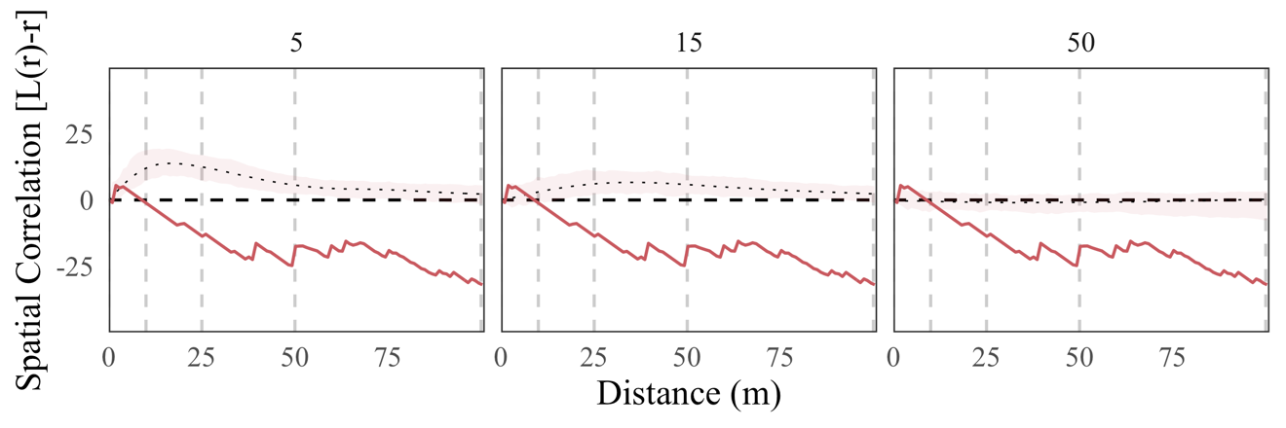 | No | Yes
 | 2003 | 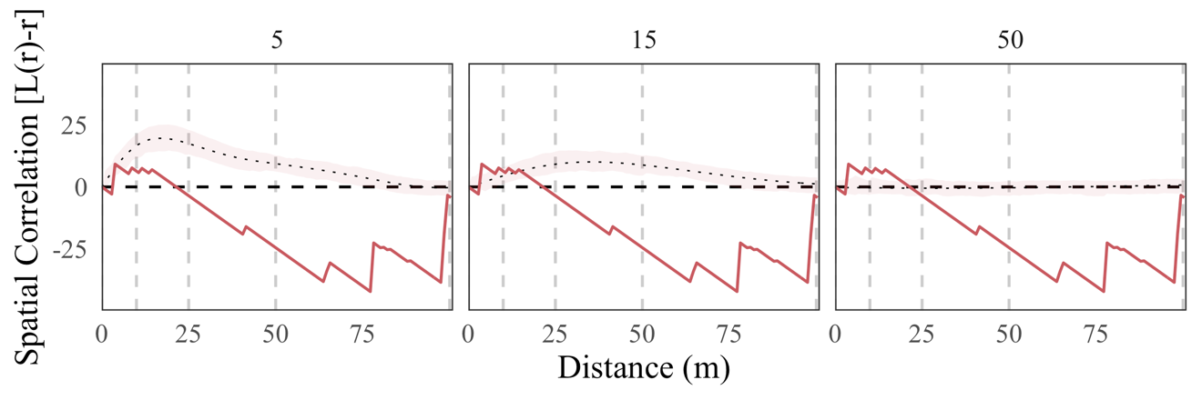 | No | Yes
B | 2002 | 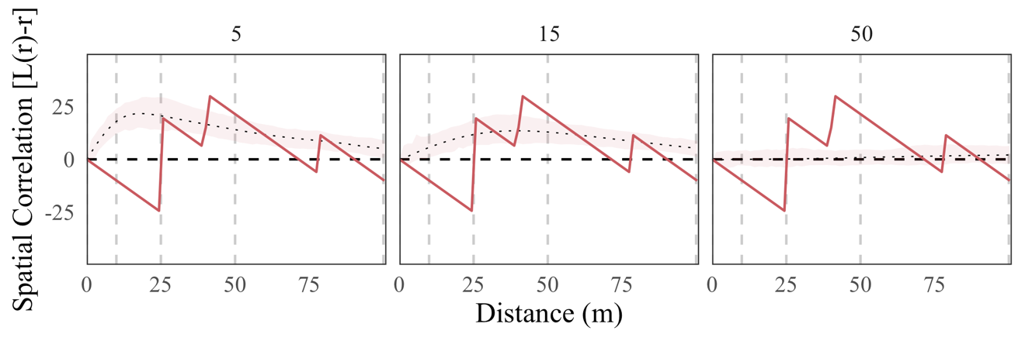 | X | X
 |  | 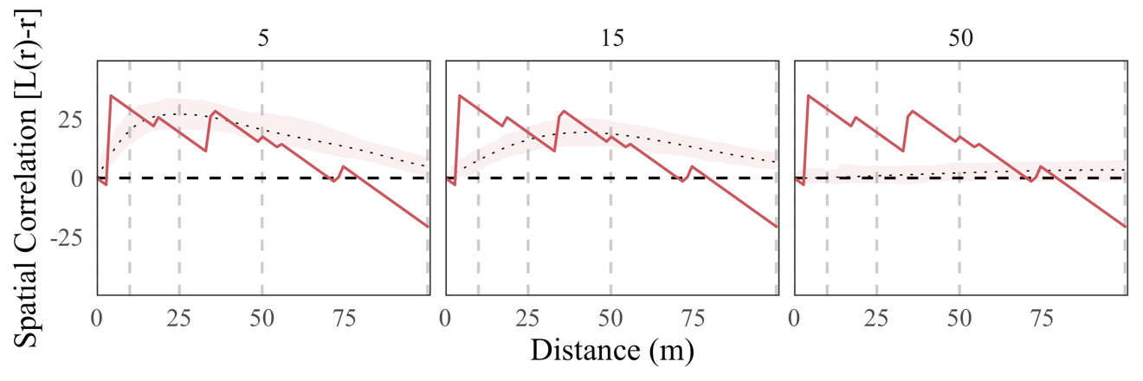 | X | X
D | 2003 | 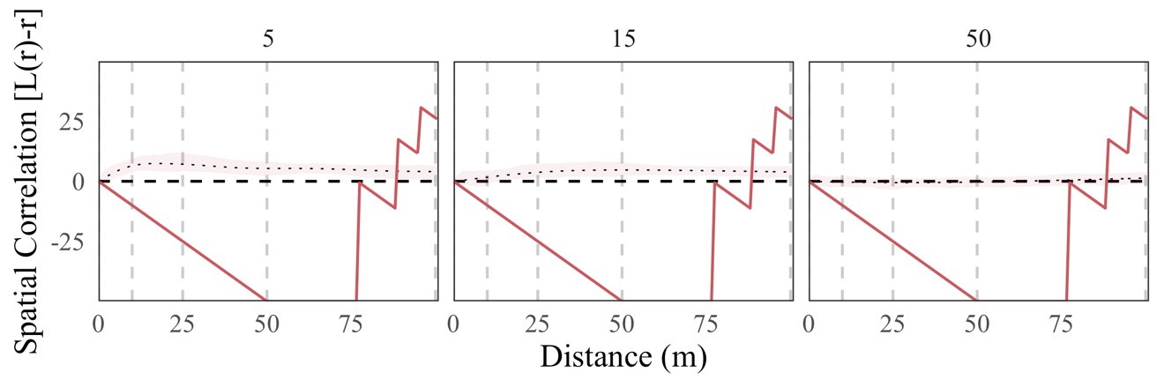 | X | X
E | 2003 | 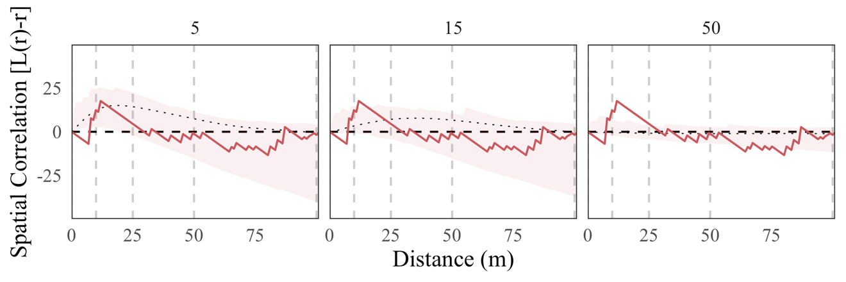 | No | No
F | 2005 | 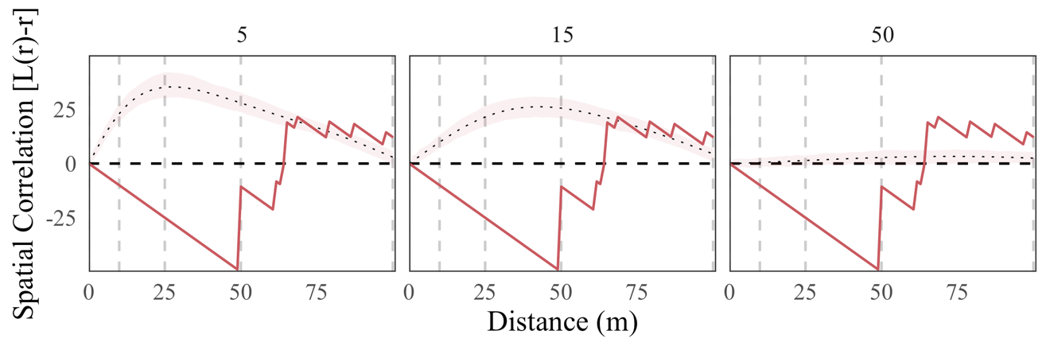 | X | X
G | 2004 | 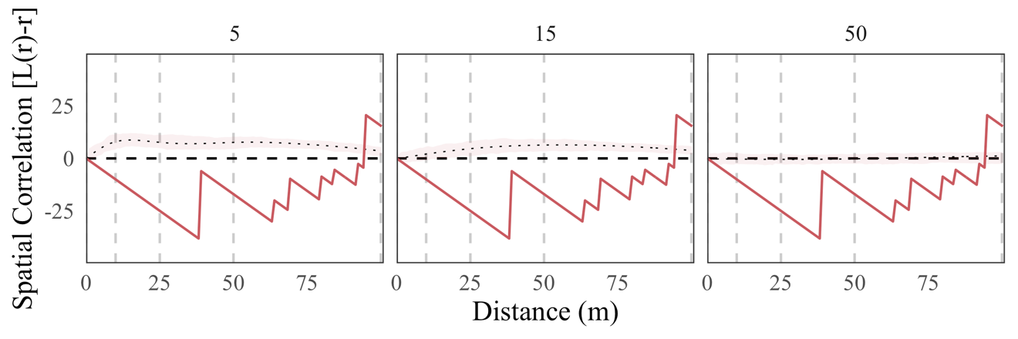 | X | X

