Supporting Information
Systematic Optimization and Predictive Modeling of CVD-Grown Monolayer WS₂ for Opto-Nanoelectronics Applications
M Bakhtiar Azimª*, Munim Shahriar Jawad^{b}, Ahsiur Rahman Nirjhar^{b}
ªSchool of Engineering Science, Simon Fraser University, 8888 University Dr W, Burnaby, BC V5A 1S6, Canada
^{b}Department of Materials and Metallurgical Engineering (MME), Bangladesh University of Engineering and Technology (BUET), East Campus, Dhaka-1000, Bangladesh
*Corresponding Author: mbazim31@gmail.com
a
b
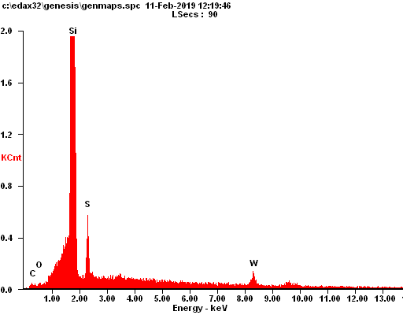
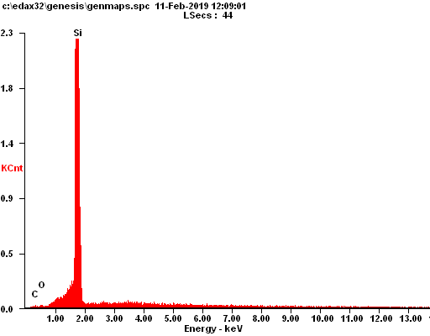
Figure S1: EDX of (a) bare substrate before CVD deposition and (b) As-grown monolayer WS₂ on substrate after CVD deposition

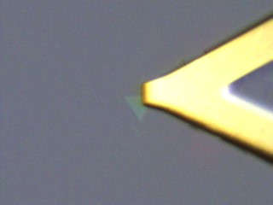
Figure S2: AFM operation on identified monolayer WS₂

