Supplementary material

Probabilistic Tsunami Hazard Assessment in The Lesser Sunda Islands

Shofia Karima^{1,2*}, Hamzah Latief³, Iyan E. Mulia⁴, Gandhi Napitupulu^{5,3}
^{1*}Master’s Degree in Earth Sciences, Faculty of Earth Science and Engineering, Bandung Institute of Technology, Jalan Ganesha No. 10, Bandung, 100190, Indonesia.
²Research Center for Geological Disaster, National Research and Innovation Agency, Bandung 40293, Indonesia
³Environmental and Applied Oceanography Research Group, Faculty of Earth Science and Technology, Bandung Institute of Technology, Bandung 40132, Indonesia
⁴Faculty of Earth Science and Technology, Bandung Institute of Technology, Bandung 40132, Indonesia
⁵Coastal Hazards and Energy System Science Laboratory, Graduate School of Innovation and Practice for Smart Society, Hiroshima University, Hiroshima, 739-8529, Japan
shof002@brin.go.id

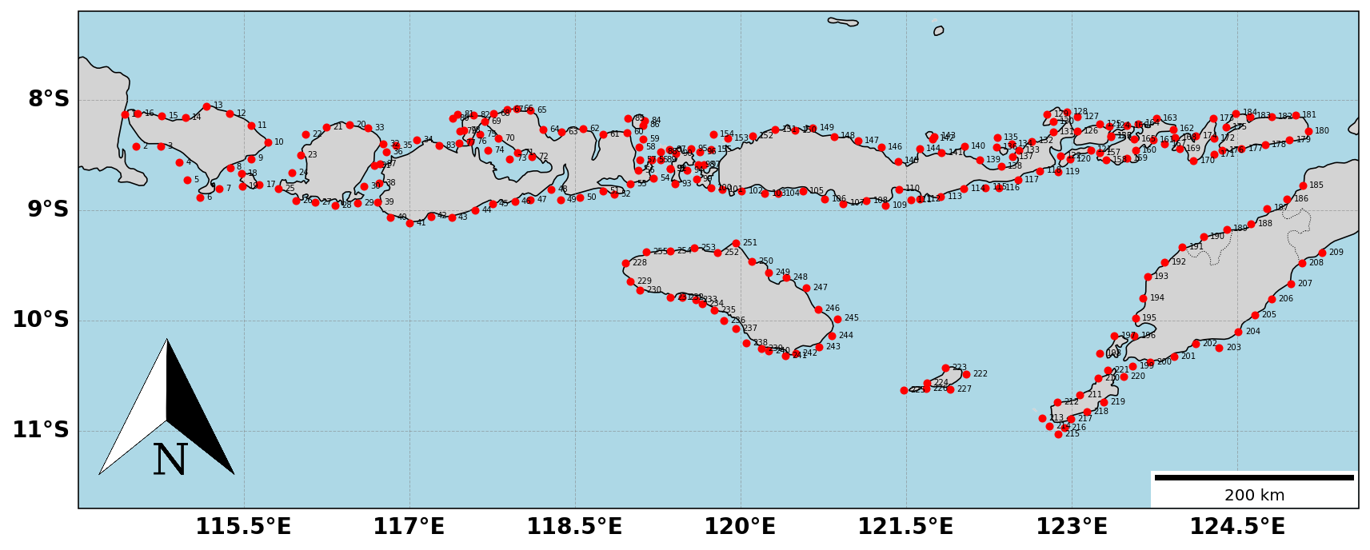
(a)
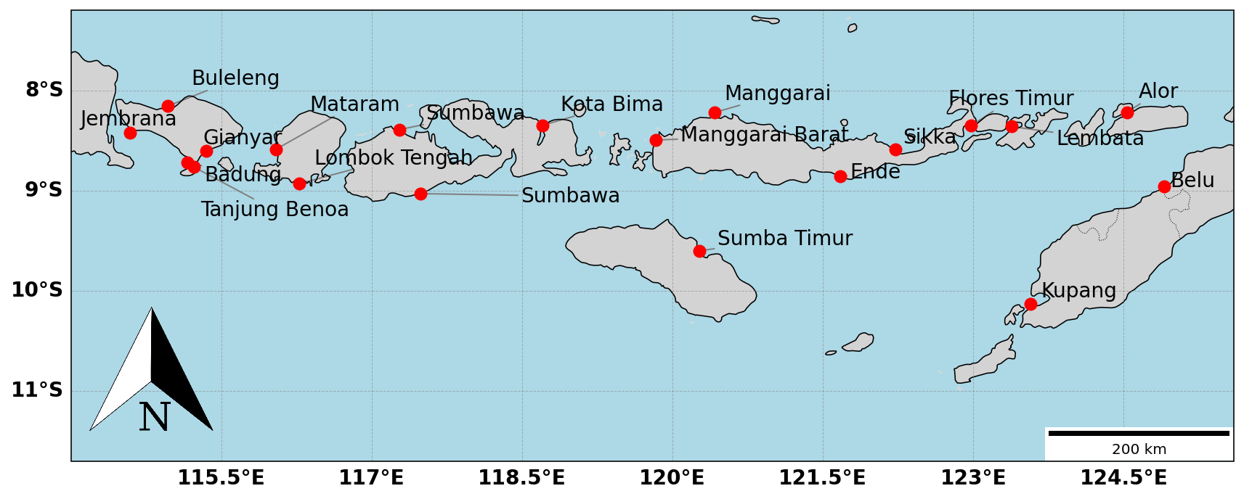
(b)
Supplementary Fig. 1 The location of (a) 255 points of interest and (b) 20 strategic locations.
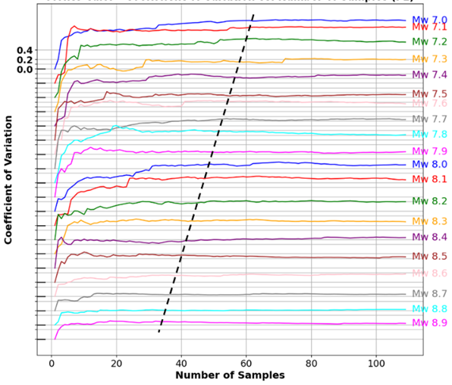
Supplementary Fig. 2 Monte Carlo analysis for East Java Subduction

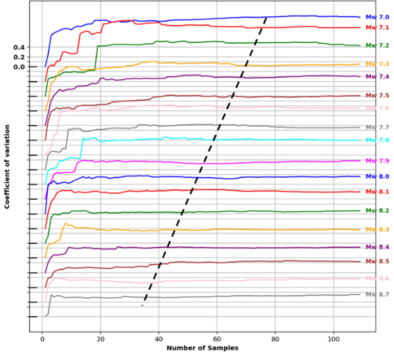
Supplementary Fig. 3 Monte Carlo analysis for Bali Subduction
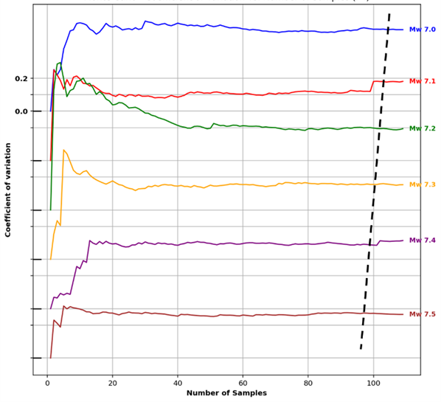
Supplementary Fig. 4 Monte Carlo analysis for Timor FTB 1

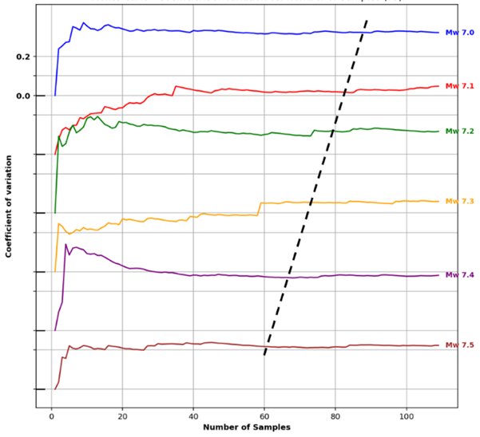
Supplementary Fig. 5 Monte Carlo analysis for Timor FTB 2

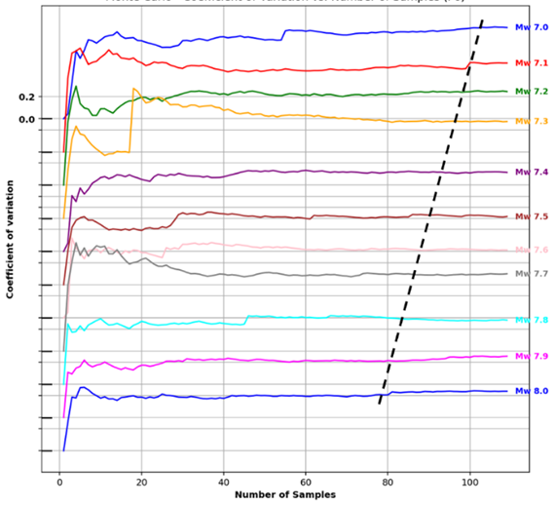
Supplementary Fig. 6 Monte Carlo analysis for Timor FTB 3

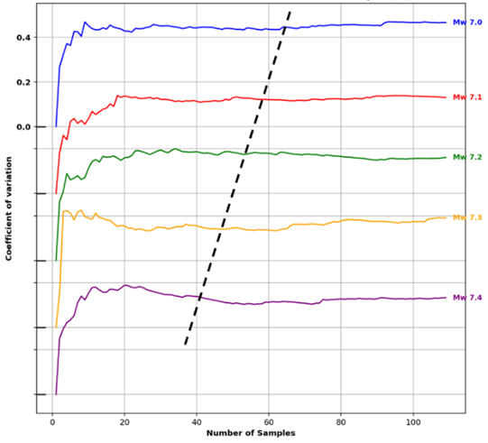
Supplementary Fig.7 Monte Carlo analysis for Bali Thrust

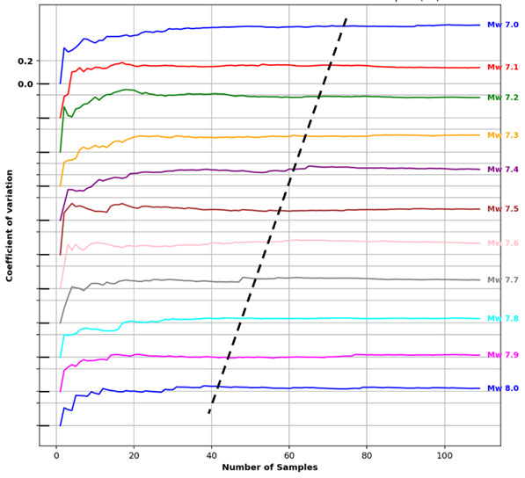
Supplementary Fig. 8 Monte Carlo analysis for Sumbawa Thrust.

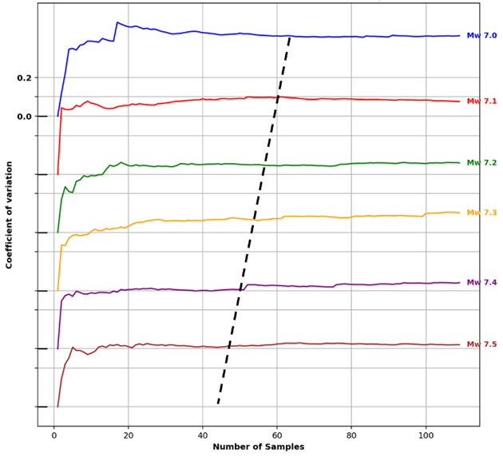
Supplementary Fig. 9 Monte Carlo analysis for Flores Thrust 1.

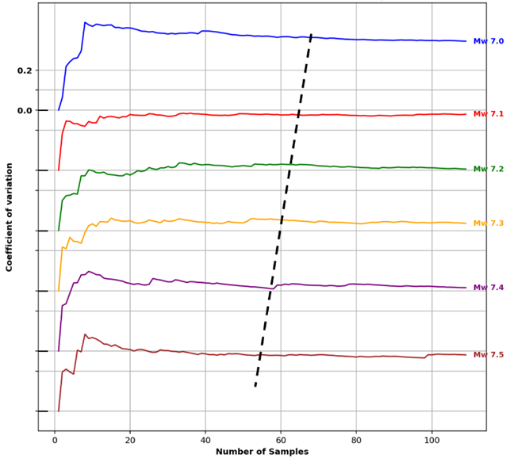
Supplementary Fig. 10 Monte Carlo analysis for Flores Thrust 2

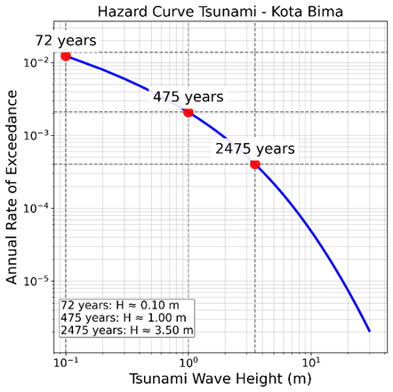 | 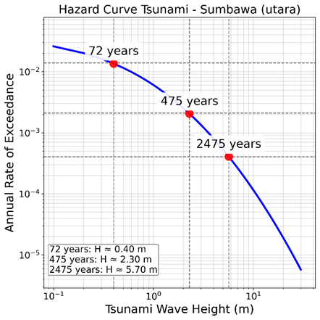
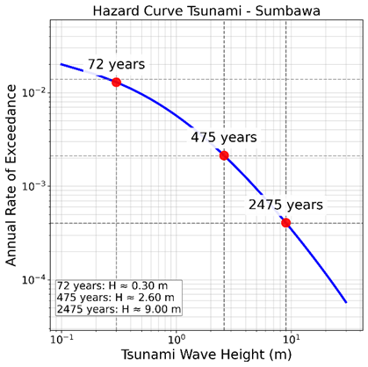 | 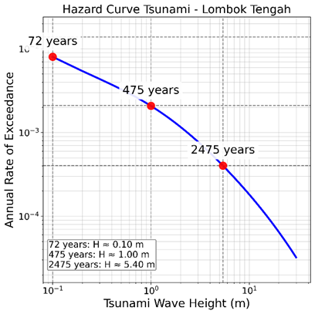
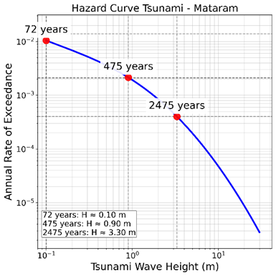
Supplementary Fig. 11 Hazard curves for strategic location in NTB

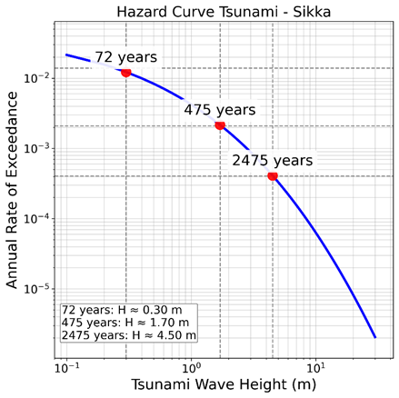 | 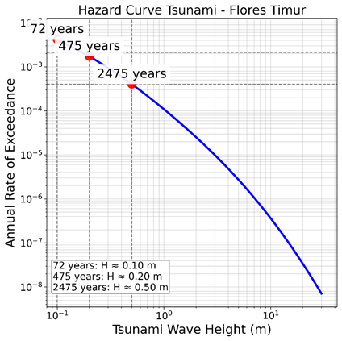
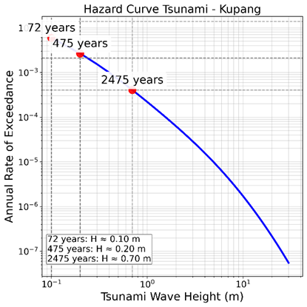 | 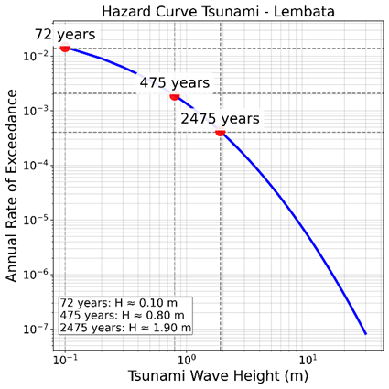
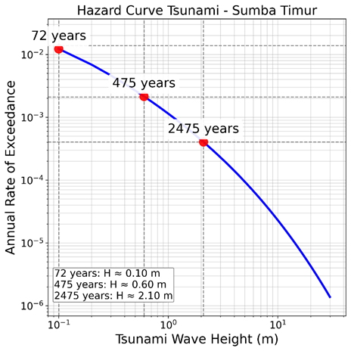 | 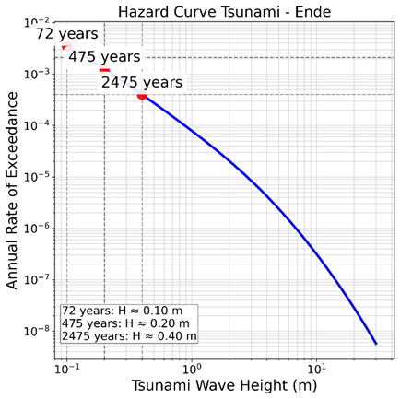
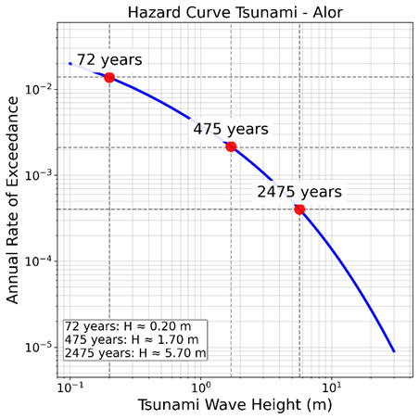 | 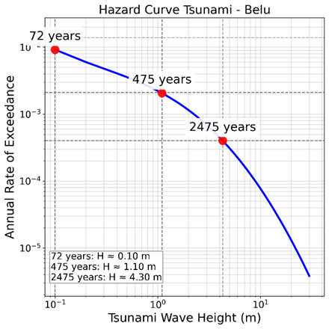
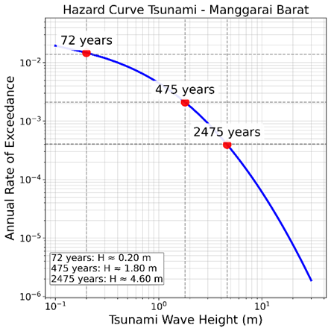 | 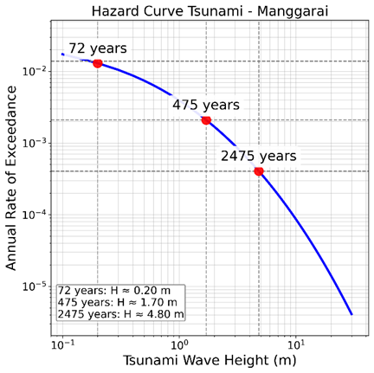
Supplementary Fig. 12 Hazard curves for strategic location in NTT

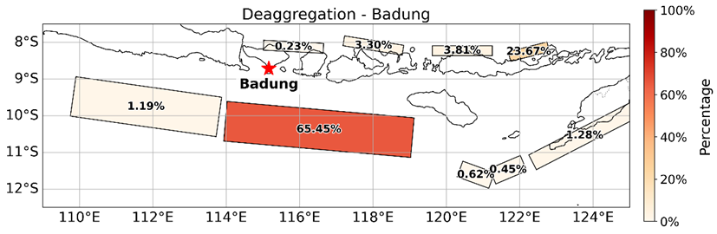
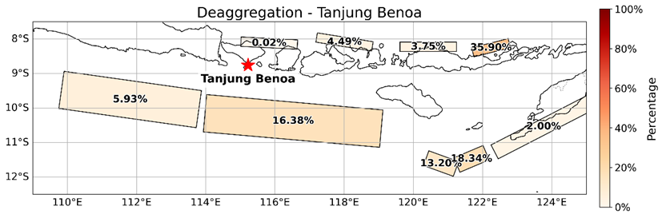
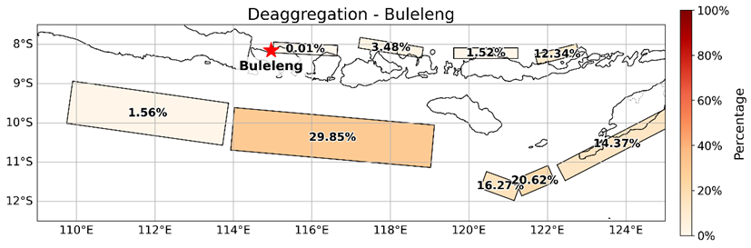
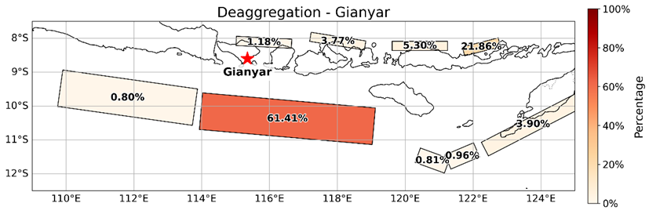
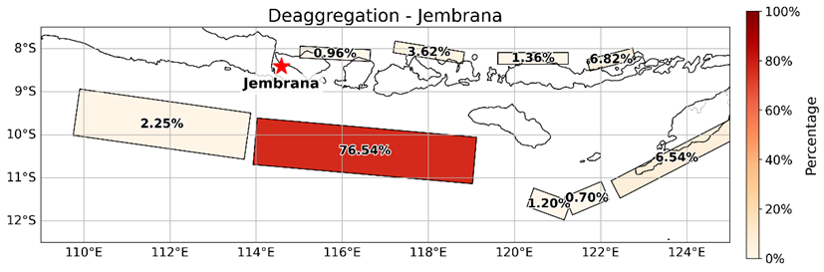
Supplementary Fig. 13 Deaggregation for 5 locations in Bali (RP 475 years)

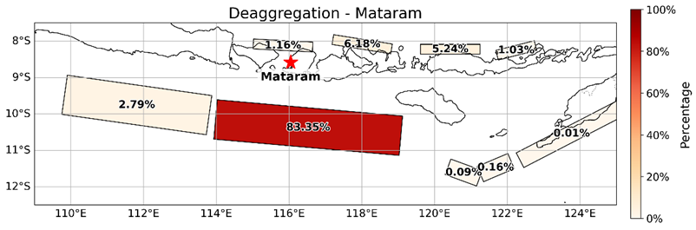
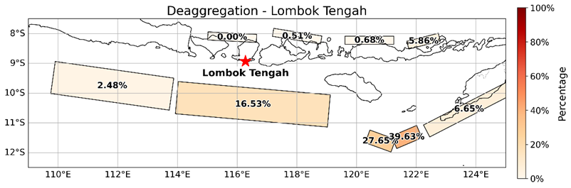
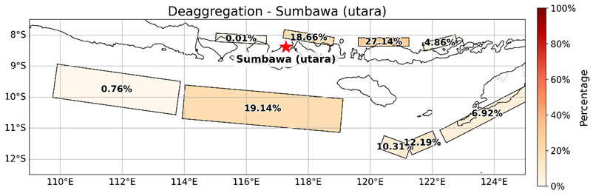
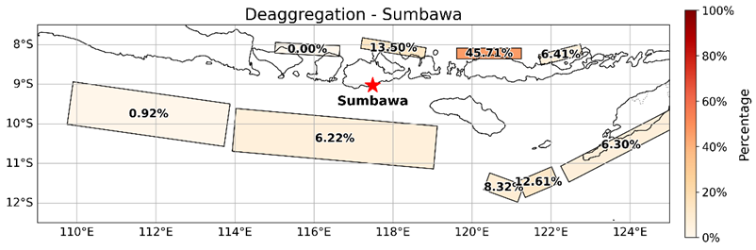
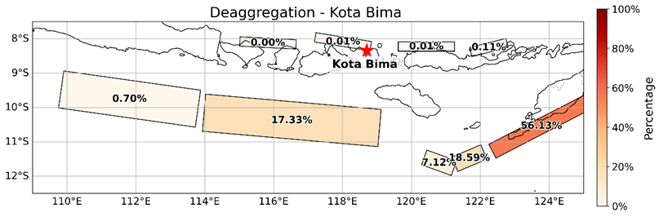
Supplementary Fig. 13 Deaggregation for 5 locations in NTB (RP 475 years)

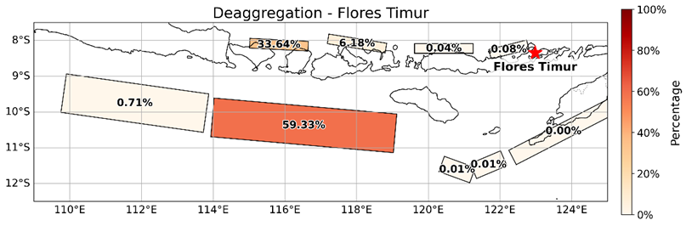
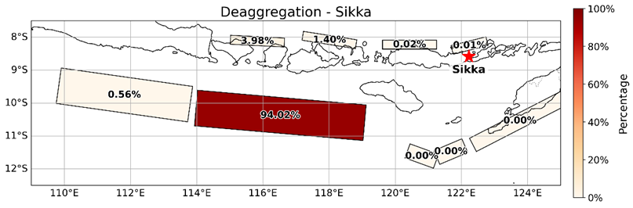
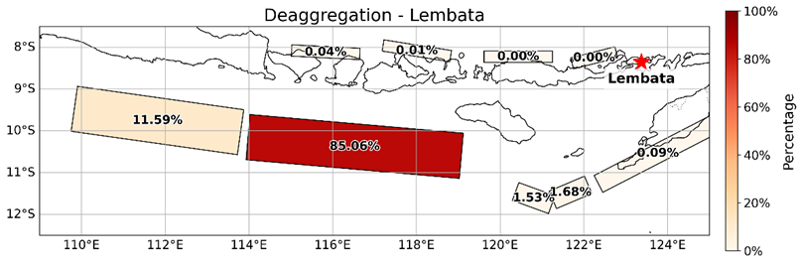
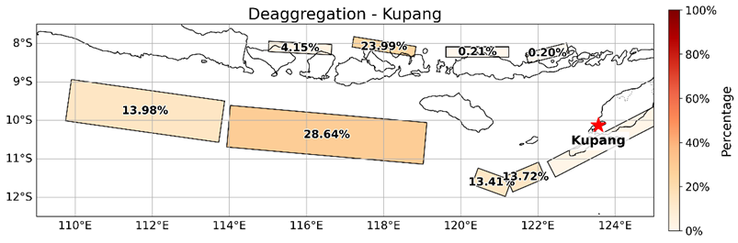
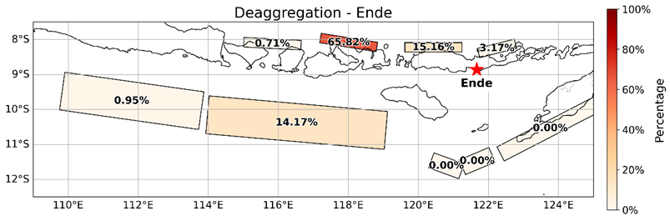
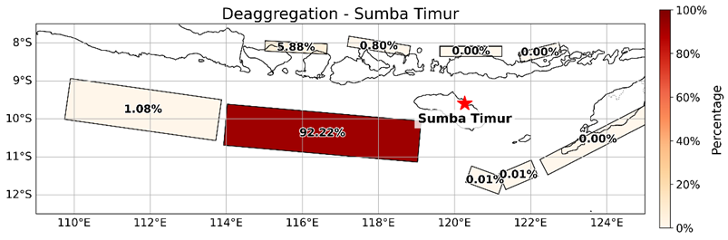
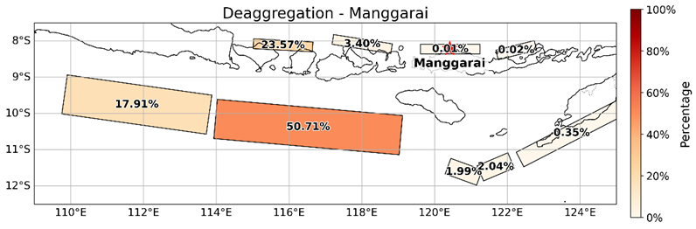
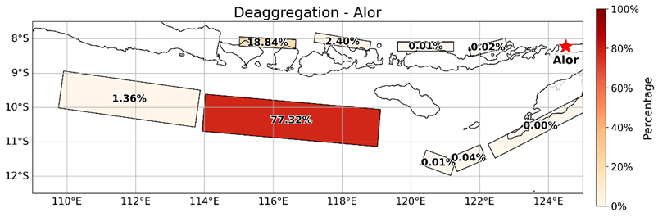
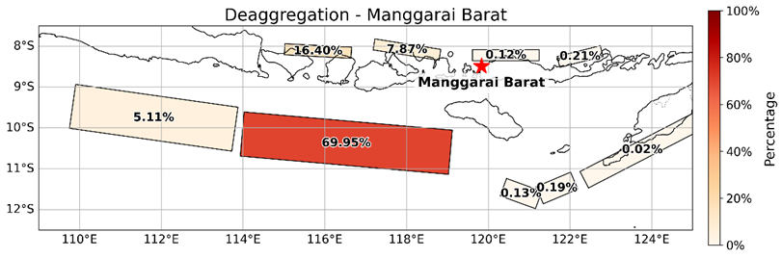
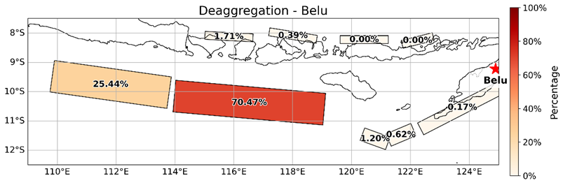
Supplementary Fig. 13 Deaggregation for 10 locations in NTT (RP 475 years)

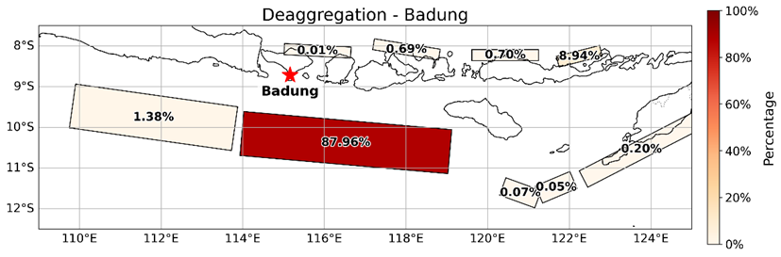
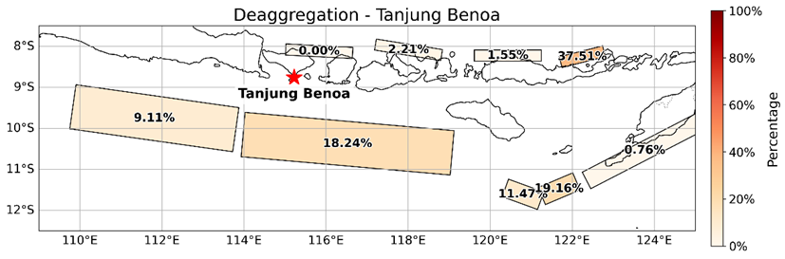
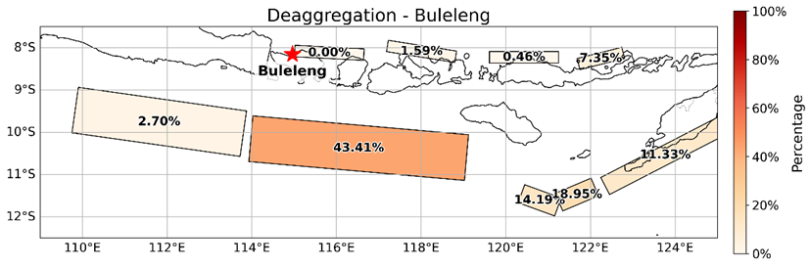
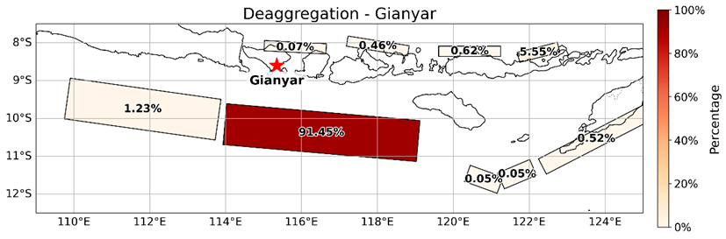
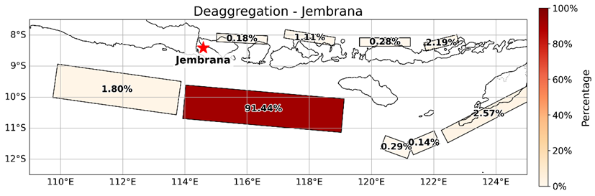
Supplementary Fig. 14 Deaggregation for 5 locations in Bali (RP 2475 years)

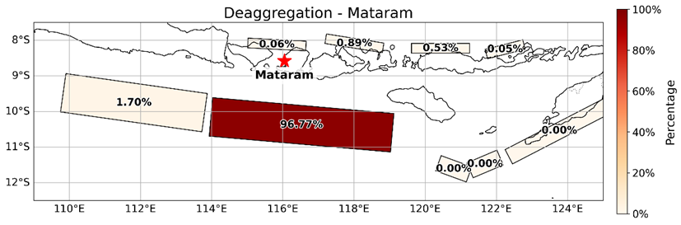
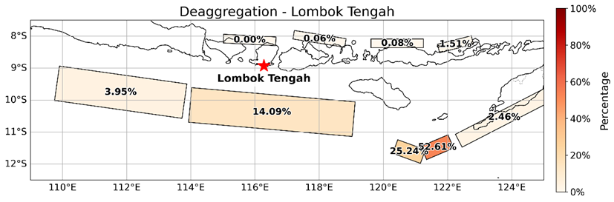
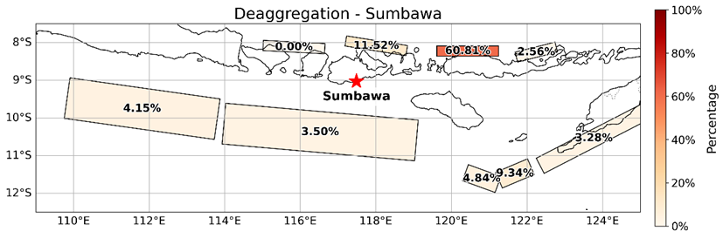
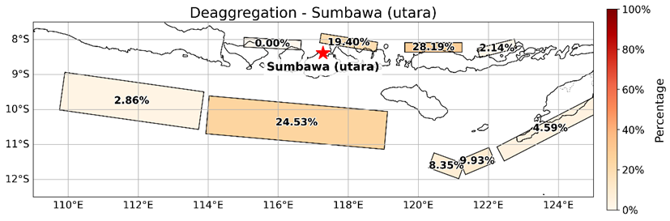
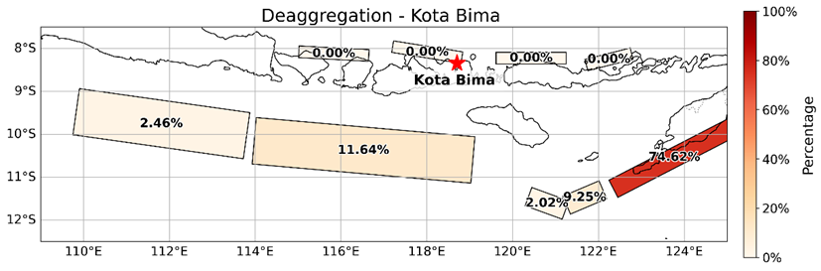
Supplementary Fig. 15 Deaggregation for 5 locations in NTB (RP 2475 years)

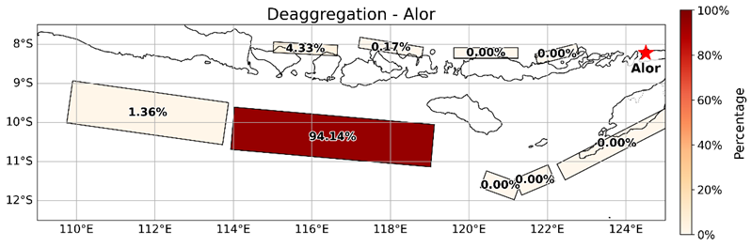
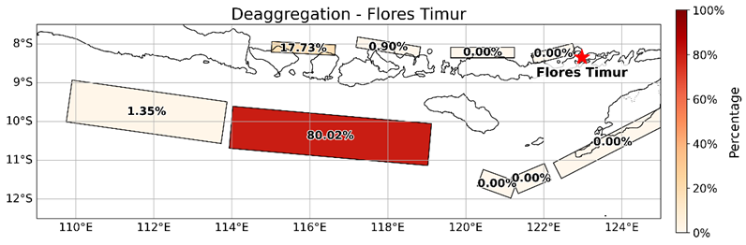
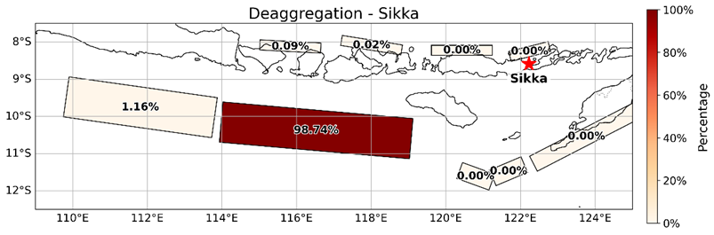
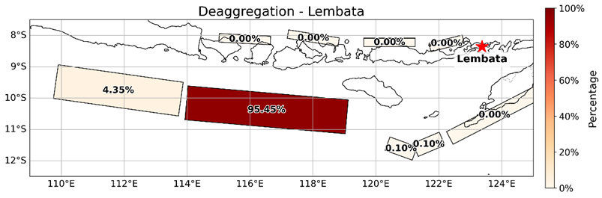
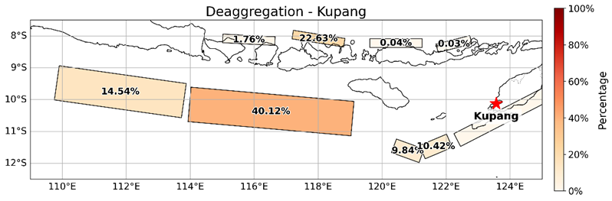
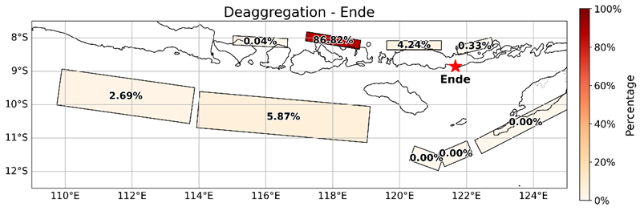
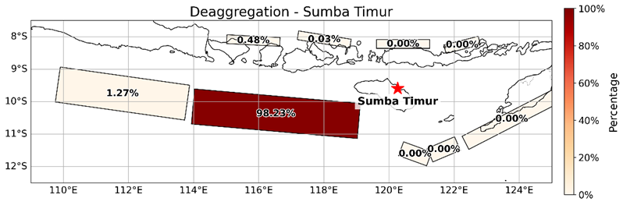
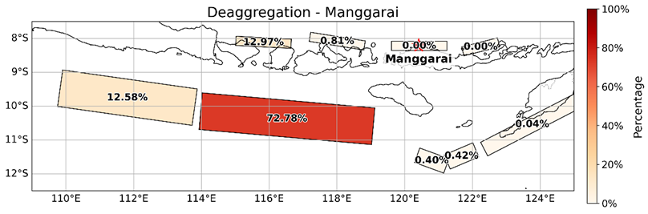
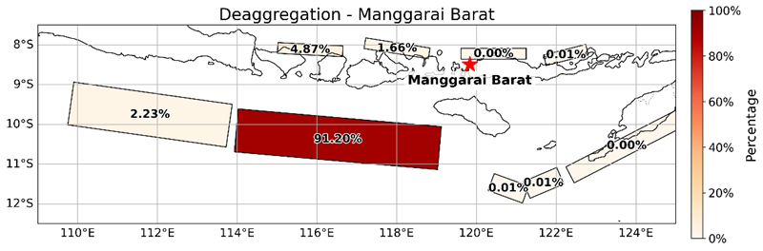
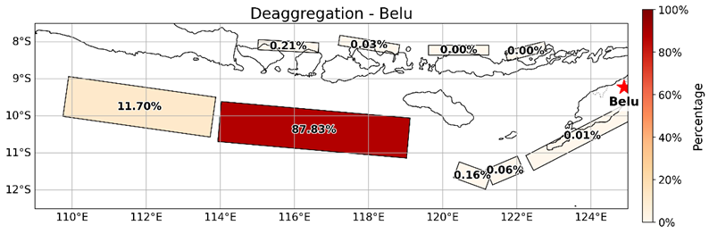
Supplementary Fig. 15 Deaggregation for 10 locations in NTT (RP 2475 years)

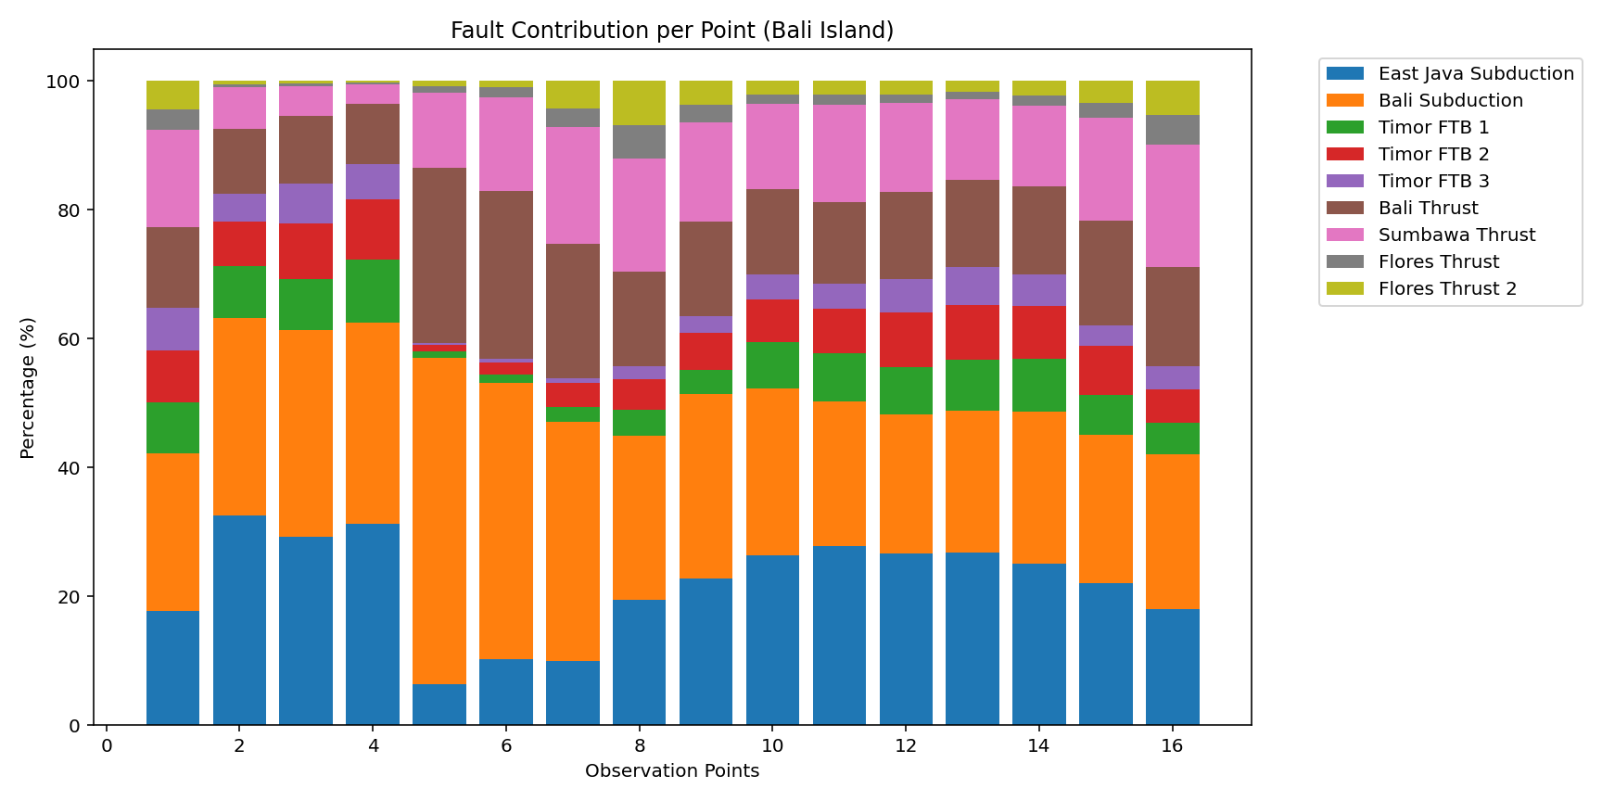
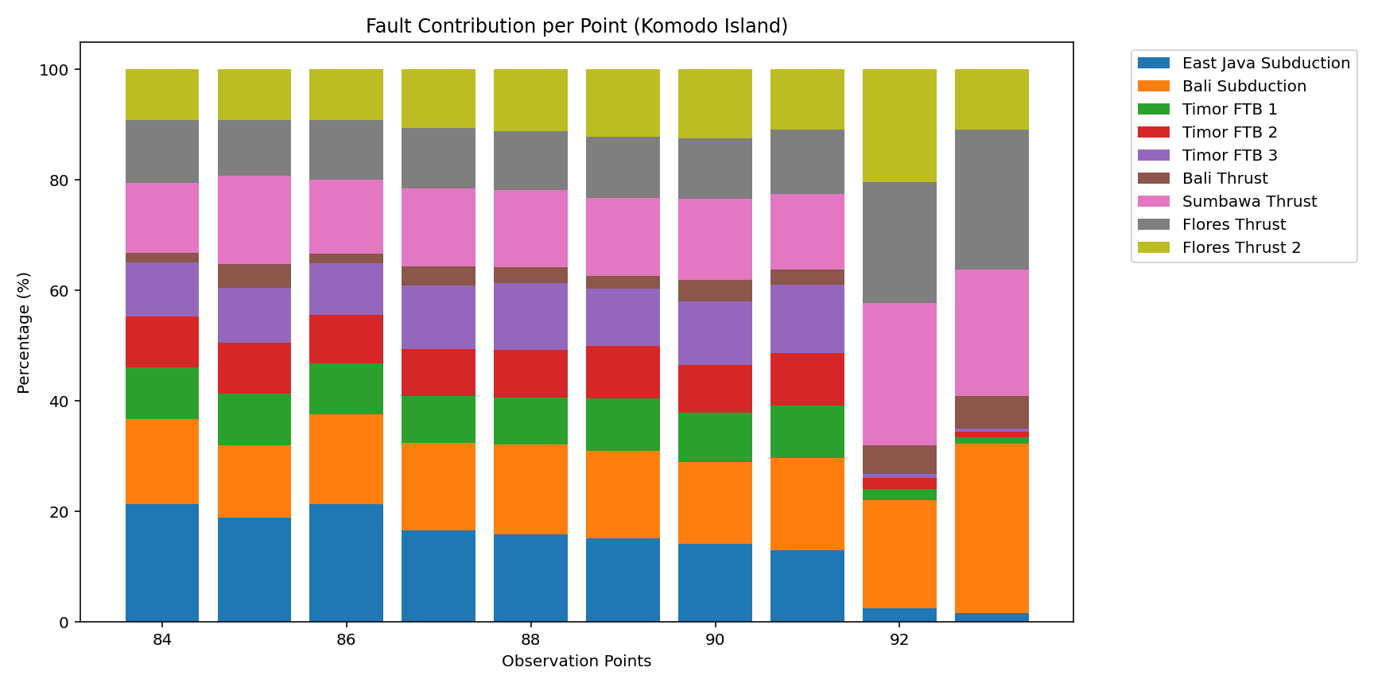
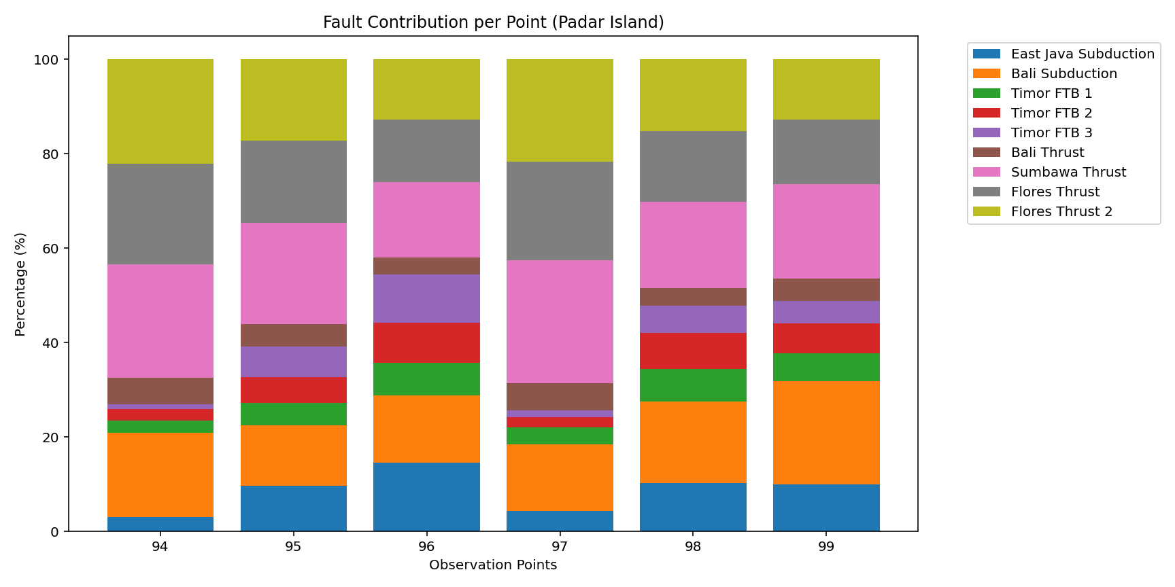
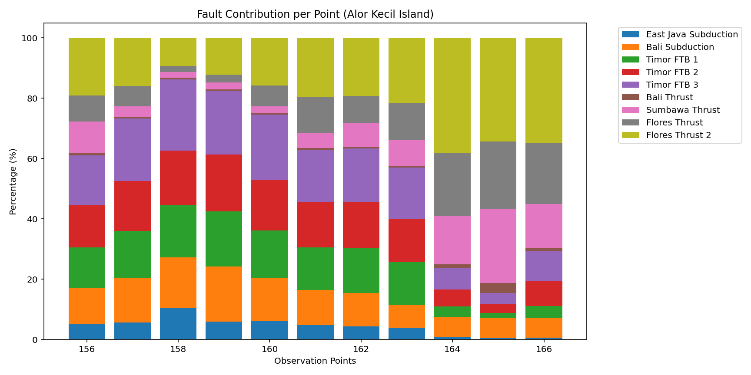
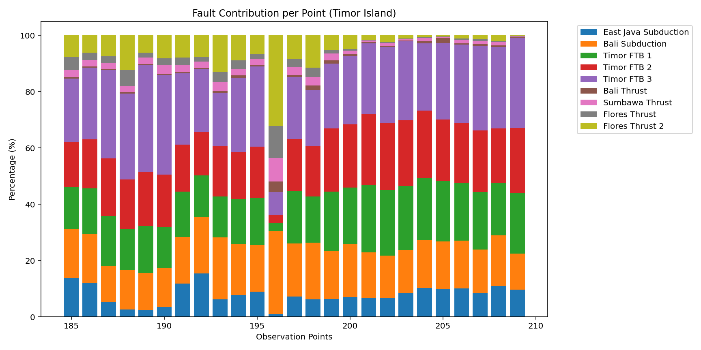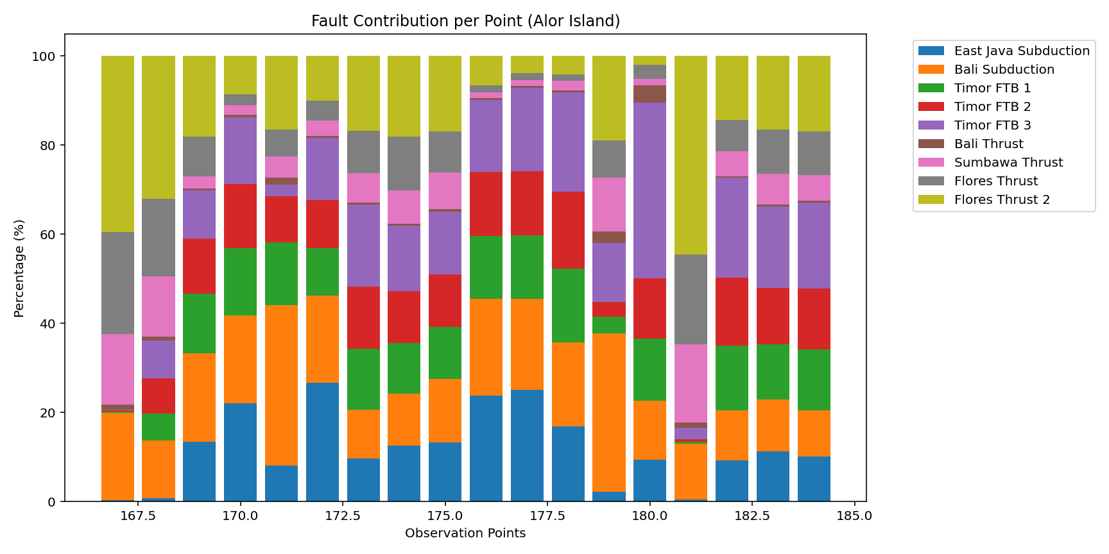
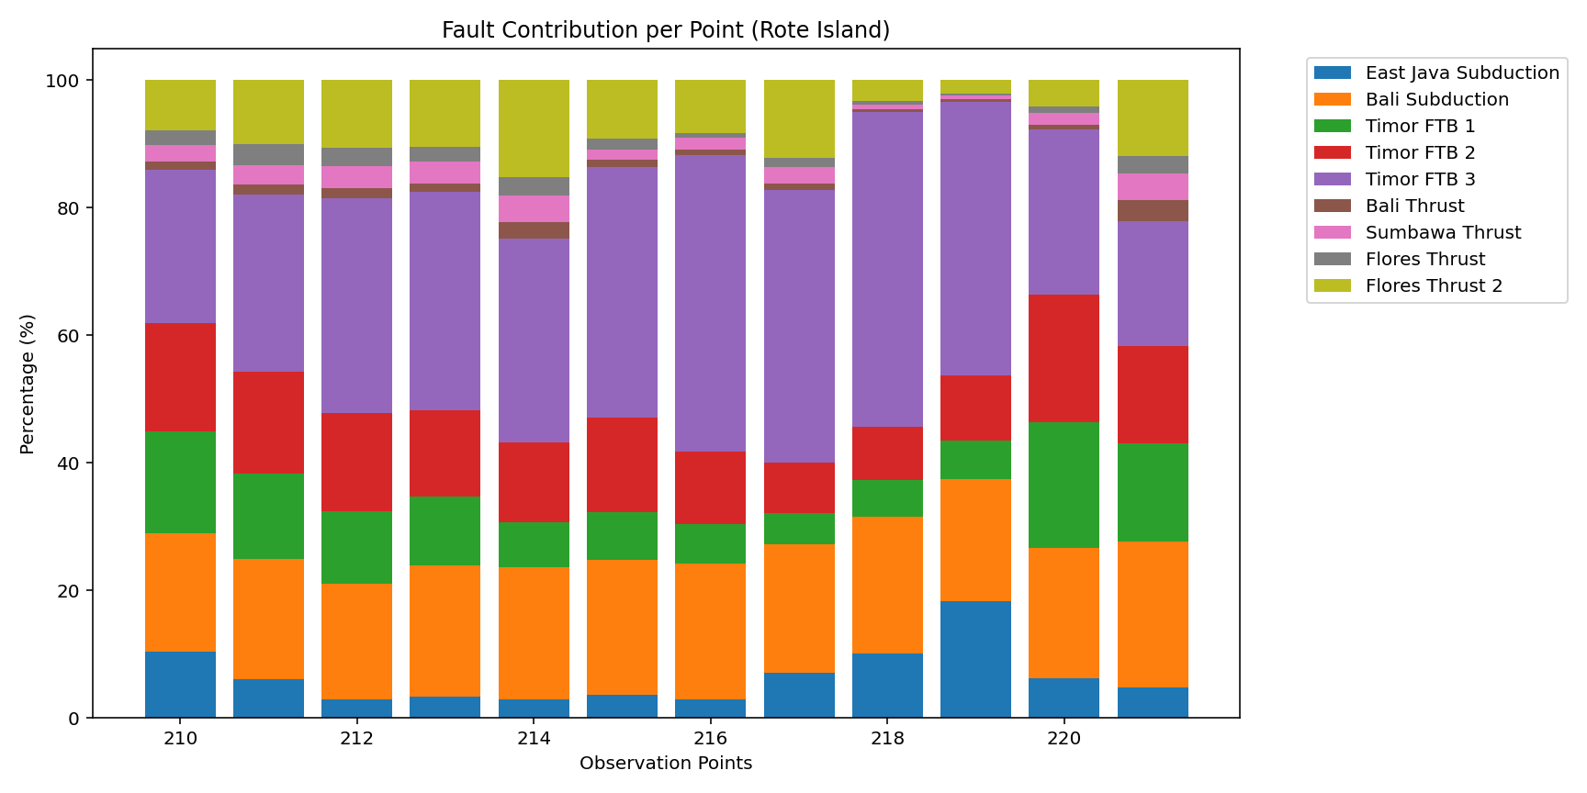
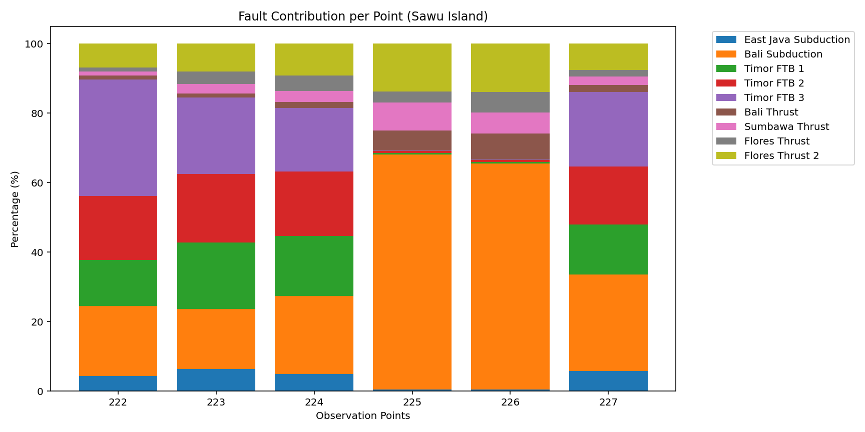
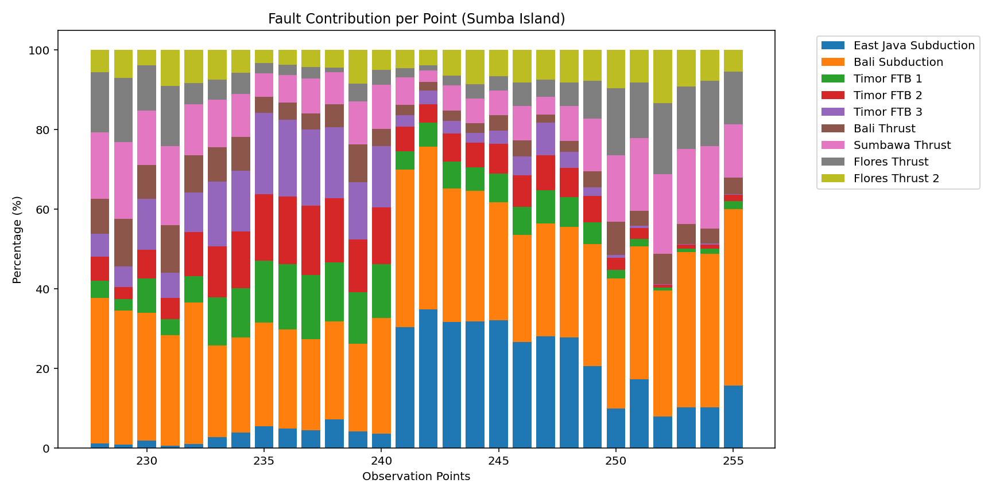
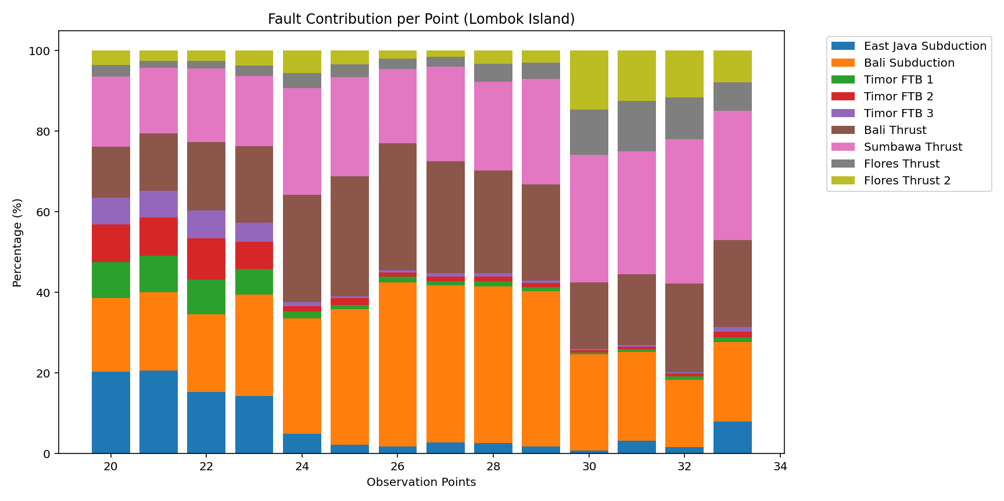
Supplementary Fig. 16 Deaggregation for 12 islands (255 observation points)

