Supplementary Figure 1

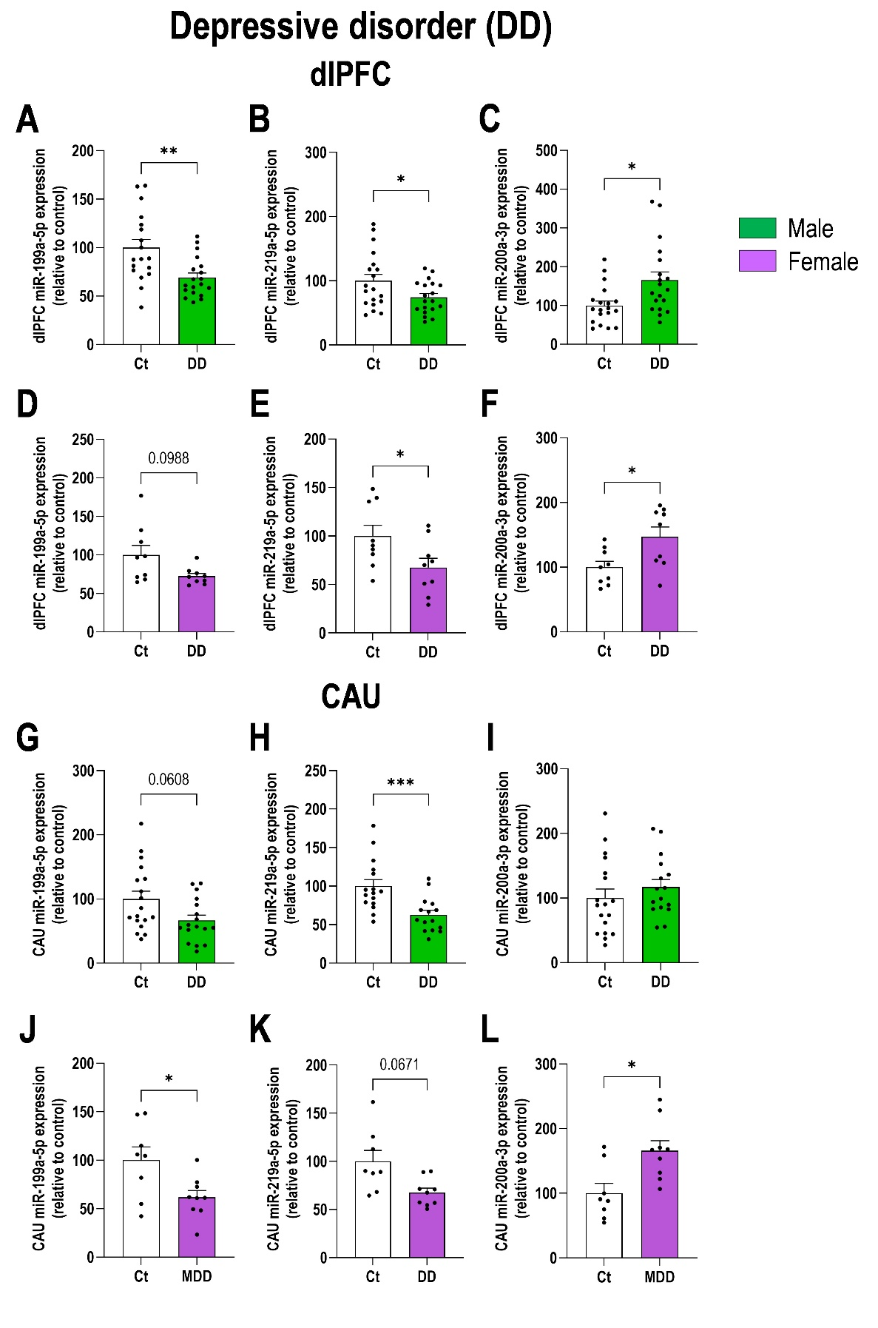

Supplementary Figure 1. Sex-dependent analysis of dysregulated miRNAs in postmortem brains samples of patients with depressive disorder (DD). A-C) Expression levels of miR-199a-5p, miR-219a-5p, and miR-200a-3p in the dorsolateral prefrontal cortex (dlPFC) of male patients with DD compared to non-DD males in the control group (Ct). D-F) Expression levels of these three miRNAs in the dlPFC of female patients with DD compared to non-DD female in the Ct group. G-H) Expression levels of miR-199a-5p, miR-219a-5p, and miR-200a-3p in the caudate nucleus (CAU) of male patients with DD compared to non-DD males in the Ct group (Ct). J-L) Expression levels of these three miRNAs in the CAU of female patients with DD compared to non-DD female in the Ct group. Data is plotted as mean ± SEM. Data points represent individual human samples. * p < 0.05, ** p < 0.01, *** p < 0.001 versus respective controls (detailed statistical analysis in supplementary excel file).

Supplementary Figure 2
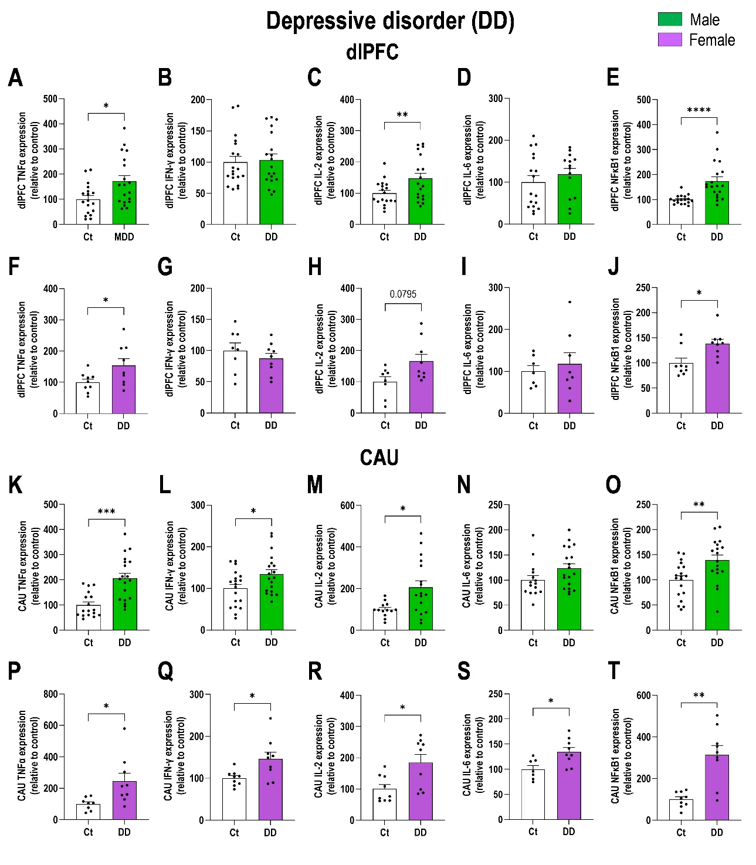

Supplementary Figure 2. Sex-dependent analysis of inflammatory mRNAs markers in postmortem brains samples of patients with depressive disorder (DD). A-E) Expression levels of TNFα, IFN-γ, IL-2, IL-6, and NFκB1 mRNAs in the dorsolateral prefrontal cortex (dlPFC) of male patients with DD compared to non-DD males in the control group (Ct). F-J) Expression levels of the same inflammatory marker mRNAs in the dlPFC of female patients with DD compared to non-DD female in the Ct group. K-O) Expression levels of TNFα, IFN-γ, IL-2, IL-6, and NFκB1 mRNAs in the caudate nucleus (CAU) of male patients with DD compared to non-DD males in the Ct group (Ct). J-L) Expression levels of the same inflammatory marker mRNAs in the CAU of female patients with DD compared to non-DD female in the Ct group. Data is plotted as mean ± SEM. Data points represent individual human samples. * p < 0.05, ** p < 0.01, *** p < 0.001, **** p < 0.0001 versus respective controls (detailed statistical analysis in supplementary excel file).

Supplementary Figure 3

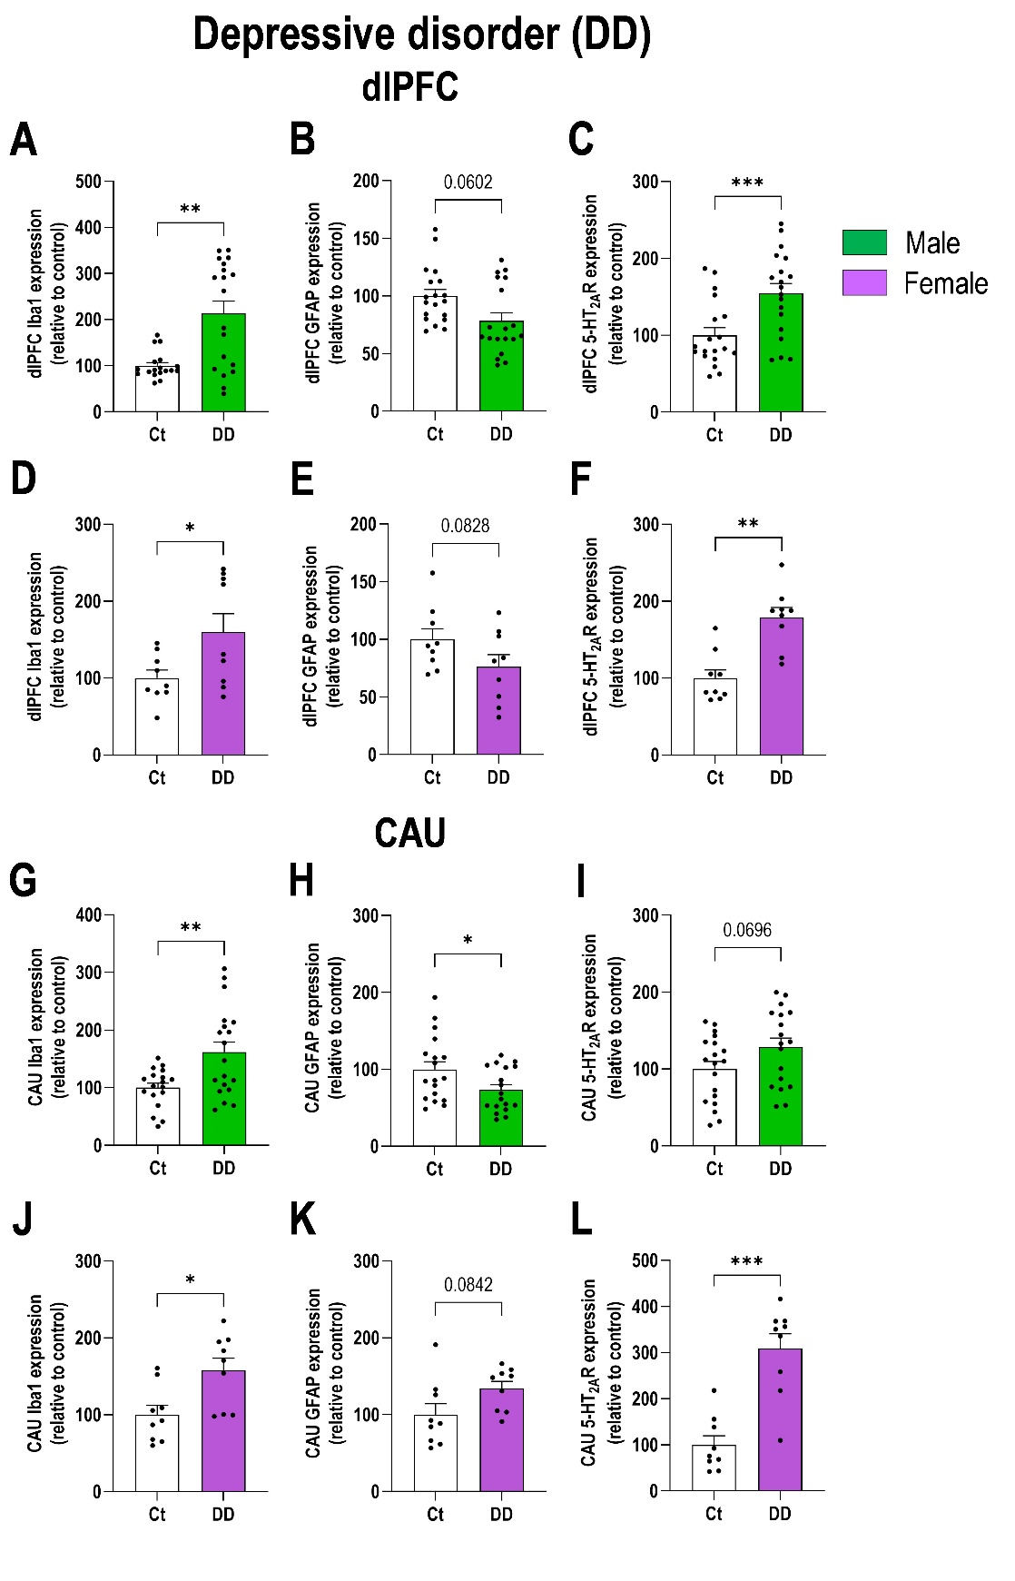

Supplementary Figure 3. Sex-dependent analysis of glial and serotonin (5-HT) signaling markers in postmortem brains samples of patients with depressive disorder (DD). A-C) Expression levels of Iba1, GFAP, and 5-HT_{2A}R mRNAs in the dorsolateral prefrontal cortex (dlPFC) of patients with DD compared to non-DD males in the control group (Ct). D-F) Expression levels of the same mRNAs in the dlPFC of female patients with DD compared to non-DD female in the Ct group. G-I) Expression levels of Iba1, GFAP, and 5-HT_{2A}R mRNAs in the caudate nucleus (CAU) of male patients with DD compared to non-DD males in the Ct group (Ct). J-L) Expression levels of the same mRNAs in the CAU of female patients with DD compared to non-DD female in the Ct group. Data is plotted as mean ± SEM. Data points represent individual human samples. * p < 0.05, ** p < 0.01, *** p < 0.001 versus respective controls (detailed statistical analysis in supplementary excel file).

Supplementary Figure 4

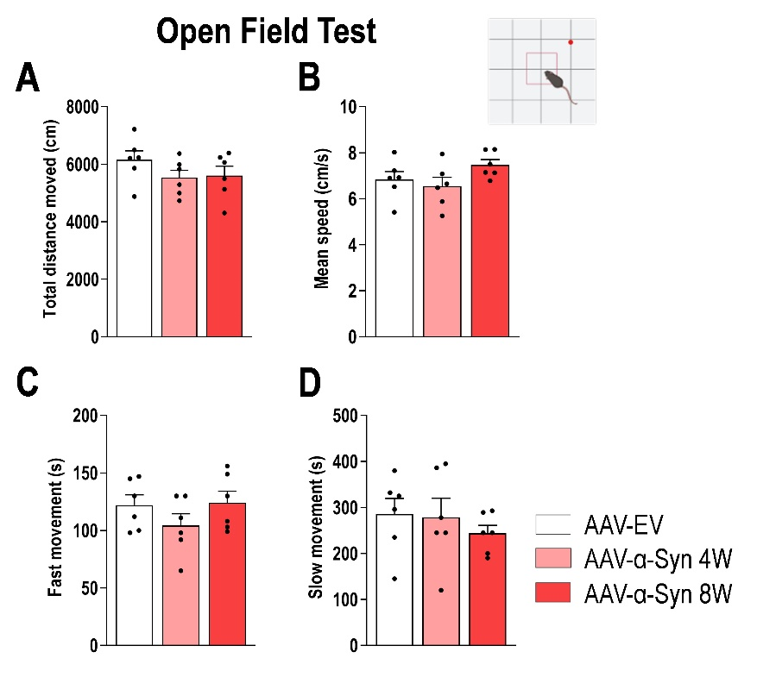

Supplementary Figure 4. Locomotor activity in the mouse model of α-synucleinopathy with depressive phenotype. A-B) Mice with human α-Syn accumulation in the serotonin (5-HT) system displayed comparable performance in the open field compared with control mice (AAV-EV). Bar graph showing quantification of: total distance traveled (A), average speed (B), fast movement (C), and slow movement (D). Data is plotted as mean ± SEM. Data points represent individual mice (detailed statistical analysis in supplementary excel file).

