Title: Grass root litter and soil carbon quality paradoxically control Q₁₀ of labile and recalcitrant carbon pools in a semi-arid Inceptisol

Table S1. Soil and climatic properties of the experimental site
Soil (0-15 cm) and climatic variables | Value
Soil textural class and soil taxonomical class | Sandy loam; Typic Haplustepts hypothermic
Soil organic carbon (SOC) | 1.00 g kg⁻¹
Sodium bicarbonate extractable phosphorus (P) | 9.1 kg ha⁻¹
Potassium chloride extractable nitrogen (N) | 182 kg ha⁻¹
Ammonium chloride extractable potassium (K) | 252 kg ha⁻¹
Soil pH | 7.34
Mean (mean of 2015-2023) annual rainfall | 842 mm
Mean (mean of 2015-2023) daily maximum temperature | 35.6 °C
Mean (mean of 2015-2023) daily minimum temperature | 27.7 °C
Mean (mean of 2015-2023) monthly evaporation | 163.5 mm
Wind velocity (May-June) | >7.8 km h⁻¹
Soil loss due to erosion | 13 Mg ha⁻¹ yr⁻¹

Table S2. The root dry weight, surface density (RSD), root decay rate (RDR), root decomposition within 180 days (RD₁₈₀) and bulk soil carbon concentration at top (TSL) and sub-surface (SSL) soil layers under various grass covers in semi-arid restored land
Grassland type# | Root dry weight (g plant⁻¹) | RDR (mg day⁻¹) | RD₁₈₀ (%) | Dry matter production (Mg ha⁻¹) | Bulk soil carbon concentration (g kg⁻¹)
 |  |  |  |  | 0-20 cm | 21-40 cm
C.cil# | 23.07a$ | 1.71a | 54.68a | 7.76b | 1.82a | 1.47a
P.max | 10.55d | 0.27d | 38.59d | 9.83a | 1.41c | 1.33b
C.ful | 11.57c | 0.78c | 44.40c | 7.83b | 1.40c | 0.68e
H.con | 11.68c | 0.08e | 33.45e | 7.09c | 1.43c | 0.97c
S.ner | 19.43b | 1.22b | 50.98b | 4.88e | 1.69b | 1.38ab
V.ziz | 9.47d | 0.07e | 37.95d | 6.21d | 1.33d | 0.82d
#See materials and methods for details
$Statistical inference according to Tukey's test is shown by lowercase letters.

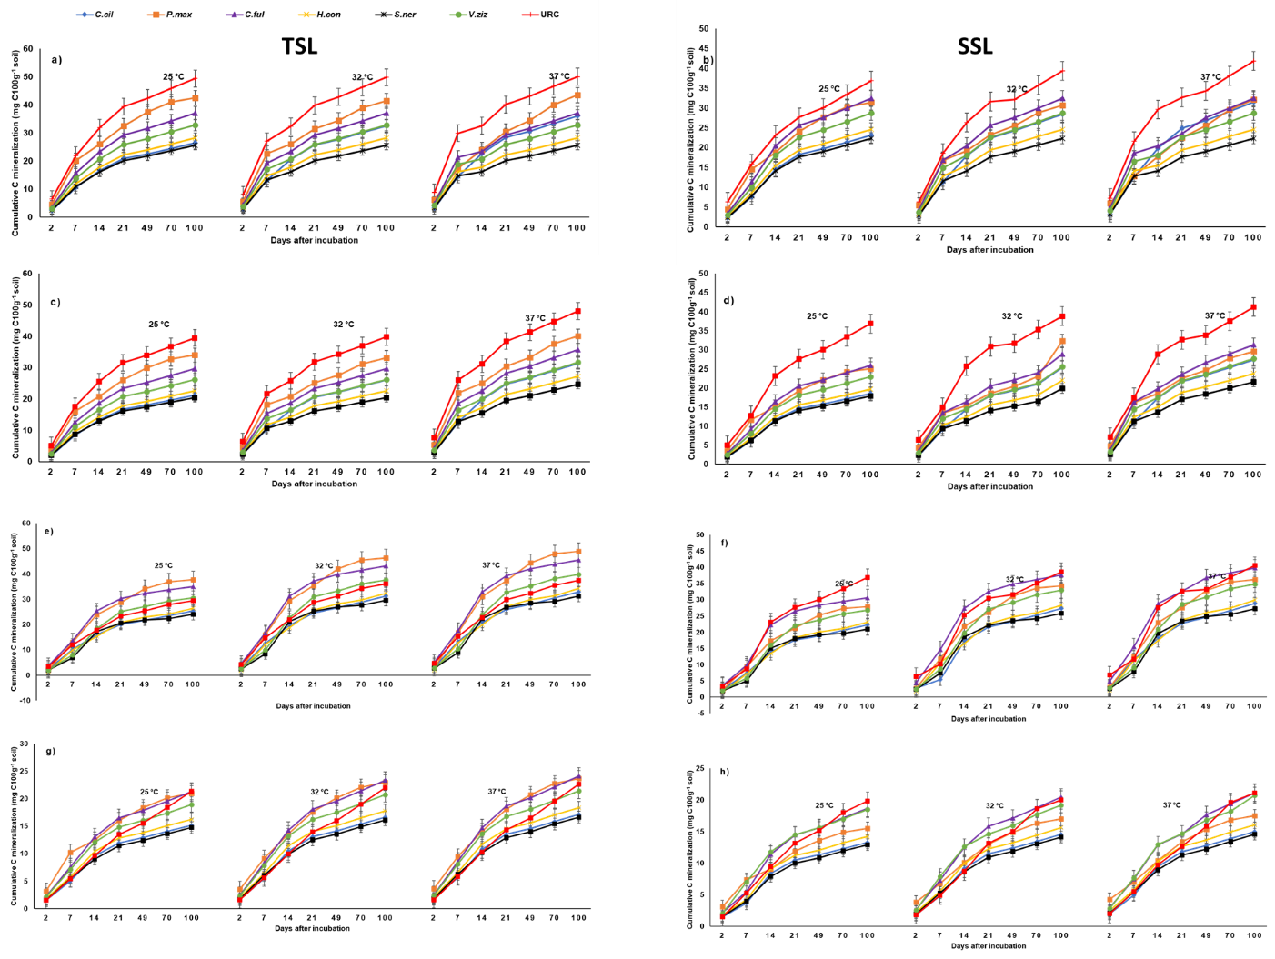
Figure S1. Impact of grass covers on cumulative carbon (C) mineralization from bulk soil (a and b), macroaggregate (c and d), microaggregate (e and f), and silt plus clay (g and g) at 25, 32, and 37 °C temperatures at top (TSL) and sub-surface (SSL) soil layers in semi-arid restored land. Error bars signify statistical difference following Tukey’s HSD test.
C.cil: Cenchrus ciliaris; C.ful: Chrysopogon fulvus; P.max: Panicum maximus; S.ner: Sehima nervosum; H.con: Heteropogon contortus; V.ziz: Vetiveria zizanioides; URC: Unrestored control;

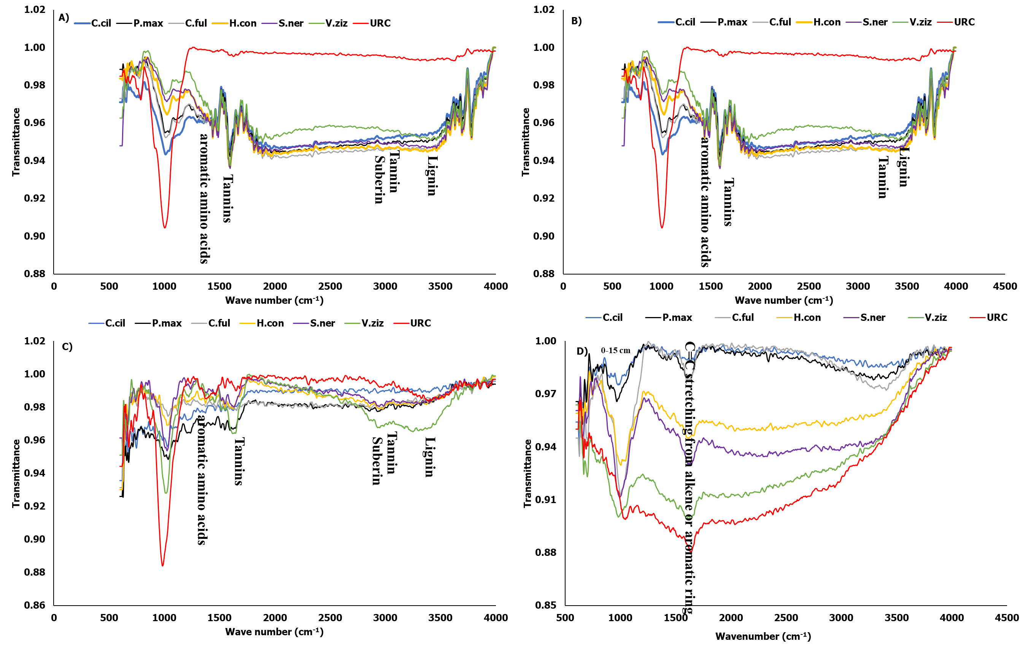
Figure S2. FTIR spectra of soil organic matter in A) bulk soil, B) macroaggregate, C) microaggregate, and D) silt+clay of different grasses at top soil layers in semi-arid restored land.
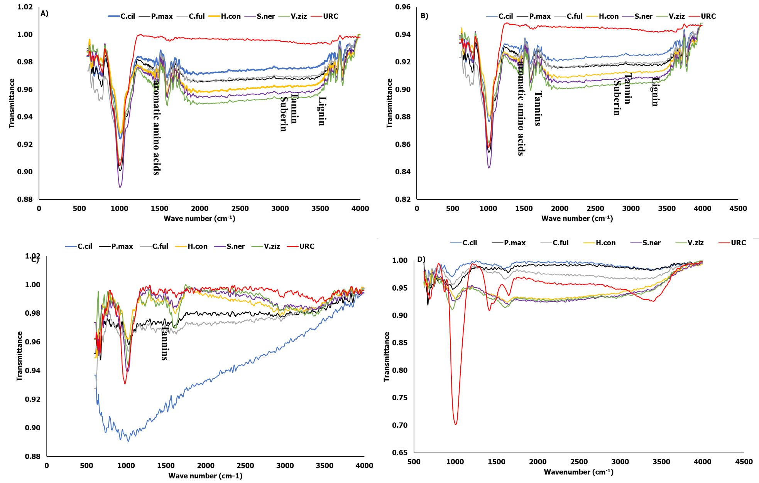
Figure S3. FTIR spectra of soil organic matter in A) bulk soil, B) macroaggregate, C) microaggregate, and D) silt+clay of different grasses at deep soil layers in semi-arid restored land.

