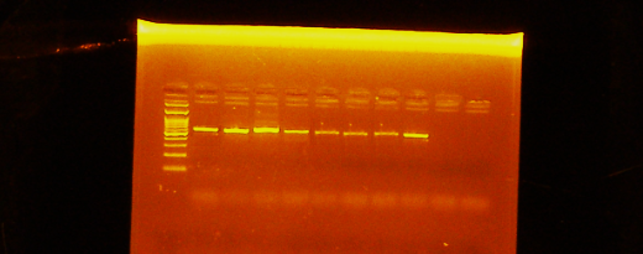
The non-cropped block corresponding to Figure 3.
Agarose gel electrophoresis of the ITS1/ITS4 rDNA PCR products. Lanes 1-8 were representation of Cladosporium strains. M is the 100 bp molecular size marker, and lanes 9 and 10 are negative controls

