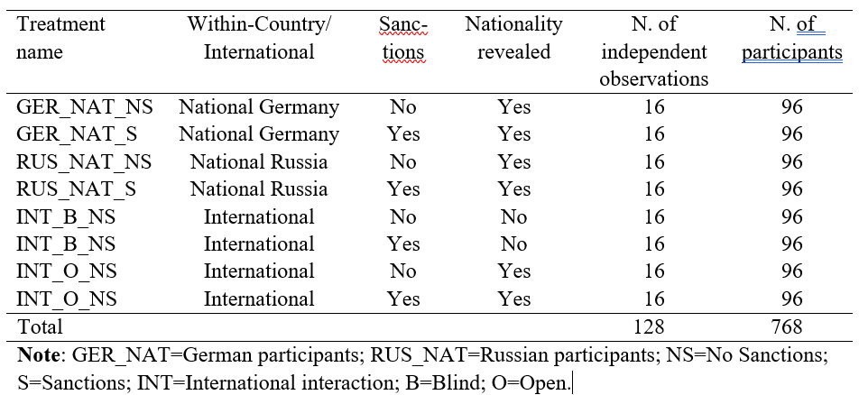
Table 1 | Summary of Experimental Design

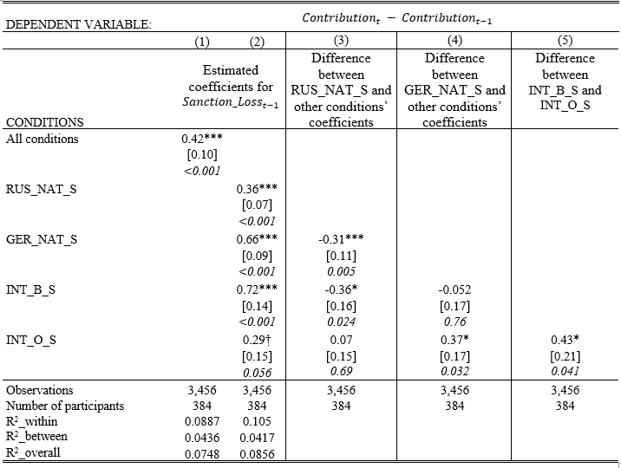
Table 2 | Econometric analysis of the impact of sanctions on cooperation. We fitted an OLS estimator to a model having as dependent variable the variation in Contribution between period t and t-1, for t=2,…10. The Table reports the estimated coefficients for tokens lost due to sanctions by other group members in the previous period ${Sanction_Loss}_{t-1}$ across all treatments (column 1) and for each treatment (column 2). Columns 3-5 report the results of t-tests over the null hypothesis that a certain treatment coefficient is different from the coefficient of another treatment. Fixed effects for treatments and periods are included. Heteroskedasticity-robust standard errors clustered at the individual level are in brackets and p-values in italics. The full regression output and further details on the specification are reported in Table S11. *** p<0.001; ** p<0.01; * p<0.05; † p<0.10.

